**Project No.** **06-05**

ACRP 06-05:

**GUIDANCE FOR DIVERSITY IN AIRPORT BUSINESSES CONTRACTING AND WORKFORCE PROGRAMS**

AIRPORT CONTRACTING DIVERSITY BENEFIT-COST TOOL USER GUIDE

**Prepared for**

**Airport Cooperative Research Program**

**Transportation Research Board**

**of**

**The National Academies of Sciences, Engineering, and Medicine**

**Richard A. Krop, Jaime Rooke, Jon McDonnell**

**The Cadmus Group LLC**

**Waltham, MA**

**Nancy K. West**

**Exstare Federal Services Group, LLC**

**Alexandria, VA**

**Mara Rosales**

**Rosales Law Partners LLP**

**San Francisco, CA**

**September 2019**

Permission to use any unoriginal material has been

obtained from all copyright holders as needed.

**This Page Intentionally Left Blank**

*ACKNOWLEDGEMENT OF SPONSORSHIP*

This work was sponsored by one or more of the following as noted:

American Association of State Highway and Transportation Officials, in cooperation with the Federal Highway Administration, and was conducted in the **National Cooperative Highway Research Program**,

Federal Transit Administration and was conducted in the **Transit Cooperative Research Program**,

Federal Aviation Administration and was conducted in the **Airport Cooperative Research Program**,

**X**

The National Highway Safety Administration and was conducted in the **Behavioral Traffic Safety Cooperative Research Program**,

which is administered by the Transportation Research Board of the National Academies of Sciences, Engineering, and Medicine.

*DISCLAIMER*

This is an uncorrected draft as submitted by the Contractor. The opinions and conclusions expressed or implied herein are those of the Contractor. They are not necessarily those of the Transportation Research Board, the Academies, or the program sponsors.

**This Page Intentionally Left Blank**

**Project No. 06-05**

ACRP 06-05:

**GUIDANCE FOR DIVERSITY IN AIRPORT BUSINESSES CONTRACTING AND WORKFORCE PROGRAMS**

AIRPORT CONTRACTING DIVERSITY BENEFIT-COST TOOL USER GUIDE

**Prepared for**

**Airport Cooperative Research Program**

**Transportation Research Board**

**of**

**The National Academies of Sciences, Engineering, and Medicine**

**Richard A. Krop, Jaime Rooke, Jon McDonnell**

**The Cadmus Group LLC**

**Waltham, MA**

**Nancy K. West**

**Exstare Federal Services Group, LLC**

**Alexandria, VA**

**Mara Rosales**

**Rosales Law Partners LLP**

**San Francisco, CA**

**September 2019**

Permission to use any unoriginal material has been

obtained from all copyright holders as needed.

**This Page Intentionally Left Blank**

**CONTENTS**

List of Tables vii

List of Figures viii

Tool Overview 1

Getting Started 1

Organization and Formatting 1

Review of tabs 2

Data Map 4

General user tips 5

General Inputs 6

Participation Goals 8

DBE Analysis 9

Inputs 9

Results 16

Local and Small Business Analysis 17

Inputs 18

Results 18

ACDBE Analysis 21

Inputs 22

Results 30

Cost-effectiveness and Economic Impacts 32

Inputs 32

Results 33

Example Data and Outcomes 34

Businesses 34

Contracts 37

Concessionaires 39

Concessions Contracts 40

List of Tables

Table 1. Breakdown of different cell formats used throughout the workbook and their meanings. 3

Table 2. Instructions for data fields in the *Inputs2-Participation Goals* tab 8

Table 3. Instructions for data fields in the DBE Analysis tabs 10

Table 4: Instructions for data fields in ACDBE tabs 24

Table 5: Instructions for data fields in cost-effectiveness and economic impacts tab 34

List of Figures

Figure 1: Pop-up window that may appear when opening the workbook. 1

Figure 2: High level organization tool analyses. 2

Figure 3: Example of how tab grouping is color coded. 3

Figure 4: Data map that depicts the flow of information between tabs in the tool. 5

Figure 5. Automatic warning when an entry does not match one of the data entry options for that field. 6

Figure 6: The header on the top of calculation tables that exist in the margins of some output tabs. 6

Figure 7: Decision hierarchy for DBE results tab. 17

Figure 8: Decision Hierarchy for small business results tab. 19

Figure 9: Decision Hierarchy for Local Results tab 21

[Figure 10: Entering Business Name 35](https://cadmus.sharepoint.com/sites/collaboration/4563-P03/Shared%20Documents/Task%2010%20-%20Finalize%20Deliverables/ACRP%2006-05%20Tool%20Users%20Guide%20Copy%201.docx#_Toc20167532)

[Figure 11: Reference Year Drop-down Menu 35](https://cadmus.sharepoint.com/sites/collaboration/4563-P03/Shared%20Documents/Task%2010%20-%20Finalize%20Deliverables/ACRP%2006-05%20Tool%20Users%20Guide%20Copy%201.docx#_Toc20167533)

[Figure 12: Business Certification Status Drop-down 36](https://cadmus.sharepoint.com/sites/collaboration/4563-P03/Shared%20Documents/Task%2010%20-%20Finalize%20Deliverables/ACRP%2006-05%20Tool%20Users%20Guide%20Copy%201.docx#_Toc20167534)

[Figure 13: Business Bid History Drop-down Menu 36](https://cadmus.sharepoint.com/sites/collaboration/4563-P03/Shared%20Documents/Task%2010%20-%20Finalize%20Deliverables/ACRP%2006-05%20Tool%20Users%20Guide%20Copy%201.docx#_Toc20167535)

Figure 14: Example of completed Inputs3-Businesses tab through column G. 37

Figure 15: Example of completed Inputs3-Businesses tab through column Q. 37

Figure 16: Example of completed Inputs4- Contracts tab through column H. 38

Figure 17: Example of completed Inputs4- Contracts tab through column T. 39

Figure 18: Example of completed Inputs5- Concessionaires tab through column F. 40

Figure 19: Example of completed Inputs5- Concessionaires tab through column O. 40

Figure 20: Example of completed Inputs6- Concessions Contracts tab through column I. 41

Figure 21: Example of completed Inputs6- Concessions Contracts tab through column AA. 42

Tool Overview

***Purpose:*** The Airport Contracting Diversity Benefit-Cost Tool (tool) is intended to enable airport diversity programs to track data over time and develop a comprehensive understanding of the outcomes of their contracting diversity program. There are many benefits of improving diversity in contracting, as described in detail in the guidebook. However, it is not possible to quantify or monetize all these potential benefits. This tool focuses on metrics that can be developed based on contracting data that are readily available at most airports. It can also enable airports to track information relevant to their diversity programs; anticipate the information that will help them evaluate their programs, even if they are not equipped to collect the information at this time; provide detailed analysis to help airports “drill down” into the details of the data and provide ready-to-use graphics to help airports quickly assess their diversity programs, identify trends, and communicate results.

***Intended Audience/Users:*** This tool was developed for airport diversity program staff with basic familiarity with Excel and access to information about airport contracts and concessions. The tool has user protections that will prevent overriding critical formulas. A basic Excel user should be able to easily navigate the various tabs of the tool, understand the outputs, and use filters to drill down into the details of the inputs and results tables.

***Excel-based tool:*** Excel was selected as the platform for this tool because it is accessible, easy to navigate and is highly compatible with a range of software-related security restrictions.

Getting Started

***Saving the tool:*** The tool can be saved easily to any computer or server that is compatible with Excel. It is recommended that the user save backup copies of the tool to avoid the loss of data in the case of inadvertent deletions or software failure.

***Opening the tool:*** When opening the tool in Excel, it is possible that pop-ups may appear. Click “Enable Content” if a security warning appears towards the top of the page (Figure 1). The tool does not contain macros and should not trigger the user’s security software. If you encounter problems when opening the document, contact your organization’s information technology (IT) representative for assistance.



Figure 1: Pop-up window that may appear when opening the workbook.

***Workbook is protected:*** The workbook has been protected to maintain the integrity of the formulas and formatting used throughout. Users should be aware that some cells have been protected against being edited. Although protected, all cells are unhidden, which means that users can view their formulas to better understand how the tool functions.

Organization and Formatting

This tool is organized into four distinct analyses: (1) DBE analysis; (2) local and small business analysis; (3) ACDBE analysis; and (4) cost effectiveness and economic benefits analysis. The user can enter data into the tool to conduct one or all these analyses, but it is not necessary to complete all portions of the tool to see informative outputs. Figure 2 summarizes the functions of each analysis. For easy navigation, the tool uses color coding to organize the tabs into these four analyses.

Figure 2: High level organization tool analyses.

Review of tabs

***Input Tabs:*** Tabs labelled *Inputs 1-7* require user input. Input tabs contain cells formatted for hard data entry, mandatory entry, no entry, and error (see Table 1 for a complete list of cell formats and their meanings). The user should begin by completing the inputs in the *Inputs1-General* and *Inputs2-Participation Goals* tabs. Within each analysis identified in Figure 2, the input tabs should be completed in the order that they appear in the workbook. For example, *Inputs3-Businesses* should be completed before *Inputs4-Contracts* for the DBE analysis. Inputs tabs are broken into four groups and color coded: General (green), DBE (orange), ACDBE (yellow), and Economic Impacts (blue) (see Figure 2 and Figure 3).

***Results Tabs:*** Tabs that have the letter *R* prepended to the title (e.g., *R1- DBE Participation*)do not require user input and are prepopulated based on user inputs in related tabs. Outputs tabs are grouped with their associated inputs tab. For example, all the tabs for the DBE analysis are grouped and color-coded, as shown in Figure 3. These tabs include mostly of cells formatted for calculation results (calculated) and subtotal results (summations of calculation results). See Table 1 for a complete list of cell formatting and their meaning.



Figure 3: Example of how tab grouping is color coded.

***Graphs/figures:*** Tabs that have the letter R prepended and the word *Graphics* appended do not require user input and are intended to summarize the results tab that they are associated with. Each graphics tabs contain two elements: a summary table for calculation purposes and a series of auto-populating graphical representations. The comparisons that are being graphicly represented have been pre-selected base on the anticipated interests of the tool’s user base and audience.

Table 1. Breakdown of different cell formats used throughout the workbook and their meanings.

| Formatting | Applies To | Purpose | Description |
| --- | --- | --- | --- |
|  | Inputs Tabs | Hard Data Entry Cell | Cells with no fill are data entry cells. These will either require a manual entry or selection from a drop-down list. |
|  | Inputs Tabs | Formula Cell | Cells with light grey fill have formulas and will auto-populate as data are entered into the tool. |
|  | Inputs Tabs | Mandatory Entry Cell | Upon entering a business or concessionaire name in the Inputs3, Inputs4, Input5, and Inputs6 tabs, mandatory cells will turn blue. These cells must have an entry for the tool to function. |
|  | Inputs Tabs | No Entry Cell | Cells with dark grey fill should not have entries. These cells will change color based on the selections made in other cells in the tool. |
|  | Inputs Tabs | Error Cell | A red cell indicates that there has been a data entry error that must be corrected. |
|  | Results Tabs | Calculation Results Cell | Cells with a light fill and white border include formulas that the tool uses to calculate results based on date entries in the Inputs tabs. These cells cannot be modified. |
|  | Results Tabs | Subtotal Results Cell | Cells with a dark fill and white border include formulas that calculate subtotals based on the results in the light-yellow cells. These cells cannot be modified. |

Data Map

The tool draws from multiple tabs to generate the results and final economic outputs tabs. Figure 4 provides a graphical depiction of the tool and how each tab is connected. As seen in the figure, data entries in the *General Inputs* tab are used by every analysis in the tool. Therefore, it is critical that the user enters data into all fields in this tab carefully in order for the tool to function properly. Entries in the *Participation Goals* tab are used in the results tabs of the DBE, Local and Small Business, and ACDBE analyses.

In the DBE analysis, the DBE inputs tabs reference each other to populate formula-based cells and to populate drop-down options in one field. The DBE analysis inputs tabs are used to populate results in the DBE analysis results and Local and Small Business results tabs. The tab structure in the ACDBE analysis is similar to that of the DBE analysis. In the ACDBE analysis, the ACDBE inputs tabs reference each other, and the ACDBE inputs tabs are both used to populate all four of the ACDBE results tabs. Finally, the Economic Outputs tabs draw from the data entered into the *General Inputs*, *Inputs4- Contracts*, *Inputs6- Concessions Contracts*, and the *Inputs7-Program Costs* tabs.



Figure 4: Data map that depicts the flow of information between tabs in the tool.

General user tips

***Move Left to Right:*** When inputting information into the tool users should move left to right (across columns) and from top to bottom (by rows). This process will maximize the tool’s formatting functionalities. Once data are entered into the tool, the user can go back into fields to correct or update data, as needed.

***Use Drop-down Menus:*** When applicable, users must use the pre-populated drop-down menus in the tool. Cells that contain drown menus are created with data validation so that users cannot input options that are not included in the drop-down menu. Figure 5 provides an example of a warning that will pop up if an incorrect entry is made in a drop-down field.

Figure 5. Automatic warning when an entry does not match one of the data entry options for that field.

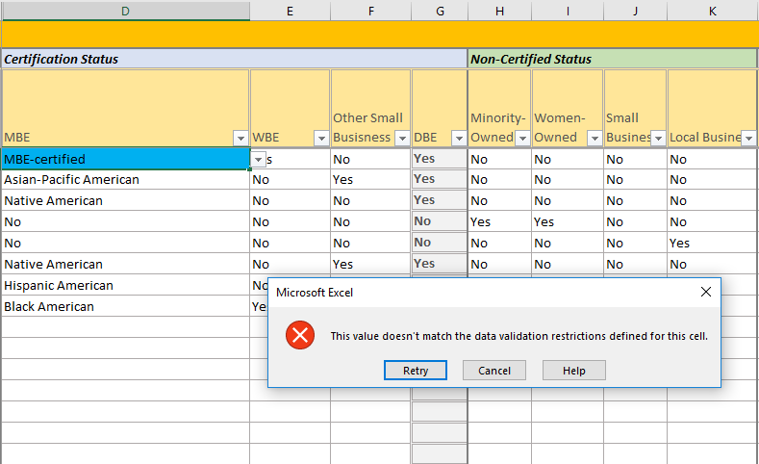

***Calculation Tables Do Not Require Inputs:*** In the margins of *Inputs4- Contracts*, *Inputs6- Concessions Contracts* and each graphics tab there are tables denoted *For Calculation Purposes Only* (Figure 6). These tables are used by the tool to format and calculate data in a way that is conducive to the graphs in the graphics tabs. Users can disregard these calculation tables or use them to understand more about the tool’s functionality. As previously mentioned, the tool was designed to enable the user to examine all formulas used to develop the tool’s results and outputs.

Figure 6: The header on the top of calculation tables that exist in the margins of some output tabs.

General Inputs

The first step when using the tool is to enter basic information into the *Inputs1-General* tab. The data fields in this tab are used throughout the tool, and the tool will not function without these fields. For example, the starting year of the analysis, the inflation rate, and other basic inputs are needed in this tab. The table below provides a detailed description of each field and instructions for how to fill them out.

| **Term or Field** | **Type of Field** | **Required?** | Definitions |
| --- | --- | --- | --- |
| General Information: Inputs1- General | | | |
| Term of the Analysis | Manual Entry | Yes | The number of years that the airport would like to evaluate in this tool. A term of 10 years will result in the tool populating headers for 10 years (e.g., 2020 to 2030). This term can be adjusted at any point in the analysis. The tool can accommodate a term up to 15 years. |
| Starting Year of the Analysis | Manual Entry | Yes | The first year the airport wants to track and report data. The tool tracks all data on an annual basis, and the airport must define the period that corresponds to each year and enter data accordingly. For example, "2020" in the tool can correspond to the airport's fiscal year for 2020. An airport may choose to begin the analysis a year or more prior to the current year to capture significant events, program milestones, or goal timeframes. For example, if the current year is 2020, but the airport may choose to begin tracking data from 2018. In this case, the starting year would be 2018. |
| Start of 3-Year DBE Goal Cycle | Manual Entry | Yes | This is the first year of the airport's DBE goal cycle. The tool will use this field to adjust tables and figures to reflect the airport's cycle. For example, entering "2020" means that the three-year cycle is 2020-2022. |
| Start of 3-Year ACDBE Goal Cycle | Manual Entry | Yes | This is the first year of the airport's ACDBE goal cycle. The tool will use this field to adjust tables and figures to reflect the airport's cycle. For example, entering "2020" means that the three-year cycle is 2020-2022. |
| Airport Name | Manual Entry | No | Enter the name of the airport using the tool. |
| Location City | Manual Entry | No | Enter the city in which the airport is located. |
| Location State | Drop Down | Yes | Select the state in which the airport is located. |
| Year of Dollars for Output | Manual Entry | Yes | Enter the year of the dollars for the output of the economic impact analysis. For example, if 2025 is entered, then the tool will inflate all output to 2025 USD using the inflation factor specified in the next field. |
| Set Inflation Rate | Drop Down | Yes | The inflation rate in this field is used to adjust dollar values for the economic impact analysis results to the year specified in the previous field, "Year of Dollars for Output". Use this field to indicate whether you want the tool to use a default inflation rate or whether you want to specify your own inflation rate. If "Avg Annual US Rate" is selected, then the tool will use the average inflation rate based on the Bureau of Labor Statistics' Consumer Price Index. The tool can only calculate inflation rates up to 2018, which is the most current inflation number available from BLS at the time this tool was developed. However, the tool will apply the average annual inflation rate to all years, even those following 2018. If "User Rate" is selected, then the user can specify an average inflation rate. |
| First year to use in calculation of average inflation: | Drop Down | Yes | If the "Avg Annual US Rate" was selected in the previous field, then use this field to specify the first year over which the tool should calculate the average annual inflation rate. |
| First year to use in calculation of average inflation: | Drop Down | Yes | If the "Avg Annual US Rate" was selected in the previous field, then use this field to specify the last year over which the tool should calculate the average annual inflation rate. |
| Specify inflation rate for 2019 and forward | Manual Entry | Yes | If "User Rate" was selected in the "Select Inflation Rate" field, the user will use this field to enter the annual inflation factor from 2017 to the year of the output specified in the "Year of Dollars for Output". This option is more precise if the user knows the actual inflation factor for the year of output. |

Participation Goals

The next step when using the tool is to enter information related to the airport’s diversity goals into the *Inputs2-Participation Goals* tab. The tool uses the airport’s DBE and ACDBE participation goals as a basis against which to evaluate the airport’s actual DBE and ACDBE participation on a yearly basis. While these fields are not required for the tool to function, it is highly recommended that the user populate these fields to maximize the potential of the tool. The participation goals entered into this tab are populated in the DBE and ACDBE results tabs. It is not necessary that airports enter their participation goals into this tab—the tool will evaluate other inputs without this information. However, the “goals” fields in the results tabs will be empty if goals information is not entered into this tab. The table below provides a detailed description of each field and instructions for how to fill them out.

Table 2. Instructions for data fields in the *Inputs2-Participation Goals* tab

| Term or Field | Type of Field | Required? | Definitions |
| --- | --- | --- | --- |
| Inputs2- Participation Goals | | | |
| DBE participation goal (% of federal dollars) | Manual Entry | No | Enter the airport's annual DBE participation goal under each year. This goal is a percentage of contract dollars to DBEs in each year. |
| Overall 3-Year DBE participation goal (% of federal dollars) | Manual Entry | No | Enter the airport's overall 3-year DBE participation goal, as a percentage of contract dollars. Do not enter values into fields marked "Off Cycle". |
| ACDBE participation goal for non-car rental concessions (% of gross revenue) | Manual Entry | No | Enter the airport's annual ACDBE participation goal for non-car rental concessions under each year. This goal is the sum of revenues from prime and subconcessions with ACDBEs divided by all revenues |
| Overall 3-Year ACDBE participation goal for non-car rental concessions (% of gross revenue) | Manual Entry | No | Enter the airport's overall 3-year ACDBE participation goal for non-car rental concessions, as a percentage of dollars. Do not enter values into fields marked "Off Cycle". |
| ACDBE participation goal for car rental concessions (% of gross revenue OR expenditures on goods & services) | Manual Entry | No | Enter the airport's annual ACDBE participation goal for car rental concessions under each year. This goal is the sum of expenditures on goods and services that go to ACDBEs divided by all expenditures on goods and services. For airports that have ACDBE prime car rental operators, then this goal can be based on total gross revenues. |
| Overall 3-Year ACDBE participation goal for car rental concessions (% of gross revenue) | Manual Entry | No | Enter the airport's overall 3-year ACDBE participation goal for car rental concessions, as a percentage of dollars. Do not enter values into fields marked "Off Cycle". |
| Awards to Local Businesses (% of dollars) | Manual Entry | No | Enter the airport's annual goal for local business participation on non-federally assisted projects. |
| Awards to Small Businesses (% of dollars) | Manual Entry | No | Enter the airport's annual goal for small business participation on non-federally assisted projects. |

DBE Analysis

Highlighted in orange in the tool, the DBE analysis is the first analysis in the tool and is intended to assess the airport’s DBE participation on federally assisted contracts. The tabs associated with this analysis are *Inputs3- Businesses, Inputs4- Contracts, R1- DBE Participation, R1a- DBE Graphics.*

Inputs

***Inputs3- Businesses:*** This input tab is designed to track businesses that contract with the airport, and if the user wants to enhance their analyses, this tab can also be used to track the bidding process. For example, the airport can enter details about each bidder responding to a request for proposal to track the pool of businesses bidding on projects. For a more basic approach to using the tool, the airport can simply enter the information about businesses that are ultimately awarded contracts. A detailed example of how this tab is filled out can be found below in the *Example Data and Outcomes* section.

The tab functions as a complete database of businesses working for the airport. A single row is used to document the characteristics of a single business. For example, the row includes the business name, its DBE certification status, whether it is minority- or woman-owned, and whether it is a small or local business. These details are essential for the tool to function and must be entered to obtain accurate results in the results tabs. If desired, this tab can also track information about the businesses’ contracting history with the airport. This may be of interest to the airport if it wants to track when new businesses contract with the airport for the first time or whether DBE businesses return to the airport. However, these data on the business’ contracting history with the airport are not necessary for the tool to generate results for the DBE analysis. See Table 3 for detailed instructions for data entry in each field in this tab.

In some cases, the user may not want to enter every business separately. The tool is flexible enough to reduce the data entry burden and still produce outputs in the results tabs. Rather than entering every business in its own row, the airport can develop a typical business profile for each *type* of business working for the airport. These profiles can then be used in the *Inputs4-Contracts* tab to represent these specific *types* of businesses. For example, assume the airport is working with five MBE-certified businesses: Business A, Business B, Business C, Business D, and Business E. Rather than entering each of these businesses in its own row, the airport can create an *MBE Certified* profile to represent all of these businesses. Using this approach, the airport can avoid entering and maintaining data for five separate businesses and just use this profile to represent all MBEs. Similarly, the airport can create a profile for each type of business working with the airport: WBE, small business, local business, etc.

**Simplify the Tool: Business Profiles**

Create a single profile in the *Inputs3- Businesses* tab that represents all businesses working with the airport for each type of business. Rather than entering data for dozens of businesses, the airport can simplify data entry to a handful of profiles.

***Inputs4- Contracts:***This input tab is designed to track contracts with the airport and the businesses that are awarded those contracts. This tab is designed such that each row documents one business working on one contract. If a contract has more than one business (such as a prime and a subcontractor), then a separate row is used to document each business working on the contract. Each row represents a unique contract-business combination. For example, if an airport has three contracts, each with three businesses, then this tab would include nine rows of data entry. In the case that one business works on three separate contracts over the period of analysis, then that business would be entered in three separate rows

**FAQ:**

Q: Should the user report all businesses contracting with the airport?

A: This is ultimately up to the airport and depends on the desired level of detail in the analysis. If DBE businesses are omitted from the inputs tabs, then the percentage of total participation with not reflect those businesses. Accurate percentages depend on complete reporting.

If the airport is using the simplified “profile” approach described above, then each row would represent a unique contract-profile combination. Assume that businesses A and B are not DBE businesses and business C is a WBE, the detailed approach would have three rows: one specifying each business working on the contract. However, if the airport opts to use the simplified “profile approach”, the airport could simply enter two rows of data: one for the DBE profile and one for the non-DBE profile. For airports with many contracts and many contractors, this approach can considerably reduce the data entry burden.

For a more enhanced use of the tool, the user can also track bidders on requests for proposals. See Table 3 for detailed instructions for data entry in each field in this tab. A detailed example of how this tab is filled out can be found below in the *Example Data and Outcomes* section.

Table 3. Instructions for data fields in the DBE Analysis tabs

| Term or Field | Type of Field | Required? | Definitions |
| --- | --- | --- | --- |
| Inputs3- Businesses | | | |
| Name of Business | Manual Entry | Yes | Enter the name of the business. Each business should be entered once unless its certification status changes over time. For example, if a business that was originally entered as a DBE certified firm is no longer certified, the airport should leave the original entry unchanged and add a new row for this business with its current status. The "Reference Year" field (defined below) will distinguish multiple rows for the same business. |
| Reference Year | Manual Entry | Yes | This is the year for which a business’ DBE certification status is current. The business’ DBE certification status may change over time. The tool accommodates this by allowing a new entry in the "Businesses" tab to reflect the changes. When a contractor's DBE status changes, the user should create a new entry for that business with a "Reference Year" equal to the year the business’ status changed. For example, if "Rob's Concrete Company" was originally entered in 2020 with no DBE certification, that entry would read "Rob's Concrete Company as of 2020." If the company were to gain DBE certification in 2024, then a new entry for that year would be entered in the tab and would read "Rob's Concrete Company as of 2024". This allows the tool to update a company’s status without changing past information. In the case that a firm’s DBE status is renewed yearly, the reference year does not need to be changed if the firm’s DBE status remains the same from year to the next. |
| MBE | Drop Down | Yes | Use this field to specify whether the owner of a DBE certified minority-owned business is Black American, Hispanic American, Native American, Asian-Pacific American, or Subcontinent Asian American, including women who are in these ethnic groups. Use the drop-down menu to specify the appropriate entry. This field is required for the tool to function and will be blue until data are entered. |
| WBE | Drop Down | Yes | Use this field to specify whether the owner of a DBE certified woman-owned business is a non-minority woman. Do not include women who are Black American, Hispanic American, Native American, Asian-Pacific American, or Subcontinent Asian American. Use the drop-down menu to specify "Yes" or "No". |
| DBE Other Small Businesses | Drop Down | Yes | Use this field to specify whether the owner of a DBE certified business is other than a minority or non-minority woman. Use the drop-down field to specify "Yes" or "No". |
| Certified DBE | Auto-populate | n/a | This field auto-populates based on whether a business is DBE certified. If the MBE, WBE, or Other fields indicate that the business is DBE certified, then this field will say "Yes". |
| Non-Certified Minority-Owned Business | Drop Down | Yes | Use this field to specify minority-owned businesses that are not DBE certified. Select "Yes" if the business is minority-owned. |
| Non-Certified Women-Owned Business | Drop Down | Yes | Use this field to specify non-minority woman-owned businesses that are not DBE certified. Select "Yes" if the business is woman-owned. If the business has already been classified as minority-owned, then this field should be "No". |
| Non-Certified Small Business | Drop Down | Yes | Use this field to specify whether this is a small business. This tool does not define the requirements to be classified as a "small business". The definition of a "small business" should conform to the definition used by the airport or local or regional government. If the business meets the airport's definition of small, select "Yes" in this field. These businesses may or may not be DBE certified. |
| Local Business | Drop Down | Yes | Use this field to specify whether the business is a "local business," as defined by the airport. These businesses may or may not be DBE certified. |
| Did the company bid before [YEAR]? | Drop Down | No | The date reference in this field will update to reflect the starting year of the analysis (as specified in the General Inputs tab). The airport should select "Yes" if the business has bid on work with the airport before the specified year, even if the firm did not win the work. It should select "No" if the company has never bid on work with the airport before the specified year. If the airport does not know whether the business has bid on work before, then it is suggested that the airport select "No". |
| Did the company win before [YEAR]? | Drop Down | No | The date reference in this field will update to reflect the starting year of the analysis (as specified in the General Inputs tab). The airport should select "Yes" if the business has worked with the airport as a prime contractor or subcontractor before the specified year. It should select "No" if the business has never worked with the airport before the specified year. If the airport does not know whether the business has worked with the airport before, then it is suggested that the airport select "No". If the answer to the previous field ("Did the company bid before [YEAR]?") was "No", then this field will automatically be shaded grey. If the business has never bid before, then the tool assumes that it has not won a contract. If "Yes" is incorrectly entered into this field, the tool will shade the field red to alert the user. |
| Did company win prime contract before [YEAR]? | Drop Down | No | The date reference in this field will update to reflect the starting year of the analysis (as specified in the General Inputs tab). The airport should select "Yes" if the business has worked as a prime contractor with the airport before the specified year. It should select "No" if the business has never worked as a prime contractor with the airport before the specified year. Note: If the airport entered "No" for the previous column ("Did the company win before [YEAR]"), then this field should also be "No". If the airport does not know whether the business has worked as a prime before, then it is suggested that the airport select "No". If the answer to either of the two previous fields ("Did the company bid before [YEAR]?" or "Did the company win before [YEAR]?") was "No", then this field will automatically be shaded grey. If the business has never bid or won a contract before, then the tool assumes that it has not won a contract as a prime. If "Yes" is incorrectly entered into this field, the tool will shade the field red to alert the user. |
| First Year Contract | Auto-populate | n/a | This field will automatically populate with the first year the business worked with the airport based on the responses in the previous three fields and based on the entries in the *Inputs3-Contracts* tab. If the business has worked with the airport prior to the starting year of the analysis, then this field will populate with "Before [YEAR]" where [YEAR] is the starting year of the analysis. If the business has never worked with the airport before, this field will populate with "Never." If a contract with this business is added to the *Inputs3-Contracts* tab, then this field will update to reflect the first year of that contract. |
| First Year Prime Contract | Auto-populate | n/a | This field will automatically populate with the first year the business worked directly as a prime contractor with the airport, based on the responses in the previous three fields and based on the entries in the *Inputs3-Contracts* tab. If the business has worked with the airport as a prime contractor prior to the starting year of the analysis, then this field will populate with "Before [YEAR]" where [YEAR] is the starting year of the analysis. If the business has never worked with the airport as a prime contractor, this field will populate with "Never." If this business is added as a prime contractor in the *Inputs3-Contracts* tab, then this field will update to reflect the first year of its prime contract. |
| First Year Subcontract | Auto-populate | n/a | This field will automatically populate with the first year the business worked as a subcontractor to a prime contractor at the airport, based on the responses in the previous three fields and based on the entries in the *Inputs3-Contracts* tab. If the business has worked as a subcontractor prior to the starting year of the analysis, then this field will populate with "Before [YEAR]" where [YEAR] is the starting year of the analysis. If the business has never worked at the airport as a subcontractor, this field will populate with "Never." If this business is added as a subcontractor to the *Inputs3-Contracts* tab, then this field will update to reflect the first year of that subcontract. |
| Notes | Manual Entry | No | General notes. |
| Inputs4- Contracts | | | |
| Contract/RFP | Manual Entry | Yes | The *Inputs3-Contracts* tab tracks each company that bids on and/or was awarded contracts. If the airport is tracking contract awards only, then this field will be a unique identifier for each contract (e.g., contract number or title). If the airport is also tracking bids and proposals, then this field will be a unique identifier for each bid and proposal (e.g., bid number, Request for Proposals title). There will be a row for each company associated with a bid and/or proposal, so there may be multiple rows for each of these solicitations. |
| Company Unique ID | Drop Down | Yes | This field specifies which company has bid on or won a contract with the airport. Select the company and reference year from a drop down list. The list will provide all companies entered in the *Inputs2-Businesses* tab. |
| Federal Funding | Drop Down | Yes | The airport will use this field to specify whether the contract includes federal funding. If a contract is for a project that has at least $1 of federal funding, then this field should be "Yes." If the contract is for a project that has $0 of federal funding, then this field should say "No". |
| Contract Type | Drop Down | Yes | This field will specify the type of contract: Construction, construction-related professional services, or other goods and services. Use the drop down menu to select the most appropriate option. |
| Contract Type: Construction | n/a | n/a | This refers to contracts that involve construction at the airport. For example, airside projects (e.g. airfield paving), terminal expansion and renovation projects, and landside projects (e.g. roadways and parking facilities) would be included in this category. |
| Contract Type: Construction-related professional services | n/a | n/a | This refers to professional services that support construction at the airport. For example, engineering, planning, and design services would fall under this category. |
| Contract Type: Other goods and services | n/a | n/a | This refers to goods and services contracts that are not related to construction or construction-related professional services at the airport. For example, airport office supplies, furniture and equipment, human resource consulting services, vehicle leasing, and catering. |
| 6-Digit Contractor NAICS Code | Manual Entry | No | Enter the 6-digit NAICS code that aligns with the work a contractor is performing. This field is for information purposes only and is not used by the tool for any calculations or output. |
| Contractor NAICS Code | Auto-populate | n/a | This field auto-populates with the name of the NAICS code entered into the previous cell. This field is for information purposes only and is not used by the tool for any calculations or output. |
| Year of Contract | Auto-populate | n/a | This field autopopulates with the first year the contract is in place. The formula returns the first year in which expenditures are entered into this tab. For example, if a contract is added to the tab and the first expenditures are documented under 2021, then this field will populate with "2021". If no expenditures are entered in columns M through AA, then this field will remain blank. If expenditures for subcontractors do not align with the expenditures for the prime contractor, then this field will populate with different dates. This ensures that the starting date for each prime contract and subcontract is tied to when payments are first made on their relevant portions of the project. |
| Win | Drop Down | Yes | This field should specify whether the company won the contract. If the airport is tracking bids and/or proposals, then this field should say "No" for each bid and/or proposal that did not ultimately win the contract. If the airport is only tracking existing contracts, then this field will be "Yes" for all entries. |
| Prime or Sub | Drop Down | Yes | This field should specify whether the business is awarded the contract as a prime contractor or a subcontractor. If the airport has one contract with one prime contractor that has two subcontractors, then there will be three separate rows: one row for the prime and one row for each subcontractor. If the "Win" field equals "No", then this field should not be filled in. The tool uses grey fill in this field if "Win" equals "No" to indicate that the field should not be populated. If "Win" equals "No" and this field equals "Prime" or "Sub", then the tool will use red fill to prompt the user to correct the error. |
| Returning Contractor? | Auto-populate | n/a | This field auto-populates using data from the *Inputs2-Businesses* tab to specify whether the business has previously been hired by the airport. If the business has worked at the airport, either as a prime contractor or as a subcontractor prior to the year specified in the "Year of Contract" field, then this field will be "Yes". If this contract is the first time the business has worked with the airport, then this field will be "No". |
| Notes | Manual Entry | No | The airport can use this field to enter any notes relevant to each contract entry. |
| Contract Expenditures by Year | Manual Entry | Yes | The airport should enter the expenditures on each contract for each year the contract is in place. The values entered in these columns should sum to equal the total value of each individual contract. If a contract includes more than one row because it has a prime and one or more subcontractors, then the sum of the columns and rows for these businesses should equal the total contract value. Contract expenditures for the prime contractors should NOT include expenditures that go to subcontractors. Those values should be included in each subcontractor's row. This distinction is essential as the tool uses this to distinguish what amount of contract expenditures go toward prime versus subcontractors. If the airport is tracking contractors who submit a bid or a proposal, then the "Win" field is used to distinguish the businesses that won the contract from those who did not win a contract. Therefore, if the "Win" field is equal to "No", then no contract expenditures should be entered in these fields. The tool uses grey fill in these fields if "Win" equals "No" to indicate that the field should not be populated. If "Win" equals "No" and a dollar amount is entered into any of the "Contract Expenditures by Year" fields, then the tool will use red fill to prompt the user to correct the error. |

Results

***R1- DBE Participation:*** This output tab provides a detailed breakdown of DBE participation in federally-assisted projects compared to their goalsin addition to a high-level overview.

The high-level overview is located at the top of the tab and includes basic tables that show the airport’s DBE participation in comparison to its goals on a yearly basis and according to the airport’s three-year goal cycle (as defined in the *Inputs1-General* tab). These tables allow users to quickly interpret results and glean general information about the airport’s progress towards its goals. This analysis represents all federally assisted contracts (contracts for projects that receive at least $1 of federal assistance) and all businesses that participated in those contracts during the period of analysis. It is important to note that none of the values represented in this tab are double counted. Airports can use these high-level tables as a quick summary of participation over time and they can also be copied and pasted into reports.

Further down on this tab, the user will see a detailed break-down of results from data entered in the *Inputs4- Contracts* tab. The detailed breakdown is generally organized according to the following hierarchy:

* Contract type (construction, construction-related professional services, and other goods and services)
* Contractor type (prime contractor, subcontractor)
* Certification status (DBE status and non-DBE certified diverse business status)

It should be noted that the contract type *Other Good and Services* is broken down between sub and prime contractor types in this section for consistency and completeness even though it is unlikely that this breakdown is applicable in most scenarios when dealing with contracts on federally-funded projects. It is more likely to be the case that all goods and services contracts are assigned to subcontractors under non-federally funded portions of federal contracts.

Even if a business qualifies under multiple characteristics, the tool enforces this hierarchy (Figure 7) to avoid double counting dollar amounts. For example, if a business working on a contract is a certified woman- and minority-owned enterprise, it is classified as and MBE. The detailed breakdown is intended to show airports where they need to focus their attention. It can show airports which certification status represents most of the DBE participation within a particular category.

***R1a- DBE Graphics:*** This output tab contains auto-populated graphs that representations airport’s DBE participation in federally assisted projects compared to its goals. Below is an example of a graphical representation that appears in this tab.

* **Chart 1: DBE Participation in Federally Assisted Projects (Percent of Contract Dollars):** This chart compares actual DBE participation in federally assisted projects against the airport's DBE participation goals each year. DBE participation is calculated based on total money that is spent on WBE, MBE and other DBE certified businesses. Total contract expenditures are calculated using all contracts dollars that go to federally assisted projects.
* **Chart 2: Actual DBE Participation by DBE Type**: This chart compares actual DBE participation, by DBE type, against the airport's DBE participation goals each year.
* **Chart 3: DBE Participation by 3-Year Goal Cycle:** Like chart 1, this chart compares participation of DBE certified businesses in the airport contracts by 3-Year cycle against the airport's stated DBE contract participation goals.
* 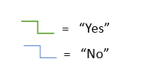**Chart 4: DBE Participation by contract type:** This chart compares actual DBE participation, by contract type, against the airport's DBE participation goals each year.

Figure 7: Decision hierarchy for DBE results tab.

* **Chart 5: DBE Participation by DBE type for prime contracts only:** This chart compares actual DBE participation, by contract type and for prime contracts only, against the airport's DBE participation goals each year.
* **Chart 6: DBE Participation and Non-certified Minority and Women-owned Participation:** This displays DBE and non-certified minority and women-owned participation in contracts. This comparison demonstrates the airport's diversity achievements using a broader definition of "diverse" business.

Local and Small Business Analysis

Highlighted in gray, these tabs offer a closer examination of DBE participation in non-federally assisted projects. These tabs are derived from information that users enter in the DBE analysis tabs. The tabs associated with this analysis are *R2- Small Business Participation, R2a- Small Business Graphics, R3- Local Business Participation and R3a- Local Business Graphics.*

Inputs

***Inputs3- Businesses:*** This input tab can be used to track businesses that contract with the airport, and if the user wants to enhance their analyses, can also be used to track the bidding process. A detailed description of the function of this tab can be found above (Inputs) and a description of how this tab is filled out can be found below in the *Example Data and Outcomes* section.

***Inputs4- Contracts:*** This input tab can be used to track active contracts with the airport and if the user wants to enhance their analyses, can also be used to track RFPs. A detailed description of the function of this tab can be found above (Inputs) and a description of how this tab is filled out can be found below in the *Example Data and Outcomes* section.

Results

***R2- Small Business Participation:*** This output tab provides a detailed breakdown of small business participation in non-federally assisted projects compared to their goalsin addition to a high-level overview. By providing an analysis of small business participation this tab will allow airports to see how small business contribute to their DBE goals on non-federally assisted (local) projects. The difference between this tab and *R1- DBE Participation* is that the total contract expenditures that are calculated in this tab account for all airport contracts that do not receive federal assistance. Contracts that do not receive federally assistance, referred to as local contracts, are then broken down by contract type (construction versus construction related professional service versus other goods and services), then by small businesses type (small versus other businesses (not small)) and finally by diverse businesses status (minority-owned versus women-owned (non-minority) versus local businesses (non-minority, non-women) versus other small (non-minority, non-women, non-local)). Users can use this tab to better understand which types of diverse businesses make up their small business participation on local contracts.

Towards the top of the tab, a high-level overview allows users to quickly interpret results and glean general information about the airport’s progress towards its goals. This analysis represents all non-federally assisted contracts (contracts for projects that receive no federal assistance) and all businesses that participated in those contracts during the period of analysis. It is important to note that none of the values represented in this tab are double counted. A decision hierarchy is imposed on these results so that contract dollars for each contract are only assigned to one category within the tab. For instance, if a small business that participates on a non-federally funded contract is both minority-owned and women-owned, the value of the contract that it received will be represented on the minority-owned business line only. If users are interested in learning more about how this decision hierarchy works, they can refer to the formulas within the calculation table in columns AK-BA on the *Inputs4- Contracts* tab. Airports can use these high-level tables as a quick summary of participation over time and they can also be copied and pasted into reports.

Towards the bottom of the tab, a detailed break-down shows contract participation by contract type (construction versus construction-related professional service versus other goods and services), then by small businesses type (small versus other businesses (not small) and finally by diverse businesses status (minority-owned versus women-owned (non-minority) versus local businesses (non-minority, non-women) versus other small (non-minority, non-women, non-local)). Even if a business qualifies under multiple characteristics, the tool enforces a hierarchy to avoid double counting dollar amounts (Figure 8). The detailed breakdown can give airports a more nuanced understanding of DBE participation by showing which certification status represents most of the DBE participation within a category.

Figure 8: Decision Hierarchy for small business results tab.

***R2a- Small Business Graphics:*** This output tab contains auto-populated graphs that represent airport’s small business participation in non-federally assisted projects compared to its goals. Each graphical representation is described in more detail below.

* **Chart 1: Local overall participation by type of contract:** This chart compares actual small business participation, broken down by type of contract, against the airport's local participation goals each year. Participation is calculated by dividing gross revenue from contracts that are awarded to certified-small businesses by total contract revenue from non-federally assisted projects.
* **Chart 2: Small Participation by type of Local Company:** This chart compares actual small participation, broken down by type of local company, against the airport's small businesses participation goals each year. Participation is calculated by dividing gross revenue from contracts that are awarded to certified-small businesses by total contract revenue from non-federally assisted projects.

***R3- Local Business Participation:*** Similar to *R2-Small Business Participation,* this output tab provides a detailed breakdown of local business participation in non-federally assisted projects compared to their goalsin addition to a high-level overview. By providing an analysis of local business participation this tab will allow airports to see how local business contribute to their DBE goals on non-federally assisted (local) projects. The difference between this tab and *R1- DBE Participation* is that the total contract expenditures that are calculated in this tab account for all airport contracts that do not receive federal assistance. The *R1- DBE Participation* tab accounts only for projects that receive at least $1 of federal assistance. The *R3- Local Business Participation* tab and the *R2- Small Business Participation* tab analyze the same data (projects that do not receive federal assistance). The difference between these two tabs is the way in which they break down the small, local, and diversity categories. Both tabs are incorporated into the tool so that users can analyze their non-federally assisted contracts in different ways. Contracts that do not receive federally assistance, referred to as local contracts, are then broken down by contract type (construction versus construction related professional service versus other goods and services), then by local businesses type (local versus other businesses (not local)) and finally by diverse businesses status (minority-owned versus women-owned (non-minority) versus small businesses (non-minority, non-women) versus other local (non-minority, non-women, non-small)). Users can use this tab to better understand which types of diverse businesses make up their small business participation on local contracts.

Also similar to *R2-Small Businesses Participation,* a high-level overview, found towards to the top of the page, allows users to quickly interpret results and glean general information about the airport’s progress towards its goals. This analysis represents all non-federally assisted contracts (contracts for projects that receive no federal assistance) and all businesses that participated in those contracts during the period of analysis. It is important to note that none of the values represented in this tab are double counted. A decision hierarchy is imposed on these results so that contract dollars for each contract are only assigned to one category within the tab. For instance, if a local business that participates on a non-federally funded contract is both minority-owned and women-owned, the value of the contract that it received will be represented on the minority-owned business line only. If users are interested in learning more about how this decision hierarchy works, they can refer to the formulas within the calculation table in columns AV-BA on the *Inputs4- Contracts* tab. Airports can use these high-level tables as a quick summary of participation over time and they can also be copied and pasted into reports.

Towards the bottom of the tab, a detailed break-down shows contract participation by contract type (construction versus construction related professional service versus other goods and services), then by small businesses type (local versus other businesses (not local)) and finally by diverse businesses status (minority-owned versus women-owned (non-minority) versus small businesses (non-minority, non-women) versus other l (non-minority, non-women, non-local)). Even if a business qualifies under multiple characteristics, the tool enforces a hierarchy to avoid double counting dollar amounts (Figure 9). The detailed breakdown can give airports a more nuanced understanding of DBE participation by showing which certification status represents most of the DBE participation within a category.

Figure 9: Decision Hierarchy for Local Results tab

***R3a- Local Business Graphics:*** This output tab contains auto-populated graphs that representations airport’s Local Business participation in non-federally assisted projects compared to its goals. Below is an example of a graphical representation that appears in this tab.

* **Chart 1: Local overall participation by type of contract:** This chart compares actual local business participation, broken down by type of contract, against the airport's local participation goals each year. Participation is calculated by dividing gross revenue from contracts that are awarded to certified-local businesses by total contract revenue from non-federally assisted projects.
* **Chart 2: Local Participation by type of Local Company:** This chart compares actual local participation, broken down by type of local company, against the airport's local participation goals each year. Participation is calculated by dividing gross revenue from contracts that are awarded to certified-local businesses by total contract revenue.

ACDBE Analysis

Highlighted in yellow, these tabs offer a closer examination of ACDBE participation in non-federally assisted projects. These tabs are derived from information that users enter in the DBE analysis tabs. The tabs associated with this analysis are *Inputs5- Concessionaires, Inputs6- Concessions Contracts, R5- ACDBE Participation NonCar, R5a- ACDBE NonCar Graphics, R6- ACDBE Participation CarRental and R6a- ACDBE CarRental Graphics.*

Inputs

***Inputs5- Concessionaires***: This input tab can be used to track concessionaires who submit solicitations and/or are awarded contracts with the airport. If users want to enhance their analyses, this tab can also be used to track the bidding process. For example, the airport can enter details about each bidder responding to a request for proposal to track the pool of concessionaires bidding on contracts. For a more basic approach to using the using the tool, the airport can simply enter the information about concessionaires that are ultimately awarded concessions contracts. A detailed description of how this tab is filled out can be found below in the *Example Data and Outcomes* section.

Similar to the *Inputs3- Businesses* tab, this tab functions as a complete database of concessionaires working with the airport. A single row is used to document the characteristics of a single concessionaire. For example, the row includes the concessionaire’s name ad its ACDBE status, whether it is minority- or women-owned. These details are essential for the tool to function and must be entered to obtain accurate results in the results tabs. If desired, this can also track information about the concessionaires’ contracting history with the airport. This may be of interest to the airport if it wants to track when new concessionaires contract with the airport for the first time or whether ACDBE concessionaires return to the airport. However, these data on the concessionaires’ contracting history with the airport are not necessary for the tool to generate results for the ACDBE analysis. See Table 4 for detailed instructions for data entry for each field in this tab.

Similar to *Inputs3-Businesses* tab, the user may not want to enter every concessionaire separately. The tool is flexible enough to reduce the data entry burden and still produce outputs in the results tabs. Rather than entering every concessionaire in its own row, the airport can develop a typical concessionaire profile for each *type* of concessionaire working for the airport. These profiles can then be used in the *Inputs6-Concessions Contracts* tab to represent these specific *types* of concessionaire. For example, assume the airport is working with five ACDBE-certified minority-owned businesses: Concessionaire A, Concessionaire B, Concessionaire C, Concessionaire D, and Concessionaire E. Rather than entering each of these concessionaires in its own row, the airport can create an ACDBE-Certified Minority-Owned profile to represent all of these businesses. Using this approach, the airport can avoid entering and maintaining data for five separate concessionaires and just use this profile to represent all ACDBE-certified minority-owned concessionaires. Similarly, the airport can create a profile for each type of concessionaire working with the airport: ACDBE-certified minority-owned, ACDBE-certified women-owned, non-ACDBE-certified minority-owned, etc.

**Simplify the Tool: Business Profiles**

Create a single profile in the *Inputs5- Concessionaires* tab that represents all concessionaires working with the airport for each type of concessionaire. Rather than entering data for dozens of concessionaires, the airport can simplify data entry to a handful of profiles.

***Inputs6- Concessions Contracts:*** This inputs tab can be used to track active concessions contracts with the airport and if the user wants to enhance their analyses, can also be used to track concession agreements. Similar to the *Inputs4- Contracts* tab, this tab is designed such that each row documents one concessionaire working on one concession contract. If a concession contract has more than one concessionaire, then a separate row is used to document each concessionaire working on the contract. For example, of an airport has three concessions contracts, each with three concessionaires, then this tab would include nine rows of data entry. Each row represents a unique contract-concessionaire combination. If the airport is using the simplified “profile” approach described above, then each row would represent a unique contract-profile combination. For example, if the airport has three concessionaires (A, B and C) working on Concession agreement “1”, the detailed approach would have three rows: one specifying each concessionaire working on the contract. However, assume that concessionaire A and B are not ACDBE-certified concessionaires and concessionaire C is ACDBE-certified minority owned. In this case, the airport could simply enter two rows of data: one for the ACDBE profile and one for the non-ACDBE profile. For airports with many concession agreements and concessionaires, this approach can considerably reduce the data entry burden. See Table 4 for detailed instructions for data entry in each field in this tab. A detailed description of how this tab is filled out can be found below in the *Example Data and Outcomes* section.

Table 4: Instructions for data fields in ACDBE tabs

| Term or Field | Type of Field | Required? | Definitions |
| --- | --- | --- | --- |
| Inputs5- Concessionaires | | | |
| Name of Company | Manual Entry | Yes | Enter the name of the concessionaire into this tab. |
| Reference year | Drop Down | Yes | This is the year for which a business’ ACDBE certification status is current. The business’ ACDBE certification status may change over time. The tool accommodates this by allowing a new entry in the *Inputs5- Concessionaires* tab to reflect the changes. If a concessionaire's ACDBE status changes, the user should create a new entry for that concessionaire with a "reference year" equal to the year the business’ status changed. For example, if "Richard's Retail" was originally entered in 2020 with no ACDBE certification, that entry would read "Richard's Retail as of 2020." If the concessionaire were to gain ACDBE certification in 2024, then a new entry for that year would be entered in the tab and would read "Richard's Retail as of 2024". This allows the tool to update the business’ ACDBE status without changing past information. |
| ACDBE Minority | Drop Down | Yes | This field specifies whether a concessionaire holds certification status as a minority-owned ACDBE. Minority-owned ACDBEs are further classified as Black American, Hispanic American, Asian-Pacific American, Asian-Indian American, and Native American. Use the drop-down menu to select the appropriate entry. |
| ACDBE Non-Minority Women Owned | Drop Down | Yes | This field specifies whether a concessionaire holds certification status as a non-minority women-owned ACDBE. If the concessionaire is a certified women-owned ACDBE, then select "Yes". However, if the concessionaire is already classified as a minority-owned ACDBE, then this field should be "No". |
| ACDBE | Auto-populate | Yes | This field auto-populates to specify whether a company holds certification status as a Airport Concession Disadvantaged Business Enterprise (ACDBE) based on the entries for ACDBE Minority and ACDBE Non-Minority Women Owned fields. If either of these fields are "Yes", then this field will populate as "Yes". |
| Minority-Owned | Drop Down | Yes | Use this field to specify whether this is a minority-owned concession business that is not certified as an ACDBE. Select "Yes" if the business is minority owned. |
| Women-Owned | Drop Down | Yes | Use this field to specify whether this is a non-minority woman-owned concession business that is not certified as an ACDBE. Select "Yes" if the business is woman-owned. If the business has already been classified as minority-owned, then this field should be "No". |
| Small Business | Drop Down | Yes | Use this field to specify whether this is a small concession business. This tool does not define the requirements to be classified as a "small business". The definition of a "small business" should conform to the definition used by the airport or local or regional government. If the business meets the airport's definition of small, select "Yes" in this field. If the business has already been classified as minority-owned or women-owned, this field can still be "Yes". |
| Did concessionaire submit a proposal before 2019? | Drop Down | No | The date reference in this field will update to reflect the starting year of the analysis (as specified in the General Inputs tab). The airport should select "Yes" if the business has submitted a concession proposal to the airport before the specified year, even in the company did not win the concession opportunity. It should select "No" if the company has never submitted a concession proposal to the airport before the specified year. If the airport does not know whether the business submitted a proposal before, then it is suggested that the airport select "No". |
| Was concessionaire awarded a contract before 2019? | Drop Down | No | The date reference in this field will update to reflect the starting year of the analysis (as specified in the General Inputs tab). The airport should select "Yes" if the business has worked as a concessionaire at the airport before the specified year. It should select "No" if the business has never been a concessionaire at the airport before the specified year. If the airport does not know whether the business has been a concessionaire at the airport before, then it is suggested that the airport select "No". |
| Was concessionaire awarded a PRIME contract before 2019? | Drop Down | No | The date reference in this field will update to reflect the starting year of the analysis (as specified in the General Inputs tab). The airport should select "Yes" if the business has been a prime concessionaire at the airport before the specified year. It should select "No" if the business has never been a prime concessionaire at the airport before the specified year. Prime Concessionaires have a direct relationship with the airport (e.g., a company who has a lease agreement directly with the airport to operate a concession). Note: If the airport entered "No" for the previous column ("Did the company win before [YEAR]"), then this field should also be "No". If the airport does not know whether the business has been a prime concessionaire before, then it is suggested that the airport select "No". |
| First Year Award | Auto-populate | n/a | This field will automatically populate with the first year the business was a concessionaire at the airport. If the business has been a concessionaire at the airport prior to the starting year of the analysis, then this field will populate with "Before [YEAR]" where [YEAR] is the starting year of the analysis. |
| First Year Prime Award | Auto-populate | n/a | This field will automatically populate with the first year the business was a prime concessionaire at the airport. If the business was a prime concessionaire at the airport prior to the starting year of the analysis, then this field will populate with "Before [YEAR]" where [YEAR] is the starting year of the analysis. |
| First Year Subconcession Award | Auto-populate | n/a | This field will automatically populate with the first year the business was a subconcessionaire at the airport. A subconcessionaire is a firm that has a sublease or other agreement with a prime concessionaire, rather than with the airport itself, to operate a concession at the airport . If the business was a subconcessionaire at the airport prior to the starting year of the analysis, then this field will populate with "Before [YEAR]" where [YEAR] is the starting year of the analysis. |
| Notes | Manual Entry | No |  |
| Inputs6- Concessions Contracts | | | |
| Contract/Opportunity | Manual Entry | Yes | The *Inputs5-Concessions Contracts* tab tracks each company that submitted a concessions proposal and/or was awarded a prime concession. If the airport is tracking contracts only, then this field will be a unique identifier for each Concession agreement (e.g., agreement number or title). If the airport is also tracking proposals for concessions, then this field will be a unique identifier of each concession opportunity. There will be a row for each company associated with a proposal or contract award, so there may be multiple rows for each concession opportunity. |
| Company Name and Date | Drop Down | Yes | This field specifies which company has submitted a proposal or been awarded a prime concession contract with the airport. Select the company and reference year from a drop down list. The list will provide all companies entered in the *Inputs4-Concessionaires* tab. |
| Year of First Concession Contract | Auto-populate | n/a | This field automatically calculates using data entered in the *Inputs4-Concessionaires* tab. The field indicates the year that the concessionaire first contracted with the airport. |
| Concession Type | Drop Down | Yes | Use this field to indicate the type of concession represented in each row. Concession types include: car rental, food and beverage, retail, other non-car rental passenger services, and management contracts that are included in the airport’s concession program. |
| Concession Type: Car Rental | n/a | n/a | Car rental concessions include all car rental concessions at the airport. |
| Concession Type: Food and Beverage | n/a |  | Food and beverage concessions are in-terminal concessions such as casual dining restaurants, quick-serve or quick-casual units, bars, and specialty coffee. |
| Concession Type: Retail | n/a | n/a | Retail concessions are in-terminal concessions that include convenience retail (e.g., newsstands, gift shops, and convenience stores), specialty retail (i.e., shops offering a specialized line of merchandise including but not limited to jewelry, apparel, cosmetics, toys, and luggage), and duty-free shops. |
| Concession Type: Other Non-Car Rental Passenger Services | n/a | n/a | Other passenger services are non-car rental concessions that cover a wide variety of amenities and personal services for passengers. These include but are not limited to automated teller machines (ATMs), foreign exchange kiosks, business centers, hair salons, luggage services, and massage services. This category also includes any other concessions that are not already captured in the other categories, such as advertising. |
| Concession Type: Management | n/a | n/a | A management contract that is included in the airport’s concession program is an agreement between the airport and a firm to manage a portion of the airport's facilities or operations (e.g., manage the parking facilities). The airport pays businesses for providing these management services. Management contracts only apply to non-car rental concessions. |
| Contract Type | Drop Down | Yes | Use this field to specify the contract type of the concession. Contract types include: prime, subconcession, joint venture, and management. |
| Contract Type: Prime | n/a | n/a | Prime concessions are concessions who have a direct relationship with the airport (e.g., a business that has a lease agreement directly with the airport to operate a concession). |
| Contract Type: Subconcession | n/a | n/a | Subconcessions are businesses that have a sublease or other agreement with a prime concessionaire, rather than with the airport itself, to operate a concession at the airport. The user should use one subconcession per row. If there are two or more subconcessions on a single prime concession agreement, there should be one entry for the prime concession agreement and one entry for each subconcession agreement. |
| Contract Type: Joint Venture | n/a | n/a | Joint ventures are concessions arrangements as defined in 49 CFR Part 23 as "an association of an ACDBE firm and one or more other firms to carry out a single, for-profit business enterprise, for which the parties combine their property, capital, efforts, skills, and knowledge, and in which the ACDBE is responsible for a distinct, clearly defined portion of the work of the contract and whose shares in the capital contribution, control, management, risks, and profits of the joint venture are commensurate with its ownership interest. Joint venture entities are not certified as ACDBEs." Each concessionaire that is part of the joint venture should be entered in its own row and the contract type for both rows should be "Joint Venture". For example, consider a joint venture by Firm A and Firm B, and Firm A is an ACDBE certified firm and Firm B is not ACDBE certified. In the *Inputs5-Concessions Contracts* tab, there should be an entry for each firm, each in a separate row. The "Contract Type" would be "Joint Venture" for both entries. |
| Contract Type: Management | n/a | n/a | This entry should be selected if and only if "Management" was selected as the Concession Type. If a concession type other than "Management" was selected as the Concession Type, the Contract Type field will turn red if one of the management options is not selected. For example, if a retail concession is selected as a Concession Type, then "Management" should not be selected. Similarly, if "Management" was selected as the Concession Type, then the Contract Type field will turn red if an option other than "Management" is selected. |
| Year of Concession Contract | Auto-populate | n/a | This field auto populates with the first year the concession contract is in place. The formula returns the first year in which revenue or management services payments are entered into this tab. For example, if a concession contract is added to the tab and the first revenues are documented under 2021, then this field will populate with "2021". If no revenues or management services payments are entered in columns J through EN, then this field will remain blank. If revenues for subconcessionaires do not align with the revenue for the prime concessionaire, then this field will populate with different dates. This ensures that the starting date for each prime concessionaire and subconcessionaire is tied to when revenues are first collected. |
| Returning concessionaire? | Auto-populate | n/a | This field auto-populates using data from the *Inputs5-Concessionaires* tab to specify whether the business has previously held a concession contract with the airport or a subconcession contract with a concessionaire of the airport. If the concessionaire has worked at the airport, either as a prime concessionaire or as a subconcessionaire prior to the year specified in the "Year of Concession Contract" field, then this field will be "Yes". If this is the first time the business has held a concession contract with the airport or a subconcession contract with a prime concessionaire, then this field will be "No". |
| Awarded Concession? | Drop Down | Yes | This field should specify whether the business was awarded the concession contract with the airport or a subconcession contract with the prime concessionaire. If the airport is tracking proposals for concessions, then this field should say "No" for each proposal that did not ultimately win the contract. If the airport is only tracking existing concessions contracts, then this field will be "Yes" for all entries. |
| Notes | Manual Entry | No |  |
| Gross Revenue | Manual Entry | Yes | Use this field to enter the total dollar value of gross revenue generated by each concession per year. Gross revenue does not apply to Management Contracts. If a management contract is selected as the Concession Type, this field will be grey to avoid incorrectly entering management contract payments. To avoid double counting, it is imperative that gross revenue be split among concessionaires when there is a prime concessionaire/subconcessionaire or joint venture agreement in place. For example, if Firm A and Firm B are a joint venture and the joint venture generates $1M in gross revenue, and Firm A generates 80% of the revenue and Firm B generates the remaining 20%, the user should put $800k in the row for Firm A and $200k in the row for Firm B. Similarly, if Firm A is the prime concessionaire and Firm B is the subconcessionaire, gross revenue should be divided between the two firms. This approach avoids double counting in the output of the tool and enables the tool to attribute the appropriate amount of gross revenue to ACDBE certified firms when two or more firms are under the same concession contract. |
| Management Services Payments | Manual Entry | Yes | Use this field to enter total payments made per year to firms working for the airport under a management contract. This field should only be used when "Management Contracts" is specified in the Concession Type field. If any other type of concession was entered into the "Concession Type" field, the "Management Services Payments" field will turn grey to avoid incorrectly entering gross revenue as management contract payments. |
| Purchase of Goods and Services from ACDBEs (Dollars) - Black American | Manual Entry | No | Use this field to enter payments made per year by concessionaires, including management contractors, for the purchase of goods and services from Black American-owned ACDBE firms. These dollar values are independent from the gross revenue entered in the "Gross Revenue" field. For example, assume that Firm A operates a food and beverage concession and generates $1.1M in a given year. In that same year, Firm A spent $50,000 for purchases of goods and services from Black American-owned ACDBE firms. Then the airport would enter $1.1M under Gross Revenue, and $50,000 under the "Purchase of Goods and Services from ACDBEs (Dollars) - Black American" field. |
| Purchase of Goods and Services from ACDBEs (Dollars) - Hispanic American | Manual Entry | No | Use this field to enter payments made per year by concessionaires, including management contractors, for the purchase of goods and services from Hispanic American-owned ACDBE firms. These dollar values are independent from the gross revenue entered in the "Gross Revenue" field. For example, assume that Firm B operates a retail concession and generates $1.1M in a given year. In that same year, Firm B spent $0 for purchases of goods and services from Hispanic American-owned ACDBE firms. Then the airport would enter $1.1M under Gross Revenue, and $0 under the "Purchase of Goods and Services from ACDBEs (Dollars) - Hispanic American" field. |
| Purchase of Goods and Services from ACDBEs (Dollars) - Asian-Pacific American | Manual Entry | No | Use this field to enter payments made per year by concessionaires, including management contractors, for the purchase of goods and services from Asian-Pacific American ACDBE firms. These dollar values are independent from the gross revenue entered in the "Gross Revenue" field. For example, assume that Firm B operates a retail concession and generates $1.1M in a given year. In that same year, Firm B spent $100,000 for purchases of goods and services from Asian-Pacific American-owned ACDBE firms. Then the airport would enter $1.1M under Gross Revenue, and $100,000 under the "Purchase of Goods and Services from ACDBEs (Dollars) - Asian-Pacific American" field. |
| Purchase of Goods and Services from ACDBEs (Dollars) - Asian-Indian American | Manual Entry | No | Use this field to enter payments made per year by concessionaires for the purchase of goods and services from Asian-Indian American-owned ACDBE firms. These dollar values are independent from the gross revenue entered in the "Gross Revenue" field. For example, assume that Firm B operates a food and beverage concession and generates $1.1M in a given year. In that same year, Firm B spent $600,000 for purchases of goods and services from Asian-American-owned ACDBE firms. Then the airport would enter $1.1M under Gross Revenue, and $600,000 under the "Purchase of Goods and Services from ACDBEs (Dollars) - Asian-Indian American" field. |
| Purchase of Goods and Services from ACDBEs (Dollars) - Native American | Manual Entry | No | Use this field to enter payments made per year by concessionaires for the purchase of goods and services from Native American-owned ACDBE firms. These dollar values are independent from the gross revenue entered in the "Gross Revenue" field. For example, assume that Firm C operates a retail concession and generates $1.1M in a given year. In that same year, Firm B spent $225,000 for purchases of goods and services from Native American-owned ACDBE firms. Then the airport would enter $1.1M under Gross Revenue, and $225,000 under the "Purchase of Goods and Services from ACDBEs (Dollars) - Native American" field. |
| Purchase of Goods and Services from ACDBEs (Dollars) - ACDBE Non-Minority Women Owned | Manual Entry | No | Use this field to enter payments made per year by concessionaires for the purchase of goods and services from Non-Minority Woman-owned ACDBE firms. These dollar values are independent from the gross revenue entered in the "Gross Revenue" field. For example, assume that Firm B operates a retail concession and generates $1.1M in a given year. In that same year, Firm B spent $200,000 for purchases of goods and services from Non-Minority Woman-owned ACDBE firms. Then the airport would enter $1.1M under Gross Revenue, and $200,000 under the "Purchase of Goods and Services from ACDBEs (Dollars) - ACDBE Non-Minority Women Owned" field. |
| Purchase of Goods and Services from ACDBEs (Dollars) - Other Non-ACDBE | Manual Entry | No | Use this field to enter payments made per year by concessionaires for the purchase of goods and services from non-ACDBE firms. These dollar values are independent from the gross revenue entered in the "Gross Revenue" field. Using the same example for Firm A above, the airport would enter $500,000 under the "Purchase of Goods and Services from ACDBEs (Dollars) - Other Non-ACDBE" field. |

Results

***R5- ACDBE Participation NonCar:*** This output tab provides a detailed breakdown of ACDBE participation in concessions compared to their goalsin addition to a high-level overview.

The high-level overview allows users to quickly interpret results and glean general information about the airport’s progress towards its goals. This analysis represents all non-car rental concessions agreements and all businesses that participated in those concession agreements during the period of analysis. It is important to note that none of the values represented in this tab are double counted. Airports can use these high-level tables as a quick summary of participation over time and they can also be copied and pasted into reports.

The detailed break-down shows concessions contract participation by certification status, concession type and contract type. The detailed breakdown is organized first by contract type (non-car rental concessions, retail or other non-car passenger services), contractor type (prime versus sub) and finally by certification status (ACDBE status and non-ACDBE certified diverse business status). The analysis also breaks out concession’s expenditures on goods and services and the value of management contracts on separate tables. Expenditures on goods and services encompass money paid by concessionaires to businesses. This break down is included because money that concessionaires spend on purchasing goods and services from ACDBE certified businesses is counted towards the airports ACDBE participation goal. Management contracts are also broken out by ACDBE certification and non-certified diverse business designation. Although management contracts are not counted towards the airport’s ACDBE participation goals, airports may still want to use this table to understand this vehicle for ACDBE participation.

***R5a- ACDBE NonCar Graphics:*** This tab uses the results from the Results5 tab to provide graphics that demonstrate ACDBE participation in non-car rental concessions. These charts can be copied and pasted into communication materials or used to evaluate trends and progress over several years.

* **Chart 1: ACDBE Participation in Non-Car Rental Concessions as a Percentage of Gross Revenue and Expenditures on Goods and Services:** This chart compares actual non-car rental ACDBE participation against the airport's non-car rental ACDBE participation goals each year. Participation is calculated by dividing concession revenue from ACDBE certified businesses and concession expenditures on goods and services from ACDBE certified businesses by total concession revenue and expenditures on goods and services. It is important to note that the airports ACDBE goal does not include the purchase of goods and services from non-ACDBE certified businesses but that that number is included in the actual participation value that is represented in this graph.
* **Chart 2: Non-Car Rental ACDBE Overall Participation as a Percentage of Gross Revenue and Expenditures on Goods and Services Compared with 3-Year Participation Goals:** This chart compares actual 3-Year non-car rental ACDBE participation against the airport's 3-Year non-car rental ACDBE participation goals each year.
* **Chart 3: ACDBE Participation in Non-Car Rental Concessions by ACDBE type:** This chart breaks down actual non-car rental ACDBE participation by ADCBE type and compares it to the non-car rental ACDBE participation goals.
* **Chart 4: ACDBE Participation in Non-Car Rental Concessions by Concession Type:** This chart breaks down actual non-care rental ACDBE participation by concession type and compares it to the non-care rental ACDBE participation goals.
* **Chart 5: ACDBE participation by Prime ACDBE Type:** This chart breaks down actual Prime ACDBE participation by ACDBE type and compares it to the ACDBE participation goals.

***R6- ACDBE Participation CarRental:*** This output tab provides a detailed breakdown of ACDBE participation in concessions compared to their goalsin addition to a high-level overview.

The high-level overview allows users to quickly interpret results and glean general information about the airport’s progress towards its goals. This analysis represents all car rental concessions agreements and all businesses that participated in those concession agreements during the period of analysis. It is important to note that none of the values represented in this tab are double counted. Airports can use these high-level tables as a quick summary of participation over time and they can also be copied and pasted into reports.

The detailed break-down shows concessions contract participation by certification status, concession type and contract type. The detailed breakdown is organized first by contract type (car rental concessions, retail or other car passenger services), contractor type (prime versus sub) and finally by certification status (ACDBE status and non-ACDBE certified diverse business status). The analysis also breaks out concession’s expenditures on goods and services and the value of management contracts on separate tables. Expenditures on goods and services encompass money paid by concessionaires to businesses. This break down is included because money that concessionaires spend on purchasing goods and services from ACDBE certified businesses is counted towards the airports ACDBE participation goal. Management contracts are also broken out by ACDBE certification and non-certified diverse business designation. Although management contracts are not counted towards the airport’s ACDBE participation goals, airports may still want to use this table to understand this vehicle for ACDBE participation.

***R6a- ACDBE CarRental Graphics:*** This tab uses the results from the Results6 tab to provide graphics that demonstrate ACDBE participation in car rental concessions. These charts can be copied and pasted into communication materials or used to evaluate trends and progress over several years.

* **Chart 1: Car Rental ACDBE Overall Participation as a Percentage of Gross Revenue and Expenditures on Goods and Services Compared with Participation Goals:** This chart compares actual car rental ACDBE participation against the airport's car rental ACDBE participation goals each year. Participation is calculated by dividing concession revenue from ACDBE-certified businesses and concession expenditures on goods and services from ACDBE certified businesses by total concession revenue and expenditures on goods and services.
* **Chart 2: Car Rental ACDBE Overall Participation as a Percentage of Gross Revenue and Expenditures on Goods and Services Compared with 3-Year Participation Goals:** This chart compares actual 3-Year car rental ACDBE participation against the airport's 3-Year non-car rental ACDBE participation goals each year.
* **Chart 3: ACDBE Participation in Car Rental Concessions by ACDBE type:** This chart breaks down actual ACDBE participation in car rental concessions by ADCBE type and compares it to the car rental ACDBE participation goals.
* **Chart 4: ACDBE & Non-ACDBE Diverse Business Participation in Car Rental Concessions:** This chart breaks down actual ACDBE and non-ACDBE diverse business participation in car rental concession revenues. Because concessionaries do not track non-ACDBE diverse business participation in car rental expenditures on goods and services, this chart does not include those expenditures.
* **Chart 5: ACDBE participation by Prime ACDBE Type:** This chart breaks down actual Prime ACDBE participation by ACDBE type and compares it to the ACDBE participation goals.

Cost-effectiveness and Economic Impacts

Highlighted in blue, the cost effectiveness and economic impacts analysis is the first analysis in the tool and is intended to provide information about airport DBE participation on federally assisted contracts. The tabs associated with this analysis are *Inputs7- Program Costs, R7- Benefits and R7a- Benefits Graphics.*

Inputs

***Inputs7- Program Costs:*** This input tab can be used to track the costs associated with airport diversity programs over time. Users are asked to break down their diversity program costs into multiple categories in addition to estimating the number of FTEs that work on their programs. Unlike other input tabs, this tab does not have multiple level of analyses depending on inputs and all fields must be entered for it to work properly. Within the tab, users are asked to break down their diversity program costs by cost categories. The cost category is included so that users can get a better sense of where their diversity program costs are derived but do not affect the outcome of the analyses. If users are unsure which cost category a certain program should fall under, they can simply enter these amounts into the “Other” category. Definitions for each of these cost categories can be found in Table 5.

Table 5: Instructions for data fields in cost-effectiveness and economic impacts tab

|  |  |  |  |
| --- | --- | --- | --- |
| Term or Field | Type of Field | Required? | Definitions |
| Diversity Program Details | | | |
| How many annual in-house FTEs are dedicated to business diversity program implementation? | Manual | No | Enter the total number of full-time equivalents (FTEs) working on business diversity program implementation. This field is for documentation purposes only and is not used for any of the tool results. |
| Estimated total annual cost dedicated to diversity program | Auto-populate | No | This field automatically adds the values entered under each of the cost categories. |
| Staffing | Manual | No | Enter total annual costs associated with staff salaries and benefits. |
| Outreach | Manual |  | Enter total annual costs associated with outreach activities. Outreach includes networking events (e.g., facility rental), catering, promotional items, printing costs, (e.g., diversity program brochures), etc. |
| Technical Assistance | Manual | No | Enter total annual costs associated with technical assistance. This includes business development programs (mentor/protégé programs). |
| Training | Manual | No | Enter total annual costs associated with training. This includes the cost of staff training, including registration fees for classes, training materials (e.g. course manuals), consultant fees. |
| Program Development and Implementation | Manual | No | Enter total annual costs associated with diversity program development and implementation. These costs include consulting services (disparity studies, economic impact studies), compliance software, website development and legal expenses. |
| Sponsorships | Manual | No | Enter total annual costs associated with sponsorships, including conferences, meetings, local organizations’ ceremonious occasions. |
| Travel | Manual | No | Enter total annual costs associated with travel. These costs should include traveling to conferences, meetings and trainings; such as flights, per diem, car rentals and hotels. |
| Additional cost incurred outside the program's budget | Manual | No | Enter total annual costs for any activities or expenses not captured in any of the other cost categories listed above. |

Results

***R7- Benefits:*** This output tab provides a summary of cost-effectiveness measures and economic impacts that are associated with the airport’s diversity programs. In addition to a high-level overview, a detailed break down of the economic impacts of diversity programs on both ACDBE and DBE businesses is included towards the bottom of the page.

The high-level overview provides a summary of the amount that airports spend on their diversity programs (broken down by program activity) compared with the economic impact of those programs (in terms of dollars awarded to DBE and ACDBE-certified businesses.

The detailed break-down shows employment impacts (in terms of FTEs), labor income impacts (in terms of dollars paid to businesses) and value added (in terms of gross regional product) of diversity programs by each DBE/ ADCBE-certification category. Airports can use this analysis to understand which businesses benefitted from their diversity programs and to better understand the extent of their diversity program’s impact.

***R7a- Benefits Graphics:*** This tab uses the results from the Results7 tab to provide graphics that demonstrate economic benefits of diversity in airport contracts and concessions. These charts can be copied and pasted into communication materials or used to evaluate trends and progress over several years.

* **Chart 1: Number of Diverse firms per $1M spent on diversity programs:** This chart calculates the number of diverse firms that are contracted by the airport per every $1 million that the airport spends on its diversity efforts. Diversity efforts are calculated using the model's definition.
* **Chart 2: Labor income to diverse firms per dollar spent on diversity program:** This chart calculates the number of dollars that went to diverse firms through airport contracts or concession per every dollar that airports spend on their diversity programs.
* **Chart 3: Employment (FTE) by DBE certification, non-certified, and other:** This chart shows the number of full-time employees that are generated from airport contract expenditures by DBE certification type, non-certified and other businesses.
* **Chart 4: Added Value by DBE Certification, non-certified and other:** This chart displays the Added Value in terms of gross regional product that is results from each contract expenditures on each DBE certification type, non-certification type and other category.
* **Chart 5: Labor Income by DBE certification, non-certified, and other:** This chart displays Labor Income impacts generated from contract expenditures on DBE certified, non-certified and other businesses.

Example Data and Outcomes

*This section will contain a scenario of a typical set of inputs for both the Businesses and Contracts tab and the Concessionaires and Concessions Contracts tabs. These examples are intended to highlight nuances and caveats of the tool and its capabilities as well as demonstrate to the user how inputs are entered.*

*The user in this scenario has chosen 2017 as the base year for their analyses.*

Businesses

7 companies are currently working at the airport. These companies are described below:

* **Business A:** WBE and non-minority DBE certified; has not previously worked at the airport as a prime contractor or subcontractor; the information is up-to-date as of 2019.
* **Business B:** MBE (Asian-Pacific American)/and SBE certified; has previouslyworked at the airport as a subcontractor; the information is up-to-date as of 2019.
* **Business C:** No certification status; has not previously worked at the airport as a prime contractor or subcontractor; the information is up-to-date as of 2019.
* **Business D:** Not a certified MBE, WBE, SBE or DBE; is woman-owned and minority-owned; has previously contracted with the airport as a prime contractor; the information is up-to-date as of 2019.
* **Business E:** Not a certified MBE, WBE, SBE or DBE; is a local business; has previously contracted with the airport as a prime contractor; the information is up-to-date as of 2019.
* **Business F:** MBE (Native American)/SBE; has not previously worked at the airport; the information is up-to-date as of 2019.
* **Business G:** MBE (Hispanic American)/ SBE; has previously worked at the airport as a subcontractor; the information is up-to-date as of 2019.
* **Business A:** MBE (Black American)/ DBE; has not previously worked at the airport; the information is up-to-date as of 2021.

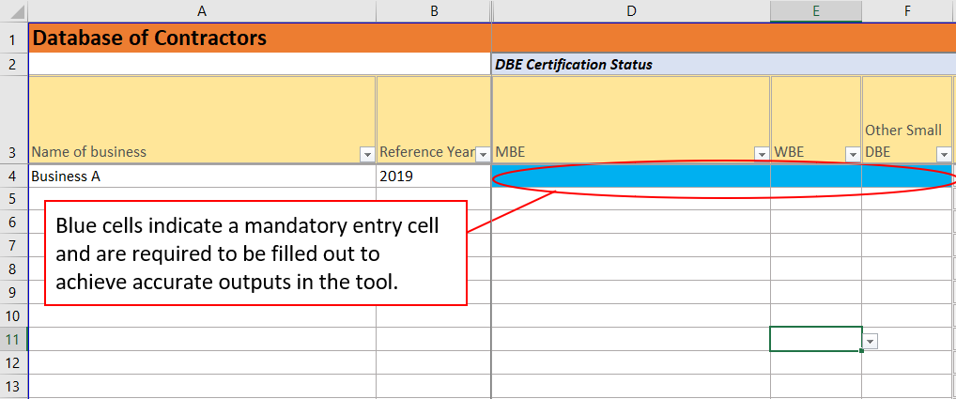*Step 1: Enter Business Name. Begin on the Inputs3- Businesses tab in the first blank cell in column A.*

**Figure 10: Entering Business Name**

*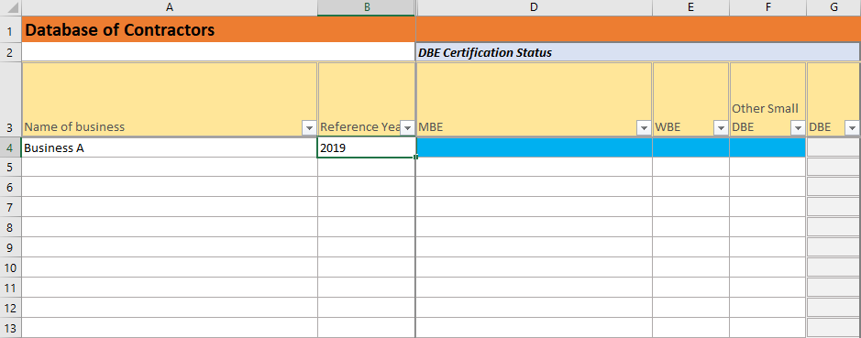Step 2: Use the drop-down menu to enter the Reference Year. This is the most recent year that all the information for this business is accurate for.*

**Figure 11: Reference Year Drop-down Menu**

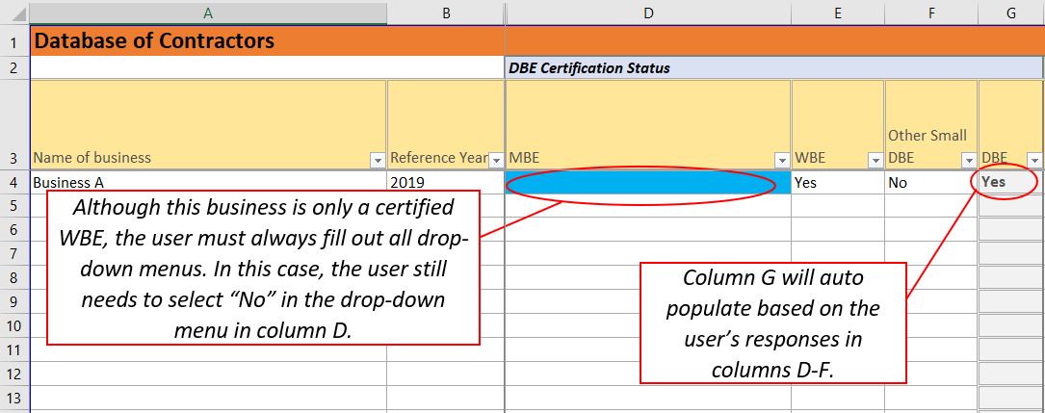*Step 3: Use the drop-down menu to select the business’ certification status.*

**Figure 12: Business Certification Status Drop-down**

*Step 4: Use the drop-down menu to select the business’ non-certification status.*

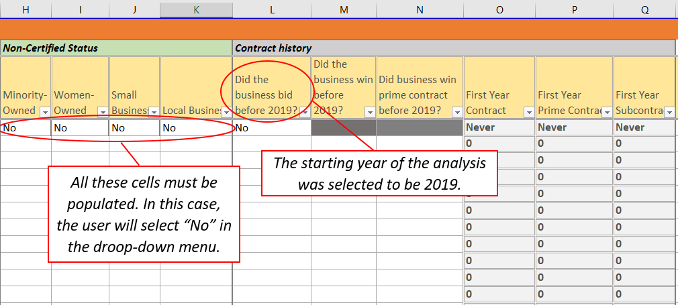*Step 5: Use the drop-down menu to answer if the business bid before 2019.*

**Figure 13: Business Bid History Drop-down Menu**

*Step 6: If the business bid before 2019, proceed to select yes or no in the drop-down menu for the contract history questions in column M and N. In the example above, the drop-down menu has been blacked out based on the answer in column L.*

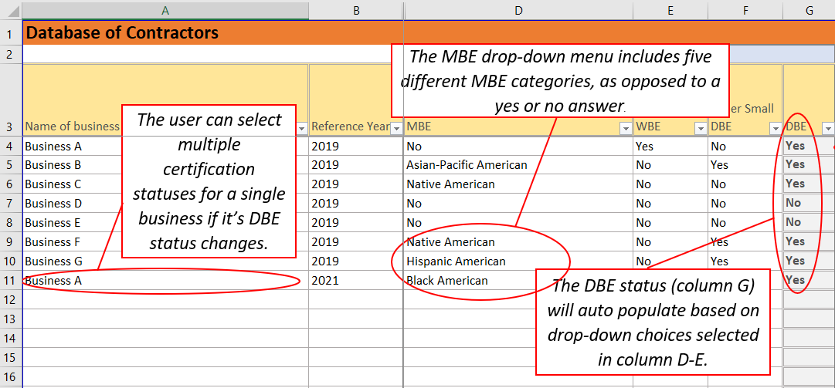

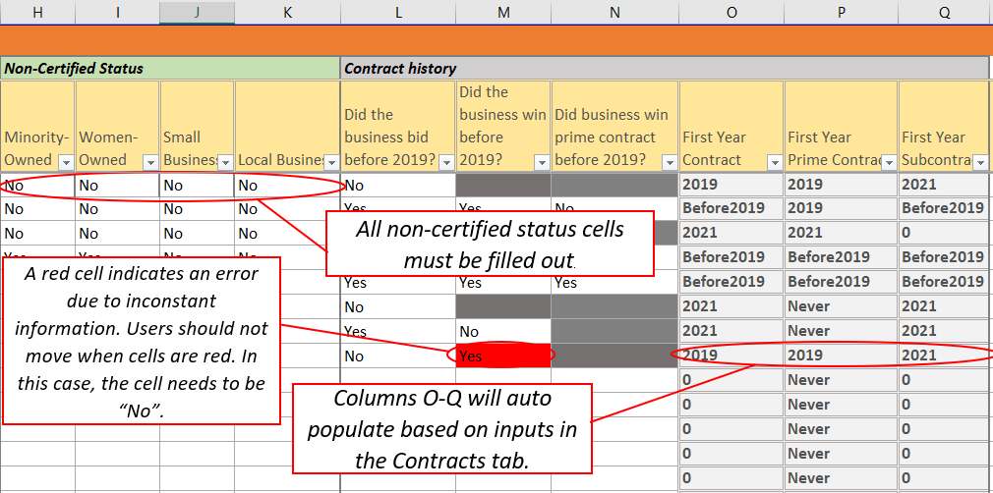Figure 14: Example of completed Inputs3-Businesses tab through column G.

Figure 15: Example of completed Inputs3-Businesses tab through column Q.

Contracts

The airport currently has 3 contracts in place.  These contracts are described below:

* **Contract 1:** A federally-construction project to rehabilitate the airport’s runway. This project receives federal funding. Business D is the prime contractor and Businesses A and E are subcontractors. The contract value is $15 million over seven years (2019 to 2025), of which $14.35 million will be paid to Business D, $400k will be paid to Business A and $250k will be paid to Business E.
* **Contract 2:** A contract to provide IT consulting services to the airport. This project does not receive federal funding. Business B is the prime contractor and Business F and G are subcontractors. The contract value is $3 million over seven years (2019 to 2025), of which $2 million will be paid to Business B, $500k will be paid to Business F and $500k will be paid to Business G.
* **Contract 3:** A construction-related professional services contract to provide engineering consulting services to the airport. The project does not receive federal funding. Business C is the prime contractor and Business B, G and D are subcontractors. The contract value is $15 million over five years (2021 to 2025), of which $10 million will be paid to Business C, $2 million to Business B, $2 million to Business G and $1 million to Business A.

*Steps 1: Begin by filling out the name of the Contract/ RFP in column A.*

*Step 2: Continue by selecting the business’ unique ID.*

*Step 3: Choose whether the contract is federally assisted or not (receives at least $1 of federal funding).*

*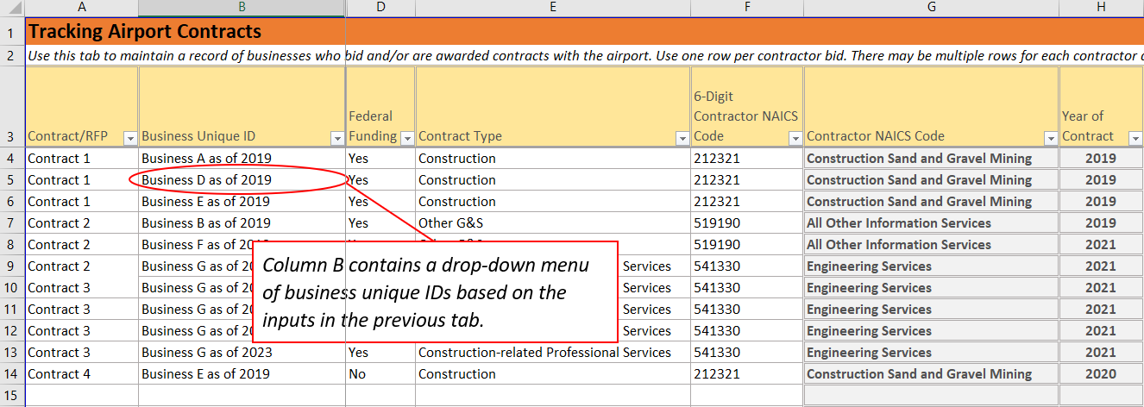Step 4: Choose the contract type from the drop-down menu.*

Figure 16: Example of completed Inputs4- Contracts tab through column H.

*Steps 5: Select “Yes” or “No” from the drop-down menu to show if the business won the contract.*

*Step 6: Choose “sub” or “prime” from the drop-down menu.*

*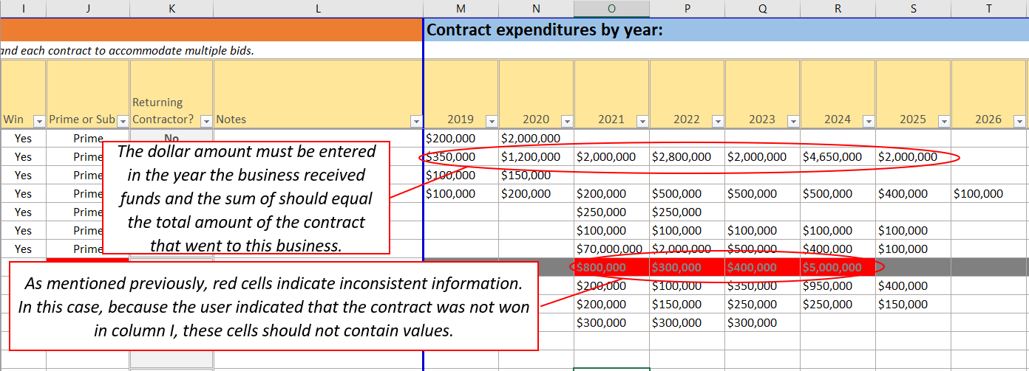Step 7: Enter the dollar amount the contract in each year the business received payments from the airport.*

Figure 17: Example of completed Inputs4- Contracts tab through column T.

Concessionaires

The airport has 5 concessionaires it is working with. These concessionaires are described below:

* **Concessionaire A:** Certified Small Business; has not previously contracted with the airport, the information is up-to-date as of 2019.
* **Concessionaire B:** ACDBE certified woman-owned; has previously contracted with the airport as a prime concessionaire; the information is up-to-date as of 2019.
* **Concessionaire C:** ACDBE certified minority-owned (Native American); has previously operated at the airport as a sub concessionaire; the information is up-to-date as of 2019.
* **Concessionaire D:** Non-ACDBE certified women-owned & minority-owned; has previously contracted with the airport as a prime concessionaire; the information is up to date as of 2019.
* **Concessionaire E:** No certification status; has previously contracted with the airport as a prime concessionaire; the information is current as of 2019.
* **Concessionaire A:** Certified Small business & women-owned; has not previously contracted with the airport or operated as a sub concessionaire at the airport; the information is current as of 2021.

*Step 1: Enter Business Name. Begin on the Inputs5- Concessionaires tab in the first blank cell in column A.*

*Step 2: Use the drop-down menu to enter the Reference Year. This is the most recent year that all the information for this business is accurate for.*

*Step 3: Use the drop-down menus to select the business’ certification status.*

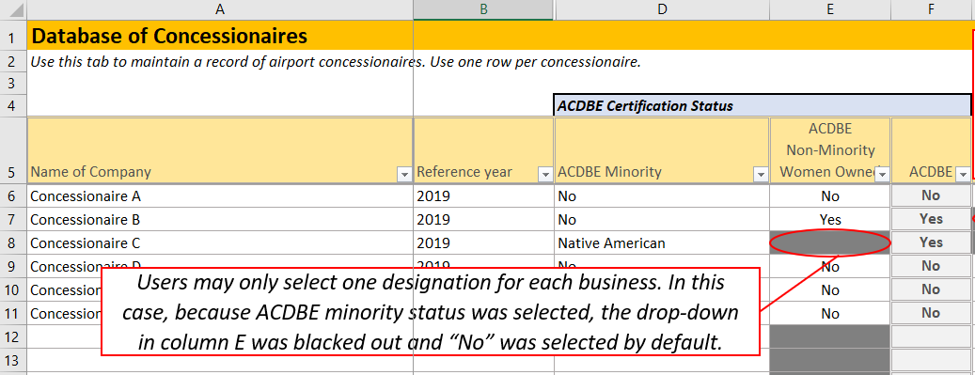

Figure 18: Example of completed Inputs5- Concessionaires tab through column F.

*Step 4: Use the drop-down menus to select the business’ non-certification status.*

*Step 5: use the drop-down menu to answer if the business bid before 2019.*

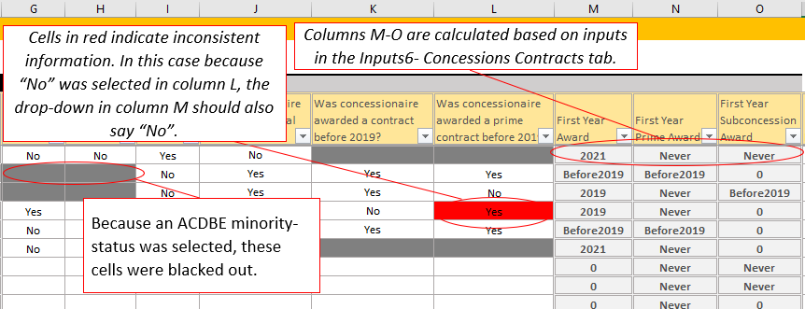*Step 6: If the business bid before 2019, proceed to select yes or no in the drop-down menu for the contract history questions in column L and M.*

Figure 19: Example of completed Inputs5- Concessionaires tab through column O.

Concessions Contracts

The airport currently has 5 concession agreements. These agreements are listed below.

* **Concession Agreement 1: Concessionaires B and D** are a joint venture that operates a news and gift store under a direct lease with the airport. This concessionaire purchased $500k worth of goods and Services from an ACDBE certified woman-owned business from 2019-2021. The joint venture generated $5 million in gross revenue over seven years (2019-2025) of which $2.5 million was generated by Concessionaire D and $2.5 million was generated by Concessionaire B.
* **Concession Agreement 2:** Concessionaire E operates a full-service restaurant, a yogurt stand, and a donut shop under a direct lease with the airport. Concessionaire B and Concessionaire C are sub concessionaires that operate the yogurt stand and the donut shop. Gross revenue is 5 million over 3 years (2019-2021) of which 3 million is generated by Concessionaire E and $1 million is generated by each sub concessionaire during the three-year period.
* **Management Contract 3:** A parking operator provides parking management services to the airport under a management contract with the airport. Concessionaire A provides the management services. The contract value of $2 million over 4 years (2021-2024) is paid to Concessionaire A.
* **Management Contract 4:** A bus company provides shuttle bus management and operation services under a management contract with the airport. Concessionaire B provides the management services. The contract value of $5 million over 3 years (2019-2021) is paid to Concessionaire B.
* **Concession Agreement 5:** A car rental company operates one of the airport’s car rental concessions. Concessionaire E is the prime concessionaire and purchases goods and services from Concessionaires C and A as of 2019. Concessionaire E generates $15 million in gross revenue over 3 years (2019-2021), and purchases $50K in goods from Concessionaire C and $23K in services from Concessionaire A during the three-year period.

*Steps 1: Begin by filling out the name of the Contract/ Opportunity in column A.*

*Step 2: Continue by selecting the business’ unique ID.*

*Step 3: Choose the concession type from the drop-down menu.*

*Step 4: Choose the contract type from the drop-down menu.*

*Steps 5: Select “Yes” or “No” from the drop-down menu to show if the business was awarded the concession.*

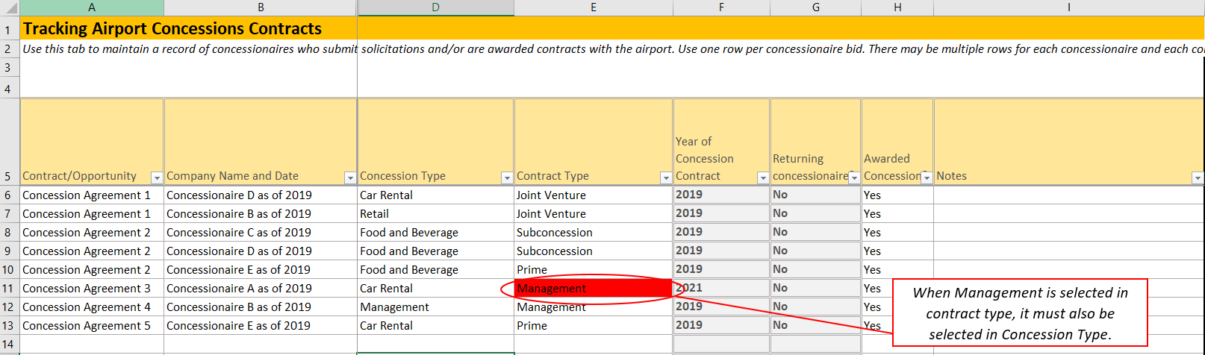

Figure 20: Example of completed Inputs6- Concessions Contracts tab through column I.

*Step 7: Enter the dollar amount the contract in each year the business received payments from the airport. If the information pertains to a management contract, enter the amount in the column labelled “Management Payments”. For any other concession type, use the column labelled “Gross Revenue”.*

*Step 8: Enter dollar amount of the amount that the concessionaire spent on goods and services that were purchased from ACDBEs. The dollar amount should fall under the correct column based on the year that the payment was made and the diversity status of the business that provided the goods and services.*

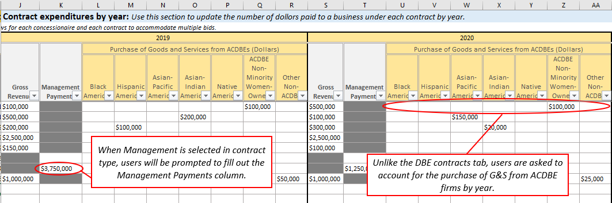

Figure 21: Example of completed Inputs6- Concessions Contracts tab through column AA.