ACRP Research Report 219: Appendices B Through S

B. AUTONOMOUS VEHICLE USES DESCRIBED BY IATA A-2
C. GUIDING PRINCIPLES ON DATA FOR AV INTEGRATION (U.S. DOT) A-3
D. STAKEHOLDER INPUT A-4
E. Scholarly LITERATURE FOR AIRSIDE APPLICATIONS A-21
F. FAA MASTER PLANNING ALTERNATIVES ANALYSIS PROCESS A-32
G. AIRPORT STAKEHOLDERS A-33
H. RISK ASSESSMENT A-36
I. RELATIONSHIP BETWEEN EVALUATION CRITERIA, ASSESSMENT AREAS,
AND SUPPORTING PRINCIPLES AND EXAMPLES A-59
J. BENEFIT COST ANALYSIS A-64
K. HUMAN FACTORS DEFINITIONS A-81
L. WEIGHTING FACTORS FOR EVALUATION CRITERIA A-83
M. Supporting Information: AGVT for FOD Inspection A-84
N. Supporting Information: AGVT for Airfield Mowing A-86
Airfield Turf Management & Wildlife Hazard Considerations
for AGVT Technologies A-88
O. Supporting Information: AGVT for Snow and Ice Control A-95
P. Supporting Information: AGVT for Perimeter Inspection A-99
Q. Supporting Information: AGVT for Aircraft Pushback
and Tug/Taxi A-106
R. Supporting Information: AGVT for Baggage Carts A-108
S. TERMS AND ACRONYMS A-111

B. AUTONOMOUS VEHICLE USES DESCRIBED BY IATA
IATA Suggests the following Ground Vehicle and UAV applications.

Ground vehicles:
• Airside ground service vehicles and equipment
Autonomous ground vehicles can be used for baggage and cargo carts, dollies and loaders, as well as for aircraft tugs and jet bridges; automated vehicles serve as escort vehicles, as well as shuttle employees and shuttles
• Airside robots
Robot loaders can help load cargo onto aircraft, screen cargo, support airside inspections, provide perimeter monitoring, lawn mowing, aircraft deicing and snow clearance
• Airside deliveries
Autonomous ground vehicles can be used to deliver passengers and employees, transport catering supplies and cleaning crews, serve passengers or people with reduced mobility (PRM) as well as transfer parts for maintenance needs
• Landside transport
Autonomous vehicle technologies can transport PRM using wheelchairs and terminal carts, be used as rental car and parking lot shuttles, and transport employees, passengers and baggage.
• Landside and terminal operations
Autonomous vehicle technologies can be used for mobile security robots and mobile kiosks

UAV
• Inspections
UAV can support inspections of aircraft, buildings, construction, runways and for security
• Deliveries
UAV can support deliveries of cargo, baggage, maintenance supplies (parts and tools), and food and beverage service for aircraft
• Surveillance and monitoring
UAV can provide perimeter security, as well as surveillance and monitoring of traffic and remote areas to increase safety
• Operational
UAV can guide aircraft to gates or remote stands, be used for wildlife hazing, and as a defense tactic for unauthorized drones
• Construction
UAV can support construction design

Reference (Appendix B, Autonomous Vehicle Uses Described by IATA)

International Air Transport Association (IATA). (2017). IATA Simplifying the Business (StB) 2017. https://www.iata.org/whatwedo/stb/Documents/StB-White-Paper-2017.pdf

C. GUIDING PRINCIPLES ON DATA FOR AV INTEGRATION (U.S. DOT)

Text below is an excerpt from U.S. DOT’s Data for Automated Vehicle Integration, Guiding Principles (2018).

These Guiding Principles on Data for Automated Vehicle Integration define an approach for U.S. DOT and our stakeholders to prioritize and facilitate the iterative development of voluntary data exchanges to address critical issues slowing the safe and efficient integration of AVs. The principles will shape actions by U.S. DOT and its partners to increase access to data for AV integration, and will help lead to actionable priorities and clear roles in implementation. U.S. DOT continues to refine these principles and use them to engage with potential data generators and users.

Principle #1: Promote proactive, data-driven safety, cybersecurity, and privacy-protection practices.
U.S. DOT aims to accelerate the safe U.S. integration of AV by encouraging private sector innovation while ensuring appropriate safeguards for cybersecurity, confidential business information, and privacy. Proactive safety practices identify and mitigate risks before they cause harm. Such practices require timely data and analysis that cut across traditional silos. To develop appropriate system safeguards, the U.S. DOT, local jurisdictions, and industry partners would benefit from multi-modal data from testing and development efforts to inform investments and policies.

Principle #2: Act as a facilitator to inspire and enable voluntary data exchanges.
Industry and government share the objective of bringing safer AVs to market more quickly, and recognize the enabling role of data exchanges. U.S. DOT is uniquely positioned to convene stakeholders around mutually beneficial use cases and common standards. Sometimes, U.S. DOT will directly manage raw or anonymized data but often our role will be to enable others to exchange data via a range of mechanisms.

Principle #3: Start small to demonstrate value, and scale what works toward a bigger vision.
The U.S. DOT and our stakeholders cannot define all data exchange opportunities upfront and will need to build policies and capabilities iteratively via agile and collaborative methods. We should start small, and focus initially on areas of clearest public-private benefit and the smallest amount of data exchange necessary to answer critical questions – while keeping in mind long term goals and needs.

Principle #4: Coordinate across modes to reduce costs, reduce industry burden, and accelerate action.
Similar types of data exchanges will be valuable for similar purposes across all modes of transportation. U.S. DOT’s operating administrations and external stakeholders can learn from each other and share tools and resources to reduce costs and time to deploy capabilities, while improving interoperability. Also, some agencies make duplicative requests for industry information, increasing the cost of partnering with the government. Consolidating and streamlining those requests can reduce costs and increase interest in collaboration.

Reference (Appendix C, Guiding Principles on Data for AV Integration)

U.S. DOT. (2018, November 16). Data for Automated Vehicle Integration, Guiding Principles. https://www.transportation.gov/av/data

D. STAKEHOLDER INPUT

This section provides additional information about stakeholder input. Stakeholder input was invited from airport stakeholders including aviation industry professionals and other professionals whose perspective and experience are relevant to airside AGVT. The research team made effort to ensure that stakeholders represent a variety of organizations that represent:

• Different size airports (e.g., ranging from general aviation (GA) airports to NPIAS large hub primary commercial service airports).
• Different airport geographic locations representing the east coast, greater Midwest, west coast and south (e.g., Maine, New Jersey, Indiana, Illinois, Wisconsin, California, Utah and Texas).
• Airlines (both passenger and cargo service), and aviation professionals with experience in ramp activities, airport operations, vehicle maintenance, information technology, and airport funding and finance.
• Expertise in automated vehicle technology and ramp equipment and operations, including the perspective of a vehicle OEM, equipment supplier, and ramp service provider.
• Regulatory and government agencies, including TSA and FAA.
• Aviation consultants and aviation companies that provide software and equipment for airside operations.

Stakeholder viewpoints have been documented but not attributed to a specific organization.

Much of the discussion in this appendix is centered on the stakeholder input to support and guide the initial prioritization activities. However, stakeholder input was requested and provided throughout all phases of the research, and stakeholders provided valuable input during the development of the evaluation methodology, as well as during the detailed evaluation process. The research team is indebted to the airports, airlines, equipment and technology vendors that provided invaluable input.

Table D-1 provides a list of stakeholders that were included as part of the initial study advisory committee identified in the proposal, expanded to include additional stakeholders who provided input through a variety of means, including the online survey, individual interviews, emails, and other means.

The following sections provide more detailed ranking information from the survey, and comments from stakeholders, both from the survey and from a workshop held at an industry conference for ground operations professionals. This stakeholder input was all important in prioritizing the technology applications for more detailed evaluation. A summary of the prioritization considerations is provided in Table D-3 (beginning on page A-27).

The next section provides information about the survey respondents, as well as additional information about criteria weighting and responses to Likert questions regarding AGVT implementation.

Table D-1. Airport Stakeholders
Category | Organization
Airports | Arlington Municipal (GKY, Regional GA and Reliever)
 | Blue Grass Airport (LEX, Small Hub)
 | Boston Logan (BOS, Large hub)
 | Charlotte (CLT, Large hub)
 | Charlotte Douglass (CLT, Large hub)
 | Chicago Department of Aviation (MDW and ORD, Large hubs)
 | Cincinnati (CVG, medium hub)
 | Columbus Municipal (BAK, Regional GA)
 | Delphi (1I9, Local GA)
 | Duluth (DLH, Non-hub)
 | Edmonton International (YEG, Medium hub Canadian equivalent)
 | El Paso (ELP, Small hub)
 | Fort Worth Meacham (FTW)
 | Gary Chicago (GA, National GA)
 | General Mitchell (MKE, Medium hub)
 | Harrisburg International Airport (MDT, Small hub)
 | Huntingburg (HNB, Regional GA)
 | Indianapolis (IND, Medium hub)
 | Indianapolis Executive (TYQ, National GA and Reliever)
 | Indianapolis Executive (TYQ, National GA and Reliever)
 | John F. Kennedy (JFK, Large hub)
 | LaGuardia (LGA, Large hub)
 | Mesquite Metro (HQZ, Regional GA and Reliever)
 | Middle Georgia Regional (MCN)
 | Milwaukee (MKE, Medium hub)
 | Monroe County (BMG, Regional GA)
 | Morristown Airport (MMU, National GA and Reliever)
 | Newark Liberty (EWA. Large hub)
 | Orlando (MCO, Large hub)
 | Page Field (FMY, National GA and Reliever)
 | Portland (PDX, Large hub)
 | Portland International Jetport (PWM, Small hub)
 | Purdue (LAF, Regional GA)
 | Range Regional (HIB, Non-hub)

Table D-1. Stakeholders (continued)
Category | Organization
Airports (Continued) | San Diego (SAN, Large hub)
 | San Francisco (SFO, Large hub)
 | South Bend (SBN, Non-hub)
 | Southwest Florida (RSW, Medium hub)
 | Stewart (SWF, Non-hub)
 | Sugar Land Regional Airport (SGR, National GA and Reliever)
 | Teterboro (TEB, National GA and Reliever)
 | Utah Airports represented by Utah Division of Aeronautics (Airports of all sizes)
 | Victoria (VCT, Regional GA)
Airlines and  Air Cargo | American Airlines
 | Southwest Airlines
 | Lufthansa
 | United Airlines
 | UPS
 | Amazon Air
Technology, Equipment and Ramp Services GSE and Service Providers | UGE (United Ground Express)
 | Israel Aerospace Industries (IAI, TaxiBot)
 | Ford Motor Company Automated Vehicle
Eisennman (provides warehouse automation logistics and conveyance)
(warehouse automation logistics and conveyance)
 | Team Eagle
 | Mototok
 | Harris Corporation
 | Echo Robotics
 | Northstar Robotics
 | Smart Guided Systems
Regulatory and Government | TSA
 | FAA (including air traffic, airports, aviation safety, and research)
 | NASA
Aviation Consultants | Woolpert
 | Landrum and Brown
 | C&S Companies
Other | Aviation Financial Consulting
 | Cummins Corporate Flight

Detailed Ranking Information from Online Survey

Additional information from the survey includes rankings from the online survey regarding the preferred technologies for airport applications (Figure D-1) and ramp applications (Figure D-2).

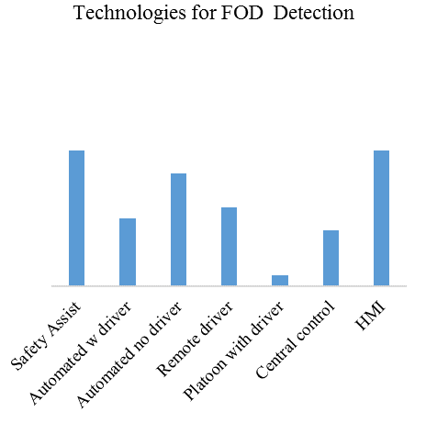 | 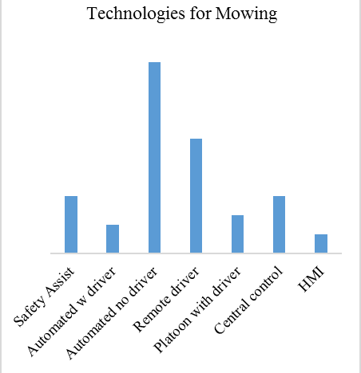
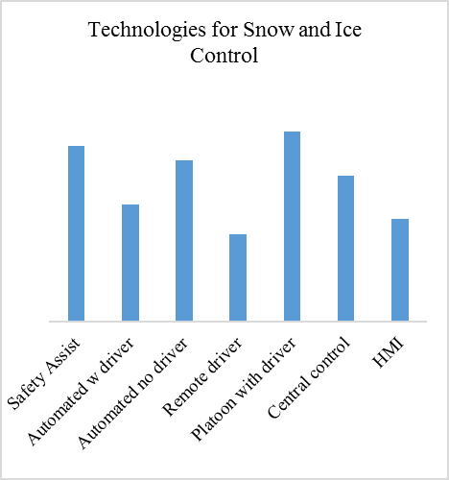 | 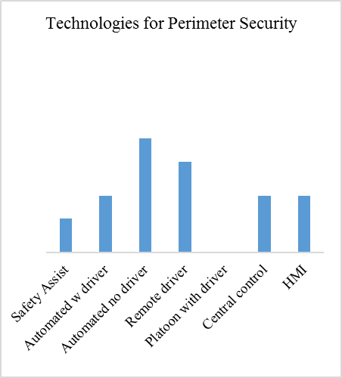
Figure D-1. Preferred Technologies for Airport Applications

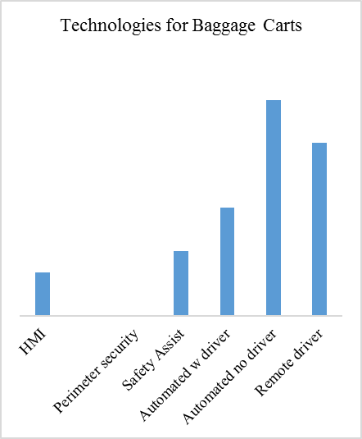 | 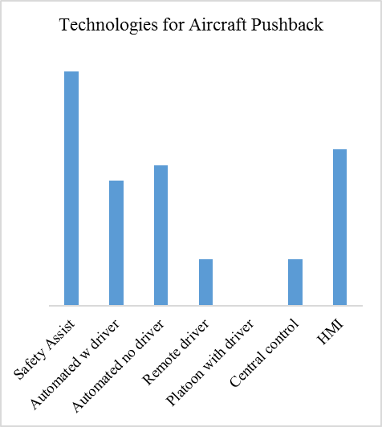
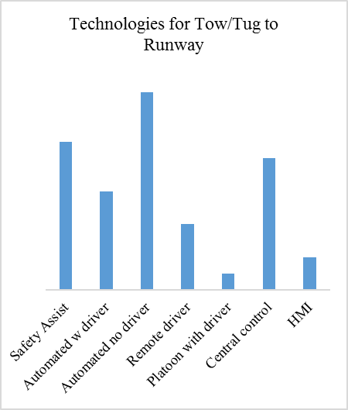 | 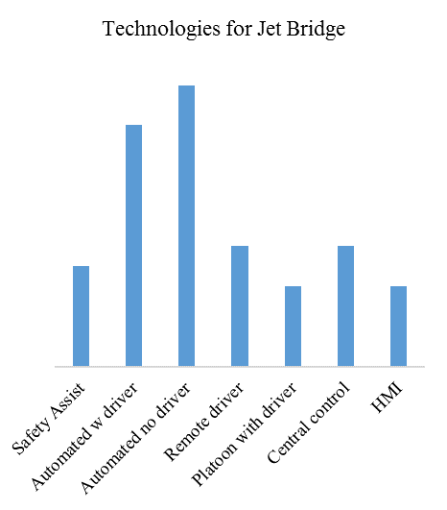
Figure D-2. Preferred Technologies for Ramp Applications

Comments from Stakeholders

Table D-2 provides comments from the online survey. Comments from participants at the industry conference and workshop for ground operations, and comments from conversations with stakeholders (both in person and on the phone).

Table D-2. Comments from Online Survey
The application of technology shouldn't be limited to operational constraints. If technology provides a better way and requires operational modification then as long as the evaluation bares that out then adjust the operation. We are most interested in automated mowing technology. The potential to multiply our maintenance forces by freeing them from our expansive mowing season would be huge.
Relying on automation for airside ground operations is interesting, but due to the potential damage and injury on the ramp areas precludes safe operations. Weather and other considerations will be very hard to integrate into the software.
Safety is paramount on an airfield. Technology must be proven, but not delayed trying to make it perfect.
I’m concerned of AI and AV resulting in the loss of jobs.
I believe this was a good survey, but would certainly like the opportunity to expand on some of my selections.¹
Other priorities for ground vehicle operations: ADS-B tracking in vehicles
Other priorities for ground vehicle operations: Reducing air emissions
Other technologies to improve operations: Bag tugs
Other factors that must be considered: Budgetary
Other factors that must be considered: Affordable Training
Other factors that must be considered: Reliability and Safety
¹The online survey included a field in which respondents could provide their email. All respondents who provided an email were contacted and follow up telephone conversations were invited.

Input from the grounds operations industry conference session in the Fall of 2018 and follow up individual conversations resulted in the following input:
• Better HMI to support fleet management would be helpful.
• Jet bridge sensing technologies to decrease aircraft damage would be useful. The advanced technologies at Changi Airport were specifically mentioned.
• Cameras and sensors could be used for employee assessments, however, this application may conflict with cultural considerations, such as Just Culture.
• Use of Augmented Reality and Virtual Reality would be helpful for training purposes. Training courses such as those sponsored by IATA currently include practical training with virtual reality. (RAMPVR is IATA’s virtual reality training and is described on their webpage: https://www.iata.org/training/Pages/rampvr.aspx.)
• Advanced technologies for maintenance inspections would be helpful.
• AV that can deliver containers from the in-ground utility pit to the aircraft and then assist in the loading process would be helpful.
• AV for catering that can assist loading onto the aircraft would be helpful; currently agents push carts from the truck onto the aircraft.
• AV and advanced technologies would be helpful if they increase the reliability and efficiency of aircraft turns.
• AV applications that reduce the impact of staffing issues when lighting strikes would be helpful.
• Automated cargo loading would be a good application for advanced technologies.
• Parking assist for aircraft would be useful.
• It may be useful to use AV to transport equipment, however, if personnel are needed to load or perform other tasks, then there may not be a benefit to the automation of equipment movement.
• Automation for the belt loader and jetway are high priority do to the potential for aircraft damage. The cost of aircraft damage is significant, not only due to the direct cost of aircraft repair, but also due to the associated cost of delay.
• Interlock technology for carts may be useful.
• Technology that confirms power cords are plugged and other tasks have been accomplished may be helpful.
• Magnets may have potential. (This may refer to automation that tracks on a magnetized strip, such as a smart cart.)

Suggestions raised at industry conference that were beyond the scope of this research include the following:
• Airline personnel suggested that technology investments should focus on passenger service rather than airside applications.
• Advanced technologies and AV would also be useful for special service requests and other applications for disabled passengers.
• UAV may be useful for wildlife management.
• It might be useful to use facial recognition to recognize intoxicated passengers before boarding.

Concerns raised at industry conference include the following:
• Funding technologies and return on investment are important.
• Airlines are concerned about investing in technology that the passenger can see, such as technologies in the terminal.
• Cybersecurity is important for any technologies.
• Human factors concerns would make the use of L3 or any automation where people must monitor the environment with vigilance and human response may be needed less desirable.
• Change management would be needed for the introduction of technology.
• The addition of technology and the removal of people would reduce the continuous inspection that people currently provide in terms of aircraft damage identification.
• The use of technology may put pressure on the capacity and capability of radio communication channels.
• Airports and air carriers may not have similar goals for technology and relationships may suffer and/or not support technology implementation.
• The inclusion of cameras and video that are part of AV and advanced technologies may not be consistent with employee privacy concerns, passenger privacy concerns, and Just Culture concepts.

Additional feedback from airport stakeholders included one-on-one and small group discussions for more robust feedback than a survey or workshop could provide (in person and on the phone). This feedback resulted in the following comments.
• Airports and air carriers may not have similar goals for technology and relationships may suffer and/or not support technology implementation.
• A major consideration is funding and return on investment. Airline margins are tight and funding for any proposed improvements is a concern.
• Automation for the belt loader and jetway are high priority due to the potential for aircraft damage. The cost of aircraft damage is significant, not only due to the direct cost of aircraft repair, but also due to the associated cost of delay.
• Auto docking technology may be useful. Some airlines use targets on aircraft and jet bridges for alignment.
• Interlock technology for carts may be useful.
• Technology that confirms power cords are plugged and other tasks have been accomplished may be helpful.
• It may be helpful to consider the four levels of automation in the cockpit when looking forward to automation of airside activities. (Add description of the four levels of automation)
• There will be opponents to the introduction of automation and new technologies. It is worthwhile to identify long terms goals and wins, as well as the “low hanging fruit” that makes sense for immediate implementation.
• Mowing, snow removal and wildlife management are the most interesting applications for AV.
• AV or UAV wildlife management that could identify and track wildlife would be useful.
• Some airport personnel expressed a preference for automation since it would be safer and eliminate human error.
• AV for snow removal would reduce damage due to lights.
• AV for mowing could be done at night when there are no operations.
• AV could be implemented as part of a 5-year plan to reduce the labor impacts and assure that people are available to cover the duties when the automated system is down.
• Safety assist may be useful if paired with a runway incursion system; current systems use geofencing and provide a warning but future systems may be able to provide automated braking.
• Previous deployments of technologies have been faced with sabotage from employees who felt threatened by change, even if the new technology did not propose or lead to personnel changes.
• Improved HMI may be as simple as a big red button on the baggage cart.
• Back up cameras and warnings have been implemented as standard equipment at some stations for some organizations.
• The U.S. should become more active in this area, otherwise European airports and companies will develop the practices that will become the standards in the future.
• Some airports have deployed remote mowing for steep grades.
• While some airports are interested in safety assist and technologies that prevent runway incursions with automated breaking, other airports think it would be a distraction.
• Operating procedures and airport agreements that allow airport ground vehicles to drive on the airfield without ATC approval were cited.
• Some airports suggested that technology could be a lever to support institutional goals such as collaboration and cooperation among different airlines.
• Some airports suggested that they evaluate advanced technologies in a similar way that they evaluate other potential airport products or equipment.
• Some small GA airports are examining automated mowing at the local level. There are also vendors exploring this application given the potential market including golf courses.

A summary of prioritization considerations is shown in Table D-3.

Stakeholder input was used to support the prioritization of applications and technologies for further evaluation. Stakeholder input was also used in the development of assessment areas, and supporting principles and examples for the evaluation criteria.

Table D-3. Summary of Prioritization Considerations
 | Stakeholder  Interest | Deploymentsand Demos | Scholarly Interest | Comments
Ramp and Aircraft Activities |  |  |  | • Airlines are not inclined to spend money on technology the passenger does not see.  • Airlines rather than airports may be the likely lead on these technologies, therefore more of a private sector activity.  • Ramp workers may sabotage equipment.  • Union workers may cause problems at some locations.  • System failure and manual backups must be available.
Aircraft pushback | Highest | Heathrow and  Changi Airports | High | • Would be helpful in airports with congested “cul-de-sacs”.  • Would be helpful if it could overcome personnel issues wrt weather issues (e.g., lighting).
Aircraft tow or tug to/from runway | High | Frankfurt,  Mumbai, and  New Delhi  Airports |  | • Would be helpful for emissions reductions and fuel savings.  • May require geometry that allows holding areas and charging stations.
Baggage carts | High | The Hague (inside airport) | Moderate-Low | • Airlines are interested in safety assist for baggage carts  • Airlines are not very interested in full automation of baggage carts.  • Ramp workers may sabotage equipment.  • Union workers may cause problems.  • AV companies are interested if it will help provide delivery solutions that would translate to the roadway sector.
Belt loader | Moderate | - | - | • Proximity to aircraft makes it riskier for AV.  • This solution would require robotics more than AGVT for success.
Catering truck | Very Low | - | Low | • Airlines are not inclined to spend money on technology the passenger does not see.
Container/ULD loader (cargo) | Low-Moderate | Ports | - | • Cargo applications are not a top priority for airlines, especially since they are not visible for passengers.  • Cargo operators such as UPS would implement technologies independently if they are appropriate.  • Much of the benefits for automation would require robotics and not merely AGVT.

Table D-3. Summary of Prioritization Considerations (continued)
Dollies (cargo carts) | Moderate | Heathrow and  Changi Airports | - | • Cargo applications are not a top priority for airlines or most airports.  • The technologies evaluated for baggage carts may have application for dollies.
Deicing | Moderate | - | - | • Benefits would include reduced exposure for people to hazardous chemicals.  • Would require robotics in addition to AGVT.
Jet bridge | Moderate | Changi Airport | - | • Airlines are not inclined to spend money on technology the passenger does not see.
Lavatory service | None | - | - | • Benefits would include reduced exposure for people to hazardous chemicals.  • Would require robotics in addition to AGVT.
Refueling pump | Low | - | - | • Would require robotics in addition to AGVT.  • Airlines are not inclined to spend money on technology the passenger does not see.
Refueling tanker
Water carriage | None | - | - | • Airlines are not inclined to spend money on technology the passenger does not see.
Wing walker | Moderate | - | - | • Would be of interest if it could allow aircraft to enter or leave gate area during lighting warnings.  • Automated aircraft docking plus automated aircraft taxi/tug may eliminate need for wing walker.
Airport Operations |  |  |  | • The routine nature of many airport operations activities may be compatible with AV capabilities as the technology matures.  • Automatically generated records of airport conditions may support documentation requirements needed for certification under Part 139.
Construction inspections | Low | - | - | • Construction contractors have already implemented automated 3D milling and paving.  • Construction contractors will bring AV innovation to airports when the technology is mature enough to benefit airports
Emergency response | Moderate | - | - | • AV may be able to manage situations that humans cannot due to hazardous chemicals.  • Some response may require robotics rather than AV.  • Robotic bomb response has proven to be a success.
Escort vehicle | Low | - | - | • A small automated escort vehicle may be more fuel efficient than a traditional vehicle.
FOD detection and removal | High | - | High | • Combining AV capabilities with existing technologies such as FOD Boss may allow a fully automated FOD system.  • The routine nature of these inspections makes it well suited for a fixed path deployment..

Table D-3. Summary of Prioritization Considerations (continued)
Friction testing | Moderate | - |  | • May be analogous to automation of RCAM.
Light inspection | Low | - | - | • May be analogous to sign and marking inspection.  • Could potentially be combined with FOD detection inspection for efficiency, just as human personnel may conduct multiple inspections at once.
Mowing | High | Remote  Mowing on steep slopes at some airports | Moderate | • Applications for both GA and commercial airports.  • Mowing is an on-going task for many airports.  • Automation may be most beneficial if it is paired with automation for winter tasks since the same personnel may be used for mowing in the summer and snow removal in the winter.
Paved area inspection | Moderate | - | - | • AV may be well suited to identify pavement cracks and other components of the paved area inspection.
Perimeter security | High | Indianapolis Motor Speedway  Israel and Edmonton Airports | - | • AV for perimeter security has been demonstrated although there are no “off the shelf” systems with a corresponding list price.
RCAM determination | Low | - | - | • Automated friction measurements could reduce airfield delay.  • The RCAM may be completed after the snow removal equipment has left the runway; if the RCAM is not adequate, it can take a while before the snow removal equipment returns, which can result in a significant delay
Safety area inspection | Moderate | - | - | • Machine vision capabilities of AV combined with a robust airfield map and the routine nature of these inspections suggest these deployments could be viable.
Signs and marking inspections | Low | - | -
Snow and ice control | High | Fagernes,  Oslo and  Winnipeg Airports | Moderate | • Platoon technology from trucking sector makes this a strong candidate to reduce manpower requirements and address HF fatigue issues.  • Some ops personnel think it is as much an art as a science and have a hard time imagining that a machine can complete the task unassisted by a person.  • GA airports would particularly benefit from this if it could be remotely activated (or automatically activated).
Wildlife management | Moderate-High | - | - | • Would be of interest but complexity of task suggests it is more appropriate for later deployment.  • UAV have been used for wildlife hazing.

Survey Respondents

The online survey was distributed via the internet, and invitations to participate in the survey were distributed via personalized emails, as well as general invitations on aviation forums. The survey included multiple choice questions regarding the most appropriate AGVT applications and technologies, as well as the opportunity to provide comments regarding concerns, and/or ideas for other applications and technologies. A total of 116 responses were received.

The survey respondents are shown in Figure D-3. Of the 116 respondents, the majority represented airports; a few airports had multiple respondents, which would occur if both an ops manager and an IT manager at the same airport took the survey. One goal of this survey was to assure that airport stakeholders were adequately represented, and based on the survey responses, this goal was met. Additional information about the airports that responded to the survey is provided in the following section, Airport Data. The pilots included in the survey were professional pilots for airlines and corporate flight departments. The research team also obtained feedback from airlines ground operations professionals at an industry conference workshop, to assure feedback from this important constituent, as well.

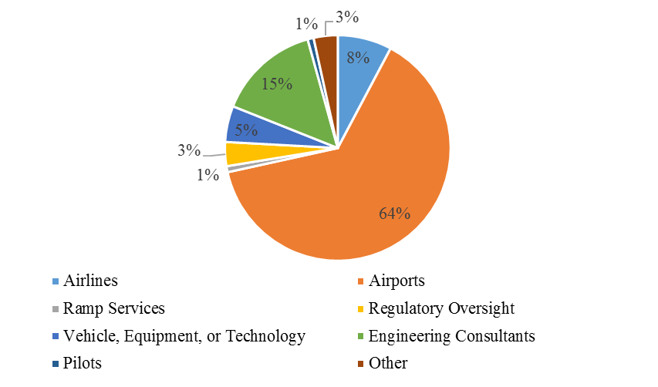
Figure D-3. Survey Respondents

Airport Data

Responses from airports reflect activities at both GA and commercial airports, including all NPIAS categories. As shown in Figure D-4, 80% of responding airports held a Part 139 certificate, and 20% were GA airports that did not hold a Part 139 certificate.

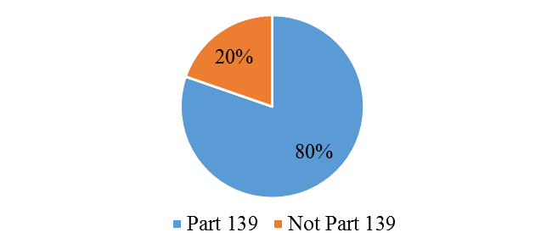
a) Airport certification under Part 139
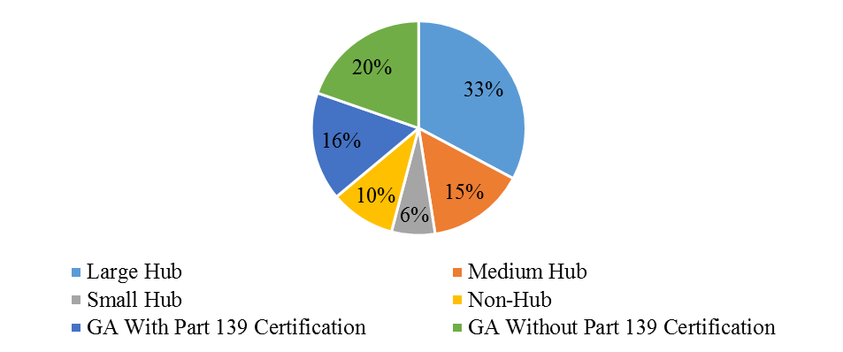
b) Airport NPIAS category
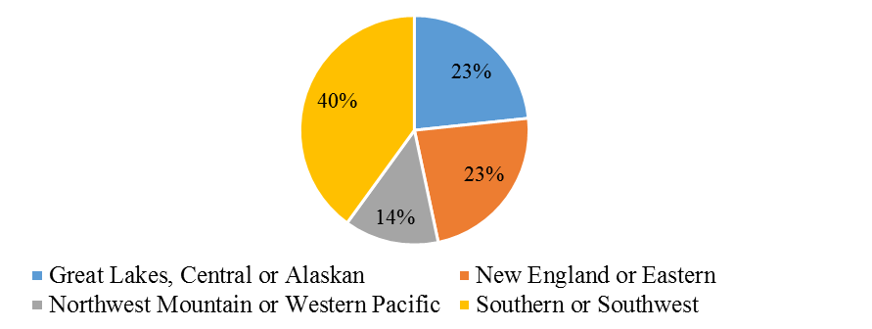
c) Airport region
Figure D-4. Airport Characteristics of Survey Responses
In terms of airport category, all NPIAS categories were represented, as shown in Figure D-4b. The most responses were from large hub airports, reflecting 33% of responses; medium hub airports reflected 15% of responses; small and non-hub airport environments were represented by 6% and 10% of the responses. GA airports were reflected in 36% of responses, and 16% of the responses were from people who worked at GA airports that held a Part 139 certificate.

The airports were from around the country, as shown in Figure D-4c. Responses include:
• 40% from the Southern or Southwest region, which includes
AL, FL, GA, KY, MS, NC, PR, SC, TN, VI, AR, LA, NM, OK, and TX;
• 23% from the New England and Eastern regions, which includes
CT, ME, MA, NH, RI, VT, DC, DE, MD, NJ, NY, PA, VA, and WVA;
• 23% from the Great Lakes, Central and Alaskan regions, which includes
IL, IN, MI, MN, ND, OH, SD, WI, IA, KS, MO, NE, and AK; and
• 8% from the Northwest Mountain and Western Pacific regions, which includes
CO, ID, MT, OR, UT, WA, WY, AZ, CA, HI, NV, GU, AS, and MH.

Criteria

Respondents were asked to rate how important each of the criteria are for successful implementation on a scale from 0 to 10, with 10 being most important. The results are shown in Figure D-5. Three respondents identified “Other” factors as being important, namely budgetary, affordability, and reliability, each of which was rated as a ten by the person who identified it as an important factor. Operational impacts are identified as the most important consideration, with an average value of 9.1, although all factors were recognized as important. The range of values for each criteria varies more considerably, with a minimum value of 1 for Stakeholder Acceptance; a minimum value of 2 for Infrastructure Impacts, Ease of Adoption, Potential Benefits, and Human Factors; a minimum value of 3 for Technological Feasibility; and a minimum value of 6 for Operational Impacts. These minimum values reflect that all responses reflect the importance of AGVT smoothly integrating with operational impacts.

Range
Figure D-5. Importance of Criteria

AGVT Integration Issues

Several questions using a Likert scale were presented to gain additional insight regarding perspectives on integration. Responses are shown in Figure D-6 and indicate that technologies should be proven in other sectors before being deployed airside (Figure D-6a), and there will be challenges for workers to adapt to new technologies (Figure D-6b), although new technologies may present a viable solution to capacity issues (Figure 6c). There were mixed perspectives regarding how smoothly previous technology deployments have gone, many responses were neutral, and slightly more responses indicated that previous deployments had not gone smoothly (Figure D-6d). Despite the perspective that technologies should be proven in other sectors (such as the roadway sector, as illustrated in Figure D-6a), most respondents indicated that the US should be a leader in airside AGVT deployment (Figure D-6e), and were optimistic that their organization has the capabilities to successfully deploy airside technology (Figure D-6f). Responses also indicate that strong support for the concept that proposed technology should support current operational procedures, rather than change procedures (Figure D-6g). This perspective is consistent with the high ranking for the operational impacts evaluation criteria discussed previously and illustrated in Figure D-3.

a) Technology should be proven elsewhere (e.g., roadways) before it is implemented airside. | b) It will be challenging for workers to adapt to new technologies.
c) Technologies may be a valuable solution to capacity issues at airports | d) The integration of new airside technologies has historically gone smoothly
Figure D-6. Responses to Likert Questions about AGVT Implementation
e) In the global aviation sector, the US should be a leader for the integration of airside technologies. | f) Our organization has knowledge of potential airside technologies and applications.
g) Technology should support current operational procedures rather than change procedures.
Figure D-6. Responses to Likert Questions about AGVT Implementation (continued)

E. Scholarly LITERATURE FOR AIRSIDE APPLICATIONS
AGVT Application Category | Summary | Development Stage | Year | Location | Source
AGVT Background | Provides overview of NextGen surface-trajectory based operations and identifies research issues and gaps | Concept/ Background | 2014 | California | Hooey, B. L., Cheng, V. H., & Foyle, D. C. (2014). A concept of operations for far-term Surface Trajectory-Based Operations (STBO). NASA TM-2014-218354. Moffett Field, CA: NASA Ames Research Center. http://human-factors. arc. nasa. gov/groups/HCSL/publications/STBO% 20ConOps_TM_2014_218354. pdf.
AGVT Background | Review of function allocation between humans and automation (UAS & AGVT) | Concept Analysis/ Background | 2016 | Georgia | Feigh, K., & Pritchett, A. (2016). Function Allocation between Human and Automation and Between Air and Ground. Unmanned Aircraft Systems, 319.
AGVT Background | Analysis of automation opportunities in aircraft ground handling | Concept Analysis | 2017 | France | Tabares, D. A., & Mora-Camino, F. A. C. (2017, June). Aircraft ground handling: Analysis for automation. In 17th AIAA Aviation Technology, Integration, and Operations Conference (pp. 16-p). AIAA.
AGVT Background | Review of trends in the use of digital technology in airport ground operations | Background | 2018 | Germany | Kovynyov, I., & Mikut, R. (2018). Digital Transformation in Airport Ground Operations. arXiv preprint arXiv:1805.09142.
AGVT Testing, Validation, & Benefit Measurement Methods | Using ASDE-X surveillance datasets to measure airport performance characteristics | Evaluation of Airport Operational Performance | 2013 | Massachu-setts | Khadilkar, H., & Balakrishnan, H. (2013). Metrics to characterize airport operational performance using surface surveillance data. Air Traffic Control Quarterly, 21(2), 183-206.
AGVT Testing, Validation, & Benefit Measurement Methods | ATC Tower simulator for ground operations | Simulation Software | 2015 | France | Chua, Z. K., André, F., & Cousy, M. (2015). Development of an ATC Tower Simulator to Simulate Ground Operations. In AIAA Modeling and Simulation Technologies Conference (p. 2494).
AGVT Testing, Validation, & Benefit Measurement Methods | Evaluation of Datalink and autonomous taxiing tugs' effect on airport taxiing operations and ATC workload | Evaluation of Airport Taxiing Performance, Acceptance Attitudes | 2016 | France | Chua, Z., Cousy, M., Causse, M., & Lancelot, F. (2016, September). Initial assessment of the impact of modern taxiing techniques on airport ground control. In Proceedings of the International Conference on Human-Computer Interaction in Aerospace (p. 17). ACM.
AGVT Testing, Validation, & Benefit Measurement Methods | Case study of HMI validation of new cockpit technologies supporting all conditions operations | Evaluation of HMI | 2016 | Ireland | Cahill, J., McDonald, N., Morrison, R., & Lynch, D. (2016). The operational validation of new cockpit technologies supporting all conditions operations: a case study. Cognition, Technology & Work, 18(3), 479-509.
AGVT Testing, Validation, & Benefit Measurement Methods | Side-by-side evaluation of German & U.S. airport surface traffic management concepts that defines common performance metrics | Evaluation of Surface Traffic Management | 2016 | Germany | Zhu, Z., Okuniek, N., Gerdes, I., Schier, S., Lee, H., & Jung, Y. (2016). Performance Evaluation of the Approaches and Algorithms for Hamburg Airport Operations.
AGVT Testing, Validation, & Benefit Measurement Methods | Reviews existing methods of estimating taxiing delay and proposes new methods that use software, statistical tools, and regression models | Evaluation of Airport Taxiing Performance | 2017 | China | Zhang, Y., & Wang, Q. (2017). Methods for determining unimpeded aircraft taxiing time and evaluating airport taxiing performance. Chinese Journal of Aeronautics, 30(2), 523-537.
Automated Taxi Operations | Airport taxiway navigation system | Patent | 2014 | Colorado | Doose, R., Ellerbrock, R. W., Hulet, G. L., Jauglias, J. M., & Majka, M. T. (2014). U.S. Patent No. 8,788,187. Washington, DC: U.S. Patent and Trademark Office.
Automated Taxi Operations | Simulated human-in-the-loop evaluation of an Advanced Surface Movement Guidance and Control System (A-SMGCS) operational concept | Concept/ Simulation | 2014 | Germany | Kocks, S., Oehme, A., Rad, T., Budweg, B., & Feuerle, T. (2014). Evaluation of an automated taxi concept in a distributed simulation environment. In Air Traffic Management and Systems (pp. 107-130). Springer, Tokyo.
Automated Taxi Operations | Module for identification of conflict points for intelligent taxiing | Model/ Computer Tool/ Simulation | 2015 | Poland | Czarnecki, M., & Skorupski, J. (2015). Method for identification of conflict points in the intelligent system of an aircraft taxi route choice. Archives of Transport System Telematics, 8.
Automated Taxi Operations | SafeTug Preliminary Report | Concept | 2015 | California | Morris, R., Chang, M. L., Archer, R., Cross II, E. V., Thompson, S., Franke, J. L., ... & Hemann, G. (2015, January). Self-Driving Aircraft Towing Vehicles: A Preliminary Report. In AAAI Workshop: AI for Transportation.
Automated Taxi Operations | SafeTug Final Report | Concept | 2015 | California | Morris, R., Chang, M. L., McGuire, K., Archer, R., Cross II, E. V., Thompson, S., … & Hemann, G. Semi-Autonomous Aircraft Towing Vehicles.
Automated Taxi Operations | Fleet management algorithm for Automatic Taxi Operations | Concept/ Simulation | 2016 | Italy | Sirigu, G., Battipede, M., Gili, P., & Clarke, J. P. (2016). A fleet management algorithm for automatic taxi operations. In ICRAT 2016 7th International Conference on Research in Air Transportation (pp. 1-5).
Automated Taxi Operations | Trajectory planning algorithm for aircraft taxi automation | Concept/ Modeling | 2016 | China | Zhang, T., Ding, M., Wang, B., & Chen, Q. (2016). Conflict‐free time‐based trajectory planning for aircraft taxi automation with refined taxiway modeling. Journal of Advanced Transportation, 50(3), 326-347.
Automated Taxi Operations | Self-pushback system for aircraft | Patent | 2016 | Maryland | Cox, I. W., Gilleran, N., & Goldman, J. (2016). U.S. Patent No. 9,334,047. Washington, DC: U.S. Patent and Trademark Office.
Automated Taxi Operations | Thesis outlining machine vision methods/issues for automated taxiing of UAS | Development of Enabling Technology | 2017 | United Kingdom | Eaton, W. H. (2017). Automated taxiing for unmanned aircraft systems (Doctoral dissertation).
Automated Taxi Operations | Review of trajectory-based taxi operations concept and ATC procedures to manage aircraft with autonomous engine-off taxi technologies | Concept/ Procedure | 2017 | Germany | Okuniek, N., & Beckmann, D. (2017, September). Towards higher level of A-SMGCS: Handshake of electric taxi and trajectory-based taxi operations. In Digital Avionics Systems Conference (DASC), 2017 IEEE/AIAA 36th (pp. 1-10). IEEE.
Automated Taxi Operations | Thesis modeling autonomous taxi and pushback of an Airbus A320 | Concept/ Modeling | 2017 | Belgium | Quinet, S. (2017). Modeling with Robotran the autonomous electrical taxi and pushback operations of an Airbus A320 (Master’s thesis).
Automated Taxi Operations | Routing algorithm for autonomous taxi operations | Simulation/ Testing of Routing Algorithm | 2018 | Italy | Sirigu, G., Cassaro, M., Battipede, M., & Gili, P. (2018). Autonomous taxi operations: algorithms for the solution of the routing problem. In 2018 AIAA Information Systems-AIAA Infotech@ Aerospace (p. 2143).
Automated Taxi Operations | Dissertation on planning and reconfigurable control of a fleet of unmanned vehicles for aircraft taxi operations | Doctoral dissertation | 2018 | Italy | Sirigu, G. (2018). Planning and reconfigurable control of a fleet of unmanned vehicles for taxi operations in airport environment.
Automated Mowing | Proof of concept testbed development for sensor array to enable roadside automated mowing | Development and Testing of Enabling Technologies | 2011 | California | Arsenault, A., Velinsky, S. A., & Lasky, T. A. (2011). A low-cost sensor array and test platform for automated roadside mowing. IEEE/ASME Transactions on Mechatronics, 16(3), 592-597.
Automated Mowing | Automated Vehicle Location system to enhance roadside mowing operations | Pilot Project | 2017 | Minnesota | Potter, A. S., & Bayer, C. (2017). An Innovative Approach to Smarter Mowing, Utilizing Automated Vehicle Location to Enhance Mowing Operations (No. MN/RC 2017-11). Minnesota Department of Transportation, Research Services & Library.
Automated Pavement Inspection/ Repair | Motion planning and control algorithm for crack-filling robot | Concept/ Simulation | 2017 | China | Guo, C., Yu, K., Gong, Y., & Yi, J. (2017, August). Optimal motion planning and control of a crack filling robot for civil infrastructure automation. In Automation Science and Engineering (CASE), 2017 13th IEEE Conference on (pp. 1463-1468). IEEE.
Automated Snow/Ice Control | Multi-robot system and algorithm for snow shoveling method for airports | Concept/ Simulation/ Hardware Tests | 2008 | Czech Republic/ Germany | Saska, M., Hess, M., & Schilling, K. (2008, May). Efficient airport snow shoveling by applying autonomous multi-vehicle formations. In Robotics and Automation, 2008. ICRA 2008. IEEE International Conference on (pp. 1684-1690). IEEE.
Automated Snow/Ice Control | Multi-robot system and algorithm for snow shoveling method for airports | Concept/ Simulation/ Hardware Tests | 2009 | Germany/ Czech Republic | Hess, M., Saska, M., & Schilling, K. (2009). Application of coordinated multi-vehicle formations for snow shoveling on airports. Intelligent Service Robotics, 2(4), 205.
Automated Snow/Ice Control | Multi-robot system and algorithm for snow shoveling method for airports | Simulation/ Hardware Tests | 2010 | Czech Republic/ Germany | Saska, M., Vonásek, V., & Krajník, T. (2010, October). Airport snow shoveling. In Intelligent Robots and Systems (IROS), 2010 IEEE/RSJ International Conference on (pp. 2531-2532). IEEE.
Automated Snow/Ice Control | Optimization and dispatch system for airport snow removal | Concept/ Simulation | 2011 | China | Wang, L. W., Yao, G. P., Wei, J. L., & Shi, X. D. (2011). Design of Airport Snow Removal Operation Optimization and Dispatch System. In Applied Mechanics and Materials (Vol. 52, pp. 54-58). Trans Tech Publications.
Automated Surveillance | ADS-B conflict alerting between aircraft and surface vehicles | Concept/ Testing | 2013 | Kunzi | Kunzi, F. (2013). Reduction of Collisions Between Aircraft and Surface Vehicles: Conflict Alerting on Airport Surfaces Enabled by Automatic Dependent Surveillance-Broadcast. Transportation Research Record: Journal of the Transportation Research Board, (2325), 56-62.
Automated Surveillance | Object assessment for automated video tracking | Concept/ Framework/ Exemplar Case | 2014 | Gibraltar Airport | Blasch, E., Wang, Z., Shen, D., Ling, H., & Chen, G. (2014, June). Surveillance of ground vehicles for airport security. In Geospatial InfoFusion and Video Analytics IV; and Motion Imagery for ISR and Situational Awareness II (Vol. 9089, p. 90890B). International Society for Optics and Photonics.
Automated Surveillance | Methods for autonomous tracking and surveillance | Patent | 2015 | California/ Washington | Kokkeby, K. L., Lutter, R. P., Munoz, M. L., Cathey, F. W., Hilliard, D. J., & Olson, T. L. (2015). U.S. Patent No. 9,026,272. Washington, DC: U.S. Patent and Trademark Office.
Automated Surveillance | Runway surveillance system and method | Patent | 2016 | Singapore | Chew, K. M. D. (2016). U.S. Patent No. 9,483,952. Washington, DC: U.S. Patent and Trademark Office.
Automated Surveillance | Computer vision to monitor gate operations | Testing of Enabling Technologies | 2016 | California | Lu, H. L., Vaddi, S., Cheng, V., & Tsai, J. (2016). Airport Gate Operation Monitoring Using Computer Vision Techniques. In 16th AIAA Aviation Technology, Integration, and Operations Conference (p. 3912).
Automated Surveillance | Controller-in-the-loop study using LiDAR Point Clouds to improve ATC's situational awareness | Testing of Enabling Technologies | 2016 | Germany | Mund, J., Latzel, P., & Fricke, H. (2016). Can LiDAR Point Clouds effectively contribute to Safer Apron Operations?.
Automated Surveillance | UAS to support airport safety and operations | Concept Analysis | 2017 | Indiana | Hubbard, S., Pak, A., Gu, Y., & Jin, Y. (2017). UAS to support airport safety and operations: opportunities and challenges. Journal of unmanned vehicle systems, 6(1), 1-17.
Automated Surveillance | Monitoring and control system for improving safety of ground movement of aircraft | Patent | 2018 | Maryland | Cox, I. W., Cox, R. T., Vana, J., & Goldman, J. (2018). U.S. Patent No. 9,958,867. Washington, DC: U.S. Patent and Trademark Office.
Automated Surveillance | Intelligent video surveillance & collaborative robot for maintenance | Concept/ Testing | 2018 | France | Donadio, F., Frejaville, J., Larnier, S., & Vetault, S. (2018). Artificial intelligence and collaborative robot to improve airport operations. In Online Engineering & Internet of Things (pp. 973-986). Springer, Cham.
Automated Surveillance | Runway activity monitoring, logging and analysis for aircraft touchdown detection and abnormal behavior alerting | Patent | 2018 | Illinois | Nitzan, A., Goner, A., & Teshuva-Winkler, S. (2018). U.S. Patent Application No. 15/821,773.
Driver/ Pilot Assist | Closed airport surface alerting system for ground vehicles approaching zone of awareness | Patent | 2013 | Washington | Khatwa, R., Lancaster, J., & Corcoran III, J. J. (2013). U.S. Patent No. 8,478,461. Washington, DC: U.S. Patent and Trademark Office.
Driver/ Pilot Assist | Concept for an aircraft-based method for conflict detection and resolution in the airport terminal maneuvering area | Concept | 2013 | Virginia | Otero, S. D., Barker, G. D., & Jones, D. R. (2013). Initial Concept for Terminal Area Conflict Detection, Alerting, and Resolution Capability On or Near the Airport Surface, Version 2.0.
Enabling Technologies for AGVT | LiDAR requirements and optimized sensor positioning for point-cloud based risk mitigation at airport aprons | Performance Requirements and Recommended Positioning | 2014 | Germany | Mund, J., Meyer, L., & Fricke, H. (2014). LiDAR Performance Requirements and Optimized Sensor Positioning for Point Cloud-based Risk Mitigation at Airport Aprons. In Proceedings of the 6th International Conference on Research in Air Transportation.
Enabling Technologies for AGVT | optimizing GNSS signal for airside autonomous ground vehicle | System Architecture/ Mathematical Modeling | 2016 | Australia | Bijjahalli, S., Ramasamy, S., & Sabatini, R. (2016). A Novel GNSS Integrity Augmentation System for Autonomous Airport Ground Operations. Proceedings of the Institute of Navigation GNSS.
Enabling Technologies for AGVT | Testing sensor requirements for Autonomous Service Vehicles | Testing of Enabling Technologies | 2016 | Florida | Coyle, E., Currier, P., Butka, B., Spitzer, D., & Director, E. M. (2016). IDENTIFICATION OF AUTONOMOUS SERVICE VEHICLE REQUIREMENTS (Contract #: BDV22-934-01).
Enabling Technologies for AGVT | Radar for prevention of runway incursions, FOD management, possibly bird-strike prevention and intruder detection | Testing of Enabling Technologies | 2016 | Italy | Galati, G., Piracci, E. G., & Ferri, M. (2016, September). High resolution, millimeter-wave radar applications to airport safety. In Ultrawideband and Ultrashort Impulse Signals (UWBUSIS), 2016 8th International Conference on (pp. 21-26). IEEE.
Enabling Technologies for AGVT | LiDar point cloud-based object classification | Concept/ Testing | 2016 | Germany | Mund, J., Frank, M., Dieke-Meier, F., Fricke, H., Meyer, L., & Rother, C. (2016, April). Introducing LiDAR Point Cloud-based Object Classification for Safer Apron Operations. In Proceedings of the International Symposium on Enhanced Solutions for Aircraft and Vehicle Surveillance Applications, Berlin, Germany (pp. 7-8).
Enabling Technologies for AGVT | Monitoring taxiing and landing aircraft with LiDAR object classification | Concept/ Testing | 2018 | Ohio | Koppanyi, Z., & Toth, C. K. (2018). Object Tracking with LiDAR: Monitoring Taxiing and Landing Aircraft. Applied Sciences, 8(2), 234.
FOD Detection/Removal | Detection system and method for foreign objects on a surface | Patent | 2013 | Singapore | Tan, E. C., Khong, W. W., Wee, K. Y., & Chong, S. R. (2013). U.S. Patent No. 8,547,530. Washington, DC: U.S. Patent and Trademark Office.
FOD Detection/Removal | FMCW radar for FOD detection | Design Procedure | 2013 | China | Zhang, J., Zheng, C., Yang, B., Yao, X., & Miao, J. (2013, August). Design Procedures and Considerations of FOD Detection Millimeter-Wave FMCW Radar. In Green Computing and Communications (GreenCom), 2013 IEEE and Internet of Things (iThings/CPSCom), IEEE International Conference on and IEEE Cyber, Physical and Social Computing (pp. 1612-1617). IEEE.
FOD Detection/Removal | Method and apparatus for detection of FOD | Patent | 2014 | Quebec | Habel, R., Laurent, J., Hébert, J. F., & Talbot, M. (2014). U.S. Patent Application No. 14/375,806.
FOD Detection/Removal | Performance evaluation of LiDAR point clouds for automated FOD detection | Concept/ Testing | 2015 | Germany | Mund, J., Zouhar, A., Meyer, L., Fricke, H., & Rother, C. (2015, September). Performance evaluation of LiDAR point clouds towards automated FOD detection on airport aprons. In Proceedings of the 5th International Conference on Application and Theory of Automation In Command and Control Systems (pp. 85-94). ACM.
FOD Detection/Removal | Region Based Convolutional Neural Network for FOD detection on Airfield Pavement | Concept/ Testing | 2016 | China | Cao, X., Wang, P., Meng, C., Bai, X., Gong, G., Liu, M., & Qi, J. (2018). Region Based CNN for Foreign Object Debris Detection on Airfield Pavement. Sensors, 18(3), 737.
FOD Detection/Removal | Multi-robot approach for autonomous FOD removal | Concept/ Simulation | 2016 | Turkey | Öztürk, S., & Kuzucuoğlu, A. E. (2016). A multi-robot coordination approach for autonomous runway Foreign Object Debris (FOD) clearance. Robotics and Autonomous Systems, 75, 244-259.
FOD Detection/Removal | System and method for high speed surface and subsurface FOD and defect detection | Patent | 2018 | Illinois | Thompson, J. G., & Safai, M. (2018). U.S. Patent Application No. 15/225,440.
FOD Detection/Removal | Foreign object debris material recognition based on convolutional neural networks | Concept/ Testing | 2018 | China | Xu, H., Han, Z., Feng, S., Zhou, H., & Fang, Y. (2018). Foreign object debris material recognition based on convolutional neural networks. EURASIP Journal on Image and Video Processing, 2018(1), 21.
Improved HMI | Automatic identification of aircraft pushback direction using existing video camera feeds installed at gates | Concept/ Testing of Algorithm | 2013 | India | Gellaboina, M. K., Sridhar, D., Swaminathan, G., & Mohideen, I. (2013, September). Aircraft push back direction indicator. In 2013 IEEE International Conference on Image Processing (pp. 4559-4563). IEEE.
Improved HMI | Surface guidance system for aircraft equipped with heads-up display | Master’s Thesis | 2013 | England | Gu, J. (2013). Aircraft head-up display surface guidance system.
Improved HMI | Integrated airport operations interface | Concept/ Early Design Process | 2013 | United Kingdom | Yan, Z. X., & Eftekhari, M. (2013, April). An integrated airport operations interface integrating and automating airport operations. In PROCEEDINGS OF THE 2ND INTERNATIONAL SYMPOSIUM ON COMPUTER, COMMUNICATION, CONTROL AND AUTOMATION (Vol. 68, pp. 401-405).
Improved HMI | Patent for communicating taxiing routing | Patent | 2016 | Illinois | Zimmer, N., Vaaben, B., Pytel, K., & Azcuenaga, B. A. (2016). U.S. Patent No. 9,396,663. Washington, DC: U.S. Patent and Trademark Office.
Platooning AGVT | Trajectory planning and stabilization for formations | Concept/ Simulation/ Hardware Experiment | 2013 | Czech Republic | Saska, M., Spurný, V., & Přeučil, L. (2013, September). Trajectory planning and stabilization for formations acting in dynamic environments. In Portuguese Conference on Artificial Intelligence (pp. 319-330). Springer, Berlin, Heidelberg.
Platooning AGVT | Coordination system for multiple off-road vehicles | Patent | 2014 | North Dakota | Anderson, N. W. (2014). U.S. Patent No. 8,639,408. Washington, DC: U.S. Patent and Trademark Office.
Supporting Infrastructure for AGVT | Mobile station for unmanned vehicle | Patent | 2013 | North Dakota | Anderson, N. W. (2013). U.S. Patent No. 8,442,700. Washington, DC: U.S. Patent and Trademark Office.
Supporting Infrastructure for AGVT | Path planning and return to base station for autonomous mobile device | Patent | 2014 | Taiwan | Chen, T. C., & Kai-Sheng, L. E. E. (2014). U.S. Patent No. 8,918,241. Washington, DC: U.S. Patent and Trademark Office.
Supporting Infrastructure for AGVT | Base station for autonomous mobile work system | Patent | 2017 | Ohio | Smith, S. W., Wolf, M., & Guadiz, M. S. (2017). U.S. Patent No. 9,829,891. Washington, DC: U.S. Patent and Trademark Office.

F. FAA MASTER PLANNING ALTERNATIVES ANALYSIS PROCESS

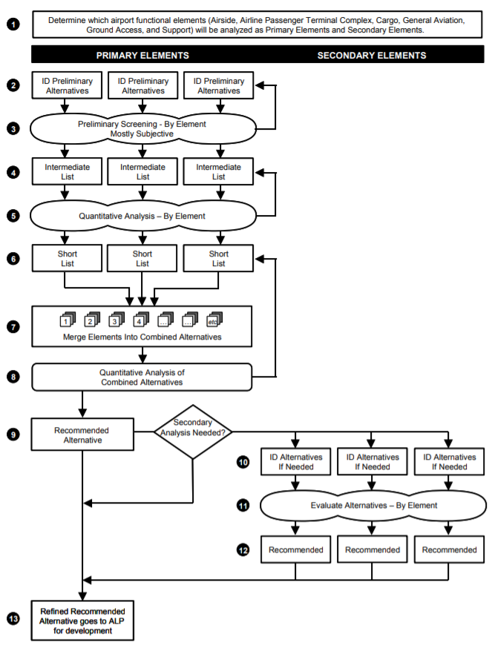
Figure F-1. Alternatives Analysis in FAA Master Planning Process (FAA, 2015)

Reference (Appendix F, FAA Master Planning Alternatives Analysis Process)

Federal Aviation Administration. (2015). Advisory Circular 150/5070-6B, Change 2 to Airport Master Plans. https://www.faa.gov/documentLibrary/media/Advisory_Circular/AC_150_5070-6B_with_chg_1&2.pdf.

G. AIRPORT STAKEHOLDERS

Select definitions were based on those provided in Chapter 4 of Guidance for Planning, Design, and Operations of Airport Communications Center (Kipp & Nessi, 2017).

Air Ambulance and Rescue Operators –Work closely with the airport and control tower to ensure access to the airspace and airport resources during emergencies that require the air ambulance or other aid related vehicle.

Air Cargo Operators and Passenger Airlines – Work with airport operations to ensure smooth cargo operations and efficient passenger service. Passenger service may include scheduled and unscheduled passenger service.

Aircraft Service Operators (e.g., catering, ground service, fueling) – Provide support for aircraft operators and operate on the ramp and access routes.

Aircraft Storage Operator –Works alongside airport operations or an FBO to provide storage to any aviation organization and work with airport development groups to plan for future growth.

Airfield Operations – Conduct inspections and maintenance of airfield for FAR Part 139 issues, advise and assist operations staff for response to airside issues/events, initiate maintenance work orders for airfield issues, issue Notices to Airmen (NOTAMs), and respond to irregular operations (IROPS) and emergencies.

Airline Dispatch – Coordinates between airline maintenance, flight crews, and schedulers, to determine and inform when planes will be active, stationary, or out of service.

Airline Ramp Control or Ramp Tower – Speaks with airlines and coordinate with other controllers the positions and intentions of every aircraft within their facility area.

Airport Board of Directors or Executive Group – Manages department heads, defines annual budgets, plans for future airport growth, votes on airport rules and capital purchases, and directs the overall path of the airport. The group meets periodically and is usually comprised of community individuals of high status.

Airport District Office (ADO) – Oversees airport certification through the FAA, ensures development is to standards and laws, and answers questions pertaining to airport compliance with Part 139.

Airport Engineering – Plans the airport growth, writes or assists with airport layout plan (ALP) and capital improvement plan (CIP), coordinates with contractors and employees to perform construction, and oversees the developments to ensure quality and compliance with appropriate standards.

Airport Manager/Director – Directs day-to-day aspects of the airport, manages department heads, makes major decisions that do not require board approval or vote, and sometimes works on airport documents such as the ALP, ASP, and CIP.

Airport Security - Monitors pedestrian and vehicle doors and gates including checkpoint alarms; assists with response to security issues and emergencies, and coordinates with TSA and the badging office.

ARFF Dispatchers - Dispatch ARFF and medical response, monitor responses, and coordinate resource requests when necessary.

Cargo Airlines – Provide scheduled or unscheduled cargo service at the airport; passenger airlines may also provide cargo service. Cargo airlines may be signatory airlines, in which case they play a larger role in airport financial decisions.

Commercial Service & Charter Airlines – Provide scheduled and unscheduled passenger service. Communicate with passengers and pilots directly, work with the airport to understand situations, receive support, and get resources. Commercial service operators may have more connections to the airport than a small charter airline. Airlines may be signatory, in which case they play a larger role in airport financial decisions.

Communications Dispatchers - Dispatch key airport personnel (e.g., police, fire, medical, operations, and maintenance), monitor security and dispatch a responder to alarms, monitor security closed-circuit TV (CCTV) cameras, handle call-taking/call triage, initiate maintenance request orders, and log daily activities logged.

Customs and Border Protection (CBP) - Works with the airport to ascertain information on travelers or aircraft movements or to request additional resources during emergencies at international airports.

Environmental Regulatory Authority – Closely watches the airport and communicates with airport operations or executives to ensure the airport meets environmental regulations.

Federal Aviation Administration (FAA) - Works with the airport to ensure compliance with federal aviation regulations and maintain a safe atmosphere. May also work with the airport during aircraft alerts/emergencies, and deal with issues affecting the movement of aircraft (e.g., a security breach in the terminal or delayed arrival or departure of aircraft). FAA includes ATC, Aviation Safety Inspectors, and Airport Safety regulated through the ADO for Part 139.

Federal Agencies – Include the National Transportation Safety Board (NTSB), the Federal Bureau of Investigation (FBI), and other agencies that become involved when the situation warrants.

Flight School – Coordinates with the airport regarding scheduling of flight training activities and works with airport planning to ensure operations do not negatively affect the airport.

General Aviation (GA) & Fixed-Based Operators (FBOs) – Communicate with the airport to seek local information or for assistance such as ground handling or disabled aircraft removal.
GA includes air taxi, corporate transportation and business aviation, as well as flight schools and emergency air ambulance services. FBOs provide services for GA activities, potentially including ramp space, hangar rentals, fuel services, and maintenance services.

Law Enforcement Officer (LEO) Dispatcher - Dispatches police, monitors patrols, and assists with resource requests when necessary.
Local Political Jurisdiction (aka local agency, such as a city or county) – Creates laws and ordinances that may benefit or harm the airport, and sometimes performs public relations tasks on behalf of the airport (when the local agency such as a city or county is the airport sponsor). Local agency also provides direction as to the role of the airport, and potentially provides a financial subsidy, especially in the case of GA airports.

Maintenance - Manages maintenance work order requests and monitors environmental factors, power systems, moving walkways/escalators/ elevators, baggage handling systems, and building maintenance systems.

Maintenance Trade Departments - Interacts with the airport concerning maintenance request status or when additional resources are needed.

Maintenance Repair and Overhaul (MRO) – MRO companies provide commercial aircraft maintenance and repair.

Mutual-Aid Responders (include police, fire, medical personnel) – Respond to airport incidents and emergencies when additional resources are requested. The airport provides communication among staging areas or radio channel assignments between field staff and mutual aid and may also track and log responders’ requests.

Neighborhood Association – Works with an environmental regulatory authority, the airport or other agencies to ensure negative impacts from the airports are minimized.

Operations Director – Coordinates airport operations and typically reports to the airport manager/director. The operations director also informs ATC of operational issues and coordinates during emergencies, works on airside development, and meets with stakeholders to receive input on operations areas.

Planning Office (state, regional, local) – Coordinates with airport executives to lay out planning ideas and concepts in the local area, region and/or state.

Ramp Operations Workers – May report to airlines or airport but ultimately work to serve airliners at a gate or a parking space. Workers may operate various types of ground service equipment (GSE).

Transportation Security Administration (TSA) - Monitors checkpoint alarms and door response, monitors security checkpoints and adjusts staffing as needed, and works with airport personnel during regular operations and emergencies.

Wildlife Agencies – Work with airport operations to determine proper mitigation procedures and make sure wildlife laws are followed. They may also ensure wildlife procedures are being performed correctly and in compliance with the airport wildlife management plan.

Reference (Appendix G)
Kipp, D., & Nessi, D. (2018). Guidance for Planning, Design, and Operations of Airport Communications Centers. Washington, District of Columbia: Airport Cooperative Research Program. https://www.nap.edu/read/24980/chapter/6.

H. RISK ASSESSMENT

Introduction

Any new technology or procedure introduced to airside activities brings with it potential risks. These risks need to be evaluated on their likelihood and severity to get a more complete idea of the possible impacts. The airport environment for General Aviation and Commercial Service airports can at times be distinctly different due to the variance in traffic and frequency of operations. Thus, it is important to evaluate hazards and risks in both environments when considering airside applications for AGVT. This risk assessment will evaluate these both, and also look at the means by which they could be mitigated or eliminated.

Safety Management System

In 2001, the International Civil Aviation Organization (ICAO) introduced Standards and Recommended Practices for Aerodrome Safety Management, and in November 2005, ICAO amended Annex 14, Volume I (Aerodrome Design and Operations) to require contracting states to establish a safety management system (SMS). According to FAA’s Notice of Proposed Rulemaking (NPRM), [the FAA] “supports conformity of U.S. aviation safety regulations with ICAO standards and recommended practices. The agency intends to meet the intent of the ICAO standard in a way that complements existing airport safety regulations in 14 CFR Part 139” (FAA, 2010, p. 1). SMS is now a core concept in the aviation industry recognized by both FAA and ICAO. This structured and business-like approach to managing and improving safety in all facets of the aviation industry has been described by the FAA in a series of Advisory Circulars. The applicable AC is Advisory Circular 150/5200-37 Introduction to Safety Management Systems (SMS) for Airport Operations (FAA, 2007) and the proposed draft revision (2016c). Per this AC, SMS includes four distinct components: Safety Polity, Safety Assurance, Safety Risk Management, and Safety Promotion (Figure H-1). Each component has an important role in SMS, and they come together to form a complete SMS program.

SMS for all part 139 airports was proposed in the Notice of Proposed Rule Making (NPRM) in October 2010, however, in 2016 the FAA issued a Supplemental Notice of Proposed Rulemaking (SNPRM) (FAA 2016d) which reduced the number of airports that needed an SMS to 265 airports that are certificated under Part 139; airports that must have an SMS program include the following:

• Classified as a small, medium, or large hub airport in the National Plan of Integrated Airport Systems;
• Identified by the U.S. Customs and Border Protection as a port of entry, designated international airport, landing rights airport, or user fee airport; or
• Identified as having more than 100,000 total annual operations.

This requirement maximizes safety benefits in the least burdensome manner and is consistent with international standards. Airports that are not required to have an SMS may still use FAA resources and implement selected practices to ensure safety at their airport. Implementing SMS in the General Aviation environment is strongly encouraged, but not required under any current regulations.

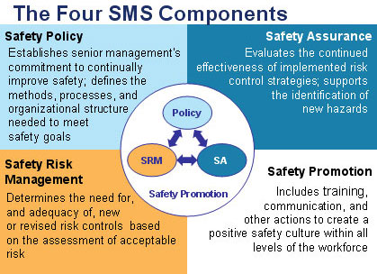
Figure H-1. The Four Safety Management System (SMS) Components (FAA, 2017)

Safety Risk Management

Safety Risk Management (SRM) is one of four distinct elements of Safety Management Systems (SMS). According to FAA AC 150/5200-37, “SRM is a systematic, explicit, and comprehensive approach for managing safety risk at all levels throughout the airport” (2007). SRM is divided into 5 major phases designed to build off of each other, guiding airport operators through a thorough risk assessment. These will be used as a guideline for assessing the risks that AGVT pose when used in the airport environment.
These five phases of SRM are:

1. Describe the system. The system description should include the functions, general physical characteristics and resources, and operations of the system, according to Safety Management Systems for Airports, Volume 2 (Ayres, 2009). The objective is to characterize and document the scale of the problem, and identify stakeholders. The system will look different for each airport.

2. Identify hazards. Hazard identification is the act of pinpointing any circumstance with the potential to cause injury to personnel, damage to equipment or structures, loss of material, or reduction of the ability to perform a task. Hazards are not to be confused with risk, which is the consequence of a hazard.

3. Determine risk. A risk is the “what could go wrong” scenario. Risks are consequences of hazards, meaning there must be an initial hazard that leads to the risk. A runway retaining water is a hazard, and an aircraft skidding off of the runway due to the water is a risk.

4. Assess and analyze risk. Risk assessment includes an assessment of the likelihood and severity of potential threats, as illustrated by the Risk Matrix shown in Figure H-2. The Risk Matrix gives a physical framework to illustrate the likeliness and severity of each risk.

5. Treat and monitor risk. The final phase of SRM looks at what can be done to mitigate the risks identified. This step is vital to having a complete and practical SMS. A follow-up risk assessment should be included to ensure no new hazards are created by the chosen mitigation technique.

The well-established framework for risk assessment using SRM will be used to analyze the risk associated with the potential implementation of automated ground vehicle technologies. The concepts presented in FAA resources such as AC 150/5200-37 Introduction to Safety Management Systems (SMS) for Airport Operations (FAA, 2007) are used in the development of the risk assessment. Other resources used include:

• Safety Management Systems for Airports, Volume 2 (2009).
• FAA Order 8000.369B - Safety Management System (2016b).
• NPIAS Airport Categories (2016a).

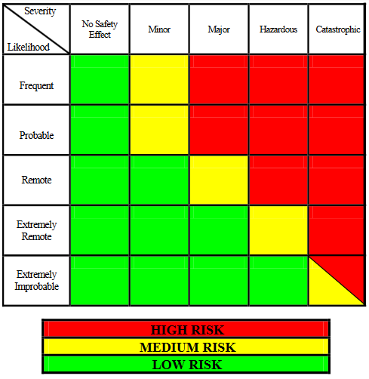
Figure H-2. Predictive Risk Matrix (FAA, 2007)

Considerations Regarding Airport Size

No two airports are alike, and the large differences in General Aviation and Commercial airports lend each to have their own unique Risk Assessment criteria. Advanced ground vehicle technologies will have similar hazards involved no matter where they are implemented, such as technological malfunctions and cyber-security attacks, but the risks associated with them differ depending on the size of the airport operation. An event that may be considered “major” at a GA airport could be “catastrophic” at a Commercial airport, due to larger operation at a commercial airport.

Two risk assessments will be analyzed, one for General Aviation airport operations and one for Primary commercial airport operations.

Levels of Automation

SAE International has developed a model for identifying the 5 levels of automation (NHTSA, 2018). This model is used throughout all transportation industries for determining current and future levels of automation. Not all applications for AVGT require full automation, and many can benefit from implementing small elements of automation. Hazards identified in this risk assessment will be divided into the SAE automation level that is most appropriate.

• At SAE Level 0, the human driver does everything;
• At SAE Level 1, advanced driver assistance system (ADAS) provides limited assistance with some functions (e.g., backup warning beep);
• At SAE Level 2, ADAS can conduct some parts of the driving task, while the human continues to monitor the driving environment and performs the rest of the driving task (e.g., cruise control);
• At SAE Level 3, vehicle automated driving system (ADS) can conduct some parts of the driving task and monitor the driving environment in some instances, but the human driver must be ready to take back control when the automated system requests;
• At SAE Level 4, ADS can conduct the driving task and monitor the driving environment, and the human need not take back control, but the automated system can operate only in certain environments and under certain conditions;
• At SAE Level 5, vehicle ADS can perform all driving tasks, under all conditions that a human driver could perform them.

Example Application for General Aviation Airport: White County Airport (KMCX)

1. Describe the System
According to the National Plan of Integrated Airport Systems (NPIAS), General Aviation airports are public-use airports that do not have scheduled commercial air service or have less than 2,500 annual passenger enplanements (FAA 2016a). The FAA reports that there are 2,952 GA airports in the U.S. that are included in the NPIAS and eligible for federal funding (FAA 2012). The airport activity at GA airports is less intensive than commercial airports, and their ramp operations are often handled by a single entity or Fixed-Base Operator (FBO). Most GA airports also do not have a control tower, as is the case with White County Airport in Monticello, Indiana, and must rely on the local emergency response in case of an accident on the airfield. Flight operations at this category of airport are handled entirely by the pilots of private aircraft, speaking to each other over radios.

Stakeholders of GA airports include local governments, hangar tenants, local businesses, the local community, emergency services, FBO operators, and airport management.

There are several uses for advanced ground vehicle technologies within the General Aviation environment, each with their own hazards and risks. The applications of AGVT in this environment are better suited for the daily operations of the airfield itself, rather than the interface with the commercial airlines or passengers. Staffing constraints at smaller GA airports also play a big role in the applications of AGVT, as tight budgets limit how many airport operations personnel are employed and to what extent new technology may be purchased and utilized.

2. Identify Hazards
The hazards that General Aviation airports could face when using AGVT include cyber-security attacks, human error, changes in the operating system, malfunctions in the technology, and power outages.
Operational hazards that are unique to general aviation airports include a less monitored airport environment (no control tower), lower levels of security and passenger screening, and an increased number of student pilots.

3. Determine risk
The risks associated with the previous hazards are outlined in the table below. These risks are identified with the level of automation that they most closely fit into, based on the five level model identified by SAE International (NHTSA, 2018).

Table H-1. Risks and Hazards in General Aviation Airport Environment
Hazard # | Hazards | Risk Scenarios | SAE Level of Automation
1 | Cybersecurity Attack | (a) Loss of control of automated vehicle(s) resulting in damage to aircraft  (b) Private information about airport tenants is stolen  (c) Gate on perimeter fence is opened | (a) L4-L5  (b) L3-L5  (c) L3
2 | Human Error | (a) Operator leading platoon of automated snowplows veers into taxiway lights  (b) Airport employees become too reliant on automated systems, forgetting how to do daily tasks. | (a) L3  (b) L3-L5
3 | Change in operating system | (a) AGVT is inoperative for extended period of time, bringing airport operations to a standstill  (b) Airport operating system is incompatible with one required for AGVT. | (a) L4-L5  (b) L1-L5
4 | Malfunction in Technology | (a) Obstacle warning alert on airport operations truck does not activate, driver backs into aircraft | (a) L1-L3
5 | Power Outage | (a) Autonomous snowplow communication system is inoperative, runway does not get plowed | (a) L4-L5

4. Assess and Analyze the Risk
The Risk Matrix in Figure H-3 has been designed to identify the likeliness and severity of each risk described in Table H-1 above. Likeliness ranges from frequent to extremely improbably, and severity ranges from catastrophic to having no safety effect. This table can be used to determine the greatest risks when implementing AGVT in the General Aviation airport environment.

Risk Matrix |  | Severity
 |  | No Safety Effect | Minor | Major | Hazardous | Catastrophic
Likelihood | Frequent
 | Probable
 | Remote |  |  | 1(a), 3(a) | 1(b)
 | Extremely Remote |  | 2(b), 3(b) | 2(a) | 4(a) | 5(a)
 | Extremely Improbable |  | 1(c)
Figure H-3. General Aviation Risk Matrix

5. Treat and Monitor Risk
This risk assessment tells us that the most likely and severe hazard at the airport is a power outage leading to an autonomous snowplow communication system becoming inoperative, resulting in the runway not being plowed. This risk could be mitigated by assuring there is a backup system in place for the snowplows, where they could be easily switched to manual operation without a communication system.
Risk is easier to manage at a small general aviation airport, as the impact on operations is often much smaller than at a commercial airport.

All risk scenarios can be mitigated with the proper forethought and preventative action. The recommended mitigation techniques for each risk are outlined in Table H-2 below.

Table H-2. Mitigation Techniques for Risks at General Aviation Airports
Hazards | Risk Scenarios | Risk Mitigation Technique
Cybersecurity Attack | (a) Loss of control of automated vehicle(s) resulting in damage to aircraft  (b) Private information about airport tenants is stolen  (c) Gate on perimeter fence is opened | (a) Failsafe backup where vehicle and be remotely shut off  (b) Cybersecurity specialist creates secure network  (c) System alerts airport operations that a gate has been opened
Human Error | (a) Operator leading platoon of automated snowplows veers into taxiway lights  (b) Airport employees become too reliant on automated systems, forgetting how to do daily tasks. | (a) Intensive training of snowplow operators  (b) Recurrent training or regular shifts without automation
Change in operating system | (a) AGVT is inoperative for extended period of time, bringing airport operations to a standstill  (b) Airport operating system is incompatible with one required for AGVT. | (a) Option to return any automated vehicle to manual mode if needed  (b) Thorough research into required operating system prior to implementation
Malfunction in Technology | (a) Obstacle warning alert on airport operations truck does not activate, driver backs into aircraft | (a) Automation awareness training to teach airport employees how they should be redundant in their operations
Power Outage | (a) Autonomous snowplow communication system is inoperative, runway does not get plowed | (a) Manual snowplow option available at all times

Example Application for Primary Commercial Service Airport: Blue Grass Airport (KLEX)

1. Describe the System
The FAA describes Primary Airports as commercial service airports that have more than 10,000 passenger boardings per year (FAA, 2016a). Primary commercial airports have their own unique hazards and risks that General Aviation airports do not have. The airport operations are generally busier, faster, and more high-risk, as major airlines fly thousands of passengers in and out throughout the day and must stay on schedule. The ramp area is typically more congested as well, with baggage carts and aircraft servicing vehicles rushing to get the plane ready for the next departure. AGVT has more applications in this environment, and the risks involved with those must be considered. Blue Grass Airport in Lexington, Kentucky was kept in mind while assessing possible hazards and associated risks for AVGT in the Primary airport environment, as it is a small hub primary airport and likely an ideal location to begin implementing AGVT.

Operations at Blue Grass Airport are executed by the Airport Operations department, with assistance from airline station managers, fixed-based operator personnel, and Air Traffic Control. In 2017 Blue Grass Airport served a total of 637,301 passengers (enplanements) (ACAIS, 2018).
Stakeholders for a Primary Airport include local government, airlines, passengers, hangar tenants, concessions, ground-handling companies, Air Traffic Control, TSA, emergency response personnel, and airport management.

2. Identify Hazards
The hazards that Commercial airports could face when using AGVT include cyber-security attacks, human error, changes in the operating system, malfunctions in the technology, and power outages.

3. Determine risk
The risks associated with the previous hazards are outlined in Table H-3. These risks are identified with the level of automation that they most closely fit into, based on the five level model identified by SAE International (NHTSA, 2018).

Table H-3. Risks and Hazards that Could Be Found in a Commercial Airport Environment
Hazard # | Description of Hazard | Risk Scenarios | SAE Level of Automation
1 | Cybersecurity Attack | (a) Loss of control of automated vehicle, causing a collision with an aircraft  (b) Data breach leading to leak of security weak points  (c) FIDS system hijacked | (a) L4-L5  (b) L1-L5  (c) L3
2 | Human Error | (a) Operator leading platoon of automated snowplows veers one into taxiway lights  (b) Airport employees become too reliant on automated systems, forgetting how to do daily tasks | (a) L3  (b) L3-L5
3 | Change in operating system | (a) AGVT is inoperative for extended period of time due to needed software upgrade  (b) New airport operating systems may be incompatible with ones required for AGVT.  (c) All previously recorded operational data is erased.  (d) AGVT is unable to adapt to emergency or unexpected situation that arises | (a) L4-L5  (b) L2-L5  (c) L3-L5  (d) L4-L5
4 | Malfunction in System | (a) Autonomous bus strands passengers between terminal and parking facility  (b) Automated jet bridge collides with side of aircraft  (c) Artificial Intelligence makes an immoral or unethical decision in the face of an airport emergency. Example: automated emergency response vehicle hits pedestrian while attempting to reach accident site  (d) Automated vehicle unintentionally drives into movement area  (e) Automated mower clearing grass hits runway edge light | (a) L4-L5  (b) L3-L5  (c) L4-L5  (d) L4-L5  (e) L4-L5
5 | Power Outage | (a) Major operating system become inoperative, causing ground delays for all air carriers as baggage carts must be returned to manual mode and staffed  (b) Loss of access control leading to a breach of the sterile area | (a) L4-L5  (b) L3-L5

4. Assess and Analyze the Risk
The Risk Matrix (Figure H-4) has been designed to identify the likeliness and severity of each risk described in Table H-3 above. Likeliness ranges from frequent to extremely improbably, and severity ranges from catastrophic to having no safety effect. This table can be used to determine the greatest risks when implementing AGVT in the Commercial airport environment.

Risk Matrix |  | Severity
 |  | No Safety Effect | Minor | Major | Hazardous | Catastrophic
Likelihood | Frequent
 | Probable |  | 4(e) | 4(b)
 | Remote | 1(c) | 2(a), 3(b) | 1(a), 3(a), 5(a) | 1(b), 3(d), 5(b)
 | Extremely Remote |  | 2(b), 3(c), 4(a) |  | 4(c)
 | Extremely Improbable
Figure H-4. Commercial Airport Risk Matrix

5. Treat and Monitor Risk
A risk assessment of hazards in a commercial airport environment shows us that the most likely and severe risk is that of a data breach leading to the leak of security weak points. This could be catastrophic for a large airport, as airport security is vital in deterring terrorists. Anything connected to the internet is hackable, and airports are especially vulnerable to cybersecurity attacks due to the necessary interconnectivity of their systems (Kohli, D., 2018). Airports are already recognizing this weakness, and are actively working to combat it. For example, Munich Airport has created a center called the Information Security Hub (ISH) which has the purpose of protecting the airport and airlines from cyber-crime. The center houses a team of IT specialists who will work with European aviation industry experts to develop strategies for defending against cyber-attacks (Airport World, 2018a). Initiatives like this will help airports move into the connected world of AGVT without fear of being hacked.

Table H-4. Mitigation Techniques for Risks at Primary Commercial Airports
Hazards | Risk Scenarios | Risk Mitigation Technique
Cybersecurity Attack | (a) Loss of control of automated vehicle, causing a collision with an aircraft  (b) Data breach leading to leak of security weak points  (c) FIDS system hijacked | (a) Failsafe backup where vehicle and be remotely shut off  (b) Cybersecurity specialist creates secure network  (c) Redundant systems to protect FIDS
Human Error | (a) Operator leading platoon of automated snowplows veers one into taxiway lights  (b) Airport employees become too reliant on automated systems, forgetting how to do daily tasks | (a) Intensive training of snowplow operators  (b) Recurrent training or regular shifts without automation
Change in operating system | (a) AGVT is inoperative for extended period of time due to needed software upgrade  (b) New airport operating systems may be incompatible with ones required for AGVT.  (c) All previously recorded operational data is erased.  (d) AGVT is unable to adapt to emergency or unexpected situation that arises | (a) Option to return any automated vehicle to manual mode if needed  (b) Thorough research into required operating system prior to implementation  (c) Hard copies or remote backups kept for all historic data  (d) Do not place AGVT into roles that could become dangerous in changing conditions
Malfunction in Technology | (a) Autonomous bus strands passengers between terminal and parking facility  (b) Automated jet bridge collides with side of aircraft  (c) Artificial Intelligence makes an immoral or unethical decision in the face of an airport emergency. Example: automated emergency response vehicle hits pedestrian while attempting to reach accident site  (d) Automated vehicle unintentionally drives into movement area | (a) Strong maintenance program ready to deploy personnel to fix bus  (b) Employee monitoring jet bridge operation at all times  (c) Ethics program with predetermined decisions in difficult situations  (d) System for “locking out” the vehicle from entering certain areas  (e) Use manual mower for area closest to runway edge lights

Table H-4. Mitigation Techniques for Risks at Primary Commercial Airports (Continued)
Hazards | Risk Scenarios | Risk Mitigation Technique
Malfunction in Technology (continued) | (e) Automated mower clearing grass hits runway edge light | (e) Use manual mower for area closest to runway edge lights
Power Outage | (a) Major operating system become inoperative, causing ground delays for all air carriers as baggage carts must be returned to manual mode and staffed  (b) Loss of access control leading to a breach of the sterile area | (a) Employees on hand at all times with quick access to manual mode controls  (b) Alert that goes off when access control has been compromised

Bowtie Analysis Methodology

Bowtie analysis and bowtie diagrams can be used to analyze and communicate risk. The bowtie method is compatible with the risk assessment used in SMS, however, the terminology is slightly different. The bowtie diagram is composed of a hazard, top event, threats and consequences, and barriers. The diagram is shaped like a bow-tie, creating a clear differentiation between proactive and reactive risk management (CGE Academy, 2018). One benefit of using this methodology is that it provides a risk overview of multiple plausible scenarios, in a single snapshot. Another benefit of the bowtie analysis is that it can provide a framework for safety monitoring, with counts and record keeping for each prevention and recovery barrier. In this way, the bowtie can be used to monitor that identified hazards are managed to an acceptable level (ALARP) (CGE Academy, 2018)

The first application of the bowtie methodology dates back to the late eighties or early nineties after an investigation of the Piper Alpha platform explosion in 1988 that killed 168 people. In the early nineties, the bowtie method was adopted by the Royal Dutch Shell Group as a standard to analyze, manage and communicate risks. The bowtie method helps ensure the appropriate risk controls are consistently in place throughout operations (CGE Academy, 2018). The bowtie methodology can be used to reflect three concepts: fault tree analysis, event tree analysis, and causal factors charting.

Bowtie analysis is a tool that can be used to address all five phases of the Safety Risk Management (SRM). A general bowtie diagram is shown in Figure H-5.

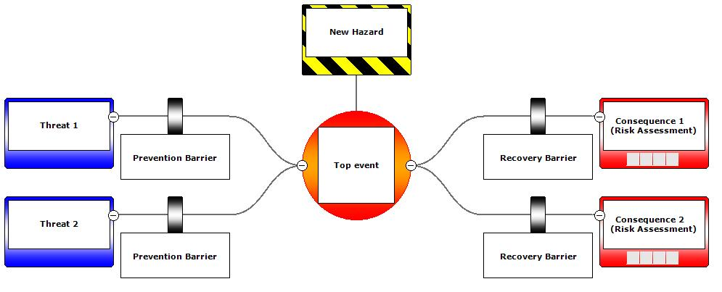
Figure H-5. General Bowtie Diagram

The five SRM phases were described previously in this appendix. Below are descriptions of the terms used in Figure H-5. Although the terms used in bowtie analysis may vary slightly from the terminology used in SMS and SRA (e.g., the term “Top Event” is used in bowtie analysis but not in SMS or SRA), the concepts are similar (MAAR, 2017).

1. Hazard: Describes the desired state or activity that is part of normal operations. Defines the context and scope of the bowtie diagram.
2. Top event: Is a deviation from the desired state or activity which happens before major damage has occurred with the possibility to recover.
3. Threat: Actions that could lead directly to the top event.
4. Threat control and prevention (proactive risk management): Eliminates the Threat or prevents the Top Event.
5. Recovery barriers (reactive risk management): Avoids or mitigates the Consequence(s).
6. Consequences: Are the hazardous outcomes arising from the Top Event. In parenthesis is the risk assessment value of each consequence, taking into account the pro and re-active barriers put in place.

Figures H-6 through H-14 provide bowtie diagrams of the AGVT that may be appropriate for implementation. It is challenging to conduct SRM for AGVT since there is no data regarding equipment failure in the airside environment. Data collected from airside deployment of AGVT can be used to support future SRM.

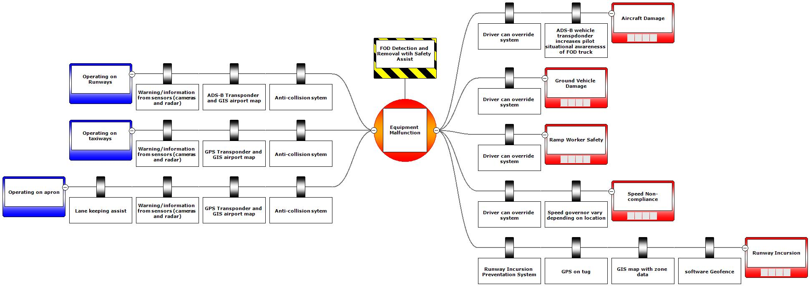
Figure H-6. Risk Assessment: FOD Detection and Removal with Safety Assist

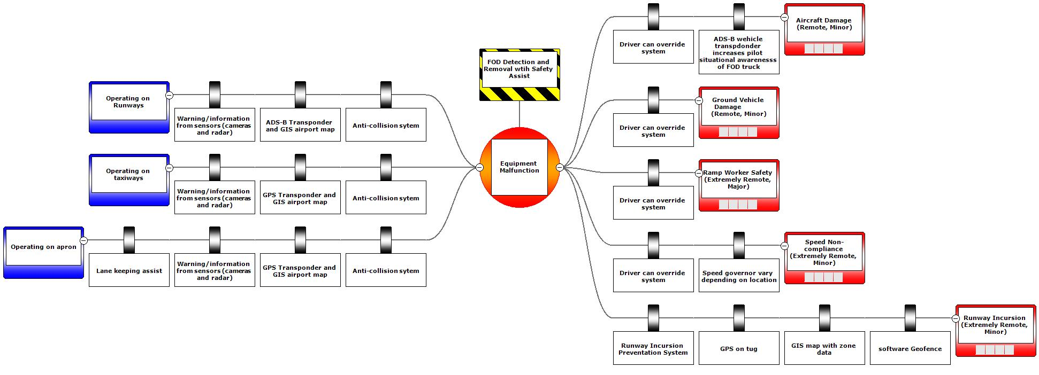
Figure H-7. Risk Assessment: FOD Detection and Removal, Automated with Safety Driver

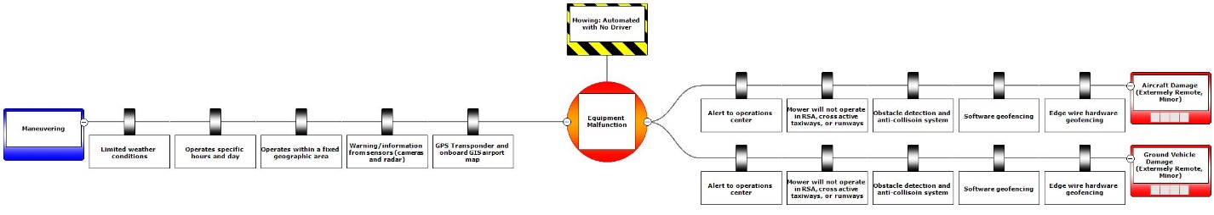
Figure H-8. Risk Assessment: Mowing Automated with No Safety Driver

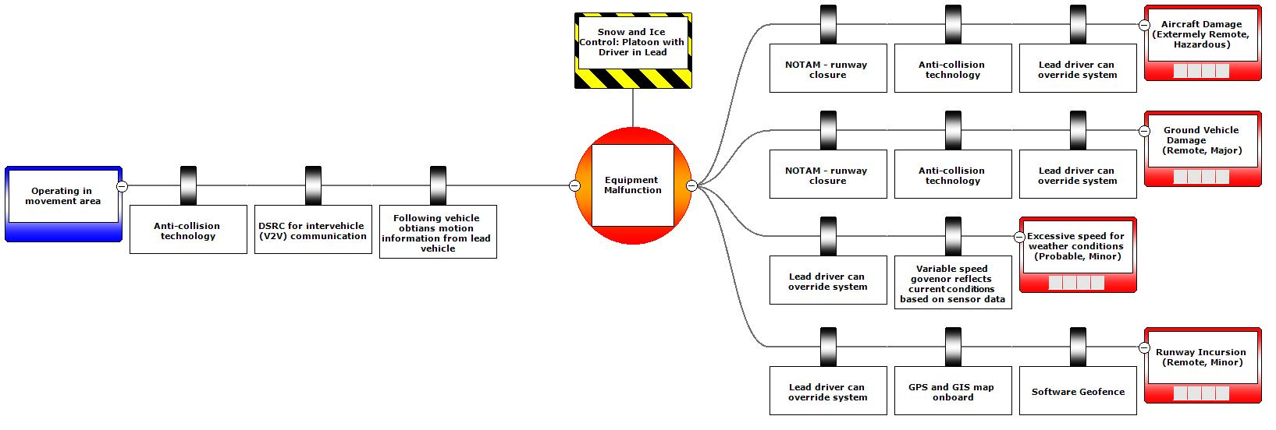
Figure H-9. Risk Assessment: Snow and Ice Control, Platoon with Driver in Lead

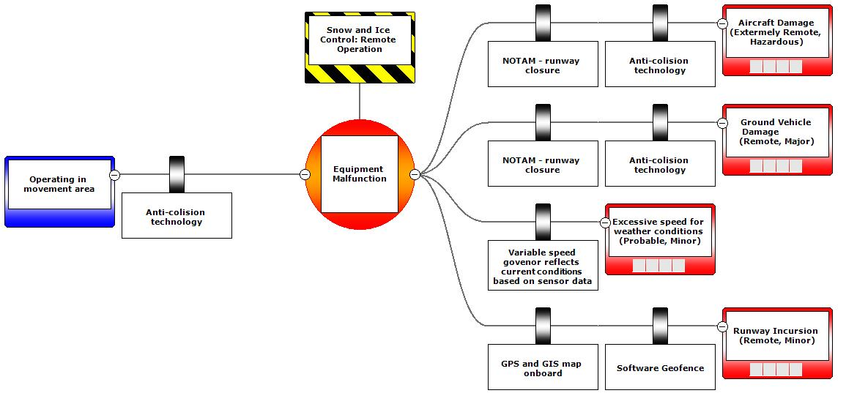
Figure H-10. Risk Assessment: Snow and Ice Control, Remote

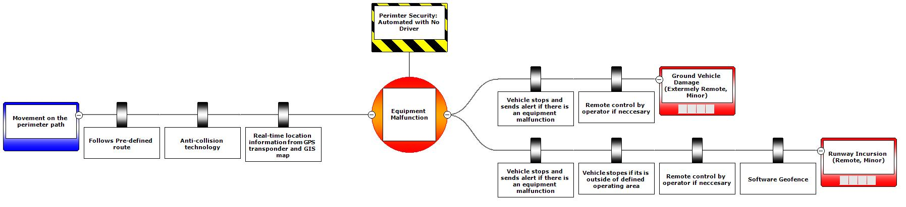

Figure H-11. Risk Assessment: Perimeter Security, Automated No Driver

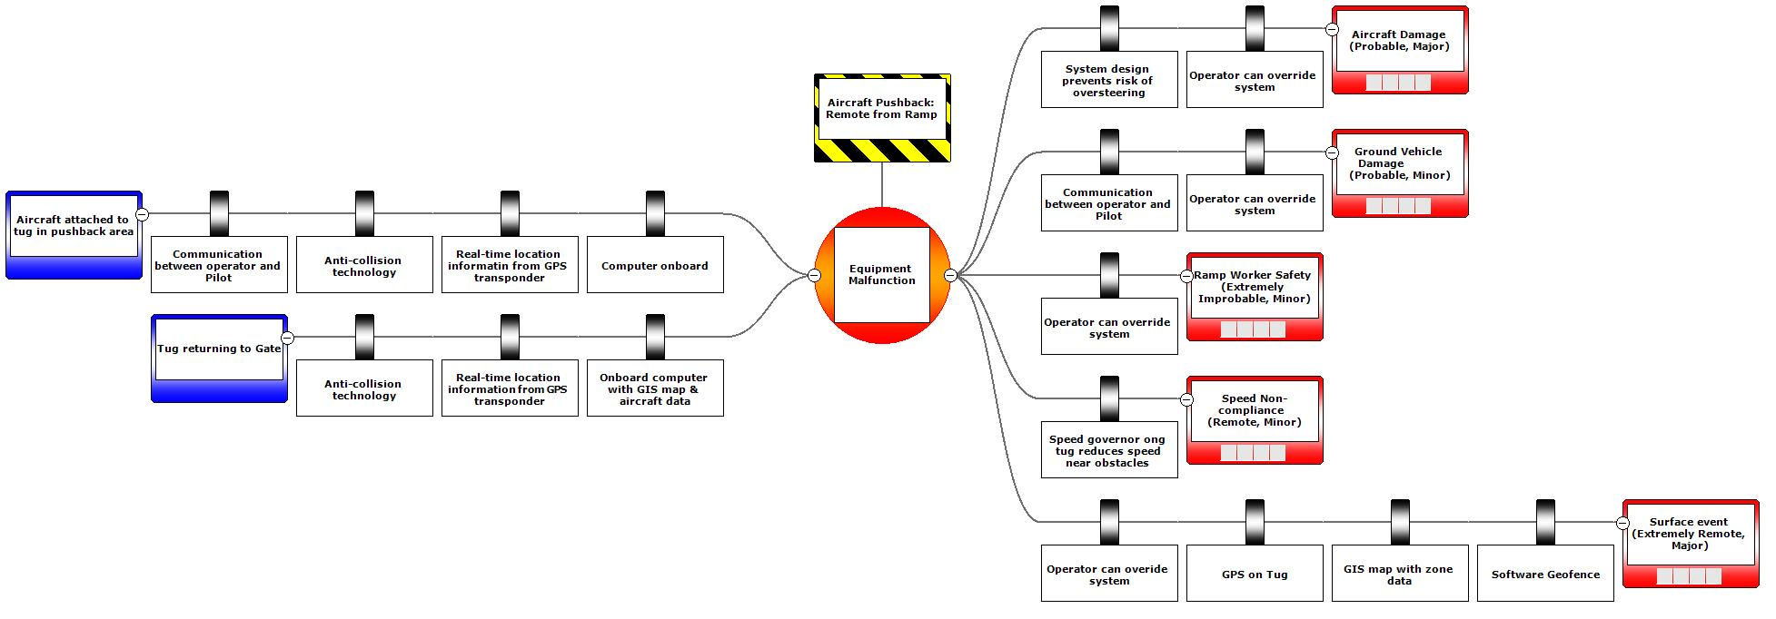
Figure H-12. Risk Assessment: Aircraft Pushback Remote from Ramp

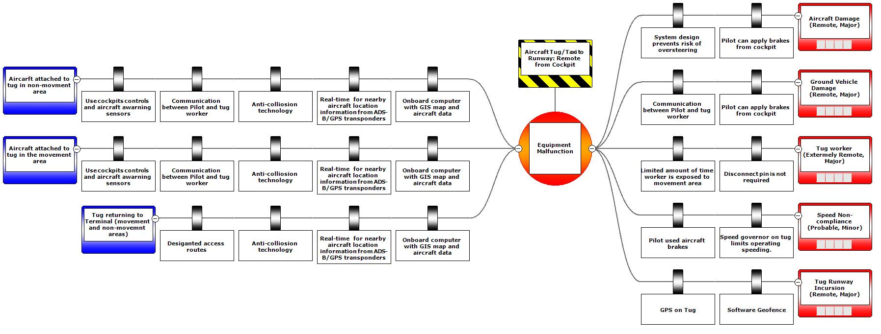
Figure H-13. Risk Assessment: Aircraft Tug to Runway Remote from Cockpit

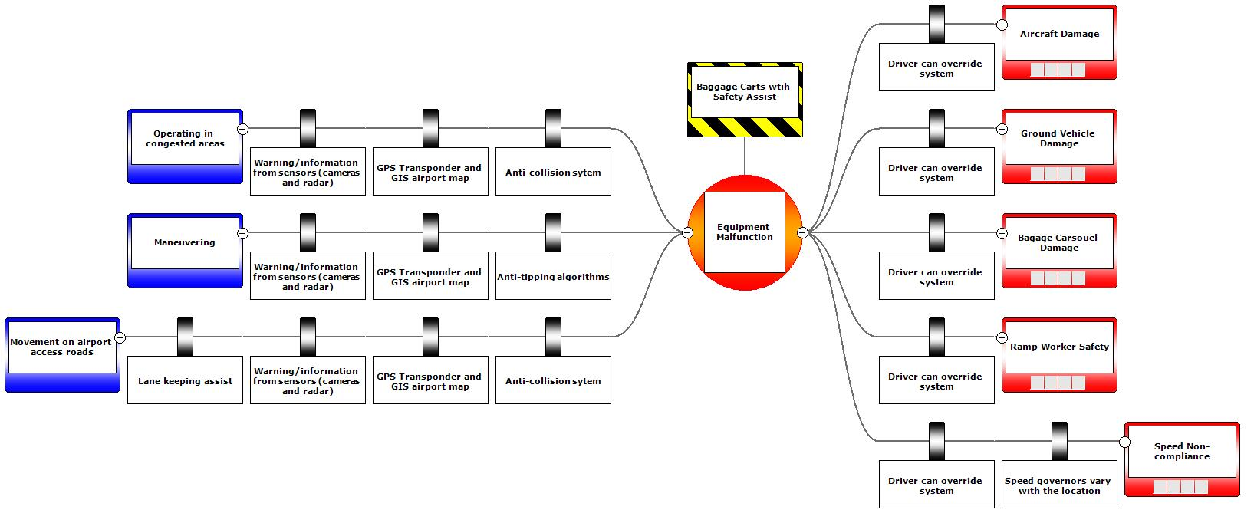
Figure H-14. Risk Assessment, Baggage Carts with Safety Assist

References (Appendix H, Risk Assessment)

ACAIS. (2018, October 2). Commercial Service Airports (Rank Order) Based on Calendar Year 2017 Enplanements. https://www.faa.gov/airports/planning_capacity/passenger_allcargo_stats/passenger/media/cy17-commercial-service-enplanements.pdf.
Airport World. (2018, January 31). Munich Airport Unveils New Centre To Fight Cyber Crime. http://www.airport-world.com/news/general-news/6531-munich-airport-unveils-new-centre-to-fight-cyber-crime.html.
Ayres, M., Jr., Shirazi, H., Cardoso, S., Brown, J., Speir, R., Selezneva. (2009). Safety Management Systems for Airports. Guidebook, 2, 1-167. https://www.nap.edu/read/14316/chapter/1.
CGE Academy. (2018). CGE Risk Management Solutions. https://www.cgerisk.com/knowledgebase/Main_Page
Federal Aviation Administration. (2007). Introduction to Safety Management Systems for Airport Operators. https://www.faa.gov/documentLibrary/media/advisory_circular/150-5200-37/150_5200_37.pdf.
Federal Aviation Administration. (2010, October 7). Safety Management Systems for Certificated Airports: A Proposed Rule by the Federal Aviation Administration. https://www.faa.gov/documentLibrary/media/advisory_circular/150-5200-37/150_5200_37.pdf.
Federal Aviation Administration. (2012, May). General Aviation Airports: A National Asset. https://www.faa.gov/airports/planning_capacity/ga_study/media/2012AssetReport.pdf.
Federal Aviation Administration. (2016a, March 3). Airport Categories. https://www.faa.gov/airports/planning_capacity/passenger_allcargo_stats/categories/.
Federal Aviation Administration. (2016b, March 18). FAA Order 8000.369B - Safety Management System. https://www.faa.gov/documentLibrary/media/Order/FAA_Order_8000.369B.pdf.
FAA. (2016c, June 21). Draft Advisory Circular 150/520-37A Draft. Safety Management Systems for Airports. https://www.faa.gov/documentLibrary/media/Advisory_Circular/draft-150-5200-37a.pdf
Federal Aviation Administration. (2016d, July 14). Safety Management System for Certificated Airports. Supplemental notice of proposed rulemaking (SNPRM) https://www.federalregister.gov/d/2016-16596.
Federal Aviation Administration. (2017, September 11). Safety Management System Components. https://www.faa.gov/about/initiatives/sms/explained/components.
Kohli, D. (2018, January 28). Expert View: Five reasons why airlines and airports face a big risk of cyberattacks and what can be done about them. http://www.transportsecurityworld.com/five-reasons-why-airlines-airports-big-risk-cyberattacks.
Monitoring Agency for Asia Region (MAAR). (2017, July 7). Safety Barriers for LHD (Large height deviation) with Bowtie Methodology. https://www.icao.int/APAC/Meetings/2017%20RASMAG22/Safety%20Barriers%20for%20LHD%20with%20Bowtie%20Methodology%20(MAAR).pdf
National Highway Traffic Safety Administration (NHTSA). (2018, April 13). Automated Vehicles for Safety. https://www.nhtsa.gov/technology-innovation/automated-vehicles-safety.

I. RELATIONSHIP BETWEEN EVALUATION CRITERIA, ASSESSMENT AREAS, AND SUPPORTING PRINCIPLES AND EXAMPLES
HF | Stk Acc | E of Adopt | Ben | Op I | Tech Feas | Infr I |  | Assessment Area  Supporting Principles and Examples
x |  |  |  |  |  |  | 1 | Reflects ergonomic principles and accommodates physical attributes of users (Anthropometrics and Biomechanics)
x | x | x |  |  |  |  | 2 | Good Computer-Human Interaction (CHI) supports Ease of use (dialogues, interfaces and procedures across functions)
x |  |  |  |  |  |  |  | Displays and Controls design and arrangement is consistent with tasks and actions
x |  |  |  |  |  |  |  | Information Presentation uses consistent labels, symbols, colors, terms, formats and data fields
x |  |  |  |  |  |  |  | Information Requirements are met (needed info is available and useable)
x |  |  |  |  |  |  |  | Input / Output (I/O) Devices allow critical tasks to be performed quickly and accurately)
x |  |  |  |  |  |  |  | Visual/Auditory Alerts enhance safety
X |  |  |  | x |  |  | 3 | Functional Design is Compatible with Operations and Maintenance requirements
X |  |  |  |  |  |  | 4 | Compatible with Existing or Proposed Procedures (operating and maintenance procedures are simple, consistent and easy to use)
X |  |  |  |  |  |  |  | Appropriate Documentation can be provided in suitable format
X | X | X |  | x |  |  | 5 | Appropriate Allocation of Function allows technology to perform appropriate tasks while removing burdensome tasks from people and ensuring humans can maintain situational awareness
X |  |  |  | x |  |  | 6 | Provides needed Communications and supports Teamwork
X |  |  |  |  |  |  |  | Communication with ATC, Ramp Control, Airport Operations and Ramp workers, as needed including the ability to signal intent with people
x | X | X |  |  |  |  | 7 | Compatible with Existing Culture and supports positive culture (addresses organizational and sociological environment in which change will occur)
 |  |  | x |  |  |  | 8 | Supports institutional goals
 |  | X |  |  | x |  | 9 | Considers previous organizational experience with technology or other related initiatives

HF | Stk Acc | E of Adopt | Ben | Op I | Tech Feas | Infr I |  | Assessment Area  Supporting Principles and Examples
 | X | X |  |  |  |  | 10 | Compatible with existing workforce constraints and considerations (e.g., union rules)
X |  |  |  | x |  |  | 11 | Compatible with Environment including extremes and reflects impact of environment on human-system performance; ideally reduces need for humans to perform in harsh environment
X | x | x | x | x |  |  | 12 | Operational suitability ensures system supports user to perform job and system provides interoperability and consistency with other system elements
X | x | x |  |  |  |  |  | Compatibility with Airside Practices and Procedures (including stakeholder intent to use)
x | x | x | X |  |  |  | 13 | Increase safety and reduce human exposure to health and safety hazards
x |  |  | X |  |  |  |  | Reduce worker fatigue
 |  |  | X |  |  |  |  | Reduce worker exposure to hazards
 |  |  | X |  |  |  |  | Reduce worker injuries (severity and incidence) and fatalities
 |  |  | X |  |  |  |  | Reduce runway incursions
X |  |  | x | x |  |  | 14 | Enhance situational awareness including operator and airport situational awareness
X |  |  | x | x |  |  |  | Improve airport situational monitoring through provision of metrics or real-time data
X | x | x | X |  |  |  | 15 | Compatible with staffing needs and requirements
X | x | x |  |  |  |  |  | Compatible User Training needed for success including knowledge and skills to interface with system and design to support learning and retention
X | x | x |  |  |  |  |  | Considers needs for New Knowledge, Skills, and Abilities (KSA) to perform tasks as well as selection requirements for users (existing or new personnel or contractors)
X | x | x |  |  |  |  |  | Considers the need for Special Skills and Tools
X | x | x |  |  |  |  | 16 | Project requirements are compatible with workforce rules
X |  |  |  |  |  |  | 17 | Supports work space requirements; adequate work space for personnel, equipment and tools, and movements under normal, adverse and emergency conditions

HF | Stk Acc | E of Adopt | Ben | Op I | Tech Feas | Infr I |  | Assessment Area  Supporting Principles and Examples
X |  |  |  |  |  |  | 18 | Compatible with Workload requirements; including physical, cognitive and decision-making resources
X |  |  |  |  |  |  |  | Considers operator, other ramp personnel, ATC, MGMT and airport and other stakeholders
 |  | x |  |  | X |  | 19 | Overall estimated Technical Readiness Level (TRL) is compatible with candidate project
 |  | x |  |  | X |  | 20 | Software readiness level is compatible with proposed application
 |  | x |  |  | X |  | 21 | Hardware readiness level is compatible with proposed application
 |  | x |  |  | X |  | 22 | Integration readiness level is compatible with proposed application
 |  | x |  |  | X |  | 23 | System readiness level is compatible with proposed application
 | x | x |  |  | X |  | 24 | Confidence in key information is compatible with proposed application
 | x | x |  |  | X |  | 25 | Quality and reliability of available data is compatible with proposed application
x |  |  |  |  | X |  | 26 | Process to be automated is repetitive and predictable (consider allocation of function)
 |  |  |  | x | X |  | 27 | Operation in isolated environment (not subject to unpredictable crossing traffic)
 |  |  | X | x |  |  | 28 | Provides useful data to enhance current or future operations
 |  |  | X | x |  |  |  | Project will result in data or information to support future deployment
 |  |  | X | x |  |  |  | Improve airport situational monitoring through provision of metrics or real-time data
 |  |  | X | x |  |  | 29 | Provides increased oversight or better documentation of activities and events
 | x | x |  |  | X |  | 30 | Provides system redundancy in the event of technology failure or unexpected operating conditions
 |  |  |  |  |  |  |  | Human or technical backup can take over if needed
 | X | X |  |  | X |  |  | Technology is reliable and trusted by users
 |  |  |  |  | X |  | 31 | Technology response in emergency is adequate and appropriate

HF | Stk Acc | E of Adopt | Ben | Op I | Tech Feas | Infr I |  | Assessment Area  Supporting Principles and Examples
 |  | x |  |  |  | X | 32 | Requirements for automation to integrate with existing infrastructure systems (e.g., ATC, ground control, ASDE-X or other airport infrastructure) provide benefits that offset costs
 |  |  |  |  |  | X |  | Requirements for new central control infrastructure provide benefits that offset costs
 |  |  |  |  |  | X |  | Requirements for new infrastructure on the airfield or ramp are safe and provide benefits that offset costs
 |  |  | x | X |  | x | 33 | Allows current infrastructure to operate at higher capacity (more demand) without new construction
 |  | x |  |  |  | X | 34 | Project is compatible with future infrastructure plans and needs
 | X | X | X |  |  |  | 35 | Project provides expected cost savings (positive B/C, benefits outweigh cost)
 | X | X | X |  |  |  |  | Benefits accrue to entities that incur a cost (in $ or inconvenience)
 | x | x | X |  |  |  |  | Reduces aircraft damage and property damage (incidence and severity)
 | x | x | X |  |  |  |  | Reduce personnel costs (including overtime)
 | x | x | X |  |  |  | 36 | Increases security or efficiency of security (e.g., fewer breaches or false alarms)
 | x | x | x | X |  |  | 37 | Increases efficiency
 |  |  | x | X |  |  |  | Improves equipment utilization
 |  |  | x | X |  |  |  | Improves efficiency of operations by reducing reliance on human capital
 |  |  | x | X |  |  |  | Improves efficiency of operations by providing reliable time for task completion
 |  |  | x | X |  |  |  | Reduce aircraft delay at airport
 |  |  |  |  |  |  |  | Reduce aircraft delay in system
 |  | x | X | x |  |  | 38 | Reduces emissions or other environmental benefits
 | X | X |  |  |  |  | 39 | Considers funding and financial implications
 | X | X | x |  |  |  |  | Considers capital costs and eligibility of potential funding sources
 | X | X | x |  |  |  |  | Operating costs can be recovered with appropriate revenue stream
 | X | X |  | x |  |  | 40 | Considers needs for regulatory compliance and approval of operations (including airport certification, etc.)
 | x |  |  |  |  |  |  | FAA, TSA, OSHA, CPB, etc.

HF | Stk Acc | E of Adopt | Ben | Op I | Tech Feas | Infr I |  | Assessment Area  Supporting Principles and Examples
 | X |  |  |  |  |  | 41 | Technology can be implemented incrementally
 | X |  |  |  |  |  |  | Viable interim phases vs. “all-or-nothing”
 |  | x |  |  | X |  | 42 | Technology Adaptability, candidate technology can successfully be adapted to airside use
 |  | x |  |  | X |  |  | System adaptability, including procedure changes and training requirements
 |  | x |  | x | X |  |  | Need for additional equipment to manage AV in proximity of aircraft
 |  | x |  |  | X |  |  | Need for additional procedures for compliance with ATC and other airside protocol
 |  | x |  |  | X |  |  | Need for additional resources due to airside environment
 |  | x |  |  | X |  | 43 | Technology risks including security and cybersecurity have been identified and successfully mitigated
 |  | x |  |  | X |  | 44 | Technology sustainability is adequate and commensurate with investment, includes the expected life of technology before replacement, assessment of the long term benefits and the needed support for the technology
x | x | x |  | x | x | X | 45 | Minimal changes to the airport infrastructure are required

Key:
X Recommended for inclusion with this evaluation criteria
x Could also or alternately be included with this evaluation criteria

J. BENEFIT COST ANALYSIS

Assessment of the Business Case for AGVT for Airside Operations

The mission of the Federal Aviation Administration (FAA) is to provide the safest, most efficient aerospace system in the world (FAA, 2017). The vision for International Civil Aviation Organization (ICAO) is to achieve sustainable growth in civil aviation (ICAO, n.d.). Our nation’s airports must meet both of these challenges. Developing a safe, efficient, and sustainable airport operations environment is one of the top priorities of airports and airlines throughout the United States. Reaching this goal requires innovation, forward thinking, and a willingness to try solutions that have not been attempted in the past.
According to the FAA’s FY2018-2038 Aerospace Forecast (FAA, 2018b), domestic mainline enplanements are forecast to increase 3.4% per year, and international enplanements are forecast to grow 3.3% through the forecast horizon. As the aviation industry continues to expand, airports must find innovative ways to meet the growing demand, and improve operations without sacrificing safety. The integration of advanced ground vehicle technologies (AGVT) into airside operations may be one way that airports can successfully innovate and the utilization of AGVT may increase safety for existing operations, and/or provide a mechanism to serve the increased volume of traffic expected in the future.

Automation and advanced vehicle technologies have a much higher profile in other transportation sectors, such as roadways and port operations. Automated vehicle technology is often cited as a safety solution in the roadway sector since approximately 94% of roadway crashes are attributed to human error (NHTSA, 2015). The potential to increase safety, save lives, and reduce the cost of crashes is a strong incentive for automated vehicle technologies. Most of the media attention is on “self-driving” cars, although this terminology and vocabulary can be misleading. SAE International has developed a model for identifying the 5 levels of automation (NHTSA, 2018). This model is used throughout all transportation industries for determining current and future levels of automation.

• At SAE Level 0, the human driver does everything;
• At SAE Level 1, advanced driver assistance system (ADAS) provides limited assistance with some functions (e.g., backup warning beep);
• At SAE Level 2, ADAS can conduct some parts of the driving task, while the human continues to monitor the driving environment and performs the rest of the driving task (e.g., cruise control);
• At SAE Level 3, vehicle automated driving system (ADS) can conduct some parts of the driving task and monitor the driving environment in some instances, but the human driver must be ready to take back control when the automated system requests;
• At SAE Level 4, ADS can conduct the driving task and monitor the driving environment, and the human need not take back control, but the automated system can operate only in certain environments and under certain conditions;
• At SAE Level 5, vehicle ADS can perform all driving tasks, under all conditions that a human driver could perform them.

Auto manufacturers and the popular press can further confuse the issue with respect to inconsistent terminology. For example, Tesla uses the term “autopilot” for its Level 2 system (Hughes, 2017) although marketing material and media coverage (and even the term autopilot) may imply a higher level of automation.

As advanced ground vehicle technologies (AGTV) advance in the roadway sector, it is reasonable to investigate whether there may be similar potential gains in terms of safety for airside operations at airports. The potential benefits of automated vehicle technologies to reduce human error for airside operations could be significant since, according to the FAA, “the majority of ramp accidents and incidents involve some type of human error or violation of company policies, processes and procedures.” (Pierobon, M. 2014). Furthermore, the potential for AGVT applications airside becomes broader when all levels of automation are considered, especially given the number and variety of vehicles used for airside operations.

Even if AGVT can increase safety and provide important benefits, the cost of these technologies must be analyzed in a systematic way to ensure that they represent the best investment of scarce airport financial resources. There are numerous methods to assess the business case for a proposed technology. One widely used method for private entities is Financial Analysis. Financial Analysis considers only the cash benefits and costs accruing to the corporation making the investment. This method of analysis may not accurately represent the situation in the airport environment since many costs and benefits are difficult to quantify. “Public costs and benefits may not be fully captured in market transactions due to imperfect information. The full value of saved passenger time or improved air safety attributable to an investment may not be understood by passengers and thus may be difficult to recover through higher air fares and airport fees.” (FAA, 1999).

This analysis utilizes a benefit cost analysis (BCA) methodology for the business case of a proposed technology application. The BCA methodology has many advantages. BCA is widely used in many applications and is easily understood. Typically, an investment would only be considered if the benefits exceed the costs (benefit cost ratio or B/C > 1). In some cases, it may be desirable to compare the relative B/C ratios as one factor to consider when evaluating different alternatives.

This benefit cost analysis is based on the FAA Airport Benefit Cost Analysis Guidance document (FAA, 1999), which is regulatory for airports seeking Airport Improvement Plan (AIP) funds for projects costing more than $10 million in discretionary funds over the life of the project (FAA, 2014). In this planning level analysis for new technologies, certain aspects of the analysis have been simplified. If a proposed technology will be funded through AIP, then the FAA document should be consulted and the FAA guidelines should be closely followed.

Overview of BCA Methodology

The methodology presented in FAA Airport Benefit Cost Analysis Guidance document (FAA, 1999) provides a detailed project level assessment for large projects. The BCA methodology presented here is a simplified framework for planning level analysis, as a result, it uses a simplified approach and omits some steps (e.g., establish a reasonable level of effort which reflects the work and expense required to conduct the BCA, perform a sensitivity analysis, and compare the B/C of alternatives). In this analysis, the BCA calculates all benefits and costs in the current dollars, and does not consider the potential impacts of induced demand, passenger comfort and convenience, or macro-economic impacts associated with airport projects (e.g., economic development impacts for the urban area). In general, it would be appropriate to identify and acknowledge these factors for consideration by decision makers even though the impact is not quantified in this analysis. For more detailed analysis, the FAA Airport Benefit Cost Analysis Guidance should be consulted.

This planning level BCA is based on the following steps:

1. Define Project Objectives
2. Specify Assumptions
3. Identify the Base Case
4. Determine Appropriate Evaluation Period
5. Identify, Quantify, and Evaluate Benefits and Costs
6. Make Recommendations

Define Project Objectives

Typical project objectives for the integration of AGVT is to safely and/or efficiently conduct airside operations. To assure that this objective is met, a separate operational and functional assessment of the proposed AGVT needs to be completed to assure that implementation would, at a minimum, meet the current safety and efficiency performance. Any increase in safety and/or efficiency would be reflected in increased benefits resulting from fewer incidents and accidents and more efficient use of equipment and personnel (e.g., the value of accidents avoided and the reduced hours of labor).

Specify Assumptions

The assumptions used in the BCA have a significant impact on the results of the analysis, so all assumptions need to be explicitly stated. For projects that have a longer evaluation period, assumptions regarding future airport conditions, including aircraft traffic projections, will have a significant impact on the results and recommendations.

In the long term, airport operations may be more reliant on technology. For example, as NextGen components are implemented, aircraft separation is expected to decrease, as is aircraft delay for both arrivals and departures. Reduced aircraft separation may make investments in AGVT more practical. For example, if AGVT can reduce the time needed for regular runway inspections, there will be less disruption to aircraft operations. Similarly, increased runway capacity and air traffic due to NextGen may put additional pressure on fast and reliable ramp activities. In this future scenario in which air traffic is optimized, and the cost of AGVT to improve the speed and reliability of airside activities may be an important strategy to ensure an adequate service level.

Identify the Base Case

The base case is the reference point against which incremental benefits and costs of the proposed alternative are measured. In many cases, the base case is the status quo or “do nothing” alternative for airside operations at the airport of interest. This base case may reflect the existing conditions, or in some cases, it may reflect the purchase price of new equipment slated for acquisition without AGVT. In some cases, such as a large infrastructure project incorporating AGVT with a significant useful life, it may be more appropriate to use the optimal course of action without AGVT as the base case. In many cases, the “do nothing” scenario is less appropriate as the planning horizon and evaluation period increase, since existing conditions often cannot accommodate projected demand in the future.

Determine Appropriate Evaluation Period

The evaluation period is typically based on the life of the proposed asset. For large infrastructure projects such as a runway or taxiway project, an appropriate evaluation period may be 20 years or more. The evaluation period for AGVT would typically be much shorter since technologies change and improve much more quickly. The speed of technology change is sometimes described using Moore’s Law, which is based on the fact that change is exponential rather than linear. Moore’s law was identified in 1965 but is still used to guide long-term planning and set targets for research and development in the semiconductor and digital electronics industry (Roser and Ritchie 2017). The useful life for a computer may be 3 to 5 years; and the useful life for software may be 3 years. It may be appropriate to purchase AGVT with a contract for software updates, and such a contract may be necessary to access the data required for maintenance activities.

The rapid rate of progress for advanced technologies must be balanced with the life expectancy for the ground vehicles. If AGVT are being integrated or retrofit into existing vehicles, the evaluation period should reflect the remaining life of the vehicle. If AGVT are being considered as part of a new vehicle purchase, the evaluation period should reflect the expected life of the vehicle. Table J-1 provides the expected average useful life for a variety of typical airport vehicles based on information from the FAA VALE Program Technical Report (FAA, 2010).

Table J-1. Average Useful Life for Airside Vehicles
Ground Support Equipment (GSE) | Average Useful Life (years) | Ground Access Vehicles (GAV) | Average Useful Life (years)
Baggage tug | 13 | Cars/vans/pickup trucks | 10
Belt loader | 11 | Flatbed/large trucks | 12
Aircraft tractor | 14 | Vacuum sweeper trucks | 10
Cargo loader | 11 | Fuel trucks | 14
Lavatory truck | 13 | Dump trucks | 11
Cabin service truck | 10 | 19-35 foot buses | 10
Water service truck | 10 | 40+ foot buses | 12
Deicer trucks | 14
Fork lifts | 13
Fuel cart | 14
Construction equipment | 10
Lawn care equipment | 10
Snow removal equipment | 10
Mobile ground power unit | 10
Emergency equipment | 10
Source: (FAA, 2010)

Identify, Quantify, and Evaluate Benefits and Costs

All quantifiable benefits and costs of the AGVT should be estimated for each year of the project life span and translated to dollar values. To estimate benefits, identify the types, amounts, and values of the expected benefits associated with the project. Typical benefits include reduced delay, more efficient use of equipment, safer operations, and reduced environmental impacts. Costs typically reflect the capital cost, as well as operating and maintenance costs associated with the project.

Not all benefits and costs can be easily quantified and translated to dollar values; FAA terms these as "hard-to-quantify" and suggest they be listed and described so they can be considered by decision-makers. In some cases, it may be possible to suggest a range of dollar values that may be associated with hard-to-quantify benefits and costs. Although hard-to-quantify, these benefits and costs may be very important to the outcome of the analysis. Both benefits and costs are expressed in constant dollars throughout the life of the project, based on the dollars in the year the BCA is conducted.

Benefits

Benefits associated with AVGT may include the savings to current and future airside operations due to increased efficiency and increased safety. Increased efficiency may include reduced and more predictable process time, and reduced labor requirements. Increased safety may include reduced costs due to injuries that are eliminated and aircraft damage avoided. Examples of potential benefits are described below.

Improved Schedule Reliability. AGVT may provide increased reliability since automated equipment will perform the same task, the same way, in the same amount of time, each time. This consistency will make airside operations more predictable, even for tasks that use people. AGVT may also improve reliability by reducing human error (e.g., bringing the wrong kind of equipment for the aircraft, or difficulties locating the needed equipment). Although ramp work and airport operations have standard processes and procedures, there are still variations in the time required to execute tasks for different people, different crews, and different shifts, and even for the same person, crew or shift at different times or in different conditions.

More Efficient Fleet Management. AGVT may provide opportunities for more efficient fleet management, including asset location, and deployment, whether completely automated or via decision support tools for supervisors. AGVT may also allow more precision and accuracy in aircraft parking and the positioning of other ramp equipment; this predictability and accuracy may increase capacity of ramps and also increase the need for automation due to tight tolerances.

More Efficient Employees. AGVT may increase employee productivity and efficiency by transferring routine tasks that are typically done by a ramp or operations employee (such as a FOD check or runway friction test after a storm) to an automated ground vehicle. This transfer would reduce labor requirements for current tasks and free up the employee time for other tasks. AGVT may allow one employee to monitor multiple ground vehicles. For example, one employee may monitor the operation of three snowplows from the cab of the lead snowplow.

Reduced Aircraft Turn Time. AGVT may reduce aircraft turn time between flights. Reduced turn times may result from increased efficiency and reliability, and/or improved fleet management that supports optimized equipment allocation and more efficient routes. Reduced turn times may also be associated with a reduced reliance on people, who may be more sensitive to harsh environmental conditions such as heat and cold, and who may be delayed by thunderstorms or other weather conditions. AGVT may also reduce aircraft delay due to reduced turn time and increased schedule reliability.

Time Savings. A reduction in the labor required for ramp activities and airport operations would correlated with a reduced labor cost. The labor cost may be re-allocated to other activities (a soft cost savings), may equate to a reduced workforce (hard cost savings); alternately, the airport may be able to increase the output with the existing labor force due to increased efficiency.

In more detailed analysis, it may be appropriate to quantify the impact of time savings due to reduced delay and improved schedule reliability for the aircraft, passengers and cargo, however, this is beyond the scope of this analysis. Conceptually, the time savings for aircraft, passenger and cargo can be quantified by multiplying the reduction in delay by the value of that time for aircraft (aircraft type by block hour) (GRA, Inc., 2004), passengers, and cargo. Cargo delay can be estimated based on the opportunity cost using data provided by operators. Time allocated to accommodate potential delays may be valued at a lower rate than the time spent in unexpected delay, and there may be multiplier effects for delays at airports because delay propagates through the system, however, this detailed analysis is beyond the scope of this planning level methodology.

Reduction in Injuries and Fatalities. According to International Air Transport Association (IATA) data published by the Flight Safety Foundation (2007), worldwide there are 27,000 ramp accidents reported (approximately 1 per 1,000 departures), and approximately 243,000 people are injured in ramp accidents (approximately 9 per 1,000 departures). The Flight Safety Foundation (2007) also found that these accidents and injuries result in an expense of approximately $10 billion each year. The incident and accident rates may vary significantly at different airports, depending on a variety of factors. Minimizing the negative impacts of human errors will decrease the frequency of ramp accidents and result in savings to airlines, airports and consumers in the long term. As shown in Table J-2, the injury and illness rate for scheduled passenger air transportation is significantly higher than the U.S. average for employees in all work sectors. If AGVT can reduce the injury and illness rate, then significant savings may be expected. Table J-3 provides information regarding the direct costs of injuries and fatalities. Note that these values reflect only direct costs. Indirect costs may be significantly higher than direct costs and include lost production time, time to hire a replacement worker, reduced morale, cost for paperwork related to the injury, Occupational Safety and Health Administration (OSHA) penalties (OSHA, n.d.), and public relations implications. Similarly for incidents, if AGVT can reduce the incident rate, then significant savings may be expected, since incidents may cause aircraft damage and delay, both of which are costly.

Table J-2. Incidence Rates of Nonfatal Occupational Injuries and Illness, 2016
Industry | NAICS Code¹ | Worker Non-Fatal Injury and Illness Rate²
US Average for all industries  (private, state and local) |  | 3.2
Air Transportation | 481 | 6.7
Scheduled Air Transportation | 4811 | 7.3
Scheduled Passenger Air Transportation | 481111 | 7.4
Schedule Freight Air Transportation | 481112 | 1.3
Coal Mining | 2121 | 3.7
Forestry and Logging | 113 | 3.6
Construction | 23 | 3.2
¹ NAICS = North American Industry Classification System for the United States, 2017.
² Rates represent the number of injuries and illnesses per 100 full-time workers and are calculated as:
(N/EH) x 200,000, where N = number of injuries & illnesses and EH = total hours worked during calendar year.
Source: (Bureau of Labor Statistics (BLS), n.d.).

Table J-3. Direct Costs Associated with an Injury or Fatality (2015 dollars)
Injury Code (AIS Code¹) | Description of Maximum Injury | Total Direct Costs
AIS 1 | Minor | $28,800
AIS 2 | Moderate | $451,200
AIS 3 | Serious | $1,008,000
AIS 4 | Severe | $2,553,600
AIS 5 | Critical | $5,692,800
AIS 6 | Fatal | $9,600,000
¹ AIS = Abbreviated Injury Scale.
Source: (FAA, 2016).

Difficult-to-Quantify Benefits. AGVT may provide a number of benefits that are difficult to quantify. These may also be referred to as intangibles. For L1 and L2 technologies, ramp and operations employees may benefit from assistive technologies that reduce their workload. Similarly, employees may benefit from the predictability associated with automated processes, a benefit of that may be hard to measure. To the extent that AGVT reduce workload, they may reduce worker fatigue, the benefits of which may be hard to quantify in the short term. The secondary benefits of AGVT may be hard to anticipate. Just as smart phones provided a catalyst for many time saving apps, the introduction of technologies to support airside operations may provide a platform for additional innovation that may be hard to quantify. Other possible benefits of AGVT include the availability of additional data that may useful for process analysis, and safety and security; reduced insurance costs when safety benefits are realized; and reduced need for additional ramp and operations personnel to accommodate growth in the aviation demand.

Costs

Costs reflect the resources that will be required to implement the proposed AGVT. Costs should include the capital cost and labor required to implement, as well as operating and maintenance, and any costs associated with the development of new procedures that are needed to integrate the technology into the existing operations (e.g., development of safety procedures and/or additional coordination with stakeholders). Costs should reflect all costs borne, whether paid for by the airport, airlines, other governmental units (including the FAA), passengers or the general public. In some cases, as for benefits, costs may be “hard to quantify”, in which case they can be acknowledged explicitly for decision makers to consider, even if they do not have a value associated with them. An example of a “hard to quantify“ cost may be strained relations with labor, local politicians, or the community if increased capacity can be accommodated with AGVT instead of additional personnel hires.

In most cases, the cost of AGVT will include capital, operating and maintenance (O&M) costs. O&M costs may include personnel costs, consumables, energy and utilities, facilities, telecommunications, computer service costs, spares and equipment, handling and transportation, and recurring training (and travel) (Hoffer et al, 1998). Although beyond the scope of this discussion, in more detailed analysis for larger projects, it may be appropriate to explicitly consider the opportunity costs, incremental costs, and sunk costs. Another consideration would be allowable costs for different categories of expenditure, and available funding sources that correlate with different kinds of costs. Examples of potential costs are described below.

Capital Costs. Capital costs include the hardware, software and labor to retrofit AGVT to existing equipment or the additional capital cost for AGVT as an optional add-on when purchasing new equipment. This cost may be significant for large-scale deployments and for higher levels of automation. Higher initial costs may make acquisition of some AGVT more difficult for smaller airports.

One study by consulting firm Roland Berger estimates that full automation will add approximately $23,400 to the price of a semi-truck (Kilcarr, 2016). Fifteen percent of this cost is attributable to hardware (e.g., sensors, cameras, and automated steering components) and 85% of this cost attributable to software (Kilcarr, 2016). Other estimates suggest that the cost of retrofit for full automation may be closer to $50,000 (based on personal communications with a vendor in October 2018), illustrating the uncertainty associated with planning and evaluating AGVT projects.

Maintenance Costs. Costs for standard maintenance such as oil changes may not change for vehicles equipped with AGVT. Automation and collision avoidance capabilities may make collisions and damage to vehicles and vehicle components less likely, particularly as more airside vehicles incorporate AGVT. However, the cameras, sensors, microprocessors and hardware required by AGVT are expensive and some of this equipment may be located in bumpers, fenders and mirrors, where it is it vulnerable to damage.

For passenger vehicles, the repair costs may be more than five times the repair cost for conventional parts. For example, in 2017, it cost $166 to fix a conventional left mirror on a 2015 Mercedes-Benz ML350, and $925 to fix the same mirror with collision-avoidance technology. It cost $390 to fix a conventional left mirror on a Lexus RX 350, and $840 to fix the same mirror with collision-avoidance technology. As the percent of airside vehicles with AGVT increases, the likelihood of collisions will presumably offset the higher cost of repairs. For roadways, some insurers estimate 25% to 50% of all vehicles on the road will have to have forward-collision prevention systems before accident rates decline enough to offset higher repair costs. Approximately 14% of 2016 passenger vehicles were equipped with collision-mitigation technology (Rogers and Scism, 2017).

Maintenance costs may also increase because current maintenance personnel may not have the expertise required to provide maintenance for the AGVT components and the specialized onboard systems.

Operating Costs. Operating costs such as fuel consumption may decrease due to optimized engine performance through automation, however, there may be other operating costs that will increase, such as periodic costs for updated software and/or recurring costs for software subscriptions. Other operating costs may include the need for increased cybersecurity. As vehicles incorporate advanced technologies, including those capable of automated operation and remote surveillance and operation, the threat of cybersecurity breaches increases. Airports and airlines must address the potential for cybersecurity threats both initially and on an on-going basis to ensure that hackers cannot access vehicles or equipment. This is especially important since airports are often an attractive target for terrorism.

Other Costs. Other costs associated with the implementation of AGVT include the cost to train employees or stakeholders, and the transition cost associated with the AGVT, including the development of new procedures and any coordination needed with airports stakeholders.

Difficult-to-Quantify Costs. AGVT may also incur costs that are difficult-to-quantify; in some cases, these costs are intangibles, in other cases they are hard to estimate and measure. The level of automation will have a significant impact on the cost. L1 and L2 technologies that focus on driver assistance may have lower associated costs, and costs that are easier to anticipate. The integration of AGVT that are completely automated may incur a number of costs that are difficult to quantify. Costs associated with a reduced workforce may incur costs that are difficult-to-quantify in terms of good will, impact on the local economy, and relationships with unions and other airport employee stakeholder groups. Union relations may be especially important in the aviation sector, due to the strength of unions and the high percentage of unionized employees. This potential disruption may be lessened if workforce reductions are accomplished through attrition and if displaced employees can be reassigned to other tasks. In some cases, the potential disruption from employees may include sabotage, in which case the cost of additional monitoring and/or replacement of damaged equipment should be considered.

Calculate B/C
The benefit cost ratio (B/C) is calculated as the total benefits in current dollars divided the total costs in current dollars.

Make Recommendations

A proposed AGVT project with a B/C less than one typically would not be considered for implementation, unless the difficult-to-quantify benefits are very compelling. Similarly, a proposed AGVT with a B/C greater than one may be appropriate for implementation, with due consideration to the difficult-to-quantify benefits and costs.

As the B/C ratio increases, the return on investment increases, and there is evidence to suggest that the project is worth implementation. In some cases, it may be useful to estimate the B/C for multiple projects that have a similar evaluation period, and compare the B/C to assess which projects would be expected to provide a higher return on investment.

Case Study 1: AGVT Retrofit for Snow Removal Equipment (SRE)

This case study is conceptual, and intended to reflect the BCA process. A Midwestern airport is considering investing in AGVT to support snow removal activities. The airport proposes to add L2 equipment to two snowplows.

1. Define Project Objectives. The airport wishes to acquire the equipment as a pilot study to evaluate it as a tool to address challenges the airport is having finding qualified personnel to keep the airfield clear during the long Midwestern winters.

2. Specify Assumptions. The airport wishes to retrofit two exiting snowplows that are five years old with equipment that will allow them to operate the snowplows as a coordinated platoon, controlled by a driver in the lead snowplow. It is assumed that operational analysis and risk assessment indicate that the proposed AGVT will perform satisfactorily with risks that are lower than the current system; this is reasonable since the proposed automation is L2, which requires the lead driver to maintain responsibility for monitoring the environment. It is assumed that the need for coordination with stakeholders is negligible since the equipment will have a driver in the vehicle.

3. Identify the Base Case. The base case is the do nothing scenario in which the airport uses the existing two snowplows with two drivers who will operate the snowplows in a traditional way and be paid overtime, as needed.

4. Determine Appropriate Evaluation Period. The evaluation period is 5 years to reflect the remaining years of service on the five-year-old snowplows.

5. Identify, Quantify, and Evaluate Benefits and Costs. A summary of expected benefits and costs for items that can be quantified is shown in Table J-4. Per the FAA methodology, costs and benefits are expressed in constant study year dollars. The present value of costs and benefits should then be determined using the annual real discount rate (net of inflation since values are expressed in constant study year dollars).

Benefits. Benefits include the reduction in labor costs that will accrue by having a single driver operate two snowplows. Difficult-to-quantify benefits include:

• Reduced stress on the supervisor, who has often had to make multiple new hires during a single winter;
• Reduced workload and fatigue for the driver in the lead snowplow, who will benefit from a system that uses autonomous control in a well-defined and well-known environment; and
• Opportunity for airport to learn from the deployment and better understand the potential for AGVT in other applications.

Costs. Costs include the initial capital cost, maintenance costs, and operating costs. There are no difficult-to-quantify costs that need to be considered in this case study.

According to the FAA, the present value should be determined based on the future annual benefits in constant dollars, and the future annual costs in constant dollars. Updates on the appropriate real discount rate can be found by consulting the Office of Management and Budget (U.S. Government Publishing Office, 2018). The real discount rate is affected by the evaluation period as well as current and projected financial activities. The current real interest rate in percent is -0.6 for five years. The present values for the expected benefits and costs due to the implementation of AGVT for the snowplows are shown in Table J-4 and calculated based on the following equation.

Table J-4. Estimated Costs and Benefits for Cast Study 1: AGVT Retrofit for SRE
Project Element | Current SRE | Retrofit AGVT into Current SRE | Benefit or Cost due to AGVT Retrofit
Year 1 Annual personnel cost for snowplow drivers¹ | $80,000 | $43,000 | $37,000  benefit in year 1 due to reduced personnel costs
Years 2- 5 Annual personnel cost for snowplow drivers | $80,000 | $40,000 | $40,000 annual benefit  in years 2 through 5 due to reduced personnel costs
Capital cost for AGVT for two snowplows with capability for control from the lead snowplow | $0 | $150,000 | $150,000  capital cost in year 1
Annual operating and maintenance cost for two snowplows² | $15,000 | $20,000 | $5,000 annual cost  in years 1 through 5 due to increased cost for software and sensor replacement.
¹ Higher cost for AGVT reflects need for driver training in Year 1. Personnel cost reflects the cost of labor and benefits for the portion of the year devoted to snow removal activities.
² Does not include cost for fuel which is assumed to be the same for both scenarios. Operating and maintenance cost is higher for AGVT to reflect need for sensor replacement and software updates.

$$NPV= \sum_{t=0}^{k}{\frac{FV}{(1+r)\text{t}}}$$

Where: NPV = Net present value,
FV = future value, may be benefit or cost,
r = annual real discount rate,
k = number of years from base year (aka evaluation period),
t= index running from 0 to k representing year under consideration.

Table J-5. Estimated Costs and Benefits for Cast Study 1: Retrofit AGVT
Project Year | Discount Rate Factor | Cost | PV Cost | Benefit³ | PV Benefit
2019 | (1+ -0.006)¹ = 0.994 | $150,000¹ | $150,905
2019 | (1+ -0.006)¹ = 0.994 | $5,000² | $5,030 | $37,223 | $37,223
2020 | (1+ -0.006)² = 0.988 | $5,000 | $5,061 | $40,000 | $40,484
2021 | (1+ -0.006)³ = 0.982 | $5,000 | $5,091 | $40,000 | $40,729
2022 | (1+ -0.006)⁴ = 0.976 | $5,000 | $5,122 | $40,000 | $40,975
2023 | (1+ -0.006)⁵ = 0.970 | $5,000 | $5,153 | $40,000 | $41,222
Total |  |  | $176,362 |  | $200,633
¹ Capital cost.
² Increased cost for software and sensor replacement in years 1 through 5.
³ Benefit associated with reduced personnel costs, reduced in year 1 to reflect need for training.

Benefit Cost Ratio. The resulting B/C = $200,633 / $176,362 = 1.14.

6. Make Recommendations. The benefit cost ratio is greater than 1, so this project is worth considering for implementation. The B/C above 1, combined with assessment of the difficult-to-quantify benefits and a lack difficult-to-quantify costs, this appears to be a reasonable project for implementation. This example illustrates that the significant capital cost ($150,000) may be offset by a reduction in personnel costs over the five-year expected life of the project. Combined with the “hard to quantify” benefits provided by the opportunity to learn more about the potential for AGVT, this is a sound financial decision worth investing in.

Case Study 2: AGVT for Ground Service Equipment (GSE)

This case study is conceptual, and intended to reflect the BCA process. The contractor that provides ground services for an airport on the Atlantic Coast is considering investing in AGVT, specifically for the addition of a collision avoidance system for ten of the cargo loaders currently in service.

1. Define Project Objectives. The contractor wishes to increase ramp safety and reduce the costs associated with ramp accidents. To meet this goal, they are considering adding L2 collision avoidance system to ten cargo loaders in an effort to reduce ramp injuries.

2. Specify Assumptions. It is assumed that operational analysis and risk assessment indicate that the proposed AGVT will perform satisfactorily and will reduce the likelihood of injuries. It is expected that the implementation of collision avoidance systems on ten cargo loaders will result in one fewer injury per year. It is assumed that the collision avoidance systems will not necessitate any training, and will not have any associated operational or maintenance costs over the evaluation period.

3. Identify the Base Case. The base case is the do nothing scenario in which the contractor uses the existing cargo loaders.

4. Determine Appropriate Evaluation Period. The evaluation period is 3 years to reflect the duration of the existing contract for service at the airport. This evaluation period is less than the remaining life of the equipment and the expected useful life of the technology.

5. Identify, Quantify, and Evaluate Benefits and Costs. A summary of expected benefits and costs for items that can be quantified is shown in Table J-6.

Benefits. Benefits include the reduction in cost that will accrue from having one less injury per year due to the installation of collision avoidance systems on ten cargo loaders. Difficult-to-quantify benefits include:

• Reduction of indirect costs associated with the injury that was eliminated;
• Improved employee morale associated with a reduction in injury;
• Increased goodwill with airport and airlines due to proactive approach to safety; and
• There is likely to be a reduction in the likelihood of aircraft damage due to the collision avoidance equipment.

Costs. Costs include the initial capital cost for the purchase and installation of the collision avoidance systems on ten cargo loaders. There are no difficult-to-quantify costs that need to be considered in this case study.

Table J-6. Estimated Costs and Benefits for Cast Study 2: AGVT Retrofit for GSE
Project Element | Current Cargo Loader Equipment | Retrofit AGVT into Current Cargo Loader Equipment | Benefit or Cost due to retrofit of AGVT
Annual benefit associated with the reduction of 1 injury¹ | $0 | $451,200 | $451,200 each year due to reduced accident cost
Capital cost for AGVT for ten cargo loaders | $0 | 10 * $7,000  = $70,000 | $70,000 in year 1
Additional annual operating and maintenance costs for AGVT for ten cargo loaders | $0 | $1,000 | $1,000 each year due to equipment repair
¹ The cost of a moderate injury is $451,200; the cost of a minor injury is $28,800 (see Table J-3).

According to the FAA, the present value should be determined based on the future annual benefits in constant dollars, and the future annual costs in constant dollars. Updates on the appropriate real discount rate can be found by consulting the Office of Management and Budget (U.S. Government Publishing Office, 2018). The real discount rate is affected by the evaluation period as well as current and projected financial activities. The current real interest rate in percent is -0.8 for three years. The present values for the expected benefits and costs due to the implementation of AGVT for the cargo loaders is shown in Table J-7.
$$NPV= \sum_{t=0}^{k}{\frac{FV}{(1+r)\text{t}}}$$

Where: NPV = Net present value,
FV = future value, may be benefit or cost,
r = annual real discount rate,
k = number of years from base year (aka evaluation period),
t= index running from 0 to k representing year under consideration.

Table J-7. Estimated Costs and Benefits for Cast Study 1: Retrofit AGVT
Project Year | Discount Rate Factor | Cost | PV Cost | Benefit³ | PV Benefit
2019 | (1+ -0.008)¹ = 0.992 | $70,000¹ | $70,565
2019 | (1+ -0.008)¹ = 0.992 | $1,000 | $1,008 | $451,200 | $454,839
2020 | (1+ -0.008)² = 0.984 | $1,000 | $1,016 | $451,200 | $458,507
2021 | (1+ -0.008)³ = 0.976 | $1,000 | $1,024 | $451,200 | $462,204
Total |  |  | $73,613 |  | $1,375,550
¹ Capital cost.
² Increased cost for equipment repair in years 1 through 3.
³ Benefit associated with reduced personnel costs, reduced in year 1 to reflect need for training.

Benefit Cost Ratio. The resulting B/C = $1,375,550 / $73,613 = 18.7.

6. Make Recommendations. The benefit cost ratio is significantly more than 1, so this project is worth considering for implementation. The high B/C, combined with consideration of the difficult-to-quantify benefits and a lack difficult-to-quantify costs, this appears to be an excellent project for implementation. In this case, sensitivity analysis indicates that the project would also be warranted even if:

• One minor injury were avoided per year:
B/C = $87,801/$73,613 = 1.2, OR

• One moderate injury in year 2 was avoided over the three year period:
B/C = $458,507/$73,613 = 6.2.

This example illustrates that a reduction in injuries can quickly offset the investment in AGVT.

Other Considerations

This BCA provides an overview of a planning level methodology to estimate the business case for the evaluation of AGVT. There are other considerations that may also be appropriate during the assessment of the business case, as outlined below.

Environmental. Environmental considerations include both the human factors associated with working in harsh environments and the potential for AGVT to reduce the impact of airside operations on the environment.

One article from the New York Times (Mouawad, 2014) highlighted the potential impact of weather on airside operations and the subsequent impact on airline delays during winter weather months. In one dramatic example, Chicago O’Hare International Airport had to cancel 1,600 flights in one day as temperatures fell below -12 degrees. In these conditions, ground service workers such as baggage handlers could not safety stay outside more than 15 minutes at a time. As a result, aircraft turns and refueling operations took much longer than usual, resulting in airline delays that propagated throughout the airport system. In this case, airport operations were severely limited by human factors and the ability of workers to perform in harsh conditions. This is presumably a limitation that machines do not have; as a result, the capability to automate would have secondary benefits in some conditions.

Some studies suggest that automation will improve fuel efficiency since automated equipment can be optimized for improved fuel economy. This could result in benefits in terms of reduced fuel consumption and reduced emissions. A reduction in fuel consumption and emissions from airside operations could have a measureable impact since currently GSE represent approximately 3-5% of emissions regulated under State Implementation Plans (SIP) nationwide (FAA, 2010).

Regulatory. Regulatory considerations include the need to coordinate the addition of AGVT in airside operations with the existing regulatory framework, including integration with FAA and OSHA rules and regulations. The new technologies may require additional time for approval and operation, particularly in the movement area where all activities are governed by air traffic control. AGVT may benefit from activities in related sectors, such as UAS. For example, Savannah/Hilton Head International Airport has collaborated with the consulting firm Woolpert and the FAA to begin integrating Unmanned Aerial Systems into their daily operations (Wysocky, 2018). These devices are being used as tools to manage wildlife and inspect the perimeter in a more efficient and thorough manner. This framework may be useful to consider as protocol is developed for the integration of AGVT into airside activities.

Economic Development and Labor Considerations. Aviation is a fast growing sector of the economy and critical to local, regional, state, national and international mobility for people and goods. The civil aviation sector provides 11 million jobs and represents over 1.6 trillion dollars of economic activity, or more than 5% of the U.S. gross domestic product, according to the FAA’s Economic Impact of Civil Aviation on the U.S. Economy report (2016). Any potential disruptor to economic development, including a disruptor for employment, should be carefully considered, especially if higher level AGVT are assessed for implementation, and if these AGVT would eliminate jobs.

Conclusions and Recommendations

In conclusion, the integration of AGVT provides many promising benefits in terms of efficiency and safety, especially as airports seek ways to manage the expected growth in demand in the future. The BCA methodology outlined in this document provides a way for airport stakeholders to assess the business case for AGVT, which will assure that AGVT meet not only operational objectives, but also assure that sound financial decisions are being made.

References (Appendix J, Benefit Cost Analysis)

Bureau of Labor Statistics (BLS). (n.d.). Injuries, Illnesses and Fatalities. https://www.bls.gov/iif/.
Federal Aviation Administration (FAA). (1999, December 15). FAA Airport Benefit-Cost Analysis Guidance. FAA Office of Aviation Policy and Plans. https://www.faa.gov/regulations_policies/policy_guidance/benefit_cost/media/1999_FAA_Airport_Benefit_Cost_Analysis_Guidance.pdf.
Federal Aviation Administration (FAA). (2010, December 2). Voluntary Airport Low Emission Program Technical Report, Version 7. DOT/FAA/AR-04/3. U.S. DOT FAA Office of Airports, Airport Planning and Programming. https://www.faa.gov/airports/environmental/vale/media/vale_techreport_v7.pdf.
Federal Aviation Administration (FAA). (2014, September 30). Airport Improvement Program Handbook Order 5100.38D. https://www.faa.gov/airports/aip/aip_handbook/media/AIP-Handbook-Order-5100-38D.pdf#page=57.
Federal Aviation Administration. (2015). Advisory Circular 150/5070-6B, Change 2 to Airport Master Plans. https://www.faa.gov/documentLibrary/media/Advisory_Circular/AC_150_5070-6B_with_chg_1&2.pdf.
Federal Aviation Association. (September 2016). Section 2: Treatment of the Values of Life and Injury in Economic Analysis (with revisions). https://www.faa.gov/regulations_policies/policy_guidance/benefit_cost/media/econ-value-section-2-tx-values.pdf.
Federal Aviation Administration. (2016, November). The Economic Impact of Civil Aviation on the U.S. Economy. https://www.faa.gov/air_traffic/publications/media/2016-economic-impact-report_FINAL.pdf.
Federal Aviation Administration (FAA). (2017, July 24). Safety: The Foundation of Everything We Do. https://www.faa.gov/about/safety_efficiency/
Federal Aviation Administration. (2018). FAA Aerospace Forecast, Fiscal Years 2018-2038. https://www.faa.gov/data_research/aviation/aerospace_forecasts/media/FY2018-38_FAA_Aerospace_Forecast.pdf.
Flight Safety Foundation. (2007). Ground Accident Prevention (GAP). https://flightsafety.org/toolkits-resources/past-safety-initiatives/ground-accident-prevention-gap/.
GRA, Incorporated. (2004, December). Economic Values for FAA Investment and Regulatory Decisions, a Guide. https://www.faa.gov/regulations_policies/policy_guidance/benefit_cost/media/050404 Critical Values Dec 31 Report 07Jan05.pdf.
Hoffer, S., Spitz, W., Loboda, E. & Gee, D. (1998). Economic Values for Evaluation of Federal Aviation Administration Investment and Regulatory Programs, FAA-APO-98-4, USDOT. https://www.faa.gov/regulations_policies/policy_guidance/benefit_cost/media/ECONOMIC.pdf.
Hughes, J. (2017, November 03). Car Autonomy Levels Explained. http://www.thedrive.com/sheetmetal/15724/what-are-these-levels-of-autonomy-anyway.
ICAO. (n.d.). Vision and Mission. https://www.icao.int/about-icao/Council/Pages/vision-and-mission.aspx.
Kilcarr, S. (2016, April 11). New Study Focuses on Timeline and Cost of Autonomous Trucks. http://www.fleetowner.com/technology/new-study-focuses-timeline-and-cost-autonomous-trucks.
Mouawad, J. (2014, January 06). Bone-Chilling Cold a Crippling Blow to Air Travel. https://www.nytimes.com/2014/01/07/business/frigid-weather-cripples-air-travel-system.html?_r=0.
National Highway Traffic Safety Administration (NHTSA). (2015, February). Traffic Safety Facts. https://crashstats.nhtsa.dot.gov/Api/Public/ViewPublication/812115.
Occupational Safety and Health Administration (OSHA). (n.d.) OSHAcademy Occupational Safety & Health Training, Direct and Indirect Costs of Accidents, Course 700, Introduction to Safety Management. https://www.oshatrain.org/courses/pages/700costs.html.
Pierobon, M. (2014, May 22). A Management Perspective on Human Factors in Ground Operations. http://www.aviationpros.com/article/11411946/a-management-perspective-on-human-factors-in-ground-operations.
Rogers, C. and Scism, L. (2017, April 3). Why Your Extra-Safe Car Costs More to Insure. Wall Street Journal.
Roser, M., & Ritchie, H. (2017). Technological Progress. https://ourworldindata.org/technological-progress.
US Government Publishing Office. (2018, February 8). Federal Register Volume 83, Number 27. [FR Doc No: 2018-02520, Notices, Pages 5646-5647. https://www.gpo.gov/fdsys/pkg/FR-2018-02-08/pdf/2018-02520.pdf.
United States of America, Department of Transportation, Federal Aviation Administration. (2016). The Economic Impact of Civil Aviation on the U.S. Economy (pp. 1-36). Washington, District of Columbia: FAA.
USA OMB, INEGI, & Statistics Canada. (2017). North American Industry Classification System (pp. 1-963) (United States of America, United States Office of Management and Budget). Washington, District of Columbia.
Wysocky, K. (2018, April). Savannah/Hilton Head Int'l Prepares to Integrate Drones into Airport & Airfield Operations. http://www.airportimprovement.com/article/savannahhilton-head-int-l-prepares-integrate-drones-airport-airfield-operations.

K. HUMAN FACTORS DEFINITIONS

Table K-1. FAA Human Factors Areas
1. Allocation of Function: Assigning those roles/functions/tasks for which the human or equipment performs better while enabling the human to maintain awareness of the operational situation.
2. Anthropometrics and Biomechanics: Accommodating the physical attributes of its user population (e.g., from the 1st through 99th percentile levels).
3. CHI (Computer-Human Interaction): Employing effective and consistent user dialogues, interfaces, and procedures across system functions.
4. Communications and Teamwork: Applying system design considerations to enhance required user communications and teamwork.
5. Displays and Controls: Designing and arranging displays and controls to be consistent with the operator’s and maintainer’s tasks and actions.
6. Documentation: Preparing user documentation and technical manuals in a suitable format of information presentation, at the appropriate reading level, and with the required degree of technical sophistication and clarity.
7. Environment: Accommodating environmental factors (including extremes) to which the system will be subjected and understanding the associated effects on human-system performance.
8. Functional Design: Applying human-centered design for usability and compatibility with operational and maintenance concepts.
9. Human Error: Examining design and contextual conditions (including supervisory and organizational influences) as causal factors contributing to human error, and consideration of objectives for error tolerance, error prevention, and error correction/recovery.
10. Information Presentation: Enhancing operator and maintainer performance through the use of effective and consistent labels, symbols, colors, terms, acronyms, abbreviations, formats, and data fields.
11. Information Requirements: Ensuring the availability and usability of information needed by the operator and maintainer for a specific task when it is needed, and in a form that is directly usable.
12. I/O Devices: Selecting input and output (I/O) methods and devices that allow operators or maintainers to perform tasks, especially critical tasks, quickly and accurately.
13. KSAs: Measuring the knowledge, skills, and abilities (KSAs) required to perform job-related tasks, and determining appropriate selection requirements for users.
14. Operational Suitability: Ensuring that the system appropriately supports the user in performing intended functions while maintaining interoperability and consistency with other system elements or support systems
15. Procedures: Designing operation and maintenance procedures for simplicity, consistency, and ease of use.
16. Safety and Health: Preventing/reducing operator and maintainer exposure to safety and health hazards.
17. Situational Awareness: Enabling operators or maintainers to perceive and understand elements of the current situation, and project them to future operational situations.
18. Special Skills and Tools: Minimizing the need for special or unique operator or maintainer skills, abilities, tools, or characteristics.
19. Staffing: Accommodating constraints and efficiencies for staffing levels and organizational structures.

Table K-1. FAA Human Factors Areas (Continued)
20. Training: Applying methods to enhance operator or maintainer acquisition of the knowledge and skills needed to interface with the system, and designing that system so that these skills are easily learned and retained.
21. Visual/Auditory Alerts: Designing visual and auditory alerts (including error messages) to invoke the necessary operator and maintainer response.
22. Workload: Assessing the net demands or impacts upon the physical, cognitive, and decision-making resources of an operator or maintainer using objective and subjective performance measures.
23. Work Space: Designing adequate work space for personnel and their tools or equipment, and providing sufficient space for the movements and actions that personnel perform during operational and maintenance tasks under normal, adverse, and emergency conditions.
24. Culture: Addressing the organizational and sociological environment into which any change, including new technologies and procedures, will be introduced.

References (Appendix K, Human Factors Definitions)

FAA (2012, June). Human Factors Acquisition Job Aid. https://www.hf.faa.gov/workbenchtools/Tools/HFAcqJobAid2012.pdf .

L. WEIGHTING FACTORS FOR EVALUATION CRITERIA

Results from the online survey suggest the following average weights when airport stakeholders were asked to rank evaluation criteria from 0 (not at all important) to 10 (most important).

Table L-1. Weighting Factors Based on Online Survey
Criteria | Average Score (100 = most important)
Ease of Adoption | 83
Stakeholder Acceptance | 79
Technology Feasibility | 88
Infrastructure Impacts | 81
Operational Impacts | 91
Benefits | 88
Human Factors | 87
Mean Score | 85

M. Supporting Information: AGVT for FOD Inspection

FOD Costs Reported by Boeing. Boeing reports that the maintenance costs associated with FOD can be significant as evidenced by the repair costs shown in Table. M-1. The cost of repairs due to FOD damage often exceed $1 million for a single event, which reflects more than 20% of the original purchase price for an engine; collectively, FOD damage costs the industry an estimated $4 billion each year (Boeing, n.d.). While the cost for engine repair is a direct cost of FOD damage, there are also numerous indirect costs of FOD damage which are harder to quantify. These indirect costs include flight delays and cancellations, schedule disruptions which require aircraft repositioning and crew changes, liability due to personnel injuries, and additional work for airline management and staff (per Boeing’s FOD and Maintenance Costs available at http://www.boeing.com/commercial/aeromagazine/aero_01/s/s01/index.html.).

Table M-1. FOD and Maintenance Costs Reported by Boeing (Boeing, n.d.)
Repair | Estimated Cost
MD-11 engine overhaul to correct FOD damage | $500,000 to $1.6 million  (original engine cost $8 to $10 million)
MD-11 fan blades (per set¹) | $25,000
MD-80 engine overhaul to correct FOD damage | $250,000 to $1.0 million  (original engine cost $3 to $4 million)
MD-80 fan blades (per set¹) | $7,000
¹ Fan blades must be replaced as a set.

Additional Reference Documents. Below are additional references that may be relevant for AGVT to support FOD management.

The proposed FOD management application is addressed by the following AC and includes additional references relevant to AGVT for FOD management.
• AC 150/5210-24 - Airport Foreign Object Debris (FOD) Management, 9/30/2010
Includes information on personnel safety, equipment safety, identification and marking equipment, training requirements, vehicle requirements including battery system, electromagnetic interference, workmanship and materials, etc. with reference to the following standards:
o SAE ARP 1247. (2010). Aircraft Ground Support Equipment – General Requirements.
Includes information on equipment, inspection, specification conformance, etc. This document was revised in 2018 (subsequent to the publication of this AC).
o SAE ARP 1247. (2018). Aircraft Ground Support Equipment – General Requirements.
o MIL-STD-461, Class 3D, Requirements for the Control of Electromagnetic Interference Emissions and Susceptibility.
Includes guidance for radio suppression and operating in the amplitude aircraft radio frequency of 75 MHz to 136 MHz.

The proposed FOD management application would utilize FOD Detection Equipment, which is addressed by the following AC.
• AC 150/5220-24, Airport Foreign Object Debris (FOD) Detection Equipment, 9/30/2009
Includes information on performance standards for FOD equipment including stationary and mobile radar systems, electro-optical systems, and hybrid systems that combine radar and electro-optical technologies. This information is useful for airports that plan to procure a FOD detection system.

The proposed Safety assist technology would utilize ADS-B transponders for ground vehicles which are addressed by the following FAA resources.
• AC 150/5220-26, Airport Ground Vehicle Automatic Dependent Surveillance - Broadcast (ADS-B) Out Squitter Equipment, 11/14/2011.
Includes information on ADS-B equipment for ground vehicles, including performance requirements for compatibility with ATC and Part 91, as well as information regarding installation and maintenance of equipment.
• Vehicle Automatic Dependent Surveillance - Broadcast (ADS-B) Specification, Version 2.4, 5/1/2012.
This FAA report provides technical specifications for ADS-B transponders for ground vehicles.
• Larger airports that may be eligible to use AIP funding for ADS-B transponders can get additional information through their Regional Airports Division and Airport District Office.

The proposed Safety assist technology would include a runway incursion warning system (RIWS). The following AC and referenced materials would be relevant for consideration for this component of the project.
• Draft AC 150/5210-25A. (posted 12/06/2018). Performance Specification for Airport Vehicle Runway Incursion Warning Systems (RIWS).
Includes information about GPS position accuracy (less than 10 ft, 95% of the time), update rate (minimum of one per second), error warnings (e.g., due to signal interference), and false alarm rate (1 per 500 hours of use excluding those due to GPS signal availability), and missed alarm (max 1 per 1000), environmental conditions for operation, power requirements, installation and testing requirements, training requirements, maintenance requirements, information display unit including moving map, and mobile app requirements with references to standards and information in the following documents:
o FAA HFDS-STD-001. (2012). Human Factor Design Standard.
Includes information about caution alarms, audible alarms, and other human factors considerations. Also includes information about automation, user acceptance, training, function allocation, and a variety of other topics that relate to human factors and automation. This document was revised in 2016.
o MIL-STD-1427G. (2012). Department of Defense Design Criteria Standard, Human Engineering.
Includes information on visual alarms.
o RTCA/DO-208. (1991, July). Minimum Operational Performance Standards for Airborne 32 Supplemental Navigation Equipment Using Global Positioning System (GPS).
Includes performance specifications for RIWS.
o RTCA/DO-257. (2013). Minimum Operational Performance Standards for the Depiction of Navigational Information on Electronic Maps.
Includes information on airport map display and database and requirements for controls, labels, color, symbols, responsiveness and map features.
o RTCA/DO-272. (2011). User Requirements for Aerodrome Mapping Information.
Includes information on airport map data requirements.

N. Supporting Information: AGVT for Airfield Mowing

Frangible Objects. All objects in the RSA must be frangible. Low profile AGVT mowers may be able to operate in the RSA during aircraft operations if they are considered frangible objects by FAA. The Sola Airport uses short PVC pipes as a secondary obstacle next to the runway to ensure mowers do not impede the runway or taxiway surface; if a similar strategy were used at an airport in the US, either frangible PVC pipes or wood posts could be used, as long as they are frangible.

The FAA defines frangibility in AC 150/5220-23 as the “ability of an object to break, distort, or yield when impacted by another object” (FAA, 2009). To be classified as a frangible object, the object must be “designed to have minimal mass and absorb a minimal amount of energy during an impact event” (FAA, 2009). Objects should be designed to minimize damage to an aircraft during an excursion and the frangible item should give way with the minimum impact and duration possible, and although there is no set standard regarding the exact force at which an object must give way to in order to be considered frangible, it should not be greater than 13,000 pounds (FAA, 2009).

If the base of a frangible object must be permanently fixed to the ground, certain specifications of PVC piping or wood may be used. The FAA’s AC is aligned with ICAO’s Aerodrome Design Manual: Part 6 Frangibility. ICAO states that in order for an item to be frangible, it must have a failure mechanism (ICAO, 2006); this could be a breakaway housing. The FAA specifications on fixed bases are below:

If permanently fixed maintenance stands are to be used, they should be made of material no stronger than Schedule 40, 2.0 inch (51 mm) diameter PVC piping or pressure treated wood posts (preferably Southern Pine or Douglas Fir) no larger than 4 x 4 inches (0.1 x 0.1 m) in size. Additionally, if wood is used, 1.0 inch (25 mm) diameter holes must be drilled completely through the center of each face of the post, at a height no greater than 3.0 inches (76 mm) above the surrounding grade (p. 9).

A draft AC 150/5220-23A published 9/27/2018 has been published and may provide guidance in the future. This draft AC references the FAA Frangibility Guidebook, published by the FAA William J. Hughes Technical Center as an additional resource (DOT/FAA/TC-xx/xx).

Additional Reference Documents. Below are additional reference documents that acknowledge the importance of mowing.

• FAA Order 5190.6B – Airport Compliance Manual, 9/30/2009
Section 7.4.d. Inspect turf airfields at regular intervals to ensure there are no holes or depressions, and otherwise to ensure that all turf areas are preserved through clearing, seeding, fertilizing, and mowing.

• AC 150/5300-13A 604.3 - Airport Design, 2/26/2014
Protection. Maintenance activities such as mowing or the use of service vehicles within the critical area should be coordinated with the tower and local FAA technical operations offices to prevent a degradation of the function of the NAVAID during Instrument Flight Rules (IFR) conditions when the operation of the NAVAID is critical. Proposed construction in the vicinity of any NAVAID must be reviewed and analyzed as mentioned in paragraph 603 to determine any potential impacts to the function of the NAVAID. For off airport NAVAIDs, installation of fencing or guardrails along the perimeter of the critical area is needed to keep these areas clear. For certain systems, due to false reflective targets or poor accuracy, care should be exercised when a decision to fence around a critical area is made.

• AC 150/5210-20A - Ground Vehicle Operations to Include Taxiing or Towing an Aircraft on Airports, 9/1/2015
Section 3.1.4.1. The Runway Safety Area (RSA) must normally be clear at all times during air carrier/aircraft operations. However, there may be situations and/or circumstances where airport operations require vehicles or equipment to be in the RSA for a limited amount of time. Examples may include scheduled or unscheduled NAVAID maintenance/repair, mowing operations, or other airport safety-related circumstances where personnel and equipment will be in the RSA during air carrier/aircraft operations. When circumstances allow, drivers will drop needed equipment within the RSA and park the vehicle outside the RSA.

• AC 150/5210-5D - Painting, Marking, and Lighting of Vehicles Used on an Airport, 4/1/2010
AC 150/5210-5D provides guidance in regards to the painting, marking, and lighting of vehicles used at airports which also applies to mowers. While the term mowing is not included within the document, as an airport vehicle, it should follow suit as all others on airport property. Some of the required items for Part 139 airports for vehicles operating within the AOA include painting the vehicle a distinguishing color such as neon green or yellow, listing a vehicle identifier with numbers on the side and the top, retroreflective tape for the outline or length of the vehicle, and a form of vehicle lighting such as beacons or LED light bars.

• FAA Known ‘Best Practices’ for Airfield Safety – Airport Personnel, 5/29/2018.
FAA has identified many best practices that relate to general safety when mowing (e.g., always think Safety First); there are three best practices that specifically address mowing, as follows:
o Maintain a well-defined mowing plan and procedures, including specific area designations. (This is also advocated by Cunningham (2005), who notes that designations facilitate communications and coordination, which helps ensure safety for ground crews working to support wildlife management and for pilots and aircraft operations).
o Use a patch, or spot system, for mowing and/or farming operations.
o Issue NOTAMS for snow removal operations and mowing operations.

Technical Memo on Mowing and Wildlife Hazard Management

Airfield Turf Management & Wildlife Hazard Considerations
for AGVT Technologies
Technical Memorandum

Prepared by Sarah Brammell, Blue Wing Environmental, LLC - Qualified Airport Wildlife Biologist
May 9, 2019

Introduction

This memorandum has been developed to provide supporting information for the Airport Cooperative Research Program (ACRP) Project 03-48 “Advanced Ground Vehicle Technologies (AGVT) for Airside Operations.” The purpose of this document is to provide a brief overview of the potential wildlife hazard attractant created by airfield turf, a summary of guidance and requirements for managing airfield turf, and considerations and recommendations for advanced ground vehicle technologies (AGVT) mowing operations on an airfield. AGVT mowing equipment and systems may provide a unique opportunity for airports to increase compliance with recommended airfield turf grass heights, present different options for types and sizes of equipment, and provide flexibility in the timing of mowing operations which may provide airports a benefit to reduce the attractiveness of the airfield turf or the mowing operations to wildlife.

Overview of Airfield Turf Issues Related to Wildlife Hazard Attractants

Many airports throughout the U.S. have a variety of grass, broad leaf, or other ground cover plant species covering the airfield that is not used for aviation operations. Airfield turf plant species vary from airport to airport and region to region. In general, airports maintain these areas by mowing, growth inhibitors, and herbicide. Airfield turf may exist between taxiways and runways, around the perimeter of the operating surfaces, near ramps, and often extend to the perimeter or security fence that secures the airport operation area (AOA). There are several exceptions to the establishment and maintenance of airfield turf which include arid climates and volcanic locations where turf grass is unable to grow under normal conditions. In addition, several airports have installed artificial turf on their AOA. The information in this memorandum is focused on the potential attractants, agency guidance, and recommendations regarding a maintained, grass airfield turf.

In regard to wildlife hazard attractants, airfield turf may represent one of the largest habitat types on an airport. When airports mow and maintain the airfield turf, they are maintaining a prairie-type habitat, similar to a short grass prairie ecosystem that is regularly “maintained” by grazing animals. Prairie habitats provide food and shelter for numerous species of animals including invertebrates (insects), reptiles, birds, and small to large mammals. While airports typically have a fence system that excludes grazing animals such as deer, smaller mammals, birds, reptiles, and invertebrates are not excluded through fencing. Smaller animals and insects are not usually a high strike risk to aviation; however, they serve as a prey base for larger animals that are a higher strike risk to aviation.

There are multiple factors to consider when evaluating airfield turf relative to wildlife hazards and prey base species or populations. The first factor is a food source, either directly from the plant or from insects or prey animals living in the grass habitat. Often there are plant species other than grass (e.g., broad leaf weeds and legumes) that provide a food source either from the plant itself or seeds and fruit produced by the plant. Species of concern that feed on grass include deer and geese which are two of the highest risk species to aviation. As mentioned above, deer are typically excluded from the AOA through fencing, but geese can access the AOA. Airport personnel deploy multiple techniques to deter, harass, or remove geese from the airfield (e.g., pyrotechnics, canines, trapping, or depredation). Most other bird species feeding in the airfield turf are foraging on broad leaf weed species, seeds, fruit, insects, and small prey animals. Mammals, such as coyotes and foxes are attracted to airfields if they support rodent or rabbit populations. Depending on predator and prey species, airports can utilize insecticides and rodenticides for prey species and trapping, harassing, or depredation for high risk predator species.

The second factor to consider is cover; at certain heights and densities, the plants create cover for smaller animals and in some instances mowed thatch (mower clippings) create clump-like masses for small mammals to shelter under. The third factor is grass height and density, which play a part in both food and cover but also in disrupting inter-flock communication for smaller birds and can impact ease of foraging by larger bird species. Short grass, below a bird’s eye level, allows flocking birds to maintain visual communication, which assists in predator avoidance. Longer grass heights usually discourage small flocking birds, such as European starlings, from utilizing the airfield turf. Longer, dense grass may decrease the accessibility for birds such as grackles and crows to walk through the habitat to forage. Longer grass that is mowed less frequently also decreases fresh grass growth which is attractive for geese to forage. In addition, less frequent mowing may stimulate grass seed production that could result in a thicker grass monoculture, outcompeting broad leaf weeds or other plant species that provide a food source. While there are general recommendations on grass height management by both the Federal Aviation Administration (FAA) and U.S Air Force (USAF), in some cases ranging from 6 to 14 inches, grass height management should be based on airport and species-specific goals to reduce the attractiveness to high risk species. Airports work with qualified airport wildlife biologists to identify types of food sources present within the airfield turf, prey base species of concern (attracting higher strike risk species), shelter opportunities, and airport-specific grass management strategies for height and plant species composition goals.

Airfield Turf Management Guidance and Requirements

Federal Aviation Administration

The FAA provides guidance to airports through advisory circulars (AC), CertAlerts, and through the joint FAA, U.S. Department of Agriculture (USDA) wildlife hazard management handbook. FAA ACs are mandatory for any airport that received federal grant-in-aid from the FAA and CertAlerts are to address specific items for certificated commercial passenger airports, under Title 14 Code of Federal Regulation (CFR) Part 139 - Certification of Airports. The FAA/USDA handbook provides best management practices for airport to evaluate and mitigate wildlife hazard at airports (both commercial service and general aviation airports).

FAA AC 150/5200-33B “Hazardous Wildlife Attractions on or Near Airports” (2007) - This AC provides general guidance on turf grass in Section 2-7 (b) as follows:

Turf grass areas can be highly attractive to a variety of hazardous wildlife species. Research conducted by the USDA Wildlife Services’ National Wildlife Research Center has shown that no one grass management regime will deter all species of hazardous wildlife in all situations. In cooperation with wildlife damage management biologist, airport operators should develop airport turf grass management plans on a prescription basis, depending on the airport’s geographic locations and the type of hazardous wildlife likely to frequent the airport.

FAA CertAlert 98-05 “Grasses Attractive to Hazardous Wildlife” - This CertAlert states the following:

Airport operators should ensure that grass species and other varieties of plants attractive to hazardous wildlife are not used on the airport. Disturbed areas or areas in need of re-vegetating should not be planted with seed mixtures containing millet or any other large-seed producing grass.
For airport property already planted with seed mixtures containing millet or other large-seed producing grasses, it is recommended that disking, plowing, or other suitable agricultural practice be employed to prevent plant maturation and seed head production.

FAA & USDA “Wildlife Hazard Management at Airports; A Manual for Airport Personnel” - The manual discusses the potential attractants created by airfield grass (food and cover), management strategies, and references both civilian and military recommendations for grass heights as follows:

Section 9.2 Wildlife Control Strategies
[9.2.B.I - Food] On airside areas, the large expanses of grass and forbs can sometimes provide ideal habitat for rodent and insect populations that attract raptors, gulls, other bird species, and mammalian predators such as coyotes. In addition, grasses allowed to produce seed heads can provide a desirable food source for doves, blackbirds, and other flocking species. The management of airside vegetation to minimize rodents, insects, and seeds might be complex, requiring insecticide, herbicide, and rodenticide applications; changes in vegetation cover; and adjustments in mowing schedules (e.g., mowing at night to minimize bird feeding on insects exposed by the mowing). Such management plans will need to be developed in conjunction with professional wildlife biologists and horticulturists knowledgeable with the local wildlife populations, vegetation, and growing conditions (see below).

[9.2.B.II Cover] The management of an airport’s airside ground cover to minimize bird activity is a controversial subject in North America. The general recommendation, based on studies in England in the 1960s and 1970s, has been to maintain a monoculture of grass at a height of 6-10 inches (Transport Canada) or 7-14 inches (U.S. Air Force). Tall grass, by interfering with visibility and ground movements, is thought to discourage many species of birds from loafing and feeding. However, the limited studies conducted in North America have not provided a consensus of opinion on the utility of tall-grass management for airports. For example, Canada geese do not appear to be discouraged by tall grass. In addition, maintenance of tall grass can result in increased rodent populations, a food source for raptors. Finally, maintenance of monotypic, uniform stands of tall grass is difficult and expensive on many airports because of varying soil conditions and the need for fertilizer and herbicide applications. Arid regions in the western US cannot maintain tall grass without irrigation. The main principles to follow are to use a vegetation cover and mowing regime that do not result in a build-up of rodent numbers or the production of seeds, forage, or insects desired by birds.

U.S. Air Force
There are military airfields and joint civilian airports that are subject to USAF regulations and instructions related to airfield turf management.

USAF Instruction 91-212 Bird/Wildlife Aircraft Strike Hazard (BASH) Management Program - This mandatory compliance document describes the minimum and maximum grass heights for military airfields in Section 3.2 Mitigation Practices, as follows:

3.2.1.2. Vegetative cover within the Aircraft Movement Area shall be maintained at a height between 7 to 14 inches and converted to locally adapted vegetation species deemed unattractive to birds and other wildlife. (T-2) At a minimum, maintain the vegetative cover at the above prescribed height 500 feet beyond the Aircraft Movement Area boundary where able. (T-2) It is highly recommended to maintain vegetation located inside the security fence that allows unimpeded access to the Aircraft Movement Area at 7 to 14 inches to remove cover for large and small mammals. The 7 to 14 inch standard is designed to minimize mowing frequency and improve growing conditions while providing minimal wildlife attraction. Vegetative cover between 7-14 inches discourages flocking species from foraging on the airfield as reduced visibility disrupts bird inter-flock communication and flock integrity by reducing the ability to detect and respond to predators. Vegetative cover exceeding 14 inches may attract some ground nesting birds and provide cover or food for rodents that may in turn attract predatory birds and mammals. Vegetative cover exceeding 14 inches will also provide cover for larger animals (deer, coyotes, turkeys, etc.) making them difficult to detect and remove. Although Bahia grass and many other grasses may produce prominent seed stalks, the height of these seed heads should not be the sole reason for mowing. As turf grass will eventually go to seed, mowing to eliminate seeding will increase mowing cycles. Coordinate mowing with periods of low flight activity. Begin mowing adjacent to runways and finish in the infield or outer most vegetation areas. This will cause insects and other animals to move away from aircraft takeoff and landing areas. Additionally, avoid mowing vegetation shorter next to the runway than in other areas as much as possible. Alternate the directional pattern of mowing to prevent the development of ruts and subsequent ponding of water.

Considerations and Recommendations Related to AGVT Turf Management Operations & Equipment

Potential Benefits

Management of Airfield Grass Height. AGVT equipment could be set to cut grass at a specific height, similar to manned equipment. However, it is not unusual for manned mowing equipment height to be adjusted throughout the year for different purposes and by different operators which may result in grass being cut at heights lower than recommended. AGVT equipment may have less operator interactions to manually setting mower heights, therefore, less potential for unauthorized changes in mower deck heights. Minimum grass management heights should be airport specific and set based of the airport’s FAA approved Wildlife Hazard Management Plan or in conjunction with a FAA Qualified Airport Wildlife Biologist. Typically, minimum grass heights are 6 or 7 inches (FAA and USAF recommendations) but may differ due to species specific management strategies.

Mowing Operation - Time of Day. The actual activity of mowing the airfield is an attractant to wildlife. Species such as cattle egrets, tree swallows, and raptors have been observed following mowers to forage on insects or small animals that are dispersed by the mower. To reduce the attractiveness of the airfield to these species, operators can consider mowing at night when these species are not active. This recommendation often poses a safety concern and staffing issue. However, if AGVT equipment can be utilized to mow on airfields, mowing at night may be an option. This could alleviate the attraction to diurnal (active during the day) species. There is the potential for nocturnal species to be attracted to the mowing activities, such as owls, but they are likely to occur in far fewer numbers than diurnal species.

Mowing Equipment. AGVT mowing equipment may be smaller or lighter than existing mowing equipment which could benefit airfields when mowing in wet conditions. At times, airport operators cannot mow wet portions of the airfield as it creates ruts and potential for getting equipment stuck in soft ground conditions. Ruts can cause water to collect on the airfield which can create another wildlife hazard attractant. Not mowing areas during rainy periods can allow grass heights to reach heights higher than maximum recommended heights. If AGVT mowing equipment could be operated in softer ground conditions than traditional equipment, it may allow more consistent mowing to meet height recommendations and create fewer ruts on the airfield.

Another consideration is outfitting AGVT equipment with bird exclusion devices (e.g., bird spikes or bird spiders) to deter birds from perching on equipment. Birds, such as cattle egrets, have been observed standing on mowing equipment during mowing operations using the mower as a perch during foraging.

Meeting Changing Staffing Needs for Mowing Operations. Airfield turf management activities such as mowing can be labor intensive and require constant mowing activities in regions with active growing seasons. This may cause a staffing stress on airports to be able to provide enough support during growing months while scaling back in colder or dryer months. A benefit of AGVT operations may be possible if multiple machines could either run autonomously or by a single operator assisted system. This may allow a more adaptive mowing regime to meet the growth rates on the airfield without drastically altering staffing needs.

Potential Challenges

Operator Observations. Often times, equipment operators mowing the airfield communicate wildlife observations to airport operations staff. This information can be valuable to identify potential high-risk species and coordinate timely response efforts. AGVT equipment, if monitored via video, may be able to observe wildlife to a degree but fully automated equipment without video monitoring would not provide this capability. The extent to which mowing operations are integrated into the wildlife hazard management program will affect the degree to which the lack of these observations would impact a program. The benefits of AGVT may outweigh the need for mowing operator observations. This topic should be reviewed by the airport’s wildlife coordinator prior to implementing an AGVT system on the airfield.

Carcass Detection. Equipment operators may provide valuable observations of carcasses by having firsthand knowledge of inadvertently hitting an animal or observing a carcass while mowing. Carcasses can be extremely attractive to scavenger species such as vultures and eagles which pose a high risk to aviation safety. AGVT equipment, if monitored via video, may be able to observe carcasses to a degree but fully automated equipment without video monitoring would not provide that capability.
Conclusion

Airfield turf management is an integral part of an airport’s wildlife hazard management program. At many airports, the airfield turf represents the largest habitat on the airfield and, at times, is a wildlife hazard management attractant. Implementation of new technologies or equipment that enable airports to consistently manage grass heights and provide flexibility in the timing of mowing activities could reduce the attractiveness of the airfield or mowing activities to wildlife. AGVT mowing equipment may provide a benefit to airport managers by being able to adapt to mowing needs during growth periods and non-growth periods to maintain compliance with recommended grass heights without drastically affecting staffing levels. AGVT equipment may also provide a more consistent grass mowing height through constant mower deck settings. Airport specific benefits may occur due to the ability to conduct nighttime mowing operations with AGVT equipment to lessen the attractant of the activity of mowing. Potential challenges including the lack of human observation by the mowing operator to report high-risk species observed during mowing and to remove carcasses from the airfield when observed. These potential challenges should be discussed by airport managers and wildlife coordinators prior to implementing an AGVT mowing program. Overall, AGVT mowing equipment may provide airport managers with options to consider for grass management operations that may benefit their overall efficiency and compliance with airfield turf management objectives, thus reducing the attractiveness of the airfield to wildlife. However, the potential effectiveness and practicality of implementing AGVT mowing equipment to support wildlife hazard management programs should be coordinated with a qualified airport wildlife biologist and the implementation plan should be documented in the airport’s FAA approved Wildlife Hazard Management Plan.

Sample Cost for Mowing at Midwestern Airport

The cost effectiveness of proposed AGVT will depend on both the cost of AGVT mowing equipment and the existing mowing costs. Airports may mow with airport employees and equipment or may contract for mowing services. Mowing costs can vary dramatically depending on the airfield size, complexity, terrain, and accessibility, weather, mowing frequency, region of the country and local labor market.

One Midwestern airport that contracts out for mowing reported the following costs:

1. Mowing contract acres: 153 acres

2. Actual estimated acres mowed on the airside: 75%-85% (estimated)
115 to 130 acres

3. Cost: $500 per mowed acre is a reasonable annual cost for contract mowing at this airport
A. 2018:
$59,500 Actual annual cost
Based on $8,500 per month (Flat-rate agreement) for 7 months (April – October)

B. 2019:
$54,066 Estimated annual cost
Expected based on cost per mow agreement

These values are probably lower than in many parts of the country (perhaps even half of the costs in other regions). Nebraska reports a cost ranging from $10 to $20 per acre for mowing (one time cost) and $5 to $65 for mowing grass pasture or land in the Conservation Reserve Program (one time cost). While these reflect the agricultural sector, they provide an order of magnitude estimate and reflect the cost for equipment, fuel, labor and supplies (McClure, G., 2018).

References (Appendix N, AGVT for Mowing)

Cunningham, L.G. (2005, November 17). Runway Safety, Lessons Learned and Best Operating Practices. FAA. Presented to 21st Annual Airports Conference.

McClure, G. (2018). Custom Rates. University of Nebraska-Lincoln Institute of Agriculture and Natural Resources Agricultural Economics. https://agecon.unl.edu/custom-rates.

O. Supporting Information: AGVT for Snow and Ice Control

Additional FAA Reference Documents. Below are additional reference documents that may be relevant for AGVT to support snow and ice management.

• AC 150/5200-30D, Airport Field Condition Assessments and Winter Operations Safety, 7/29/21016

14 Part 139.313 requires certificated airports to create, maintain, and follow through with a snow and ice control plan (SICP) which details the snow removal activities and processes (FAA, 2011). Topics addressed by the SICP are outlined in AC 150/5200-30D and include staffing, equipment preparation, weather forecasting, chain of command, and event findings from past weather events. The SICP must identify priority areas and explain the procedures for completing the tasks required for efficient snow removal. Details must include how to execute the plan for different contaminants (e.g., wet or dry snow) and the equipment that should be used to clear the priority areas in different conditions and in response to different events. In the long term, the plans outlined in the SICP may be used to develop pre-planned paths and activities that can be executed or supported by AGVT. Similarly, data collected from AGVT sensors may be used to improve the SICP.

Airports must designate and clear priority facilities first. The main runway, taxiway, and ramp are Priority 1, as are access routes for aircraft rescue and firefighting (ARFF) and emergency equipment, access to essential NAVAIDs, and centralized deicing facilities. Clearance of Priority 1 areas ensure a minimum level of acceptable service for aircraft. Secondary and crosswind runways and corresponding taxiways and ramp areas are typically designated Priority 2; Priority 3 areas may include perimeter roads and service roads in the aircraft operating area (AOA). Target clearance times for Priority 1 areas are based on the number of annual airport operations and whether the airport provides commercial service as shown in Table O-1.

Table O-1. Target Priority 1 Clearance Time for 1” of Snow (Source: AC 150/5200-30D)
Commercial Airports | Non-Commercial Airports | Number of Operations
30 Minutes | 2 Hours | 40,000 or More
1 Hour | 3 Hours | 10,000 – but less than 40,000
1 Hour, 30 Minutes | 4 Hours | 6,000 – but less than 10,000
2 Hours | 6 Hours | Less than 6,000

Snowplows may use a formed metal blade angled to lift up snow and throw it to the side of the plow where it forms a windrow; the distance the snow is thrown depends on the shape and size of the plow, as well as the composition of the snow. Rotary plows may then pick up the windrow of snow, and use a turbine fan to shoot the snow out of a chute and off the runway. High-speed rotary plows can quickly remove and displace snow compared to traditional plows. Sometimes snowplows are used as buckets and push snow in one direction while compacting it down.

The blade end of a plow may also be used for ice scraping, although this may cause damage to the pavement so a better approach may be to use material spreaders to apply FAA approved deicing liquid or granular deicer. Material spreaders often serve a dual purpose, such as plowing. Since the runways are maintained to a no worse than wet condition, runway brooms or sweepers use bristles to take snow out of cracks and eliminate slush and debris from surfaces; when paired with an air dryer or blaster, the process may remove all precipitation, and result in a dry runway. Carrier vehicles are used to transport or haul away snow (e.g., for melting or storage at an appropriate location on the airfield).

AC 150/5200-30D includes the RCAM, which is used by airport operations personnel to assess and report runway field conditions to pilots and is shown in Figure O-1. The RCAM is reported as three numbers, with each number representing one-third of the runway. A dry runway with zero contaminant would be reported 6/6/6. A runway that has less than 1/8” of snow at one end and is dry in the middle and at the other end would be reported as 5/6/6. Long term, AGVT sensor data could potentially be used to automatically provide an RCAM, using sensor data, and automated image processing as described earlier.

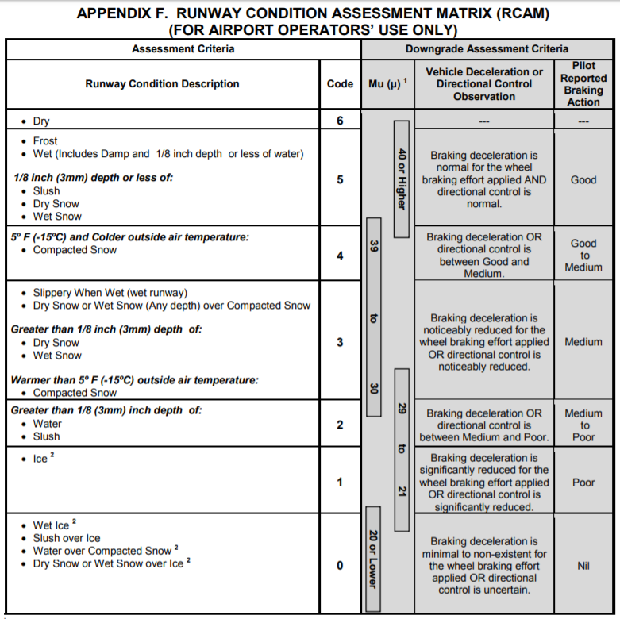
Figure O-1. RCAM as Defined by AC 150-5200-30D (image: FAA, 2016a)

Other FAA documentation that may be relevant for related SRE includes the following:
• AC 150/5300-18A – Buildings for Storage and Maintenance of Airport Snow and Ice Control Equipment and Materials, 9/14/2007.
• Airport Snow and Ice Control Plan Revision. Cert-Alert 16-02 (FAA, 2016).

AGVT would likely be integrated on SRE and if funded by AIP or other FAA funds, it would need to be stored in buildings or other protected space, as described in AC 150/5300-18A.

The Airport Snow and Ice Control Plan Revision Cert-Alert provided a new Snow and Ice Control Plan (SNIP) Template that is consistent with the revised Advisory Circular 150/5200-30D, Airport Field Condition Assessments and Winter Operations Safety, dated 29 Jul 2016.

Airports that hold a certificate under Part 139 will have corresponding documentation in their Airport Certification Manual, referencing Snow and Ice Control (reference 139.313), Airport Self-Inspection Program (reference 139.327), and Airport Condition Reporting (reference 139.327).

Related Technologies in Other Sectors. Advanced technologies in other sectors have supported both platooning and remote operations. For example, the John Deere Autotrac™ documents weather and field conditions including wind direction, wind speed, weather, soil and field conditions, which can be recorded and viewed with any web connected device (2019). This information is presented with real-time maps and information on area remaining and estimated time to completion. Machine Sync feature can be used during harvest to automatically adjust tractor and grain cart speed and position with combine (John Deere, 2019).

References (Appendix O, AGVT for Snow and Ice Control)

Federal Aviation Administration. (2011). 139.313 Snow and Ice Control (United States of America, Government Publishing Office). https://www.govinfo.gov/content/pkg/CFR-2011-title14-vol3/pdf/CFR-2011-title14-vol3-sec139-313.pdf
Federal Aviation Administration. (2017a). Field Condition (FICON) Reporting. N JO 7930.107. US Department of Transportation. Washington, District of Columbia. https://www.faa.gov/documentLibrary/media/Notice/N_JO_7930.107_Field_Condition_(FICON)_Reporting.pdf
Federal Aviation Administration. (2017b, August 22). Procurement and Contracting Under AIP - Equipment Procurement. https://www.faa.gov/airports/aip/procurement/equipment/
John Deere. (March 12, 2019). Simplify Harvesting with the New John Deere Software Update
https://vanwall.com/simplify-harvesting-with-the-new-john-deere-software-update/
Torregrossa, M. (2016, November 2). FAA Implements New Airport Runway Reporting for Snow and Ice Safety. Michigan Local News. https://www.mlive.com/weather/2016/11/faa_implements_new_runway_repo.html

P.

P. Supporting Information: AGVT for Perimeter Inspection

A. Supporting Information: AGVT for Perimeter Security

Additional Reference Documents. Below are additional references and resources that may be relevant for AGVT for Perimeter Security. Components of the following Federal Regulations are particularly relevant to include 49 CFR Parts 139, 1540, and 1542.

49 CFR Part 139.335 (Part 139 addresses Airport Certification)
• 139.335 A. In a manner authorized by the Administrator, each certificate holder must provide—
o Safeguards to prevent inadvertent entry to the movement area by unauthorized persons or vehicles; and
o Reasonable protection of persons and property from aircraft blast.
• 139.335 B. Fencing that meets the requirements of applicable FAA and Transportation Security Administration security regulations in areas subject to these regulations is acceptable for meeting the requirements of paragraph (a)(l) of this section.

49 CFR Part 1540 (General Rules for Civil Aviation Security)
• 1540.105. No one is permitted to interfere or compromise a security system, nor are they allowed within the secured areas without meeting all security and certification requirements while following all procedures.
• 1540.115. A person is considered a security threat if they are threatening transportation or national security as a whole, present the threat of terrorism or hijacking, or threaten civilians
o Detected threats are to be reported to the FAA and TSA, listing a statement of the activity and the reason for why someone is deemed a threat. TSA will reply to this statement.

49 CFR Part 1542 (Airport Security)
• 1542.1 Airports that are required to maintain certification are to maintain a security program under 49 CFR Part 1542.
• 1542.5. The Transportation Security Administration is permitted to inspect an airport and its documentation at any time to ensure compliance with Part 1542.
• 1542.103. An airport security program must include a list of every secured area and airport boundaries, every security activity that occurs on airport property, how the airport performs access control including identification media, all airport signage related to security, airfield maps listing all features, and other detailed security information.
• 1542.107. All changes to the airport security program must be submitted to the TSA for approval
o Temporary changes can also be made but a notification must be made as to the duration of these changes.
• 1542.201. Every airport is required to create a secured area which they must protect by patrolling, maintaining access control, identifying individuals, and posting signage.
• 1542.213. Airports are to ensure that security personnel have an understanding of this section which discusses escorting and challenging procedures, job responsibilities, personnel restrictions, and other security topics.
• 1542.215. Airports that have a security program must ensure they have an adequate amount of security personnel and/or law enforcement that are available to respond to incidents in a proper amount of time.
• 1542.221. Every airport is required to record every law enforcement action, detailing everything from type of weapons to suspect personal information.
• 1542.303. Each certified airport is required to address and follow all security directives published by the TSA within a certain period of time.
• 1542.307. Airports must establish procedures for dealing with security incidents that are specific to their operation, checking ever 1 calendar year that everyone remains certified.

Stakeholder Feedback regarding Challenges to Implementation. The following text addresses more detailed and specific concerns regarding challenges which are generally addressed in the evaluation.

• Radio Frequency (RF) interference.
o RF transmissions at an airport are very prevalent, including radar, Wi-Fi, instrument landing systems, cellular, and other means of wireless communication and data transfer. AGVT that rely on a wireless connection to follow a pre-programmed route using GPS “gates” to ensure the vehicle knows where it is may frequently go off course or lose connection with the operator base due to wireless interference.
o It would be an unacceptable risk for automated or autonomous vehicles to go off course airside in the secured area, where expensive aircraft are loaded and unloaded, passenger baggage and cargo is stored and moved, and maintenance vehicles, fuel trucks, and catering delivery vehicles are present. It may be possible to overcome positioning problems caused by RF interference by using the GIS map, the GPS transponder, and the vehicle IMU and encoder. In warmer climates it may be possible to overcome RF interference by having the automated vehicles use a light sensor and follow a planned route painted onto the ground. This may work on a perimeter path but may not work for pavement areas shared with aircraft, unless the vehicle can utilize existing pavement markings which are compliant with FAA regulations. In colder climates, snow may obscure a painted line.

• Safety and Security Visual Requirements Mandated by FAA regulatory requirements.
o Aircraft with engines engaged have flashing light signals on the top and bottom of the fuselage that act as visual indicators to people in the vicinity that the aircraft is about to move. This ensures that other vehicles and people stay clear of the aircraft. Any automated or autonomous vehicle will need to recognize this safety signal, since aircraft movements may be random and unpredictable.
o Vehicles and people may not move behind aircraft that are about to push back, because the aircraft engines are engaged and could damage them with jet blast or prop wash.
o Perimeter fencing, both FAA and TSA govern aspects of the fencing, though it is primarily intended as a wildlife mitigation measure. As a result, the state of repair of the fence, height of the fence, and condition of barbed or concertina wire must be detectable by the automated vehicle
o Additional wildlife mitigation – airports are required to have wildlife mitigation plans that may include noise to scare away birds, or means to alert the tower of the presence of flocks of birds that my endanger aircraft taking off or landing. Any perimeter automated vehicle should be considered for fitting with wildlife recognition and mitigation measures.
• Safety and Security Visual Requirements Mandated by TSA regulatory requirements.
o On the perimeter, TSA requires that airports prevent and detect unauthorized access to the AOA or Secured areas. Warning signage is required, which must be detectable and readable by the automated vehicle.
o The AGVT must be able to differentiate between wildlife and humans, and ideally should be able to detect whether or not the person is displaying the required unexpired AOA badge for that airport, or the unexpired Security Identification Display Area (SIDA) badge. This capability may be challenging, and an alternative may be to provide an alert for a human operator to follow up when a person is detected, and have a two-way radio transmission and CCTV feed to allow the human operator to verbally challenge the individual and have them present the credentials to the camera for viewing and confirmation.
o Generally, the ability to transmit alerts to an Airport Operations Center (AOC) should be a feature of any system, in order to allow for timely response to a suspicious incident. These alerts should also be capable of being sent to the TSA Coordination Center (CC) for that airport.

• Data encryption.
o Cybersecurity is an emerging area of oversight from TSA and FAA, though neither has strong policies in place for protection of information both stored and in transmission. However, TSA has issued an Information Circular (IC) to airports with many recommendations for data encryption, physical and logical controls for IT systems, and procedures to ensure system security.
o There is a potential for RFID skimmers to steal data from ID badges, and use that to produce fraudulent access control media.
o AGVT must be able to transmit and receive data in an encrypted format, as all these transmissions would contain Sensitive Security Information (SSI), which may not be unprotected, and the disclosure of which could cause harm to the security of the transportation system.

• Integration.
o AGVT vehicles could be used as single, autonomous entities, but in many areas, particularly in the Secured area ramp, they would need to be networked as part of an autonomous transportation system structure. While vehicles could function independently, the transfer of data to other vehicles (technology that is used in current automated features in passenger vehicles) would promote safety in the active environment, but would also likely require additional cybersecurity measures.

TSA Background Information, Bibliography. TSA provides background information for GA airports including the following bibliography information excerpted from Appendix D (TSA, 2017).

The following FAA Advisory Circulars are specifically referenced and current advisory circulars can be found on the FAA website at www.faa.gov.
o 150/5200-31A, Airport Emergency Plan.
o 150/5300-13, Airport Design.
o 150/5360-13, Planning and Design Guidelines for Airport Terminal Facilities, which furnishes guidance material for the planning and design of airport terminal buildings and related facilities.
o 150/5370-10, Standards for Specifying Construction of Airports.

Establishment of the Department of Homeland Security, Transportation Security Administration.
On November 19, 2001, Congress enacted the Aviation and Transportation Security Act (ATSA), Public Law 107–71, 115 Stat. 597, which established TSA. Pursuant to ATSA, TSA became responsible for security in all modes of transportation, including civil aviation under Chapter 449 of title 49, United States Code, related research and development activities, and other transportation security functions exercised by DOT. Consequently 14 CFR parts 107, 108, 109, and certain provisions of part 129 were removed and transferred into the relevant parts of Title 49 of the Code of Federal Regulations.

TSA issues and administers Transportation Security Regulations (TSRs), which are codified in Title 49 of the Code of Federal Regulations (CFR), Chapter XII, parts 1500 through 1699).15 The following regulations apply to regulated aviation entities, not necessarily to GA operators or facilities, and are provided for reference and informational purposes only.

• Part 15, Protection of Sensitive Security Information - This part governs the maintenance, safeguarding, and disclosure of records and information that the Secretary of DOT has determined to be Sensitive Security Information, as defined in § 15.5. This part does not apply to the maintenance, safeguarding, or disclosure of classified national security information, as defined by Executive Order 12968, or to other sensitive unclassified information that is not SSI, but that nonetheless may be exempt from public disclosure under the Freedom of Information Act. In addition, in the case of information that has been designated as critical infrastructure information under section 214 of the Homeland Security Act, the receipt, maintenance, or disclosure of such information by a Federal agency or employee is governed by section 214 and any implementing regulations, not by this part.

• Part 1520, Protection of Sensitive Security Information - This part governs the maintenance, safeguarding, and disclosure of records and information that TSA has determined to be Sensitive Security Information, as defined in § 1520.5. This part does not apply to the maintenance, safeguarding, or disclosure of classified national security information, as defined by Executive Order 12968, or to other sensitive unclassified information that is not SSI, but that nonetheless may be exempt from public disclosure under the Freedom of Information Act. In addition, in the case of information that has been designated as critical infrastructure information under section 214 of the Homeland Security Act, the receipt, maintenance, or disclosure of such information by a Federal agency or employee is governed by section 214 and any implementing regulations, not by this part.
• Part 1540, Civil Aviation Security: General Rules - This part contains rules that cover all segments of civil aviation security. It contains definitions that apply to Subchapter C, and rules that apply to persons engaged in aviation-related activities, including passengers, aviation employees, airport operators, aircraft operators, foreign air carriers, and others.

• Part 1542, Airport Security - This part requires airport operators regularly serving U.S. and foreign passenger air carriers to adopt and carry out a security program approved by TSA. It describes requirements for security programs, including establishing secured areas, air operations areas, security identification display areas, and access control systems. This part also contains requirements for fingerprint-based criminal history record checks of individuals seeking unescorted access authority at a regulated airport. This part also describes the requirements related to Security Directives issued to airport operators. This part also provides that TSA may enter and be present at an airport that does not have a security program under this part, without access media or identification media issued or approved by an airport operator or aircraft operator, to inspect an aircraft operator operating under a security program under part 1544 of this chapter, or a foreign air carrier operating under a security program under part 1546 of this chapter. 49 CFR 1542.5(e).

• Part 1544, Aircraft Operator Security: Air Carriers and Commercial Operators - This part applies to certain aircraft operators holding operating certificates for certain scheduled passenger operations, public charter passenger operations, private charter passenger operations, all-cargo operations, and certain other aircraft operators. This part requires such operators to adopt and carry out a security program approved by TSA. It contains requirements for screening of passengers and property, and fingerprint-based criminal history record checks for flight crew members and those with unescorted access authority. This part also describes requirements applicable to law enforcement officers flying armed aboard an aircraft. This part describes the requirements related to Security Directives issued to aircraft operators.

• Part 1550, Aircraft Security Under General Operating and Flight Rules - This Part applies to the operation of aircraft for which there are no security requirements in other Parts of Chapter XII, Subchapter B – Security Rules for All Modes of Transportation.

• Part 1552, Flight Schools - This subpart applies to flight schools that provide instruction under 49 U.S.C. Subtitle VII, Part A, in the operation of aircraft or aircraft simulators, and individuals who apply to obtain such instruction or who receive such instruction.

• Part 1554, Aircraft Repair Station Security - This part applies to repair stations and requires repair stations certificated under 14 CFR Part 145 to allow TSA and DHS officials to enter, conduct inspections, and view and copy records as needed to carry out TSA’s security-related statutory and regulatory responsibilities. The regulation also requires these repair stations to comply with security directives when issued by the TSA. The regulation also requires certain repair stations to implement a limited number of security measures.

• Part 1562, Operations in the Washington, DC, Metropolitan Area - This subpart applies to the following airports, and individuals who operate an aircraft to or from those airports, that are located within the airspace designated as the Washington, DC, Metropolitan Area Flight Restricted Zone by the Federal Aviation Administration: 1) College Park Airport (CGS); 2) Potomac Airfield (VKX); and Washington Executive/Hyde Field (W32).

TSA Background Information, Security Assessment. TSA provides background information for GA airports including the following information regarding airport security assessment and protective measures excerpted from Appendix A (TSA, 2017).

The topics below are presented for an airport to conduct a self-assessment with respect to preparedness, detection, response and recover. The topics provide examples of the kind of access and barriers that would need to be checked, the potential monitoring and surveillance requirements, and cybersecurity considerations. TSA inspection areas are included to illustrate that barrier and check points are merely one component of an airport security system.

3. ACCESS CONTROLS
a. Controlled entrances (for example, doors, entryways, gates, turnstiles, door alarms)
b. Control of Materials (for example, fuel, other)
c. Secure perimeter (for example, fences, bollards)
d. Restricted access areas (for example, key assets, roofs, HVAC, fuel farms, electrical vaults)
e. Access identification (for example, employee badges, biometrics, etc.)
f. Signage
g. CCTV
h. Other

4. BARRIERS
a. Walls, earth banks & berms (blast protection)
b. Fences (for example, barbed wire, chain link)
c. Screens & shields (for example, visual screening)
d. Vehicle barriers (for example, bollards, jersey barriers, planters, vehicles used as temporary barriers)
e. Other

5. MONITORING & SURVEILLANCE
a. CCTV (for example, fixed, pan, IR, Thermal)
b. Motion Detectors
c. Fire & Carbon Monoxide Detectors
d. Explosive Detectors
e. Chemical Agent Detectors
f. Biological Agent Detectors
g. Radiological Agent Detectors
h. Metal Detectors
i. Night-vision Optics (IR, thermal)
j. Lighting (for example, buildings, perimeter)
k. Other

7. INSPECTION
a. Check Points (strategic locations, guard shack, etc.
b. Personnel Searches (for example, employees, visitors, contractors, vendors)
c. Vehicle searches (for example, cars, trucks)
d. Aircraft searches (based & transient)
e. Hangar searches (private, FBO, SASO)
f. Building searches (all)
g. Cargo & Shipment searches

9. CYBER SECURITY
a. Firewalls (VPN, etc.)
b. Virus Protection
c. Password Procedures
d. Information Encryption
e. Computer Access Control
f. Intrusion Detection
g. Redundant & Back Up Systems
h. Hosted Sites
i. Third Party Assessment
j. Other

Reference (Appendix P, AGVT for Perimeter Security)
Transportation Security Administration (TSA). (2017, July). Security Guidelines for General Aviation Airport Operators and Users. Information Publication A-001, Version 2. https://www.tsa.gov/sites/default/files/2017_ga_security_guidelines.pdf

Q.

Q. Supporting Information: AGVT for Aircraft Pushback and Tug/Taxi

Additional Reference Documents. Below are additional references and resources that may be relevant for AGVT for Aircraft Pushback and Tug/Taxi.

AC 00-34A, Aircraft Ground Handling and Servicing, 9/10/1974.
Presents “generally accepted information and safety practices” (AC 00-34A, 1974). The following information may be useful in the evaluation of tug and pushback.
• 4. Pilots should have an unobstructed view of anyone directing their aircraft.
• 7A. No one is to ever tow an aircraft in congested areas without support from guides to ensure clearance and help direct movement.
• 7B. No fewer than two individuals are to tow large aircraft. One should be located in the cockpit and another should be inside the tug.
• 8. Taxiing aircraft should only be performed by qualified pilots or personnel

AC 00-65, Towbar and Towbarless Movement of Aircraft, 11/8/2010.
Details guidance on how to perform the task safely, based on previously recorded cases.
• D2. Towing personnel are to not place themselves in front of or behind aircraft tires during operation of a tow vehicle.
• D3/4. Placards are to be used to detail any special instructions or circumstances for tug usage
• D7. Tow personnel are to be very aware of their surrounding environment, looking out for any problems that could cause them harm
• G. Tug operators are responsible for their tug and should listen to every command from the pilots of the aircraft they are towing so they can halt the operation in an emergency
• H. Wing walkers should be placed at each wingtip to ensure clearance and (I) one can be placed at the tail during reverse or tight operations
• O. Before beginning the tug operation, personnel should examine their work to ensure that they have properly attached the tug to the aircraft

AC 150/5210-20A, Ground Vehicle Operations to include Taxiing or Towing an Aircraft on Airports, 9/1/2015.
Provides guidance on ground vehicle training, which includes taxiing and towing aircraft.
• 1.1. If an aircraft is being moved without the intention of flight, anyone taxiing or towing an aircraft must be movement area certified.
• 2.2.2.1. All new employees of Part 139 certified airports are training in accordance with the regulations and are required to demonstrate their ability to operate a vehicle at an airport, including communicating with their air traffic control tower
o Under 2.2.2.2 and 2.2.2.3, trained employees will receive recurrent and remedial training as long as they are employed
• 3.1.1. When moving an aircraft across a runway, it is preferred that the operator use the designated departure end of the runway, rather than a midpoint, to lessen the chance of an incursion with aircraft on the runway.
• 3.1.3. All vehicles that frequently operate in the movement area should be highly visible at all times which includes installing the proper lights for night usage
• 5.1. Ground vehicle personnel may need situational awareness training where they can help an individual become more focused on visual scanning and radio communications. Training also includes discussing the potential risks that distractions such as technology create
• 5.2. Some airports may attempt to increase awareness by limiting ground vehicles to certain airport routes where congestion is low so they may have less to be concerned about while driving
• Appendix 1.7.1. Every ground vehicle operator must complete training and pass certification tests to be permitted to operate on the airside.
o Extra certifications should be received in order to operate special vehicle classes
o All operators are to yield the right-of-way to any aircraft
• Appendix 1.7.2. All vehicles are to be certified and registered before being utilized on the airside
o This may include adding lights, reflectors, and identification
• Appendix 1.7.3. All ground vehicles that are a part of an accident are to come to a halt, remain on scene, call for and obtain aid resources, and provide all information to the proper authorities.
• Appendix 4.3. All vehicle operators are to be in contact with air traffic control when in the movement area. Communicating with a tower includes listing who you are, where you are, and what your intentions are. Repeating what air traffic control commands is imperative.

Existing software for simulation and visualization of aircraft, GSE and ground vehicle movements.
Software such as AviPlan Pro can be used to model aircraft and surrounding space, and support an airport GIS map with the required obstacle free zone and optimal aircraft pushback path for the specific aircraft.
• Pushback paths with safety clearance to meet regulatory and advisory guidelines (FAA and ICAO) can be modeled, simulated, and may form the basis for future AGV.
• Aircraft movement on taxiways and taxilanes can be simulated to reflect aircraft and tug specifications and performance characteristics (turning radius and wingtip clearance).
• Software can also be used to identify and simulate routes, paths and parking for GSE consistent with aircraft clearance requirements during different phases of the aircraft turn (aircraft parking, aircraft turn and aircraft pushback).
• An electronic database of aircraft specifications linked to aircraft tail numbers can be used to support real-time data regarding obstacles and clearance requirements and will reflect the actual aircraft characteristics of aircraft current parked on a MARS (multiple aircraft ramp stand).

Ramp workers must be familiar with a wide range of equipment, and may have different procedures required for different airlines. The references below provide sample procedures and examples of operating instructions for different GSE.
• IATA Ground Operations Manual (IGOM), 8th Edition. Effective 1 January – 31 December 2019. ISBN 978-92-9229-797-8. International Air Transport Association, Montreal-Geneva.
• Pushback and Tow Tractor Operating Instructions. Piedmont Airlines. http://piedmontgse.com/downloads/GSE%20Ramp%20Training/GSE%20Equipment%20Operating%20Instructions/Tow%20Tractors%20&%20Pushbacks/Operating%20Guide%20for%20Tow%20Tractors%20and%20Pushbacks.pdf

R. Supporting Information: AGVT for Baggage Carts

Equipment Size. Approximate size of baggage carts may be 5.5 ft wide x 11 ft (or up to almost 15 ft) long; tugs may be 5 or 5 ft wide, 10 ft long, and 6 ft tall (with cab) (Textron GSE, n.d.; Landrum & Brown, 2010).

GSE Operation addressed by Airport Rules and Regulations. Airports may limit the number of carts that can be towed to four (or six in some cases), and may limit speeds to 15 or 20 mph on service roads away from aircraft and to 4 mph (walking speed) near aircraft. The appropriate operating speed depends on the area. Although airport rules and regulations may vary, drivers may receive a citation under the state vehicle code and a fine under the airport rules and regulations (e.g., SFO, 2018); the citation would be a moving violation on the employee’s driver’s license. Depending on the airport and the employer, driving privileges may be suspended (e.g., for a second offense) and/or revoked (e.g., for a third offense), which may result in employee dismissal. AGVT that supports safe driving may reduce the enforcement burden and help ensure safe ground vehicle operations.

Industry Recommendations. SAE Aircraft Ground Support Equipment Committee AGE-3 published Aerospace Standard Aerospace Recommended Practice (ARP) 1558 regarding the use of both passive and active systems to prevent aircraft damage by GSE (2019). In this document, passive systems refers to GSE fenders and bumpers rather than passive safety assist technology. Selected excerpts and concepts are provided below. Although the primary focus is for operation of GSE near aircraft, many of the concepts (e.g., complacency, training, characteristics of alert), are relevant regardless of the GSE operating area.

Active aircraft avoidance systems should be considered additional protection and should not be a substitute for operator training. Active aircraft detection system may be based on a variety of technologies including:
• Aircraft contact: micro-switches, pressure or deformation sensitive fenders/bumpers, etc.
• Distance: radar, laser, or ultrasonic sensors, folding arm with a wheel (as used on passenger boarding bridges), etc.
o Radar sensors if used should operate in the 5.8 GHz band, have a limited range, and be approved for use on airports.
o Laser sensors if used should be class 1 of EIC 60825-1. In the event of a higher class rating being used, the additional precautions required by EIC 60825-1 shall be applied.
o Ultrasonic sensors if used shall comply with IEC 60947-5-2.
• Operator awareness systems: e.g., closed circuit TV, etc.

Installation of active warning or automatic protection systems is never a substitute for systematic training of vehicle operators to exert maximum precaution at all times and specifically when operating near the aircraft and in the last moments of aircraft docking.

Overreliance on active systems can result in more damage than they prevent, and operator training must be applied in the same manner whether or not an active system (which should only be considered additional protection), is fitted onto the vehicle.

Alerting functions should issue a warning signal whenever the sensor exceeds a preset value beyond which damage may occur. The warning shall:
• Activate unmistakable audible and visual driver warnings, and
• Record the time and maximum value of the measured parameter(s).

The preset values shall be adjustable and recordings shall be accessible only by authorized maintenance personnel, and made inaccessible to tampering from non-authorized persons.

A system to detect actual aircraft contact shall be provided whenever GSE is used to dock a composite fuselage aircraft; record of the time and maximum measured parameter is required to meet airworthiness regulation requirements and allow inspection by qualified personnel prior to dispatch. Structural damage to the aircraft damage may occur without visible evidence. Although the load limits and correlating preset sensor not-to-exceed values are not yet available from aircraft manufacturers, this should not preclude the development of supporting GSE alerting systems.

GSE operator and active systems should reduce GSE speed to 8 in/sec (“inching”) when the GSE is within 20 inches of the aircraft, and should stop 2 to 5 inches from the aircraft (this is consistent with ISO 6966-2) by stopping the power source or idling the engine. The GSE travelling brakes should automatically activate so the GSE comes to a complete stop before damage to the aircraft occurs. The inching speed is used to evaluate both active and passive systems.
Detection systems activated at a distance shall provide audible and visual warning to the operator, and can be used to automatically stop movement. In this case, the power source shall be stopped or the engine brought to idle and the travelling brakes automatically activated, so that the GSE, already travelling at the "inching" speed defined in 3.4.2, comes to a complete stop before touching the aircraft, but leaving no more than 5 inches (120 mm) horizontal clearance to the fuselage. The inching speed should be identified by the “snail” graphic symbol, and the higher approach speed appropriate in the Equipment Restraint Area (ERA) should be identified by the “turtle” symbol.

It is recommended that all active safety functions should be made fail-safe, i.e., render the vehicle inoperative in the event of their malfunction.

International Standards. The following international standards are available from American National Standards Institute, 25 West 43rd Street, 4th Floor, New York, NY 10036, Tel: 212-642-4900, www.ansi.org.
• ISO 6966-2 Aircraft ground equipment - Basic requirements - Part 2: Safety requirements
• ISO 11532 Aircraft ground equipment - Graphical symbols
• IEC 60825-1 Safety of laser products - Part 1: Equipment classification and requirements
• IEC 60947-5-2 Low-voltage switch gear and control gear - Part 5-2: Control circuit devices and switching elements - Proximity switches

References (Appendix R, AGVT for Baggage Carts)

Landrum & Brown (2010). Airport Passenger Terminal Planning and Design: Volume 1: Guidebook. ACRP Report 25. ISBN 9780307118200. http://onlinepubs.trb.org/Onlinepubs/acrp/acrp_rpt_025v1.pdf
ISO 6966-2:2014(E) (2014, August 1). Aircraft Ground Equipment – Basic Requirements – Part 2: Safety Requirements. International Organization for Standardization.

References (Appendix R, AGVT for Baggage Carts, continued)

San Francisco International Airport (SFO) (2018, December 4). Rules and Regulations. http://media.flysfo.com.s3.amazonaws.com/media/sfo/about-sfo/Rules_and_Regulations_12-4-18.pdf
SAE Aircraft Ground Support Equipment Committee (SAE AGE-3) (2019, March 28). Interface Protection – Ground Equipment to Aircraft. https://saemobilus.sae.org/content/arp1558
Textron GSE (2019). Tractors. https://textrongse.txtsv.com/tractors

S. TERMS AND ACRONYMS

Acronym or Term | Definition
AC | Advisory Circular
ADAS | Automated/Advanced Driver Assistance Systems
ADS | Automated Driving system
ADS-B | Automatic Dependent Surveillance – Broadcast
ADT | Articulated Dump Trucks
AEB | Automatic Emergency Braking
AGVT | Advanced Ground Vehicle Technology
AHP | Analytical Hierarchy Process
AIP | Airport Improvement Program
ALARP  AMG | As Low as Reasonably Practical (reference to safety risks)  Automated Machine Guidance
AOA  AOC | Air Operations Area  Airport Operations Center
ARFF | Airport Rescue and Firefighting
ASDE-X | Airport Surface Detection System – Model X
ASIAS | Aviation Safety Information Analysis and Sharing System
ATC | Air Traffic Control
ATCT  ATD-2 | Air Traffic Control Tower  Airspace Technology Demonstration 2
A-VDGS | Advanced Visual Docking Guidance System
ATIMS | Asset Tracking and Incursion Management System
AV | Automated Vehicle
AV START | American Vision for Safer Transportation through Advancement of Revolutionary Technologies Act
B/C  BCA | Benefit Cost Ratio  Benefit-Cost Analysis
BSW | Blind-Spot Warning
CAAC | Civil Aviation Administration of China
CAST | Commercial Aviation Safety Team
CATV | Connected and Autonomous Transport Vehicles
CHI  CONOPS | Computer-Human Interaction  Concept of Operations
CRA | Conceptual Risk Assessment
CSF  CTAF | Critical Success Factors  Common Traffic Advisory Frequency
CV | Connected Vehicle
DOT | Department of Transportation
DSRC | Dedicated Short-Range Radio Communication
FAA | Federal Aviation Administration
FAVP | Federal Automated Vehicles Policy
FBO | Fixed-Base Operator
FLIR | Forward-Facing Infrared Camera
FMVSS | Federal Motor Vehicle Safety Standards
FOD | Foreign Object Debris
Acronym or Term | Definition
FTA | Federal Transit Administration
GA | General Aviation
GAO  GBAS | Government Accountability Office  Ground Based Augmentation System
GIS  GPS | Global Information System  Global Positioning System
GSE | Ground Service Equipment
HF | Human Factors
HMI | Human-Machine Interface
HRET | High-Reach Extendable Turret (Oshkosh Airport Products)
HMI  IADS | Human Systems Integration  Integrated Arrival, Departure, and Surface System
IATA | International Air Transport Association
ICAO | International Civil Aviation Organization
ICAS | Incursion Collision Avoidance System
IFA | Initial Feasibility Assessment
IIHS  IMU  I/O  ISH | Insurance Institute for Highway Safety  Inertial Measurement Unit  Input/Output  Information Security Hub
KSA  LDW  LiDAR | Knowledge, Skills and Abilities  Lane Departure Warning  Light Detection and Ranging
LKA | Lane-Keeping Assist
MRO  NASA | Maintenance Repair and Overhaul  National Aeronautics and Space Administration
NCSL | National Conference of State Legislatures
NHTSA | National Highway Traffic Safety Administration
NPRM | Notice of Proposed Rulemaking
NTSB | National Transportation Safety Board
OPA | Optical Phase Array
OSHA  OTA  PFC | Occupational Safety and Hazard Administration  Over-the-Air  Passenger Facility Charge
PRM | Passengers with Reduced Mobility
QFD  RIMDAS | Quality Function Deployment  Runway Incursion Monitoring Detection Alerting System
RIPS | Runway Incursion Prevention Systems
RIWS  RTCA  SAE | Runway Incursion Warning Systems  Radio Technical Commission for Aeronautics  Society of Automotive Engineers
SELF DRIVE | Safely Ensuring Lives Future Deployment and Research in Vehicle Evolution Act
SESAR  SIP | Single European Sky ATM Research  State Implementation Plans
Acronym or Term | Definition
SLAM  SMART | Simultaneous Localization and Mapping  Smart Mobility Advanced Research and Test (Center)
SMS | Safety/Security Management System
SRE | Snow Removal Equipment
SRM | Safety Risk Management
StB | Simplifying the Business
TEU | Twenty-Foot Equivalent Unit
TQM  TRA | Total Quality Management  Technology Readiness Assessment
TRL | Technology Readiness Level
TSA | Transportation Security Administration
UAS  US | Unmanned Aerial System  United States
VAA | Vehicle Assist and Automation
VDGS | Visual Docking Guidance System
V2I | Vehicle to Infrastructure
V2V | Vehicle to Vehicle
V2X | Vehicle to Everything
WAAS | Wide Area Augmentation System

Reference (Appendix S, Terms and Acronyms)
US DOT. (2018, October 4). Preparing for the Future of Transportation Automated Vehicles 3.0. https://www.transportation.gov/av/3.

