appendix K
Skipped Item Analysis Results
The horizontal axis represents each individual respondent for the survey. The vertical axis represents each item of the scoring tool from questions 10 through 17. Each blue diamond represents a non-numeric response, such "not applicable", "don't know", or skipped responses. Items with multiple overlapping diamonds (for example question 16e) are items where many people gave non-numeric responses.
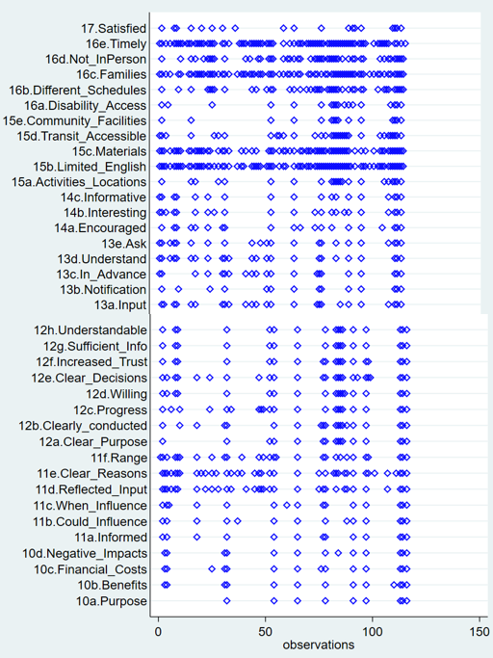
Source: PRR, Inc.

