Appendix C. Technical Support Document Template

As described earlier, the coloring scheme in the draft PA template, and its associated TSD, is as follows:
Black text = Text that generally will not need to be modified and can be used for a national PA and for individual state PAs;
Red text = Information (e.g. report or study citations) at a Federal or state level that is not yet complete and can be added at a later date when a national PA or state PA is finalized;
Blue text = Text to be added containing information relevant to a particular state in order to allow completion of a state –specific PA and its associated TSD.

FHWA-STATE DOT AGREEMENT ON PROJECT-LEVEL CARBON MONOXIDE AIR QUALITY ANALYSIS

TECHNICAL SUPPORT DOCUMENT

Prepared by
STATE DOT
Environmental Office

Date

Contents
Appendix C. Technical Support Document Template C-1
Contents C-3
List of Figures C-4
List of Tables C-4
C-1 Executive Summary C-6
C-2 Background C-7
C-2.1 Air Quality Standards for CO C-7
C-2.2 Highway Projects & CO Requirements C-7
C-2.3 Decline in CO Concentrations C-9
C-3 Status of CO Analyses C-12
C-4 Description of Modeling C-13
C-4.1 MOVES Modeling C-13
C-4.1.1 Relative Humidity C-15
C-4.1.2 Temperature C-15
C-4.1.3 Link Source Type Distribution C-15
C-4.1.4 Age Distribution C-17
C-4.1.5 Fuel Supply and Formulation C-17
C-4.1.6 Link Average Speed and Operating Mode Distribution C-18
C-4.1.7 Emissions Processes C-18
C-4.1.8 Inspection and Maintenance Program C-18
C-4.2 Dispersion Modeling: CAL3QHC C-18
C-4.2.1 Intersections, Freeways, and Arterials C-18
C-4.2.2 Interchanges C-20
C-5 Background Concentration C-26
C-6 Persistence Factor C-28
C-7 Results C-29
C-7.1 Comparison to NAAQS C-29
C-7.2 Freeway and Arterials C-29
C-7.2.1 Sensitivity Analysis for 11-foot Wide Urban Freeway Lanes C-30
C-7.3 Intersections C-30
C-7.4 Interchanges C-31
C-8 Terms of Agreement C-32
Attachment to the Technical Support Document C-33

List of Figures
Figure C-0.1 – National Carbon Monoxide Emission Inventory C-8
Figure C-2 - Total VMT (in millions) for the United States. Source: State Smart Transportation Initiative. C-10
Figure C-3 - National Trends in CO Concentration. 1980-2012 (Annual 2nd High 8-hour
average N=89). The white line represents the average of all sites, the top of the shaded
region represents the 90th percentile concentration and the bottom represents the 10th percentile C-10
Figure C-4 - Reductions in allowable engine CO emission rates per mile by model year C-11
Figure C-5 - Sensitivity of CO Emission Rates to Temperature C-15
Figure C-6 - Intersection configuration used for modeling with link placement C-21
Figure C-7 - South-West Quadrant Receptor Grid Used for Intersection Modeling C-22
Figure C-8 - Typical Modeling Layout for Freeways and Arterials C-23
Figure C-9 - Intersection Geometry Modeled. Each oncoming direction has 4 approach
and 2 left turn lanes as well as 4 departure lanes. C-24
Figure C-10 - Interchange Configuration with nearby freeway and intersection/ramp
layout C-25

List of Tables
Table C-1 - Current National Ambient Air Quality Standards (NAAQS) for
Carbon Monoxide (CO) C-7
Table C-2 - Projected CO Reductions from EPA’s Tier 3 Program C-11
Table C-3 - MOVES input parameters by scenario C-14
Table C-4 - Link Source Type Fractions C-16
Table C-5 - Fuel types listed for source types C-17
Table C-6 - Fuel formulation used for the analysis C-18
Table C-7 – Nationwide Network of CO Monitoring Stations Ranked Concentrations
2011-2013 C-26
Table C-8 - Comparison of maximum predicted one-hour CO concentrations (not
including background concentrations) for a 22 lane (11 in each direction) urban freeway
using 12-foot and 11-foot lane widths C-30
Table C-9 - One-hour CO concentrations (not including background concentrations) for freeways and arterials in urban and rural settings of varying lane and grade
configuration* C-33
Table C-10 - One-hour CO concentrations (not including background concentrations)
for rural and urban intersections at varying approach speeds for a six approach lane intersection for each leg at two percent grade. C-34
Table C-11 - One-hour CO concentrations at varying intersection approach speeds and
distances from an urban freeway at varying lane configurations C-35

C-1 Executive Summary
This Technical Support Document (TSD) provides background and technical information in support of the Programmatic Agreement (PA) between the STATE DOT and the STATE Division of FHWA related to project level carbon monoxide (CO) air quality analysis. This TSD and the associated PA establish which project types and conditions are not expected to exceed CO National Ambient Air Quality Standards (NAAQS) and therefore do not require a quantitative air quality analysis.
The PA was developed as a result of:
- A long history of analyzing highway projects for potential CO impacts by the STATE DOT
- Ongoing reductions in vehicle emissions
- Ongoing reductions in measured CO concentrations
- Recent activities at the federal level, which document the infeasibility of CO ambient air standards being exceeded by certain transportation project types and conditions.
The analyses described in this TSD demonstrate, with a high degree of confidence, that implementation of these project types under the conditions listed could not cause or contribute to a violation of the ambient air standards for CO. The project types covered are: freeways, arterials, interchanges and intersections.
It is recognized that, from time to time, new emission or dispersion models may be developed and approved or that underlying ambient or technical conditions may change. As necessary, this TSD will be updated to reflect these changes.

C-2 Background

C-2.1 Air Quality Standards for CO
Under the Clean Air Act, EPA is required to set National Ambient Air Quality Standards for six principal air pollutants, including CO (Table C-1). The standards are set to avoid adverse impacts to public health and the environment. The Clean Air Act identifies two types of national ambient air quality standards. Primary standards provide public health protection, including protecting the health of "sensitive" populations such as asthmatics, children, and the elderly with an adequate margin of safety. Secondary standards provide public welfare protection, including protecting against decreased visibility and damage to animals, crops, vegetation, and buildings. There are currently no secondary standards for CO.
Table C-1 - Current National Ambient Air Quality Standards (NAAQS) for Carbon Monoxide (CO)
Pollutant  [final rule cite] | Primary/  Secondary | Averaging Time | Level | Form
Carbon Monoxide  [76 FR 54294, Aug 31, 2011] | primary | 8-hour | 9 ppm | Not to be exceeded more than once per year
 |  | 1-hour | 35 ppm
Source: http://www.epa.gov/air/criteria.html
EPA designates geographic regions as in attainment or nonattainment of the NAAQS. Generally, regions that met NAAQS when the standards were promulgated and have continued to meet those standards for a given pollutant are designated attainment areas. Regions that were deemed out of compliance when NAAQS were promulgated and that continue to exceed the NAAQS for a given pollutant are designated nonattainment areas. Regions that were previously out of compliance with the standard but have since come into compliance are designated maintenance areas. As of September 27, 2010, all former CO nonattainment areas were determined to be in compliance for CO, and so have been re-designated as maintenance areas.
States with nonattainment or maintenance areas were required under the Clean Air Act to develop State Implementation Plans (SIPs) adopting transportation conformity requirements at least as stringent as the federal requirements. Some states also adopted additional requirements beyond those prescribed under the Clean Air Act. INSERT INFO ABOUT STATES COMPLIANCE STANDING. INSERT STATE REQUIREMENTS FROM CONFORMITY SIPS, IF ANY.

C-2.2 Highway Projects & CO Requirements
Nationally, annual CO emissions in the US total over 82 million short tons. Mobile sources, including gasoline fueled cars, trucks, buses and off-road vehicles, are responsible for approximately 51% of this total (Figure C-1).

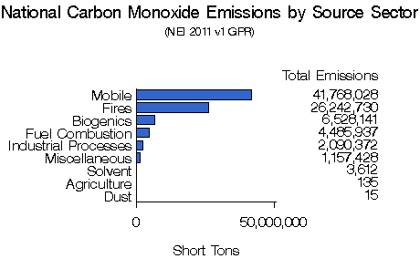
Figure C-1 – National Carbon Monoxide Emission Inventory
Source: http://www.epa.gov/cgi-bin/broker?_service=data&_debug=0&_program=dataprog.national_1.sas&polchoice=CO
A similar situation exists at the state level. In STATE – INSERT IFORMATION ON STATE CO INVENTORY AS APPROPRIATE.
INSERT FIGURE OR TABLE ON STATE CO INVENTORY
Because of the significant CO pollution attributable to mobile sources, transportation agencies have been required to examine the effect of their highway projects on CO levels in the project area. Indeed, under Section 176(c) of the Clean Air Act (the conformity provision), in order to proceed, certain highway projects are required to demonstrate that the incremental addition of CO emissions as a result of the project will not cause or contribute to a violation of the CO NAAQS. The analysis necessary to demonstrate this is typically performed during the environmental studies undertaken to examine environmental impacts of the project.
In addition, the Federal Highway Administration (FHWA) Carbon Monoxide (CO) Categorical Hot-Spot Finding (FHWA, February, 2014) documented conditions for urban intersections in CO maintenance areas that did not require a specific project-level hot-spot analysis, but could instead rely on the categorical finding to determine whether the project was in compliance. This finding was the result of steadily declining ambient CO concentrations over the past several decades.
For transportation projects involving federal funding or action, the environmental analysis is performed pursuant to the requirements of the National Environmental Policy Act (NEPA). Enacted on January 1, 1970, NEPA established a national environmental policy focused on federal activities with the goal of balancing a sustainable environment with other essential present and future needs. NEPA established a requirement for federal agencies to consider the potential environmental consequences of their proposals, document the analysis, and make this information available to the public for comment prior to implementation. NEPA also requires Federal agencies to use an interdisciplinary approach in planning and decision making for any action that adversely impacts the environment. As implemented by FHWA, this means investigating and avoiding potential impacts to the social and natural environment (such as a violation of the CO NAAQS) when considering approval of proposed transportation projects. FHWA’s policy and regulations implementing NEPA are found at 23 CFR § 771.105.
Many states have enacted a state version of NEPA to cover state actions and funding. Similar to NEPA, the state versions typically require an examination of potential environmental impacts and appropriate action to mitigate these impacts to the extent practicable. INSERT HERE INFORMATION ABOUT STATE ENVIRONMENTAL REQUIREMENTS.
As mentioned above, regions of the nation that had did not meet the NAAQS for CO when the standards were promulgated were designated as nonattainment areas under the Clean Air Act. Those areas have since all reached attainment of the CO standard based on monitoring or modeling studies and most are now designated as maintenance areas. However, under Section 176(c) of the Clean Air Act (the transportation conformity provision), certain transportation projects in maintenance areas are required to demonstrate that the project will not cause or contribute to a violation of the CO standard. However, the Federal Highway Administration (FHWA) Carbon Monoxide (CO) Categorical Hot-Spot Finding (FHWA, February 2014) documents conditions for urban intersections in CO maintenance areas that do not require a specific project-level hot-spot analysis but can instead rely on the categorical finding.

C-2.3 Decline in CO Concentrations
The likelihood of highway projects leading to violations of the CO NAAQS has been significantly reduced over the last few decades. Indeed, while vehicle miles traveled (VMT) have seen a long term general increase over time. Recently, however, within the last five years or so, there been a leveling off and decline of VMT.
Figure C-2 shows the trend in VMT at a national level. This has also been the case at the state level.
Background CO concentrations are also critical in determining a project’s impact in terms of NAAQS. At the national level, background CO concentrations have seen significant decreases over the past ~25 years. Indeed, the nationwide network of CO air quality monitoring sites have reported a 78% decline in the 90th percentile of maximum 8-hour CO concentration from 9.5 ppm, above the NAAQS for CO (9 ppm—see 9.5 Table C-1) in 1990 to 2.1 ppm, well below the NAAQS for CO, in 2012 (Figure C-3). This significant decrease in CO background concentrations allow much higher traffic volumes to be screened out under the programmatic agreement. Similar reductions have been found at the state level.
INSERT INFORMATION AND FIGURE OR TABLE, IF APPLICABLE, REGARDING STATE CO MONITORING DATA.
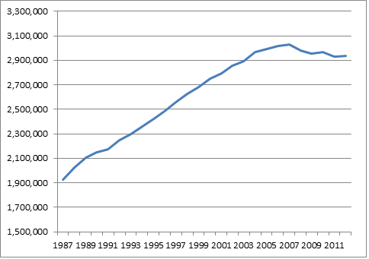
Figure C-2 - Total VMT (in millions) for the United States. Source: State Smart Transportation Initiative.
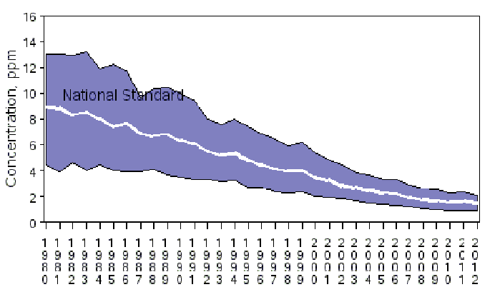
Source: http://www.epa.gov/airtrends/carbon.html
Figure C-3 - National Trends in CO Concentration. 1980-2012 (Annual 2nd High 8-hour average N=89). The white line represents the average of all sites, the top of the shaded region represents the 90th percentile concentration and the bottom represents the 10th percentile
The largest contributor to the substantial reductions in CO concentrations has been the Federal Motor Vehicle Emission Control Program, which sets emission limits for on-road vehicles. This program has been responsible for a 95% reduction in CO emissions from light-duty vehicles. Comparably large reductions have also been realized in emissions from light-duty trucks (Figure C-4). Additional CO emissions reductions are expected to result from EPA’s Tier 3 Control Program, enacted in April 2014, which places limits on the sulfur content of gasoline. Although CO emission rates are not directly regulated under the Tier 3 Control Program, the additional stringency on sulfur content in gasoline will reduce CO emissions by extending the effective life of vehicle catalysts. When fully implemented, by 2030, Tier 3 is expected to produce an additional 24% reduction in CO emissions (Table C-2).

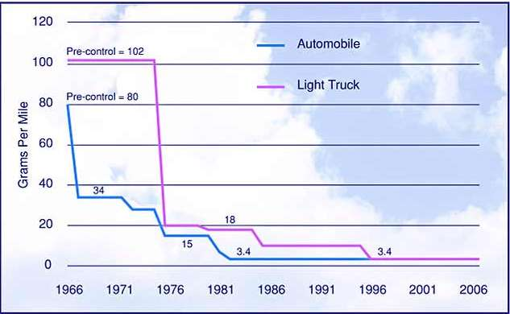
Source: http://www.fhwa.dot.gov/environment/air_quality/publications/fact_book/page14alt3.cfm
Figure C-4 - Reductions in allowable engine CO emission rates per mile by model year
Table C-2 - Projected CO Reductions from EPA’s Tier 3 Program
 | [Annual U.S. tons]
 | 2018 | 2030
Reduction from pre-Tier 3 fleet due to sulfur standard | 122,171 | 17,734
Reduction from Tier 3 fleet due to vehicle and sulfur standards | 156,708 | 3,440,307
Total reduction | 278,879 | 3,458,041
Percent reduction in on road CO emissions | 2% | 24%
Source: https://www.federalregister.gov/articles/2014/04/28/2014-06954/control-of-air-pollution-from-motor-vehicles-tier-3-motor-vehicle-emission-and-fuel-standards

The low ambient CO concentrations and the anticipated continued decline of these concentrations suggest that violations of the current CO NAAQS are unlikely today and into the future. As a result, any changes to local CO concentrations resulting from highway projects are highly unlikely to cause or contribute to a violation of these standards. It is efficient, therefore, to reduce CO analyses for highway projects to the maximum extent reasonable while still monitoring situations that could lead to high levels of ambient CO concentrations.

C-3 Status of CO Analyses

For highway projects involving federal funding or action, project-level CO analyses are performed pursuant to the requirements of the National Environmental Policy Act (NEPA). Enacted on January 1, 1970, NEPA established a national environmental policy requiring federal agencies to take consideration of the environmental impact of proposed projects in their planning and decision making. Specifically, NEPA established a requirement for federal agencies to perform an environmental assessment that considers the potential environmental consequences of their proposed projects. If the environmental assessment finding is that the project will have significant impact, then the federal agency must prepare an environmental impact statement (EIS). The EIS details the environmental consequences of the project and provides reasonable alternatives or amendments that would mitigate these impacts. NEPA requirements encompass any project, public or private, that receives federal funding, though it is the burden of the federal agency to perform the analysis. When applied to FHWA highway projects, NEPA requires consideration of potential environmental impacts—including violation of CO NAAQS, when considering approval of the projects. FHWA’s policy and regulations implementing NEPA are found at 23 CFR § 771.105.
Nineteen states have enacted a state version of NEPA to cover state and state funded projects. Thus, for state level highway projects, CO analysis may be required in accordance with state NEPA analogues. Like NEPA, the state versions typically require an examination of potential environmental impacts and proposal of efforts to mitigate these impacts to a practical extent. States may also require CO analyses in order for a project to comply with transportation conformity requirements. Project transportation conformity requirements are found in 40 CFR Parts 51 and 93. INSERT HERE INFORMATION ABOUT STATE ENVIRONMENTAL REQUIREMENTS.
Guidance related to performing these analyses may be found in the FHWA Technical Advisory T6640.8A (October 30, 1987). With respect to air quality, the guidance recognizes that microscale air quality analyses may be performed for some projects but does not offer any methodological guidance beyond adding background concentrations to the project contribution or the preferred alternative to arrive at a total CO concentration for comparison to the NAAQS. Using this general guidance, many states developed their own guidelines and procedures tailored to state policies and air quality status.
The Federal Highway Administration (FHWA) Carbon Monoxide (CO) Categorical Hot-Spot Finding (FHWA, February 2014) documented conditions for urban intersections in CO maintenance areas that did not require a project-specific hot-spot analysis but could instead rely upon the categorical finding. The finding was based on extensive modeling of atmospheric, geometric, and traffic situations associated with urban intersections. The modeling procedures used to make this finding are detailed below.

C-4 Description of Modeling

The models used in CO air quality analysis have evolved over time. For emissions, the MOBILE series of models were used predominantly until the 2010 release of the first version of MOVES (Motor Vehicle Emission Simulator). Similarly, dispersion models have undergone changes over time. Highway sources have historically been treated as line sources using Gaussian dispersion to deliver CO from the source to the receptor. The HIWAY and CALINE series of models were developed to allow for modeling of roadways. However, it was realized that congested intersections, with most vehicles experiencing idling and acceleration and deceleration associated with a traffic signal, may be more of a concern for CO levels than free-flowing highways. To account for intersection scenarios, queuing algorithms were added to dispersion models, resulting in the current series of CAL3QHC and CAL3QHC(R) models. This analysis used MOVES (version MOVES2010b) and CAL3QHC (version 042440) for emissions and dispersion modeling, respectively.
INSERT TEXT OF STATE SITUATION. TOPICS COULD INCLUDE: CHRONOLOGY OF GUIDANCE AND PROCEDURES, PREVIOUS AGREEMENTS, DOCUMENT STATUS OF PROJECT-LEVEL MODELING. A DISCUSSION ON THE CAPITAL PROGRAM (I.E. TYPES OF PROJECTS, MAJOR VS MINOR PROJECTS) WITHIN THE STATE TO SHOW SMALL PERCENTAGE OF PROJECTS WITH NEED FOR AIR QUALITY ANALYSIS
The assumptions and inputs to the modeling process were conservative and/or worst-case. Conservative here refers to a modeling approach that, by design, has a tendency to over-estimate concentrations. This approach leads to higher concentrations than might otherwise be expected. If a project does not cause a violation with these conservative inputs and assumptions, then a violation under “real-world” conditions is extremely unlikely to occur. This is standard practice in transportation air quality modeling. Further discussion of how this conservative emissions and air dispersion modeling was conducted is provided in the remainder of this section.

C-4.1 MOVES Modeling
Emission modeling was performed using the MOVES model (version MOVES2010b). The emissions parameters for MOVES were specified in the Run Specification file (Runspec) and in the Project Data Manager (PDM). All applications of the MOVES model were conducted at the project level scale. Multiple MOVES runs were conducted for varying roadway grades to establish CO emissions rates. Other MOVES input parameters such as temperature and relative humidity were fixed to be conservative and consistent with the dispersion modeling component of the analysis (see section C-5 Background Concentration). Table C-3 describes the input parameters that were used in the Runspec and PDM for the MOVES component of the analysis.

Table C-3 - MOVES input parameters by scenario
Parameter | Freeway | Arterial | Intersection
Scale | Project Level Domain | Project Level Domain | Project Level Domain
Year | 2015 | 2015 | 2015
Time Span- Month | January | January | January
Time Span - Hour | 12:00 AM | 12:00 AM | 12:00 AM
Time Span - Day | Weekday | Weekday | Weekday
Geographic Bounds | Custom Domain | Custom Domain | Custom Domain
Temperature | -10° Fahrenheit | -10° Fahrenheit | -10° Fahrenheit
Relative Humidity | 100% | 100% | 100%
Fuel Formulation | Gasoline – Formulation ID - 3812 | Gasoline – Formulation ID - 3812 | Gasoline – Formulation ID - 3812
 | Diesel – Formulation ID - 20011 | Diesel – Formulation ID - 20011 | Diesel – Formulation ID - 20011
 | CNG – Formulation ID - 30 | CNG – Formulation ID - 30 | CNG – Formulation ID - 30
Fleet Mix | Emission Source Type and Fuel Combinations for 2015 with a Shift to 0% Heavy-Duty Truck Volumes to Reflect Higher CO emission Rates from Gasoline Vehicles (refer to Table C-4 through Table C-6) | Emission Source Type and Fuel Combinations for 2015 with a Shift to 0% Heavy-Duty Truck Volumes to Reflect Higher CO emission Rates from Gasoline Vehicles (refer to Table C-4 through Table C-6) | Emission Source Type and Fuel Combinations for 2015 with a Shift to 0% Heavy-Duty Truck Volumes to Reflect Higher CO emission Rates from Gasoline Vehicles (refer to Table C-4 through Table C-6)
Age Distribution | 2015 National Default | 2015 National Default | 2015 National Default
Link Source Type Distribution | Variable - Based on 2015 National Default VMT for Urban Restricted Access Road Type | Variable - Based on 2015 National Default VMT for Urban Unrestricted Access Road Type | Variable - Based on 2015 National Default VMT for Urban Unrestricted Access Road Type
Road Type | Urban and Rural Restricted Access | Urban and Rural Unrestricted Access | Urban and Rural Unrestricted Access
Link Average Speed | 74 mph | 45 mph | 15, 25 and 35 mph approach and idle (intersection)
Grade | ±7% , ±4%, ± 2%, ± 0% (uphill and downhill grade) | ±4%, ± 2%, ± 0% (uphill and downhill grade) | ± 2% (cross direction) and 0% grade in other direction (intersection)
Inspection & Maintenance | None | None | None

C-4.1.1 Relative Humidity
A value of 100% relative humidity was used for the emission modeling. It is important to note that for temperatures of 75 degrees Fahrenheit and below, relative humidity has no effect on CO emission rates.

C-4.1.2 Temperature
Sensitivity tests with MOVES show that emission rates are not sensitive to cold temperatures for running exhaust and crankcase exhaust emissions (Figure C-5). A value of -10 degrees Fahrenheit was used in the analysis. Notably, MOVES predicts higher CO at T > 75 degrees Fahrenheit due to air conditioning use. However, because CO is a winter air pollution problem, this higher emission rate is excessively conservative and thus was not used in the analysis.

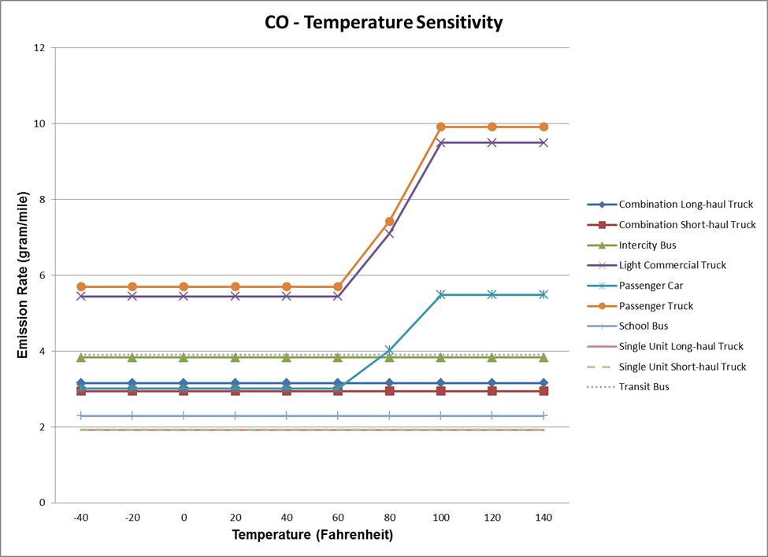
Figure C-5 - Sensitivity of CO Emission Rates to Temperature

C-4.1.3 Link Source Type Distribution
The national default Source Type Distribution was obtained from a national scale MOVES run for the 2015 calendar year. Utilizing the vehicle miles traveled (VMT) information from the ‘movesactivityoutput’ table within the output database, the Source Type Distributions were transformed into a Source Type Hour Fraction for intersection, arterial, and freeway scenarios. To ensure conservative results, the Source Type Hour Fraction was based upon the national default, but adjusted, in two steps, to reflect a higher proportion of vehicles that have higher CO emissions rates. These two steps are detailed below:
- Passenger trucks have the highest CO emission rates of all MOVES source types, except gasoline operated single unit trucks. Passenger cars have the largest fraction of the total national vehicle mix and passenger trucks are the second largest fraction of the total national vehicle mix. To ensure conservative emissions rate estimates for the PA, the Source Type Hour Fraction was adjusted to reflect a 50/50 proportional split between passenger car and passenger truck source types.
- Gasoline vehicle types generally have higher CO emission rates than diesel vehicle types within MOVES. In the Federal Highway Administration (FHWA) Carbon Monoxide (CO) Categorical Hot-Spot Finding (FHWA, February 2014), it was assumed that the lowest observed fraction of non-gasoline vehicles was 5% of the total vehicle mix. To provide a more conservative emission rate than used in the Federal Highway Administration (FHWA) Carbon Monoxide (CO) Categorical Hot-Spot Finding, the national default Source Type Hour Fraction was adjusted by reducing combination and single-unit trucks to represent 0% of the total fleet mix. The remaining 5% fraction was added to the passenger truck source type after the conservative 50/50 passenger car to passenger truck split was applied.
These two adjustments are reflected in:

Table C-4 for the Link Source Type Fractions utilized for the freeway, arterial, and intersection scenarios.

Table C-4 - Link Source Type Fractions
sourceTypeID | Description | SourceTypeHourFraction
11 | Motorcycle | 0.005546
21 | Passenger Car | 0.423629
31 | Passenger Truck | 0.473629
32 | Light Commercial Truck | 0.093704
41 | Intercity Bus | 0.000762
42 | Transit Bus | 0.000211
43 | School Bus | 0.00085
51 | Refuse Truck | 0.000331
52 | Single Unit Short-haul Truck | 0
53 | Single Unit Long-haul Truck | 0
54 | Motor Home | 0.001338
61 | Combination Short-haul Truck | 0
62 | Combination Long-haul Truck | 0
Table C-5 lists the source type and fuel type combination that were modeled in all scenarios.

Table C-5 - Fuel types listed for source types
Source Types | Fuel Type(s)
Motorcycle | Gasoline
Passenger Car | Diesel Fuel and Gasoline
Passenger Truck | Diesel Fuel and Gasoline
Light Commercial Truck | Diesel Fuel and Gasoline
Refuse Truck | Diesel Fuel and Gasoline
Motor Home | Diesel Fuel and Gasoline
School Bus | Diesel Fuel and Gasoline
Transit Bus | Diesel Fuel, Gasoline, CNG
Intercity Bus | Diesel Fuel
Single Unit Short-haul Truck | Diesel Fuel and Gasoline
Single Unit Long-haul Truck | Diesel Fuel and Gasoline
Combination Short-haul Truck | Diesel Fuel and Gasoline
Combination Long-haul Truck | Diesel Fuel

C-4.1.4 Age Distribution
The 2015 national default age distribution was utilized and is consistent with the analysis year that was modeled.

C-4.1.5 Fuel Supply and Formulation
Fuel formulation parameters can significantly affect the CO emission rates. Joint analyses conducted by FHWA and EPA in the Federal Highway Administration (FHWA) Carbon Monoxide (CO) Categorical Hot-Spot Finding determined the effects of certain fuel parameters on CO emission rates. Fuel parameters that can effect CO emission rates include Reid vapor pressure (RVP), sulfur content, ethanol (ETOH), percent of fuel evaporated at 200 degrees and 300 degrees Fahrenheit (E200/E300), and distillation parameters T50 and T90. Those analyses determined that fuel formulation ID 3812 yields higher CO emission rates than other relevant fuel formulations. Table C-6 lists the fuel formulation that was used in both the Federal Highway Administration (FHWA) Carbon Monoxide (CO) Categorical Hot-Spot Finding and this analysis.

Table C-6 - Fuel formulation used for the analysis
Fuel Type | fuelFormulationID | RVP | Sulfur Content (ppm) | ETOHVolume | e200 | e300 | T50 | T90
Diesel | 20011 | 0 | 11 | 0 | 0 | 0 | - | -
Gasoline | 3812 | 15.7 | 28 | 10 | 58.1352 | 94.8717 | 183.214 | 275.447
CNG | 30 | 0 | 0 | 0 | 0 | 0 | 0 | 0

C-4.1.6 Link Average Speed and Operating Mode Distribution
When average speed is utilized in the ‘Links’ input file, entered through the MOVES’ PDM, MOVES creates an operating mode distribution based upon the default drive schedules located in the default database. This operating mode distribution was used represent the freeways, arterials and intersection scenarios. The speeds used in the analysis for each facility type are shown in Table C-3.

C-4.1.7 Emissions Processes
The ‘Running Exhaust’ and ‘Crankcase Running Exhaust’ emissions process were utilized in the intersection, freeway, and arterial scenarios.

C-4.1.8 Inspection and Maintenance Program
An inspection and maintenance (I/M) program produces CO emissions rate benefits. As a conservative assumption, I/M programs were not included in the analysis.

C-4.2 Dispersion Modeling: CAL3QHC
The inputs for the dispersion modeling followed EPA’s 1992 Guidance for CO determinations using CAL3QHC (version 04244) and were consistent with the approach used by the Federal Highway Administration (FHWA) Carbon Monoxide (CO) Categorical Hot-Spot Finding for intersections. As for emissions modeling, the dispersion modeling used conservative and, in many cases, worst-case inputs and assumptions. The modeling approach is described in greater detail below:

C-4.2.1 Intersections, Freeways, and Arterials
- As a conservative assumption, the wind speed was set to 1.0 m/s (the lower limit of CAL3QHC meaningful input)
- Wind direction was modeled every ten degrees from 0 to 350 degrees.
- A mixing height of 1000 m was used, consistent with standard modeling procedures. Sensitivity testing has shown that due to the close proximity of the receptors, mixing height has negligible influence on the dispersion analysis.
- For urban modeling, a surface roughness (z0) of 108 cm was used, corresponding to a single family residential setting. The single family residential setting is the least rough setting for an urban environment and is conservative. The recommended surface roughness in urban areas can vary from 108 to 370 cm. For rural areas, a surface roughness of 1.0 cm was used, which corresponds to a moderately short grass height (6-8 cm) as identified in the Kansas prairie grass. Shorter grass heights are unlikely to be found most rural locations.
- The 1992 EPA CO Guidelines specifies a stability class of D (neutral) for urban areas and E (stable) for rural areas. These guidelines were applied in the model.
- Receptor Placement
  - Freeways and Arterials:
    - Receptors were modeled per the CAL3QHC and 1992 EPA Guidance and were located starting at 30 feet from the outside lane for freeways to account for off-road safety clearance. Receptors were located starting at 10 feet from roadway edge for arterials (where the general public has access and within the limitations of the model to predict valid concentrations).
    - Receptors were placed on both sides of the roadway extending out to 295 feet from the roadway and were modeled to establish decreasing CO concentrations with distance.
  - Intersections:
    - Receptors were modeled per the CAL3QHC and 1992 EPA Guidance and began at 10 feet from roadway edge.
    - A grid of receptors was used in each quadrant to ensure the worst case concentrations were identified. The grid spacing started at 10 feet from each roadway and then extended in 25 foot increments from the intersection up to 500 feet in order to simulate the mid-block position. To ensure that the maximum mid-block concentration was found a receptor was placed at 2,500 feet from the intersection. This allowed analysis of the intervening values.
    - Intersections were modeled per the CAL3QHC and 1992 EPA Guidance, beginning at 10 feet from roadway edge.
    - Figure C-6 shows a typical intersection configuration with link geometry. Figure C-7 shows the layout of receptors for the southeast quadrant.
- Link Geometries and Activity Levels
  - Freeways and Arterials
    - 5,000 foot links were evaluated to avoid end effects.
    - Receptors were evaluated at the center of the defined link to avoid end effects.
    - Facilities were evaluated from 2 to 14 total lanes.
    - Median width was 3.3 feet for freeways and 0 feet for arterials
    - Lane width was 12 feet and sensitivity testing was performed using 11 foot lane width.
    - Traffic volumes were conservatively modeled as 2,200 vehicles-per-lane-per-hour.
    - Figure C-8 shows a typical modeling scenario.
  - Intersections.
    - Approach and departure links extended 2,500 feet from the center of the intersection to ensure end effects at receptor locations are not encountered.
    - Links were input for the start and end locations per the guidance in the CAL3QHC User Manual. Figure C-9 shows an example of the link placement.
    - Queue lengths were as established during modeling.
    - Turn lanes were modeled per suggested guidance in the AASHTO Green Book.

C-4.2.2 Interchanges
The CAL3QHC dispersion model results from the six-lane intersection (2 left turn lanes and 4 through lanes) were used to develop threshold PA CO concentration levels for the interchange configuration. A variable number of freeway lanes (even number of lanes ranging from 2 -22 lanes) were simulated. Likewise, various distances from the edge of the nearest freeway travel lane to the edge of the nearest travel lane of the interchange ramp (10, 20, 30, 60, 80, 100, 125, 150, 175, 300, 500 and 1,000 feet) were simulated. Figure C-10 shows the layout of the interchange. As a result, the CO contribution for an interchange project for any given combination of the modeled number of freeway lanes and distances from the freeway to the interchange can be estimated. The total of the freeway contribution, intersection contribution, and background can then be directly compared to the CO NAAQS.

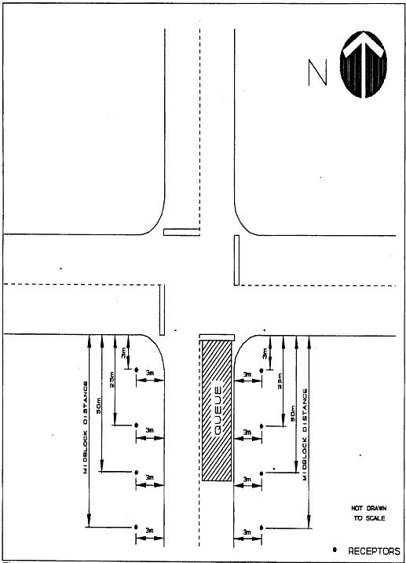
Figure C-6 - Intersection configuration used for modeling with link placement

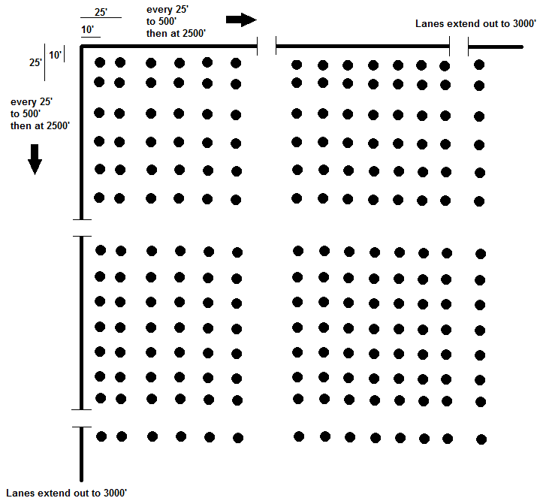
Figure C-7 - South-West Quadrant Receptor Grid Used for Intersection Modeling

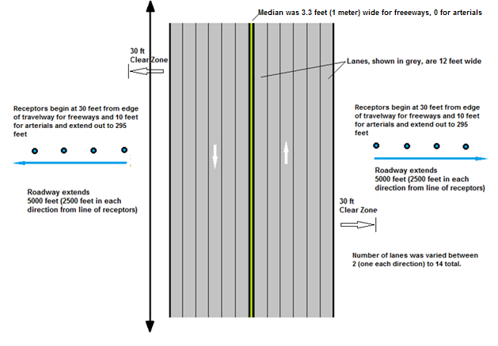
Figure C-8 - Typical Modeling Layout for Freeways and Arterials

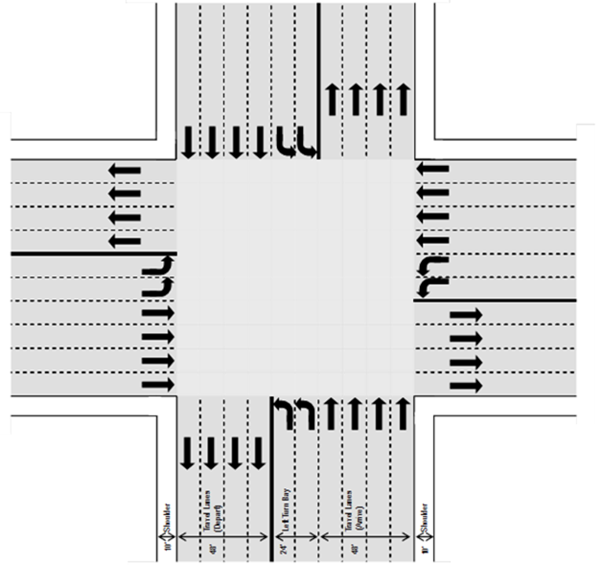
Figure C-9 - Intersection Geometry Modeled. Each oncoming direction has 4 approach and 2 left turn lanes as well as 4 departure lanes.
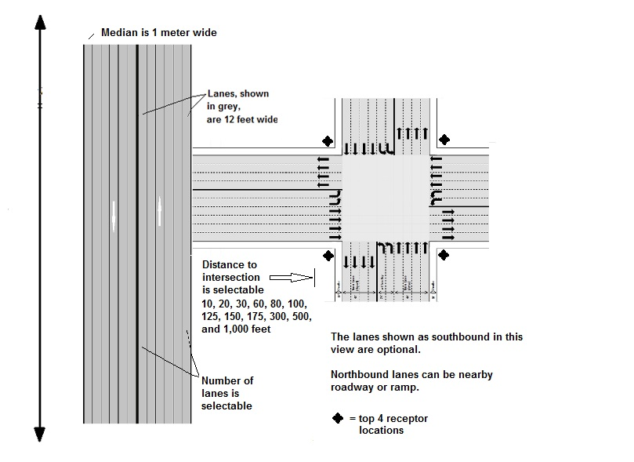
Figure C-10 - Interchange Configuration with nearby freeway and intersection/ramp layout

C-5 Background Concentration

THE BACKGROUND DISCUSSION CAN EITHER USE THE FIRST PARAGRAPH IF STATE CO MONITORING DATA IS USED TO DETERMINE BACKGROUND OR THE SECOND PARAGRAPH WHICH USED THE NATIONAL BACKGROUND.
Background concentrations were determined from data collected over the previous calendar year by STATE AIR AGENCY operated ambient CO monitors. The 2nd highest non-overlapping representative monitored CO concentrations from the most recent calendar year was used to arrive at a background concentration value to be used for project analysis. This method produced a 1-hour background concentration of 5.1 ppm and an 8-hour background concentration of 2.6 ppm.
FOR NATIONAL BACKGROUND
To develop a realistic nationwide CO background concentration, the 2nd highest non-overlapping observed CO concentrations from each of the nation’s CO monitoring stations were ranked for each of the three most recent years (2011-2013). These data were extracted from EPA’s AIRS database. The 99th, 95th and 90th percentiles for each year were calculated and reviewed. Based on this review, it was determined that a reasonably conservative value, applicable to almost any location nationwide, is the highest 95th percentile CO concentration from the past three years (Table C-7). Using this value, the representative 1-hour background concentration was determined to be 5.1 ppm and the representative 8-hour background concentration was determined to be 2.6 ppm.
Table C-7 – Nationwide Network of CO Monitoring Stations Ranked Concentrations 2011-2013
 | 2nd High Maximum 8-hour CO Concentrations (ppm)
Percentile | 2011 | 2012 | 2013 | Average
99th | 5.8 | 4.6 | 4.6 | 5.0
95th | 2.8 | 2.5 | 2.5 | 2.6
90th | 2.4 | 2.1 | 2.1 | 2.2
 | 2nd High Maximum 1-hour CO Concentrations (ppm)
99th | 15.3 | 8.0 | 7.9 | 10.4
95th | 5.5 | 4.8 | 5.0 | 5.1
90th | 4.6 | 3.5 | 3.5 | 3.9
Number of CO monitoring stations with > 75% completeness criteria | 286 | 284 | 198
Source: USEPA AIRData (2014)

FUTURE BACKGROUND
For future years mobile sources will remain the primary source of CO emissions nationwide. To adjust for future CO concentrations as a result of emissions rate changes in the mobile source fleet, the changes in CO emissions as projected by MOVES using the conservative gasoline fleet mix were explored. Based on the emission trends as shown in Figure C-4 and Table C-2, a further decrease in CO concentrations in the range of 30-40% relative to the 2015 fleet is anticipated by 2030, with concentrations anticipated to remain unchanged for future years. VMT is also projected to remain flat nationwide as shown in Figure C-2. The projected changes in the nationwide gasoline consumption via the US Energy Information Agency were examined to see if an adjustment would be required to account for increased or decreased gasoline fuel consumption (assuming no new control technology is introduced to reduce CO emissions). Overall, these trends suggest a reduction in future CO emissions. However to preserve the conservative, “worst-case” approach, no reductions in future background levels were assumed for this study. Thus, the results presented in the following Section C-7 Results are representative of 2015 and later years.

C-6 Persistence Factor

In order to derive an 8-hour CO concentration from the modeled 1-hour CO concentration, a persistence factor was applied to the modeled 1-hour concentration. The persistence factor accounts for variability in traffic (i.e., less traffic during off peak hours) and meteorological conditions (i.e., changes in wind speed, wind direction, and temperature) between the 1-hour time frame and the 8-hour time frame. The persistence factor is the ratio between the maximum 1-hour concentration and the resulting maximum 8-hour concentration in the 8-hour time frame containing the maximum 1-hour concentration. The persistence factor recommended by EPA for a local area is derived from the average of the highest 10 non-overlapping 8-hour CO concentrations over the previous three years.
Where representative monitoring data is not available, EPA recommends the use of a persistence factor of 0.7. For this study, the persistence factor was determined from an examination of the ambient CO monitors operated by the STATE AIR AGENCY. Examination of CO monitoring data for the latest three years yielded a persistence factor of 0.7. OR based on EPA recommended factor of 0.7 as local representative CO monitoring data was unavailable.
Examination of state or local air quality monitoring data may yield persistence factors that are different than the national default value of 0.7. If a state or local specific persistence factor is developed, it would be multiplied by the maximum 1-hour concentration and added to the state or local specific 8-hour background concentration to determine compliance with the 8-hour CO NAAQS.

C-7 Results

The results of the emissions and dispersion modeling, coupled with the selected background concentrations and persistence factor values produce an estimate of the impact of a given highway project in terms of CO concentration. These results can then be added to the representative background concentration and compared to NAAQS to determine if a potential project cannot produce CO concentrations high enough to result in an exceedance of the NAAQS, and would therefore eligible for the programmatic agreement. The results for the project types and conditions discussed above are presented here.

C-7.1 Comparison to NAAQS
Results from the dispersion modeling for each facility type, possible geometries, and number of lanes, grade and volume were added to the representative background concentration value. These combined results were compared with the current 1 and 8-hour CO NAAQS to determine if the scenario met or exceeded the standard. The comparison began with project scenarios that yield the highest concentrations and were iterated downward to determine which scenario first passes. The results from the comparison are a set of tables which identify those projects which pass a specific scenario. These results are the basis for the highway project types and conditions identified in the programmatic agreement.
In order to compare results to the 1-hour CO standard, the total CO concentration for a given scenario is derived by adding the 1-hour CO background concentration to the 1-hour modeled project contribution CO concentration:

$$Total 1-hr CO= 1-hour background + 1-hour project contribution$$

In order to compare results to the 8-hour CO standard, the total CO concentration for a given scenario is derived by multiplying the 1-hour modeled project contribution CO concentration by the persistence factor and then adding the 8-hour CO background concentration:

$$Total 8-hour CO=1-hour project contribution x persistence factor + 8-hour background$$

C-7.2 Freeway and Arterials
Based on the MOVES2010b and CAL3QHC (version 04244) inputs and assumptions described above, the maximum 1-hour CO concentrations for urban and rural arterials and freeways were calculated for varying lane and grade combinations. Table C-9, attached, shows the lane and grade combinations for arterials and freeways in urban and rural locations that do not produce emissions sufficient to result in an exceedance of the 8-hour CO standard. In all cases, the 8-hour CO standard is the limiting case. Thus, freeway and arterial projects with lane and grade conditions less than or equal to those shown in Table C-9 also do not require project-specific modeling to demonstrate compliance with CO ambient standards

C-7.2.1 Sensitivity Analysis for 11-foot Wide Urban Freeway Lanes
To assess the impact of lane width on modeled concentration, 10, 12, 14, 16, 18, 20 and 22-lane urban freeways were modeled using an 11 foot lane width. The 22-lane freeway showed the maximum response to this change in lane width, with a relative increase in concentration of 2%. Both sides of the freeway showed the same response. Table C-8 shows the relative change at each receptor between the 11 and 12 foot lane widths, as measured from the edge of the closest lane, for the 22-lane scenario. Note that the distance from the travel lane to the receptor location remains the same for both the 11 and 12 foot lane width. Based on this minimal impact on CO levels between the 11 and 12 foot lanes, both widths are covered by the draft PA and TSD templates for freeway and arterial project types.
Table C-8 - Comparison of maximum predicted one-hour CO concentrations (not including background concentrations) for a 22 lane (11 in each direction) urban freeway using 12-foot and 11-foot lane widths
 | Distance¹ | Standard 12 foot lane width | 11 foot lane width | Difference | Difference
Receptor | (m) | Concentration (ppm) | Concentration (ppm) | Concentration (ppm) | percent
1 | 10 | 11.6 | 11.8 | 0.2 | 2%
2 | 20 | 10.6 | 10.8 | 0.2 | 2%
3 | 30 | 9.6 | 9.7 | 0.1 | 1%
4 | 55 | 8.0 | 8.1 | 0.1 | 1%
5 | 80 | 6.9 | 7 | 0.1 | 1%
6 | 105 | 6.1 | 6.2 | 0.1 | 2%
7 | 130 | 5.6 | 5.6 | 0.0 | 0%
8 | 155 | 5.1 | 5.2 | 0.1 | 2%
9 | 180 | 4.7 | 4.8 | 0.1 | 2%
10 | 295 | 3.6 | 3.6 | 0.0 | 0%
¹ Distance from edge of the nearest travel lane

C-7.3 Intersections
Table C-10, attached, shows the maximum 1-hour CO concentration for various approach speeds for a six approach lane intersection project (2 left turn lanes and 4 through lanes) for which a project-level air quality analysis will not be required to demonstrate compliance with CO ambient air quality standards (NAAQS). These results assume the same background and persistence factors previously discussed (sections C-5 Background Concentration and C-6 Persistence Factor) and that the intersection has a 2% grade and a skew angle of 90 degrees. Consequently, intersections with grades lower than 2% and fewer than 6 lanes will also not require project-specific modeling to demonstrate compliance with CO ambient air quality standards. The state may also want to conduct modeling for intersections with skew angles other than 90 degree to include in the PA. That discussion would be inserted here. The STATE also conducted modeling for a XX skew angle. The results presented are in Table XX (attached).
The intersection was modeled as a 90 degree intersection, meaning that the roadways intersect at right angles. Skew angle intersections—intersections with approaches that do not intersect at right angles, are not included in the current PA, although they may be added in a future update. Highly congested intersections (whose approach speed is less than 15 mph) are also not covered by the PA, although they too may be added in a future update.

C-7.4 Interchanges
Table C-11, attached, shows the one-hour CO concentrations that, with the assumed 8-hour CO background level and persistence factor, do not produce concentrations that would cause or contribute to an exceedance of the 8-hour CO ambient air standard (NAAQS) and therefore will not require project-specific CO modeling to demonstrate compliance with the ambient CO standards (NAAQS). The table columns represent varying distances from the edge of the nearest freeway travel lane to the edge of the nearest interchange ramp. The table rows represent varying numbers of travel lanes. The intersection geometry is the same as in the intersection case, with six lanes on each approach (4 approach, 2 left turn) and 4 departure lanes, all with a 2% grade or less. This is a conservative approach for this type of project because freeway interchanges generally have a one- or two-lane ramp approaching or departing from the intersection.
The freeway was modeled at a 0% grade in both rural and urban locations. However, because the rural interchange results were considerably higher than would be useful for a PA, only the urban results are presented here. Thus, an urban interchange project where the freeway with the appropriate lane configuration is at least as far from the nearby intersection with speeds greater than the slowest speed shown in Table C-11 does not exceed the 8-hour CO standard and therefore does not require project-specific CO modeling to demonstrate compliance with the ambient CO standards.

C-8 Terms of Agreement

For the project types and conditions listed above, project environmental documentation will not require a quantitative air quality analysis for CO. Due to the extensive modeling work performed for the Federal Highway Administration (FHWA) Carbon Monoxide (CO) Categorical Hot-Spot Finding (FHWA, February 2014) and the National Cooperative Highway Research Project 25-25, Task 78: Programmatic Agreements for Project-Level Air Quality Analyses (2015), highway projects that meet the above-listed project conditions and types may address air quality requirements qualitatively with statements such as:
“The proposed project does not exceed the project types and conditions listed in the Programmatic Agreement between the Federal Highway Administration and the STATE Department of Transportation for streamlining the project-level air quality analysis process for carbon monoxide. Modeling using "worst-case" parameters has been conducted for these project types and conditions. It has been determined that projects, such as this one, for which the conditions are not exceeded, would not significantly impact air quality and would not cause or contribute to a new violation, increase the frequency or severity of an existing violation, or delay timely attainment of the National Ambient Air Quality Standards for carbon monoxide.”
Or
“An air quality analysis is not necessary as this project will not increase traffic volumes, reduce source-receptor distances, or change other existing conditions to such a degree as to jeopardize attainment of the National Ambient Air Quality Standards for carbon monoxide.”
The technical analysis to support the Programmatic Agreement between the STATE Division of FHWA and the STATE Department of Transportation only extends to the project types and conditions listed above. Projects of different types or project having different conditions (i.e., freeways having more than the number of lanes shown in Table C-9 may require a project-specific modeling to document compliance with the CO NAAQS.
The STATE Department of Transportation will coordinate with STATE Division of FHWA (and the STATE AIR QUALITY AGENCY) when underlying assumptions related to the Programmatic Agreement may change. This could include, but is not limited to:
- Project types and/or conditions not covered by the Programmatic Agreement;
- Updates to emission or dispersion models or release of new, relevant models;
- Updates to model inputs and/or planning assumptions.

Attachment to the Technical Support Document
Table C-9 - One-hour CO concentrations (not including background concentrations) for
freeways and arterials in urban and rural settings of varying lane and grade configuration*
 |  |  |  | GRADE
FACILITY | LOCATION | LANES | 0 |  | 2 | 4 | 7
Arterial | Urban | 12 | 6.7 |  | 8.5
Arterial | Urban | 10 | 6.0 |  | 7.6
Arterial | Urban | 8 | 5.2 |  | 6.6
Arterial | Urban | 6 | 4.3 |  | 5.4 | 7.5
Arterial | Urban | 4 | 3.2 |  | 3.9 | 5.5
Arterial | Urban | 2 | 1.8 |  | 2.2 | 3.0
Arterial | Rural | 8 | 8.7
Arterial | Rural | 6 | 7.2 |  | 8.6
Arterial | Rural | 4 | 5.4 |  | 6.3 | 8.6
Arterial | Rural | 2 | 3.1 |  | 3.6 | 4.9
Freeway | Urban | 20 | 9.0
Freeway | Urban | 18 | 8.6
Freeway | Urban | 16 | 7.9
Freeway | Urban | 14 | 7.2
Freeway | Urban | 12 | 6.5
Freeway | Urban | 10 | 5.6 |  | 8.0
Freeway | Urban | 8 | 4.7 |  | 6.6
Freeway | Urban | 6 | 3.7 |  | 5.1 | 7.2
Freeway | Urban | 4 | 2.7 |  | 3.5 | 4.9 | 6.2
Freeway | Urban | 2 | 1.4 |  | 1.7 | 2.4 | 3.1
Freeway | Rural | 8 | 8.0
Freeway | Rural | 6 | 6.4 |  | 8.6
Freeway | Rural | 4 | 4.5 |  | 5.9 | 8.2
Freeway | Rural | 2 | 2.4 |  | 3.0 | 4.2 | 5.3
*These findings apply to scenarios with average speed ranging from 45 to 56 mph for arterials and 19 to 74 mph for freeways.

Table C-10 - One-hour CO concentrations (not including background concentrations)
for rural and urban intersections at varying approach speeds for a six approach lane
intersection for each leg at two percent grade.
LOCATION | APPROACH SPEED (MPH) | CONCENTRATION (PPM)
Urban | 15 | 6.5
Urban | 25 | 5.7
Urban | 35 | 5.2
Rural | 25 | 8.8
Rural | 35 | 8.4

Table C-11 - One-hour CO concentrations at varying intersection approach speeds and distances from an urban freeway at varying lane configurations
Urban Freeway Contribution of CO (PPM) at 15 mph Approach Speed with Increasing Distance from Freeway Pavement Edge (ft)
NUMBER OF LANES | 10 | 20 | 30 | 60 | 80 | 100 | 125 | 150 | 175 | 300 | 500 | 1000
2 | 8.5 | 7.8 | 7.5 | 7.1 | 6.9 | 6.7 | 6.7 | 6.6 | 6.5 | 6.5 | 6.3 | 6.3
4 |  |  | 8.8 | 8 | 7.6 | 7.4 | 7.2 | 7.1 | 7.1 | 6.7 | 6.5 | 6.3
6 |  |  |  | 8.9 | 8.4 | 8.1 | 7.9 | 7.6 | 7.6 | 7.1 | 6.8 | 6.5
8 |  |  |  |  | 9.1 | 8.7 | 8.4 | 8.1 | 8 | 7.4 | 7.1 | 6.7
10 |  |  |  |  |  |  | 9 | 8.7 | 8.5 | 7.8 | 7.3 | 6.8
12 |  |  |  |  |  |  |  | 9.1 | 8.9 | 8.1 | 7.6 | 6.9
14 |  |  |  |  |  |  |  |  |  | 8.5 | 7.8 | 7.1
16 |  |  |  |  |  |  |  |  |  | 8.8 | 8 | 7.2
18 |  |  |  |  |  |  |  |  |  | 9.1 | 8.2 | 7.4
20 |  |  |  |  |  |  |  |  |  |  | 8.5 | 7.5
22 |  |  |  |  |  |  |  |  |  |  | 8.7 | 7.6
Urban Freeway Contribution of CO (PPM) at 25 mph Approach Speed with Increasing Distance from Freeway Pavement Edge (ft)
NUMBER OF LANES | 10 | 20 | 30 | 60 | 80 | 100 | 125 | 150 | 175 | 300 | 500 | 1000
2 | 7.9 | 7.2 | 6.9 | 6.5 | 6.3 | 6.1 | 6.1 | 6 | 5.9 | 5.9 | 5.7 | 5.7
4 |  | 8.7 | 8.2 | 7.4 | 7 | 6.8 | 6.6 | 6.5 | 6.5 | 6.1 | 5.9 | 5.7
6 |  |  |  | 8.3 | 7.8 | 7.5 | 7.3 | 7 | 7 | 6.5 | 6.2 | 5.9
8 |  |  |  | 9.1 | 8.5 | 8.1 | 7.8 | 7.5 | 7.4 | 6.8 | 6.5 | 6.1
10 |  |  |  |  | 9.1 | 8.7 | 8.4 | 8.1 | 7.9 | 7.2 | 6.7 | 6.2
12 |  |  |  |  |  |  | 8.8 | 8.5 | 8.3 | 7.5 | 7 | 6.3
14 |  |  |  |  |  |  |  | 9 | 8.7 | 7.9 | 7.2 | 6.5
16 |  |  |  |  |  |  |  |  | 9.1 | 8.2 | 7.4 | 6.6
18 |  |  |  |  |  |  |  |  |  | 8.5 | 7.6 | 6.8
20 |  |  |  |  |  |  |  |  |  | 8.7 | 7.9 | 6.9
22 |  |  |  |  |  |  |  |  |  | 9.1 | 8.1 | 7
Urban Freeway Contribution of CO (PPM) at 35 mph Approach Speed with Increasing Distance from Freeway Pavement Edge (ft)
NUMBER OF LANES | 10 | 20 | 30 | 60 | 80 | 100 | 125 | 150 | 175 | 300 | 500 | 1000
2 | 7.3 | 6.6 | 6.3 | 5.9 | 5.7 | 5.5 | 5.5 | 5.4 | 5.3 | 5.3 | 5.1 | 5.1
4 | 9.0 | 8.1 | 7.6 | 6.8 | 6.4 | 6.2 | 6 | 5.9 | 5.9 | 5.5 | 5.3 | 5.1
6 |  |  | 8.6 | 7.7 | 7.2 | 6.9 | 6.7 | 6.4 | 6.4 | 5.9 | 5.6 | 5.3
8 |  |  |  | 8.5 | 7.9 | 7.5 | 7.2 | 6.9 | 6.8 | 6.2 | 5.9 | 5.5
10 |  |  |  |  | 8.5 | 8.1 | 7.8 | 7.5 | 7.3 | 6.6 | 6.1 | 5.6
12 |  |  |  |  |  | 8.7 | 8.2 | 7.9 | 7.7 | 6.9 | 6.4 | 5.7
14 |  |  |  |  |  |  | 8.8 | 8.4 | 8.1 | 7.3 | 6.6 | 5.9
16 |  |  |  |  |  |  |  | 8.9 | 8.5 | 7.6 | 6.8 | 6
18 |  |  |  |  |  |  |  |  | 8.9 | 7.9 | 7 | 6.2
20 |  |  |  |  |  |  |  |  |  | 8.1 | 7.3 | 6.3
22 |  |  |  |  |  |  |  |  |  | 8.5 | 7.5 | 6.4

See: http://www.fhwa.dot.gov/environment/air_quality/conformity/policy_and_guidance/cmcf/
See http://ntl.bts.gov/lib/46000/46500/46598/DOT-VNTSC-FHWA-12-05.pdf and http://www.epa.gov/ttnchie1/conference/ei19/session6/choi.pdf
For temperatures below 60°F combination long-haul diesel trucks, intercity and transit diesel buses are higher than gasoline passenger cars but are lower than gasoline passenger trucks and gasoline light commercial trucks.
Businger, J.A., J.C. Wingaard, Y. U. Isumi and E. F. Bradley, 1971 “Flux Profile Relationships in the Atmospheric Surface Layer”, J. Atm Sci., 28:181-191.
Based on an 8-hour CO background concentration of 2.6 ppm and a persistence factor of 0.7
See: http://www.fhwa.dot.gov/environment/air_quality/conformity/policy_and_guidance/cmcf/
E. Carr et al., NCHRP 25-25/Task78,“Programmatic Agreements for Project-Level Air Quality Analyses”, 2015. See: http://apps.trb.org/cmsfeed/TRBNetProjectDisplay.asp?ProjectID=3311

