Background Concentration Documentation Template
This document provides a standardized and concise template for documenting the decision points involved in establishing background concentrations for particulate matter hot-spot analysis. This template could be used as one component of the overall PM hot-spot analysis technical report for a specific project.
The template documentation is focused on the most common method of determining background concentrations—selecting a single representative monitor. The template could be adopted with relatively few modifications to a project that requires interpolation of background concentrations from multiple monitors. The template does not address using Chemical Transport Modeling (CTM) to establish background concentrations. However, the procedures for selecting a representative monitor location are similar when using CTM predictions.
The template needs to be modified for the specific needs of each project.
The following color-coded text is used in the template:
- Black text = required headings
- Blue text = instructions and guidance to be considered and deleted from the final document
- Red text = boilerplate text to be inserted into document, as appropriate
- Purple text = sample text that can be used in document, as appropriate

Determine Representative Monitor
Based on a consideration of several monitors in the area, the [insert name/location of monitor] Central Phoenix Monitor was selected as representative of the project area because it is upwind of the project area, is the closest monitor to the project area, and has similar land use (See Table 1 and Figure 1). If there was interagency consultation involved in the selection of the representative monitor, note consultation here and attach supporting meeting minutes/emails in an appendix.

Table 1. PM monitors considered for background concentrations. Bold values indicate monitor selected as most representative of the project area.
AQS ID | Location | Distance from Project Area (miles) | Upwind from Project Area?¹ | Purpose | Geographic Scale | Land Use | Height Above Ground Level (feet) | Density/ Mix of Sources Similar to Project Area? | Latest 3 Years w/ Complete Data Available
04-013-3010 | Greenwood, 1128 N. 27th Ave | 2.5 | No | Population exposure | Middle scale | Single-family residential. 275 feet S of I-10 | 10* | Similar, but project area is closer to downtown core | 2010-2012
04-013-3002 | Central Phoenix, 1645 E Roosevelt St. | 1.6 | Yes | Population exposure | Neighborhood | Single-family and multi-family residential. 0.3 miles S of I-10 | 10* | Similar, but project area is closer to downtown core | 2010-2012
04-013-9812 | Durango Complex, 2702 AC Ester Brook Blvd. | 3.5 | No | Highest concentration | Middle scale | Warehouses and office, 0.7 miles SW of I-17 | 10* | Similar, but project area is closer to downtown core | 2010-2012
04-013-9997 | JLG Supersite, 4530 N 17th Ave. | 3.2 | No | Population exposure | Neighborhood | Single and multi-family residential, one mile E of I-17 | 10* | Similar, but project area is closer to downtown core | 2010-2012
¹ Note source of met data
*Monitor height is dummy value; actual value would need to be obtained from state air agency or AQS as it is not part of EPA’s publicly available KML files.
[Insert map of monitoring locations that includes wind rose.]
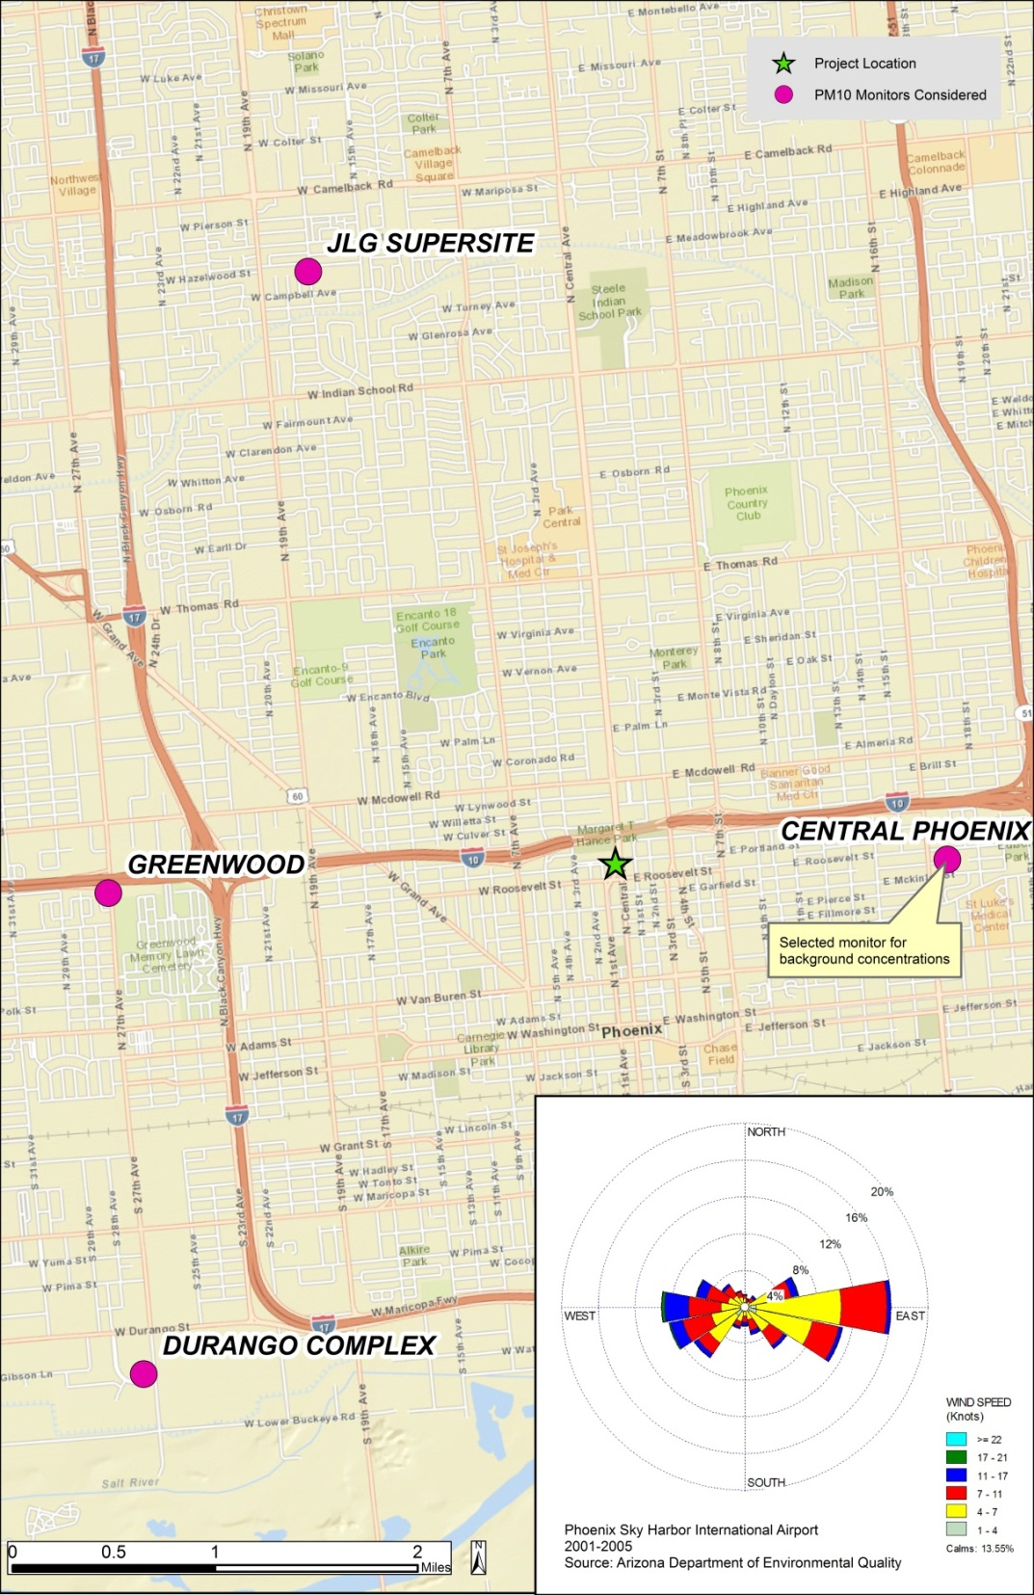
Figure 1. Map of PM₁₀ monitors (purple dots), project location (green star), and a wind rose from Phoenix Sky Harbor International Airport (inset image) used to determine background concentrations.

Monitor Data Collection and Processing
Hourly and daily [PM_{2.5} and/or PM₁₀] data for the years [insert three year period] was obtained for the selected Central Phoenix monitor from the EPA AirData website. A list of the exceptional events that have been concurred upon by EPA was obtained from the local air agency (See Table 2 and Appendix). Data that were affected by an exceptional event, and concurred upon by EPA, were removed and the data set was checked to ensure that it meets the 75% completeness criteria (Table 3). Include a copy of the AQS report in the appendix.
Table 2. Date and 24-hr PM₁₀ concentrations impacted by exceptional events as concurred upon by EPA for the Central Phoenix Monitor between 2010 and 2012.
Date | 24-hr Average PM₁₀ Concentrations (μg/m³) | AQS Exceptional Event Qualifier Code
7/3/2011 | 279 | RJ (High winds)
7/5/2011 | 277 | RJ (High winds)
7/18/2011 | 210 | RJ (High winds)
8/18/2011 | 232 | RJ (High winds)
8/25/2011 | 308 | RJ (High winds)
8/27/2011 | 233 | RJ (High winds)
9/2/2011 | 307 | RJ (High winds)
11/4/2011 | 222 | RJ (High winds)
6/27/2012 | 340 | RJ (High winds)

Table 3. The number of samples collected, the number of possible sampling days, and the percent data completeness for each quarter of each year (list years) at the (monitor name and pollutant) monitor after removal of data affected by exceptional events.
Year | Quarter | # Samples | # Possible | Completeness (%)
2010 | 1 | 90 | 90 | 100.0%
 | 2 | 91 | 91 | 100.0%
 | 3 | 92 | 92 | 100.0%
 | 4 | 92 | 92 | 100.0%
2011 | 1 | 90 | 90 | 100.0%
 | 2 | 91 | 91 | 100.0%
 | 3 | 85 | 92 | 92.4%
 | 4 | 91 | 92 | 98.9%
2012 | 1 | 91 | 91 | 100.0%
 | 2 | 90 | 91 | 98.9%
 | 3 | 91 | 92 | 98.9%
 | 4 | 92 | 92 | 100.0%
Note whether or not the data include potential exceptional events data flagged by the state air quality agency.

Calculate PM Background Concentrations
PM₁₀/PM_{2.5} background concentrations were calculated in accordance with the EPA Quantitative PM Hot-Spot guidance. The PM₁₀ background concentration for the selected Central Phoenix monitor is 144 μg/m³.

Template for Addressing Data for Exceptional-Type and Air Transport Events in Background PM Calculations for PM Hot-Spot Analysis
This document provides a template for a screening analysis to determine whether exceptional-type events are potentially impacting monitor data. If warranted by the screening analysis, a template for documenting the procedures used to analyze the potential exceptional-type events in detail to support the removal of exceptional-type event data from the calculation of background concentrations is provided. These methods are not currently supported by EPA guidance and should not be used for project level hot-spot analyses at this time. Nevertheless, the research team has found that these approaches could be useful for determining representative background concentrations and could also help inform the development of future approaches to the issue of exceptional-type events in project-level analysis.

Exceptional-Type Event Screening Analysis
A screening analysis was conducted to determine whether or not further analysis of exceptional-type events impacts on the background concentrations by recalculating the monitor design values to exclude flagged potential exceptional events and/or 95th percentile and higher concentrations. Complete Table 1 for the NAAQS relevant to the project site. For example, for the Phoenix case study, see Table 2. The results of the screening analysis (Table 2) show the removal of potential exceptional events and unusually high concentrations would not appreciably change the background concentrations, which continue to be below the NAAQS. Therefore, the background concentrations based on no data exclusion were used in the PM hot-spot analysis and no further analysis of exceptional event issues was necessary.
Or
The results of the screening analysis show the removal of potential exceptional events and unusually high concentrations would substantially change the background concentrations, resulting in the NAAQS being met. Therefore, further analysis of exceptional-type event impacts on the data was conducted to determine a representative background concentration for the PM hot-spot analysis.
Table 1. Background PM concentrations including values with and without EPA concurrence on the exclusion of data from exceptional and exceptional type events for [insert monitor name] between [insert Year 1 and Year 3].
National Ambient Air Quality Standards (NAAQS) | Background Concentration with Exceptional Event Data Exclusion (µg/m³) | Background Concentration Excluding Flagged Exceptional Events (Not Concurred by EPA) & > 95th Percentile Values (µg/m³) | Difference (μg/m³)
Annual Average PM_{2.5}
24-hr Average PM_{2.5} (note whether Tier 1 or Tier 2)
24-hr Average PM₁₀
Table 2. Background PM concentrations including values with and without EPA concurrence on the exclusion of data from exceptional and exceptional type events for the Central Phoenix monitor between 2010–2012.
National Ambient Air Quality Standards (NAAQS) | Background Concentration with Exceptional Event Data Exclusion (µg/m³) | Background Concentration Excluding Flagged Exceptional Events (Not Concurred by EPA) & > 95th Percentile Values (µg/m³) | Difference (μg/m³)
24-hour Average PM₁₀ | 144 | 118 | 26

Exceptional-Type Event Detailed Analysis
The purpose of this section is to comprehensively review the available data on potential exception-type and air transport events to reach a conclusion on which (if any) data would be appropriate for exclusion from background concentrations for a PM hot-spot analysis. Not all headings may be relevant for a given analysis and can be deleted as appropriate.

Hourly Meteorological Data
Hourly meteorological data for the analysis of potential exceptional-type events were obtained for the [insert site/airport name] from the NOAA National Climatic Data Center.

Wood Smoke Screening
Residential wood smoke impacts on a monitor are not considered an exceptional event, therefore days with greater than 95th percentile PM concentrations were reviewed for potential indicators of wood smoke. Specifically, the days were reviewed to determine if temperatures were below 40 °F or other regionally-appropriate threshold, the season the unusually high values occurred, and whether or not the days included major holidays (especially Thanksgiving, Christmas, and New Year’s Eve) when increased use of wood stoves would be likely regardless of the temperature. All of the unusually high concentrations occurred on summer days with temperatures over 40 °F, therefore, wood smoke was unlikely a factor in the high concentrations. Refer to [insert appendix name] for supporting documentation for the wood smoke assessment.

Reported Visibility Obstructions
METAR data included in the ASOS files were examined for reports of visibility obstructions, which can support identification of exceptional-type events and air transport. Blowing dust (BLDU), haze (HZ), and dust storms (DS) were reported on several of the high PM₁₀ concentration days, along with reduced visibilities. For example, Figure 1 shows hourly PM₁₀ at the Central Phoenix monitor and visibility at the Phoenix Sky Harbor International Airport on August 2 and 3, 2011. A large drop in visibility was recorded at Phoenix Sky Harbor International Airport, coincident with high PM₁₀ concentrations at the Central Phoenix PM₁₀ monitor.
[Include figures illustrating relationship between visibility obstructions and PM concentrations (see TM 3 for examples).]
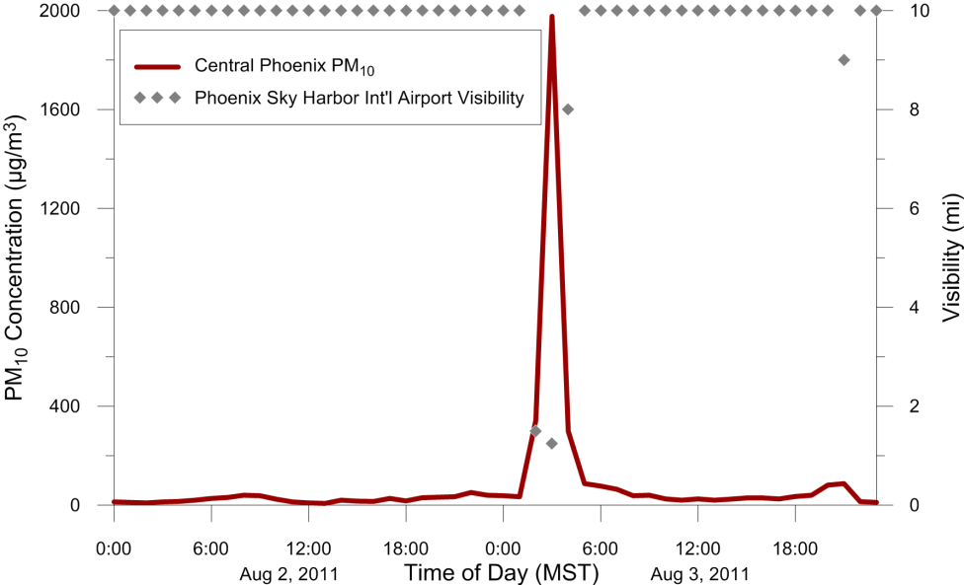
Figure 1. Hourly PM₁₀ concentrations at the Central Phoenix monitor and visibility at the Phoenix Sky Harbor International Airport monitor on August 2 and 3, 2011.

Wind Speeds
Wind speed data were examined for the potential exceptional-type events because wind speeds over 25 mph can indicate exceptional conditions where dust control measures are overcome. Gusty winds were recorded at the Phoenix Sky Harbor International Airport monitor on several of the high PM₁₀ concentration days. For example, Figure 2 shows time series of hourly wind speeds and wind gusts at Phoenix Sky Harbor International Airport and PM₁₀ at the Central Phoenix monitor on August 2 and 3, 2011. The high PM₁₀ concentrations observed on August 3, 2011, coincided with windy conditions (wind gusts over 25 mph) in the Phoenix area.
[Include figures illustrating the relationship between wind speed/gusts and PM concentrations (see TM 3 for examples).]
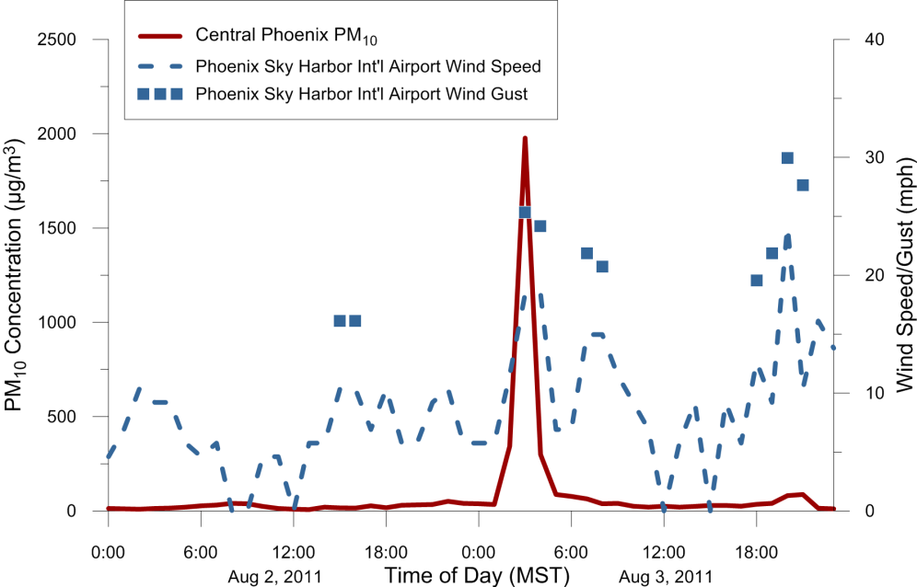
Figure 2. Hourly PM₁₀ concentrations at the Central Phoenix monitor and wind speeds at the Phoenix Sky Harbor International Airport monitor on August 2 and 3, 2011.

Review of Other Monitors
Exceptional or exceptional-type events may affect multiple monitors in a region, thus, it is important to consider data from other nearby monitors. Data for other monitors in the region were reviewed to determine if any of these monitors had data flagged for an exceptional event on the days with 95th percentile exceedances at the selected monitor. In addition to PM_{2.5} and/or PM₁₀ data, the following pollutants were reviewed for exceptional event flags at other monitors: [list pollutants]. As documented in [insert appendix name], PM_{2.5} and/or PM₁₀ data at Phoenix area monitors were flagged for exceptional events on a majority of the dates when high PM₁₀ concentrations were recorded at the selected Central Phoenix monitor.

Smoke Plumes
Smoke and haze from wild or prescribed fires can cause elevated PM concentrations. The potential for smoke plumes was first examined with the Hazard Mapping System on AirNow-Tech, which does not necessarily indicate the presence of ground level smoke. No smoke plumes occurred on the days with 95th percentile exceedances, therefore, further investigation of smoke plumes was not warranted. Note that additional data sources beyond HMS (such as other satellite imagery or media reports) are needed to confirm the presence of ground-level smoke, see Section 5 of the Final Report.

Trajectory Analysis
The HYSPLIT tool was used to examine whether dust or smoke transport from upwind sources could have impacted the selected monitor. Google Earth imagery shows undeveloped regions south of
Phoenix, including the Sonoran and Gila deserts to the southwest. HYSPLIT trajectories indicate that
air was transported through these desert regions and reached Phoenix on several of the event dates indicating that windblown dust may have contributed to the high PM10 concentrations observed at the Central Phoenix monitor on those days, given that wind speeds were sufficiently high. Include HYSPLIT screenshots as figures or in appendix.

Conclusion
This section should summarize the conclusions reached based on the data collection and analysis described above to justify whether or not some or all of the potential exceptional-type data should be excluded from the PM hot-spot analysis background concentrations. Note the role of interagency consultation in reaching the conclusions. The discussion is necessarily specific to the particular context and data. On several of the days when high PM₁₀ concentrations were recorded at the Central Phoenix monitor, HYSPLIT trajectories indicate that transport of dust from undeveloped lands outside of Phoenix may have contributed to the high PM₁₀ concentrations recorded. High gusty winds (i.e., winds greater than 25 mph) were reported at the nearby Phoenix Sky Harbor International Airport monitor, along with reports of reduced visibilities, blowing dust, and/or haze. EPA guidance states that exceedances due to high wind events are eligible for exclusion under the EER (FR 72 Part 55 13565). Additionally, data from nearby monitors were flagged for exceptional events on some of the high PM₁₀ concentration days, indicating that the events that occurred on those days were widespread and regional in nature. For some of the dates, exceptional event demonstration packages have been submitted to EPA for nearby Maricopa County monitors, and EPA has concurred that exceedances at those monitors were caused by high wind events. High winds did not occur on June 20, 2012; however, HMS smoke plume imagery shows that the Phoenix area was likely impacted by smoke on that day. Data impacted by smoke from wildfires are also eligible for exclusion under the EER (FR 72 Part 55 13566). PM₁₀ concentrations on the identified dates were above the 95th percentile for 2010−2012, indicating that concentrations on those days were in excess of normal historical fluctuations.
Table 3 summarizes the days recommended for exclusion due to exceptional-type events. In summary, nine days were excluded because they were flagged by the reporting agency as having been affected by an exceptional event, seven days were excluded because they were flagged by the reporting agency as having been affected by an exceptional event and EPA concurred on exceptional event demonstrations from nearby monitors, and 21 of 39 additional days were removed from the original Central Phoenix 2010−2012 PM₁₀ data set due to the exceptional-type nature of the local conditions when the high PM₁₀ values were observed (e.g. windblown dust). The remaining data were used to calculate a PM₁₀ background concentration of 118 μg/m³, which is the highest 24-hr PM₁₀ concentration over the three years of monitoring data after the exceptional event and exceptional-type event data days have been removed
Table 3. Screening results for days when high PM₁₀ concentrations (>95th percentile) were recorded at the Central Phoenix monitor.
Date | PM₁₀ Conc. (µg/m³) | METAR | Gusty/ High Winds?¹ | Visibility Reduction? | HMS Smoke?² | PM EE Flags | EPA Concurrence on EE Demo³ | Recommended for Exceptional-Type Event Designation | Removal Justification | Notes
8/3/2011 | 144.3 | HZ | Yes | Yes | No | Yes | Yes | Yes | Windblown dust
9/11/2011 | 129.3 | BLDU | Yes | Yes | No | Yes | Yes | Yes | Windblown dust
7/20/2011 | 122.0 | BLDU | Yes | Yes | No | Yes | No | Yes | Windblown dust
8/15/2012 | 117.8 | HZ | No | No | No | Yes | No | No | N/A
6/20/2012 | 115.9 | - | No | No | Yes | Yes | No | Yes | Smoke
7/8/2011 | 115.0 | - | No | No | No | Yes | Yes | Yes | Windblown dust
10/15/2010 | 106.3 | - | Yes | Yes | No | Yes | No | Yes | Windblown dust
10/4/2011 | 105.8 | BLDU | Yes | Yes | No | Yes | Yes | Yes | Windblown dust
3/21/2011 | 104.0 | HZ | Yes | Yes | No | No | No | Yes | Windblown dust
9/12/2011 | 102.8 | HZ | Yes | Yes | No | Yes | Yes | Yes | Windblown dust
8/7/2011 | 99.6 | HZ | No | Yes | No | Yes | No | No | N/A
6/16/2012 | 97.8 | - | No | No | No | Yes | Yes | Yes | Windblown dust
9/9/2011 | 94.5 | HZ | No | Yes | No | Yes | No | No | N/A
7/15/2012 | 90.3 | BLDU | Yes | Yes | No | No | No | Yes | Windblown dust
8/13/2012 | 87.5 | BLDU | Yes | Yes | Yes | No | No | Yes | Windblown dust
9/27/2011 | 86.8 | BLDU | Yes | Yes | Yes | Yes | No | Yes | Windblown dust
4/13/2012 | 82.7 | - | Yes | No | No | Yes | No | No | N/A
6/26/2012 | 80.8 | - | Yes | Yes | No | No | No | Yes | Windblown dust
5/24/2012 | 80.2 | - | No | No | No | No | No | No | N/A
8/28/2011 | 79.8 | BLDU | Yes | Yes | No | Yes | Yes | Yes | Windblown dust
3/7/2012 | 79.6 | - | Yes | No | No | No | No | No | N/A
7/9/2011 | 78.1 | - | Yes | Yes | No | Yes | No | Yes | Windblown dust
7/3/2012 | 77.4 | - | Yes | No | No | No | No | No | N/A
9/10/2012 | 75.0 | - | Yes | Yes | No | Yes | No | Yes | Windblown dust
1/1/2012 | 73.5 | - | No | No | No | No | No | No | N/A
8/5/2011 | 73.5 | - | Yes | No | No | Yes | No | No | N/A
7/7/2011 | 69.2 | - | No | No | No | Yes | Yes | Yes | Windblown dust
11/3/2011 | 68.0 | - | No | No | No | No | No | No | N/A
6/28/2012 | 67.3 | - | No | Yes | No | No | No | No | N/A
8/11/2011 | 66.2 | - | No | No | No | No | No | No | N/A
3/6/2012 | 65.2 | - | Yes | No | No | No | No | No | N/A
9/30/2011 | 64.6 | - | Yes | No | No | Yes | No | No | N/A
5/9/2012 | 64.6 | BLDU, DS | Yes | Yes | No | Yes | No | Yes | Windblown dust
11/16/2012 | 63.7 | - | No | No | No | No | No | No | N/A
10/2/2010 | 63.2 | - | Yes | Yes | No | Yes | No | Yes | Windblown dust
5/25/2012 | 62.3 | - | Yes | No | No | No | No | No | N/A
7/21/2012 | 62.2 | BLDU | Yes | Yes | No | No | No | Yes | Windblown dust
8/15/2010 | 62.0 | - | No | Yes | No | No | No | No | N/A
6/29/2011 | 60.1 | - | Yes | No | No | No | No | No | N/A
¹ Winds exceeding 25 mph.
² HMS smoke plume imagery in AirNow-Tech are available for July 16, 2011, to present.
³ EPA has concurred on an exceptional event demonstration for a nearby PM monitor.

