|  |  |  |
| --- | --- | --- |
|  | |  |
| NCHRP 25-46  User Manual for Clean Truck Strategies Analysis Tool |
|  |  |  |
|  |  | May 2017 |
|  |  | Prepared for |
|  |  | National Academies  Transportation Research Board  Cooperative Research Programs  500 5th Street, N.W.  Washington, D.C. 20001 |
|  |  | Prepared by |
|  |  | ICF International  620 Folsom St.  Suite No. 200  San Francisco, CA 94107 |



**Contents**

1. Introduction 1

1.1. Installation of the Tool and Computer Requirements 1

2. Overview of Tool Scope and Outputs 3

2.1. Analysis Types 3

2.2. Analysis Years 3

2.3. Geographic Scale 4

2.4. Truck Types 5

2.5. Types of Outputs 6

2.6. Strategies 6

2.6.1. Alternative Fuels 7

2.6.2. Exhaust Retrofits 10

2.6.3. Aerodynamic Devices 11

2.6.4. Tires 13

2.6.5. Idle Reduction 14

2.6.6. Accelerated Retirement 14

3. Default Inputs in the Tool 16

4. Implementation of the Analysis Options 17

4.1. Tool Structure 17

4.2. Tool Buttons 19

4.3. Truck Deployment Analysis 20

4.4. Funding Impact Analysis 27

4.5. Incentive Analysis 31

5. Development of Inputs 34

5.1. Emission Factors 34

5.1.1. Truck Categories 34

5.1.2. Geographic Categories 34

5.1.3. Parameters Extracted from MOVES 40

5.2. Relative Reduction Factors 43

5.3. Cost Estimates 47

5.4. Useful Lifetime 51

6. Examples 52

6.1. MPO Case Study 54

6.1.1. Truck Deployment Analysis – Alternative Fuels 54

6.1.2. Truck Deployment Analysis – Accelerated Retirement 56

6.1.3. Funding Impact Analysis 58

6.1.4. Incentive Analysis 60

6.2. State DOT Case Study 62

6.2.1. Incentive Analysis – Idle Reduction 62

6.2.2. Truck Deployment Analysis – Alternative Fuels 65

6.2.3. Funding Impact Analysis 68

6.3. Port Operator Case Study 70

6.3.1. Truck Deployment Analysis – Alternative Fuels 70

6.3.2. Truck Deployment Analysis – Accelerated Retirement 72

**Tables**

Table 1. Analysis Types Used in the Tool 3

Table 2. Analysis Years Used in the Tool 3

Table 3. Geographic Scales Used in the Tool, and Related Truck Types 4

Table 4. Truck Types Used in the Tool 5

Table 5. Types of Outputs Provided in the Tool 6

Table 6. Alternative Fuels Used in the Tool 7

Table 7. Exhaust Retrofits Used in the Tool 10

Table 8. Aerodynamic Devices Used in the Tool 11

Table 9. Tire Modifications Used in the Tool 13

Table 10. Idle Reductions Used in the Tool 14

Table 11. Types of Default Data Provided in the Tool 16

Table 12. Descriptions of Tool Symbols 19

Table 13. Core-based Statistical Areas Used in the MOVES Modeling Supporting the Tool’s Metropolitan Geographic Scale 35

Table 14. Counties Used in the MOVES Modeling Supporting the Tool’s “County/Municipal” Geograhic Scale 37

Table 15. Default Annual Average Mileage Accumulation Rates 41

Table 16. Average Age by Truck Type and Analysis Year used in the Tool 41

Table 17. Default Vehicle Populations used in the Tool 42

Table 18. Default Extended Annual Idle Hours by Geographic Scale 42

Table 19. RRFs for Alternative Fuel Scenarios 43

Table 20. CO2 Emissions per kWh from Power Plants for Charging Electric Vehicles 44

Table 21. RRFs for Other Strategy Types 46

Table 22. Incremental Capital Costs for Alternative-fuel Scenarios 47

Table 23. Incremental Capital Costs for Other Scenarios 48

Table 24. Incremental Operation and Maintenance Costs for Exhaust Retrofits 48

Table 25. Search Criteria for Truck-purchase Costs 49

Table 26. Coefficients of Truck-cost Cubic Equation 49

Table 27. Default Fuel Prices Used in the Tool 51

Table 28: Useful Lifetimes 51

**Figures**

Figure 1. Aerodynamic Devices Used in the Tool 12

Figure 2. Second by Second Port Driving Cycle Components 39

Figure 3. Port Driving Cycle used for Port Facility in Tool 39

Figure 4. North American Electric Corporation Map of U.S. Regions of Electricity Generation 45

Figure 5. Derived Truck-purchase Costs Based on Age and Type 50

Acronyms and Abbreviations

|  |  |
| --- | --- |
| Acronym / Abbreviation | Stands For |
| ATIS | Automatic tire inflation systems |
| B20 | 20 percent blend of biodiesel with petroleum diesel |
| CNG | Compressed natural gas |
| CO2 | Carbon dioxide |
| Combo | Combination |
| DEF | Diesel exhaust fluid |
| DGE | Diesel gallon equivalent |
| DOC | Diesel oxidation catalyst |
| DPF | Diesel particulate filter |
| EPA | U.S. Environmental Protection Agency |
| EV | Electric vehicle |
| FAME | Fatty acid methyl ester |
| gal | Gallon |
| Gas | Gasoline |
| GGE | Gasoline gallon equivalent |
| GHG | Greenhouse gases |
| HC | Hydrocarbons |
| kWh | Kilowatt hour |
| LNG | Liquefied natural gas |
| LPG | Liquefied petroleum gas |
| MOVES | Motor Vehicle Emissions Simulator |
| NOx | Oxides of nitrogen |
| PM2.5 | Particulate matter smaller than 2.5 microns |
| R100 | 100 percent renewable diesel |
| RCNG | Renewable natural gas in compressed form |
| RLNG | Renewable natural gas in liquefied form |
| tons | Short tons |
| VMT | Vehicle miles traveled |



# Introduction

This document is a User Manual for the NCHRP 25-46 Clean Truck Strategies Analysis Tool. The purpose of the Tool is to enable users to quickly evaluate various strategies to reduce freight truck emissions by presenting cost, emission reduction, and cost effectiveness. The Tool is designed to be useful to a diverse set of public agencies with varied objectives and resources. For example, some agencies might be concerned primarily with reducing greenhouse gas (GHG) emissions, while others are more focused on reducing oxides of nitrogen (NOx) or particulate matter (PM); also some agencies might have sufficient funding to support a major incentive program for clean trucks, while others might have little or no discretionary funding. In addition, the Tool can support agencies at different geographic scales: state, metropolitan area, county/municipality, and facility.

Each strategy analysis requires different inputs and provides different outputs. The Tool is necessarily generalized, relying on averages and default values but allowing users to input information to override default values. For example, the default values in the Tool for the annual vehicle miles traveled (VMT) by truck type reflect national averages, but users can replace these default values with local data.

Section 1.1 contains a description of what settings to use so that the Tool opens and functions properly. Section 2 of this Manual contains summary descriptions of the scope of the Tool and the outputs it produces. Section 3 outlines the default inputs to the Tool. Section 4 contains a more complete description of each analysis option in the Tool (Truck Deployment Analysis, Investment Analysis, and Incentive Analysis); it also includes a brief description of how the Tool works. Section 5 contains additional information on the modeling and other data sources used to develop the emission factors, fuel-use data, and cost increments used in the Tool. Section 6 contains examples of how users at different at the state, local, or facility level can use the Tool to answer common questions they may face; each hypothetical scenario includes detailed sample values to input into the Tool and a description of how to interpret the results.

## Installation of the Tool and Computer Requirements

Tool Users must have a full installation of Microsoft® Excel™, version 2007 or more recent.

You must have macros enabled in Excel to use the Tool. If your Excel settings disable macros from functioning and the Tool will not run, save it to the desired location on your computer or network drive. Then open a new (blank) instance of Excel. Under *File*, go to *Options*. Then, go to the *Trust Center* section and click the *Trust Center Settings* button. Under *Trusted Locations*, click the *Add new location* button, and add the folder where the Tool is as a trusted location.

With these settings engaged, open the Tool (either by selecting *File*, then *Open* in Excel, or by double-clicking the file in the folder). It will open to the *Select Analysis* screen with the Excel menu bar, cell and row designations hidden (i.e., it shows the worksheet contents in full-screen mode). Microsoft has several online help pages on the Trust Center[1] and on Macro Security[2]; in particular, look into Macro Security if the Tool does not open properly.

# Overview of Tool Scope and Outputs

## Analysis Types

The Tool allows the three types of analyses described in Table 1.

Table 1. Analysis Types Used in the Tool

|  |
| --- |
| Truck Deployment Analysis  Allows an agency to see the emissions benefits, costs, and cost effectiveness of replacing trucks or retrofitting trucks with certain advanced technologies or alternative fuels. |
| Funding Impact Analysis  Estimates the number of replaced or retrofitted trucks, and corresponding emissions benefits, if an agency were to invest a given amount of money into clean-truck strategies.  The agency can then see which approaches/strategies yield the greatest emission benefit or are the most cost effective. |
| Incentive Analysis  Estimates the payback period to truck owners when the public agency covers only a portion of a strategy’s incremental cost.  User selects a truck type and strategy that results in fuel savings, and the Tool calculates the emissions benefits, cost effectiveness, and payback period for the truck owner (how many years it would take for the fuel savings to cover the non-incentivized incremental cost). The Tool calculates these for 25, 50, and 75 percent incentivizing of the full strategy cost.  Many strategies result in fuel savings for truck owners, so public agencies often provide only a portion of the strategy cost on the assumption that the owner will be willing to pay for the balance. To maximize the benefits of the public funds, the agency will typically seek to set the incentive at the lowest level that will still generate interest among truck owners. |

## Analysis Years

The Tool calculates benefits for the years shown in Table 2.

Table 2. Analysis Years Used in the Tool

|  |
| --- |
| 2015 |
| 2020 |
| 2025 |
| 2030 |
| 2035 |
| 2040 |

## Geographic Scale

The Tool models the five geographic scales described in Table 3. The applicable truck types are also shown and are discussed further in Section 2.4. The ways that MOVES was used to model these geographic scales are addressed in Section 5.1.2.

Table 3. Geographic Scales Used in the Tool, and Related Truck Types

|  |  |
| --- | --- |
| Geographic Scale | Applicable Truck Types |
| **State**  Average state geographical area.  Derived from MOVES. | All |
| **Metropolitan**  Metropolitan planning organization area.  Derived from MOVES as an average of the four largest metropolitan areas. | All |
| **County/Municipal**  County or city area.  Derived from MOVES as an average of 33 counties. | All |
| **Distribution Center**  Typical distribution center, served by long haul trucks and drayage trucks. | Combination Units |
| **Port**  Typical port which drayage trucks frequent.  Includes on-port movements (i.e., idling, creep mode, low speed transient operation) and off-port movements within 20 miles of the port.  If the Tool user wants to analyze ports with longer truck-travel distances, the county/municipal geographic scale should be selected. | Combination unit Short Hauls |

## Truck Types

The Tool models the four truck types described in Table 4. The truck types used in MOVES are addressed in Section 5.1.1.

Table 4. Truck Types Used in the Tool

|  |
| --- |
| **Single unit Short Haul**  Represents local pick-up and delivery trucks that can be fueled on either diesel or gasoline.  Generally class 3, class 4, or class 5 trucks that travel less than 50 miles round trip. |
| **Single unit Long Haul**  Represents regional delivery box trucks, fueled on diesel, that transfer goods between cities.  Generally class 6 or class 7, and traveling 100 miles or more per day. |
| **Combination unit Short Haul**  Represents drayage trucks, fueled on diesel, that generally move between manufacturing facilities, warehousing facilities (e.g., distribution centers), and intermodal terminals (e.g., ports).  Generally class 8 traveling less than 50 miles round trip per day. |
| **Combination unit Long Haul**  Represents class 8 long haul trucks (e.g., line-haul trucks), fueled on diesel, that have one or two trailers and cover long distances, generally more than 100 miles per day. |

## Types of Outputs

The Tool provides the types of outputs listed in Table 5. The derivation of default values for these variables can be found in Section 5.

Table 5. Types of Outputs Provided in the Tool

|  |
| --- |
| **Fuel use** |
| * Running (mi/gal) |
| * Extended idle (gal/hr; only combination unit long hauls) |
| * Total, running + extended idle (gal/yr) |
| **Pollutants**   * NOx |
| * Fine PM (PM2.5) |
| * Carbon dioxide (CO2) |
| **Emissions** |
| * Running |
| * Brake wear (PM2.5 only) |
| * Tire wear (PM2.5 only) |
| * Extended idle (only combination unit long hauls) |
| * Emission factors (g/mi; g/hr for extended idle) |
| * Total program emissions (short tons) |
| * Differences between baseline and modification/replacement |
| **Costs** |
| * Capital costs of modified or replacement truck(s) |
| * Fuel costs of baseline and modified/replacement truck(s) |
| * Differences between baseline and modification/replacement |
| **Cost effectiveness** |
| * Dollars per change in short tons of emissions (assuming all the funding was used to reduce that pollutant only) |
| **Investment payoff (Investment Analysis only)** |
| * Number of trucks to which the selected modification can be applied with the user-provided hypothetical investment dollars |
| **Incentive payoff (Incentive Analysis only)** |
| * Number of years for fuel savings (after application of selected modification) to pay off the capital costs not covered by the incentive-provided hypothetical incentive dollars |

## Strategies

The Tool allows for analysis of a variety of clean truck strategies, as described in Sections 2.6.1 through 2.6.6. Not all strategies can be analyzed for every situation. For each strategy, the Manual shows which combination of Analysis Type (Deployment, Funding Impact, or Incentive Analysis), Geographic Scale (State, Metropolitan, County/Municipal, Distribution Center, or Port), and Truck Type (Single unit short haul, Single unit long haul, Combo unit short haul, and Combo unit long haul) the user can analyze the strategy in the Tool.

### Alternative Fuels

As described in Table 6, the Tool evaluates several alternative fuels, though some apply to only a subset of truck types.

Table 6. Alternative Fuels Used in the Tool

|  |  |  |  |
| --- | --- | --- | --- |
| Alternative Fuel | Analysis Typesa | Geo-graphic Scalesb | Truck Typesc |
| **Compressed Natural Gas (CNG)**  This option in the Tool assumes the purchase of a new CNG truck, and the old truck will be scrapped.  Traditionally, refuse trucks, local pickup and delivery vehicles, and other centrally fueled truck fleets have been early adopters of CNG. CNG has been less widely deployed in the long haul truck market because it contains less energy per unit of volume than diesel and liquefied natural gas. | Dep,Fund | All | All |
| **Liquefied Natural Gas (LNG)**  This option in the Tool assumes the purchase of a new LNG truck, and the old truck will be scrapped.  Recent advances in tank storage capacity and fast-fill refueling technology for LNG, along with the surging supply of domestic natural gas, have made LNG a more viable option for long haul trucking. The higher energy density and on-board storage capacity of LNG have made it a more appealing option for some trucking fleets. | Dep,Fund | All | 5 |
| **Renewable CNG (RCNG)**  This option assumes the use of compressed renewable natural gas (e.g., landfill gas). It assumes the purchase of a new CNG truck and the old truck will be scrapped. | Dep,Fund | All | All |
| **Renewable LNG (RLNG)**  This option assumes the use of liquefied renewable natural gas (e.g., landfill gas). It assumes the purchase of a new LNG truck and the old truck will be scrapped. | Dep,Fund | All | 5 |
| **CNG in a Low NOx Engine**  This option assumes the use of compressed natural gas in a low-NOx natural gas engine (0.02 g/bhp-hr NOx level). It assumes the purchase of a new CNG low NOx truck and the old truck will be scrapped.  Although these engines currently are not large enough for use in line-haul trucks, the tool allows this option for all truck types. | Dep,Fund | All | All |
| **LNG in a Low NOx Engine**  This option assumes the use of liquefied natural gas in a low-NOx natural gas engine (0.02 g/bhp-hr NOx level). It assumes the purchase of a new LNG low-NOx truck, and the old truck will be scrapped. | Dep,Fund | All | 5 |
| **RCNG in a Low NOx Engine**  This option assumes the use of compressed renewable natural gas (e.g., landfill gas) used in a low-NOx natural gas engine (0.02 g/bhp-hr NOx level). It assumes the purchase of a new CNG low NOx truck and the old truck will be scrapped.  Although these engines currently are not large enough for use in line-haul trucks, the tool allows this option for all truck types. | Dep,Fund | All | All |
| **RLNG in a Low NOx Engine**  This option assumes the use of liquefied natural gas (e.g., landfill gas) used in a low-NOx natural gas engine (0.02 g/bhp-hr NOx level). It assumes the purchase of a new LNG low NOx truck and the old truck will be scrapped.  Although these engines currently are not large enough for use in line-haul trucks, the tool allows this option for all truck types. | Dep,Fund | All | 5 |
| **Propane**  This option in the Tool assumes the purchase of a new LPG truck, and the old truck will be scrapped.  Also referred to as liquefied petroleum gas (LPG), propane is well suited for gasoline engines because it has a high octane rating. | Dep,Fund | All | 1,2 |
| **Biodiesel (B20)**  This option is a “drop-in” fuel, meaning it can be used in any diesel engine (although older diesel engines may have issues with pump seals); the Tool assumes no scrapping of old trucks and no purchasing of new trucks.  Biodiesel is a fatty acid methyl ester (FAME) that can be synthesized from vegetable oils, waste oils, fats, and grease. Biodiesel is usually blended with petroleum diesel. B20 is a 20% blend of biodiesel by volume with petroleum diesel. As of April 2016, there were 206 public biodiesel stations and 484 private stations in the US. | Dep | All | 2,3,4,5 |
| **Renewable Diesel (R100)**  This option is a “drop-in” replacement for petroleum diesel and therefore can be used anywhere petroleum diesel is used; the Tool assumes no scrapping of old trucks and no purchasing of new trucks.  Renewable diesel is generally made by hydrotreating FAME, which yields a drop-in replacement for diesel. R100 meets the American Society of the International Association for Testing and Materials petroleum diesel specification and makes it compatible with existing diesel infrastructure and vehicles. R100 has a lower cetane rating than biodiesel, thus limiting the NOx increases typically experienced with FAME fuels. | Dep | All | 2,3,4,5 |
| **Hybrid**  This option in the Tool assumes the purchase of a new hybrid truck, and the old truck will be scrapped.  In a hybrid truck, a diesel or gasoline engine is paired with an electric motor/generator or hydraulics. Hybrid applications tend to have the greatest fuel-efficiency improvements and emission-reductions benefits for smaller trucks that are more engaged in stop-and-go traffic, idling, or where parasitic loads on engines for air conditioning or other vehicle utilities are common. | All | All | 1,2,4 |
| **Electric**  This option in the Tool assumes the purchase of a new electric truck, and the old truck will be scrapped.  Battery electric vehicles replace the entire engine and drive train of a conventional vehicle with an electric motor and generator, powered by a battery pack. The range of battery electric vehicles is dependent on the battery technology and the size of the battery pack. For electric trucks only, GHG emissions from electricity generation are estimated, based upon average or user-entered electrical grid mix. | All | All | 1,2,4 |
| aCodes used in this table for analysis types: **Dep**=Deployment **Fund**=Funding Impact **Inc**=Incentive | | | |
| bCodes used in this table for geographic scales: **S**=State **M**=Metropolitan **C**=County/Municipal **D**=Distribution Center **P**=Port | | | |
| cCodes used in this table for truck types: **1**=Single unit Short Haul, Gasoline **2**=Single unit Short Haul, Diesel **3**=Single unit Long Haul **4**=Combination unit Short Haul **5**=Combination unit Long Haul | | | |

### Exhaust Retrofits

Exhaust retrofits reduce emissions by replacing the muffler with a catalyst or particulate filter. These can be added to older trucks to reduce emissions. Newer trucks already have these devices. The retrofits used in the Tool are described in Table 7.

Table 7. Exhaust Retrofits Used in the Tool

|  |  |  |  |  |
| --- | --- | --- | --- | --- |
| Exhaust Retrofit | Analysis Typesa | Geo-graphic Scalesb | Truck Typesc | |
| **Diesel Oxidation Catalyst (DOC)**  Only for 1991-2003 engine model years.  An after-treatment device that reduces carbon monoxide, hydrocarbons (HC), and the organic carbon component of PM. Typically housed in a stainless steel structure connected to the exhaust system muffler. Can be used in combination with Selective Catalytic Reduction (SCR) to reduce emissions further. Not needed with Diesel Particulate Filters (DPFs), because DPFs generally include catalytic material. | Dep,Fund | All | 2,3,4,5 | |
| **Diesel Particulate Filter (DPF)**  Can only be used on 1994–2006 trucks which are in good operating condition (trucks of model year 2007 and newer already have DPFs as original equipment).  An after-treatment device that captures PM from the exhaust gas flow. To prevent plugging of the filter, filtered PM must be oxidized through a regeneration process (i.e., the trapped particles must be burned away). DPFs are labeled passive or active, depending on the method of regeneration. Regeneration is accomplished by either raising the exhaust gas temperature or by lowering the diesel PM ignition temperature through the use of a catalyst. Catalysts can be applied as a coating on the filter or installed upstream of the filter. Passive and semi-active DPFs require operating temperatures above certain thresholds for a portion of time in order to oxidize the PM. Active systems use a separate heat source to raise the gas temperatures high enough for regeneration. | Dep,Fund | All | 2,3,4,5 | |
| aCodes used in this table for analysis types: **Dep**=Deployment **Fund**=Funding Impact **Inc**=Incentive | | | |
| bCodes used in this table for geographic scales: **S**=State **M**=Metropolitan **C**=County/Municipal **D**=Distribution Center **P**=Port | | | |
| cCodes used in this table for truck types: **1**=Single unit Short Haul, Gasoline **2**=Single unit Short Haul, Diesel **3**=Single unit Long Haul **4**=Combination unit Short Haul **5**=Combination unit Long Haul | | | |

### Aerodynamic Devices

Various aerodynamic devices can be added to existing trucks. These tend to provide the most benefits for long haul trucks and therefore are limited to long haul trucks in the Tool. Generally they reduce the aerodynamic drag of the vehicle and increase fuel economy, thereby reducing CO2 emissions. The devices can be used in combination on a given truck, but the combined fuel economy results will likely be less than the sum of all the various aerodynamic devices added. Each Tool choice is described in Table 8 and shown in Figure 1.

Table 8. Aerodynamic Devices Used in the Tool

|  |  |  |  |
| --- | --- | --- | --- |
| Aerodynamic Device | Analysis Typesa | Geo-graphic Scalesb | Truck Typesc |
| **Boat Tail**  Sometimes called a trailer tail, A tapering protrusion mounted on the rear of a truck or trailer to reduce aerodynamic drag. | All | S,M,C,D | 3,5 |
| **Trailer Gap Fairing**  Also known as gap reducers. Usually rounded additions to the sides and/or top of the front of the trailer that reduce the gap between the tractor and trailer. | All | S,M,C,D | 5 |
| **Roof Fairings**  Extends over the cab of a tractor and has enclosed sides. Designed to improve the flow of air over and around a tractor-trailer, reducing aerodynamic drag and increasing fuel efficiency. Some are collapsible to allow for the fairing to be taken down when the tractor is operated with a non-box trailer or without an attached trailer. | All | S,M,C,D | 3,5 |
| **Tractor Side Fairings**  Also known as cab fairings. Extend downward from the base of the cab between the wheels of the tractor, covering the open space and streamlining the fuel tank(s). In some cases, may consist of a single component that is a wheel-to-wheel fairing. In other cases, consists of two components—a partial side fairing and a fuel tank fairing. | All | S,M,C,D | 5 |
| **Trailer Side Skirts**  Also called trailer fairings. Extend down from the bottom of the trailer to cover part of the open space between the tractor and the rear wheels. Improve airflow around the trailer and reduce drag. Can be used on either the front trailer or both trailers with increased results. | All | S,M,C,D | 5 |
| **Fuel Tank Skirts**  Cover the fuel tank and reduce aerodynamic drag caused by the fuel tank. | All | S,M,C,D | 5 |
| aCodes used in this table for analysis types: **Dep**=Deployment **Fund**=Funding Impact **Inc**=Incentive | | | |
| bCodes used in this table for geographic scales: **S**=State **M**=Metropolitan **C**=County/Municipal **D**=Distribution Center **P**=Port | | | |
| cCodes used in this table for truck types: **1**=Single unit Short Haul, Gasoline **2**=Single unit Short Haul, Diesel **3**=Single unit Long Haul **4**=Combination unit Short Haul **5**=Combination unit Long Haul | | | |

Figure 1. Aerodynamic Devices Used in the Tool



### Tires

Energy lost due to resistance or friction at the point where tires meet the road can have an impact on the fuel economy of trucks, especially tractor-trailers because they have more tires. Three strategies in the Tool relate to tires, as summarized in Table 9.

Table 9. Tire Modifications Used in the Tool

|  |  |  |  |  |
| --- | --- | --- | --- | --- |
| Tire Modification | | Analysis Typesa | Geo-graphic Scalesb | Truck Typesc |
| **Low Rolling Resistance Tires**  Minimize the energy lost as heat as the tire rolls. Achieved through the use of alternative tire materials, designed and verified for specific axle positions (i.e., steer, drive, or trailer). Low rolling resistance can also be achieved through retreads as well as tire replacements. | | Dep,Fund | All | All |
| **Wide-Base Single Tires**  Replaces two thinner tires (which are heavy and produce high rolling resistance) with a single tire (with an aluminum rim that is lighter than two standard tires and wheels and has lower rolling resistance). | | Dep,Fund | All | All |
| **Tire Pressure Systems**  Proper tire inflation is a critical element that fleets consider when they seek to optimize performance, fuel economy, maintenance, tire wear, and driver satisfaction/comfort. Tire pressure systems are designed to overcome a variety of causes of tire under-inflation. With properly inflated tires, tire rolling resistance is decreased and fuel use is reduced compared to under-inflation. | **Tire Pressure Monitoring**  Provides direct measurement of tire pressure. Some technologies also include temperature readings. Users establish a preset pressure target; when the pressure drops below this threshold, the driver and/or maintenance staff are alerted. Available for trailers and tractors. | Dep,Fund | S,M,C,D | 5 |
| **Automatic Tire Inflation (ATIS)**  Monitor and continually adjust the level of pressurized air in tires, maintaining proper tire inflation automatically, even while the truck is moving. | Dep,Fund | S,M,C,D | 5 |
| **Dual Tire Equalizers**  Maintain equal pressure in dual assemblies, which helps prevent premature wear and failure. Use a single sensor to monitor the pressure in both tires of a dual-tire assembly, with a hose connection to each tire valve stem. When pressure levels between the tires do not match, the system will bring the two tires to the same pressure level. No air is added or removed by the equalizer unit; if air loss continues, the leaking tire is isolated and a visual signal is sent the driver. | Dep,Fund | S,M,C,D | 5 |
| **Central Tire Inflation**  Similar to ATIS, but the driver can increase/decrease tire inflation from the cab depending on the operating conditions of the vehicle. Typically intended for off-road or military truck applications. | Dep,Fund | S,M,C,D | 5 |
| **Passive Tire Containment**  Offer ways to maintain air in the tire without any action to measure, report, or adjust inflation pressure once a tire has been aired up. Nitrogen inflation attempts to reduce natural pressure losses due to diffusion through the casing. Use of tire sealants, in several forms, is generally aimed at downtime reduction due to air loss caused by small punctures. | Dep,Fund | S,M,C,D | 5 |
| aCodes used in this table for analysis types: **Dep**=Deployment **Fund**=Funding Impact **Inc**=Incentive | | | | | |
| bCodes used in this table for geographic scales: **S**=State **M**=Metropolitan **C**=County/Municipal **D**=Distribution Center **P**=Port | | | | | |
| cCodes used in this table for truck types: **1**=Single unit Short Haul, Gasoline **2**=Single unit Short Haul, Diesel **3**=Single unit Long Haul **4**=Combination unit Short Haul **5**=Combination unit Long Haul | | | | | |

### Idle Reduction

Truckers report idling between one and ten hours per day. The American Trucking Association estimates that trucks engaged in long haul option average about six hours per day of idling time. Truckers often idle to provide heating and cooling for the cab, and sleeper trucks have a number of additional power demands, or hotel loads, related to amenities such as appliances and electronics. The technologies included in the Tool that can reduce long duration idling are described in Table 10.

Table 10. Idle Reductions Used in the Tool

|  |  |  |  |  |
| --- | --- | --- | --- | --- |
| Idle Reduction | Analysis Typesa | Geo-graphic Scalesb | Truck Typesc | |
| **Fuel Operated Heaters**  Include cab/bunk heaters, which supply warm air directly from a small combustion flame to the heat exchanger, as opposed to the primary engine. Can also be designed to include cooling options, if necessary. | All | S,M,C,D | 5 | |
| **Auxiliary Power Units**  Portable vehicle-mounted systems that provide power for climate control and electrical devices when the engine is shut off. Typically powered by either a small diesel combustion engine and generator or batteries (external or internal). | All | S,M,C,D | 5 | |
| **Auto start/stop**  Electric-powered systems that automatically shut down the main engine when idling by monitoring engine temperature or battery charge level. Restarts the engine when needed based on a set time period or temperature. Cab heating and cooling is provided when the engine is on, but not when it is off. Does not provide additional power for other loads. | All | S,M,C,D | 5 | |
| aCodes used in this table for analysis types: **Dep**=Deployment **Fund**=Funding Impact **Inc**=Incentive | | | |
| bCodes used in this table for geographic scales: **S**=State **M**=Metropolitan **C**=County/Municipal **D**=Distribution Center **P**=Port | | | |
| cCodes used in this table for truck types: **1**=Single unit Short Haul, Gasoline **2**=Single unit Short Haul, Diesel **3**=Single unit Long Haul **4**=Combination unit Short Haul **5**=Combination unit Long Haul | | | |

### Accelerated Retirement

Replacing older diesel trucks with newer trucks can significantly reduce PM, NOx and CO2 emissions, because newer trucks are subject to emissions regulations that are more stringent. Freight trucks typically have useful lifespans longer than a decade, and may remain in a fleet as long as the operating and maintenance costs do not exceed the payments on a newer vehicle or as long as the vehicle meets regulations.

Currently, accelerated retirement programs focus on replacing trucks older than model year 2007 with or replacing pre-2010 trucks with new trucks. By analysis years 2020 and 2025, nearly all pre-2007 trucks will be out of service, so accelerated retirement for those years should focus on replacing pre-2010 trucks. By analysis years 2030, the Federal Phase I GHG regulations for trucks will be fully phased in, and the replacement of pre-2018 could be considered. By analysis years 2035 and 2040, the Federal Phase II GHG regulations will be fully phased in, and the replacement of pre-2027 could be considered. This option assumes the replaced trucks will be scrapped and the replacement trucks are new. Though these are the recommended replacement points, the user may use any breakpoint in the Tool within 30 years prior to the analysis year.

# Default Inputs in the Tool

The Tool is preloaded with default data on the information shown Table 11. As discussed in Sections 4.3 through 4.5, users may override some default values with custom data, for annual mileage accumulation, annual idle hours, fuel purchase prices, and power-plant CO2 emission rates. The derivation of these defaults is discussed in Section 5.

Table 11. Types of Default Data Provided in the Tool

|  |
| --- |
| **Basic Vehicle Data** (By Analysis Year, Truck Type, Baseline Fuel Type, and Geographic Scale)**:** |
| * Annual mileage accumulation |
| * Annual idle hours (combination unit long hauls only) |
| * Vehicle population |
| **Vehicle Factors** (By Analysis Year, Truck Type, Baseline Fuel Type, Geographic Scale, and Model Year; see also Section 5.1)**:** |
| * Running emission factors (g/mi; NOx, PM2.5, CO2) |
| * Extended idle emission factors (gal/hr; NOx, PM2.5, CO2; combination unit long hauls only) |
| * Bake- and tire-wear emission factors (g/mi; PM2.5) |
| * Fuel economy (mi/gal) |
| * Travel fraction (for the specified combination of analysis year, truck type, baseline fuel type, and geographic scale: the fraction of total VMT accounted for by each model year) |
| **Fuels** (see also Section 5.3)**:** |
| * Purchase price per gallon: |
| * Diesel (petroleum and others) |
| * Gasoline |
| * Propane |
| * Purchase price per gasoline and diesel gallon equivalents: |
| * Natural gas (petroleum and renewable) |
| * Propane |
| * Biodiesel and renewable diesel |
| * Electric |
| * Purchase price per kilowatt hours for electricity |
| * Emissions generated by power plant to charge electric vehicle (g CO2 / kWh) |
| **Modification Factors** (By Modification Type, Truck Type, and Baseline Fuel Type; see also Sections 5.2 and 5.3)**:** |
| * Changes in running emissions (NOx, PM2.5, CO2) |
| * Changes in emissions from brake wear and tire wear (PM2.5) |
| * Changes in fuel economy |
| * Cost of modification |
| * Changes in costs of operation and maintenance |

# Implementation of the Analysis Options

## Tool Structure

The Clean Truck Strategies Tool was developed in Microsoft® Excel™ with Visual Basic® for Applications (VBA). The user can open the Tool like they would any other Microsoft Office™ file, if the user has Microsoft Office. The Tool is designed to open full screen and with a customized look—without most of the framework of the Excel application, except for scroll bars. The user should not see an application toolbar/ribbon along the top (where *File*, *Insert*, etc. menus are), the Excel formula bar, the spreadsheet column and row numbering, or spreadsheet tabs along the bottom. The Tool is designed to open this way because the user interacts with the Tool using customized buttons that are inside the spreadsheet instead of along the framework of the software application, and because the user is not permitted to modify formulas or spreadsheets in general. The Tool was designed to be “locked down” to control the user’s experience and to protect the Tool’s contents from inadvertent or intentional changes by the user; this includes an inability to save the Tool, but outputs may be saved by first using the export feature and the subsequently saving the exported file of outputs.

The Tool was designed using a combination of the features listed below.

* Static spreadsheet contents (e.g., various descriptive text)
* Navigation buttons (e.g., to advance to the next sheet, return to the previous sheet, clear the contents of the sheet)
* Data-entry cells (where the user can type in information or use a pull-down to select data; some also auto-populate with default values, which the user can override)
* Selection buttons (which the user can click to select an option; some allow multiple options to be selected)
* Calculation formulas (to implement various calculations of emissions, costs, etc.)
* Data-validation procedures (to provide some real-time quality control of user-entered data)

Programming code in VBA

Navigating the Tool using the various navigation buttons and selection buttons is accomplished using VBA programming. In most cases, clicking a button runs a VBA subroutine that completes the intended action (e.g., navigates to the proper spreadsheet, enables or disables other options based on the button that was clicked, etc.).

The user will notice some cases where they click a button to make one selection about the scope of their analysis, and that immediately causes other potential options on the screen to become enabled (i.e., descriptive text becomes black, selection button becomes visible) or disabled (i.e., descriptive text becomes gray, selection button becomes invisible). One example is selecting geographic scale for the Truck Deployment Analysis: selecting state, metropolitan, or county/municipal will enable all available truck types, but selecting distribution center will disable single unit trucks (leaving combination unit trucks as the only enabled option), and selecting port will disable all trucks except for combination unit short hauls.

In some cases, clicking a selection button on one sheet will dictate the next sheet the user sees, and/or will enable/disable options on one or more future sheets. One example is in the Truck Deployment Analysis: in one sheet the user selects analysis year, geographic scale, truck type(s), and modification type; the choice of modification type impacts the next sheet that is shown (the next sheet is specific to the modification type), and the specific modifications available on that next sheet are enabled/disabled based on the user’s choices for geographic scale and truck type(s); the choice of truck type(s) also modifies the next sheet so that the user can only enter additional information for the selected type(s), and it modifies yet another sheet to enable/disable fuel types.

The VBA programming code conducts some quality control measures, which occurs on some sheets when the user clicks the button to advance to the next sheet or step. A pop-up window might appear when clicking the *Next* or *Calculate* button, and it will indicate that there was a problem with one or more user selections on the sheet. Otherwise, some user-entered data are checked in real-time by Excel data-validation procedures (outside of VBA)—in these cases, a pop-up window will provide immediate feedback if the entered value is out of bounds or otherwise unexpected.

Finally, the VBA programming code facilitates other “behind-the-scenes” steps like recording the selections the user makes and exporting the Tool’s outputs to a new Excel file.

## Tool Buttons

The Tool has several buttons, as described in Table 12.

Table 12. Descriptions of Tool Symbols

| **Symbol** | **Description** |
| --- | --- |
|  | Reset Tool: Reset all selections in the Tool to defaults, return to the *Select Analysis* home page |
| **Next** | Move to the next screen |
| C:\Udrivesync\NCHRP\select all icon green.gif | Select All: Check all selections in the column below |
|  | Erase selections on the current screen |
|  | Help Screen: Provides help on the various options within a screen. |
| Navigation Bar – Previous screens are in green, current page is in white and future pages are in grey. Clicking one of the green arrows brings you back to that screen. | |
|  | Provides detailed outputs |
|  | Provides tabular outputs |
|  | Creates an Excel spreadsheet of results |

## Truck Deployment Analysis

In the Truck Deployment Analysis, users will want to understand the benefits and costs of employing a given strategy. In this case, the user already knows which strategy will be deployed, but needs to know the benefits and costs of the strategy.

The first choice the user will make is choosing the truck deployment analysis as shown below and then click *Next*:

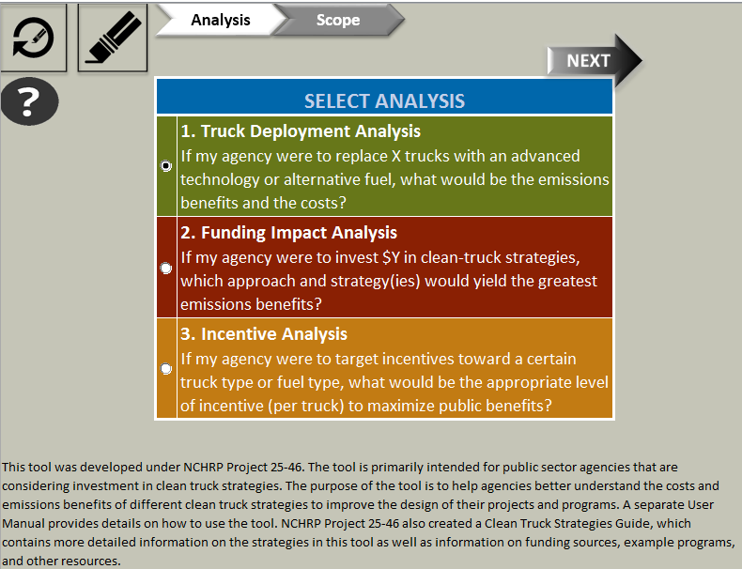

The user must then select the analysis year of interest, the geographic scale of the analysis, the truck type(s) of interest, and the type of modification. The user can run the Tool several times for different analyses if desired. More details on these choices can be found in Section 2 of this User Manual.

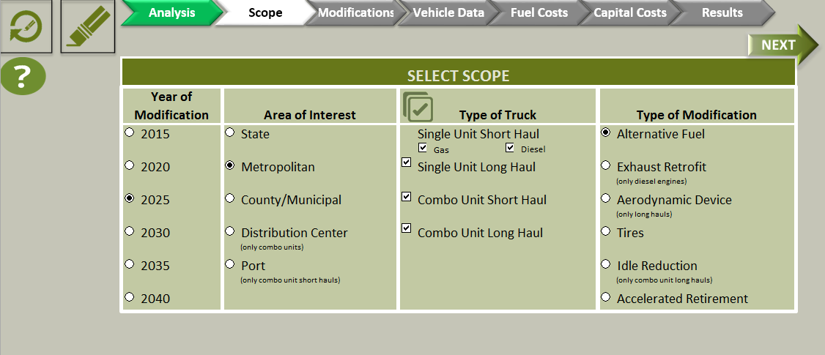

Once the modification is chosen, additional screens will appear to select the choices within the type of modification. These are detailed in Section 2.6 of this User Manual. For alternative fuels, the user will be asked the type of alternative fuels of interest, as shown below and explained further in Section 2.6.1.

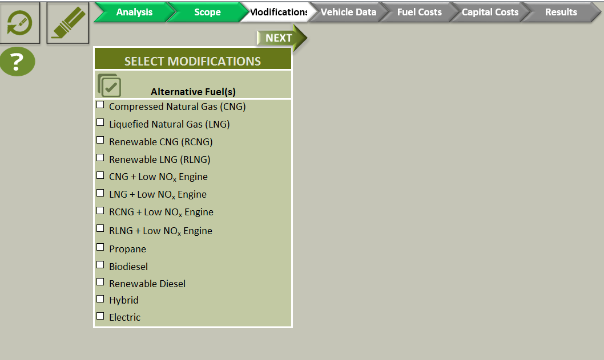

For Exhaust Retrofits, the user will be asked the type of exhaust retrofits of interest. As these strategies are applicable only for engine model years prior to 2006, this choice will not be valid for later analysis years. These choices are described in Section 2.6.2 of this User Manual.

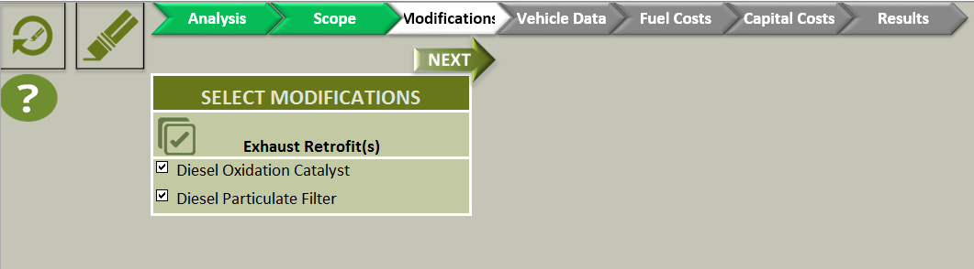

For Aerodynamic Devices, the user will be asked the types of aerodynamic devices of interest. An illustration is provided to help with identification of these devices. The Tool will allow this option only for long haul trucks, and some devices will only be allowed for combination long haul trucks. These choices are described in Section 2.6.3 of this User Manual.

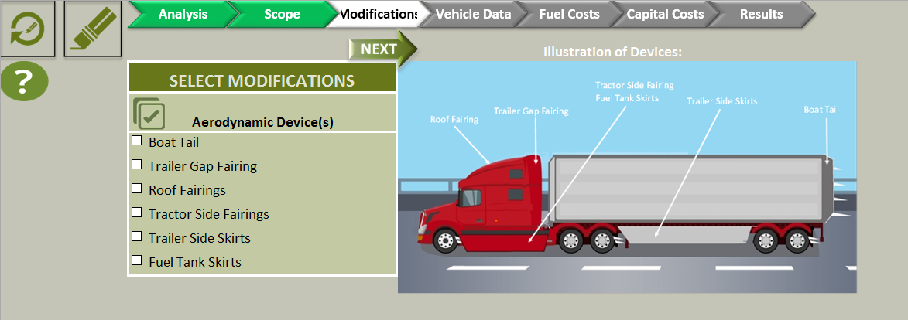

For Tires, the user will be asked the type of tire modifications of interest. Selecting Tire Pressure Systems will result in several more options displayed, as shown below and described in Section 2.6.4 of this User Manual.

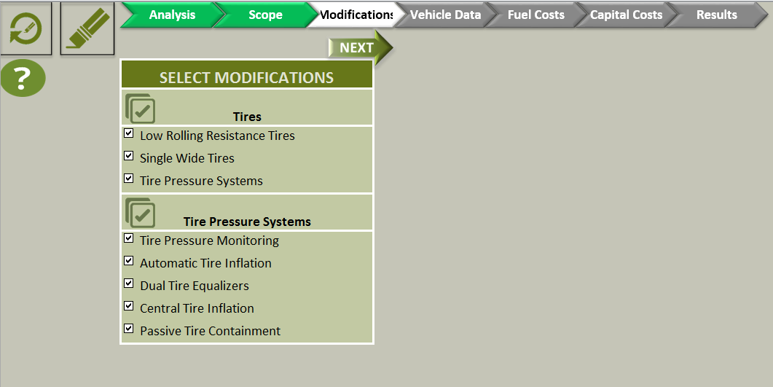

For idle reduction strategies, the user will be allowed to choose the strategies of interest. The Tool allows idle reduction analysis only for combination long haul trucks. These choices are described in Section 2.6.5 of this User Manual.

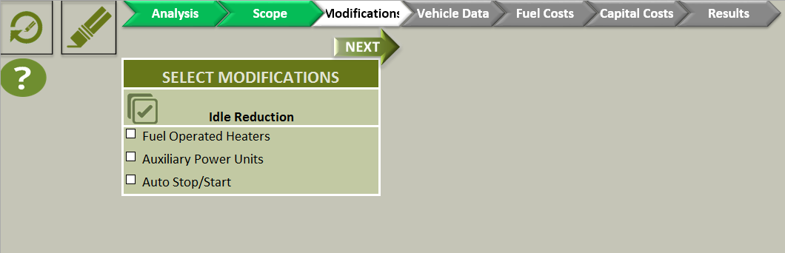

For accelerated retirement, there is no modification screen. The Tool will skip to the next screen where the user will be asked to specify the model years for the trucks that are being replaced. The Tool assumes that the replaced trucks will be scrapped. More details can be found in Section 2.6.6 of this User Manual.

Once the specific strategies are selected, the Tool will ask for further information that the user can change. The Tool auto-fills inputs with default values developed from MOVES. For accelerated retirement, the range of model years to modify/replace has already been asked for in the prior screen. The user should indicate what model year vehicles will be replaced with newer ones. For an alternative fuel option, the user needs to specify which model years will be replaced with an alternative fuel truck. For CNG, LNG, LPG, hybrid and electric options, the Tool assumes the replacement trucks are new (e.g., in analysis year 2020, the replacement trucks are 2020 model year).

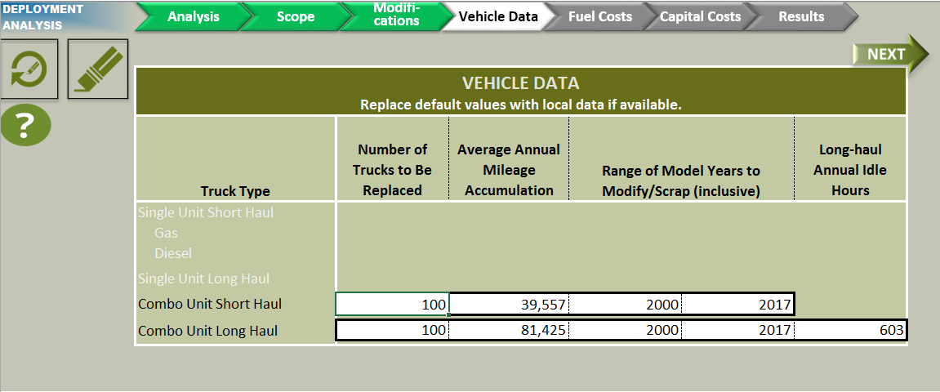

The next screen asks for fuel prices and electricity generation mix (for electric vehicle charging). The user can enter fuel prices and select fuel units from a pull-down menu. Default fuel prices are shown in this screen. If the user selects electric vehicles as an option, they can also enter the electricity grid mix their area by clicking the button in the region of interest, or they can select the national average by clicking “National Default”.

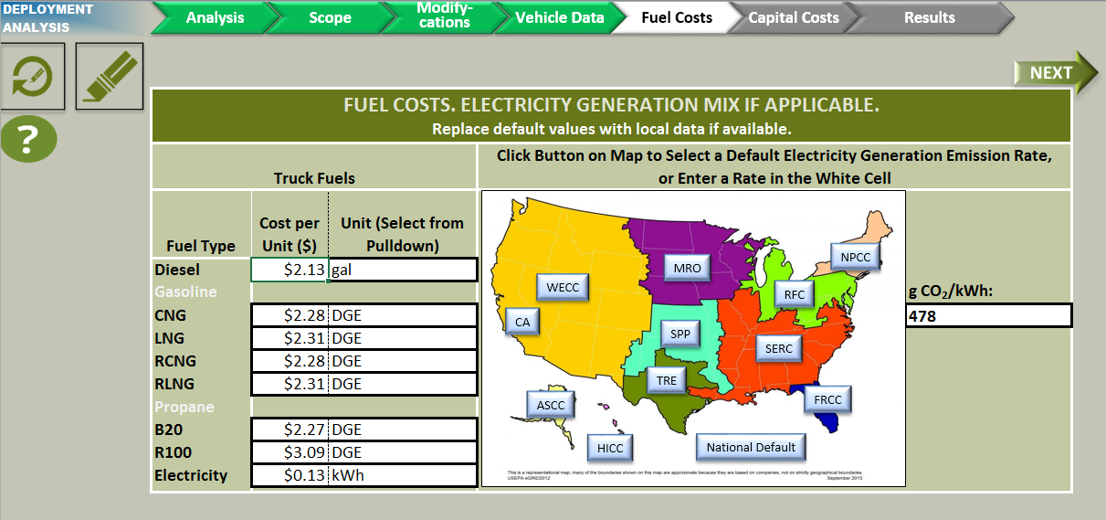

Once the grid mix area is selected, the Tool then shows the default value which can be changed with newer data if available.

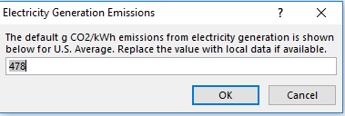

See Section 5.3 for further information on fuel costs and Section 5.2 for further information on electricity generation mix for electric vehicle charging. The next screen allows users to modify the truck or equipment costs if they have more current or local information.

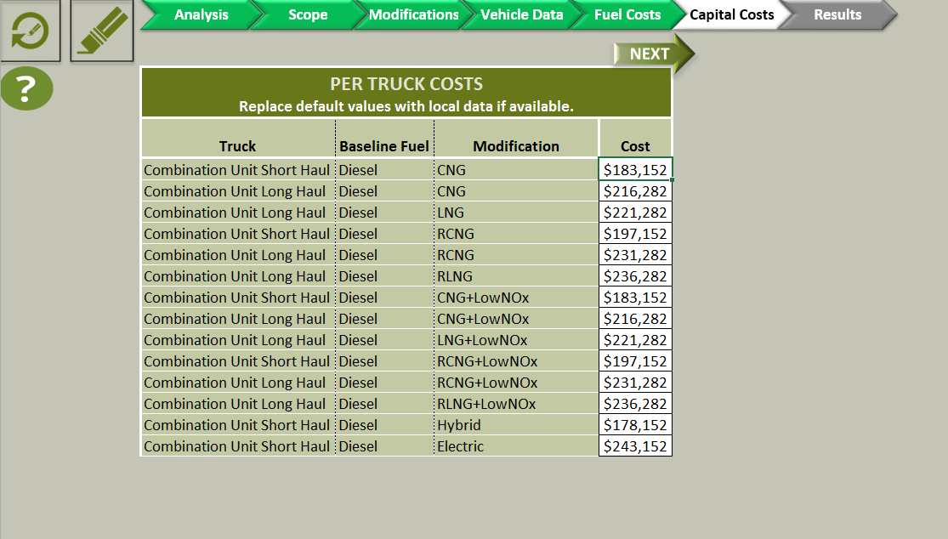

When the user clicks “Next”, the Tool will output results in a tabular format. The results show the reduction in emissions in short tons, reduction (or increase) in fuel use, costs, and cost effectiveness for NOx, PM2.5, and CO2. When multiple strategies are listed, the user can find the most cost effective or the one giving the largest emission reductions. An example of the output is shown on the next page. The user can also get a detailed output by clicking the “Go to Formatted Results” button. A sample detailed output is also shown on the next page. By clicking the Excel button, a copy of both outputs will be saved to another spreadsheet along with a sortable table of emission reductions and cost effectiveness for sorting.

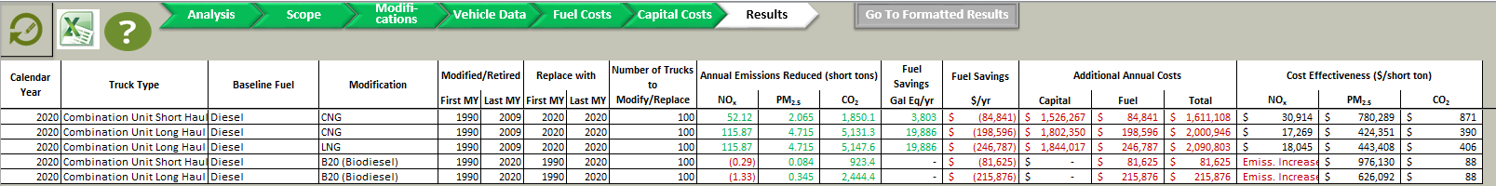

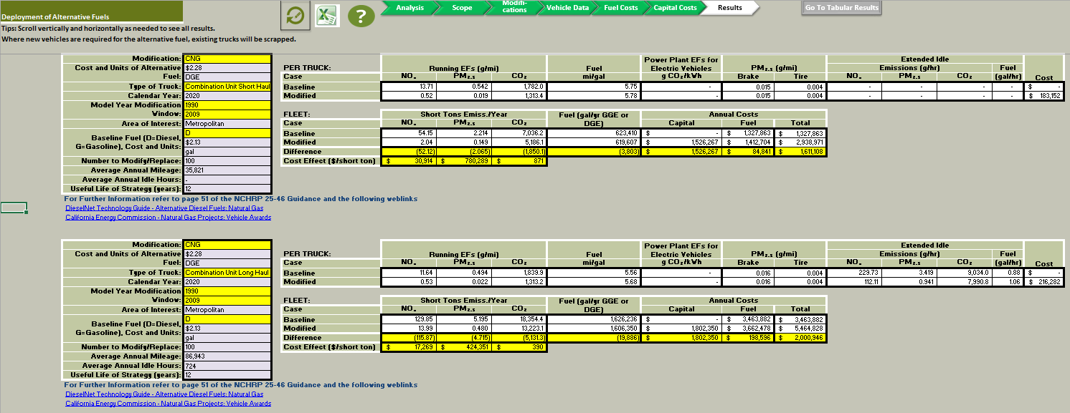

## Funding Impact Analysis

In the Funding Impact Analysis, users can determine the number of trucks and emissions benefits if an agency or organization were to invest a given amount into clean truck strategies. The user can then see which approaches/strategies yield the greatest emission benefit or are the most cost effective.

The first choice the user will make is choosing the Funding Impact Analysis as shown below, and then click “Next”.

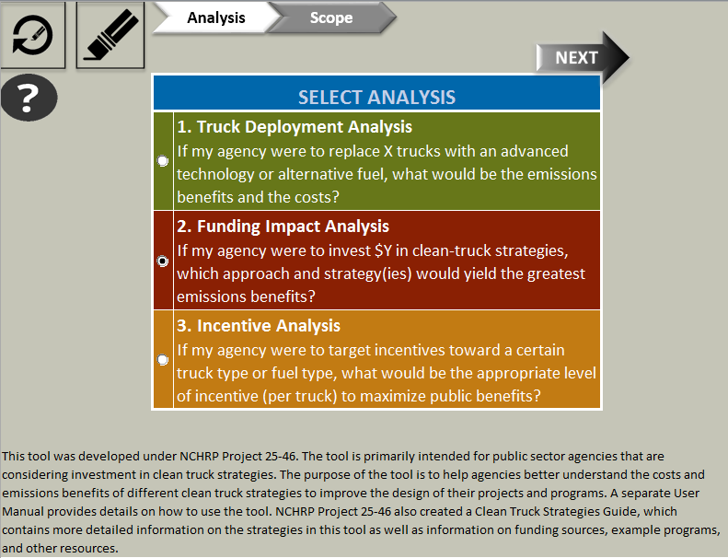

The user then chooses the analysis year, the geographic area, and the truck type. In addition, the screen asks the amount the agency wants to invest in the program. The Tool will run this analysis for only one truck type at a time. For analyzing more than one truck type, the user will run the Tool multiple times.

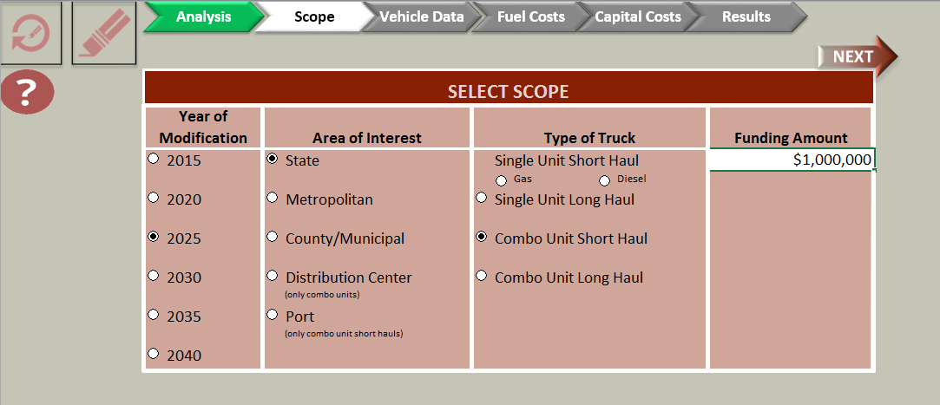

The next screen asks for annual mileage accumulation, the model years of trucks to be modified or replaced, and extended idle hours (for combination long haul trucks only).

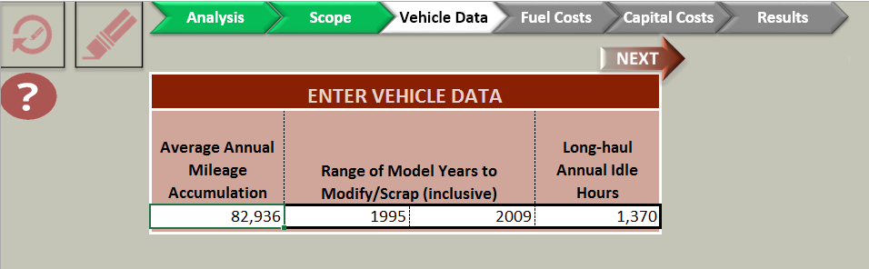

The next screen asks for fuel prices. The user can enter fuel prices and select from fuel units via a pull down menu. Default fuel prices are shown in this screen. See Section 5.3 for further information on fuel costs and Section 5.2 for further information on electricity generation mix for electric vehicle charging.

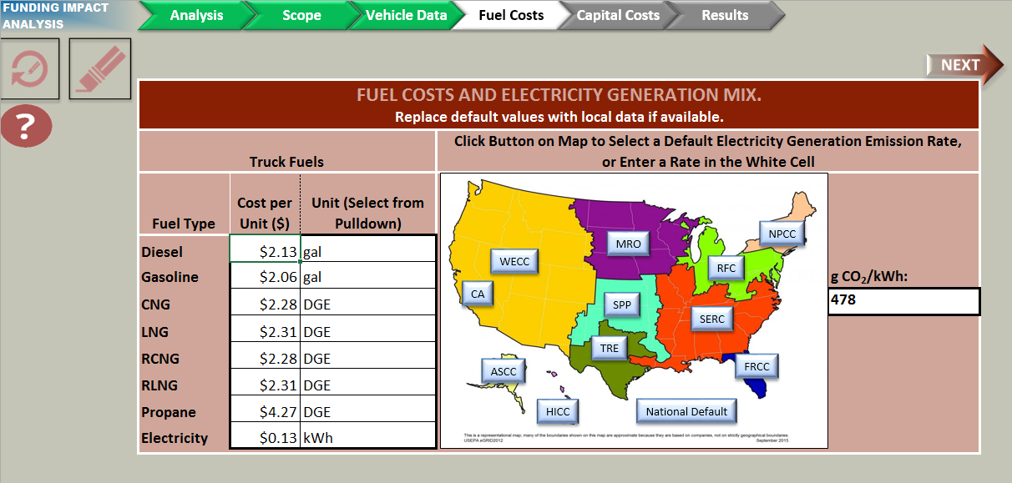

The next screen provides cost data for the new vehicles or equipment.

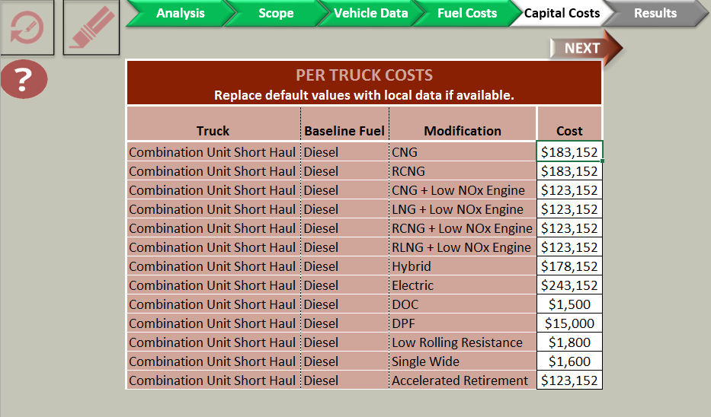

When the user clicks ”Next”, the Tool will calculate benefits and costs for all the strategies for the given truck type. The table of results shows the number of trucks that can be modified/replaced based upon the investment amount, the emissions reduced in short tons, and the cost effectiveness of the emissions reduced based upon the investment amount. An example of the output is shown on the next page. Again a detailed output can be provided by clicking the “Go to Formatted Results” button and a copy of both outputs can be saved to an Excel file by clicking the Excel button.

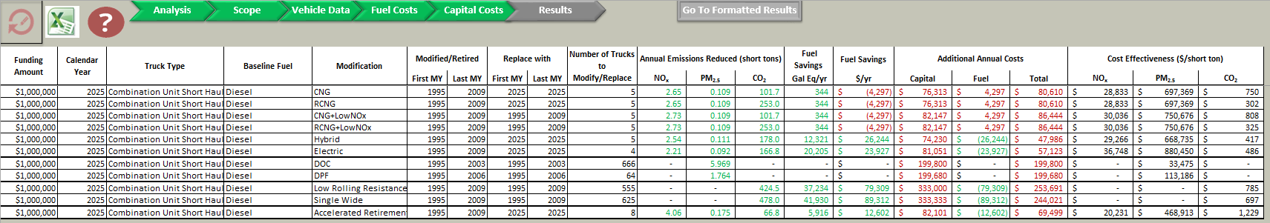

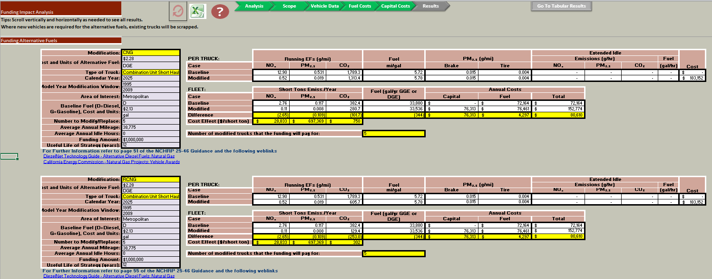

## Incentive Analysis

In the Incentive Analysis, users can analyze the payback period for truck owners if only part of the strategy incremental cost is covered. If the strategy results in fuel cost savings for the truck owner, the public agency will typically cover only a portion of the strategy cost, assuming that owners will be willing to cover the remaining cost. Public agencies will typically seek to set the incentive amount at the lowest level that still generates owner interest in order to maximize the emissions benefits of the public funding.

For this type of analysis, the user will select a strategy and targeted truck type. The Tool will calculate the payback period for the truck owner (i.e., how many years it would take for the fuel savings to cover the amount the owner paid for the truck), emissions benefits, and cost effectiveness. The options for specifying incentive levels are 25, 50, and 75 percent of the truck or equipment cost.

The first choice the user will make is choosing the incentive analysis as shown below and then click “Next”.

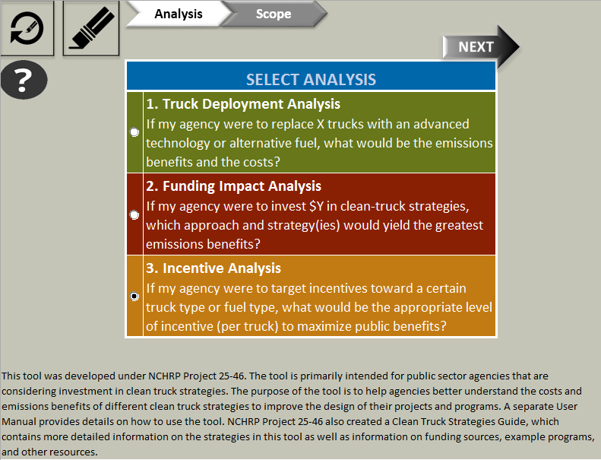

The user then chooses the analysis year, the geographic area, the truck type, and the modification type, as illustrated below.

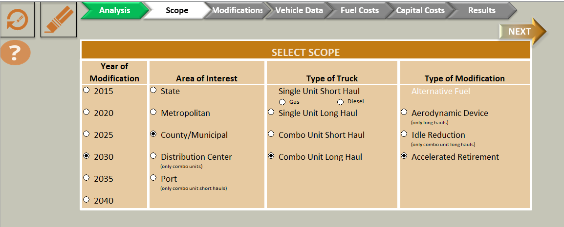

The Tool will then display the modification details screens similar to those shown in Section 4.3 along with the user entry/defaults for mileage accumulation, extended idle, vehicles to be replaced, etc. Once the user clicks to the Results screen, the Tool will examine the modification selected and calculate agency costs for a 25, 50, and 75 percent incentive plus the number of years it will take for the truck owner to recover the capital costs he or she paid with the amount saved in reduced fuel costs. More details can be viewed using the “Go to Formatted Results” button and both outputs can be saved to an Excel file by clicking the Excel button. Only those modifications that provide fuel savings are allowed for this type of analysis. Emissions results are displayed in short tons.



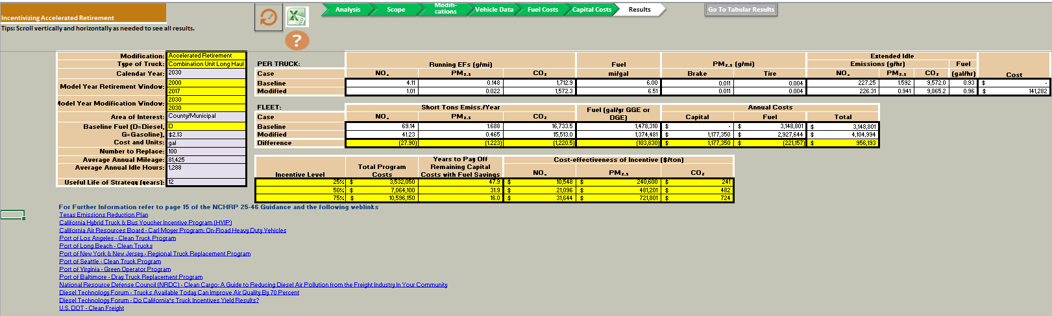

# Development of Inputs

## Emission Factors

Emission factors for calculating emissions benefits were developed using EPA’s Motor Vehicle Emission Simulator (MOVES). MOVES is EPA’s emission modeling system for on- and off-road motor vehicles. It estimates greenhouse gases and criteria and toxic air pollutants from motor vehicles at the national, county, and project level. MOVES2014a, the latest version of MOVES, represents EPA’s current understanding of vehicle emissions, provides an official default dataset of vehicle activity that is readily adaptable to the development of this Tool, and is highly familiar to air-emissions modelers for addressing planning issues, including as air quality conformity. Much more information on this model is available from EPA.[3]

Although MOVES was used to develop factors used in the Tool, the factors are based on general parameters; thus, the results from this Tool cannot be used for conformity or other regulatory purposes. Overall regional activity parameters and average emission factors representing the activity-weighted mean of the various vehicle types in each region type were produced and incorporated in the Tool. These emission factors are typically calculated as total running emissions from hourly outputs (in grams of pollutant emitted per year) divided by total running activity (in miles per year) across the modeled region; a similar analysis is made for extended idling emissions for long haul heavy duty trucks. Output emission factors have units of grams of pollutant per average mile driven or grams of pollutant per average extended idle hour.

### Truck Categories

Four basic truck types were used for the development of the Tool, as shown previously in Table 4. In MOVES, these are designated as types 50 and 60 (minus refuse trucks and motor homes).

### Geographic Categories

The Tool uses five geographic scales, as shown previously in Table 3. Each represents a distinct type of region for vehicle activity, including different road types, settings (rural or urban), and the corresponding drive cycles. The use of MOVES to model these geographic scales is discussed in the subsections below, including a fifth category (off-network) that was included in MOVES for calculation of extended idle emissions.

#### State

The state scale is intended to represent any state in the nation. Accordingly, the national default value in MOVES was used for all truck types. National averages were used to represent all 50 states, with national VMT and vehicle populations divided by 50 to represent a state average. The determination of rural or urban road types is then based on the national average values. All four truck types are considered in this geographic scale.

#### Metropolitan

The metropolitan scale is designed to represent metropolitan areas across the country. This was based upon the four largest metropolitan areas in the country, listed in Table 13. The metropolitan area was defined as a core based statistical area.[4] This definition follows US Census conventions and allows capture of fringe areas intimately related to the urban core. MOVES was run for each of these counties and results averaged over the set of counties to determine metropolitan parameters. Regional parameters, such as vehicle population and VMT, are determined as the total of all counties listed divided by 4. All four truck types are considered in this geographic scale.

Table 13. Core-based Statistical Areas Used in the MOVES Modeling Supporting the Tool’s Metropolitan Geographic Scale

|  |  |
| --- | --- |
| Region | Related County |
| New York-Newark-Jersey City, NY-NJ-PA | Dutchess County, NY |
| Putnam County, NY |
| Nassau County, NY |
| Suffolk County, NY |
| Essex County, NJ |
| Hunterdon County, NJ |
| Morris County, NJ |
| Somerset County, NJ |
| Sussex County, NJ |
| Union County, NJ |
| Pike County, Pennsylvania |
| Bergen County, NJ |
| Hudson County, NJ |
| Middlesex County, NJ |
| Monmouth County, NJ |
| Ocean County, NJ |
| Passaic County, NJ |
| Bronx County, NY |
| Kings County, NY |
| NY County, NY |
| Orange County, NY |
| Queens County, NY |
| Richmond County, NY |
| Rockland County, NY |
| Westchester County, NY |
| Los Angeles-Long Beach-Anaheim, CA | Orange County, CA |
| Los Angeles County, CA |
| Chicago-Naperville-Elgin, IL-IN-WI | Cook County, IL |
| DuPage County, IL |
| Grundy County, IL |
| Kendall County, IL |
| McHenry County, IL |
| Will County, IL |
| DeKalb County, IL |
| Kane County, IL |
| Jasper County, IN |
| Lake County, IN |
| Newton County, IN |
| Porter County, IN |
| Lake County, IL |
| Kenosha County, WI |
| Dallas-Fort Worth-Arlington, TX | Collin County, TX |
| Dallas County, TX |
| Denton County, TX |
| Ellis County, TX |
| Hunt County, TX |
| Kaufman County, TX |
| Rockwall County, TX |
| Hood County, TX |
| Johnson County, TX |
| Parker County, TX |
| Somervell County, TX |
| Tarrant County, TX |
| Wise County, TX |

#### County/Municipal

The county/municipal geographic scale was defined as a complement to the metropolitan area. In this case, the regional definition includes primarily rural areas with a small town/city core. Accordingly, Census Micropolitan Statistical Areas were used to define this geographic area. A sample of 33 counties that are considered "central" (rather than "outlying") to capture the municipal character of the regions was used. The underlying counties are listed in Table 14. As with other definitions, MOVES was run for each of these listed counties. Regional parameters, such as vehicle population and VMT, are determined as the total of all counties divided by 33. All four truck types are considered in this geographic scale.

Table 14. Counties Used in the MOVES Modeling Supporting the Tool’s “County/Municipal” Geograhic Scale

|  |  |  |
| --- | --- | --- |
| Counties | | |
| Marshall County, AL | Lenawee County, MI | Carter County, OK |
| Clark County, AR | Douglas County, MN | Jackson County, OK |
| DeSoto County, FL | Freeborn County, MN | Pontotoc County, OK |
| Sumter County, GA | Mower County, MN | Clatsop County, OR |
| DeKalb County, IN | Stanly County, NC | Adjuntas Municipio, PR |
| Steuben County, IN | Otero County, NM | Brown County, SD |
| Atchison County, KS | Cayuga County, NY | McMinn County, TN |
| Cowley County, KS | Montgomery County, NY | Andrews County, TX |
| Kennebec County, ME | Ashland County, OH | Henderson County, TX |
| Alpena County, MI | Ashtabula County, OH | Jim Wells County, TX |
| Gratiot County, MI | Athens County, OH | Grays Harbor County, WA |

#### Facility

The facility category is divided into two subtypes, namely distribution centers and ports

##### Distribution Center

For the first facility type, distribution centers were modeled only with short- and long haul combination trucks. There was no direct modeling of population or mileage accumulation for this facility type, since those cannot be normalized to a specific facility. Instead fixed values were proposed for populations that are representative of a typical distribution center. All activity in the MOVES modeling is assigned to the urban unrestricted road type. Only combination unit short and long haul trucks are allowed with this choice. For more local distribution centers, the County geographic designation was used.

##### Port

The port facility was modeled only for Short Haul Diesel Combination Truck types, representative of drayage trucks. As for Distribution Centers, population default values were fixed based upon populations at a typical large port. Only combination unit short haul trucks are allowed with this choice.

General emissions factor modeling is discussed below. However, to properly model Port facilities, specific parameters are required for modeling which are not captured in MOVES’ default parameters. Distinct drive cycle data representing the ports of Los Angeles and Long Beach was used.[5] This cycle is comprised of three categories of operations: near-dock (2-6 mi), local (<20 mi), and regional (20-120 mi). The near-dock category includes Creep, Low Speed Transient, and Short High Speed Transient components. The local cycle consists of Creep, Low Speed Transient, and Long High Speed Transient components. The regional category includes Creep, Low Speed Transient, and High Speed Cruise components. Each is provided in detailed, second-by-second profiles of speed against time.

Port facilities were modeled in MOVES at a national scale, and introduced the specific drive cycle by determining and importing a new avgSpeedDist table to represent these facilities. That table was customized by altering the default distribution of times in various speed bins to those derived from the second-by-second data for the select component cycles listed above appropriate for the tool’s scope. The second-by-second drive cycles for a combination of the Creep, Low Speed Transient, Short High Speed Transient, and Long High Speed Transient component cycles (as shown in Figure 2) that provided an approximately 20 mi total distance were included. Twenty miles from port was deemed a typical distance from a port to a distribution center where cargo is unloaded and sorted for movements using long haul trucks. Once the representative, composite drive cycle was constructed, a histogram of the speed bins that corresponded to the required entries of the avgSpeedDist table for the selected vehicle and road types was computed and imported into MOVES. Only urban unrestricted road types are considered here. The resulting driving cycle is shown in Figure 3.

Figure 2. Second by Second Port Driving Cycle Components

Machine generated alternative text:
Short High Speed Transient 
Low Speed Transient 
Tim 
2500 
20 
Creep 
1000 
Figure 10. Near-dock duty cych 
data each in 
1 soo 
Tinp 

Figure 3. Port Driving Cycle used for Port Facility in Tool



#### Off network

In addition to the five geographic scales (three primary regions and two subregions) modeled in MOVES, a sixth category was used to determine extended idle emissions. This category does not appear in the Tool, but was used only for extraction of the extended idling factors. Only combination unit long haul trucks calculate extended idle emissions in the Tool.

### Parameters Extracted from MOVES

Three main values were extracted from the MOVES modeling runs. All analysis was done with the latest version of the model, MOVES2014a, and using default database version 20151028. In all cases other than port trucks, all analyses are based entirely on default inputs to the model from this version of the default database.

#### Emission factors

All emission factors were derived in grams per mile for NOx, PM2.5, and CO2 from the model for the same regional definitions provided above. Emission factors include both running and extended idle processes. APU emissions were also included. No refueling or evaporative emissions were included. Note that CO2 emission factors in the Tool were developed using “Atmospheric CO2”, not “CO2e” in MOVES. Also, PM includes brake and tire wear. All processes include exhaust and crankcase emissions. Only diesel fuel was included for all vehicle types other than single unit short haul trucks, which is a mixture of gasoline and diesel fuels.

For all runs, the model simulations were made for the regional definitions provided in inventory mode. The emission factors were then extracted by normalizing the total emissions per total activity (distance or extended idle hours), to represent activity weighted emission factors. For all but long haul combination trucks, emission factors represent total emissions from all emission processes, normalized to distance. This produces emission factors with units of grams per mile. For the long haul truck type, two emission factors were determined. All running, non-extended idle emissions (i.e., all processes but APU and extended idle) were summed and normalized to distance to produce emission factors. Extended idle emission factors were taken as the sum of APU and extended idle processes, and normalized by hours of extended idling.

The years included for the modeling were: 2015, 2020, 2025, 2030, 2035, and 2040. All runs were made with annual pre-aggregation to speed run times. All months, hours, and days were included. Custom MySQL scripts written and executed to extract the values.

#### Mileage accumulation

Annual average VMT per vehicle (annual mileage accumulation) was also determined. Default VMT accumulation and VMT mix by road type was determined for all regional types and deemed to be the same no matter what region. Since the Tool simulates the benefits derived from the trucks and does not represent an inventory model, any modification applied to a truck would be valid for the truck whether it is within the geographic area or not.

For all regions, a national-scale MOVES run was conducted for all four truck types preserving resolution by type, andfor all road types, again preserving resolution by type. Only diesel fuel was included for all vehicle types except single unit short haul trucks. Output activity was also resolved by model year. Average annual VMT by truck class is shown in Table 15.

Table 15. Default Annual Average Mileage Accumulation Rates

|  |  |  |  |  |  |
| --- | --- | --- | --- | --- | --- |
| Year | Single unit Short Haul Gasoline | Single unit Short Haul Diesel | Single unit Long Haul Diesel | Combination unit Short Haul Diesel | Combination unit Long Haul Diesel |
| 2015 | 13,830 | 15,014 | 21,643 | 31,058 | 93,325 |
| 2020 | 14,585 | 14,693 | 21,836 | 35,821 | 86,943 |
| 2025 | 14,819 | 14,623 | 21,601 | 38,775 | 82,936 |
| 2030 | 14,828 | 14,641 | 20,889 | 39,557 | 81,425 |
| 2035 | 14,719 | 14,629 | 20,513 | 38,654 | 82,410 |
| 2040 | 14,614 | 14,615 | 20,386 | 38,053 | 83,393 |

MOVES model runs were made and custom MySQL scripts written and executed to extract the values. Mileage accumulation is defined as total distance traveled per total truck population for each of the identified categories.

Average age was also determined using MOVES for the various years and truck types and are shown in Table 16.

Table 16. Average Age by Truck Type and Analysis Year used in the Tool

|  |  |  |  |  |  |
| --- | --- | --- | --- | --- | --- |
| Year | Single unit Short Haul Gasoline | Single unit Short Haul Diesel | Single unit Long Haul Diesel | Combination unit Short Haul Diesel | Combination unit Long Haul Diesel |
| 2015 | 7.2 | 6.9 | 6.3 | 7.3 | 7.7 |
| 2020 | 6.1 | 6.2 | 5.6 | 6.3 | 8.1 |
| 2025 | 6.0 | 6.1 | 5.8 | 6.1 | 7.9 |
| 2030 | 5.9 | 6.0 | 5.9 | 6.1 | 7.4 |
| 2035 | 6.0 | 6.0 | 5.9 | 6.0 | 7.0 |
| 2040 | 5.9 | 5.9 | 5.9 | 6.0 | 6.9 |

#### Population

Default truck population (number of trucks) in each regional category as averages for the same areas were developed in a similar method to mileage accumulation. In this case, MOVES simulations as described above for each region type were conducted and the population activity data extracted. Aggregate vehicle population from runs by vehicle type, fuel type, and model year were then extracted using MySQL scripts.

As noted above, population was normalized generically to the various regions. For state analyses, the national population from the national scale run was normalized by 50 to represent an “average” state. For metropolitan, the total population from the four metropolitan areas modeled was normalized by four. For county/municipal, the population was normalized by the number of modeled counties. Default population for the “facility” geography were estimated to represent typical distribution centers and ports. Default populations used in the Tool are shown in Table 17.

Table 17. Default Vehicle Populations used in the Tool

| Year | Truck Type | State | Metro | County | Dist Ctr | Port |
| --- | --- | --- | --- | --- | --- | --- |
| 2015 | Single unit Short Haul, Gas | 46,233 | 65,684 | 497 | - | - |
| Single unit Short Haul, Diesel | 94,712 | 134,560 | 1,017 | - | - |
| Single unit Long Haul, Diesel | 4,779 | 6,788 | 51 | - | - |
| Combination unit Short Haul, Diesel | 25,928 | 36,208 | 297 | 1,000 | 4,650 |
| Combination unit Long Haul, Diesel | 28,590 | 39,883 | 330 | 750 | - |
| 2020 | Single unit Short Haul, Gas | 50,282 | 71,437 | 540 | - | - |
| Single unit Short Haul, Diesel | 107,752 | 153,086 | 1,157 | - | - |
| Single unit Long Haul, Diesel | 5,930 | 8,424 | 64 | - | - |
| Combination unit Short Haul, Diesel | 28,018 | 39,127 | 321 | 1,000 | 4,930 |
| Combination unit Long Haul, Diesel | 33,592 | 46,861 | 387 | 750 | - |
| 2025 | Single unit Short Haul, Gas | 54,469 | 77,385 | 585 | - | - |
| Single unit Short Haul, Diesel | 117,181 | 166,481 | 1,259 | - | - |
| Single unit Long Haul, Diesel | 6,748 | 9,585 | 73 | - | - |
| Combination unit Short Haul, Diesel | 29,442 | 41,116 | 337 | 1,000 | 5,225 |
| Combination unit Long Haul, Diesel | 38,120 | 53,177 | 439 | 750 | - |
| 2030 | Single unit Short Haul, Gas | 57,763 | 82,065 | 620 | - | - |
| Single unit Short Haul, Diesel | 123,351 | 175,247 | 1,325 | - | - |
| Single unit Long Haul, Diesel | 7,393 | 10,502 | 79 | - | - |
| Combination unit Short Haul, Diesel | 30,730 | 42,914 | 352 | 1,000 | 5,540 |
| Combination unit Long Haul, Diesel | 41,813 | 58,329 | 482 | 750 | - |
| 2035 | Single unit Short Haul, Gas | 61,230 | 86,991 | 658 | - | - |
| Single unit Short Haul, Diesel | 129,510 | 183,998 | 1,391 | - | - |
| Single unit Long Haul, Diesel | 7,870 | 11,179 | 85 | - | - |
| Combination unit Short Haul, Diesel | 33,169 | 46,312 | 380 | 1,000 | 5,875 |
| Combination unit Long Haul, Diesel | 44,350 | 61,868 | 511 | 750 |  |
| 2040 | Single unit Short Haul, Gas | 64,417 | 91,518 | 692 | - | - |
| Single unit Short Haul, Diesel | 135,304 | 192,229 | 1,453 | - | - |
| Single unit Long Haul, Diesel | 8,266 | 11,741 | 89 | - | - |
| Combination unit Short Haul, Diesel | 36,209 | 50,566 | 415 | 1,000 | 6,228 |
| Combination unit Long Haul, Diesel | 47,111 | 65,719 | 543 | 750 | - |

Average extended idle hours for combination unit long haul trucks were also determined from MOVES by calendar year. They are shown in Table 18.

Table 18. Default Extended Annual Idle Hours by Geographic Scale

| Year | State | Metro | County | Dist Ctr |
| --- | --- | --- | --- | --- |
| 2015 | 1,145 | 859 | 1,834 | 1,834 |
| 2020 | 964 | 724 | 1,545 | 1,545 |
| 2025 | 855 | 642 | 1,370 | 1,370 |
| 2030 | 804 | 603 | 1,288 | 1,288 |
| 2035 | 796 | 598 | 1,276 | 1,276 |
| 2040 | 801 | 601 | 1,283 | 1,283 |

## Relative Reduction Factors

To calculate the benefits of various strategies, relative reduction factors (RRFs) were determined for each strategy and truck type. An RRF is applied to the baseline or new conventional fuel vehicle emissions to determine the reductions due to the strategy. In cases where the strategy calls for an add-on device or retrofit, the RRF is applied to the baseline emissions. For those strategies that require purchase of a new vehicle, the RRF is applied to the newest model year within the analysis year of the truck type in question.

For the accelerated retirement option, the user specifies the model year range that they want to scrap and the model year range for the replacement vehicles. The Tool calculates emissions for the scrapped trucks and for the replacement trucks. Emission reductions in this case are simply the difference between the average emissions for the scrapped trucks and the average emissions for the replacement trucks.

For alternative fuels, the 2015 version of Argonne National Laboratory’s Greenhouse Gases, Regulated Emissions, and Energy Use in Transportation (GREET2015) Model was used to determine relative emission reduction factors by truck type.[6] These are shown in Table 19.

Table 19. RRFs for Alternative Fuel Scenarios

| Fuel | Truck Type | NOx | PM | CO2 | Fuel |
| --- | --- | --- | --- | --- | --- |
| CNG | Single unit Short Haul | 50% | 0% | 17.6% | -10% |
| Single unit Long Haul | 50% | 0% | 17.6% | -10% |
| Combination unit Short Haul | 50% | 0% | 17.6% | -10% |
| Combination unit Long Haul | 50% | 0% | 19% | -10% |
| LNG | Combination unit Long Haul | 50% | 0% | 19% | -10% |
| RCNG | Single unit Short Haul | 50% | 0% | 62% | -10% |
| Single unit Long Haul | 50% | 0% | 62% | -10% |
| Combination unit Short Haul | 50% | 0% | 62% | -10% |
| Combination unit Long Haul | 50% | 0% | 62% | -10% |
| RLNG | Combination unit Long Haul | 50% | 0% | 57% | -10% |
| CNG w/ Low NOx Engine | Single unit Short Haul | 90% | 0% | 17.6% | -10% |
| Single unit Long Haul | 90% | 0% | 17.6% | -10% |
| Combination unit Short Haul | 90% | 0% | 17.6% | -10% |
| Combination unit Long Haul | 90% | 0% | 19% | -10% |
| LNG w/ Low NOx Engine | Combination unit Long Haul | 90% | 0% | 19% | -10% |
| RCNG w/ Low NOx Engine | Single unit Short Haul | 90% | 0% | 62% | -10% |
| Single unit Long Haul | 90% | 0% | 62% | -10% |
| Combination unit Short Haul | 90% | 0% | 62% | -10% |
| Combination unit Long Haul | 90% | 0% | 62% | -10% |
| RLNG w/ Low NOx Engine | Combination unit Long Haul | 90% | 0% | 57% | -10% |
| B20 | All Diesel | -2% | 17% | 14% | 0% |
| RD100 | All Diesel | 4% | 4% | 70% | 0% |
| Propane | Single unit Short Haul | 0% | 0% | 1.30% | 0% |
| Hybrid | Single unit Short Haul | 0% | 0% | 40% | 40% |
| Combination unit Short Haul | 0% | 0% | 40% | 40% |
| Electric | Single unit Short Haul | 100% | 100% | See note | 250% |
| Combination unit Short Haul | 100% | 100% | See note | 250% |
| Note: Electric vehicle CO2 emissions are calculated separately based upon electricity generation grid mix. | | | | | |

A 40% RRF means that the new truck would have 60% of the emissions of the new conventional fueled truck. For fuel, the RRF is applied to fuel economy of the base vehicle. Thus a negative RRF results in a vehicle that has poorer fuel economy than the base vehicle, while a positive RRF results in a vehicle that has better fuel economy than the base vehicle. Some alternative fuel options are not applicable to some truck types (see also Table 6); the Tool will enable or disable selectable alternative fuels based on the truck(s) the user selects.

As noted above, CO2 emissions for electric vehicles are based upon the electricity generation grid mix which is used to charge the vehicles. Using GREET2015, CO2 emissions per kWh were calculated for various grid mixes for various analysis years. These are shown in Table 20 and visually in Figure 4. In addition, the user will have the option of entering their own CO2 emission rate.

Table 20. CO2 Emissions per kWh from Power Plants for Charging Electric Vehicles

|  |  |  |  |  |  |  |  |
| --- | --- | --- | --- | --- | --- | --- | --- |
| Generation Mix | | CO2 (g/kWh at plug) | | | | | |
| Abbreviation | **Description** | **2015** | **2020** | **2025** | **2030** | **2035** | **2040** |
| U.S. Ave | U.S. Average | 525 | 489 | 485 | 478 | 470 | 460 |
| ASCC | Alaska Systems Coordinating Council | 563 | 563 | 563 | 563 | 563 | 563 |
| FRCC | Florida Reliability Coordinating Council | 541 | 521 | 519 | 511 | 498 | 456 |
| HICC | Hawaii Coordinating Council | 855 | 855 | 855 | 855 | 855 | 855 |
| MRO | Midwest Reliability Organization | 667 | 661 | 661 | 658 | 647 | 628 |
| NPCC | Northeast Power Coordinating Council | 269 | 257 | 250 | 254 | 260 | 260 |
| RFC | Reliability First Corporation | 608 | 623 | 626 | 618 | 612 | 608 |
| SERC | Southeastern Electric Reliability Council | 601 | 588 | 585 | 580 | 575 | 566 |
| SPP | Southwest Power Pool | 715 | 668 | 663 | 655 | 625 | 604 |
| TRE | Texas Regional Entity | 578 | 579 | 574 | 567 | 560 | 553 |
| WECC | Western Electricity Coordinating Council | 408 | 408 | 387 | 381 | 369 | 355 |
| CA | California | 294 | 251 | 221 | 218 | 221 | 214 |

Figure 4. North American Electric Corporation Map of U.S. Regions of Electricity Generation

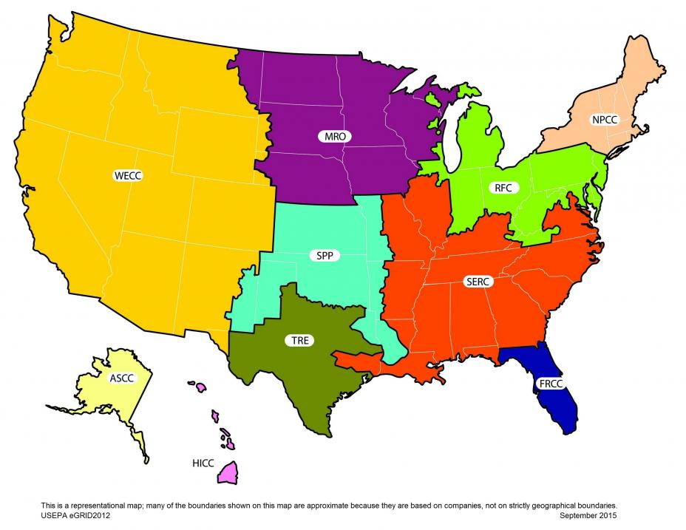

Source: Downloaded from U.S. EPA web page for Emissions & Generation Resource Integrated Database (<https://www.epa.gov/energy/egrid>), August 19, 2016.

For exhaust retrofits, aerodynamic devices, tires, and idle-reduction strategies, RRFs were determined from EPA’s Diesel Emission Quantifier tool.[7] These are listed in Table 21.

Table 21. RRFs for Other Strategy Types

| Strategy Type | Modification | Truck Type | NOx | PM | CO2 | Fuel |
| --- | --- | --- | --- | --- | --- | --- |
| Exhaust Retrofit | DOC | All Diesel MY 1991-2003 | 0% | 25% | 0% | 0% |
| DPF | All Diesel MY 1994-2006 | 0% | 85% | 0% | 0% |
| Aerodynamic Devices | Boat Tail | Single unit Long Haul | 0% | 0% | 2.7% | 2.7% |
| Combination unit Long Haul | 0% | 0% | 2.7% | 2.7% |
| Trailer Gap Fairing | Combination unit Long Haul | 0% | 0% | 2.0% | 2.0% |
| Roof Fairing | Single unit Long Haul | 0% | 0% | 2.9% | 2.9% |
| Combination unit Long Haul | 0% | 0% | 2.9% | 2.9% |
| Tractor Side Fairing | Combination unit Long Haul | 0% | 0% | 2.4% | 2.4% |
| Trailer Side Skirts | Combination unit Long Haul | 0% | 0% | 7% | 7% |
| Fuel Tank Skirt | Combination unit Long Haul | 0% | 0% | 2.4% | 2.4% |
| Tires | Low Rolling Resistance | All Trucks | 0% | 0% | 1% | 1% |
| Single Wide | All Trucks | 0% | 0% | 1% | 1% |
| Tires | Tire Pressure Monitor | Combination unit Long Haul | 0% | 0% | 1% | 1% |
| Auto Tire Inflation | Combination unit Long Haul | 0% | 0% | 1% | 1% |
| Dual Tire Equalizers | Combination unit Long Haul | 0% | 0% | 1% | 1% |
| Central Tire Inflation | Combination unit Long Haul | 0% | 0% | 1% | 1% |
| Passive Tire Containment | Combination unit Long Haul | 0% | 0% | 1% | 1% |

## Cost Estimates

To calculate cost impacts and cost effectiveness in the Tool, typical capital costs and operation-and-maintenance costs for each strategy were taken from the Clean Truck Strategies Guide developed under this project. Fuel costs are discussed later in this section.

For alternative fuel trucks that require full vehicle replacement, an incremental cost was calculated and added to the cost of a new conventional fuel truck. Incremental costs for the various alternative fuels used in the Tool are shown in Table 22. There is no capital cost for drop-in fuels such as B20 or R100, which can be used in conventional trucks without modification.

Table 22. Incremental Capital Costs for Alternative-fuel Scenarios

|  |  |  |  |  |
| --- | --- | --- | --- | --- |
| Fuel | Single unit Short Haul | Single unit Long Haul | Combination unit Short Haul | Combination unit Long Haul |
| CNG | $35,000 | $45,000 | $60,000 | $75,000 |
| LNG | N/A | N/A | N/A | $80,000 |
| RCNG | $35,000 | $45,000 | $60,000 | $75,000 |
| RLNG | N/A | N/A | N/A | $80,000 |
| CNG + Low NOx Engine | $45,000 | $57,000 | $74,000 | $90,000 |
| LNG + Low NOx Engine | N/A | N/A | N/A | $95,000 |
| RCNG + Low NOx Engine | $45,000 | $57,000 | $74,000 | $90,000 |
| RLNG + Low NOx Engine | N/A | N/A | N/A | $95,000 |
| Propane | $12,000 | N/A | N/A | N/A |
| Hybrid | $15,000 | N/A | $55,000 | N/A |
| Electric | $40,000 | N/A | $120,000 | N/A |
| Note: There is no capital cost for drop-in fuels such as B20 or R100. | | | | |

For add-on strategies (exhaust retrofits, aerodynamic and idle-reduction devices and tires), the incremental capital cost is the cost of the device. The costs do not include installation costs. Many capital costs vary widely; the Tool uses the midpoint between the low and high range of costs. Incremental costs for the various add-on strategies used in the Tool are shown in Table 23.

Table 23. Incremental Capital Costs for Other Scenarios

| Strategy Type | Modification | Single unit Short Haul | Single unit Long Haul | Combination unit Short Haul | Combination unit Long Haul |
| --- | --- | --- | --- | --- | --- |
| Exhaust Retrofit | DOC | $800 | $1,000 | $1,500 | $1,500 |
| DPF | $8,000 | $12,000 | $15,000 | $15,000 |
| Aerodynamic Devices | Boat Tail | N/A | $3,000 | N/A | $3,500 |
| Trailer Gap Fairing | N/A | N/A | N/A | $850 |
| Roof Fairing | N/A | $1,000 | N/A | $1,500 |
| Tractor Side Fairing | N/A | N/A | N/A | $1,500 |
| Trailer Side Skirts | N/A | N/A | N/A | $1,500 |
| Fuel Tank Skirt | N/A | N/A | N/A | $1,900 |
| Tires | Low Rolling Resistance | $1,000 | $1,000 | $1,800 | $1,800 |
| Single Wide | $800 | $800 | $1,600 | $1,600 |
| Tire Pressure Monitor | N/A | N/A | N/A | $750 |
| Auto Tire Inflation | N/A | N/A | N/A | $1,000 |
| Dual Tire Equalizers | N/A | N/A | N/A | $400 |
| Central Tire Inflation | N/A | N/A | N/A | $800 |
| Passive Tire Containment | N/A | N/A | N/A | $600 |
| Idle Reduction | Fuel Operated Heaters | N/A | N/A | N/A | $1,000 |
| Auxiliary Power Units | N/A | N/A | N/A | $12,000 |
| Auto Stop/Start | N/A | N/A | N/A | $2,000 |

Some exhaust retrofits require additional materials for proper operation. DPFs require yearly cleaning. In these cases, operations costs are included as part of the strategy calculations in the Tool. These are shown in Table 24.

Table 24. Incremental Operation and Maintenance Costs for Exhaust Retrofits

| Exhaust Retrofit | Single unit Short Haul | Single unit Long Haul | Combination unit Short Haul | Combination unit Long Haul |
| --- | --- | --- | --- | --- |
| DPF | $300 | $300 | $600 | $600 |

For truck replacement strategies, the Tool allows the user to select a range of model years of trucks to be replaced. To develop the net vehicle replacement costs, average truck costs were collected for trucks by model year, 1992 through 2016. Average vehicle purchase costs were collected from a new and used truck sales website.[8] The truck types included in the Tool were searched for on the website by model year using the criteria in Table 25.

Table 25. Search Criteria for Truck-purchase Costs

|  | Websitea Selection Criteria | | |
| --- | --- | --- | --- |
| Tool Truck Type | Truck Category | Fuel Type | Drivetrain |
| Single unit Short Haul, gasoline | Stepvan | Gasoline | Any |
| Single unit Short Haul, diesel | Stepvan | Diesel | Any |
| Single unit Long Haul | Box Truck – Straight Truck | Diesel | Any |
| Combination unit Short Haul | Conventional – Day Cab | Diesel | 6 x 4 |
| Combination unit Long Haul | Conventional – Sleeper Truck | Diesel | 6 x 4 |
| aTruck-sales website: <http://www.commercialtrucktrader.com/>. | | | |

All searches were adjusted to exclude any trucks listed as $0 or with no price. Average truck prices from the website are expected to change depending on the new and used stock listed; average prices in the tool were collected the week of April 25, 2016.

Truck costs were then curve-fitted to develop cubic equations for truck costs based upon truck age by truck type.

*Cost = (A x Age3) + (B x Age2) + (C x Age) + D*

Coefficients for the cubic equation are shown in Table 26 for the various truck types and graphed in Figure 5. Only the new truck costs are calculated; the replaced trucks are assumed to be scrapped.

Table 26. Coefficients of Truck-cost Cubic Equation

| Tool Truck Type | A | B | C | D |
| --- | --- | --- | --- | --- |
| Single unit Short Haul | -0.9943 | 124.314 | -4058.58 | 49785.5 |
| Single unit Long Haul | -5.4194 | 302.437 | -6372.61 | 58469.8 |
| Combination unit Short Haul | -27.9243 | 1287.13 | 19378.1 | 119172 |
| Combination unit Long Haul | -39.0937 | 1688.70 | -23538.3 | 131080 |

Figure 5. Derived Truck-purchase Costs Based on Age and Type



The default fuel prices in the Tool are national fuel prices current as of April 2016, according to the Alternative Fuel Price Report.[9] The user may substitute different fuel prices, such as regional prices which are also listed in the report. Table 27 shows the default fuel prices in the Tool, including costs per gasoline gallon equivalent (GGE) and per diesel gallon equivalent (DGE). The Tool calculates the fuel costs of the unmodified fleet, the modified fleet, and the difference between them.

Table 27. Default Fuel Prices Used in the Tool

|  |  |  |  |  |
| --- | --- | --- | --- | --- |
| Fuel | Native Units | | $/GGE | $/DGE |
| Diesel | $2.13 | gal | $1.90 | $2.13 |
| Gasoline | $2.06 | gal | $2.06 | $2.33 |
| CNG | $2.02 | GGE | $2.02 | $2.28 |
| LNG | $2.31 | DGE | $2.06 | $2.31 |
| RCNG | $2.02 | GGE | $2.02 | $2.28 |
| RLNG | $2.31 | DGE | $2.06 | $2.31 |
| Propane | $2.77 | gal | $3.79 | $4.27 |
| B20 | $2.23 | gal | $2.01 | $2.27 |
| R100 | $2.81 | gal | $2.75 | $3.09 |
| Electricity | $0.13 | kWh | $4.35 | $4.90 |

## Useful Lifetime

In order to calculate cost effectiveness, capital costs need to be divided by the useful life of the truck or device. Useful lives used in the Tool are listed in Table 28. Truck replacement lifetimes are used for alternative fuel (except drop-in fuels) and accelerated retirement strategies.

Table 28: Useful Lifetimes

|  |  |  |
| --- | --- | --- |
| Strategy | Type | Useful Life (yrs) |
| Truck Replacement | Single Unit Short Haul Trucks | 8 |
| Single Unit Long Haul Trucks | 10 |
| Combination Short Haul Trucks | 12 |
| Combination Long Haul Trucks | 12 |
| Exhaust Retrofit | | 5 |
| Aerodynamic Devices | | 5 |
| Tires | Single Wide Tires | 3 |
| Low Rolling Resistant Tires | 3 |
| Tire Pressure Monitoring Systems | 5 |
| Idle Reduction | | 5 |

# Examples

This section offers sample case studies demonstrating scenarios in which the Tool can be used. The case studies are organized by agencies that might use the Tool: a metropolitan planning organization (MPO); a State Department of Transportation; and a Port Authority. For each user type, a scenario was developed which demonstrate how the Tool can be used to assess truck emissions of different pollutants, estimate costs of clean truck programs, and compare different strategies. Although the scenarios are shown from different agency perspectives, they are not necessarily agency-specific; for example, both a Port operator and MPO may be interested in looking at incentivizing the deployment of CNG trucks to reach NOx targets.

In addition to providing realistic examples of how the Tool can be employed to answer different truck emission questions, the case studies provide step-by-step guidance on how to use the Tool and interpret the results in the context of addressing the scenario.

Each subsection below begins with a description of the case study scenario. For each case study, there are multiple analysis types described to demonstrate different ways to approach answering questions presented by the scenario. Some analyses will allow the user to determine the emission reductions of different strategies while others will determine how to address cost questions.

For each analysis type, a table is provided with sample inputs for each selection in the Tool and guidance on those inputs. The choices in the Tool include the following selections:

* **Analysis Type** – You can use any or all three analysis types to look at a problem. The Truck Deployment Analysis allows you to look at full costs of programs plus drop-in fuels (where there is no capital cost). The Funding Impact Analysis allows you to see how many trucks you can replace or modify for a given dollar amount. The Incentive Analysis shows you the payback period for incentives that cover part of the capital costs, with the remaining costs covered by fuel cost savings.
* **Year of Modification** – The analysis year is when the replacements/modifications take place. For instance, if you are working on long range plans that might go out to 2040, you need to pick analysis years before that. Generally you might want to look at 2025, 2030 and 2035 as the phase in times for the new programs or rules.
* **Area of Interest** – Area of interest is the geographic scale determines the emission factors used in the calculations. The larger the geographic scale the more freeways used, while the smaller geographic scales have more local roads. If you are an MPO, you would use Metropolitan. The geographic scale affects the mix of roadway types that go into the emission factors. This tool is *not* an emission inventory tool that will calculate all truck emission for a given geographic area.
* **Type of Truck** – The four truck types represent different segments of the heavy-duty truck populations. Single unit short haul trucks are typically urban pick-up and delivery trucks in the Class 3-5 size. Single unit long haul trucks are typically box trucks that travel within a regional area and are generally Class 6-7. Combination short haul trucks are typically drayage trucks that travel shorter distances. Combination long haul trucks are line-haul trucks that travel large distances.
* **Type of Modification** – This option is only included in Truck Deployment and Incentive Analyses. The user can select one type of modification. In some analysis types, this is followed by a selection of specific modifications; for example, by selecting the Alternative Fuels modification type, the user can then select the specific alternative fuel strategy in the following menu. Some modification types are restricted to certain types of trucks; thus, some modification types cannot be selected when the user selects some truck types, and vice versa.
* **Number of Trucks to Be Replaced** – Emission reductions and costs will be multiplied by the value entered here. The user can enter 1 if the he or she wants to see per-truck results.
* **Annual Mileage Accumulation** – This is the average miles traveled each year by the types of trucks selected for analysis. The default values come from EPA’s MOVES model. The more annual miles in this field, the more emissions benefits there will be.
* **Range of Model Years to Modify/Scrap** – These are the model years to which the strategies will be applied. Targeting older trucks will usually yield more reductions because fleets with older model year trucks are assumed to have higher average emission rates.
* **Long haul Annual Idle Hours** – This input only applies to strategies involving idle reduction strategies, which are only included for programs targeting long haul combination unit trucks.
* **Fuel Costs** – Units for most alternative fuels are in diesel gallon equivalents (DGE) in order to normalize for differences in energy content between the different fuels. Default values are national averages at the time the tool was developed. More up-to-date and regional fuel prices can be found from other sources, including the Alternative Fuels Data Center’s [Fuel Prices webpage](http://www.afdc.energy.gov/fuels/prices.html).
* **Electricity Generation Region** – The selection of the electricity mix changes the assumed GHG emissions per unit of electricity consumed. The user can assume a national value or select the region in which the targeted trucks operate. This affects the emissions results for strategies involving electric trucks.

**Capital Costs** – These are inputs for the replacement truck or equipment costs. If the truck is replaced, the tool assumes that the old truck is scrapped. The default values included in the Tool are based on research of costs in 2015. Replacing defaults with more up-to-date or local averages will improve cost and cost effectiveness estimates in the results.

After each table of input guidance, select results from using those inputs are shown. Results from the example runs are discussed and compared to address some of the questions presented in the scenario description. Note that all emission results are shows in short tons.

## MPO Case Study

***Scenario: A metropolitan planning organization (MPO) in New York State is updating its long-range transportation plan (LRTP) going out to 2040 as well as developing a regional freight plan. The MPO is looking at ways to reduce regional greenhouse gas emissions from freight trucks. The agency decides to apply for federal grant funding for a project to upgrade trucks in the region. Use the Tool to help determine which strategies the MPO should pursue.***

### Truck Deployment Analysis – Alternative Fuels

The Truck Deployment Analysis allows the user to estimate the impacts and costs of different clean truck strategy options. For each input option, enter the selections presented in the table below.

|  |  |  |
| --- | --- | --- |
| Category | Selection | Notes |
| **Analysis** | | |
| Analysis | Truck Deployment Analysis | This analysis allows the user to estimate full costs and emissions impacts of a program. |
| **Scope** | | |
| Year of Modification | 2030 | The modification year is when the modifications or replacements take place. Because the LRTP goes out to 2040 in this scenario, the user should assume modifications happen sometime before that. If 2040 is selected, the Tool assumes all changes occur in 2040, and the emissions benefits will be smaller because the Tool assumes the baseline fleet is cleaner in 2040. |
| Area of Interest | Metropolitan | Geographic scale determines the emission factors used in the calculations. The larger the geographic scale assume more freeways are used, while the smaller geographic scales have more local roads. |
| Type of Truck | Combo Unit Short Haul | For this scenario, combination short haul trucks are selected as they will operate within the metropolitan region. |
| Type of Modification | Alternative Fuel | Note that only one can be selected at a time. Accelerated Retirement will be considered in a separate analysis. Other modifications are not considered because: retrofits do not have positive GHG benefits and will be obsolete in 2030; tires have small GHG benefits; aerodynamics and idle reduction are only available for combination unit long haul trucks. |
| **Modifications** | | |
| Alternative Fuel(s) | Select all | Click the checkmark button at the top of the column to select all. Results will be displayed for each fuel separately. Strategies involving “drop-in” alternative fuels (i.e., biodiesel and renewable diesel) can be used in existing diesel trucks; all other alternative fuel selections assume existing trucks are gasoline or diesel trucks that must be replaced as part of the strategy. |
| **Vehicle Data** | | |
| Number of Trucks to Be Replaced | 100 | The results can be divided by 100 to calculate the per-truck impacts. |
| Average Annual Mileage Accumulation | Leave default values | The default values come from the MOVES model. More annual miles will result in more emissions benefits. |
| Range of Model Years to Modify/Scrap (inclusive) | 2000-2017 | This range is based on replacing pre-2018 trucks since the Heavy-Duty GHG Phase 1 rule would have been fully phased in by 2018, and the Phase 2 regulations begin. |
| Long haul Annual Idle Hours | n/a | Only applicable for strategies involving combo unit long haul trucks. |
| **Fuel Costs** | | |
| Cost per Unit | Leave default values | Default values are national averages; more up-to-date and regional fuel prices can be found at the Alternative Fuels Data Center’s [Fuel Prices webpage](http://www.afdc.energy.gov/fuels/prices.html). |
| Electricity Generation Region | NPCC | This electricity region includes New York. |
| CO2 | Leave default value (254 g/kWh) | The default value will update depending on the Electricity Generation Region selected. |
| **Capital Costs** | | |
| Cost | Leave default values | Default values are based on recent (2015) estimates. Replacing defaults with more up-to-date or local averages will improve cost and cost effectiveness estimates in the results. |

**Results**

The table below summarizes the impacts of replacing diesel with alternative fuel options on CO2 emissions. Note that the Tool produces a number of other results not shown below; CO2 impacts are only shown here as they were targeted pollutant in this scenario.

|  |  |  |
| --- | --- | --- |
| **Modification** | **Annual CO2 Emissions Reduced (tons)** | **Cost Effectiveness ($/ton)** |
| CNG | 1,657 | $1,024 |
| RCNG | 4,743 | $358 |
| CNG+Low NOx Engine | 1,657 | $1,094 |
| RCNG+Low NOx Engine | 4,743 | $382 |
| B20 (Biodiesel) | 980 | $89 |
| R100 (Renewable Diesel) | 4,900 | $121 |
| Hybrid | 3,214 | $321 |
| Electric | 5,526 | $271 |

The results show that using 100 CNG trucks in place of diesel trucks results in 1,657 fewer tons of CO2 being released each year, or a reduction of 16.6 tons per truck per year. Based on the assumed capital and operations costs and lifetime of the trucks, the CNG strategy costs $1,024 per ton of CO2 avoided.

The renewable CNG (RCNG) and renewable diesel (R100) strategies yield the largest emission reductions at 4,743 and 4,900 tons, respectively. The strategies with Low NOx engine added do not show different emission reductions because the Low NOx engines do not reduce CO2 emissions.

B20 and R100 – the two drop-in fuels – are the most cost effective. Note that the availability of these fuels may limit implementation, especially early in the development of these fuel markets; the availability of alternative fuels is discussed further in the Guide.

### Truck Deployment Analysis – Accelerated Retirement

The previous Truck Deployment Analysis allowed the user to estimate the impacts and costs of replacing older trucks with alternative fuel trucks or using alternative fuels in existing trucks. The following analysis allows the user to see the impacts and costs of replacing older trucks with newer models of diesel trucks.

For each input option, enter the selections presented in the table below.

|  |  |  |
| --- | --- | --- |
| Category | Selection | Notes |
| **Analysis** | | |
| Analysis | Truck Deployment Analysis | This analysis allows the user to estimate full costs and emissions impacts of a program. |
| **Scope** | | |
| Year of Modification | 2030 | The modification year is when the modifications or replacements take place. Because the LRTP goes out to 2040 in this scenario, the user should assume modifications happen sometime before that. If 2040 is selected, the Tool assumes all changes occur in 2040, and the emissions benefits will be smaller because the Tool assumes the baseline fleet is cleaner in 2040. |
| Area of Interest | Metropolitan | Geographic scale determines the emission factors used in the calculations. The larger the geographic scale assume more freeways are used, while the smaller geographic scales have more local roads. |
| Type of Truck | Combo Unit Short Haul | For this scenario, combination short haul trucks are selected as they will operate within the metropolitan region. |
| Type of Modification | Accelerated Retirement | This selection assumes trucks of older model years (selected on the Vehicle Data page) will be replaced with trucks of later model years. |
| **Vehicle Data** | | |
| Number of Trucks to Be Replaced | 100 | The results can be divided by 100 to calculate the per-truck impacts. |
| Average Annual Mileage Accumulation | Leave default values | The default values come from the MOVES model. More annual miles will result in more emissions benefits. |
| Range of Model Years to Modify/Scrap (inclusive) | 2000-2017 | This range is based on replacing pre-2018 trucks since the Heavy-Duty GHG Phase 1 rule would have been fully phased in by 2018, and the Phase 2 regulations begin. |
| Long haul Annual Idle Hours | n/a | Only applicable for strategies involving combo unit long haul trucks. |
| **Fuel Costs** | | |
| Cost per Unit | Leave default values | Default values are national averages; more up-to-date and regional fuel prices can be found at the Alternative Fuels Data Center’s [Fuel Prices webpage](http://www.afdc.energy.gov/fuels/prices.html). |
| Regional Mix | n/a | This selection does not apply because accelerated retirement assumes replacement with new gasoline or diesel trucks, not electric trucks. |
| CO2 | n/a | This selection does not apply for accelerated retirement. |
| **Capital Costs** | | |
| Cost | Leave default value | Default value is based on recent (2015) estimates. Replacing default with more up-to-date or local averages will improve cost and cost effectiveness estimates in the results. |

**Results**

The table below shows the CO2 emissions benefit of replacing 100 older diesel trucks with new models.

|  |  |  |
| --- | --- | --- |
| **Modification** | **Annual CO2 Emissions Reduced (tons)** | **Cost Effectiveness ($/ton)** |
| Accelerated Retirement | 433 | $2,187 |

The CO2 emission reductions are significantly smaller than reductions from alternative fuel options, with alternative fuel reductions two to ten times higher than replacing old trucks with newer models. The smaller CO2 reductions paired with the high cost of replacing trucks also makes this strategy less cost effective than the alternative fuel options. Even though many of the alternative fuel options also include replacing old trucks with expensive advanced technology trucks, their high emission reductions keep their cost effectiveness better than in this strategy.

Thus, in terms of both CO2 reductions and cost effectiveness, the alternative fuel strategies are better than accelerated retirement with new diesel trucks, with electric trucks offering the greatest CO2 benefits and the drop-in fuels being most cost effective. However, the selection of one of these strategies for a clean trucks program will depend heavily on vehicle and fuel availability and actual market prices. For example, electric trucks may not be widely available at the time of an incentive program, or there may not be enough charging or fueling infrastructure to support expansion of alternative fuel trucks; diesel trucks do not face the same uncertainty, with CO2 emission rates largely guided by the federal fuel efficiency standards and infrastructure plentiful, but there is significant uncertainty in diesel prices that could impact cost effectiveness.

### Funding Impact Analysis

The Funding Impact Analysis assumes the user knows the amount of funding available or being requested to invest in clean truck strategies. For each input option, enter the selections presented in the table below.

|  |  |  |
| --- | --- | --- |
| Category | Selection | Notes |
| **Analysis** | | |
| Analysis | Funding Impact Analysis | This analysis allows the user to estimate the number of trucks and emissions impacts of implementing various strategies with a known amount of funding. |
| **Scope** | | |
| Year of Modification | 2030 | The modification year is when the modifications or replacements take place. Because the LRTP goes out to 2040 in this scenario, the user should assume modifications happen sometime before that. If 2040 is selected, the Tool assumes all changes occur in 2040, and the emissions benefits will be smaller because the Tool assumes the baseline fleet is cleaner in 2040. |
| Area of Interest | Metropolitan | Geographic scale determines the emission factors used in the calculations. The larger the geographic scale assume more freeways are used, while the smaller geographic scales have more local roads. |
| Type of Truck | Combo Unit Short Haul | For this scenario, combination short haul trucks are selected as they will operate within the metropolitan region. |
| Funding Amount | Leave default value ($1,000,000) |  |
| **Vehicle Data** | | |
| Average Annual Mileage Accumulation | Leave default values | The default values come from the MOVES model. More annual miles will result in more emissions benefits. |
| Range of Model Years to Modify/Scrap (inclusive) | 2000-2017 | This range is based on replacing pre-2018 trucks since the Heavy-Duty GHG Phase 1 rule would have been fully phased in by 2018, and the Phase 2 regulations begin. |
| Long haul Annual Idle Hours | n/a | Only applicable for strategies involving combo unit long haul trucks. |
| **Fuel Costs** | | |
| Cost per Unit | Leave default values | Default values are national averages; more up-to-date and regional fuel prices can be found at the Alternative Fuels Data Center’s [Fuel Prices webpage](http://www.afdc.energy.gov/fuels/prices.html). |
| Electricity Generation Region | NPCC | This electricity region includes New York. |
| CO2 | Leave default value (254 g/kWh) | The default value will update depending on the Electricity Generation Region selected. |
| **Capital Costs** | | |
| Cost | Leave default values | Default values are based on recent (2015) estimates. Replacing defaults with more up-to-date or local averages will improve cost and cost effectiveness estimates in the results. |

**Results**

For each strategy option, the Tool calculates the number of trucks that can be modified or replaced for the funding amount, $1 million in this scenario. For the alternative fuel and accelerated retirement options, the number of trucks assumes that the old truck is scrapped and that the program is paying the total cost of the new vehicle (i.e., the old truck has no value because it is being scrapped). Strategies that have no capital cost (such as the drop-in fuels, B20 and R100) are not included in the Funding Impact analysis.

|  |  |  |
| --- | --- | --- |
| Modification | Number of Trucks to Modify/Replace | Annual CO2 Emissions Reduced (tons) |
| CNG | 5 | 82.8 |
| RCNG | 5 | 237.1 |
| Hybrid | 5 | 82.8 |
| DOC | 5 | 237.1 |
| DPF | 5 | 160.7 |
| Low Rolling Resistance | 666 | - |
| Single Wide | 64 | - |
| Accelerated Retirement | 555 | 409.8 |

The **Number of Trucks to Modify/Replace** is the estimate of the number of modified trucks the investment will pay for.

Although replacing a diesel truck with a new advanced diesel or alternative fuel truck can reduce pollutants much more than changing the tires on the older diesel truck, replacing tires is much cheaper. In this scenario, less than 10 trucks could be replaced with new or alternative fuel vehicles, while hundreds of trucks could be outfitted with exhaust aftertreatment devices or advanced tires; however, note that DOCs and DPFs do not reduce CO2 emissions. Thus, for the same amount of money, a low-cost strategy such as tire replacement can have a bigger total emissions impact than a high-cost strategy such as truck replacement.

However, while they may be able to impact more trucks with a low-cost strategy (e.g., putting low rolling resistance tires on 555 trucks), program administrators should also consider that they may have to implement an extensive outreach plan or else they may not be able to get full participation and achieve the estimated CO2 reductions.

Thus, the fewer the trucks to be modified or replaced, the larger the emissions benefit per truck; the greater the number of trucks, the more cost effective the investment is per truck.

### Incentive Analysis

The Incentive Analysis lets the user estimate the impacts of partially subsidizing modifications or replacements. The Incentive Analysis assumes that the public agency promotes strategies that reduce operating (i.e., fuel) costs for truck owners and the owners will be willing to pay for part of the cost. This analysis type only works for strategies that reduce fuel costs.

For each input option, enter the selections presented in the table below.

|  |  |  |
| --- | --- | --- |
| Category | Selection | Notes |
| **Analysis** | | |
| Analysis | Incentive Analysis | This analysis allows the user to examine the impacts of offering various levels of incentives. |
| **Scope** | | |
| Year of Modification | 2030 | The modification year is when the modifications or replacements take place. Because the LRTP goes out to 2040 in this scenario, the user should assume modifications happen sometime before that. If 2040 is selected, the Tool assumes all changes occur in 2040, and the emissions benefits will be smaller because the Tool assumes the baseline fleet is cleaner in 2040. |
| Area of Interest | Metropolitan | Geographic scale determines the emission factors used in the calculations. The larger the geographic scale assume more freeways are used, while the smaller geographic scales have more local roads. |
| Type of Truck | Combo Unit Short Haul | For this scenario, combination short haul trucks are selected as they will operate within the metropolitan region. |
| Type of Modification | Alternative Fuel | Note that only one can be selected at a time. |
| **Modifications** | | |
| Alternative Fuel(s) | Select all (Hybrid; Electric) | Click the checkmark button at the top of the column to select all. This analysis only considers strategies that will offset capital costs with fuel cost savings; in the Tool, this includes only hybrid and electric options under the alternative fuel strategies |
| **Vehicle Data** | | |
| Number of Trucks to Be Replaced | 100 | The results can be divided by 100 to calculate the per-truck impacts. |
| Average Annual Mileage Accumulation | Leave default values | The default values come from the MOVES model. More annual miles will result in more emissions benefits. |
| Range of Model Years to Modify/Scrap (inclusive) | 2000-2017 | This range is based on replacing pre-2018 trucks since the Heavy-Duty GHG Phase 1 rule would have been fully phased in by 2018, and the Phase 2 regulations begin. |
| Long haul Annual Idle Hours | n/a | Only applicable for strategies involving combo unit long haul trucks. |
| **Fuel Costs** | | |
| Cost per Unit | Leave default values ($2.13/gal diesel) | Default values are national averages; more up-to-date and regional fuel prices can be found at the Alternative Fuels Data Center’s [Fuel Prices webpage](http://www.afdc.energy.gov/fuels/prices.html). |
| Electricity Generation Region | NPCC | This electricity region includes New York. |
| CO2 | Leave default value (254 g/kWh) | The default value will update depending on the Electricity Generation Region selected. |
| **Capital Costs** | | |
| Cost | Leave default values | Default values are based on recent (2015) estimates. Replacing defaults with more up-to-date or local averages will improve cost, cost effectiveness, and payback estimates in the results. |

**Results**

The table below shows some of the results from the Incentive Analysis. The only alternative fuel strategy options in this analysis are to replace conventional diesel trucks with hybrid or electric versions. For each option, the Tool shows the amount of emissions reduced, the cost of purchasing these trucks, and the fuel savings from operating these trucks in place of the old trucks.

The Tool also shows the impacts if an agency running a clean trucks program funds only a portion of the new truck cost. The Incentive Level refers to the portion of the capital cost covered by the agency. As expected, the cost effectiveness improves (i.e., the dollar per ton goes down) as the agency covers more of the new truck cost.

The last column shows the payback period, or the number of years it would take for the truck owners to save enough in fuel costs to recover their portion of the truck cost. Payback periods of over three years are generally not acceptable to most trucking companies or truck owners. Although agencies can have improve their cost effectiveness and cover more trucks by covering a smaller portion of the truck cost, truck owners may not be interested in participating if there are long payback periods.

|  |  |  |  |  |  |  |
| --- | --- | --- | --- | --- | --- | --- |
| **Modification** | **CO2 Emissions Reduced (tons/yr)** | **Additional Annual Capital Costs** | **Annual Fuel Savings** | **Incentive Level** | **Cost effectiveness of Incentive ($/ton)** | **Years to Pay Off Non-incentive Capital Costs With Fuel Savings Only** |
| Hybrid | 3,214 | $1,484,600 | $453,568 | 25% | $115 | 29 |
| 50% | $231 | 20 |
| 75% | $346 | 10 |
| Electric | 5,526 | $2,026,267 | $528,349 | 25% | $92 | 35 |
| 50% | $183 | 23 |
| 75% | $275 | 12 |

While replacing trucks with hybrid or electric trucks would result in large GHG benefits, the costs are high – over $175k for a hybrid and $240k for an electric combination short haul – resulting in long payback periods. In this example, truck owners may not be interested in partially subsidized hybrid or electric trucks because the payback periods are well over three years; in fact, at incentive levels of 50% or less, truck owners may never recover their share of the purchase cost over the assumed 12-year lifetime of the truck.

Note that because the payback periods are based on fuel cost savings, these results are influenced significantly by the assumed fuel costs. The default fuel prices in the Tool (e.g., $2.13 per diesel gallon) are based on current averages which are historically low; a doubling of the diesel price could lower the payback period to 5 years for hybrid trucks and 6 years for electric trucks at a 75% incentive level. Similarly, the payback period and cost effectiveness are affected by the truck costs, which could drop significantly for programs in future years. Thus, the user should consider refining the assumed costs in the Tool when using the Incentive Analysis to calculate payback periods.

## State DOT Case Study

***Scenario: There has been concern about trucks producing PM emissions while idling overnight in Tennessee. The State DOT is considering setting up an incentive program to pay for idle reduction technologies on heavy duty long haul trucks. The agency wants to know the level of incentive to provide truck owners to make the program a success and the cost of the program to provide incentives to 200 trucks within the state.***

### Incentive Analysis – Idle Reduction

The Incentive Analysis lets the user estimate the impacts of partially subsidizing modifications or replacements. The Incentive Analysis assumes that the public agency promotes strategies that reduce operating (i.e., fuel) costs for truck owners and the owners will be willing to pay for part of the cost. This analysis type only works for strategies that reduce fuel costs.

In this scenario, the State DOT is considering covering a portion of the cost for idle reduction equipment, which will help reduce the fuel used to meet truck power demands while stationary. This analysis allows the user to compare the impacts and costs of subsidizing different types of equipment at different incentive levels.

For each input option, enter the selections presented in the table below.

|  |  |  |
| --- | --- | --- |
| Category | Selection | Notes |
| **Analysis** | | |
| Analysis | Incentive Analysis | This analysis allows the user to examine the impacts of offering various levels of incentives. |
| **Scope** | | |
| Year of Modification | 2020 | The modification year is when the modifications take place. In this scenario, the user should select the year closest to when the program is being fully implemented. Note that the later the modification year, the lower the reduction benefits will be because the Tool assumes that the average truck will be cleaner in the future. |
| Area of Interest | State | Geographic scale determines the emission factors used in the calculations. The larger the geographic scale assume more freeways are used, while the smaller geographic scales have more local roads. |
| Type of Truck | Combo Unit Long Haul | In the Tool, idle reduction strategies are only applied to combination long haul trucks. |
| Type of Modification | Idle Reduction | Indicated in the scenario. |
| **Modifications** | | |
| Idle Reduction | Select all (Fuel Operated Heaters; Auxiliary Power Units; Auto Stop/Start) | Click the checkmark button at the top of the column to select all. The Tool only considers strategies that apply directly to vehicles; thus, infrastructure-based strategies such as truck stop electrification are not included here. |
| **Vehicle Data** | | |
| Number of Trucks to Be Replaced | 200 | Indicated in the scenario. |
| Average Annual Mileage Accumulation | Leave default value (86,943) | Default values come from the MOVES model. More annual miles will result in more emissions benefits. |
| Range of Model Years to Modify/Scrap (inclusive) | Leave default values (1990-2020) | Idle reduction strategies should apply to any age truck. |
| Long haul Annual Idle Hours | Leave default value (964) | Default values are average hours determined from MOVES by the modification year and geographic scale. |
| **Fuel Costs** | | |
| Cost per Unit | Leave default values ($2.13/gal diesel) | Default values are national averages; more up-to-date and regional fuel prices can be found at the Alternative Fuels Data Center’s [Fuel Prices webpage](http://www.afdc.energy.gov/fuels/prices.html). |
| Electricity Generation Region | n/a | This selection does not apply; idle reduction strategies in the Tool are not fueled by electricity. |
| CO2 | n/a | This selection does not apply; idle reduction strategies in the Tool are not fueled electricity. |
| **Capital Costs** | | |
| Cost | Leave default values | Default values do not include installation costs. Costs vary widely. Replacing defaults with more up-to-date or local averages will improve cost, cost effectiveness, and payback estimates in the results. |

**Results**

The table below shows some of the results from the Incentive Analysis. For each idle reduction option, the Tool shows the amount of emissions reduced, the cost of purchasing 200 pieces of each type of equipment (default values do not include installation costs), and the amount of money saved on fuel by reducing engine idling.

The results of the Incentive Analysis also show the cost implications of a program administrator providing various levels of funding to cover the equipment cost. The Incentive Level refers to the portion of the capital cost covered by the program administrator, and the Total Program Costs shows how much the administrator would pay for the equipment costs at those different incentive levels.

The last column shows the payback period, or the number of years it would take for the truck owners to save enough in fuel costs to recover their portion of the equipment cost. Payback periods of over three years are generally not acceptable to most trucking companies or truck owners. Although program administrators can improve their cost effectiveness and cover more trucks by covering a smaller portion of the equipment cost, truck owners may not be interested in participating if there are long payback periods.

|  |  |  |  |  |  |  |
| --- | --- | --- | --- | --- | --- | --- |
| **Modification** | **PM2.5 Emissions Reduced (tons/yr)** | **Annual Fuel Savings** | **Incentive Level** | **Total Program Costs** | **Cost effectiveness of Incentive ($/ton)** | **Years to Pay Off Non-incentive Capital Costs With Fuel Savings Only** |
| Fuel Operated Heater | 0.351 | $345,255 | 25% | $50,000 | $28,457 | 0.4 |
| 50% | $100,000 | $56,913 | 0.3 |
| 75% | $150,000 | $85,370 | 0.1 |
| Auxiliary Power Unit | 0.390 | $383,617 | 25% | $600,000 | $307,330 | 4.7 |
| 50% | $1,200,000 | $614,661 | 3.1 |
| 75% | $1,800,000 | $921,991 | 1.6 |
| Auto Stop/Start | 0.390 | $383,617 | 25% | $100,000 | $51,222 | 0.8 |
| 50% | $200,000 | $102,443 | 0.5 |
| 75% | $300,000 | $153,665 | 0.3 |

As shown in the results, modifying 200 trucks with the different idle reduction options yields PM reductions ranging from 0.35 to 0.39 tons per year.

Although the reductions are similar, the costs vary widely between idling equipment types. Per year, costs range from $40,000 for fuel operated heaters to $480,000 for auxiliary power units for 200 trucks; thus, assuming a five-year useful lifetime for the equipment, fuel operated heaters would cost $200,000 while an APU program would cost $2.4 million.

Many funding programs do not cover the full cost of the upgrade and require vehicle owners or users to cover the remaining costs. The results of the Incentive Analysis show the cost effectiveness and years to pay off the remaining equipment cost for the truck owner (in fuel savings) if the funding agency covers 25%, 50%, or 75% of the capital cost.

Because of the relatively low cost for fuel operated heaters, a truck owner would save enough money in fuel to pay off the equipment in less than half a year, even if the agency only covers 25% of the cost. Additionally, such a program would only cost the agency $50,000 to cover 25% of the cost of heaters. In contrast, at a 25% incentive level, the more expensive APUs would take nearly five years to payback in fuel savings, which is nearly the assumed useful lifetime of an APU.

As with any of the clean truck strategies, an implementing agency must consider other factors beyond cost effectiveness when selecting a strategy. For example, direct fire heaters are unnecessary in warm climates and will not be attractive for drivers in those areas. Automatic stop/start strategies may not be popular with drivers and may require additional incentives and/or outreach for implementation.

***Scenario: The Tennessee DOT has received $2 million to reduce PM emissions from urban delivery trucks operating in the state by incentivizing truck owners to replace their vehicles with alternative fuel trucks. The agency wants to know which strategy is the most cost effective and which trucks and fuels to target.***

### Truck Deployment Analysis – Alternative Fuels

The Truck Deployment Analysis lets the user estimate the full emissions and cost impacts of different strategies to reduce PM emissions in the urban delivery trucks being targeted in this hypothetical scenario. Using this analysis, the user can compare the impacts of different alternative fuel strategies.

For each input option, enter the selections presented in the table below.

|  |  |  |
| --- | --- | --- |
| Category | Selection | Notes |
| **Analysis** | | |
| Analysis | Truck Deployment Analysis | This analysis allows the user to estimate full costs and emissions impacts of a program. |
| **Scope** | | |
| Year of Modification | 2020 | The modification year is when the modifications take place. In this scenario, the user should select the year closest to when the program is being fully implemented. Note that the later the modification year, the lower the reduction benefits will be because the Tool assumes that the average truck will be cleaner in the future. |
| Area of Interest | State | Geographic scale determines the emission factors used in the calculations. The larger the geographic scale assume more freeways are used, while the smaller geographic scales have more local roads. |
| Type of Truck | Single Unit Short Haul, Gas and Diesel | Single unit short haul trucks most closely represent local delivery trucks targeted in this scenario. |
| Type of Modification | Alternative Fuel | Indicated in the scenario. |
| **Modifications** | | |
| Alternative Fuel(s) | Select all | Click the checkmark button at the top of the column to select all. LNG is not selectable because LNG is not typically considered for short haul trucks. Results will be displayed for each fuel separately. Strategies involving “drop-in” alternative fuels (i.e., biodiesel and renewable diesel) can be used in existing diesel trucks; all other alternative fuel selections assume existing trucks are gasoline or diesel trucks that must be replaced as part of the strategy. |
| **Vehicle Data** | | |
| Number of Trucks to Be Replaced | Leave default values (100) | The results can be divided by 100 to calculate the per-truck impacts. |
| Average Annual Mileage Accumulation | Leave default values | The default values come from the MOVES model. More annual miles will result in more emissions benefits. |
| Range of Model Years to Modify/Scrap (inclusive) | Leave default values (1990-2009) | A user would adjust the values to represent the ages of trucks the agency wants to target. |
| Long haul Annual Idle Hours | n/a | Only applicable for strategies involving combo unit long haul trucks. |
| **Fuel Costs** | | |
| Cost per Unit | Leave default values | Default values are national averages; more up-to-date and regional fuel prices can be found at the Alternative Fuels Data Center’s [Fuel Prices webpage](http://www.afdc.energy.gov/fuels/prices.html). |
| Electricity Generation Region | SERC | This electricity region includes Tennessee. Note, however, that this selection only affects CO2 emissions. |
| CO2 | Leave default value (588 g/kWh) | The default value will update depending on the Electricity Generation Region selected. |
| **Capital Costs** | | |
| Cost | Leave default values | Default values are based on recent (2015) estimates. Replacing defaults with more up-to-date or local averages will improve cost and cost effectiveness estimates in the results. |

**Results**

The results from the Truck Deployment Analysis are summarized in the table below. Because there are gasoline options for single unit short haul trucks, the emission reduction results depend on the baseline fuel of the truck being replaced. Gasoline trucks generally have lower PM emissions than equivalent diesel trucks, so PM reductions are smaller when switching from gasoline to an alternative fuel truck. Certain modifications – biodiesel and renewable diesel – are drop-in fuels that replace diesel fuel and thus only apply to diesel baselines.

The Tool calculates emission reductions for NOx, PM2.5, and CO2, but only the PM2.5 reductions are shown in the table below since they were the targeted pollutant in this scenario.

In the Truck Deployment Analysis, the **Additional Annual Costs** take into account the annualized costs of the replacement trucks (the upfront cost divided by the assumed useful life of the trucks, which is eight years for single unit short haul trucks) and the costs or savings in operational fuel costs. The cost effectiveness is the annual costs divided by the emission reduction tons per year.

| **Baseline Fuel** | **Modification** | **Annual PM2.5 Emissions Reduced (tons)** | **Additional Annual Costs** | **Cost Effectiveness ($/ton)** |
| --- | --- | --- | --- | --- |
| Gasoline | CNG | 0.070 | $1,147,788 | $16,392,968 |
| Gasoline | RCNG | 0.070 | $1,147,788 | $16,392,968 |
| Gasoline | CNG+LowNOx | 0.070 | $1,272,788 | $18,178,247 |
| Gasoline | RCNG+LowNOx | 0.070 | $1,272,788 | $18,178,247 |
| Gasoline | Propane | 0.070 | $1,099,567 | $15,704,268 |
| Gasoline | Hybrid | 0.077 | $778,112 | $10,097,128 |
| Gasoline | Electric | 0.091 | $1,055,225 | $11,593,829 |
| Diesel | CNG | 0.574 | $1,165,881 | $2,031,296 |
| Diesel | RCNG | 0.574 | $1,165,881 | $2,031,296 |
| Diesel | CNG+LowNOx | 0.574 | $1,290,881 | $2,249,082 |
| Diesel | RCNG+LowNOx | 0.574 | $1,290,881 | $2,249,082 |
| Diesel | Propane | 0.574 | $1,102,963 | $1,921,676 |
| Diesel | B20 (Biodiesel) | 0.023 | $19,217 | $836,162 |
| Diesel | R100 (Renewable Diesel) | 0.005 | $131,772 | $24,368,156 |
| Diesel | Hybrid | 0.583 | $785,023 | $1,346,329 |
| Diesel | Electric | 0.599 | $1,081,820 | $1,804,584 |

The PM reductions from replacing 100 trucks are all below one ton per year. In general, the strategies replacing diesel trucks result in higher reductions than replacing gasoline trucks because diesel trucks have higher baseline PM emissions.

The costs for these strategies are high, especially since most of the alternative fuel strategies require replacing trucks. For this reason, the cost effectiveness of these strategies are generally poor with most above $1 million per ton of PM emission avoided.

The most cost effective strategies are the two that do not require truck replacements, biodiesel and renewable diesel; these strategies only cost the additional price per gallon above diesel. And the price for these fuels may go down in the future, which would make them more cost competitive with diesel. Note, however, that it is unusual for public agencies to support this strategy by subsidizing the cost of alternative fuels like biodiesel. Thus, there may be little opportunity for agencies to promote this strategy beyond investment in fueling infrastructure and supporting fuel suppliers by using biofuels in their own fleets. .

### Funding Impact Analysis

The scenario indicates that the DOT received $2 million for its alternative fuel program targeting urban delivery trucks. Knowing the funding amount, the Funding Impact Analysis allows the user to compare the benefits of implementing all of the strategies applicable to a given truck type. For example, with this analysis, the user can compare the amount of PM reductions the agency could get with $2 million by modifying diesel trucks with alternative fuels versus exhaust retrofits versus improved tires.

For each input option, enter the selections presented in the table below.

|  |  |  |
| --- | --- | --- |
| Category | Selection | Notes |
| **Analysis** | | |
| Analysis | Funding Impact Analysis | This analysis allows the user to estimate the number of trucks and emissions impacts of implementing various strategies with a known amount of funding. |
| **Scope** | | |
| Year of Modification | 2020 | The modification year is when the modifications take place. In this scenario, the user should select the year closest to when the program is being fully implemented. Note that the later the modification year, the lower the reduction benefits will be because the Tool assumes that the average truck will be cleaner in the future. |
| Area of Interest | State | Geographic scale determines the emission factors used in the calculations. The larger the geographic scale assume more freeways are used, while the smaller geographic scales have more local roads. |
| Type of Truck | Single Unit Short Haul, Gas/Diesel | Single unit short haul trucks most closely represent local delivery trucks targeted in this scenario. In the Funding Impact Analysis, only one truck type can be selected at a time. This analysis must be run again by selecting Diesel here. |
| Funding Amount | $2,000,000 |  |
| **Vehicle Data** | | |
| Average Annual Mileage Accumulation | Leave default values (14,585) | The default values come from the MOVES model. More annual miles will result in more emissions benefits. |
| Range of Model Years to Modify/Scrap (inclusive) | Leave default values (1990-2009) | A user would adjust the values to represent the ages of trucks the agency wants to target. |
| Long haul Annual Idle Hours | n/a | Only applicable for strategies involving combo unit long haul trucks. |
| **Fuel Costs** | | |
| Cost per Unit | Leave default values | Default values are national averages; more up-to-date and regional fuel prices can be found at the Alternative Fuels Data Center’s [Fuel Prices webpage](http://www.afdc.energy.gov/fuels/prices.html). |
| Electricity Generation Region | SERC | This electricity region includes Tennessee. Note, however, that this selection only affects CO2 emissions. |
| CO2 | Leave default value (588 g/kWh) | The default value will update depending on the Electricity Generation Region selected. |
| **Capital Costs** | | |
| Cost | Leave default values | Default values are based on recent (2015) estimates. Replacing defaults with more up-to-date or local averages will improve cost and cost effectiveness estimates in the results. |

**Results**

As noted in the table above, the Funding Impact Analysis has to be run twice: once for gasoline short haul trucks and then again for diesel short haul trucks. The results of both Funding Impact Analysis runs are combined in the table below, and only the alternative fuel strategies are shown.

The impacts vary depending on both the fuel of the truck being replaced and the modification. The Number of Trucks to Modify/Replace indicate how many trucks can modified with $2 million to cover capital costs. Note that drop-in alternative fuels (i.e., biodiesel and renewable diesel) are not included because the Tool assumes that incentive funding applies only to vehicle and vehicle equipment capital costs.

| **Baseline Fuel** | **Modification** | **Number of Trucks to Modify/Replace** | **Annual PM2.5 Emissions Reduced (tons)** | **Cost Effectiveness ($/ton)** |
| --- | --- | --- | --- | --- |
| Gasoline | CNG | 21 | 0.015 | $16,446,519 |
| Gasoline | RCNG | 21 | 0.015 | $16,446,519 |
| Gasoline | CNG+LowNOx | 19 | 0.013 | $18,231,798 |
| Gasoline | RCNG+LowNOx | 19 | 0.013 | $18,231,798 |
| Gasoline | Propane | 28 | 0.020 | $12,340,379 |
| Gasoline | Hybrid | 27 | 0.021 | $11,698,759 |
| Gasoline | Electric | 20 | 0.018 | $13,338,716 |
| Diesel | CNG | 21 | 0.121 | $2,006,306 |
| Diesel | RCNG | 21 | 0.121 | $2,006,306 |
| Diesel | CNG+LowNOx | 19 | 0.109 | $2,224,092 |
| Diesel | RCNG+LowNOx | 19 | 0.109 | $2,224,092 |
| Diesel | Propane | 28 | 0.161 | $1,505,399 |
| Diesel | Hybrid | 27 | 0.157 | $1,546,154 |
| Diesel | Electric | 20 | 0.120 | $2,025,136 |

Because of the cost of replacing trucks is high, replacement programs are generally expensive and cannot fully cover the cost of many trucks. With $2 million available for capital costs, a program administrator could fund the replacement of 21 gasoline or diesel trucks with CNG trucks or 27 with hybrid trucks. Note that the Tool assumes there is no value to the scrapped diesel truck being replaced and thus assumes the program covers the total cost of a new truck.

Because gasoline trucks already have relatively low PM emissions, alternative fuel trucks do not offer large PM reduction benefits. Even though diesel trucks have larger PM emissions than gasoline, these alternative fuel strategies have limited PM benefits. The funding level only allows for 20 to 30 trucks to be replaced resulting in PM reductions only in the hundreds of pounds per year.

The relatively small reductions in PM emissions combined with the high cost of truck replacement, these strategies are not very cost effective for reducing PM emissions. Even with the most cost effective option (propane or hybrid trucks), it would cost over $1.5 million to reduce one ton of PM emission per year using an alternative fuel option. For the Funding Impact Analysis, only the vehicle capital costs are considered when calculating cost effectiveness.

## Port Operator Case Study

***Scenario: As one of the larger pollution emitters in the region, the Port Authority is under pressure to improve air quality in the vicinity of the port. The Board has set aggressive emissions targets for 2030 to reduce NOx and PM by x% and CO2 by y% from the on-road trucks serving the port. The Port Authority sustainability team wants to compare a strategy that involves accelerated retirement (truck replacements) vs. a strategy that involves use of renewable natural gas (RNG) in low NOx engines. There is a landfill area near the port that generates RNG.***

### Truck Deployment Analysis – Alternative Fuels

The Truck Deployment Analysis lets the user estimate the full emissions and cost impacts of different strategies to reduce emissions from the drayage trucks being targeted in this hypothetical scenario. Using this analysis, the user can estimate the emissions impacts of replacing 100 diesel combination unit short haul trucks with trucks with advance low NOx engines fueled by renewable CNG. The results from this analysis will be compared to the results of the accelerated retirement analysis described in the following section to address the scenario.

For each input option, enter the selections presented in the table below.

|  |  |  |
| --- | --- | --- |
| Category | Selection | Notes |
| **Analysis** | | |
| Analysis | Truck Deployment Analysis | This analysis allows the user to estimate full costs and emissions impacts of a program. |
| **Scope** | | |
| Year of Modification | 2030 | The modification year is when the modifications or replacements take place. 2030 is described as the target year in the scenario, but the user can choose to select an earlier year to represent a time during the implementation of the program. |
| Area of Interest | Port | Geographic scale determines the emission factors used in the calculations. The larger the geographic scale assume more freeways are used, while the smaller geographic scales have more local roads. |
| Type of Truck | Combo Unit Short Haul | Port scenarios assume that truck programs only apply to drayage trucks, which are categorized as combination short haul trucks in the Tool. |
| Type of Modification | Alternative Fuel | Selection indicated in the scenario. |
| **Modifications** | | |
| Alternative Fuel(s) | RCNG + Low NOx Engine | Selection indicated in the scenario. CNG selection assumes that existing diesel short haul combination trucks are replaced as part of the strategy. |
| **Vehicle Data** | | |
| Number of Trucks to Be Replaced | 100 | The results can be divided by 100 to calculate the per-truck impacts. |
| Average Annual Mileage Accumulation | Leave default value (39,557) | The default values come from the MOVES model. More annual miles will result in more emissions benefits. |
| Range of Model Years to Modify/Scrap (inclusive) | Leave default values (2000-2017) | This range is based on replacing pre-2017 trucks since the Heavy-Duty GHG Phase 1 rule would have been fully phased in by 2017, and the Phase 2 regulations begin. |
| Long haul Annual Idle Hours | n/a | Only applicable for strategies involving combo unit long haul trucks. |
| **Fuel Costs** | | |
| Cost per Unit | Leave default values | Default values are national averages; more up-to-date and regional fuel prices can be found at the Alternative Fuels Data Center’s [Fuel Prices webpage](http://www.afdc.energy.gov/fuels/prices.html). |
| Electricity Generation Region | n/a | This selection does not apply to CNG replacements. |
| CO2 | n/a | This selection does not apply to CNG replacements. |
| **Capital Costs** | | |
| Cost | Leave default value ($197,152) | Default value is based on recent (2015) estimates. Replacing default with more up-to-date or local average will improve cost and cost effectiveness estimates in the results. |

**Results**

The results from this analysis are summarized and described in the following section to compare the results of the two analyses.

### Truck Deployment Analysis – Accelerated Retirement

As described in the scenario, the results of the alternative fuel truck deployment should be compared to accelerating the deployment of new diesel trucks to replace older models.

For each input option, enter the selections presented in the table below.

|  |  |  |
| --- | --- | --- |
| Category | Selection | Notes |
| **Analysis** | | |
| Analysis | Truck Deployment Analysis | This analysis allows the user to estimate full costs and emissions impacts of a program. |
| **Scope** | | |
| Year of Modification | 2030 | The modification year is when the modifications or replacements take place. 2030 is described as the target year in the scenario, but the user can choose to select an earlier year to represent a time during the implementation of the program. |
| Area of Interest | Port | Geographic scale determines the emission factors used in the calculations. The larger the geographic scale assume more freeways are used, while the smaller geographic scales have more local roads. |
| Type of Truck | Combo Unit Short Haul | Port scenarios assume that truck programs only apply to drayage trucks, which are categorized as combination short haul trucks in the Tool. |
| Type of Modification | Accelerated Retirement | This selection assumes trucks of older model years (selected on the Vehicle Data page) will be replaced with trucks of later model years. |
| **Vehicle Data** | | |
| Number of Trucks to Be Replaced | 100 | The results can be divided by 100 to calculate the per-truck impacts. |
| Average Annual Mileage Accumulation | Leave default value (39,557) | The default values come from the MOVES model. More annual miles will result in more emissions benefits. |
| Range of Model Years to Modify/Scrap (inclusive) | Leave default values (2000-2017) | This range is based on replacing pre-2018 trucks since the Heavy-Duty GHG Phase 1 rule would have been fully phased in by 2018, and the Phase 2 regulations begin. |
| Long haul Annual Idle Hours | n/a | Only applicable for strategies involving combo unit long haul trucks. |
| **Fuel Costs** | | |
| Cost per Unit | Leave default values | Default values are national averages; more up-to-date and regional fuel prices can be found at the Alternative Fuels Data Center’s [Fuel Prices webpage](http://www.afdc.energy.gov/fuels/prices.html). |
| Electricity Generation Region | n/a | This selection does not apply because accelerated retirement assumes replacement with new gasoline or diesel trucks, not electric trucks. |
| CO2 | n/a | This selection does not apply for accelerated retirement. |
| **Capital Costs** | | |
| Cost | Leave default value ($123,152) | Default value is based on recent (2015) estimates. Replacing default with more up-to-date or local average will improve cost and cost effectiveness estimates in the results. |

**Results**

The results of the alternative fuel deployment analysis described in the previous section (Section 1.3.1) and of the accelerated retirement deployment analysis described above. These analyses assume 100 model year 2017 or older conventional diesel trucks are replaced with either low NOx trucks fueled with renewable CNG or with newer model diesel trucks. Results are shown in the table below.

|  |  |  |  |  |  |  |  |  |
| --- | --- | --- | --- | --- | --- | --- | --- | --- |
| **Baseline Fuel** | **Modification** | **Annual Emissions Reduced (tons)** | | | **Capital Cost (annualized)** | **Cost Effectiveness ($/ton)** | | |
| **NOx** | **PM2.5** | **CO2** | **NOx** | **PM2.5** | **CO2** |
| Diesel | RCNG+LowNOx | 26.88 | 0.967 | 8,500 | $1,642,933 | $72,571 | $2,017,375 | $230 |
| Diesel | Accelerated Retirement | 18.30 | 0.967 | 756 | $1,026,267 | $48,504 | $918,107 | $1,174 |

The results show that deploying 100 trucks with low NOx engine and using renewable compressed natural gas will reduce NOx by 27 tons, PM by 0.97 tons, and carbon dioxide by 8,500 tons per year. Replacing trucks with new diesel trucks would reduce NOx by 18 tons, PM by 0.97 tons, and carbon dioxide by 756 tons per year. The alternative fuel option shows larger emission reductions than accelerated retirement because the alternative fuel strategy employs advanced natural gas engines, which reduce NOx emissions, and assumes the trucks are fueled with CNG produced from renewable sources (such as landfill gas in this scenario), which reduces lifecycle carbon emissions.

Based on the estimates from the Tool, replacing 100 diesel drayage trucks with low NOx engine trucks will cost $1.6 million per year for the assumed 12-year useful life of combination trucks; thus, the upfront capital cost is $19.7 million for the replacements (excluding operations and maintenance costs). Replacing an older fleet with new diesel trucks will cost $1.0 million per year, or $12.3 million total for the trucks.

Although trucks with low NOx engines and RCNG show greater NOx emission reductions than new diesel trucks, they cost over 50% more; thus, an accelerated retirement program could provide similar NOx and PM reductions but at a lower cost. If the Port Authority wants to target a small number of trucks and get the most emission reductions regardless of cost, the low NOx strategy may be best. However, if there is limited funding and the Port wants to get the most NOx and PM emissions as possible with that funding even if it means replacing more trucks, the accelerated retirement program may be a better option.



1. Microsoft help on the Trust Center: <https://support.office.com/en-us/article/Create-remove-or-change-a-trusted-location-for-your-files-f5151879-25ea-4998-80a5-4208b3540a62>.
2. Microsoft instructions on Excel macro security: <https://support.office.com/en-us/article/Change-macro-security-settings-in-Excel-3b5ec213-efcc-4d48-9efd-83d097397a7e?ui=en-US&rs=en-US&ad=US&fromAR=1>.
3. MOVES: <https://www3.epa.gov/otaq/models/moves/>.
4. Core-based statistical areas: <https://www.census.gov/geo/reference/gtc/gtc_cbsa.html>
5. TIAX, Characterization of Drayage Truck Duty Cycles at the Port of Long Beach and Port of Los Angeles, Final Report, March 2011. Available at: <http://www.cleanairactionplan.org/civica/filebank/blobdload.asp?BlobID=2515>
6. GREETmodel: <https://greet.es.anl.gov/>
7. <https://www.epa.gov/cleandiesel/diesel-emissions-quantifier-deq>
8. Truck-sales website: <http://www.commercialtrucktrader.com/>
9. Default fuel prices: U.S. Department of Energy, Clean Cities Alternative Fuel Price Report, April 2016. <http://www.afdc.energy.gov/uploads/publication/alternative_fuel_price_report_april_2016.pdf>