Why are barriers not on both sides of the road?  Most states only construct barriers when building a new road or widening an existing road. Your state’s policy governing whether a noise barrier is constructed may include factors like achievable noise reduction, number of people affected, and construction cost. Each state noise policy must conform with Federal Highway Administration regulations. If consideration of a barrier is warranted, then these state policies also specify criteria to determine barrier height, length, placement (one side or both), and material (absorptive or not).  In assessing noise impacts, a highway noise control specialist will carefully study roadway geometry, vehicle volume and mix, terrain, ground types, and noise reflections. These results inform whether a barrier should be placed on the other side of the highway too. The absence of a barrier on the other side usually means one of two things: 1) the computer-modeled future sound levels were below the state’s noise impact criteria, or 2) the barrier did not meet the state’s abatement criteria in terms of the needed noise reduction and the cost effectiveness of that reduction.  Want more information?  If you would like more information on highway noise, please contact us at the phone number or e-mail address below:  Phone: [Telephone]  E-mail: [Email address]  Web: [Web address]  [INSERT SHA LOGO]  Source: NCHRP Report 886. The National Cooperative Research Program (NCHRP) is sponsored by the individual state departments of transportation of the American Association of State Highway and Transportation Officials (AASHTO), in cooperation with the Federal Highway Administration (FHWA). NCHRP is administered by the Transportation Research Board (TRB), part of the National Academies of Sciences, Engineering, and Medicine. Any opinions and conclusions expressed or implied in resulting research products are those of the individuals and organizations who performed the research and are not necessarily those of TRB; the National Academies of Sciences, Engineering, and Medicine; or NCHRP sponsors. | 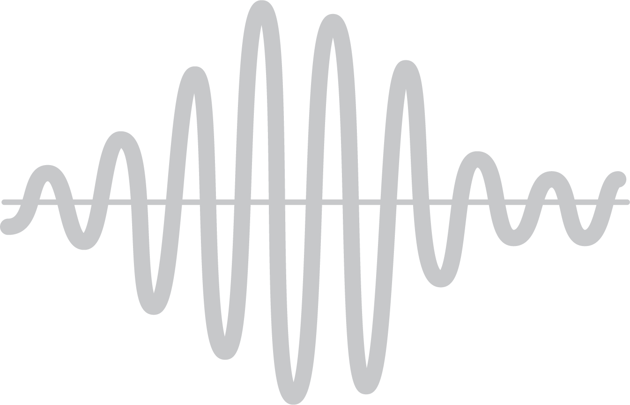 |  | REFLECTED SOUND FROM HIGHWAY NOISE BARRIERS  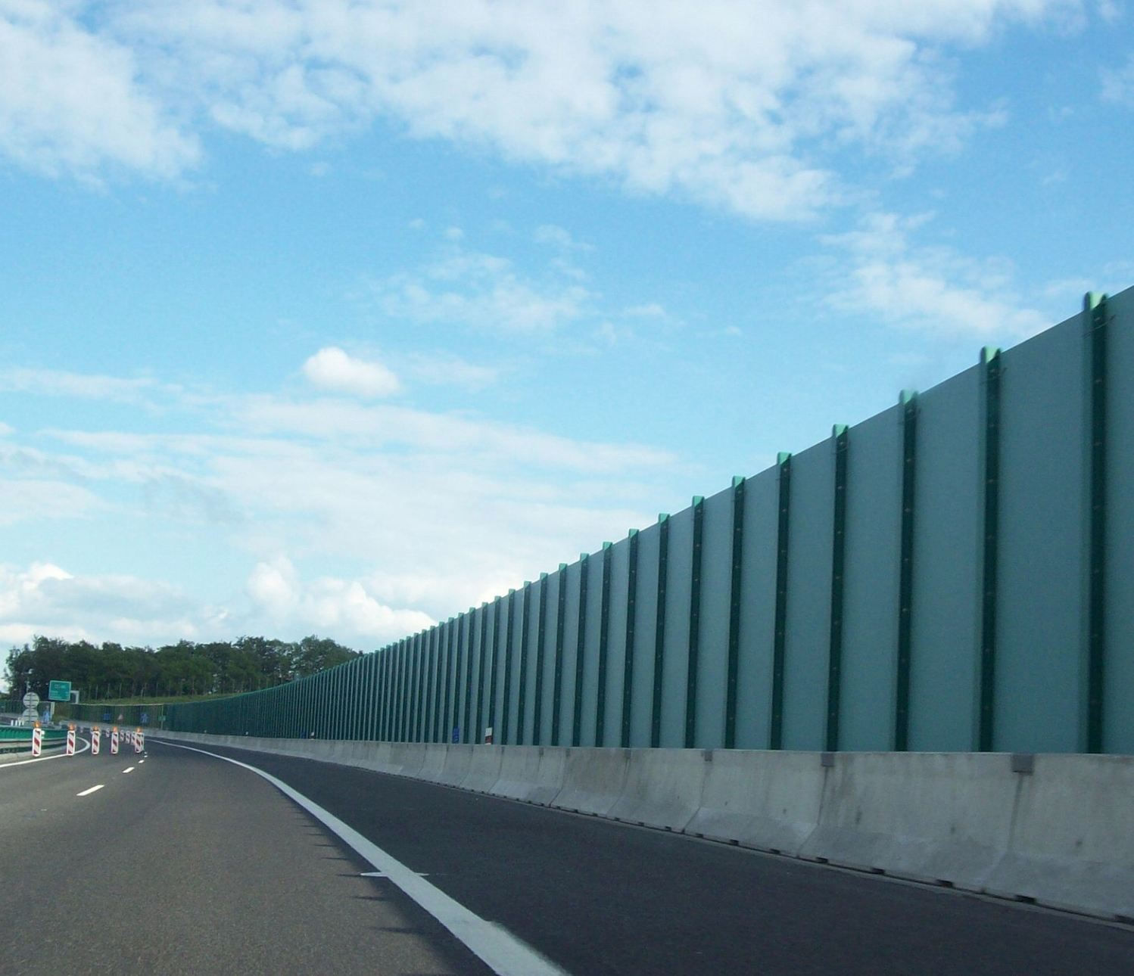  Understanding  sound reflecting off a  highway noise barrier  back across the road  [INSERT SHA LOGO]
Have you heard?  Single highway noise barriers can reflect vehicle noise to the neighborhoods opposite them.  How does that affect the sound in your community?  What factors affect reflections off a barrier?  As a vehicle travels along a highway, it generates sound. Tires, engines, and exhaust systems are the biggest contributors to the sound you hear. As the sound travels outward, it interacts with the ground, buildings, and highway noise barriers. Sound can be reflected or absorbed by these objects.  Roadside noise barriers are put in place to reduce traffic noise behind the barrier. Reflections off a reflective noise barrier increase the level of sound by a small amount on the opposite side of the highway. In this case, you may hear both the direct sound from the vehicle and the sound reflected off the barrier. Your experience of reflected sound will depend on the vehicle type and your distance from the barrier as well as the angle of the reflection, the characteristics of the ground and terrain, distance, barrier dimensions, and other nearby noise sources. |  | 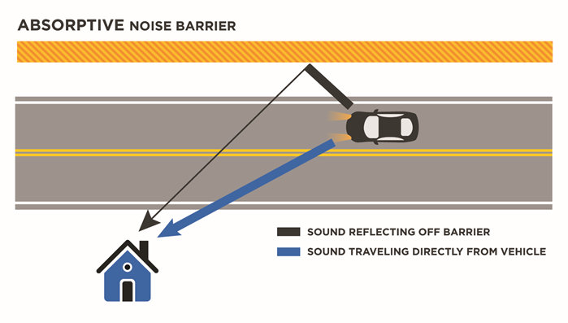 | Will I notice a difference in noise?  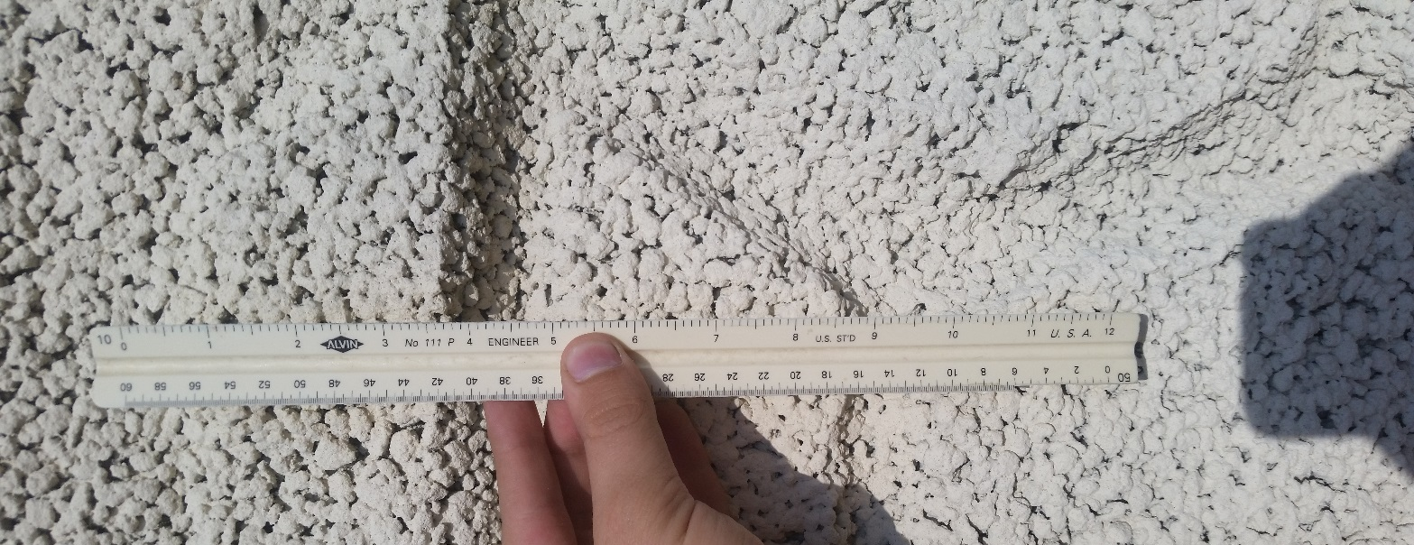  You may or may not notice a change in the noise after the barrier is constructed on the opposite side of the road. Barriers with hard surfaces like concrete, metal, and wood reflect sound and add to the direct sound from vehicles. The noise increase is usually small and may not be noticeable, but other times it may seem louder because the reflections make the sound of each passing vehicle seem to last longer. Also, the interaction of the direct and reflected sound can change the quality of the resulting sound, adding a raspy characteristic. You may be able to perceive this change in sound quality even though it is not much louder.  Do sound-absorbing barriers work?  CLOSE-UP OF AN ABSORPTIVE NOISE BARRIER  Sound-absorptive highway noise barriers reduce the amount of reflected sound. In single-barrier situations, this would help to reduce the raspy quality and apparent increase in the sound’s duration. The most common absorptive sound barriers contain porous material (see above) which helps to reduce mainly mid- to high-pitched sound reflections. Not all sound-absorbing barrier systems perform equally well.
