Supplies: Folder Construction

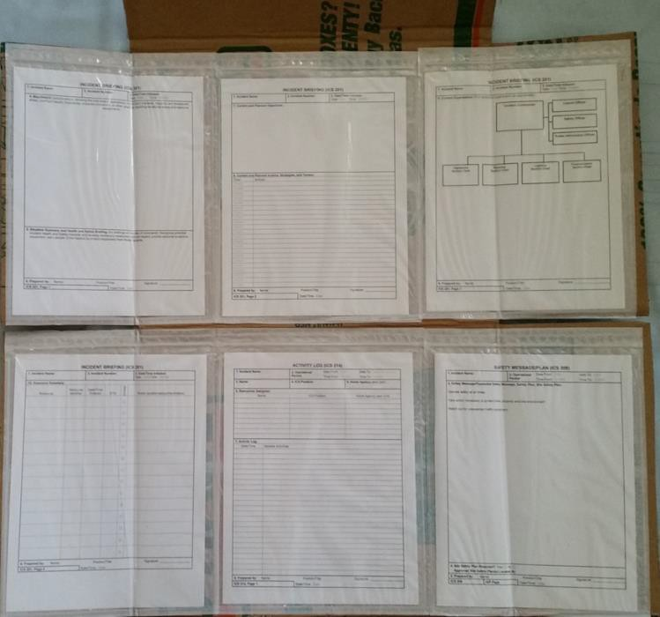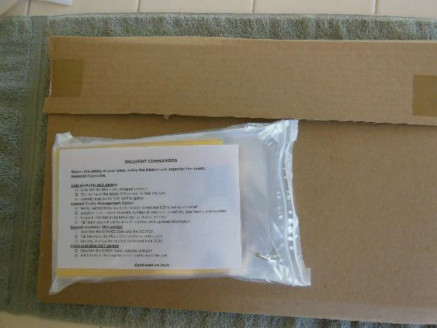

The Supervisor’s Folder. Note the top flap of cardboard that serves as both the closure and the hanging point. Note the placement of the forms across the panel, with the side flaps folding the envelopes as the folder is closed. On the right is the folded version with the blister pack of supplies in place.
Boxes – 6 panel – holds 6 different forms = medium size U-Haul boxes – 18” length x 18” width x 16” height, $1.35/box, yields 2 folders
8 panel – holds 8 different forms = 24” length x 18” width x 18” height- $3/ box, yields 2 folders
Zip lock top packing envelopes – clear reclosable packing list enclosed envelope, plain face, back load (self-adhesive), 2.0 mil thick, 9” x 12”. Need 6 or 8 per panel, plus one for outside blister pack (see below). Available in 500 per case quantity, about $.18 each
ICS forms, available online for download at http://www.training.fema.gov/emiweb/is/icsresource/icsforms.htm,
should be printed on one side only except for the ICS-214 and instructions on how to fill out forms

Supplies: Blister Pack

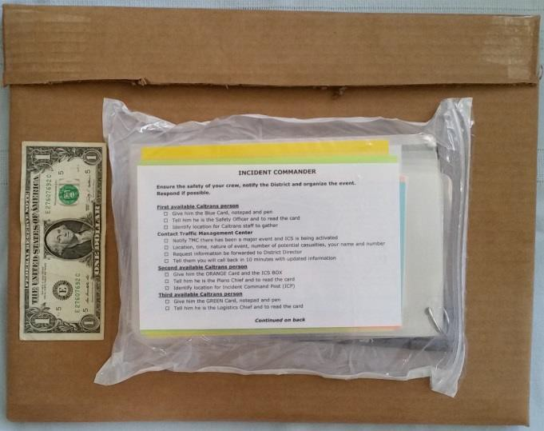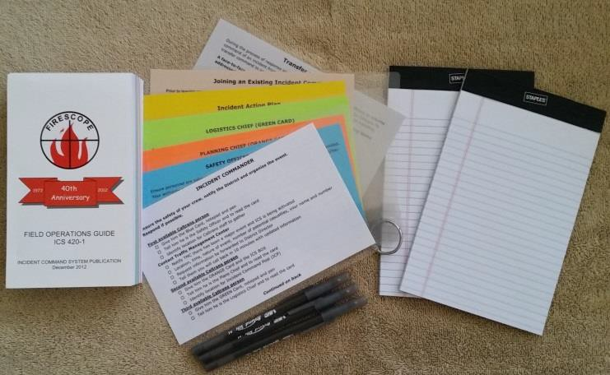

ICS Field Operations Guide – FEMA downloadable for printing (about $30 each) or mobile devices http://www.usfa.fema.gov/downloads/pdf/publications/field_operations_guide. pdf

ICS FOG may be purchased from FIRESCOPE for $5 each http://www.firescope.org/fog-order-info.htm
5” x 8” white pads, 50 sheets per pad
3 ballpoint pens
1 set of Quick Start Cards created using instructions above

Equipment
Box cutter

Directions for Folder
- Identify the ICS forms needed by your agency’s field crew: recommended 201, 208, 214, and
- Determine the number of panels required for these forms when printed one-sided, except for 214.
- Purchase appropriate sized boxes to accommodate 6 or 8 forms.
- Print 2 of each form per folder to be made, plus one set of instructions for each form
- Place 2 copies of each form and one set of instructions in each packing envelope
- Locate the seam where the cardboard overlaps on the box, use a box cutter to cut that seam. And the seam on the opposite edge of the box. You now have 2 equal cardboard panels.
- Take one panel, turn sideways so that the flaps are on the right and left sides, with the advertising or writing on the box facing up.
- Lay out the forms on the marked (advertising) side of the box so that they coincide with the seam in the middle being the folding point, with half of the envelopes above the fold and half below.
- Adhere the form envelopes to the box by removing the paper covering the self-adhesive surface.
- Use box cutter to trim bottom and sides to match packing envelopes.
- On top cut the excess flap material from each side, leaving the center panel top intact.
- Fold in flaps on the bottom and top portions of the cardboard; fold bottom half upward onto the top half; fold the remaining center portion to overlap the bottom half.
- Use packing tape on edges of top flap to seal.

Directions for Blister Pack
Take one packing envelope, with clear side facing up, open zip lock and insert 2 pads, 3 pens, the ICS FOG 420 . Put the Quick Start Cards on top with the Incident Commander card facing out.
Reseal the zip lock top of the envelope.
Turn over so adhesive side is facing up, peel off backing, fold side edges on envelope ½” in so adhesive sides stick to themselves.

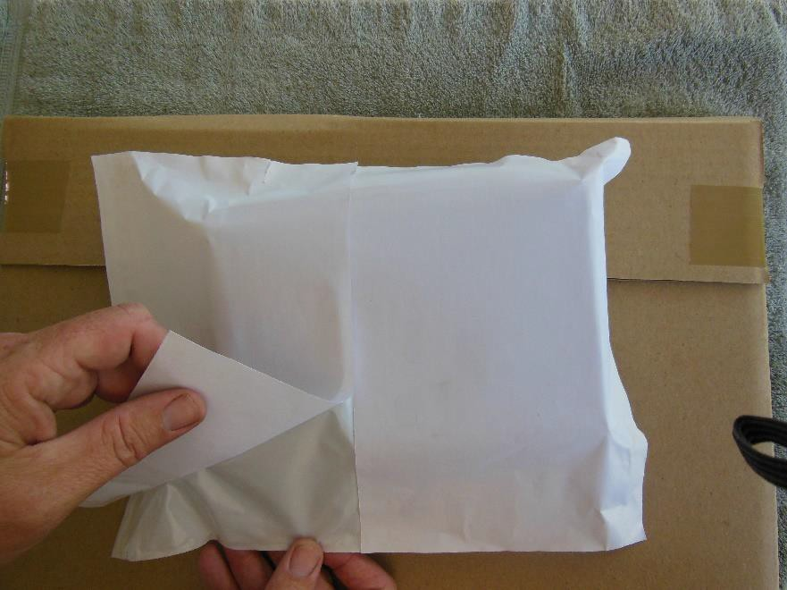
Fold in bottom ½” so adhesive edge sticks to itself.

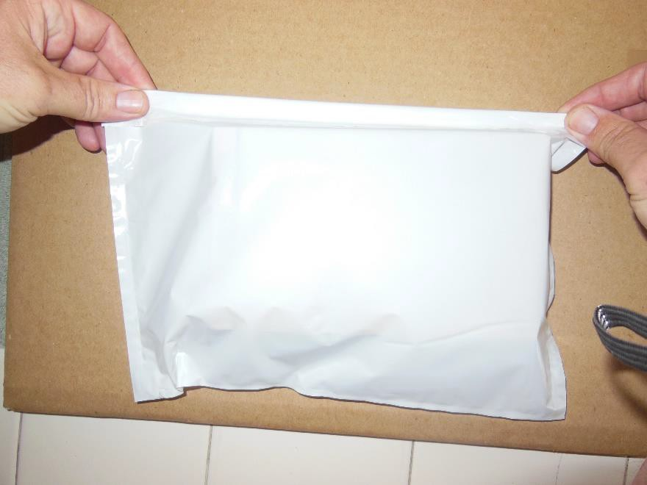

Grasp top corners of bag (edge with zip lock), position bag bottom first on the back of the cardboard folder, then lay down, and press FIRMLY into the cardboard. Press around edges to ensure full adhesion to cardboard.

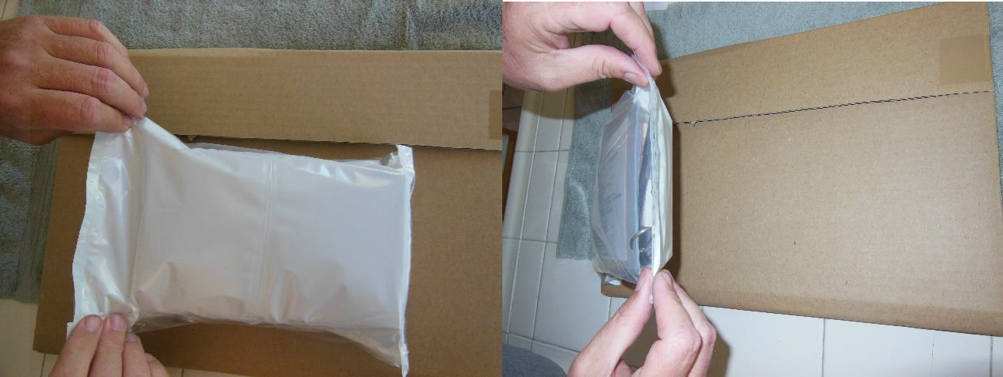

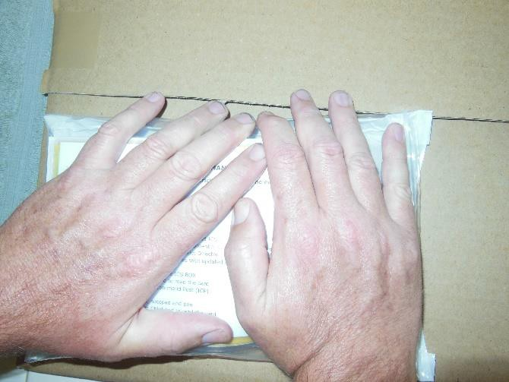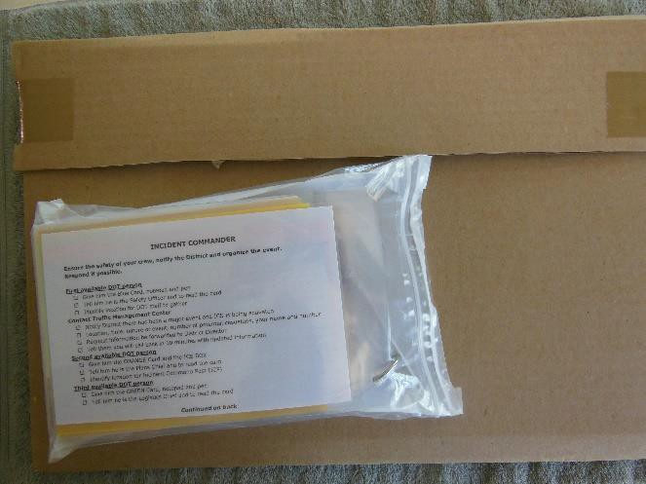

Lessons learned

Cardboard
Source this though your local U-haul, Home Depot, Walmart, Staples, Office Depot, local moving company or DOT back-dock/recycling program.

Understanding the size and flap locations is critical. When you use the box for this project its orientation is going to change from “Height” to “Length.” The flaps will go from top and bottom to right and left side. The cuts for the flaps and related fold seam will become the divider for the top and bottom.

When selecting a box to use as the source material, all three dimensions are important (LxWxH). Width will dictate the length of the flaps divided by two. For example, an 18” wide moving box will have 9” wide flaps. If the box is 18” high as well, then four packing list envelops, which are 12” tall and 9” wide, will fit side by side (two in the middle with one on each flap).

It is recommended that while field researching, take the number of packing list envelopes you intend to use. Lay them out on the potential cardboard as you intend to use it.

Going beyond 8 panels is possible, but isn’t practical due to folds and size. It is probably better to make a supplementary kit for the additional forms.

Materials, Tools and Notes

13” Laminator
http://www.amazon.com/gp/product/B0012UEQ5C?psc=1&redirect=true&ref_=oh_aui_detailpage_o01_s00
Maintained temperature with continuous feeding. Allowed packets to go through sideways for faster production. Needed to adjust tension on rollers.

5 Mil 9 x 11.5 laminating pouches
http://www.amazon.com/gp/product/B00FORXKOC?psc=1&redirect=true&ref_=oh_aui_detailpage_o00_s00
Used a variety of manufacturers, this seemed to bubble the least. 3 Mil is an option but seemed flimsy.

10mm Radius Corner Punch Rounder
http://www.amazon.com/gp/product/B0048W0MQI?psc=1&redirect=true&ref_=oh_aui_detailpage_o03_s00
This is an option but you do need to clean up the sharp edges on the laminate after going through trimmer.

Guillotine Trimmer, 15-Inch Cut Length http://www.amazon.com/gp/product/B00006IATG?psc=1&redirect=true&ref_=oh_aui_detailpage_o00_s00
Look around your administrative areas, you probably already have one.

Legal pad, 5”x 8”, 12 pads per pack
http://www.amazon.com/gp/product/B000AN0UH0?psc=1&redirect=true&ref_=oh_aui_detailpage_o01_s00

Ball pen, medium point
http://www.amazon.com/gp/product/B0012YVGOW?psc=1&redirect=true&ref_=oh_aui_detailpage_o05_s00

Binder rings, 1” capacity
http://www.amazon.com/gp/product/B00008XPLC?psc=1&redirect=true&ref_=oh_aui_detailpage_o00_s00

Cardboard for 8 panel box
http://www.amazon.com/gp/product/B00E81SZ7W?psc=1&redirect=true&ref_=oh_aui_detailpage_o00_s00
Makes two kits per box. This can be an expensive item but shouldn’t be. Source locally through U-Haul, Home Depot, Staples, etc.

Cardboard for 6 panel box.
http://www.uhaul.com/MovingSupplies/Boxes/Standard-sized-moving-boxes/Medium-Moving-Box?id=2793
Makes two kits per box. At less than $1.50 per box…

Clear Reclosable Packing List Enclosed Envelope Plain Face Back Load 2.0 Mil Thick - 9" x 12"
http://www.amazon.com/gp/product/B00BY2UWWY?psc=1&redirect=true&ref_=oh_aui_detailpage_o00_s00
Available in 500 count increments. Had problems with company sending wrong item ordering through Amazon. Recommend contacting them directly.
https://www.packagingsuppliesbymail.com/re-closable-packing-list-envelopes.html

Civil Engineer Tape
http://www.amazon.com/Copernicus-Civil-Engineer-Tape/dp/B007CLVBGC/ref=sr_1_1?ie=UTF8&qid=1442341546&sr=8- 1&keywords=civil+engineer+tape
Narrow for 1:64 scale but cheaper than other brands and more of it.

