NCHRP Project 03-131

Planning and Implementing Multimodal, Integrated Corridor Management

FINAL REPORT

Prepared for
National Cooperative Highway Research Program
Transportation Research Board
Of
The National Academies

TRANSPORTATION RESEARCH BOARD
OF THE NATIONAL ACADEMIES
PRIVILEGED DOCUMENT

This report, not release for publication, is furnished only for review to members of or participants of the CRP. This is to be regarded as fully privileged, and dissemination of the information included herein must be approved by the CRP.

Dr. Kevin T. Miller
Kapsch TrafficCom
8201 Greensboro Dr, McLean, VA 22102

with
Dr. Vassili Alexiadis, Cambridge Systematics;
Alice Chu, Cambridge Systematics;
Joel Ticatch, Kapsch TrafficCom;
Aafiya Shah, Kapsch TrafficCom;
Alyssa Phaneuf, Kimley-Horn and Associates, Inc.;
Tiffany Huang, Kimley-Horn and Associates, Inc.

May 2020
Acknowledgment
This work was sponsored by the American Association of State Highway and Transportation Officials and was conducted in the National Cooperative Highway Research Program which is administered by the Transportation Research Board of the National Academies.

Disclaimer
This is an uncorrected draft as submitted by the research team. The opinions and conclusions expressed or implied in the report are those of the authors. They are not necessarily those of the Transportation Research Board, the National Academies, or the program sponsors.

NCHRP Project 03-131

Planning and Implementing Multimodal, Integrated Corridor Management

FINAL REPORT

Prepared for
National Cooperative Highway Research Program
Transportation Research Board
Of
The National Academies

By

Dr. Kevin T. Miller, P.E., PMP
Principal Investigator
Kapsch TrafficCom

with

Dr. Vassili Alexiadis, Cambridge Systematics;
Alice Chu, Cambridge Systematics;
Joel Ticatch, Kapsch TrafficCom;
Aafiya Shah, Kapsch TrafficCom;
Alyssa Phaneuf, Kimley-Horn and Associates, Inc.;
Tiffany Huang, Kimley-Horn and Associates, Inc.

May 2020

Table of Contents
ACKNOWLEDGEMENTS 1
EXECUTIVE SUMMARY 3
Our Findings and Recommendations 4
CHAPTER 1 BACKGROUND 5
Problem Statement and Research Objective 5
CHAPTER 2 RESEARCH APPROACH 11
Integrated Corridor Management 11
ICM Concepts 12
Corridor Modes of Operation 12
Strategic Areas of ICM 13
Demand Management 13
Load Balancing 13
Event Response 13
Capital Improvement 13
Conceptual Levels within the Corridor 14
ICM Environment 14
State-of-the-Art Summary 14
Champion 15
Building Blocks of ICM 16
Available Capacity 16
Exchange of Data 16
Institutional Cooperation 16
Coordinated Response 16
Capability Maturity Framework for ICM 16
FHWA’s 10 Attributes of a Successful ICM Site 19
Significant Congestion and Unreliable Travel Times 19
Institutional Support 19
Infrastructural Availabilities 19
Multimodal Capabilities 19
Centralized Data Hub 19
Successful Procurement Practices 19
Readily Available Alternative Transit Options 20
Optimization of Existing Transportation Systems 20
Public Engagements 20
Open-mindedness for Change 20
Research Approach 20
CHAPTER 3 FINDINGS AND APPLICATIONS 25
Documents from ICM Deployment Planning Grants 25
Survey/Focus Groups Questionnaire 28
CHAPTER 4 FINDINGS OF RESEARCH 29
Overview 29
Recipients of the Questionnaire 29
Institutional Issues 30
ICM Funding Sources 32
Procurement Methods 33
Staffing and Governance of the ICM Program 33
Knowledge, Skills, and Abilities of ICM Staff 33
Multiple Corridors within the Region 34
Implementation Planning 34
Operations of the ICM Corridor 34
CHAPTER 5 SUMMARY OF THE GUIDEBOOK 35
Implementation Planning 35
Operations of the ICM Corridor 35
General Recommendations 35
ICM Operational Philosophy 35
Background on Planning for ICM 38
The “V-Diagram” Systems Engineering Process 38
ICM Planning and Deployment Framework 38
Systems Engineering Management Plan 41
CHAPTER 6 CONCLUSIONS, RECOMMENDATIONS, AND SUGGESTED RESEARCH 43
Conclusions 43
Suggested Research 43
Institutional Challenges of Implementing ICM and DSS: 43
Data and Performance Measures: 44
Decision Support and Modeling: 44
Implementation Recommendations 44
REFERENCES 45
ABBREVIATIONS, ACRONYMS, INITIALISMS, AND SYMBOLS 49
APPENDIX A: QUESTIONNAIRE 53

List of Figures
Figure 1: Systems Engineering Process 6
Figure 2: DVRPC ICM Corridor Plan 7
Figure 3: ICM Environment 14
Figure 4: ICM Capability Maturity Framework 18
Figure 5: Questionnaire Categories answered 30
Figure 6: Which products were developed as part of the ICM Project 31
Figure 7: Regional Agreements used to support ICM 32
Figure 8: Funding Sources used for ICM 33
Figure 9: Criteria for Selecting ICM Corridors 34
Figure 10: Levels of Integration 37
Figure 11: “V-Diagram” Guidebook Approach 38
Figure 12: Integrated Corridor Management Implementation Process Phases 39

List of Tables
Table 1: Mapping the Guidebook to System Engineering Process 8
Table 2: Where to Find Information in the Guidebook 9
Table 3: Guidebook Content & Document References 21
Table 4: ICM Grant documents 26
Table 5. Levels of Integration 36
Table 6. ICM Implementation Process Activities for the Planning and Concept Phase 39

ACKNOWLEDGEMENTS
The research reported herein was performed under NCHRP Project 03-131 by Kapsch TrafficCom USA. Dr. The other authors of this report include employees from Cambridge Systematics, Kimley-Horn & Associates, and Arora & Associates.
The research team gratefully appreciates the following individuals for their time and efforts in assisting with their experience and expertise in planning and implementing integrated corridor management systems:
- Susan Catlett, New Jersey DOT
- Jeremy Dilmore, Florida DOT
- Alex Estrella, SANDAG
- Mort Fahrtash, Caltrans
- Athena Hutchins, NITTEC
- Mark Plass, Florida DOT
- Paul Szatkowski, Virginia DOT
Special thanks go out to the panel members for the time, effort, and valuable input into this project, including:
- Nicholas Compin, Caltrans
- Susan Boot, Ministry of Ontario, Canada
- Vinh Dang, Washington DOT
- Wei Fan, University of North Carolina – Charlotte
- Qing He, University of Buffalo
- John Hibbard, Georgia DOT
- Jamie Kendrick, Sabra-Wang
- Khang Nguyen, City of Houston, TX
- Jon Obenberger, FHWA
- Marco Pereira, Massachusetts DOT

EXECUTIVE SUMMARY
Integrated corridor management (ICM) takes an integrated, multimodal/multiagency approach to congestion management. Rather than address the shortcomings of the separate roadways and modes in isolation, ICM treats the individual transportation components (highways and roads, transit, parking lots, bicycle and pedestrian trails, etc.) as elements of an interrelated transportation corridor. ICM uses technology and operational strategies as tools for transportation operators to address recurring and non-recurring congestion and optimizes performance of the transportation infrastructure. ICM promotes interjurisdictional coordination and the use of a broad toolbox of transportation system management and operations (TSMO) strategies to optimally detect, monitor, and respond to events and changing conditions. General benefits of ICM include improved mobility, reliability, and safety, and reductions in fuel consumption and fuel emissions.
Building on fundamental concepts dating back nearly 15 years, including the deployment of two model demonstrations in Dallas and San Diego, ICM projects are being planned and implemented on a range of corridors across North America. To support the growing interest and activity in ICM, Project 03-131 will produce a comprehensive Guidebook to assist state, regional, and local practitioners in planning, developing, implementing, deploying, and operating ICM solutions. This synthesis report – which seeks to identify key ICM foundational elements, scalable methodologies, and best-practices to be covered in the final Guidebook – draws upon existing publications, real-world planning and deployment activities, ongoing research, and the relevant experiences, insights, and expertise of the research team.
The objective of this research was to develop a guidebook for agencies planning and implementing multimodal, integrated corridor management. The guidebook features multiple real-world examples drawn from a variety of contexts and an appropriate range of agency capabilities. The chapters developed for the Guidebook are based on the 14 subject areas provided by the project panel. The 14 topics areas included:
- Defining the purpose and need of the integrated traffic management approach.
- Demonstrating the value of the integrated approach to agency administrators and policy makers (including alignment with agency directions in a broader geographical area).
- Identifying and engaging needed partner agencies and defining their respective roles.
- Deciding which scenarios will be cooperatively managed (e.g., crashes, special events, evacuation, adverse weather).
- Determining viable strategies for managing traffic during those scenarios, including multimodal approaches.
- Developing memoranda of understanding or other policies (internal and cross-agency) to support the traffic management system(s) and facilitate those strategies.
- Setting performance metrics and targets.
- Identifying data and information that should be shared between agencies and viable architectures for the sharing.
- Inventorying the ICM infrastructure (e.g., traffic management field and central elements, communications, software) and identifying needed improvements.
- Developing an appropriate staffing model, including hiring, training, and outsourcing.
- Developing a plan for ICM maintenance, sustainability, and continuous improvement.
- Identifying decision support tools, ranging from simple heuristics to complex approaches with embedded simulation models (the typical daily operation should be included as an option).
- Identifying ways to report the performance of the traffic management system(s) (e.g., dashboards) and measure (or estimate) the benefits of the actions taken.
- Developing and implementing a deployment plan for the traffic management system(s).
The provides background and concepts for ICM and a pre-ICM readiness check which are not a part of the 14 topics areas but are required foundational information to provide the readers with the basis of ICM. The 14 topic areas and other lessons learned are then addressed to provide a guidebook on planning for ICM, planning for implementing ICM, and planning for operations and maintenance of ICM.
Our Findings and Recommendations
- High-level findings of this project include several ICM Planning concepts, and gaps in areas the research team found from the literature and from stakeholder inputs.
- The objectives of the Planning and Concept Phase are to coordinate across project partners and stakeholders and gather information necessary to define the desired ICM capabilities, corridor resources and available corridor data to help inform the corridor boundaries and project needs assessment. This in turn helps project stakeholders to gain a clear understanding of where ICM may be beneficial so that they can define the high-level ICM project goals and objectives. The four major product outputs from this phase are the Project Management Plan, Systems Engineering Management Plan, Concept of Operations and the Analysis Plan, including preliminary feasibility assessment of the proposed ICM system (ICMS). These documents are crucial for organizing the management and the technical programming approach to ICM in a region and implementing an ICMS.
  - Planning for ICM can be defined in several non-serial phases to include:
  - Identify & Diagnose Problem
  - Establish ICM Objectives & Scale
  - Determine Potential Partners
  - Engage Potential Partners
  - Assess Potential Partners’ Needs
  - Develop ICM Concept of Operations
  - Designate Performance Metrics
  - Assess Benefits of the Planned ICM Deployment
  - Initiate Formal Agreements
  - Develop Plan for Implementation
- Funding for ICM is lacking in many areas and may require new procurement methods. Traditional engineering procurements do not fit technology projects very well, and some agencies have used other procurement and project development methods to design, build, and deploy ICM.
- Traditional Waterfall (Systems Engineering) development required by FHWA, may not be the most appropriate method to develop and deploy ICM systems. Most sites who have deployed have used an iterative or agile approach, which may require approval from FHWA.
- Operational Planning for ICM has shown that there are new knowledge, skills and abilities needed to operate and maintain ICM systems and the field infrastructure

CHAPTER 1 BACKGROUND
Multimodal Integrated Corridor Management (ICM) seeks to improve the flow of people and goods through busy transportation corridors by adopting an integrated, holistic, and proactive approach to transportation management. By recognizing the corridor-wide impacts that recurring and nonrecurring congestion cause, ICM promotes inter-jurisdictional coordination and the use of a broad toolbox of Transportation System Management and Operations (TSM&O) strategies to more optimally detect, monitor, and respond to events and changing conditions.
Building on ICM concepts that date back a decade and jump-started by the two major demonstration deployments in Dallas and San Diego, ICM projects are now being planned and implemented on major corridors across North America. To support the growing interest and activity in ICM, Project 03-131 seeks to generate a comprehensive Guidebook to help agencies plan, develop, implement, deploy, and operate ICM solutions to address the traffic management needs of their congested corridors. This project drew upon existing publications, ongoing research and deployment efforts, and the experiences, insights, and expertise of the research team to identify best practices and produce a guidebook that is easily understood and scalable to agencies and corridors with diverse capabilities and congestion issues.
Problem Statement and Research Objective
The objective of this research is to develop a Guidebook for agencies planning and implementing multimodal, integrated corridor (or area) management. The Guidebook will feature multiple real-world examples drawn from a variety of contexts and an appropriate range of agency capabilities. At a minimum, the Guidebook will address (though not necessarily in this order) the following:
- Defining the purpose and need of the integrated traffic management approach.
- Demonstrating the value of the integrated approach to agency administrators and policy makers (including alignment with agency directions in a broader geographical area).
- Identifying and engaging needed partner agencies and defining their respective roles.
- Deciding which scenarios will be cooperatively managed (e.g., crashes, special events, evacuation, adverse weather).
- Determining viable strategies for managing traffic during those scenarios, including multimodal approaches.
- Developing memoranda of understanding or other policies (internal and cross-agency) to support the traffic management system(s) and facilitate those strategies.
- Identifying decision support tools, ranging from simple heuristics to complex approaches with embedded simulation models (the typical daily operation should be included as an option).
- Setting performance metrics and targets.
- Identifying data and information that should be shared between agencies and viable architectures for the sharing.
- Inventorying the ICM infrastructure (e.g., traffic management field and central elements, communications, software) and identifying needed improvements.
- Identifying ways to report the performance of the traffic management system(s) (e.g., dashboards) and measure (or estimate) the benefits of the actions taken.
- Developing and implementing a deployment plan for the traffic management system(s).
- Developing an appropriate staffing model, including hiring, training, and outsourcing.
- Developing a plan for ICM maintenance, sustainability, and continuous improvement.
Our general approach to the Guidebook was to group these topic areas into phases of the Systems Engineering Process, as shown in Figure 1.
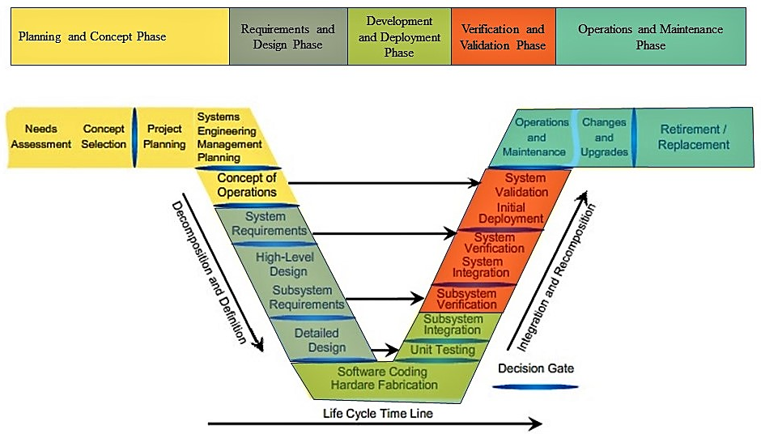
Figure 1: Systems Engineering Process
Additionally, with programs such as the California Connected Corridors, and the Delaware Regional Planning Commission’s 2035 ICM Plan (see Figure 2), which have developed processes to identify, evaluate, and prioritize multiple ICM corridors, we expect the Guidebook to address how a region or state can prioritize multiple corridors with their limitations on funding.

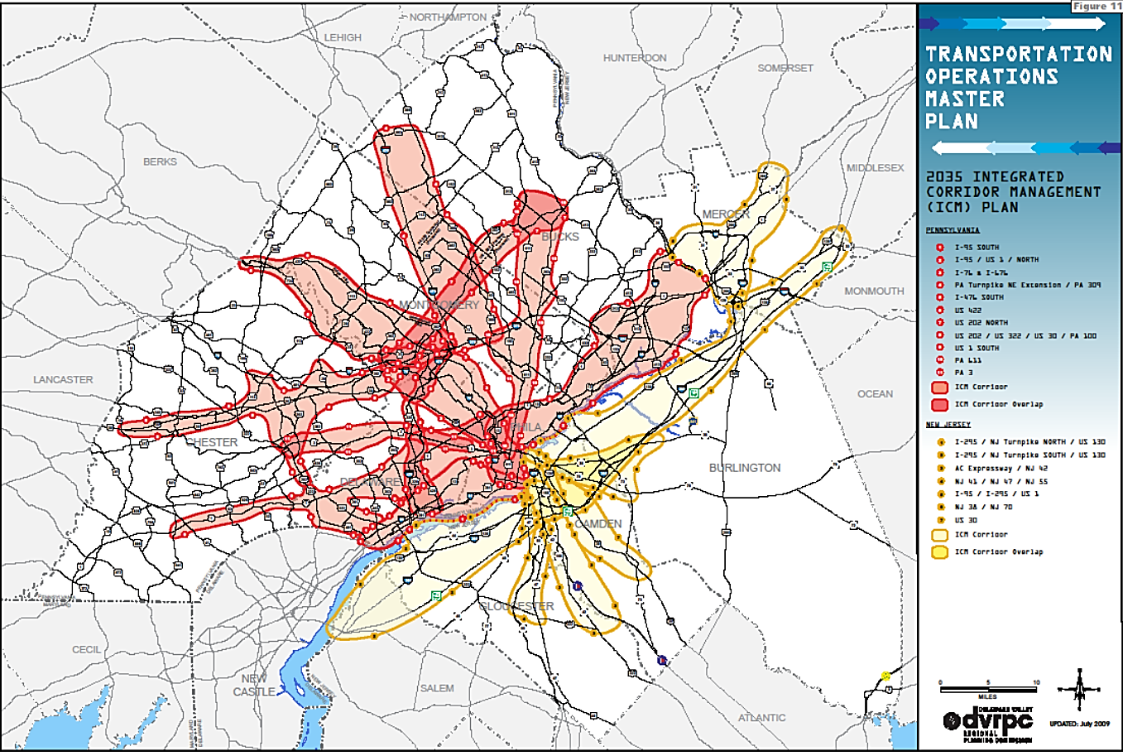
Figure 2: DVRPC ICM Corridor Plan
The systems engineering process and the three levels of integration used by USDOT in its ICM documentation (Institutional, Technical, and Operational Integration) was used as our basic structure for the research topic areas that were investigated. The Guidebook draws extensively from existing publications and ongoing research and deployment efforts. The diagram below shows the topics and how they fit into the overall systems engineering process. These topics were used to develop the Guidebook and focus on the planning aspects requested by the project panel as part of the discussion during the interim report review.

Table 1: Mapping the Guidebook to System Engineering Process
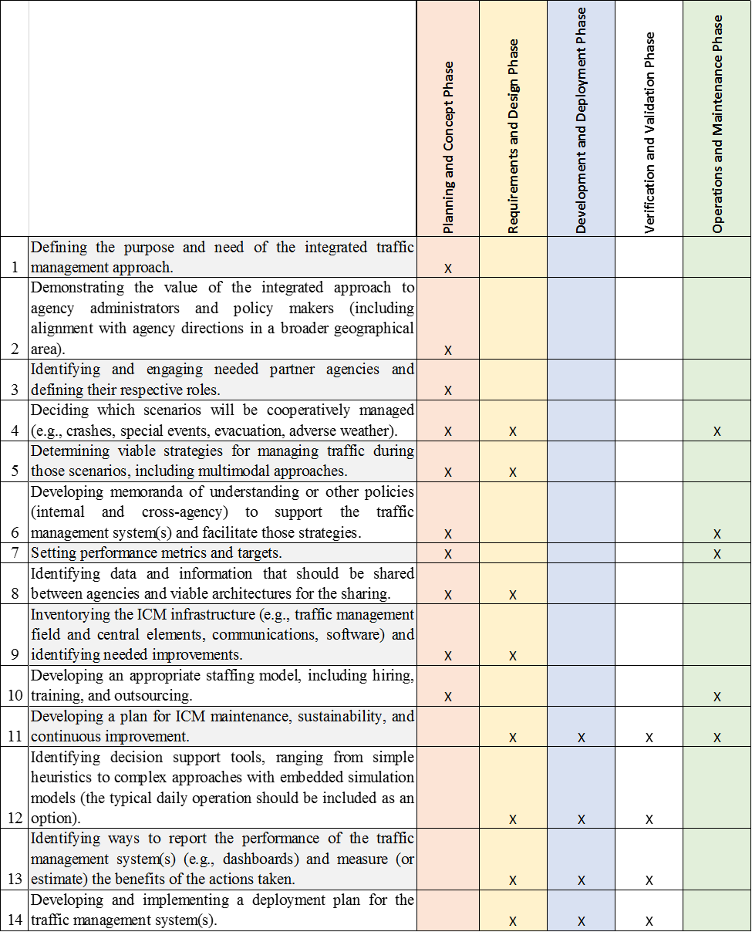

The Guidebook provides an overview of current recommended practices for the planning, design and development, and operations and maintenance of an ICM system. The Guidebook outlines information in several areas considered critical for planning, developing, implementing, and operating & maintaining an ICM Program. Stakeholder engagement throughout the process is key to a successful program and should not be overlooked.
Table 2: Where to Find Information in the Guidebook
Desired Information | Guidebook Section
Definition of Integrated Corridor Management  Overview of the approach in planning for ICM | Chapter 2 - Overview of ICM
Process of the assessment to be made as to the utility of ICM to address the agency’s issues | Chapter 3 – Beginning ICM
Planning process for ICM  Understanding of how ICM fits into the Systems Engineering Process | Chapter 4– Planning for ICM
Process for developing the architecture and design of an ICM System  The development processes that should be considered when developing an ICM System | Chapter 5 – Planning for Design and Deployment
Operational planning needed for ICM operations  Understanding needs for on-going funding for operations & maintenance of the ICM program | Chapter 6 – Planning for Operations and Maintenance

The guidebook is written and organized to describe the overarching planning process at the various systems engineering stages of a technology deployment project. The information and recommendations presented within the guidebook were developed through a literature review and stakeholder surveys and interviews were used to identify issues, needs, and best practices for ICM Planning, Development, Deployment, and Operations & Maintenance. The combination of the literature and stakeholder surveys and interviews allowed the development of the Guidebook, to include sections to address each phase of the Systems Engineering process.

CHAPTER 2 RESEARCH APPROACH
Based on the literature review synthesis developed in Task 2 and the experience of the research team, suggestions from the peer review panel, and comments from the project panel, a detailed data collection plan was developed to address the 14 base topic questions in the solicitation and focus on the planning aspects of the various phases of the project life cycle. The data collection plan used three basic components:
- Collection and review of project documents from various ICM projects
- Identification of gaps in literature that are needed for the Guidebook
- Questionnaires developed for the ICM Planning sites, and other sites identified.
Integrated Corridor Management
Integrated corridor management takes an integrated, multimodal, multiagency approach to congestion and travel management. Traditionally, the individual transportation elements tended to be managed independently, with the focus on the individual components. However, as congestion levels and incidents have increased, the rationale for managing the transportation elements within a corridor holistically or systemically has grown. ICM treats the individual transportation components – freeways, arterials, transit, parking systems, bicycles, pedestrians, etc. – as elements of an interrelated transportation corridor. It focuses on coordinated, multimodal management across modes, networks, and agencies.
An underlying principle behind the ICM concept is to operate the individual transportation networks in a more coordinated and integrated manner, that results in enhanced mobility, reliability, safety, and increased overall corridor throughput. An ICM system can be viewed as a “system of systems,” connecting individual components and enabling coordinated activities based on operational procedures mutually agreed to by the owners and operators of the various systems.
Managing each system individually results in agencies embarking on projects that relieve bottlenecks on the transportation element they are responsible for. However, the bottlenecks may not have disappeared, but instead just moved elsewhere in the overall transportation system. For example, in the event of an incident on a freeway, ICM could allow the freeway operator to communicate with arterial managers that traffic from the freeway will be diverted onto the arterials, and the signals should be timed to flush the additional traffic along the freeway corridor. Transit operators could also be informed to expect additional passengers shifting modes to their system, momentarily adding service on the transit system during the freeway incident. An effective ICM approach allows each transportation system operator to effectively and efficiently react to real-time conditions.
In the early-2000s, the U.S. Department of Transportation initiated its ICM Program, including conducting foundational research and developing a framework to model, simulate, and analyze ICM strategies. Eight ICM “pioneer sites” were competitively selected, in 2006, to participate in a 3-stage process. In Stage 1, all eight sites (see below) developed ICM concepts of operations and prepared system requirements. During Stage 2, three of the sites (marked by asterisks) conducted extensive analysis, modeling, and simulation exercises on their respective corridors. In Stage 3, two of the sites (marked in bold) were funded to demonstrate (develop, deploy, and operate) their ICM concepts:
- US-75 in Dallas, Texas*
- I-10 in Houston, Texas
- I-394 in Minneapolis, Minnesota*
- I-270 in Montgomery County, Maryland
- I-80 in Oakland, California
- IH-10 in San Antonio, Texas
- I-15 in San Diego, California*
- I-5 in Seattle, Washington
More recently, U.S. DOT initiated a new ICM Deployment Planning Grant Program, which involved funding for ICM planning activities, but not for development and deployment. In 2015, out of more than 40 applications received, 13 sites were selected to receive the planning grant funding:
- I-10, led by Maricopa County, Arizona
- I-210, led by Caltrans
- SR-4, led by Contra Costa County, California
- I-95, led by Broward County, Florida
- I-95, MD 295, and US 1, led by the Maryland State Highway Administration
- I-95, US 1, and US 9, led by the New Jersey Department of Transportation
- I-495, led by the City of New York
- I-90, led by the Niagara (New York) International Transportation Technology Coalition (NITTEC)
- I-84, led by the City of Portland, Oregon
- IH-10 and US-54/IH-110, led by the City of El Paso, Texas
- IH-35, led by the City of Austin, Texas
- Major north-south roadways, including I-15, led by the Utah Transit Authority and the Utah Department of Transportation
- Northern Virginia East-West Corridor led by the Virginia Department of Transportation
Most of these grantees wrapped up their planning activities in 2017 or 2018, and many expect to implement their plans. Additionally, several localities are using their own funding sources to develop and implement ICM (e.g., Orlando and Detroit). Others have submitted Advanced Transportation and Congestion Management Technologies Deployment Program (ATCMTD) grant applications, with ICM projects as major components of their proposals.
ICM Concepts
The four basic concepts of ICM according to USDOT’s Integrated Corridor Management: Implementation Guide and Lessons Learned are:
- Corridor Modes of Operation:
- Strategic Areas for ICM
- Conceptual Levels within the corridor
- ICM Environment
These concepts are summarized as follows.
Corridor Modes of Operation
In ICM, the modes of operation do not refer to the transportation modes in the corridor (e.g. transit, bikes, peds), but rather refer to the operational modes. All corridors operate in two major modes: Normal Mode and Event Mode. Normal mode refers to the actions taken to control day-to-day operations, including managing recurring congestion. Event Mode includes two sub-modes: planned event mode and unplanned event mode. The planned event mode may include a planned construction project in the corridor that may reduce capacity or a sporting event that increases demand in the network for a short period of time. The unplanned event mode involves incidents that decrease capacity for a period or another event that increases demand on one or more corridor networks, such as an emergency evacuation.
The corridor manager has the responsibility to assess the situation to shift corridor management strategy from Normal Mode to Event Mode and vice versa. If the event severity, impact, or duration is low, the corridor manager may not need to shift to Event Mode. The corridor manager uses the tools available in the ICM system to monitor and make decisions to shift modes.
Strategic Areas of ICM
The four areas for active management of an ICM are:
Demand Management
Addressing the patterns of usage in the corridor, demand management is the set of actions that the corridor manager can take to address the demand directly. Demand management in the Normal Mode have long-term effects on the corridor and require long lead times to implement. One such action may be implementing congestion pricing, which can result in the long-term effect of shifting demand to other roadways or modes or changing the time when people travel. Demand management in the Event Mode can happen more quickly, such as opening the HOV or HOT lanes to general purpose travel during a weather evacuation emergency.
Load Balancing
Load balancing addresses how travelers use the transportation networks in a corridor. In the Normal mode, corridor managers may see that there is far more demand in traveling on the freeways of a corridor, but there is excess capacity on the transit line along a corridor. The corridor manager may use traveler information on the freeway to compare transit and freeway driving times along the corridor, showing that the transit can be faster. Other ways to shift travelers’ modes may include providing additional first-last mile connections between travelers’ origin and destination and the transit stations. Load balancing in the Event mode may involve transit operators running more trains and buses during holiday or sporting events for planned events.
Event Response
Events are occurrences that effect either the capacity or the demand of one or more transportation networks. Events can be categorized by duration (i.e. short-term or long-term) or by their effect (i.e. reduction in capacity, increase in demand, change in demand pattern). Response to a short-term event such as a planned concert event that increases demand on the transportation network near the event location are manageable by the agencies involved in the ICM through the system by changing signal timing on nearby roadways and increasing transit operations during the ingress and egress times.
Long-term event response may change the perception of what Normal Mode operation involves. Long-term events may be a 3-day music festival that operators expect to change the management of the corridor accordingly during the event of increased demand. However, with an unplanned, long-term event like a mudslide blocking the roadway, which would require weeks or months to clear, transportation system operators may make real-time decisions in the near-term of the event, but the “normal” operations of the corridor may shift in the long-term to accommodate for the clearance operations.
Capital Improvement
Capital improvements are a long-term solution to long-term transportation problems within the corridor. These capital improvements may involve constructing additional capacity on the network, adding networks, or using ITS technology on new or existing facilities. With capital improvements of the system, the corridor operators will need to re-evaluate the strategies in place to consider the impacts to the system given expected changes.
Conceptual Levels within the Corridor
When developing the ICM approach, the three conceptual levels to be considered are physical, information processing, and execution or decision making. The physical level is the transportation infrastructure for the corridor, the information processing level is the tools and information systems that the corridor manager uses to make decisions, and the execution or decision-making level is the plans, actions, and real-time decisions that operators make with the controls available to them.
ICM Environment
Finally, the ICM environment deals with the four strategic areas and includes the three conceptual levels. It is the culmination of the pillars in ICM strategic areas being used on top of the infrastructure, information processing, and decision-making levels of the ICM. This is shown graphically in Figure 3.
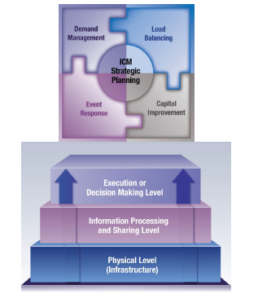
[Source: Noblis, Inc., for U.S. DOT, 2011.]
Figure 3: ICM Environment
State-of-the-Art Summary
Improving the coordination of day-to-day operations among transportation agencies that operate within heavily traveled corridors can potentially improve travel throughput and efficiency. Along many urban transportation corridors, transportation agencies within the corridor (e.g., local departments of transportation, bus operators, light rail operators, etc.) often previously managed operations independently. Today, as road users experience increased levels of congestion, delay, and incidents, this traditional operations model has become less effective in meeting the transportation needs of the people that rely on the corridor.
ICM is an approach to improving transportation that considers all elements in a corridor, including highways, arterial roads, and transit systems. By optimizing the use of existing infrastructure assets through coordinated transportation management techniques, transportation investments can go farther. There are many corridors in the country with underutilized capacity (in the form of arterials, freeway travel lanes and parallel transit capacity – e.g., bus, rail, bus rapid transit, etc.) that could benefit from ICM. The maturation of ITS technologies, availability of supporting data, and emerging multiagency institutional frameworks make ICM practical and feasible. There are a significant number of freeways, arterial, and transit optimization strategies available today that are already in widespread use across the United States. Many of these strategies are managed locally by individual agencies, often on an uncoordinated basis. Even those managed regionally are sometimes managed in isolation (asset-by-asset), rather than in an integrated fashion across a transportation corridor.
Dynamically applying these strategies in combination across a corridor in response to varying conditions can help to reduce congestion “hot spots” in the system and to improve the overall productivity and safety of the system. Furthermore, providing travelers with actionable information on alternatives (such as multimodal comparative travel times) may help to mitigate bottlenecks, reduce congestion, improve resiliency of the system during major incidents, and empower travelers to make more informed travel choices.
The intended functionality of an ICM system requires three distinct, yet interrelated, levels of integration:
- Institutional integration relates to coordination and collaboration between various agencies and jurisdictions that transcends institutional boundaries.
- Operational integration refers to multiagency and cross-network operational strategies to manage the total capacity and demand of the corridor.
- Technical integration refers to sharing and distributing information, and system operations and control functions to support the immediate analysis and response to congestion.
Some recurring best-practices gleaned from the ICM Scan Report, ICM Implementation Guidance, and multiple project reports are noted below:
Champion
Most ICM projects have had a “champion” from one of the lead agencies to jump-start the project, seek out funding, and see the planning or deployment project to completion. The scan team found that while a champion is necessary to get an ICM program started, the interjurisdictional nature of an ICM project necessitates that the program reach the point where it becomes routine and the agencies and organization provide the necessary momentum and continued support. This way, even if the champion steps away, the program will continue.
As an example, the Phoenix area has a cooperative ITS organization that began as part of the U.S. DOT Model Deployment Initiative in the mid-1990s. Today, AZTech is still being used as the regional organization that cooperatively plans ITS projects, including ICM. Some ICM planning projects, such as in Virginia, have experimented with designating multiple champions in different focus areas.
Building Blocks of ICM
Typically, several corridor-level “building blocks” are needed to ensure the viability of an ICM program. These building blocks include the following:
Available Capacity
There should be available capacity within the transportation network to manage a corridor through a multiagency or multimodal ICM approach. For example, if a freeway is congested, there ought to be capacity on an alternate freeway, the adjacent arterial network, or transit servicing the corridor.
Exchange of Data
There will need to be an exchange of data between agencies responding to an event with the managed corridor. As a minimum, this could be as simple as telephone calls discussing and agreeing to a response. For data exchange to be most effective, the scan team recommends an automated data-sharing system. Since these systems may vary among agencies responding to events, a standards-based system (e.g., C2C, TMDD, MS/ETMCC, or transit communications interface profiles) should be used for easier integration.
Institutional Cooperation
There will need to be open communication and cooperation among agencies to operate the assets within the corridor. Communications can be done informally (i.e., operational personnel share information and coordinate responses among agencies) or more formally (i.e., through intergovernmental agreements or memoranda of understanding (MOUs) that define roles and responsibilities). Some areas have been successful using high-level ITS cooperative MOUs, while others have developed ICM-specific MOUs.
Finally, ICM is a name, a concept, a tool, as a part of the much bigger concept of cooperation among regional agencies to better operate a corridor, a city, a region, and more. ICM must become an integral part of any future local, regional, and statewide ITS strategic plans. It is hoped that proper planning will ensure the essential political buy-in of the concepts and funding.
Coordinated Response
For ICM to work optimally, all agencies involved with the corridor’s operations will need to coordinate their responses to events. An agency that does not coordinate its response has the potential to negatively affect the corridor. Once the ICM program is in place and operational, it is time to test, update, and validate the response plans used by the corridor.
Capability Maturity Framework for ICM
The NCHRP Domestic Scan team led by AASHTO reviewed the implementation of ICM across the U.S. As part of the Scan Tour and subsequent report, the various ICM deployments and enabling process areas were reviewed. A portion of this review was to analyze real-time models for planning and operations for ICM, and the implementation of DSS for ICM. As part of the final report, an ICM Capability Maturity Framework/Model (CMF/CMM) was developed which included maturity for six process areas for ICM (see Figure 4). Based on the levels of maturity of the different building blocks of ICM, the Scan Team surmised that the application of a CMM for ICM can help agencies evaluate their ability to deploy an ICM program, as well as identify areas for improvement.
The CMM model is a five-level process-focused model that shows the evolutionary processes within the process areas that the scan team believes are most important for implementing and improving an ICM program. However, the basic building blocks of having a champion and having infrastructure in place are needed to begin an ICM program.
The CMM model for ICM is designed to compare a corridor agency’s existing processes to best practices developed by members of industry, government, and academia that were shown and discussed as part of the scan. These best practices reveal possible areas for improvement and provide ways to measure progress.

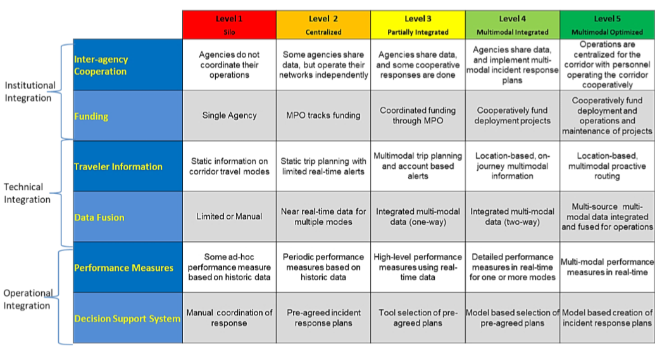
Figure 4: ICM Capability Maturity Framework
Source: Advances in Strategies for Implementing Integrated Corridor Management (ICM), pg. 11-2.

FHWA’s 10 Attributes of a Successful ICM Site
The FHWA has developed a fact sheet for agencies which presents ten attributes of successful ICM sites and describes their importance for effective implementation. These attributes include:
Significant Congestion and Unreliable Travel Times
The most critical—and obvious—attributes of a successful ICM site are noticeably high congestion and unreliable travel times. The impact of ICM is more noticeable in areas with significant congestion and delay, as improved traffic flow in these areas can be more attributable to ICM strategy implementation than in areas that experience inconsistent congestion.
Institutional Support
One of the most critical pieces of successfully implementing ICM is interagency and institutional support. Without the coordination of transportation agencies and organizations, multimodal communication and coordination is extremely difficult. Deployment of the required ICM technologies can be severely delayed or even immobilized without the support of local and regional transit agencies and the ability to send information across jurisdictions. Strong leadership is also important. ICM implementation not only requires the coordination and support of external agencies and organizations, it also relies heavily on the ability to coordinate and make decisions from an internal perspective. Like most systems, ICM implementation can only fully succeed when all parties involved work together, and a strong sense of leadership is necessary to keep all those aspects organized and the end goal on track.
Infrastructural Availabilities
ICM sites must also have the appropriate infrastructure in place to support ICM, such as parallel arterials and additional transit options. For ICM to work properly, there must be alternative means of transit to which people can shift based on the information and traffic data the system provides.
Multimodal Capabilities
ICM corridors must also can connect in a multimodal fashion. This means that the different transit organizations and agencies must be able to communicate with one another, such as bus transit, rail transit, high-occupancy- vehicle (HOV) lane management, etc. Full implementation is nearly impossible without open communication—both technologically and organizationally—between the different modes of transportation.
Centralized Data Hub
A localized transportation management center is critical for housing all communication and traffic data in one centralized location. This makes it easier to organize and analyze the different traffic data and information in a consolidated manner.
Successful Procurement Practices
The most successful ICM sites can identify the processes and practices that work, and the personnel needed to perform the job correctly and proficiently. For example, integrating traffic systems together requires a different set of skills and expertise than typical traffic engineering. Intelligent transportation systems (ITS) experts may need to be involved in the integration process to ensure it is completed effectively and knowing this information in advance eliminates wasted time spent on troubleshooting. Efficient ICM sites are fully aware of expertise requirements and act accordingly during the procurement and integration processes.
Readily Available Alternative Transit Options
Alternative transit options are a necessity for successful ICM sites. These options could include bus rapid transit, HOV lanes, alternative commuter options, commuter rail, heavy rail (e.g., subway), and light rail. Effective ICM sites already have these options in place before ICM is implemented, and therefore can more easily integrate the options together.
Optimization of Existing Transportation Systems
Successful ICM sites can determine whether the currently existing transportation systems are being fully optimized to ensure that there are no additional underlying problems with traffic networks. For example, a site must verify that roads cannot be widened any more due to surrounding infrastructure or physical location or validate that all additional alternative routes are being utilized in a manner that cannot otherwise be improved upon without ICM.
Public Engagements
Keeping stakeholders and the public engaged provides the public with better understanding of expected changes and better enables them to make more informed travel choices. A dedicated public-facing website that houses all the corridor information and serves as a one-stop shop for project information can keep the public knowledgeable of recent ICM developments. It also provides the media access to all images and videos and reminds the public that the system is still in place—even after all physical changes and construction have been installed and forgotten.
Open-mindedness for Change
Change is not always easy. While some people are more susceptible to change, others may see it as a threat to the familiar routine and be less receptive. Successful ICM sites can encourage an open mind and acceptance to changing solutions for congestion and traffic. Encouraging the public to support the changes for the betterment of congestion and travel times is an extremely important— and sometimes difficult—task.
Research Approach
Based on the Literature Review, and the further review of documents provided by the various ICM sites, the Guidebook outline was developed with references to the documents, and our team’s experience and expertise with ICM.
Table 3 provides the sub-sections agreed to by the Project Panel during the first workshop, along with references from the literature review and our documentation reviews. This provided the research team with some indication of areas that needed further research to fill the gaps identified.
Table 3: Guidebook Content & Document References
Sub-Sections | Related Documents
What it is (corridor) | ICM Implementation Guide and Lessons Learned
 | Elements of Business Rules and DSS within ICM
 | ICM and the Smart Cities
 | ICM, Transit, and MOD
Precepts (multimodal/multiagency, load-balancing, etc.) | ICM Implementation Guide and Lessons Learned
 | I-84 Oregon (Final Report)
Stakeholder engagement | ICM Implementation Guide and Lessons Learned
 | I-10 Arizona (ConOps)
 | I-210 California (ConOps; Deployment Planning; Website)
 | I-95 Florida (ConOps)
 | I-90 New York (System Operations Concept)
 | I-495 New York (ConOps)
 | NoVA East-West Virginia (ConOps)
 | IH-10 Texas (ConOps)
 | I-95/MD 295/US 1 Baltimore-Washington (ConOps)
Summary and Assessment of State-of-Play | I-10 Arizona (ConOps; PMP)
 | I-210 California (ConOps)
 | I-495 New York (ConOps)
 | IH-10 Texas (ConOps)
 | I-84 Oregon (Final Report)
 | NoVA East-West Virginia (ConOps)
Needs/Issues | ICM Implementation Guide and Lessons Learned
 | I-10 Arizona (ConOps; SRS)
 | I-210 California (ConOps; Deployment Planning)
 | I-95/MD 295/US 1 Baltimore-Washington (ConOps)
 | I-495 New York (ConOps)
 | IH-10 Texas (ConOps)
 | NoVA East-West Virginia (ConOps)
 | I-84 Oregon (Final Report)
Concepts (evaluation, i.e., data, models, etc.) | I-10 Arizona (AMS; SRS)
 | I-495 New York (ConOps)
 | I-84 Oregon (Final Report)
Implementation Planning | I-10 Arizona (ConOps)
 | I-495 New York (ConOps)
 | IH-10 Texas (Implementation Plan)
 | NoVA East-West Virginia (Implementation Plan)
 | I-84 Oregon (Final Report)
 | I-95 Florida (Implementation Plan)
Multi-phase | I-10 Arizona (ConOps; AMS)
 | I-210 California (SEMP)
 | IH-10 Texas (Implementation Plan)
Resources availability | I-10 Arizona (PMP)
 | I-210 California (Deployment Planning; Website)
 | NoVA East-West Virginia (Implementation Plan)
Procurement | I-10 Arizona (PMP)
 | I-210 California (PMP)
 | I-95 Florida (Implementation Plan)
 | I-495 New York (ConOps)
Systems Engineering and Implementation Plan process | I-10 Arizona (SEMP)
 | I-210 California (SEMP)
 | I-95 Florida (Implementation Plan)
Including – equipment, implementation plan procedure, umbrella systems, integration, data integration, agreements | I-10 Arizona (SEMP) – systems integration
 | I-210 California (ConOps; Deployment Planning; SEMP) – systems, agreements, equipment
 | I-95 Florida (Implementation Plan) - agreements
 | I-495 New York (ConOps) – agreements
 | IH-10 Texas (ConOps) – agreements
 | I-84 Oregon (Final Report) – agreements, data sharing policies
Evaluate your measures of success | ICM Implementation Guide and Lessons Learned
 | I-10 Arizona (ConOps; SRS; AMS)
 | I-210 California (ConOps; Deployment Planning)
 | I-495 New York (ConOps)
 | IH-10 Texas (ConOps)
Stakeholder coordination | I-210 California (ConOps) – operational and maintenance procedures

The research approach consisted of reviewing all documents to analysis process consistency among agencies and identifying best practices. High-level findings of this project include several ICM Planning concepts, and gaps in areas the research team found from the literature and from stakeholder inputs found common approaches:
Based on the finding of the Literature Review, Synthesis document and research completed after the project panel workshop, the project team completed a review of all documents available from the ICM Planning Sites and original ICM Pioneer sites to address the topics within the ICM Guidebook outline discussed as part of the workshop. A total of 13 ICM project sites were identified. Table 2 below summarizes the documentation reviewed by the research team from each of the ICM project sites.
The gaps identified in these documents that were identified for further research and outreach to agencies for the Guidebook included:
- What are initial and additional funding sources for ICM?
- What knowledge, skills, and abilities (KSAs) are needed to support ICM planning, implementation, and operations and maintenance? (training courses tied to the KSAs and guidance for when to outsource)
- What procurement mechanisms/processes are needed for designing, deploying, operating and maintaining ICM?
- What is an appropriate staffing model, including hiring, training, and outsourcing for operating and maintaining the ICM system?
- What are the envisioned roles and responsibilities of various entities in building, operating and maintaining the ICM system?
- What are the envisioned roles of various partners in managing traffic during different operational conditions?
- What is the staffing and governance models for our ICM?

CHAPTER 3 FINDINGS AND APPLICATIONS
High-level findings of this project include several ICM Planning concepts, and gaps in areas the research team found from the literature and from stakeholder inputs.
- The objectives of the Planning and Concept Phase are to coordinate across project partners and stakeholders and gather information necessary to define the desired ICM capabilities, corridor resources and available corridor data to help inform the corridor boundaries and project needs assessment. This in turn helps project stakeholders to gain a clear understanding of where ICM may be beneficial so that they can define the high-level ICM project goals and objectives. The four major product outputs from this phase are the Project Management Plan, Systems Engineering Management Plan, Concept of Operations and the Analysis Plan, including preliminary feasibility assessment of the proposed ICM system (ICMS). These documents are crucial for organizing the management and the technical programming approach to ICM in a region and implementing an ICMS.
- Planning for ICM can be defined in several phases to include:
- Identify & Diagnose Problem
- Establish ICM Objectives & Scale
- Determine Potential Partners
- Engage Potential Partners
- Assess Potential Partners’ Needs
- Develop ICM Concept of Operations
- Designate Performance Metrics
- Assess Benefits of the Planned ICM Deployment
- Initiate Formal Agreements
- Develop Plan for Implementation
- Funding for ICM is lacking in many areas and may require new procurement methods. Traditional engineering procurements do not fit technology projects very well, and some agencies have used other procurement and project development methods to design, build, and deploy ICM.
- Traditional Waterfall (Systems Engineering) development required by FHWA, may not be the most appropriate method to develop and deploy ICM systems. Most sites who have deployed have used an iterative or agile approach, which may require approval from FHWA.
- Operational Planning for ICM has shown that there are new knowledge, skills and abilities needed to operate and maintain ICM systems and the field infrastructure
Documents from ICM Deployment Planning Grants
Based on the finding of the Literature Review, Synthesis document and research completed after the project panel workshop, the project team completed a review of all documents available from the ICM Planning Sites and original ICM Pioneer sites to address the topics within the ICM Guidebook outline discussed as part of the workshop. A total of 13 ICM project sites were identified. Table 4, below summarizes the documentation reviewed by the research team from each of the ICM project sites.

Table 4: ICM Grant documents
ICM Grant Program Site | Lead Agency/City | Documents Prepared
Arizona  I-10 through the phoenix metro area and multiple east-west parallel routes | Maricopa County | Project Management Plan (PMP)  Systems Engineering Management Plan (SEMP)  Concept of Operations (ConOps)  Analysis, Modeling and Simulation Plan (AMS)  System Requirements Specification (SRS)
California  I-210 on a 22-mile section from the 134/210 interchange near downtown Pasadena to the Foothill Blvd interchange in La Verne | Caltrans | Concept of Operations  Project Management Plan  Systems Engineering Management Plan  Systems Requirements Specification  System Validation Plan  System Verification Plan  Core System High-Level Design
California  SR-4 in the city of Hercules from I-80 to I-680 | Contra Costa County | No documents provided
Florida  I-95 on a 25-mile section in Broward County. Commuter rail, transit bus service, inter-city rail (incl. Amtrak), park & ride lots and bike trails | Broward County | Project Management Plan  Concept of Operations  Implementation Plan  System Requirements Specification  Systems Engineering Management Plan
Maryland  Three corridors connecting WDC and Baltimore: I-95, MD 295 (the Baltimore-Washington Parkway), and US 1 between MD 32 and I-695 | MDSHA | Concept of Operations
New Jersey  New Jersey Turnpike (I-95), Garden Parkway and US 1 and US 9 from Woodbridge (south) to the Holland Tunnel (north) | NJDOT | No documents provided  Presentation from ITS World Congress
New York  In the New York/New Jersey metro area, the corridor includes sections of Route 495 (the Long Island/Queens-Midtown Expressway) and crosses midtown Manhattan, the Lincoln Tunnel and the Queens-Midtown Tunnel | City of New York | Concept of Operations
I-90 New York  I-90 within the Buffalo-Niagara region, including the Peace Bridge and the I-190/I-90 interchange to the south and the I-190/I-290 interchange to the north | NITTEC | System Operations Concept Report
I-84 Oregon  I-84 from downtown Portland encompassing over 45 square miles. Light rail and streetcar routes, Local streets, bus and bike routes | City of Portland | Final Report
IH-10 Texas  IH-10 from US-54 to Loop 375, US-54/IH-110 from IH-1 to Loop 375. This project is 16 miles combined. Includes bus routes | City of El Paso | Concept of Operations  Implementation Plan
IH-35 Texas  IH-35 between US 183 and SH 71 | City of Austin | No documents provided
North-South Roadways Utah  Major north-south roadways, representing approximately 25 miles, from downtown Salt Lake City to Lehi City, including I-15, State Street and Redwood Road. Commuter rail services | UTA and UDOT | No documents provided
NoVA East-West Virginia  Northern Virginia east-west corridors including I-66, SR 7, US 29, US 50 and SR 267. The Virginia Railway Express Manassas line, Metro Silver and Orange lines, commuter bus routes, and commuter parking lots | VDOT | Concept of Operations  Implementation Plan

Survey/Focus Groups Questionnaire
The Kapsch Team has developed a series of questions on various topics and provide those to the metropolitan areas that have performed ICM planning studies and planned for the implementation and operations of their ICM Programs. These questions were developed to identifying potential lessons learned, and sites with whom further discussions would be helpful for the research.
- Institutional Issues
- ICM Funding Sources
- Procurement Methods
- Staffing and Governance of the ICM Program
- Knowledge, Skills, and Abilities of ICM Staff
- Multiple Corridors within the Region
- Implementation Planning
- Operations of the ICM Corridor

CHAPTER 4 FINDINGS OF RESEARCH
Overview
The research team developed a series of questions on various topics and provided those to the ICM project leads that have performed ICM planning studies and planned for the implementation and operations of their ICM project. These questions were developed to identifying potential lessons learned and people with whom further discussions would be helpful for the research.
- Institutional Issues
- ICM Funding Sources
- Procurement Methods
- Staffing and Governance of the ICM Program
- Knowledge, Skills, and Abilities of ICM Staff
- Multiple Corridors within the Region
- Implementation Planning
- Operations of the ICM Corridor
Recipients of the Questionnaire
Initial questionnaire distribution was planned for the 13 ICM Planning Grant recipients and additional sites identified from the literature review and previous work by the project team. Questionnaires were distributed to contacts at the following ICM project locations:
- Maricopa County I-10 Corridor in Phoenix, AZ
- Caltrans I-210 Corridor in Pasadena, CA
- Broward County I-95 Corridor in Ft. Lauderdale, FL
- Maryland SHA I-95, MD-295, & US-1 Corridor in Baltimore, MD
- New Jersey DOT I-95, Garden State Parkway, and US-1 & U-9 Corridor in Northern New Jersey
- City of New York Route 295 Corridor in the New York/ New Jersey region
- NITTEC I-90 corridor in Buffalo, NY
- City of Portland I-84 Corridor in Portland, OR
- City of El Paso I-10 and US-54 Corridor in El Paso, TX
- City of Austin I-35 Corridor in Austin, TX
- Utah Transit Authority I-15 Corridor in Salt Lake City, UT
- Virginia DOT Northern Virginia East-West Corridor
- Florida DOT Orlando Regional ICMS in Orlando, FL
- SANDAG I-15 in San Diego, CA
The questionnaire provided in Appendix A was provided to the agencies listed above through several emails. The response rate from the survey was 56% (10 of 18 responded). The questionnaire was designed to only ask questions in the areas that the respondent selected were relevant to their ICM Program:
- Institutional Issues
- ICM Funding Sources
- Procurement Methods
- Staffing and Governance
- Knowledge, Skills, and Abilities
- Multiple Corridors
- Implementation Planning
- Operations of the ICM

Figure 5: Questionnaire Categories answered
The distribution of answers also provided the team with some indication of research and guidance needed by agencies. The areas with the least amount of information provided include:
- Procurement Methods
- Staffing and associated KSAs
- Prioritizing Multiple Corridors
This confirmed the gaps identified in the review of the literature and project documents and are areas where further research may be needed.
Institutional Issues
All survey respondents reported that they followed the standard FHWA-prescribed Systems Engineering Process and developed a Concept of Operations, which included engaging with the relevant stakeholders for the ICM project, as shown in Figure 6. Due to the funding limitations of the planning grants, not every site was able to complete a full set of systems engineering documents. Many corridors used existing regional committees, coalitions, or Transportation Systems Management and Operations (TSM&O) groups to form the basis for their ICM stakeholder groups.
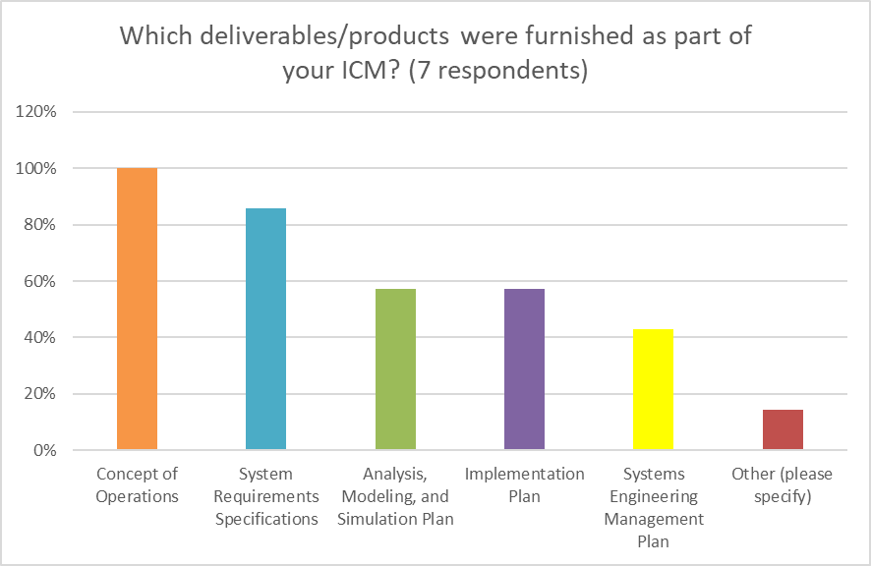
Figure 6: Which products were developed as part of the ICM Project
As show in Figure 7, various agreements were developed for the ICM project which brought together the stakeholders to cooperatively develop ICM. In all cases, a Memorandum of Understanding was developed to support the ICM program.

Figure 7: Regional Agreements used to support ICM
ICM Funding Sources
Most of the sites used some federal funding for their ICM projects (60%), a few sites have begun ICM without federal funding and instead have used planning funds from either their State or local MPO. Funding for planning seems to be easier to find for agencies starting ICM. Other sources of funding for deployment are needed, if ICM is to be used. Only three sites have begun deployment of ICM without FHWA funding (FDOT I-4, Caltrans I-210, Caltrans I-80) and have used state funds to fund them.

Figure 8: Funding Sources used for ICM
Procurement Methods
Of the sites that responded to the survey and provided documentation, all sites were using an existing procurement process and did not need modifications. The lead agency for the planning stage of the project was also the procurement lead for the few sites that have deployed or begun to deploy sites. In one instance, statewide procurement contracts were leveraged or created to support the other agencies within the corridor. FDOT has developed several statewide licenses for data services which any local agency can use. Additionally, state approved vendors have also allowed the local agencies to purchase needed field infrastructure (i.e. traffic signal controllers, dynamic message signs, and cameras).
Staffing and Governance of the ICM Program
All sites surveyed have developed a stakeholder committee (or leveraged an existing one) as discussed in Section 0, a few of the sites surveyed have developed their governance model as part of their Concept of Operations.
Knowledge, Skills, and Abilities of ICM Staff
Most sites use or plan to use existing operations staff for operation and maintenance of their ICM. Several locations identified some additional KSAs needed among their existing operations. FDOT, for example, identified traffic signal and arterial operations understanding as the area where additional training for existing staff was needed.
NCHRP Project 20-07(408) Transportation System Management and Operations (TSMO) Workforce: Skills, Positions, Recruitment, Retention, and Career Development has also developed a guidebook that identifies many positions and KSAs needed for similar TSM&O staff. The Guidebook was developed to assist agencies in defining new position descriptions, recommend recruitment strategies, and to develop training plans for existing staff.
Multiple Corridors within the Region
Many areas have not considered multiple corridors and how to prioritize them; however, based on the criteria provided by each site, a prioritization should be based on the criteria they used to select their initial corridor, as shown in Figure 9.
Additionally, one of the sites included additional factors in their comments for the quality and quantity of available infrastructure and ITS elements, the specific needs and strategies, willingness and readiness of partners, availability of funding to prioritize their corridors within the region.

Figure 9: Criteria for Selecting ICM Corridors
Implementation Planning
Unfortunately, only a few ICM projects have been implemented, or are in the process of being implemented. Respondents did not use a standard waterfall-based Systems Engineering implementation and development process. The FDOT District 5 project used an iterative process with major subsystems being developed in logical steps. San Diego used an Agile process, and several sites indicated their intention to use a similar process.
Based on the responses, and the literature review only three of the thirteen ICM Planning Grant sites developed implementation plans, which provided a road map of their intended development and deployment strategy for implementation.
Operations of the ICM Corridor
Only the Dallas and San Diego sites have developed Operation Plans for their corridors, which identified the roles & responsibilities of each agency, and the standard operating procedures for events. The I-15 corridor developed an Operational Framework document with customized business rules to assist the operations of their corridor. The Orlando I-4 ICM project has already added additional staff to the FDOT TMC to operate and manage ICM events within their region and has begun development of coordinated response plans for events on the corridor.
CHAPTER 5 SUMMARY OF THE GUIDEBOOK
Implementation Planning
Unfortunately, only a few ICM projects have been implemented, or are in the process of being implemented. All those surveyed are not or did not use a standard waterfall-based Systems Engineering implementation and development process. Both Dallas and Florida used an iterative process with major subsystems being developed in a logical step. San Diego used an Agile process, and several sites indicated their intention to use a similar process.
Three of the thirteen ICM Planning Grant sites developed implementation plans, which provided a road map of their intended development and deployment strategy for implementation.
Operations of the ICM Corridor
Only the Dallas and San Diego sites have developed Operation Plans for their corridors, which identified the roles & responsibilities of each agency, and the standard operating procedures for events. The I-15 corridor developed an Operational Framework document with customized business rules to assist the operations of their corridor. The Orlando I-4 ICM project has already added additional staff to the FDOT TMC to operate and manage ICM events within their region and has begun development of coordinated response plans for events on the corridor.
General Recommendations
Along many congested urban transportation corridors, transportation agencies within the corridor (e.g., local departments of transportation, bus operators, light rail operators, etc.) manage operations independently. Recurring and non-recurring congestion across any component of the transportation system can have widespread congestion consequences across the corridor and its users. Agencies recognize that non-coordinated operations of corridor assets are inefficient for managing events and optimizing travel throughput.
Integrated Corridor Management (ICM) is an operational concept that seeks to reduce congestion and improve performance by maximizing the use of available multi-modal capacity across a corridor, including highways, arterial roads, and transit systems. ICM promotes cooperative and collaborative traffic management across the agencies that manage various transportation system components (i.e., freeways, arterials, signals, transit, parking systems, tollways, etc.) in a congested corridor. The purpose of this chapter is to introduce the concept of Integrated Corridor Management (ICM) and provide a case for the benefits of implementing ICM in transportation planning.
Although it is common to think about ICM as a system or solution; ICM is first and foremost an operational philosophy, aiming to get agencies working more closely together. This section provides deeper insight into the operational philosophy then describes what is more commonly referred to as ICM systems.
ICM Operational Philosophy
The term “Integrated” in ICM refers to the institutional, operational, and technical integration (as described in Table 5) of key agencies that manage corridor assets. Creating an environment of collaborative and cooperative traffic management requires that agencies be willing to break down silos and barriers that have historically kept agency operations isolated.
Table 5. Levels of Integration
 | Definition | No Integration | Ideal Integration
Institutional | Coordination and collaboration between various agencies and jurisdictions that transcend institutional boundaries | Agencies have no working agreements and do not share funding | Interagency agreements and cooperatively funding deployment and operations
Operational | Multi-agency and cross-network operational strategies to manage the total capacity and demand of the corridor | Agencies operate their networks independently | Centralized operations with cooperative management across agencies. System resources managed in real time based on corridor needs
Technical | Sharing and distribution of information and system operations and control functions to support the immediate analysis of and response to events within a corridor | Siloed software applications and field infrastructure managing specific segments of the network | Tightly coupled systems with multimodal and multisource fused data and event response
Table 5 and Figure 10 present examples and requirements for cross-agency integration adopted from the NCHRP Project 20-68A U.S. Domestic Scan Program Scan 12-02 Advances in Strategies for Implementing Integrated Corridor Management (ICM) final report. These are the key attributes that jurisdictions will need to implement a successful ICM program.
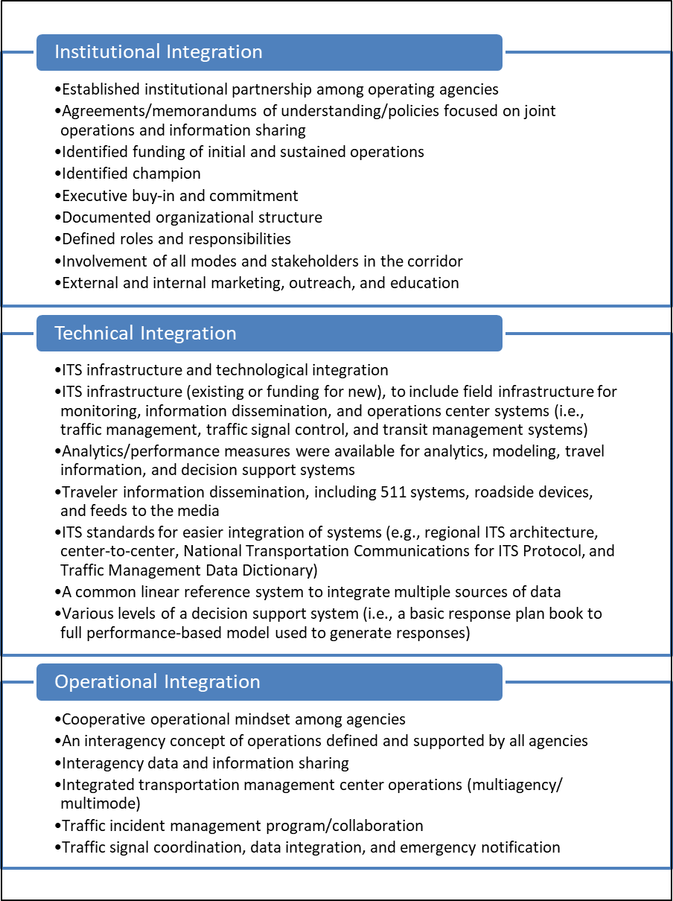
Figure 10: Levels of Integration
Background on Planning for ICM
The “V-Diagram” Systems Engineering Process
The “V-Diagram” Systems Engineering Process shown in (Source: FHWA ICM Implementation Guide)
Figure 11: “V-Diagram” Guidebook Approach has been used in the last 20 years to guide the planning, design, and deployment of all types of ITS including the early stages of ICM. In this framework, there are five phases. The first, the Planning and Concept Phase, includes Needs Assessment, Concept Selection, Project Planning, Systems Engineering Management Planning, and development of the Concept of Operations.
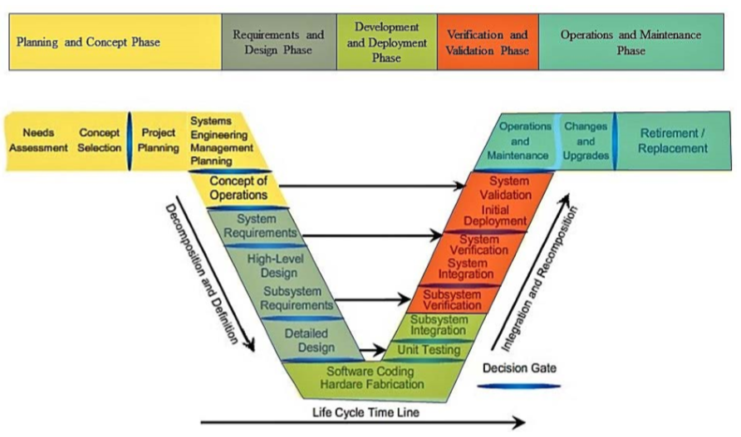
(Source: FHWA ICM Implementation Guide)
Figure 11: “V-Diagram” Guidebook Approach
ICM Planning and Deployment Framework
More recently, the Federal Highway Administration’s (FHWA) Integrated Corridor Management: Implementation Guide and Lessons Learned report tailors the traditional Systems Engineering process using experiences documented from the ICM Pioneer Sites to create a seven phase ICM implementation process, as shown in Figure 3. The ICM implementation process is generally representative of the Systems Engineering process followed by the ICM Pioneer Sites.
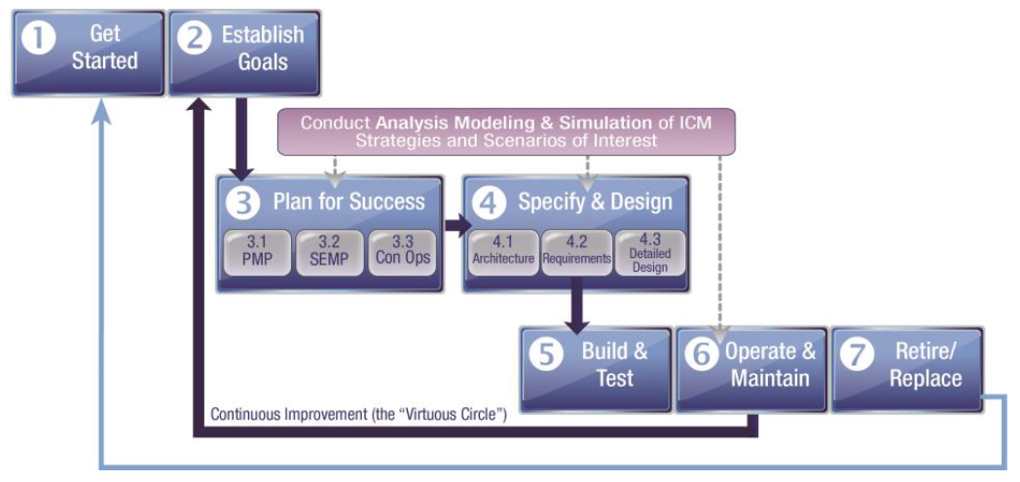
(Source: FHWA ICM Implementation Guide)
Figure 12: Integrated Corridor Management Implementation Process Phases
Table 6. ICM Implementation Process Activities for the Planning and Concept Phase ties the sub-phases of V-Diagram Planning and Concept Phase to the activities to be completed from the ICM Implementation Process. Phase 3.4 – Analysis Plan and Phase 3.5 – Stakeholders have been added to fill in gaps identified in the current ICM Implementation Process.
Table 6. ICM Implementation Process Activities for the Planning and Concept Phase
Systems Engineering V-Diagram Phase | ICM Implementation Process Phase | Activities
Needs Assessment | 1. Get Started | Foster champions and organize stakeholders
 |  | Coordinate with planning process
 |  | Interface with the regional ITS architecture
 |  | Develop and approve project charter
Concept Selection | 2. Establish Goals | Explore the ICM Concept
 |  | Develop goals, measurable objectives, and data collection needs
 |  | Analyze system problems and identify system (user) needs
 |  | Conduct Feasibility Assessment
 |  | Identify development support resources
Project Planning | 3. Plan for Success
 | 3.1 Project Management Plan (PMP) | Assess project management activities
 |  | Determine roles and responsibilities
 |  | Initial procurement discussions
 |  | Prepare Project Management Plan and supporting plans (as needed)
Systems Engineering Management Planning | 3.2 Systems Engineering Management Plan (SEMP) | Assess project management activities and technical tasks
 |  | Transition critical technologies
 |  | Define needed systems engineering processes and resources
 |  | Make procurement decisions and specify integration activities
 |  | Prepare SEMP
Concept of Operations | 3.3 Concept of Operations (ConOps) | Define/refine project vision, goals, and objectives
 |  | Explore project concepts
 |  | Develop Operational Scenarios
 |  | Develop and document Project Concept of Operations
 |  | Define system boundaries
 | 3.4 Analysis Plan | Research analysis needs of the ICM alternatives and develop a sound analysis approach based on the operational conditions and the planned objectives of the ICM strategies
 |  | Conduct analysis, modeling, and simulation iteratively to assess the feasibility of the proposed ICM strategies
 |  | Identify the most promising strategies
 |  | Identify the operational conditions under which the ICMS would be most effective
 | 3.5 Stakeholders | Identify stakeholders
 |  | Identify roles and responsibilities
 |  | Research and identify stakeholder agreements
Additional topics were added to the Planning and Concept Phase of the Guidebook regarding crosscutting activities such as stakeholder engagement, stakeholder agreements, asset management, and staffing and governance models, including:
- Specific stakeholder constraints, interests, priorities, preferences, and capabilities in the contexts of: (1) coordination of planning and operations activities with other agencies;
(2) sharing of resources and data with partners (including available and desired data); and (3) adjusting operations when corridor conditions warrant it.
- The agencies and organizations they currently collaborate with or are seeking to partner with, and the nature, structure, and motivation for those partnerships.
- Operational challenges and situations they currently encounter that could be addressed or mitigated through ICM strategies and/or improved interagency coordination.
- Performance metrics and benefit measures typically collected or tracked.
- Various types of agreements that can be used to institutionalize or formalize ICM and a discussion their strengths and weaknesses. It will include the typical stages of agreements, the areas that are covered, and how they can be defined and implemented. It will also discuss the emergence of the private sector and how agreements with private agencies can be structured.
- Identification of the process the agencies need to use to identify ICM infrastructure. That includes identifying the existing conditions, the stakeholders’ needs, and the gaps between the existing conditions and the needs. It will discuss project sequencing, identifying early winner projects, and logical antecedents for ICM strategies.
- Identification of different staffing and governance models and the pros and cons of each. It will identify the knowledge, skills, and abilities (KSAs) needed to support ICM planning, implementation, and operations and maintenance.
Systems Engineering Management Plan
USDOT requires all ITS projects funded with highway trust funds to be based on a system engineering process (refer to Figure 11). To comply with this requirement, the SEMP is generally developed early in the project process; . it is not uncommon for the SEMP to be developed before or in parallel with the ConOps. The purpose of a SEMP is to document a system engineering process that all stakeholders agree upon, to facilitate a successful project implementation. The SEMP helps to improve control of the project and common terminology, expectations, and understanding of the work being performed from planning all the way through operations and maintenance. The SEMP also helps to inform stakeholders about key project milestones and what role they will play in the success of those milestones (e.g., performing tasks or reviewing task outputs). Additionally, the SEMP identifies decision gates for the project, which require agreement from all project stakeholders for the project to move forward.
The SEMP is a living document and should be updated as additional information is learned about the system and its environment. According to FHWA’s Integrated Corridor Management: Implementation Guide and Lessons Learned report, the major items that should be included in the SEMP include:
- Task Identification – Identify tasks that must be performed and the task completion criteria (Note: tasks may be included as a work breakdown structure [WBS] which organizes tasks into a hierarchical structure and manages tasks and subtasks by name, budget, team roles and responsibilities, etc.).
- Technical Planning and Control Processes – Establish the technical program planning and control processes included in technical reviews, walkthroughs, and decision gates.
- Risk Management – Introduce the risk management plan to initiate a formal process for stakeholders to manage project risks.
- Engineering Program Integration – Provide guidance on how the various engineering teams (communications, design, information technology, multimodal, etc.) will work together to support the project development.
- Systems Engineering Process – Provide details of the Systems Engineering process that will be used to define the ICMS including the specific methodologies to be used for the ConOps, architecture, requirements, design, and testing.
- Specialty Engineering Plans and Procedures – Determine which specialty plans (human factors, system safety, system security, etc.) and procedures will be needed for the project.
- Configuration Management – Provide the configuration management plan that will facilitate control of changes to the ICMS and its artifacts including the ConOps, architecture, requirements, and design iterations.
- Performance Monitoring – Initiate system performance monitoring processes to determine which improvements may be needed for ICMS and external systems. Schedule periodic performance reviews to assess future system needs and operational improvements.
The proposed SEMP outline according to IEEE 1362 contains the following sections:
- Section 1, Purpose of Document, provides a brief statement of the purpose of the document and the plan for the systems engineering activities with special emphasis on the engineering challenges of the ICM system to be built.
- Section 2, Scope of Project, describes the planned project and the purpose of the system to be built, with special emphasis on the project’s complexities and challenges that must be addressed by the systems engineering efforts and the environment in which the project will operate.
- Section 3, Technical Planning and Control lays out the plan for the systems engineering activities. The set of activities/plans to be included in this section should cover the successful management of the project as well as any plans designed to address specific areas of the systems engineering activities.
- Section 4, Systems Engineering Process, describes the intended execution of the systems engineering processes used to develop the system (i.e., each step of the “V-diagram” life cycle technical development model) in enough detail to guide the work of the systems engineering and development teams.
- Section 5, Transitioning Critical Technologies, describes the methods and processes to be used to identify, evaluate, select, and incorporate critical technologies into the system design.
- Section 6, Integration of the System, describes the methods to be used to integrate the developed components into a functional system that meets the system requirements and is operationally supportable.
- Section 7, Integration of the Systems Engineering Effort, addresses the integration of the multi-disciplinary organizations or teams that will be performing the systems engineering activities.
ICM SEMPs that can be used for reference include the following:
- Maricopa Association of Governments, I-10 Integrated Corridor Management, Systems Engineering Management Plan, December 2015. Accessed at:
https://azmag.gov/Portals/0/Documents/TRANS_2016-014-15_I10-Integrated-Corridor-Management-(ICM)-Systems-Engineering-Management-Plan.pdf?ver=2017-04-06-111959-323.
- Partners for Advanced Transportation Technology and California Department of Transportation, Connected Corridors: I-210 Pilot Integrated Corridor Management System, Systems Engineering Management Plan, October 2015. Accessed at:
https://connected-corridors.berkeley.edu/sites/default/files/i-210_pilot_-_semp_2015-10-30.pdf.

CHAPTER 6 CONCLUSIONS, RECOMMENDATIONS, AND SUGGESTED RESEARCH
Conclusions
The purpose of this research project was to develop a Guidebook for the Planning of Multi-modal, Multi-agency Integrated Corridor Management. Following the research effort, the team was charged with developing a Guidebook which would allow public agency staff, academia, and contractors involved in planning, designing, implementing, maintaining, managing, and operating integrated corridor management systems to improve the operations of their transportation networks in a more multi-agency, multi-modal approach. This document allows readers to gain a further appreciation of how ICM planning fits into the current planning process, some of the key lessons learned from other metropolitan areas who have planned and, in some cases, implemented ICM systems. Readers are assumed to have a general awareness of intelligent transportation system (ITS) technologies and transportation management principles.
Currently, many agencies operate their transportation networks well, but do not consider the overall operation of a corridor or region to improve the throughput of travelers through the corridor by using all available capacity across modes. Integrated Corridor Management focuses on the operational, institutional, and technical coordination of multiple transportation networks and cross-network connections comprising a corridor. Moreover, ICM can encompass several activities which address the problems and needs of agencies in a region (e.g., integrated policy among stakeholders, communications among network operators and stakeholders, improving the efficiency of cross-network junctions and interfaces, real-time traffic and transit monitoring, real-time information distribution, congestion management, incident management, public awareness programs, and transportation pricing and payment).
According to USDOT, “The vision of Integrated Corridor Management (ICM) is that transportation networks will realize significant improvements in the efficient movement of people and goods through institutional collaboration and aggressive, proactive integration of existing infrastructure along major corridors. Through an ICM approach, transportation professionals manage the corridor as a multimodal system and make operational decisions for the benefit of the corridor.”
Suggested Research
The following topics are suggested for further research to advance the practice and understanding of the planning process for Integrated Corridor Management.
Identification and research of key limitations and gaps in the literature of current ICM practices would likely result in a better understanding of how to plan for the planning, implementation, and operations & maintenance of integrated corridor management programs. Topics and issues that might be addressed in future research efforts include are divided into several categories:
Institutional Challenges of Implementing ICM and DSS:
Based on the gaps identified and the various discussions with project panel members and agencies, institutional challenges are the most challenging and require on-going effort throughout the entire project life cycle. Several areas were identified that additional research could be helpful, to include:
- Change in maintenance practices to focus on: a) Quick replacement of defective data collection equipment and b) Installation and testing standards for sensor equipment
- Institutional arrangements and approaches for successful system management
- Operational organization models for ICM and DSS, including recommended language for MOUs
Data and Performance Measures:
Data is the foundation of any multi-agency, multi-modal system. The data required to detect, predict, evaluate and measure the ICM program, and systems is not insignificant. Many deployments of ICM have found that data is the most challenging technical and time-consuming effort. Several areas were identified that additional research could be helpful, to include:
- Optimal data coverage for DSS - Detection layout (placement) of sensors for optimal monitoring and identification of traffic patterns
- Research on DSS-appropriate data collection technologies and sources
- Use and data fusion of multiple data sources, including public and private data
- Risk analysis on the impact of reliability outages for detectors, communications devices, hardware, software, agency communication, etc.
- Data exchange protocols and data standards - Focus on integration across agency stovepipes
- Data filtering and fusion - Develop standard ways to accept or reject field data; How to address data gaps/missing data; How to combine or fuse data from different technologies
- Standardization of performance measures - Need to customize MOEs to two sets of users: operators and travelers; also, develop aggregate performance measure for operations
- Optimize responses based on balancing multiple objectives such as mobility improvement, emissions reduction, priority to emergency vehicles, etc.
- Evaluate how the progressive implementation of big data as a supplement to traditional data sources will change the capability and the demand for performance management
Decision Support and Modeling:
Decision support is a key strategy for implementing ICM, although it is not required for all ICM projects. Current understanding of decision support and use of models to evaluate decisions has some limitations in the current literature and knowledge base. Several areas were identified that additional research could be helpful, to include:
- Automation of real time calibration process and DSS self-learning
- Comparative review of strengths and weaknesses of existing DSS software platforms
- How to include dynamic multimodality in real-time using a unified cost function across highway and transit
- Research on key factors behind mode shift, route diversion, temporal shift, etc., and key decision variables (values of time, travel time reliability, etc.)
Implementation Recommendations
Our team recommends several implementation activities to support the outreach, and knowledge transfer of the research results and Guidebook created as part of this project. The primary activities recommended include:
- Presentations to trade groups and conferences
- Development and Presentation of Workshops to Assist Regions with Beginning or Improving their ICM Programs

REFERENCES
[1] Integrated Corridor Management and Transit and Mobility on Demand, Federal Highway Administration, U.S. Department of Transportation, Report No. FHWA-HOP-16-036, March 2016.
[2] Integrated Corridor Management and Traffic Incident Management: A Primer, Federal Highway Administration, U.S. Department of Transportation, Report No. FHWA-HOP-16-035, January 2016.
[3] Integrated Corridor Management: Implementation Guide and Lessons Learned (Final Report Version 2.0), U.S. Department of Transportation, Report No. FHWA-JPO-16-280, September 2015.
[4] Planning for Transportation Systems Management and Operations within Corridors: A Desk Reference, Federal Highway Administration, U.S. Department of Transportation, Report No. FHWA-HOP-16-037, September 2016.
[5] Systems Engineering Guidebook for Intelligent Transportation Systems, Version 3.0, California Department of Transportation (Caltrans), et al., Federal Highway Administration, U.S. Department of Transportation, November 2009.
[6] Successful Intermodal Corridor Management Practices for Sustainable System Performance, Wallace, J., Hoeft, B., Lambert, J., Martin, K., Spiller, N., Takigawa, S., Weiskopf, Lynn., & Smith, B., NCHRP Project 20-68A, Scan 14-02, October 2016.
[7] San Diego I-15 Demonstration Integrated Corridor Management System: PATH Report on Stage 3: Site Demonstration and Evaluation, Caltrans, et al., UCB-ITS-PRR-2015-03, June 2015.
[8] I-394 Integrated Corridor Management (ICM): Concept of Operations – Final, Minnesota Department of Transportation (MnDOT), March 2008.
[9] I-394 Integrated Corridor Management (ICMS): System Requirement Specification (SRS), MnDOT, March 2008.
[10] I-95 Integrated Corridor Management Project: Project Management Plan, Florida Department of Transportation (FDOT), et al., FM 4358502-1-14-01, October 2017.
[11] Concept of Operations for: I-95 Integrated Corridor Management Study, Version 4, FDOT, et al., October 2017.
[12] Elements of Business Rules and Decision Support Systems within Integrated Corridor Management: Understanding the Intersection of These Three Components, Federal Highway Administration, U.S. Department of Transportation, Report No. FHWA-HOP-17-027, October 2017.
[13] Advances in Strategies for Implementing Integrated Corridor Management (ICM), Spiller, N., Compin, N., Reshadi, A., Umfleet, B., Westhuis, T., Miller, K., & Sadegh, A.,NCHRP Project 20-68A, Scan 12-02, October 2014.
[14] Final Report: Dallas Integrated Corridor Management (ICM) Demonstration Project, Dallas Area Rapid Transit (DART), U.S. Department of Transportation, Report No. FHWA-JPO-16-234, August 2015.
[15] The Connected Corridor – New Jersey’s TSM&O Strategic Plan and ITS Architecture, Version 1.0, New Jersey Department of Transportation (NJDOT) et al., December 2014.
[16] Northern Virginia East-West ICM Planning Study: Concept of Operations, Virginia Department of Transportation (VDOT), September 2017.
[17] Northern Virginia East-West ICM Planning Study: Implementation Plan, VDOT, September 2017.
[18] I-80 ICM: Memorandum of Understanding: For Integrated Corridor Mobility Strategies in Alameda and Contra Costa Counties, Caltrans, et al.
[19] Interstate 80 Integrated Corridor Mobility (ICM) Project: Corridor System Management Plan – Executive Summary – Final, Caltrans, et al., November 2010.
[20] I-10 Integrated Corridor Management: Project Management Plan, Version 1.0, Maricopa Association of Governments (MAG), et al., December 2015.
[21] I-10 Integrated Corridor Management: Systems Engineering Management Plan, Version 1.0, MAG, et al., December 2015.
[22] I-10 Integrated Corridor Management: ICM System Requirements Specifications, Final, MAG, et al., October 2018.
[23] I-10 Integrated Corridor Management: ICM Concept of Operations, Final, MAG, et al., October 2018.
[24] I-10 Integrated Corridor Management: ICM Analysis, Modeling and Simulation (AMS) Plan, Final, MAG, et al., October 2018.
[25] Planning for Transportation Systems Management and Operations within Corridors – A Desk Reference, Federal Highway Administration, U.S. Department of Transportation, Report No. FHWA-HOP-16-037, September 2016.
[26] Advancing Metropolitan Planning for Operations: An Objectives-Driven, Performance-Based Approach – A Guidebook, Federal Highway Administration, U.S. Department of Transportation, Report No. FHWA-HOP-10-026, February 2010.
[27] Advancing Metropolitan Planning for Operations: The Building Blocks of a Model Transportation Plan Incorporating Operations – A Desk Reference, Federal Highway Administration, U.S. Department of Transportation, Report No. FHWA-HOP-10-027, April 2010.
[28] Integrated Corridor Management Concept of Operations (ConOps) for the I-495 Corridor (ICM-495) in the New York Metropolitan Region: Version 1.0, New York State Department of Transportation (NYSDOT), et al., June 2017.
[29] Connected Corridors: I-210 Pilot Integrated Corridor Management System: Concept of Operations, Caltrans, et al., June 2015.
[30] ICM Deployment Planning – The I-210 Connected Corridors Pilot (San Gabriel Valley/Los Angeles County), Caltrans, Federal Highway Administration.
[31] Transportation Operations – Integrated Corridor Management: Requirements Document – Final Report, Niagara International Transportation Technology Coalition (NITTEC), January 2010.
[32] Transportation Operations – Regional Concept for Transportation Operations – Final Report, NITTEC, January 2010.
[33] Transportation Operations – Integrated Corridor Management Systems Operational Concept – Final Report, NITTEC, June 2009.
[34] Buffalo-Niagara Integrated Corridor Management – Proposed Changes to NITTEC’s ICM System Operations Concept Report: Final Report, NITTEC, et al., June 2017.
[35] Multi-Pollutant Emissions Benefits of Transportation Strategies – Final Report, Federal Highway Administration, Report No. FHWA-HEP-07-004, November 2006.
[36] The Role of Transportation Systems Management & Operations in Supporting Livability and Sustainability: A Primer, Federal Highway Administration, U.S. Department of Transportation, Report No. FHWA-HOP-12-004, January 2012.
[37] MOSAIC: Model of Sustainability and Integrated Corridors – Phase 3: Comprehensive Model Calibration and Validation and Additional Model Enhancement, The Maryland State Highway Administration (MDSHA), et al., Report No. MD-15-SHA-UM-3-7, February 2015.
[38] Integrated Corridor Management Program: Maryland I-270 Corridor – Concept of Operations – Preliminary Draft, Maryland Department of Transportation (MDOT), et al., March 2007.
[39] Concept of Operations for the Baltimore-Washington Integrated Corridor Management Project, MDOT, et al., January 2018.
[40] El Paso IH-10 Integrated Corridor Management – Concept of Operations: Final, Version 1, Texas Department of Transportation (TxDOT), et al., February 2017.
[41] El Paso IH-10 Integrated Corridor Management – Implementation Plan, Version 1, TxDOT, et al., June 2017.
[42] Freight Advanced Traveler Information System (FRATIS) Impact Assessment: Final Report, Federal Highway Administration, Report No. FHWA-JPO-16-225, January 2016.
[43] Integrated Corridor Management Analysis, Modeling, and Simulation for the U.S. 75 Corridor in Dallas, Texas Post-Deployment Assessment Report, U.S. Department of Transportation, Report No. FHWA-JPO-16-396, November 2016.
[44] Intelligent Transportation Systems (ITS) Strategic Plan, Genesee Transportation Council, February 2011.
[45] I-84 Multimodal Corridor: A Regional Concept of Transportation Operations for Integrated Corridor Management, Oregon Department of Transportation (Oregon DOT), et al., January 2014.
[46] Concept of Operations for the I-15 Corridor in San Diego, California, Research and Innovative Technology Administration (RITA), Federal Highway Administration, Report No. FHWA-JPO-08-009, March 2008.
[47] Traffic Analysis Toolbox – Volume XIII: Integrated Corridor Management Analysis, Modeling, and Simulation Guide, U.S. Department of Transportation, Report No, FHWA-JPO-16-397, February 2017.
[48] Guide to Effective Freeway Performance Measurement: Final Report and Guidebook, NCHRP Project 3-68, Document 97, August 2006.
[49] Scoping and Conducting Data-Driven 21st Century Transportation System Analyses, Federal Highway Administration, U.S. Department of Transportation, Report No. FHWA-HOP-16-072, January 2017.
[50] Integrated Corridor Management (ICM): 10 Attributes of a Successful ICM Site, Mortenson, S., Spiller, N, & Sheehan, R., U.S. Department of Transportation, FHWA-JPO-16-415.
[51] Integrated Corridor Management and the Smart Cities Revolution: Leveraging Synergies, Federal Highway Administration, U.S. Department of Transportation, Report No. FHWA-HOP-16-075, October 2016.
[52] Integrated Corridor Management, Managed Lanes, and Congestion Pricing: A Primer, Federal Highway Administration, U.S. Department of Transportation, Report No. FHWA-HOP-16-042, November 2016.
[53] Integrated Corridor Management and Freight Opportunities, Federal Highway Administration, U.S. Department of Transportation, Report No. FHWA-HOP-15-018, December 2015.
[54] Leveraging the Promise of Connected and Autonomous Vehicles to Improve Integrated Corridor Management and Operations: A Primer, Federal Highway Administration, U.S. department of Transportation, Report No. FHWA-HOP-17-001, January 2017.
[55] I-35 Capital Area Improvement Program (Mobility 35) – Corridor Implementation Plan, TxDOT, December 2014.
[56] I-95/I-395 Integrated Corridor Management – Implementation Plan, Virginia Department of Transportation, July 2013.
[57] Integrated Corridor Management Transit Vehicle Real-Time Data Demonstration: Dallas Case Study, Federal Transit Administration, U.S. Department of Transportation, Report No. 0077, December 2014.
[58] Integrated Corridor Management and Advanced Technologies for Florida, FDOT, Grant No. BDK80 977-09, November 2012.
[59] Integrated Corridor Management Modeling Results Report: Dallas, Minneapolis, and San Diego., Research and Innovative Technology Administration, U.S. Department of Transportation, Report No. FHWA-JPO-12-037, February 2012.
[60] Regional ITS Architecture Guidance Document, Federal Highway Administration, Federal Transit Administration, & U.S. Department of Transportation, Publication No. FHWA-HOP-06-112, July 2006.
[61] The Collaborative Advantage: Realizing the Tangible Benefits of Regional Transportation Operations Collaboration – A Reference Manual, Federal Highway Administration, U.S. Department of Transportation, Report No. FHWA-HOP-08-001, August 2007.
[62] Integrated Corridor Management Research Archive, Intelligent Transportation Systems Joint Program Office, U.S. Department of Transportation.
[63] Data Integration for Integrated Corridor Management, Miller, K. Juckes, M., Dilmore, J., & Heller, R., ITS Detroit, 2018.

ABBREVIATIONS, ACRONYMS, INITIALISMS, AND SYMBOLS
AASHTO American Association of State Highway and Transportation Officials
ADA Americans with Disabilities Act
AMS Analysis, Modeling, and Simulation
ATCMTD Advanced Transportation and Congestion Management Technologies Deployment
ATIS Advanced Traveler Information System
ATMS Advanced Transportation Management System
AVL Automatic Vehicle Location
AWIS Automated Work Zone Information System
BoM Bill of Materials
BRT Bus Rapid Transit
BUILD Infrastructure for Rebuilding America
C2C Center-to-Center
CAD Computer Aided Dispatch
CCTV Closed Circuit Television
CMAQ Congestion Mitigation and Air Quality (Program)
CMM Capability Maturity Model
CMS Changeable Message Sign
CO Carbon Monoxide
ConOps Concept of Operations
DART Dallas Area Rapid Transit
DMS Dynamic Message Sign
DOT Department of Transportation
DSS Decision Support System
EV Emergency Vehicle
FHWA Federal Highway Administration
FTA Federal Transit Administration
FTE Full-Time Equivalent
GIS Geographic Information Systems
GPS Global Positioning System
HAZMAT Hazardous Materials
HOV High-Occupancy Vehicle
ICM Integrated Corridor Management
ICMS Integrated Corridor Management System
ICT Information and Communications Technologies
IEEE Institute of Electrical and Electronic Engineers
IGA Intergovernmental Agreement
IMTMS Intermodal Transportation Management System
IoT Internet of Things
ITS Intelligent Transportation System
KSA Knowledge, Skills, and Abilities
MaaS Mobility-as-a-Service
MOU Memorandum of Understanding
MPO Metropolitan Planning Organization
NCHRP National Cooperative Highway Research Program
NCTCOG North Central Texas Council of Governments
NTCIP National Transportation Communications for Intelligent Transportation System Protocol
O&M Operations and Maintenance
PDR Preliminary Design Review
PIO Public Information Officer
PMP Project Management Plan
RTM Requirements Traceability Matrix
RTMS Regional Transit Management System
RTPO Regional Transportation Planning Organizations
RTSS Real-Time Simulation System
SANDAG San Diego Association of Governments
SEMP Systems Engineering Management Plan
SOV Single Occupancy Vehicle
STIP Statewide Transportation Improvement Program
TIM Traffic Incident Management
TIP Transportation Improvement program
TMC Transportation Management Center
TMDD Traffic Management Data Dictionary
TMS Transportation Management System
TRB Transportation Research Board
TSMO Transportation Systems Management and Operations
TSP Transit Signal Priority
TxDOT Texas Department of Transportation
U.S. DOT United States Department of Transportation
VSL Variable Speed Limit
WBS Work Breakdown Structure
XML Extensible Markup Language

APPENDIX A: QUESTIONNAIRE
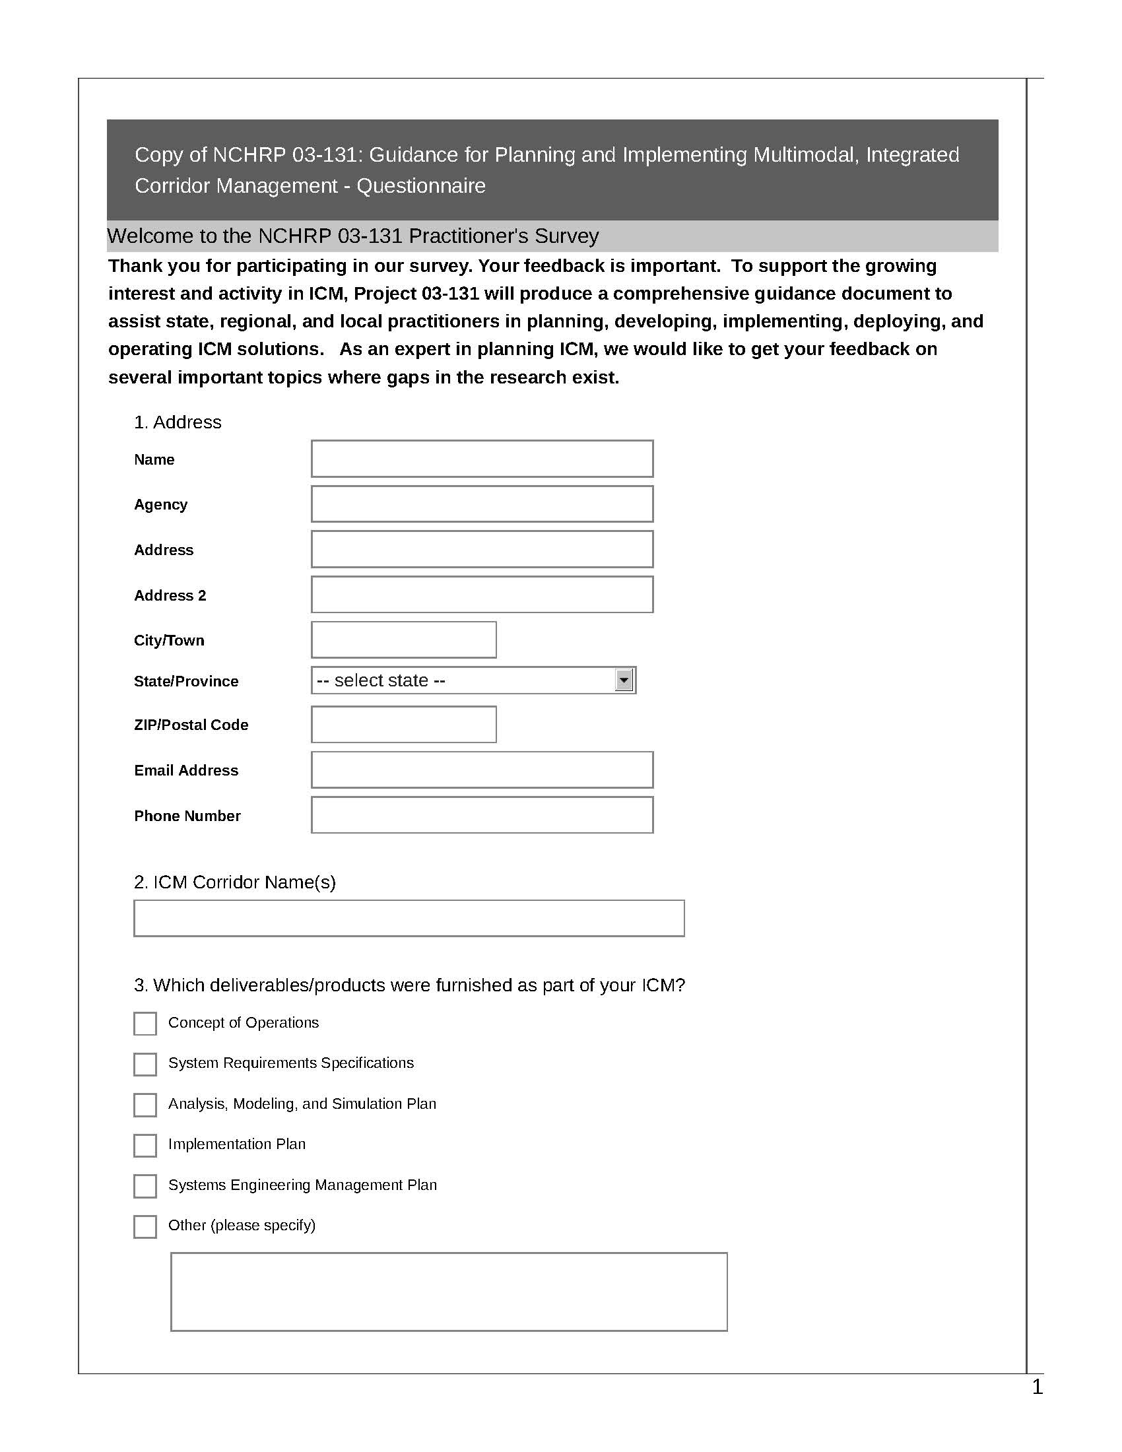

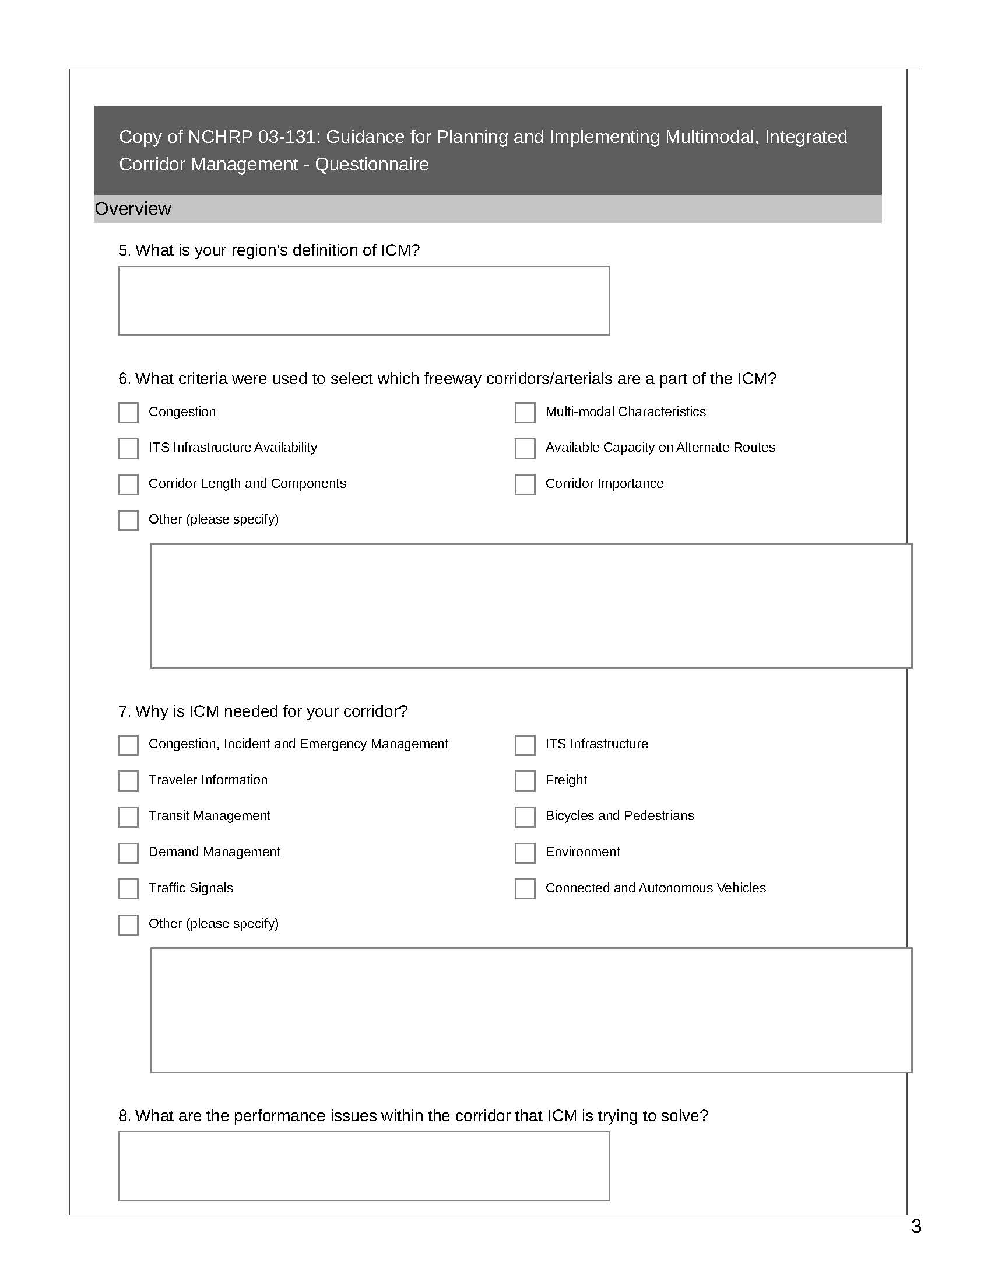

Advances in Strategies for Implementing Integrated Corridor Management (ICM), NCHRP Project 20-68A, Scan 12-02, October 2014, pp. 11-1 to 11-2. Available at: http://onlinepubs.trb.org/onlinepubs/nchrp/docs/NCHRP20-68A_12-02.pdf
Federal Highway Administration, Integrated Corridor Management: Implementation Guide and Lessons Learned (Final Report Version 2.0), Report No. FHWA-JPO-16-280, September 2015.
Accessed at: https://www.fhwa.dot.gov/cadiv/segb/views/document/sections/section8/8_4_2.cfm.

