NCHRP 20-07, Task 334

Primer on the Joint Use of Highway Safety Manual (HSM) and the Human Factors Guidelines (HFG) for Road Systems: Provide Technical Assistance to State Departments of Transportation (DOT)

Prepared for:

AASHTO Standing Committee on Highways

Prepared by:
John Campbell
Rachel Jonas
Natalie Stepien

Exponent

15375 SE 30th Place, Suite 250
Bellevue, WA 98005
September 23, 2020

The information contained in this report was prepared as part of NCHRP Project 20-07, Task 334, National Cooperative Highway Research Program.

SPECIAL NOTE: This report IS NOT an official publication of the National Cooperative Highway Research Program, Transportation Research Board, National Research Council, or The National Academies.

Acknowledgements

This study was conducted for the AASHTO Standing Committee on Highways (SCOH), with funding provided through the National Cooperative Highway Research Program (NCHRP) Project 20-07, Task 334, Primer on the Joint Use of Highway Safety Manual (HSM) and the Human Factors Guidelines (HFG) for Road Systems: Provide Technical Assistance to State Departments of Transportation. NCHRP is supported by annual voluntary contributions from the state Departments of Transportation. Project 20-07 is intended to fund quick response studies on behalf of SCOH. The report was prepared by John Campbell, Rachel Jonas, and Natalie Stephen of Exponent. The work was guided by a technical working group that included:

Bradley Estochen, Minnesota Department of Transportation
Thomas Hicks, Brudis Associates
Kenneth Kobetsky, American Association of State Highway and Transportation Officials (retired)
John Leonard, Utah Department of Transportation
Maurice Masliah, Headlight Consulting, Inc.
John Milton, Washington State Department of Transportation
Joseph Santos, Florida Department of Transportation
Samuel Tignor, Virginia Polytechnic Institute and State University
Keith Harrison, Federal Highway Administration
David Petrucci, Federal Highway Administration
Kelly Hardy, American Association of State Highway and Transportation Officials
Bernardo Kleiner, Transportation Research Board

The project was managed by Mark Bush and David Jared, NCHRP Senior Program Officers.

Disclaimer

The opinions and conclusions expressed or implied are those of the research agency that performed the research and are not necessarily those of the Transportation Research Board or its sponsoring agencies. This report has not been reviewed or accepted by the Transportation Research Board Executive Committee or the Governing Board of the National Research Council.

Contents

Page
List of Figures 2
List of Tables 3
Acronyms and Abbreviations 4
I. Introduction 5
II. Overview of this Report 6
III. Diagnostic Assessment 6
Approaches and Models to Thinking About Accidents 8
Application to Roadway Crashes 8
The Future of Diagnostic Assessment 12
IV. Overview of State DOT Assistance Efforts 15
Initial Outreach Activities 15
Technical Assistance to Arizona 16
Technical Assistance to Florida 16
Technical Assistance to Washington 17
Project Summary 17
V. References 19
VI. Appendices 21
Appendix A: Prospectus for the State DOT Assistance 22
Appendix B: DOT Assistance Project Overview 25
Appendix C: ADOT – Human Factors Training Flyer 32
Appendix D: Phoenix Human Factors Workshop Agenda 34
Appendix E: Draft WSDOT Human Factors Training Flyer 38
Appendix F: NCHRP Project HR 20-07 (334) 40

List of Figures
Page
Figure 1. Standardized accident report stages set forth in the 1910 Accident Reports Act. 7
Figure 2. Suggested taxonomy in checklist-based diagnostic assessment. 13
Figure 3. Example result from checklist-based diagnostic assessment. 13

List of Tables
Page
Table 1. Methods and tools for future consideration. 14

Acronyms and Abbreviations
AASHTO American Association of State Highway and Transportation Officials
ADOT Arizona Department of Transportation
CAP-X Capacity Analysis for Planning of Junctions
CMF Clearinghouse Crash Modification Factor
COVID-19 Coronavirus Disease 2019
DOT U.S. Department of Transportation
FDOT Florida Department of Transportation
FHWA Federal Highway Administration
HFG Human Factors Guidelines
HSM/HFG PRIMER Highway Safety Manual/Human Factor Guidelines
HFIM Human Factors Interaction Matrix
HSIP Highway Safety Improvement Program
HSM Highway Safety Manual
MMI Most Meaningful Information
MUTCD Manual on Uniform Traffic Control Devices
NCHRP National Cooperative Highway Research Program
NHI National Highway Institute
NHTSA National Highway Traffic Safety Administration
NMVCCS National Motor Vehicle Crash Causation Survey
NTSB National Transportation Safety Board
POCs points-of-contact
RSA Road Safety Audit
RSAR Road Safety Audit Review
RSAs Road Safety Audits
SPF Safety Performance Function Tool
SPICE Safety Performance of Intersection Control Evaluation
TRB Transportation Research Board
VDOT Virginia Department of Transportation
WSDOT Washington State Department of Transportation

Introduction
A number of existing guides, standards, and references are available to facilitate roadway design and operational decisions, including the AASHTO (American Association of State Highway and Transportation Officials) Green Book, and the Manual on Uniform Traffic Control Devices (MUTCD). The more recently published Highway Safety Manual (HSM; AASHTO, 2010) and Human Factors Guidelines for Road Systems (HFG; Campbell et al., 2012) offer additional resource information for designing safer roadways. The HSM is used to quantify the effects of design and operational decision-making on crash frequency and severity outcomes thus estimating the crash potential of roadway infrastructure alternatives. The HFG is used to facilitate operational decisions that reduce crash potential by providing the currently accepted factual information and insight on road users’ needs. Together these two documents enable highway planners, designers, operations engineers, and traffic engineers to incorporate features that promote the explicit consideration of crash potential for new or upgraded roadways.
Using the HSM and the HFG together means highway planners, designers, operations engineers, and traffic engineers can better diagnosis and address the contributing factors to crashes and thereby increase the effectiveness of project treatment and selection. Joint use of the HSM and the HFG will improve end users’ ability to select roadway design and operational elements based on the best-available data and promote an improve level of highway safety. However, feedback from HFG and HSM users received over the past few years indicates that by enhancing human factor knowledge of safety professional would increase the likelihood of design and operational choices achieving their optimal outcomes of crash reduction.
The objective of National Highway Cooperative Research project (NCHRP Project HR 20-07(334) was to develop a “Primer on the Joint Use of the HSM and HFG” that facilitates the combined use of the HSM and the HFG to support improved countermeasure selection for road safety. The primer is intended to be a short, instructive, and readily useful document that explains the joint use of these resources and provides state and local agencies a tool to enhance data-driven decision-making. It provides both a general step-by-step description of joint use, as well as specific examples that will illustrate how the HSM and HFG can be used together in project development to promote the highest level of safety for new or upgraded roadways. This primer will permit highway planners, designers, operations engineers, and traffic engineers to provide for the needs and limitations of the road user, thus enhancing roadway design and operational safety. It provides detailed examples that explain how the HSM and HFG can be used together to:
- Plan and develop new and improved roadway design projects,
- Support highway safety analyses, such as Road Safety Audits (RSAs),
- Understand why existing roadway designs might be causing user errors, and
- Design and operate better and safer roads.
The draft primer was completed in 2018 (see Campbell et al., 2018) and the objective of the current activity have been to pilot the use of the primer with actual end-users – safety professionals, traffic engineers, and roadway designers. Specific objectives have been to:
- assess the state of the practice and develop recommendations on methods and procedures to complete diagnostic assessments of crashes, including appropriate examples or case studies, and
- provide technical assistance to state Departments of Transportation (DOTs) on applying the Primer for the Joint Use of the Highway Safety Manual (HSM) and the Human Factors Guidelines for Road Systems (HFG) to new project designs, revisions of existing roadways, or during the conduct of road safety audits (RSAs).

Overview of this Report
- Part I of this report was the Introduction above, and Part II is this Overview.

- Part III of this report provides an overview of diagnostic assessment of accidents in general and roadway crashes in particular. It provides a brief history of diagnostic assessment as well as the current status and future directions.

- Part IV of this report summarizes key activities associated with providing technical assistance to state DOTs on human factors in general and on applying the Primer.

- Training slides, training agendas, and other materials used to support the state DOT assistance effort are provided as Appendices.

Diagnostic Assessment
Accident investigations have been conducted since the early 1800s and assessing the history and evolution of this investigative process elucidates different approaches and models to thinking about accidents that are still employed today. First, the Industrial Revolution led to an enormous increase in transportation-related technological development, which brought with it an increase in accidents. This spurred the advent of accident investigation as we know of it today. Prior to this, accidents were primarily investigated only in the context of a criminal investigation, in which blame was sought to be attributed to a particular individual or entity. As an aside, while we generally prefer and use in this report the term ‘crash’ vs. ‘accident,’ much of the earlier work in the area of diagnostic assessment was performed in the context of industrial activities and used the term ‘accidents.’ We have used ‘accident’ where appropriate and have generally used ‘crash’ to refer specifically to highway safety and roadway incidents.
The first “accident report” – conducted in an effort to determine the underlying cause of an accident and establish countermeasures for future accident prevention – was written in response to a steamboat boiler explosion, resulting in the deaths of 25 people in 1833 (Coury et al. 2010, pp. 4-5). The Connecticut River Steamboat Company – the owners of the steamboat - conducted its own investigation into the accident by combining physical evidence, witness interviews, analysis of alternative explanations, development of findings and probable cause, and development of recommendations to correct the problem (Coury et al., 2010, p. 5). Notably, these stages are remarkably similar to those taken by accident investigators today. Around the same time, railroads were rapidly being built across the United States. Given the complex communication required to coordinate train movements and schedules, human behavior – and accordingly, human error – was starting to play a bigger role in transportation accidents, warranting the need to consider the role of human beings in investigations related to these accidents (Coury et al., 2010, p. 5).
Up until the turn of the 20th Century, accident investigations were primarily done by private companies, and not by governmental organizations (Coury et al., 2010, p. 6). Between 1893 and 1911, a number of federal acts were introduced into legislation that addressed the “human” nature of transportation (e.g., limiting the number of hours a railroad worker could work in one day) (Coury et al., 2010, p. 6). Around this time, the federal government passed the 1910 Accident Reports Act, which acknowledged the necessity for the federal government to be responsible for the investigation of accidents and requiring private companies to report any accident data to the government (Coury et al., 2010, pp. 6-7). Importantly, this Act also standardized the process of accident investigation into four distinct stages (see Figure 1), which mirrors those in the first accident report discussed earlier (Coury et al., 2010, p. 7). Examination of this history reveals a striking commonality in the process used to investigate and diagnose accidents today.

Figure 1. Standardized accident report stages set forth in the 1910 Accident Reports Act.
The introduction of aviation technology – and its advancements during the second World War – led to a crucial development in transportation accident investigation, due to the increased acknowledgement of “pilot error” (Coury et al., 2010, pp. 7-11). In the 1920s, the concept of accident “taxonomy” was introduced, whereby a large contingent of aviation accidents were attributed to some form of error committed by the pilot (e.g., poor technique, judgement errors). In a classic study of human performance in transportation accidents by Fitts and Jones (1947), the authors reviewed 460 self-reported accounts of Air Force pilot errors and concluded that half of the errors they could classify were “substitution” errors, in which the wrong control was operated in the plane. Importantly, this study focused on the incompatibilities between equipment and people, paving the way for future human factors-focused approaches to accident investigation (Coury et al., 2010, pp. 15-16).

Approaches and Models to Thinking about Accidents
Researchers have long been exploring ways to approach and model accidents, and a selection of these critical to the evolution of accident investigation are discussed below. Herbert Heinrich, an industrial safety pioneer in the 1930s, developed a model of accidents described as the result of a “sequence” of events (Coury et al., 2010, p. 12). In his view, an accident can only occur “when preceded by or accompanied and directly caused by one or both of two circumstances: the unsafe act of a person and the existence of a mechanical or physical hazard.” He defined five accident factors including ancestry and social environment, fault of a person, unsafe act and/or mechanical or physical hazard, accident, and injury. According to this model, if one link is removed, then an accident cannot happen. Over half a century later, a well-known accident model was proposed in by James Reason: the “Swiss cheese” model. In this model, defenses against failure (i.e., slices of cheese) are sequentially layered alongside each other. A failure occurs when a hole in each slice momentarily aligns providing an “trajectory of accident opportunity” (Reason, 1990). Reason also introduced the concept of latent errors, which are defects that may lie dormant for many years, only emerging when the requisite triggering conditions occur (Coury et al., 2010, p. 19). In 2004, Nancy Leveson introduced a new accident model, laying out that accidents occur when external disturbances, component failure, or dysfunctional interactions among system components are not adequately handled. In this model, Leveson argued that error-based, chain-events put forth by Heinrich and Reason no longer apply to most modern systems (Coury et al., 2010, p. 20; Leveson, 2004). Taken together, the different approaches to accident investigation utilized throughout history have evolved, but reveal common themes for modeling accidents, which have been applied to developing tools for investigating accident causation. When applied to the diagnostic assessment of roadway crashes, it is important to consider that these crashes are often a result of a complex interaction between an individual (e.g., a driver) and his or her environment (e.g., a darkly-lit, curved roadway). Oftentimes, there is not one singular “hazard” on the roadway that will necessarily lead to a crash, rather a specific set of conditions that interfere with the intentions and successful operation of a driver. As well, certain roadway conditions may not stand out as obvious hazards, and instead consist of subtleties that have unsuspecting effects on human perception and behavior (e.g., the placement of trees alongside a roadway may lead to misperception of a driver as to the curvature of the roadway). Thus, traditional models of accident causation that take into account potential hazards at various stages may not sufficiently consider the complex, and often nuanced relationships between drivers and roadway features.

Application to Roadway Crashes
Building upon the approaches to thinking about accidents developed throughout history, research studies and governmental investigations have been performed to apply this framework to roadway crash causation, in which they fostered ideas about how to prevent crashes from occurring and about implementing countermeasures. In 1979, Treat and colleagues published a seminal report for the U.S. Department of Transportation that, from an analysis of over 2,000 motor vehicle crashes, nearly 93% were caused in some part by human factors; more specifically, they identified improper lookout, excessive speed, and inattention as the top reasons for crashes due to human factors issues. Other probable causes for crashes included environmental factors such as view obstructions and slick roads, as well as vehicular factors such as brake failure and tire underinflation. Treat suggested several countermeasures that prove to still be relevant today, substantiating the notion that most of these crashes are indeed due to human factors-related issues, rather than vehicular or environmental factors that would otherwise be solved with advances in automotive technology or improved infrastructure.
More recently, in order to obtain information about the events and elements that lead up to a crash, the National Highway Traffic Safety Administration (NHTSA) conducted the National Motor Vehicle Crash Causation Survey (NMVCCS), in which 6,950 crashes from 2005 to 2007 were evaluated (NHSTA, 2008). The results acquired from this survey allowed for identifying common pre-crash events and scenarios, such as turning or crossing at intersections, and for determining critical reasons underlying these events, which include driver errors, vehicle and environmental conditions, and roadway design (NHSTA, 2008). The National Transportation Safety Board (NTSB) has also helped clarify the contributing factors of crashes by generating detailed investigative reports of numerous transportation crashes, which identify major safety issues and assess the efficacy of traffic control measures in protecting pedestrians and vehicles from crashes (e.g., see NTSB, 2004; NTSB, 2009). These investigative reports have resulted in recommendations for improving roadway safety and preventing crashes.
The concept that human factors plays a fundamental role in roadway crashes has been utilized to develop systems for establishing taxonomies to better understand and assess driver errors that lead to accidents. To elaborate, in the 1990s, James Reason detailed how the psychological nature of humans contribute to accident causation by categorizing the types of errors that they commit into two groups: (1) Slips (i.e., unplanned actions), lapses (i.e., covert memory failures) and mistakes (i.e., planning or problem solving failures); and (2) Violations (i.e., motivational problems) and errors (i.e., information-handling problems) (Reason, 1995). He began developing such distinction between categories by having individuals complete a driver behavior questionnaire, which asked them to judge the frequency with which they committed various types of errors and violations when driving (Reason, 1990). From these results, Reason identified three factors: violations, dangerous errors, and relatively harmless lapses. These survey results emphasized the view that different psychological mechanisms mediate errors and violations when driving. For example, individuals who reported having the most violations tended to rate themselves as skillful drivers; errors and lapses when driving involved cognitive competence (e.g., attentional) failures; and violations involved the motivational factors of the driver (Reason, 1990). Taken together, these findings highlight the importance of considering the driver’s psychological state when assessing the errors and violations involved in crash causation.
Categorizing driver error has been used as a methodology by others to create more specific categories to inform the creation of diagnostic tools, such as checklists and questionnaires, that may be used for assessing the causes of roadway crashes. To illustrate, Wierwille et al. (2002) collected data from focus groups with officers and interviews with drivers involved in crashes to develop a novel taxonomy to describe driver errors, which included topics such as: inadequate knowledge, training, and skill; impairment; willful inappropriate behavior; and infrastructure or environment problems (Wierwille, et al. 2002). These topics highlighted the need to consider not only human factors, but also how drivers interact with the surrounding infrastructure features; this concept is exemplified by organizing the driver-related issues into a tree diagram that branches off into other contributing psychology- and infrastructure-related components (Wierwille, et al., 2002). For example, “Failure to yield at an intersection” may be the general category that describes the crashes type, but that kind of driver error may branch off into more particular components, like the type of intersection (infrastructure related) and specific reasons for not yielding (human factors related) (Wierwille, et al., 2002). Indeed, crashes are complex, and converging elements need to be considered when investigating the causes of roadway crashes (Dunn et al., 2014). This idea is emphasized by the “Crash Trifecta Concept,” which includes unsafe pre-incident behavior or maneuvers; transient driver inattention; and unexpected traffic events. The first element of the crash trifecta, unsafe pre-incident behavior or maneuver, includes actions that are typically under the driver’s control and may occur prior to the safety-critical event; examples of this element include speeding, tailgating, and making an unsafe turn (Dunn et al., 2014). The second element, transient driver inattention, which may or may not be related to the act of driving. For instance, on the one hand, a driver may be suddenly distracted when checking mirrors to determine whether or not he or she could safely move to the adjacent lane. On the other hand, the driver may become transiently distracted if their mobile phone falls on the car floor and they reach to retrieve it, which is not linked to the act of driving itself (Dunn et al., 2014). The final of the crash trifecta elements includes an unexpected traffic event, which refers to an unexpected action or random event committed by another vehicle or obstacle, such as a deer suddenly running out in front of the vehicle (Dunn et al., 2014). Taken together, these three elements elucidate that factors contributing to vehicle crashes involve an interaction between driver-related and non-driver related events. Consequently, assigning a single, unitary crash-relevant conflict as the proximal cause of the safety critical event without considering additional contributing factors is a limitation and would not address all the factors involved in the cause of a crashes (Dunn et al., 2014).
While driver errors play a significant role in causing roadway crashes, Road Safety Audits (RSAs) have clarified the safety of the actual roadways themselves. In 2004, the Transportation Research Board (TRB) executive committee described the components of a Road Safety Audit and a Road Safety Audit Review (RSAR), inspired in part by a 1996 visit to New Zealand and Australia where similar programs were being implemented (Wilson et al., 2004). In this report, an RSA is defined as a “formal and independent safety performance review of a road transportation project by an experienced team of safety specialists, addressing the safety of all road users” (Wilson et al., 2004). RSAs are intended to be proactive measures, and involve several stages including 1) planning, 2) draft design, 3) detail design, 4) traffic control device construction planning, and 5) construction. Site inspections are performed that involve considerations such as age and experience of motorists, the potential for glare and atypical lighting, and more. Checklists are used to compile this information, and audit reports often contain corrective actions. Similarly, RSARs involve safety assessments of an existing street or roadway, or a newly completed roadway section prior to its opening, in order to ensure that safety concerns are met. These processes are proactive in nature and strive to consider a combination of roadway characteristics and human factors issues. The authors of this particular report administered a survey to various state agencies that chose not to implement RSAs and RSARs, and one reason given for this decision is that officers from these agencies claimed that behavioral factors account for 85% of the crashes, and so the tools would thus not provide a good return (Wilson et al., 2004). This finding points to the lack of consideration of human factors issues in these diagnostic tools – or perception of it from state agencies. Moving forward, it is critical to consider - and properly implement into safety checklists - human factors issues in the diagnosis of roadway crashes and countermeasure development.

In more recent years, governmental organizations have made efforts to incorporate system-wide data to identify sites for potential safety improvement. This is crucial in order to properly address potential safety issues in rural areas, where the density of crashes is low, and thus individual roadways might not otherwise be specifically identified as needing improvement. One report outlines the following stages in this Systemic Tool as part of the Highway Safety Improvement Program (HSIP): 1) identification of focus crash types and risk factors, 2) screening and prioritization of candidate locations, 3) selection of countermeasures, and 4) prioritization of projects (Preston et al., 2013). The first stage, identification of focus crash types and risk factors, involves the analysis of system-wide, macro-level crash data. This stage encompasses a series of sub-steps including: a) the selection of focus crash types (e.g., using a state or regional strategic highway safety plan to identify emphasized crash-related areas, such as road departure crashes); b) the selection of focus facilities (e.g., using a “crash tree diagram” to narrow down particular risk factors associated with these crashes, such as speed and lane markings); c) the identification and evaluation of risk factors (e.g., road departure crashes are over-represented on roads with unclear edges). Other potential risk factors as a result of this analysis may include things such as: inadequate lane width, low visibility, excessive speed, and inadequate lighting. According to the authors, this tool was designed to be flexible and easy to use for agencies that choose to implement it. This tool has since been adapted to identify sites for potential safety improvements based specifically on risk factors for pedestrians. Thomas et al. (2018) created a detailed guidebook intended to serve state DOT personnel and contractors, and those involved in highway safety improvement programs, pedestrian and bicycle programs, and safety data management programs. Importantly, diagnostic assessment of roadway crashes extends outsides the United States, and into places like Europe as well. For example, Polder and Bridjs (2018) created a handbook commissioned by the European Commission to encourage self-reporting of crashes and near-crashes to capture a coherent view of roadway safety. This is important for capturing potential problem areas that might susceptible to roadway crashes, even if they have not yet occurred.

As has been discussed, accident investigation and research studies have yielded a plethora of data on roadway crashes; the access to such data and technological advances have spurred the development of several different data-driven software analysis tools that can be used for diagnostic assessment and countermeasure evaluation. One such tool is Safety Analyst, which utilizes a series of adaptive diagnostic questions to generate data in order to help identify countermeasures that could address a crash pattern and determine sites that have the highest probability for enhancing safety. Specifically, Safety Analyst is used to identify site-specific safety improvement needs and projects to address those needs (Harwood, 2010). As such, Safety Analyst focuses its efforts on predictive analyses, which reveal the locations with the greatest potential for improvement and quantify the anticipated safety performance of different projects (FHWA, 2019). In addition to Safety Analyst, several other tools that employ predictive analyses to promote road safety include the Crash Modification Factor (CMF) Clearinghouse (http://www.cmfclearinghouse.org/index.cfm), the FHWA’s Interactive Highway Safety Design Model (https://www.ihsdm.org//wiki/Welcome), and the Safety Performance Function Tool (http://spftool.com/). Importantly, not all data-driven safety analysis tools function predictively, as some employ systemic analyses and use both crash and roadway data to elucidate road features that are particularly susceptible to crashes; a few examples of tools that utilize this type of analytic approach include the Roadway Safety Foundation United States Road Assessment Program (ucRAP) software and FHWA Systemic Safety Project Selection Tool (FHWA, 2019). Collectively, these data-driven approaches have expanded the types of analyses that may be performed on crashes information, thereby lending novel insights into contributing factors and opportunities to prevent roadway crashes; however, these approaches often fail to sufficiently consider human factors components and the interaction between the driver, vehicle, and environment in their assessment. Furthermore, while these tools are indeed sophisticated and can be valuable to a seasoned researcher, many of them are too complex to be realistically usable for an everyday investigator such as State DOT employees wishing to make their local roadways safer.

The Future of Diagnostic Assessment
Successful safety management practices – including the selection of properly focused and cost-effective countermeasures – depend on an accurate understanding of the underlying contributing causes to crashes. As noted recently by Hauer (2020), crashes usually have more than one cause, and “A crash cause is a circumstance or action that, were it different, the frequency of crashes and/or their severity would be different.” Thus, an effective framework and methodology for the diagnostic assessment of crashes must include not just a review and analysis of relevant road user, environmental, and vehicle factors, but also the interactions between these factors.

Some existing materials can serve as a valuable starting point for the future. For example, the FHWA’s Highway Safety Improvement Program (HSIP) provides a number of valuable methodologies (see https://rspcb.safety.fhwa.dot.gov/noteworthy/default.aspx), including a set of advanced safety analysis methods and tools (Kuznicki et al., 2016) that will greatly benefit future activities in this area. In addition to these broad safety practices, we have found that a number of systemic safety planning methods and tools (e.g., Preston et al., 2013) are valuable resources.

What is lacking from the practitioner’s toolbox is an integrated set of procedures, methods, and tools for conducting comprehensive diagnostic assessments of the contributing factors to crashes and for identifying matching countermeasures with a potential to improve safety performance and provide a meaningful return on investment to State DOTs. Specifically, existing guides and tools: (1) do not provide adequate coverage of key contributing factors such as human factors and driver behavior, (2) are hard-to-understand, hard-to-use, and generally not designed to be ‘practitioner ready’, and (3) do not yield ‘actionable’ outcomes that include both a clear description of how proposed countermeasures will increase road user safety and the design/behavioral tradeoffs associated with the countermeasures.
There remains a need for a simple, accessible, and easy-to-use checklist for state DOT workers and local officers. Similar to the diagnostic assessment put forth with Safety Analyst, an ideal checklist would include a branching feature, in which certain questions lead to others if applicable to the situation (e.g., “Did the crash happen at night?” would lead to questions related to vehicle headlights, roadway lighting, and visual capabilities of the driver). This would maximize time and efficiency for the user in filling out the checklist and allow for a high number of potential questions.
It is critical that this checklist strongly incorporates human factors (i.e., interactions between the road user and the infrastructure) rather than purely roadway design from an engineering standpoint. Although Treat et al. (1979; p. 9, Fig. 2-2) found that human error was a contributing factor to over 90% of motor vehicle crashes, 27% of the crashes they investigated were caused in some part by interactions between the road infrastructure and the road user. One approach would be to provide a summary “diagnosis” of the crash, attributing it to factors such as inadequate visibility, vehicle speeding, or distraction (see Figure 2). This concrete diagnosis would allow for straightforward countermeasures to prevent future crashes. In some cases, a crash might not be exclusively due to one singular cause and might thus result from two or even three causes (see Figure 3). This detail would be captured in such an assessment, allowing for countermeasure development specific to the crash at hand (e.g., a crash due to both speeding and inadequate visibility, may best benefit from improved roadway signage to alert drivers of an upcoming sharp turn that is otherwise hard to see). In summary, an accessible, user-friendly, diagnostic checklist that sufficiently incorporates human factors issues (road users x infrastructure) is a critical next step in thoroughly understanding accident causation and for properly implementing successful countermeasures.

Figure 2. Suggested taxonomy in checklist-based diagnostic assessment.

Figure 3. Example result from checklist-based diagnostic assessment.
Table 1 below identifies some candidate methods and tools that we believe can be explored and potentially further developed in the future. Some are new – like methods to conduct road user task and workload analyses - while others might reflect refinements or expansions to existing tools, like the selection tools for ped/bike countermeasures. For the latter, existing tools can be examined to see what procedures are used, determining the similarities and differences across them, then combining, modifying, and/or refining the diagnostic and countermeasure selection procedures to address user requirements and gaps. Careful consideration should be given to how existing tools can be refined to reflect context; i.e., modes, roadway type, and crash types. It may be useful, for example, develop a general procedure for diagnostic assessment, but have different ‘branches’ requiring slightly different steps depending on roadway type, crash type, etc. The key questions that need to be addressed while developing new methods and tools for diagnosing contributing factors leading to crashes and selecting appropriate countermeasures are as follows:
- What key elements need to be considered when evaluating, analyzing, and diagnosing contributing factors that lead to a crash?
- What are the necessary steps after diagnosis of crash contributing factors to selection of an appropriate countermeasure?
- How should the procedures and methods be presented so they are easily understood by practitioners?
- Can the procedures and methods be automated with a tool so they can be effectively applied by practitioners?
Name | Description | Candidate/Key Source Material
Procedure & Tool: Evaluating, Analyzing, and Diagnosing the Factors that Contribute to Crashes and Countermeasure Selection procedures | Basic principles of diagnostic assessment, and countermeasure selectin including an overview of existing tools and methods. | - Existing training materials from the NCHRP 20-07(334) State DOT assistance project  - SafetyAnalystTM: Software Tools for Safety Management of Specific Highway Sites (Harwood et al., 2010; http://www.safetyanalyst.org/tools.htm#cst)
Method: Understanding Human Factors Fundamentals within the Roadway Environment | Review of the driving task, and the capabilities and limitations of road users most relevant to roadway safety performance, including distinctions in diagnostics and countermeasures between human factors and human behavior issues | - NCHRP Report 600 – the HFG (Campbell et al. 2012); plus 3rd Edition Updates -www.trb.org/Main/Blurbs/167909.aspx  - Existing training materials from the NCHRP 20-07(334) State DOT assistance project
Method: Applying the Human Factors Guidelines for Road Systems (HFG). | Overview of the HFG, objectives, content, and how to apply it to diagnostics and countermeasure selection. | - Existing training materials from NCHRP 17-47, plus updates from on-going NCHRP 17-80 (HFG 3rd Ed.)
Method and Tools: Incorporating Task Analysis & Workload Analysis into Diagnostic Assessment | Introduction to Task/Workload Analysis, overview of methods and procedures, with a group exercise. | - FHWA sources – e.g., Richard, Campbell, & Brown (2006).  - Existing training materials from the NCHRP 20-07(334) State DOT assistance project
Tool: Application of the Human Factors Interaction Matrix (HFIM) | Introduction to the HFIM and procedures for populating and applying the HFIM to crash diagnostics. | - Existing training materials from the NCHRP 20-07(334) State DOT assistance project
Tool: Conducting Safety & Operational Performance Evaluations | Comparisons of safety performance (i.e., predicted crash frequency and severity) and operational performance (e.g., in terms of volume to capacity ratio) of a variety of intersection geometry and control scenarios | - Safety Performance of Intersection Control Evaluation (SPICE) User Manual (Jenior et al. 2018A)  - Capacity Analysis for Planning of Junctions (CAP-X) Tool User Manual (Jenior et al. 2018B)
Method & Tool: Incorporating Human Factors into the Road Safety Audit (RSA)Process | Where and how new HF and other insights can be added to RSA procedures | - Existing training materials from NCHRP 17-47, plus training materials from the NCHRP 20-07(334)
Method: Using the HSM/HFG Primer | How to jointly use the HSM and the HFG to improve safety diagnostics and countermeasure solutions, with examples. | - The HSM/HFG Primer  - Existing training materials from the NCHRP 20-07(334) State DOT assistance project
Tool: Pedestrian and Bicycle Countermeasure Selection | Based on goal of treatment (e.g., mitigate a specific type of pedestrian/bicycle motor vehicle crash type), poses a series of questions related to contextual considerations of the site to recommend countermeasures. | - Existing PEDSAFE & BIKESAFE procedures  http://www.pedbikesafe.org/PEDSAFE/, http://www.pedbikesafe.org/BIKESAFE/  - New chapters on ped/bike countermeasures from on-going NCHRP 17-80 (HFG 3rd Ed.)
Table 1. Methods and tools for future consideration.

Overview of State DOT Assistance Efforts
Below, we summarize the key steps and activities associated with the technical assistance efforts. The focus of the technical assistance was to provide training to State DOT staff – primarily safety management personnel, roadway designers, and traffic engineers – in basic principles of human factors, as well as an approach to diagnostic assessment and countermeasure selection that reflects procedures outlines in the HSM/HFG Primer.

Initial Outreach Activities
The first technical activity in the state DOT assistance part of the project was to send e-mails to key contacts working at various state DOTs. These contacts included state DOT staff who had participated in the 2012-2014 pilot studies for the HFG, as well attendees at the 2018 workshop on this topic held during the 97th Annual TRB Meeting in January: Roadway Design and Operation - Using Human Factors to Guide Data-Driven Decision-Making. In addition to a brief introduction to the project, the e-mail to the key contacts included the project prospectus shown in Appendix A below was included as an attachment.
While Exponent received replies and questions from a number of states, four (4) states in particular: Virginia, Arizona, Florida, and Washington, were especially interested in the effort and requested additional information. Despite several e-mail exchanges with State DOT staff in Virginia (especially Stephen Read of the Virginia DOT (VDOT)), we determined that VDOT would not be participating in the technical assistance effort.
The next step was to schedule and conduct longer discussions with the three (3) remaining state DOT contacts to talk through the activity and to answer their questions. The slides provided in Appendix B were used to explain the technical assistance program in more detail to:
- Kohinoor Kar (Arizona DOT; ADOT)
- Joseph Santos (Florida DOT; FDOT)
- John Milton and Ida van Schalkwyk (Washington State DOT; WSDOT)
These longer discussions resulted in commitments from three (3) state DOTs: ADOT, FDOT, and WSDOT to move to the next step to define and conduct the technical assistance activities. A key goal of the technical assistance effort was to customize the training content to the extent possible.

Technical Assistance to Arizona
Arizona indicated interest in participating in the technical assistance in July of 2019. In July and August of 2019, several phone discussions were held with Dr. Kar and others from ADOT to explain the effort, answer questions, and determine how ADOT could most benefit from the technical assistance being offered.
By early September 2019, we had determined that several 1-day in-person workshops focused on helping attendees gain an understanding of how human factors and driver behavior data could be applied to roadway design and operational decisions would be the focus of the effort. The group also established the content that would be provided and set both dates and locations for the in-person training. We decided on three (3) dates in November of 2019, with training sessions to be held in both Phoenix, AZ and Tucson, AZ. The flyer that was developed to inform ADOT staff about the training opportunity and provide registration information is shown in Appendix C.
Throughout the rest of September, October, and into early November, Exponent developed a comprehensive set of slides covering the agreed-upon topics. Exponent was also responsible for maintaining a registration list of ADOT staff who wished to attend each training session and communicating status and reminders to registered ADOT staff.
The three (3) ADOT training sessions were conducted as scheduled; agendas for each of the in-person sessions shown in Appendix D. There were over 50 individuals in attendance across the three (3) training sessions. The slide sets used during the ADOT training sessions are shown in Appendix E. The precise order and mix of materials presented were slightly different across the 3 sessions as each session was customized to the interests and needs of the participants. Also, material that provided a summary of the HFG was generally used on an as-needed basis to answer a specific question about the HFG or to illustrate a particular aspect of human factors that came up during the training and subsequent discussions.

Technical Assistance to Florida
Florida indicated interest in participating in the technical assistance effort in July of 2019. In August and September of 2019, several phone discussions were held with Mr. Santos and others from FDOT to explain the effort, answer questions, and determine how FDOT could most benefit from the technical assistance being offered. These discussions continued into December.
We had tentatively planned on holding the training webinars in December, but FDOT determined that we needed more time to generate interest and support from interested groups. FDOT has a somewhat unique structure, as FDOT staff are organized into geographical districts, each with their own leads who are responsible for organizing and conducting the type of training offered in this project. For this reason, we organized a longer webinar – a sort of ‘mini-workshop’ session - to provide a more detailed description of the actual training to 1-2 representatives from each district. This webinar was held on January 8, 2020, and approximately 15 individuals from FDOT representing both the state level DOT office and the district offices attended this webinar.
The national and state-level lockdowns and disruptions associated with COVID-19 created some challenges to further discussions and development of the training. By mid-spring, it was clear that we would not be able to complete the in-person training as planned, given the COVID-19-related restrictions. We will look for future opportunities to provide this training to FDOT, perhaps as a series of webinars.

Technical Assistance to Washington
Washington indicated interest in participating in the technical assistance effort in July of 2019. In August-October of 2019, regular phone discussions were held with Drs. Milton and van Schalkwyk of WSDOT to review options for training content and delivery and determine how WSDOT could most benefit from the technical assistance being offered.
We had initially planned to conduct the WSDOT training sessions in November but decided to wait until 2020 to develop additional content and customized case studies reflecting WSDOT issues and priorities. Regular planning discussions with WSDOT continued December-March. We had tentatively scheduled training sessions in March 2019 but delayed them until June 2019 due to some schedule conflicts and the need to develop additional, customized content. In particular, additional training modules providing tutorials and background information on task analyses and workload assessment techniques were started and partially developed. A draft of the flyer that was developed to inform WSDOT staff about the training opportunity and provide registration information is shown in Appendix E.
As with the plans for Florida, the national and state-level lockdowns and disruptions associated with COVID-19 created some challenges to further discussions and development of the WSDOT training. By mid-Spring, it was clear that we would not be able to complete the in-person training as planned, given the COVID-19-related restrictions. We will look for future opportunities to provide this training to WSDOT, perhaps as a series of webinars.

Project Summary
Appendix F provides a slide set that summarizes the objectives, activities, and outcomes from this project.

References
American Association of State Highway and Transportation Officials (AASHTO). (2018). A Policy on Geometric Design of Highways and Streets. Washington DC.
American Association of State Highway and Transportation Officials (AASHTO). (2010). Highway Safety Manual, 1st Edition. Washington, DC: Author.
Campbell, J. L., M. G. Lichty, J. L. Brown, C. M. Richard, J. Graving, J. Graham, M. O'Laughlin, D. Harwood, et al. (2012). Human factors guidelines for road system, second edition. NCHRP Report 600. Transportation Research Board. Washington, D.C.
Campbell, J. L., R. Hull, and A. Maistros. (2018). Primer on the Joint Use of the Highway Safety Manual (HSM) and the Human Factors Guidelines (HFG) for Road Systems. Technical report submitted under NCHRP 20-07 (334).
Coury, B. G., Ellingstad, V. S., & Kolly, J. M. (2010). Transportation accident investigation: The development of human factors research and practice. Reviews of human factors and ergonomics, 6(1), 1-33.
Dunn, N. J., Hickman, J. S., & Hanowski, R. J. (2014). Crash trifecta: A complex driving scenario describing crash causation. Advances in Human Aspects of Transportation: Part, 3(9), 369.
Federal Highway Administration (2009). Manual on Uniform Traffic Control Devices (MUTCD). Washington, DC.
Fitts, P. M., & Jones, R. E. (1947). Analysis of factors contributing to 460" pilot-error" experiences in operating aircraft controls (pp. 332-358). Wright-Patterson Air Force Base, OH: Aero Medical Laboratory.
Harwood, D. W., D. J. Torbic, K. R. Richard, and M. M. Meyer. (2010). SafetyAnalyst TM: software tools for safety management of specific highway sites. Report no. FHWA-HRT-10-063. Federal Highway Administration.
Hauer, E. (2020). Crash causation and prevention. Accident Analysis and Prevention, 143, 105528
Jenior, P., A. Butsick, P. Haas, and B. Ray. (2018a). Safety performance for intersection control evaluation (SPICE) tool user guide. Report no. FHWA-SA-18-026. Federal Highway Administration.
Jenior, P., A. Butsick, P. Haas, and B. Ray. (2018b). Capacity analysis for planning of junctions (CAP-X) tool user manual. Report no. FHWA-SA-18-067. Federal Highway Administration.
Kuznicki, S., B. Ibarguen, J. Symoun (Toxcel), and P. Pavao. (2016). Highway safety improvement program national scam tour. Prepared for the U.S. Department of Transportation, Federal Highway Administration, Office of Safety, Washington, D.C. Report no. FHWA-SA-16-024. Vanasse Hangen Brustlin, Inc. (VHB); Toxcel, LLC. Vienna, VA; Gainesville, VA. 141 pp.
National Highway Traffic Safety Administration (NHSTA). (2008). National motor vehicle crash causation survey, Report to congress. DOT HS 811 059.
National Transportation Safety Board (NTSB) Highway Accident Report. (2004). Rear-end collision and subsequent vehicle intrusion into pedestrian space at certified farmer's market, Santa Monica, California. NTSB/HAR-04/04, PB2004-916204.
National Transportation Safety Board (NTSB). (2009). Pedal misapplication in heavy vehicles, Highway Special Investigation Report NTSB/SIR-09/02. Washington, DC.
Preston, H., R. Storm, J. D. Bennett, and B. Wemple. (2013). Systemic safety project selection tool. Prepared for the U.S. Department of Transportation, Federal Highway Administration, Office of Safety, Washington, D.C. Report no. FHWA-SA-13-019. CH2M Hill, Inc.; Cambridge Systematics, Inc. Mendota Heights, MN; Oakland, CA. 100 pp.
Polders, E., & Brijs, T. (Eds.). (2018). How to Analyse Accident Causation? A Handbook with Focus on Vulnerable Road Users. Hasselt University.
Reason, J. (1995). Understanding adverse events: human factors. BMJ Quality & Safety, 4(2), 80-89.
Reason, J., Manstead, A., Stradling, S., Baxter, J., & Campbell, K. (1990). Errors and violations on the roads: a real distinction? Ergonomics, 33(10-11), 1315-1332.
Richard, C. M., M. G. Lichty, J. L. Brown, and J. L. Campbell. (2010). Making simulators more useful for behavioral research. Task 2: develop and perform scenario analysis (final report). Battelle Center for Human Performance & Safety. Seattle, WA.
Thomas, L., Kumfer, W., Lang, K., Zegeer, C., Sandt, L., Lan, B., ... & Toole, J. (2018). Systemic Pedestrian Safety Analysis: Contractor’s Technical Report. National Cooperative Highway Research Program Project No. 17-73. Transportation Research Board.
Treat, J. R., Tumbas, N. S., McDonald, S. T., Shinar, D., & Hume, R. D. (1979). Tri-level study of the causes of traffic accidents. executive summary (No. DOTHS034353579TAC (5) Final Rpt).
Wierwille, W.W., Hanowski, R.J., Hankey, J.M., Kieliszewski, C.A., Lee, S.E., Medina, A., Keisler, A.S., Dingus, T.A., (2002). Identification and evaluation of driver errors: overview and recommendations. U.S Department of Transportation, Federal Highway Administration, Report No. FHWA-RD-02-003.
Wilson, E. M. and Lipinski, M. E. (2004). Road Safety Audits: A Synthesis of Highway Practice. National Cooperative Highway Research Program, NCHRP Synthesis 336, Transportation Research Board.

Appendices

Appendix A: Prospectus for the State DOT Assistance

Technical Assistance to State DOTs to Apply the “Primer on the Joint Use of the HSM and HFG”
Project Description and Summary
Under contract to NCHRP and Battelle, John Campbell of Exponent will provide technical assistance to state Departments of Transportation (DOTs) on applying the Primer for the Joint Use of the Highway Safety Manual (HSM) and the Human Factors Guidelines for Road Systems (HFG) to new project designs, revisions of existing roadways, or during the conduct of road safety audits (RSAs). This short document provides a description of the expectations and benefits to state DOTs considering participation in the Technical Assistance project.
Objectives and Overview of the HSM/HFG Primer
The Primer on the Joint Use of the Highway Safety Manual (HSM) and the Human Factors Guidelines (HFG) for Road Systems is intended to help planners, designers, traffic engineers, operations staff improve-decision making through the joint use of both the Highway Safety Manual (HSM) and the Human Factors Guidelines (HFG) for Road Systems (NCHRP Report 600). Both documents focus on improving safety and both are focused on infrastructure improvements, but they take a different approach:
- The HSM has an emphasis on quantifying the safety outcomes (crash frequency and or severity) associated with design alternatives.
- The HFG focuses on summarizing research relevant to road user needs, capabilities and limitations.
A number of individuals and organizations within the broader highway safety community have recognized that using the HSM and HFG together in a deliberate way has the potential to support data-driven decision making and greatly improve the quality and efficacy of safety solutions. The effort to develop Primer is the result of those discussions. The Primer describes a general process and a series of specific examples to explain the combined use of the HSM and the HFG to support improved countermeasure selection for road safety. It includes step-by-step procedures for joint use of the HSM and the HFG across a range of roadway types and crash profiles. Now that the Primer is complete and available, is it time to put it in the hands of actual end-users and assess its value for real-world applications.
Expectations and Benefits for State DOTs
Participating in this technical assistance project gives states an opportunity to receive human factors assistance and training on the topics of roadway design and diagnostic assessment, and to apply the Primer in a way that will benefit DOT staff with responsibilities for roadway design countermeasure selection and overall safety. Key steps in the technical assistance project are as follows:
Recruit DOT participants for the technical assistance. John Campbell will initiate contacts with a select group of State DOT representatives, describe the technical assistance project, identify interest in participating, answer questions about the process and timing through e-mails and conference calls, and identify states willing to participate in this project. Depending on the individual nature and scope of the projects that the state points-of-contact (POCs) develop, we anticipate that 3-6 states will be part of the technical assistance effort.
Define assistance plans for each state. Through discussions with the POCs in the participating states, develop a general plan for applying Primer and using the HFG in new project designs, the upgrading of existing roadways, countermeasure identification for ‘hot spots,’ and/or in the conduct of road safety audits. The plan will include a schedule for the state-level effort, and an overview of the training needed to provide support in how to most effectively use the Primer document and the HFG. As part of this activity, we will assess the state of the practice within the state on existing methods and procedures to complete diagnostic assessments of crashes, including appropriate examples or case studies. Specifically, what documents or procedures is the state using right now to conduct diagnostic assessments of specific locations/facilities with a higher than expected crash rate, or of individual crashes?
Conduct human factors training. Work with the POCs to distribute the Primer and associated materials (e.g., the HFG) and provide training to potential users (traffic engineers, safety engineers, RSA teams, etc.). The basic training will include an introduction to human factors in roadway design and operations, and more focused training supporting the individual states’ specific application(s) of the Primer and the HFG. The training will be customized to suit the unique needs of participating states and will last between 4 and 8 hours. More than one training session may be required for the individual states. John Campbell will work with each state to determine the most appropriate format of the training; i.e., on-line webinar vs. in-person training.
Provide on-going support to the technical assistance activity. John Campbell will provide the participating states support in the form of answering questions that may arise about how to use or interpret the Primer or the HFG, providing forms or documents to aid the state’s implementation activities, or providing additional training.
Evaluate the technical assistance activity. We will solicit and obtain evaluation data from the states through a mix of surveys, questionnaires, and in-person discussions. The evaluation will focus on how well the content, format, organization, and on-going support activities associated with the Primer and the HFG provided value during the technical assistance activity.
Timing. The timeline and schedule for the individual technical assistance efforts will necessarily be state-specific. Ideally, all training, activities, and assessments would be completed by March 31, 2020.

Appendix B: DOT Assistance Project Overview

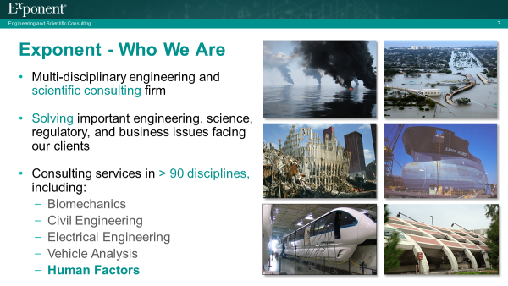
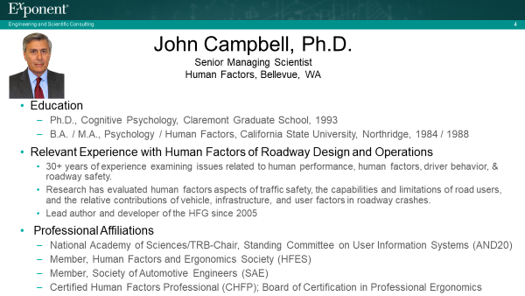
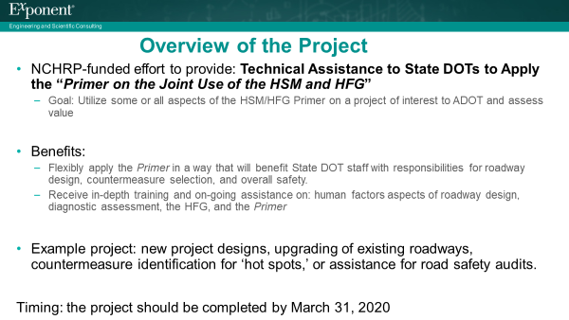
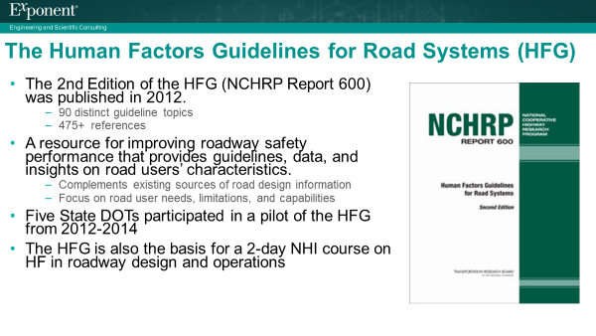
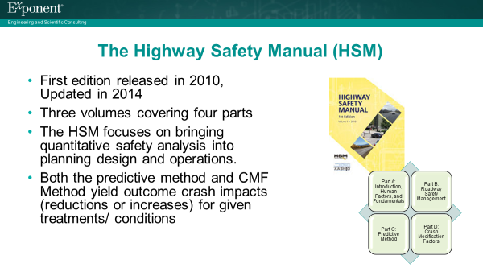
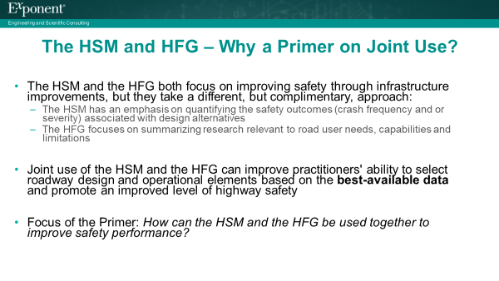
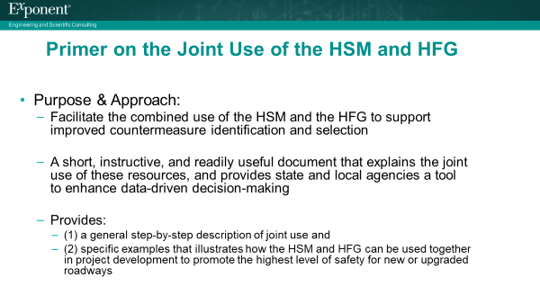
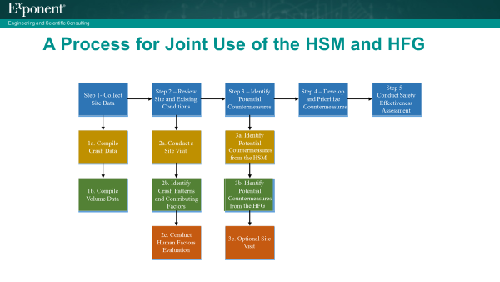
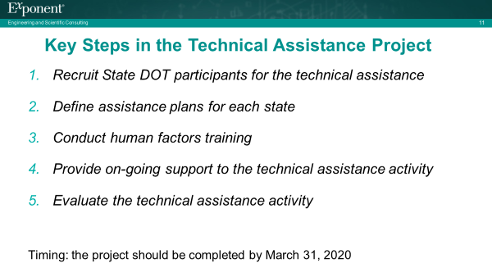

Appendix C: ADOT – Human Factors Training Flyer
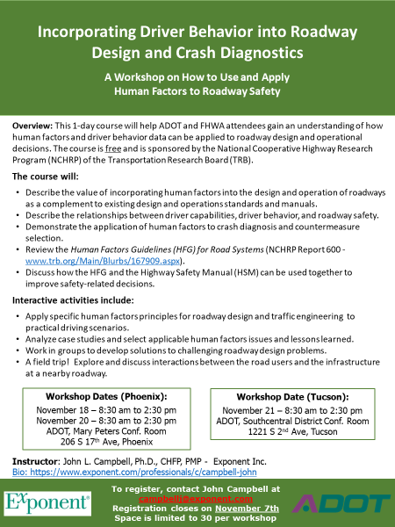

Appendix D: Phoenix Human Factors Workshop Agenda

INCORPORATING DRIVER BEHAVIOR INTO ROADWAY DESIGN AND CRASH DIAGNOSTICS
A Workshop on How to Use and Apply Human Factors to Roadway Safety

AGENDA

Monday, November 18, 2019
ADOT Mary Peters Conf. Rm.; 206 S. 17th Ave, Phoenix, AZ
TOPIC | DESCRIPTION | TIME
OPENING REMARKS | Welcome by Dallas Hammit, ADOT Deputy Director for Transportation | 8:30 - 8:40
1. Introduction to the Human Factors Workshop | - Workshop Objectives  - Self-Introductions  - Overview of Training Focus and Topics  - ‘Sneak Peek’ - A sample case study to illustrate human factors aspects of roadway design and safety | 8:40 - 9:00
2. Human Factors Fundamentals within the Roadway Environment | Review of the driving task, and the capabilities and limitations of road users most relevant to driver performance and roadway safety | 9:00 - 10:00
3. Workshop Exercise: Human Factors Aspects of a Typical Driving Scenario | Apply human factors knowledge and principles to an urban, mixed-modality driving situation. | 10:00 - 10:30
BREAK |  | 10:30 - 10:40
4. Overview of the HFG, the HSM, & the HSM/HFG Primer | Overview of the Primer on the Joint Use of the Highway Safety Manual (HSM) & the Human Factors Guidelines (HFG) for Road Systems | 10:40 - 11:00
5. Evaluating, Analyzing, and Diagnosing the Factors that Contribute to Crashes | A set of methods and tools for diagnosing contributing factors leading to crashes and identifying appropriate countermeasures. | 11:00 - 12:00
LUNCH BREAK | Lunch on your own; Q&A in the Conference Room as needed. | 12:00 - 1:00
6. Application: AZ Case Study | Field trip to 19th Ave and Jefferson St to conduct site assessment* | 1:00 - 2:30
* please dress appropriately for the weather and be prepared to use personal protection (hard hat & vest) as needed.

Course Instructor: John L Campbell, Ph.D., CHFP, Exponent Inc. https://www.exponent.com/professionals/c/campbell-john

INCORPORATING DRIVER BEHAVIOR INTO ROADWAY DESIGN AND CRASH DIAGNOSTICS
A Workshop on How to Use and Apply Human Factors to Roadway Safety

AGENDA
Wednesday, November 20, 2019
ADOT John McGee Conf. Rm.; 206 S. 17th Ave, Phoenix, AZ
TOPIC | DESCRIPTION | TIME
OPENING REMARKS | Welcome by John Halikowski, ADOT  Director | 8:30 - 8:40
1. Introduction to the Human Factors Workshop | - Workshop Objectives  - Self-Introductions  - Overview of Training Focus and Topics  - ‘Sneak Peek’ - A sample case study to illustrate human factors aspects of roadway design and safety | 8:40 - 9:00
2. Human Factors Fundamentals within the Roadway Environment | Review of the driving task, and the capabilities and limitations of road users most relevant to driver performance and roadway safety | 9:00 - 10:00
3. Workshop Exercise: Human Factors Aspects of a Typical Driving Scenario | Apply human factors knowledge and principles to an urban, mixed-modality driving situation. | 10:00 - 10:30
BREAK |  | 10:30 - 10:40
4. Overview of the HFG, the HSM, & the HSM/HFG Primer | Overview of the Primer on the Joint Use of the Highway Safety Manual (HSM) & the Human Factors Guidelines (HFG) for Road Systems | 10:40 - 11:00
5. Evaluating, Analyzing, and Diagnosing the Factors that Contribute to Crashes | A set of methods and tools for diagnosing contributing factors leading to crashes and identifying appropriate countermeasures. | 11:00 - 12:00
LUNCH BREAK | Lunch on your own; Q&A in the Conference Room as needed. | 12:00 - 1:00
6. Application: AZ Case Study | Field trip to 19th Ave and Jefferson St to conduct site assessment* | 1:00 - 2:30
* please dress appropriately for the weather and be prepared to use personal protection (hard hat & vest) as needed.

Course Instructor: John L Campbell, Ph.D., CHFP, Exponent Inc. https://www.exponent.com/professionals/c/campbell-john

INCORPORATING DRIVER BEHAVIOR INTO ROADWAY DESIGN AND CRASH DIAGNOSTICS
A Workshop on How to Use and Apply Human Factors to Roadway Safety

AGENDA
Thursday, November 21, 2019
ADOT Southcentral District Conf. Rm.; 1221 S. Second Ave, Tucson, AZ
TOPIC | DESCRIPTION | TIME
OPENING REMARKS | Welcome by Greg Byres, ADOT Planning  Director | 8:30 - 8:40
1. Introduction to the Human Factors Workshop | - Workshop Objectives  - Self-Introductions  - Overview of Training Focus and Topics  - ‘Sneak Peek’ - A sample case study to illustrate human factors aspects of roadway design and safety | 8:40 - 9:00
2. Human Factors Fundamentals within the Roadway Environment | Review of the driving task, and the capabilities and limitations of road users most relevant to driver performance and roadway safety | 9:00 - 10:00
3. Workshop Exercise: Human Factors Aspects of a Typical Driving Scenario | Apply human factors knowledge and principles to an urban, mixed-modality driving situation. | 10:00 - 10:30
BREAK |  | 10:30 - 10:40
4. Overview of the HFG, the HSM, & the HSM/HFG Primer | Overview of the Primer on the Joint Use of the Highway Safety Manual (HSM) & the Human Factors Guidelines (HFG) for Road Systems | 10:40 - 11:00
5. Evaluating, Analyzing, and Diagnosing the Factors that Contribute to Crashes | A set of methods and tools for diagnosing contributing factors leading to crashes and identifying appropriate countermeasures. | 11:00 - 12:00
LUNCH BREAK | Off-site lunch on your own and travel to the site visit. | 12:00 - 1:00
6. Application: AZ Case Study | Field trip to SR 86 (Ajo Way) and Mission Road to conduct site assessment* | 1:00 - 2:30
* please dress appropriately for the weather and be prepared to use personal protection (hard hat & vest) as needed.

Course Instructor: John L Campbell, Ph.D., CHFP, Exponent Inc. https://www.exponent.com/professionals/c/campbell-john

Appendix E: Draft WSDOT Human Factors Training Flyer

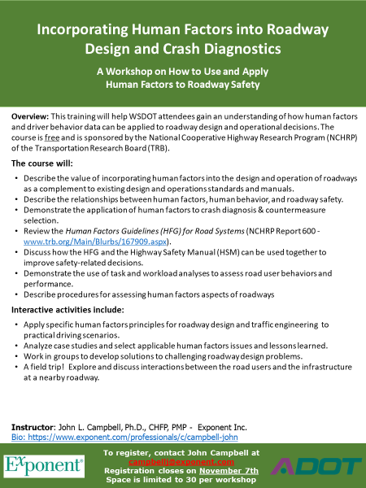

Appendix F: NCHRP Project HR 20-07 (334)

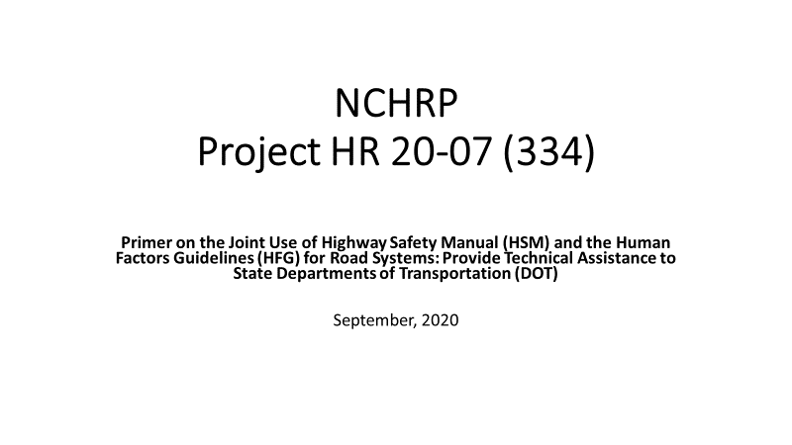

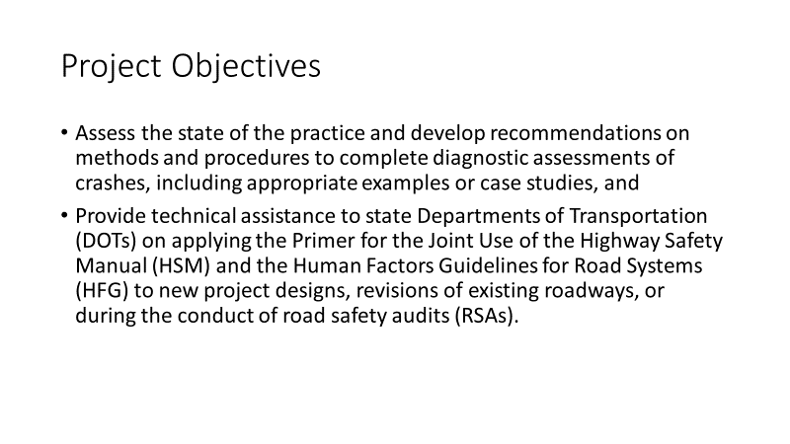
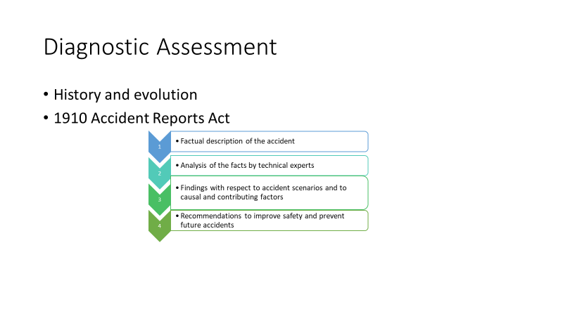

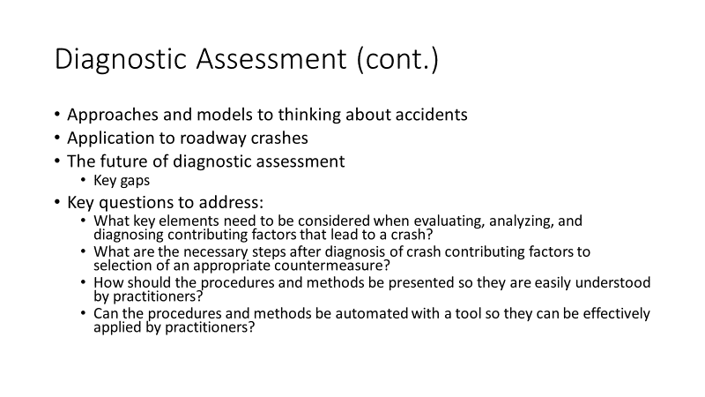

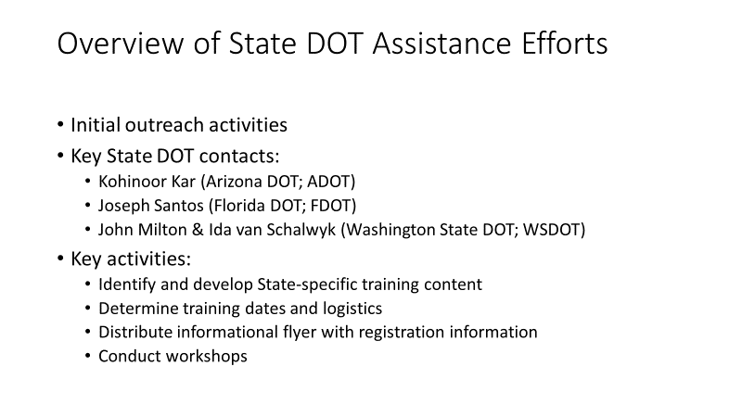

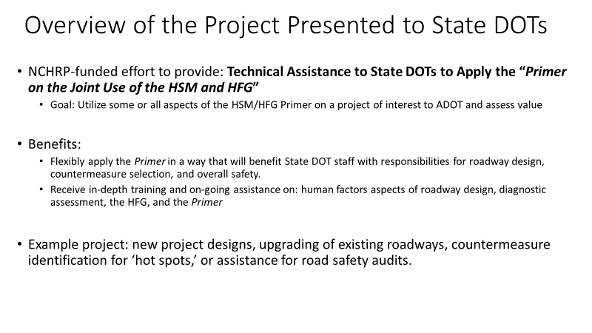

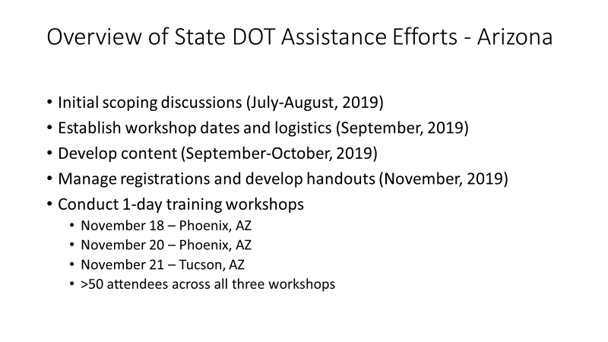

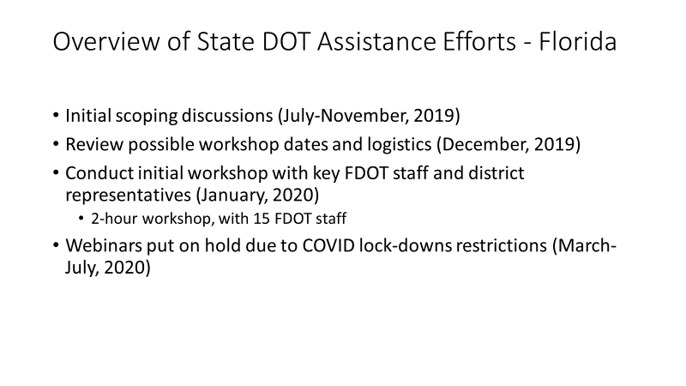

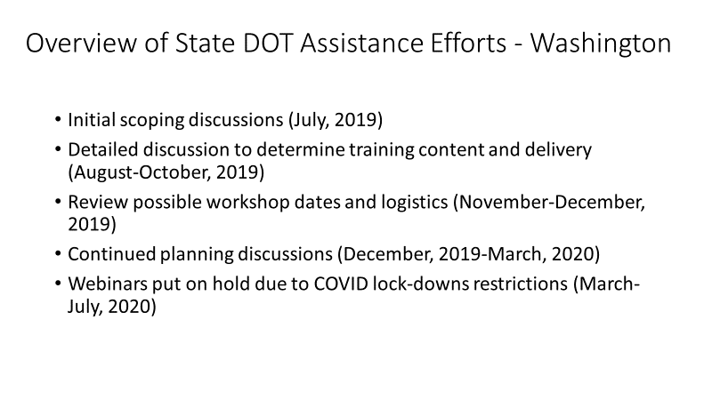

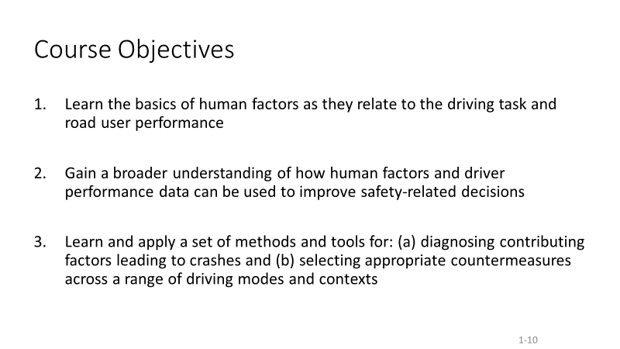

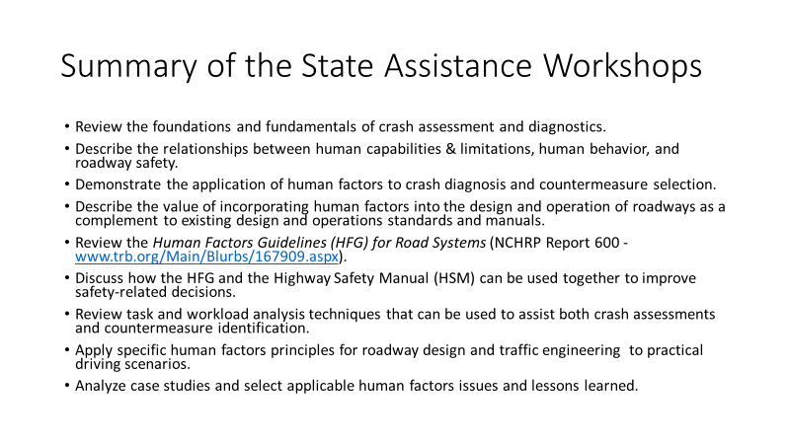

This is the ‘Primer on the Joint Use of the HSM and HFG’ developed by Battelle under NCHRP 20-07(334). A copy of this document can be provided by John Campbell upon request.
See http://www.highwaysafetymanual.org/Pages/default.aspx
See http://www.trb.org/Main/Blurbs/167909.aspx

