Bus Operator Workstation Design
for Improving Occupational Health and Safety

TCRP Report #

BUS OPERATOR WORKSTATION FEATURE GUIDELINE

Darrell Bowman
Andrew Krum
Victoria Deal

February 19, 2016
Table of Contents
BUS OPERATOR WORKSTATION FEATURE GUIDELINE 1
INTRODUCTION 5
OPERATOR WORKSTATION 7
Bus Operator Accommodation 8
Bus Operator Clearances 8
Bus Operator Workplace Width 9
Bus Operator Platform Height 10
Bus Operator Platform Access 10
Operator Workstation Lighting 11
Operator Workstation Glare 11
Ventilation 12
Ambient Noise Level 12
BUS OPERATOR’S SEAT 13
Seat Suspension Type 14
Seat Fore/Aft (Horizontal) Adjustment Range 15
Seat Up/Down (Vertical) Adjustment Range 16
Seat Back Neutral Vertical Angle 17
Seat Back Adjustment Range 18
Seat Pan Angle Adjustment Range 19
Seat Pan Cushion Length 20
Seat Pan Cushion Width 21
Seat Pan Cushion Height 22
Seat Back Width 23
Seat Back Lumbar Support 24
Seat Control Locations 24
Seat Head Restraint Height Above Seat Reference Point 25
STEERING WHEEL 26
Steering Column Dampening 26
Steering Wheel Diameter 27
Steering Wheel Rim Diameter 28
Steering Wheel Rim Clearance 28
Steering Wheel Telescope Adjustment Range 28
Steering Wheel Plane Neutral Horizontal Angle 29
Steering Wheel Plane Horizontal Angle Adjustment Range 29
Steering Wheel Plane Height from Floor 30
Steering Wheel Turning Effort 30
FOOT CONTROLS 31
Foot Control General Design 31
Foot Control Spacing 32
Foot Control Location 32
Foot Control Clearance 33
ACCELERATOR PEDAL DESIGN 34
Accelerator Pedal Plate Length 34
Accelerator Pedal Plate Width 35
Accelerator Pedal Lateral Angle 35
Accelerator Pedal Plate Horizontal Angle 36
Accelerator Pedal Plate Actuation Angle 36
BRAKE PEDAL DESIGN 38
Brake Pedal Plate Length 38
Brake Pedal Plate Width 40
Brake Pedal Plate Horizontal Angle 40
Brake Pedal Plate Actuation Angle 41
Brake Pedal Actuation Force 41
TURN SIGNAL PLATFORM DESIGN 42
Turn Signal Platform Content 42
Turn Signal Platform Angle 42
Turn Signal Platform Location 43
FARE BOX PLATFORM DESIGN 43
Fare Box Platform Positioning 43
BUS OPERATOR CONTROLS DESIGN 44
Bus Operator Controls General 44
Door Control Location 45
MIRROR DESIGN 47
Flat Mirror Reflective Surface 47
Curbside Mirror Height Above Ground 47
DAYLIGHT OPENINGS DESIGN 48
Street-Side Window View 48
REFERENCES 49
APPENDIX A: Transit Bus Frequently Used and Critical Controls in Operator Workstation 52
APPENDIX B: International Transit Bus Operator Workstation Guideline Matrix 59

INTRODUCTION

This document will provide design guidance to transit bus manufacturers for the operator workstation development of low-floor transit buses, yet it may have some applicability to other transit bus types, such as intercity buses. Its scope is limited to the key elements of operator workstation design that impact the health and well-being of the bus operator. This guidance does not focus in depth on individual control positions, for example HVAC, mirrors, and entry doors. However, a list of frequently used and critical controls as referenced in the APTA Whitebook (2013) has been provided in APPENDIX A: Transit Bus Frequently Used and Critical Controls in Operator Workstation.

These guidelines are based on the following industry standards: the previous TCRP Report 25; the American Public Transportation Association; the European initiative referred to as the European Bus System of the Future (EBSF); International Organization for Standardization (ISO) 16121 guideline; and published ergonomic design criteria and principles. A comparative list of these guidelines is provided in APPENDIX B: International Transit Bus Operator Workstation Guideline Matrix. Additionally, these guidelines will function as a “living” document to be periodically revised as changes occur in the industry, such as variations in transit bus operator demographics, application of innovations, or generation of new scientific data that further improve the well-being of bus operators.

These guidelines apply to vehicles sold in the United States and generally will apply to other nations, although some modifications may be required due to regional differences in regulations, operator anthropometry, driving tasks, or operator preferences.

Intended users of these guidelines, vehicle engineers and designers and transit bus procurement staff, shall comply with all applicable federal, state, and local regulations. These include but are not limited to federal ADA, state, and local accessibility, safety, and security requirements. Local regulations are defined as those below the state level. The bus shall meet all applicable Federal Motor Vehicle Safety Standards (FMVSS) and accommodate all applicable Federal Transit Agency (FTA) regulations in effect at the date of manufacture. In the event of conflict between the requirements of this document and any applicable legal requirement, the legal requirement shall prevail. Technical requirements that exceed the legal requirements are not expected to conflict.

The document’s structure aims to improve the comprehension of the key design criteria and their supporting rationale. At the beginning of each section, a summary is provided in a table for quick reference. More details about each guideline are provided later in the section with a standardized format that includes the following:

- Definition: provides a description of each individual operator workstation feature
- Figure: provides an illustration of each specific feature if available
- Design Guideline: provides suggested design objectives based on ergonomic principles and vehicle design literature
- Need for Design Guideline: provides the reasoning for the design criteria and factors that must be considered during the design of operator workstation features

OPERATOR WORKSTATION

The transit bus operator workstation contains the primary components and controls for driving the bus, such as the bus operator’s seat, steering wheel, pedals, and turn signals. The spatial relationship between these components and controls is crucial to the safety and well-being of the bus operator. Table 1 provides a summary of the general operator workstation guidelines.

Table 1. Operator Workstation General Guideline Summary
Dimension/Attribute | Updated Design Guideline
Bus Operator Accommodation | The design should afford at least 90% accommodation of the intended transit bus operator population.
Bus operator Stomach and Shin/Knee Clearances | The design should allow for standard SAE stomach and shin/knee clearance envelopes found in the 3-D CAD model.
Bus Operator Workplace Width | The bus operator compartment should allow for clearance to the operator’s shoulders and elbows (min. 800 mm cross-bus).
Bus operator Platform Height | Allow a seated bus operator to see a target positioned 610 mm in front of the bumper and 1067 mm above the ground. The height of the platform shall also allow for the bus operator’s vertical upward view to be less than 15º.
Bus operator Platform Access | If the bus operator platform is 300 (± 50 mm) above the bus floor, a single step should be provided. If the platform height is greater than 350 mm, steps with equal vertical spacing shall be provided with a maximum and minimum vertical spacing of 250 mm and 125 mm, respectively. The step(s) should be designed so a 127 mm diameter disc may rest on the step without any overhang. If a rectangular emergency access hatch is provided through the bus operator-side glass, the hatch must have a height of at least 650 mm and a width of at least 470 mm.
Operator Workstation Lighting | Illuminate the half of the steering wheel nearest the bus operator to a level of 5 to 10 foot candles.
Operator Workstation Glare | Minimize to the extent possible
Operator Workstation Ventilation | Outside air should be provided to the operator workstation at a minimum rate of 0.57 m³ (20 ft³)/min. Air speed at the operator’s head should be adjustable either continuously or with not less than three discrete increments from near 0 to 120 m (400 ft)/min. The operator workstation must be ventilated with 75% outside air and filtered with a retention rate of at least 50% for particles ≥ 3 µm.
Operator Workstation Noise Level | 70 dBA measured at the bus operator’s head position while driving

Bus Operator Accommodation

Definition: Accommodation is the ability of the operator workstation to (1) comfortably position a bus operator in relation to seat, steering wheel, and pedals; (2) conveniently reach controls; and (3) adequately view the outside scene (e.g., adjacent traffic, traffic signs and signals, and pedestrians). Accommodation is achieved if the bus operator can choose component locations and a posture without encountering the limits (e.g., floor, firewall, and bulkheads) of adjustment ranges (Parkinson et al., 2005). Bus operators of those vehicles designed with more adjustable bus operator packages or greater bus operator accommodation (Porter and Gyi, 2001) offer fewer incidences of musculoskeletal complaints.

Design Guideline: The design should afford at least 90% accommodation of the intended transit driver population.

Need for Design Guideline: In the past, guidelines stipulated an accommodation of the 5th percentile female to 95th percentile male; however, percentiles only represent one anthropometric dimension, stature, and cannot account for the anthropometric variance across an entire design population. An alternative approach uses multivariate anthropometric models to represent a design population. Designers would use principle component analysis (PCA) to reduce the full set of body dimensions to a smaller (usually 2 or 3) set of dimensions pertinent to the design. Using a two-dimensional (bivariate) plot of the key anthropometric dimensions, an ellipsoid can be drawn to envelop the data points at the desired level of 90% accommodation. On the boundary of that ellipsoid, designers can select a sample of values that represent the extremes in the bivariate plot and generate user models. These human models then serve as the basis for the operator workstation design. If all of these models can achieve a position within the workstation to perform the necessary tasks, then it is estimated that the design will accommodate that percentage of the design population.

Bus Operator Clearances

Definition: The SAE Stomach and Shin/Knee models define the boundaries that estimate where truck bus operator stomachs and knees are located while seated in the bus operator seats. This is a probabilistic location that can be used to package operator workstation components such as clearance between the stomach and steering wheel as well as clearance between the knee and instrument panel.

Design Guideline: The design should allow for standard SAE stomach and shin/knee clearance envelopes found in the 3-D CAD model.

Need for Design Guideline: These clearance envelopes (Figure 1) provide a probabilistic location that can be used to package operator workstation components such as clearance between the stomach and steering wheel as well as clearance between the knee and instrument panel.

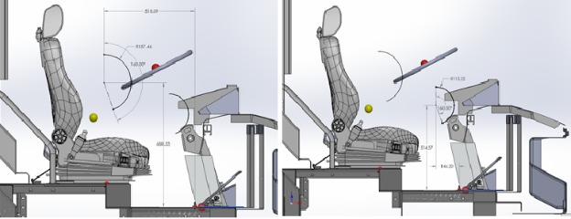
Figure 1: Workstation SAE Clearance Envelopes.

Bus Operator Workplace Width

Definition: The clearance in the bus operator compartment in the area of the seat backrest which allows for bus operator elbow and shoulder motion.
Design Guideline: The bus operator compartment shall provide clearance around the bus operator’s elbows and shoulders with a minimum cross-bus clearance of 800 mm centered on the operator centerline.

Need for Design Guideline: The bus operator requires sufficient clearance from surrounding instrument panels and controls, bus body trim, fare box, and passenger entry handles to freely move their elbows and shoulders while rotating the steering wheel for vehicle control and moving their upper body while seated to maintain visual awareness of the surrounding environment.

Bus Operator Platform Height

Definition: The bus operator platform height is the vertical distance from the bus operator’s platform to the primary bus floor (Figure 2).
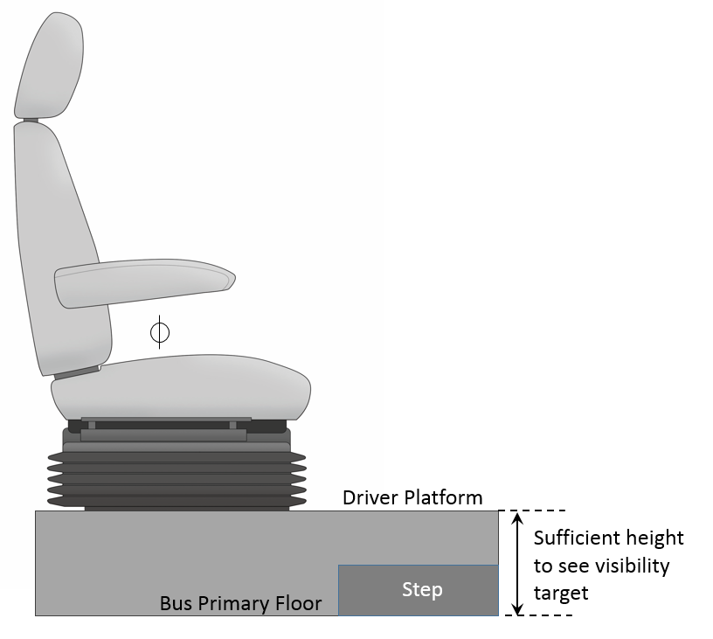
Figure 2: Bus Operator Platform Height.
Design Guideline: Allow a seated driver to see a target positioned 610 mm in front of the bumper and 1067 mm above the ground. The height of the platform shall also allow for the driver’s vertical upward view to be less than 15º.

Need for Design Guideline: An elevated bus operator platform may be needed to achieve sufficient visibility of the forward roadway.

Bus Operator Platform Access

Definition: Bus operator Platform Access refers to the means of access or egress from the bus operator’s seat.
Design Guideline: If the driver platform is 300 mm (± 50 mm) above the bus floor, a single step should be provided. If the platform height is greater than 350 mm, steps with equal vertical spacing shall be provided with a maximum and minimum vertical spacing of 250 mm and 125 mm, respectively. The step(s) should be designed so a 127 mm diameter disc may rest on the step without any overhang. If a rectangular emergency access hatch is provided through the driver-side glass, the hatch must have a height of at least 650 mm and a width of at least 470 mm.

Need for Design Guideline: Improperly designed access system might lead to slips, trips, and falls: thus, proper design of the system of steps and handholds yields safe access and egress for bus operators. Important features of the Bus operator Platform Access system include even vertical spacing of steps, adequate foot accommodation, slip-resistant surfaces, and designated handholds for balance. Emergency access through the bus operator-side glass can become important in events outside of normal operations. This alternate opening should provide the minimum clearance for operators as prescribed in SAE J185, Table 4 - Enclosure Openings.

Operator Workstation Lighting

Definition: Operator Workstation Lighting refers to the amount of illumination provided by the luminaires in the operator workstation area.

Design Guideline: Illuminate the half of the steering wheel nearest the driver to a level of 5 to 10 foot candles.

Need for Design Guideline: Appropriate area lighting is important for increased bus operator performance and safety and reduced visual strain (Spath et al., 2006).

Operator Workstation Glare

Definition: Glare is an excessive luminance or reflection that is greater than the eye can adapt (Stramler, 1993) and can cause the disruption of visual perception as well as a sensation of discomfort or pain. From a design standpoint, glare can be either direct or indirect (Kroemer et al. 1994). Looking directly at a light source, such as an inadequately shielded luminaire, causes direct glare. Reflections of the instrument panel onto the windows of the bus causes indirect glare, or veiling glare.

Design Guideline: Minimize to the extent possible

Need for Design Guideline: Glare affects the ability of the bus operator to perceive visual information. The degree of interference with visual perception can be classified from the mildest to most severe as (1) discomfort glare – distracting or uncomfortable, (2) disability glare – reduced perception of visual information, and (3) blinding glare – no visual perception even momentarily after the glare has been removed (Stramler, 1993). It is important to design surfaces (e.g., surface materials and surface angles) to limit the path between illumination sources and the bus operator’s eye.

Ventilation

Definition: The means of providing fresh air to the operator workstation.
Design Guideline: Outside air should be provided to the operator workstation at a minimum rate of 0.57 m³ (20 ft³)/min. Air speed at the operator’s head should be adjustable either continuously or with not less than three discrete increments from near 0 to 120 m (400 ft)/min. The operator workstation must be ventilated with 75% outside air and filtered with a retention rate of at least 50% for particles ≥ 3 µm.

Ambient Noise Level

Definition: For the operator of a transit bus, noise is defined as a loud, unwanted sound energy. Noise exposure is function of (1) the frequency-weighted exposure level, measured in A-weighted decibels (dBA), and (2) the exposure duration.

Design Guideline: 70 dBA measured at the driver’s head position while driving

Need for Design Guideline: Noise can be particularly disruptive to the driving task: it can interfere with important auditory signals from the vehicle, communication with passengers and surrounding traffic, and is possibly linked to acute and chronic health effects such as annoyance, hypertension, and ischemic heart disease (Passchier-Vermeer and Passchier, 2000). Therefore, it is critical to control the noise-exposure of bus operators so they can focus on performing their duties safely. In a noise pilot study, Diaz et al. 2006 reported the average continuous sound level, L_{Aeq}, was 75.6 dBA on public buses in Madrid, Spain. The range of L_{Aeq} captured by the five noise dosimeters was between 60.3 to 84.7 dBA.

Noise control should be implemented also as an effort to prevent permanent, noise-induced hearing loss (NIHL). The World Health Organization (WHO) and the U.S. Environmental Protection Agency (EPA) recommend daily allowable exposure times of 24 hours at 70 dBA, 8 hours at 75 dBA, 2.7 hours at 80 dBA, 0.9 hours at 85 dBA, and 0.3 hours at 90 dBA. Therefore, a transit bus operator driving an 8-hour day should only be subjected to a noise level below 75 dBA.

Additionally, evidence exists linking exposure to noise to several non-hearing related health effects: adverse cardiovascular effects such as hypertension and/or heart rate, changes in respiratory rate, level of annoyance, and sleep disruption (European Agency for Safety and Health at Work, 2007).

BUS OPERATOR’S SEAT

In the operator workstation, the bus operator spends the largest percentage of time in contact with the seat. Therefore, seat design is critical to the overall comfort and health of the bus operator. Table 2 provides a summary of the seat design guidelines.

Table 2. Seat Design Guideline Summary
Dimension/Attribute | Updated Design Guideline
Seat Suspension Type | Appropriately dampened to support a minimum weight of 172 kg. The suspension shall be capable of dampening adjustment in both directions. Rubber bumpers shall be provided to prevent metal-to-metal contact. Seat padding should allow a deflection of 25 mm and distribute the pressure under the buttocks and thighs.
Seat Fore/Aft (Horizontal) Adjustment Range | 230 mm
Seat Up/Down (Vertical) Adjustment Range | 165 mm
Seat Back Neutral Vertical Angle | 10º
Seat Back Angle Adjustment Range | Shall adjust in angle from a minimum of no more than 0º (vertical) to at least 15º (reclined), with infinite adjustment in between. The preferred adjustment in angle ranges from 0º (vertical) to at least 30º (reclined).
Seat Pan Angle Adjustment Range | 0º – 10º
Seat Pan Cushion Length | Shall be no more than 419 mm at its shortest length and extended to no more than 500 mm with a cushion extension feature. It is preferred that the seat pan cushion extension feature have multiple detent positions from its fully stowed to fully extended positions.
Seat Pan Cushion Width | 432 – 533 mm across the front edge of the seat cushion; 508 – 584 mm across the side bolsters
Seat Pan Cushion Height | Shall adjust in height from a minimum of 356 mm, with a minimum 165 mm vertical range of adjustment.
Seat Back Width | No less than 483 mm
Seat Back Lumbar Support | Shall provide adjustable depth lumbar back support with three individual operating lumbar cells within a minimum range of 178 – 279 mm.
Seat Control Locations | While seated, the bus operator shall be able to make seat adjustments by hand without complexity, excessive effort, or pinching. Controls shall be designed and oriented in accordance to proper human factors direction-of-motion stereotypes (e.g., up for increase, down for decrease). Adjustment mechanisms shall hold the adjustments and shall not be subjected to inadvertent changes.
Head Restraint Height Above Seat Pan | ≥ 800 mm

Seat Suspension Type

Definition: Various types of seat bases allow the bus operator to adjust the seat up and down. The most basic type of seat suspension is a “fixed” seat where the seat is directly mounted to the bus floor with a rigid structure such as metal cylinder within another metal cylinder. The operator can adjust the vertical height of the seat by loosening or removing a pin that locks the upper portion of the seat to the lower portion mounted to the floor. Other seat suspensions use either passive or active dampening via mechanical or pneumatic devices. The vertical height of these hinged seat suspensions is adjusted via air pressure. The effect of whole-body vibration on perceived comfort depends on the frequency, duration, and magnitude of the vibration, vibration waveform, the position of contact between the operator and the vibration, and the operator’s posture and orientation (Mansfield 2005). Key standards to reference for whole-body vibration include BS 6841 (1987), ISO 2631-1 (1997), and ISO 2631-5 (2004). The European Union (EU) Directive 2002/44/EC has established levels of daily exposure and limit values (EAV) (Nelson and Brereton, 2005) of 0.5 ms⁻² 8-hour energy-equivalent frequency-weighted acceleration. According to the EU Directive 2002/44/EC, if the EAV is exceeded, employers should establish a formalized program for reducing the operator’s exposure to the whole-body vibration through a variety of engineering and administrative controls. The whole-body vibration daily exposure limit value (ELV) is 1.15 ms⁻² 8-hour energy-equivalent frequency-weighted acceleration. According to the EU Directive 2002/44/EC, operators should not be exposed to whole-body vibrations above the ELV. If the ELV is exceeded, employers must take immediate action to reduce the operator’s exposure (Nelson and Brereton, 2005). While this directive is not a requirement in the U.S., it does encourage the minimum requirements for the health and safety of operators exposed to vibration.

Design Guideline: Appropriately dampened to support a minimum weight of 172 kg. The suspension shall be capable of dampening adjustment in both directions. Rubber bumpers shall be provided to prevent metal-to-metal contact. Seat padding should allow a deflection of 25 mm and distribute the pressure under the buttocks and thighs.

Need for Design Guideline: Continuous exposure to whole-body vibration is a leading risk factor in the development of low back disorders (Troup, 1988, NIOSH, 1997), particularly in operators of commercial vehicles (Magnusson et al., 1996). Proper seat suspension and seat cushion material (Blood and Johnson, 2011) protects the operator from severe whole-body vibrations caused by the dynamic forces (e.g., bumps, jolts, and other mechanical shocks) generated by the bus traveling over uneven roadways. Seat cushion padding helps to reduce discomfort caused by those vibrations transmitted from the roadway surface through the bus structure (Bhise, 2011).

Seat Fore/Aft (Horizontal) Adjustment Range

Definition: Seat horizontal adjustment refers to the fore-aft movement of the seat’s Seating Reference Point (SgRP) from its most forward to most rearward position (Figure 3).

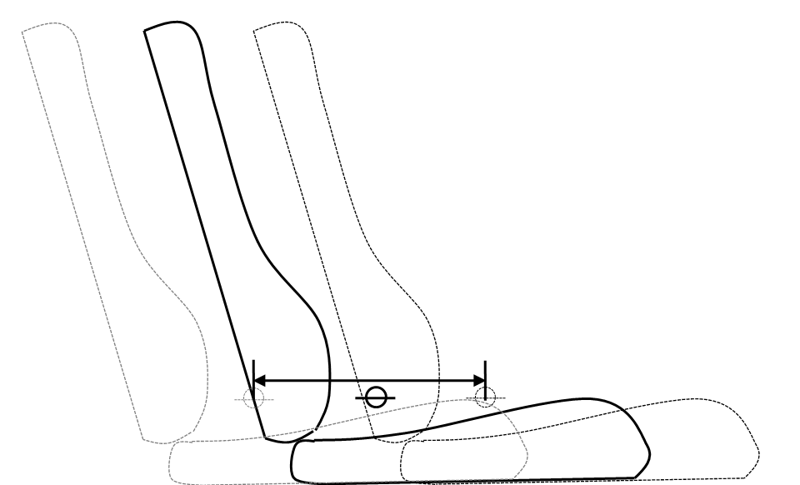
Figure 3: Seat Horizontal Adjustment.

Design Guideline: 230 mm

Need for Design Guideline: Sufficient horizontal seat travel is critical for providing a comfortable seating position. It allows the bus operator to establish the desired arm angles to the steering wheel and the leg and ankle angles to the pedals. Insufficient horizontal seat travel may result in the bus operator’s inability to achieve comfortable joint angles and create undue stress on the back and limbs. The control mechanism should be easy to find and operate in a predictable manner.

Seat Up/Down (Vertical) Adjustment Range

Definition: The seat’s vertical adjustment is measured from the seat’s SgRP’s lowest position to its highest position (see Figure 4). The leg length, represented by Popliteal (back of knee) Height, imposes a significant constraint on seat travel height.

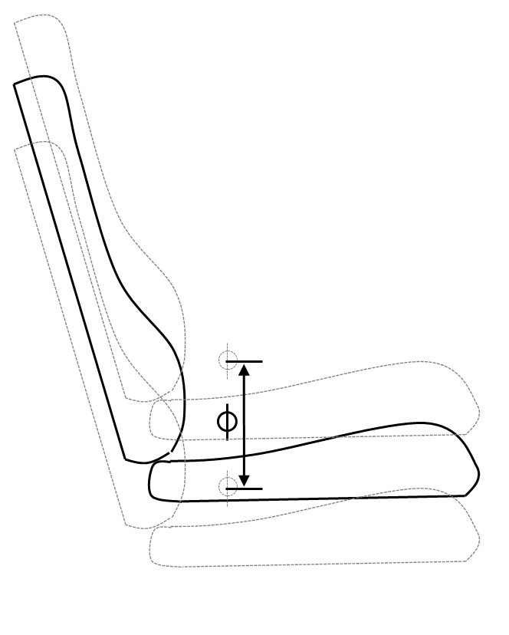
Figure 4: Seat Vertical Adjustment.
Design Guideline: 165 mm

Need for Design Guideline: An excessive seat height can be extremely uncomfortable, given the pressure on the back of the thighs (i.e., popliteal fossa) at the knee. Therefore, the vertical height of the un-deflected surface of the front edge of the cushion (waterfall) to the floor is an important factor for assessing the seat occupant’s seated comfort.

Seat Back Neutral Vertical Angle

Definition: The seat back neutral vertical angle is the design nominal value for the angle between the seat back plane and the vertical plane (Figure 5). This dimension is equivalent to the SAE J1100:A40 (seatback angle) measurement.

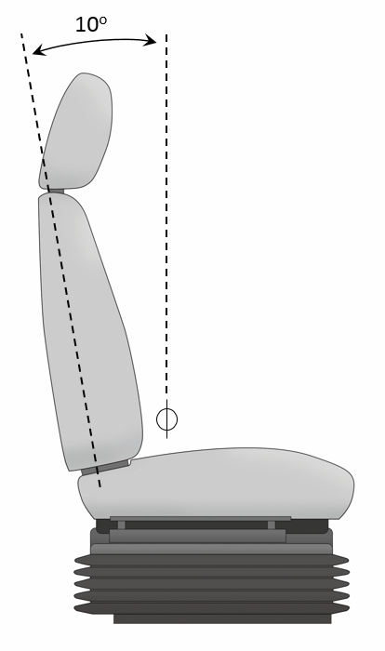

Figure 5: Seat Back Neutral Vertical Angle.

Design Guideline: 10º

Need for Design Guideline: Although this guideline is not necessary for the procurement of the operator workstation, it is an important standard value for completing ergonomic analyses such as visibility (SAE J941 Appendix E).

Seat Back Adjustment Range

Definition: Seat back angle adjustment refers to the angular movement of the seat back to allow for adjustment in the bus operator’s torso posture relative to the vertical plane at 0º (Figure 6).

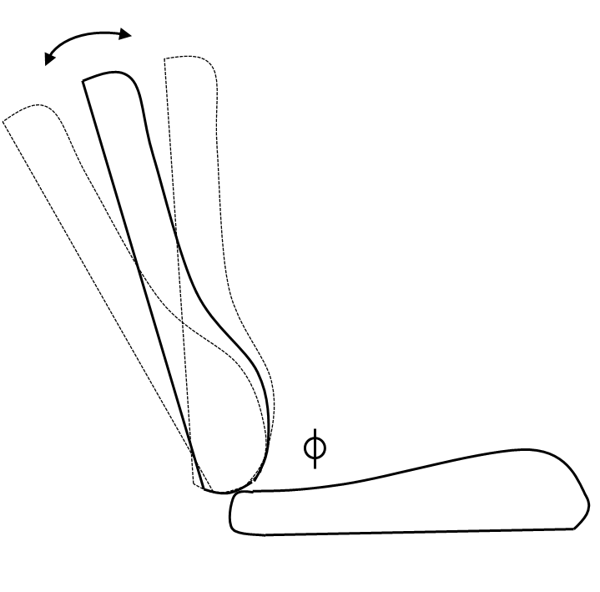
Figure 6: Seat Back Angle Adjustment.

Design Guideline: Shall adjust in angle from a minimum of no more than 0º (vertical) to at least 15º (reclined), with infinite adjustment in between. The preferred adjustment in angle ranges from 0º (vertical) to at least 30º (reclined).

Need for Design Guideline: An on-site study of city bus operators by Okunribido et al. (2006) found that bus operators reporting discomfort from sitting while driving also indicated that they drove buses with poor back rest/support. According to Kroemer et al. (1994), seat backs have two primary purposes: (1) to carry some of the weight of the torso, arms, and head; and (2) to allow for muscle relaxation. Chaffin et al. (1999) found that spinal disc pressures decreased as the backrest angle increased because the weight of the upper torso is transferred into the seat back structure. Seat back adjustment allows the operator to change the inclination of the seat back to relieve pressure on the spine and promote blood flow (Kroemer et al., 1994). Therefore, the seat back angle adjustment must be designed to encourage use so the operator may choose different seat back angles throughout the route.

Seat Pan Angle Adjustment Range

Definition: Seat pan angle adjustment refers to the angular movement of the seat pan to allow for adjustment in bus operator’s hip flexion and thigh support (see Figure 7) relative to the horizontal plane at 0º. The angled seat pan aids in the transfer of the upper torso weight into the seat back (Bhise, 2011, p. 26).

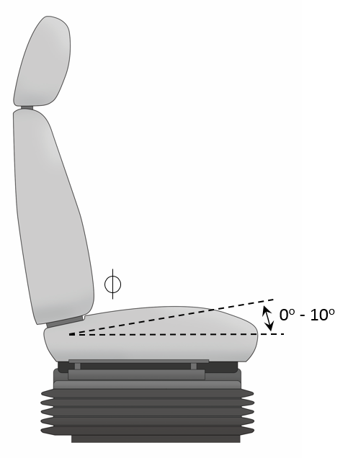
Figure 7: Seat Pan Angle Adjustment Range.
Design Guideline: 0º – 10º

Need for Design Guideline: The seat pan angle adjustment allows the bus operator to choose a comfortable posture for hip flexion and also helps to stabilize the bus operator by preventing the person from sliding forward in the seat (Diffrient et al., 1981).

Seat Pan Cushion Length

Definition: The seat pan cushion length is the distance from the intersection of the seat back and seat pan to the leading edge of the seat cushion (Figure 8).
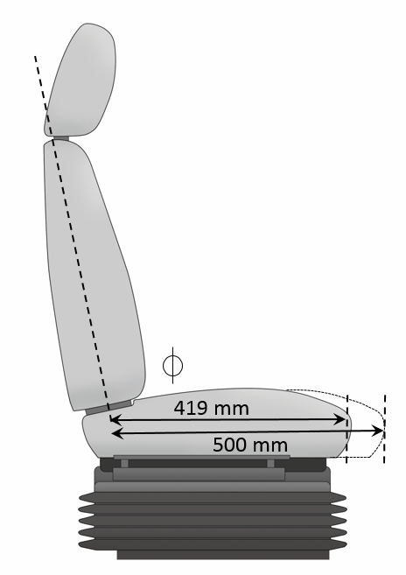
Figure 8: Seat Pan Cushion Length.

Design Guideline: Shall be no more than 419 mm at its shortest length and extended to no more than 500 mm with a cushion extension feature. It is preferred that the seat pan cushion extension feature have multiple detent positions from its fully stowed to fully extended positions.

Need for Design Guideline: Seat pan cushion length should not be longer than the bus operator’s buttock-to-popliteal length (Bhise, 2011). For reference, the U.S. truck bus operator buttock-to-popliteal for the 5th percentile female is 458 mm and 95th percentile male is 572 mm (Guan et al., 2012). Reed, Schneider, & Ricci (1994) give three reasons for the importance of effective seat pan cushion length in determining seat comfort:

- A long cushion can create pressure on the back of the occupant’s legs near the knee where there are many superficial nerves and blood vessels. Pressure in this area may lead to local discomfort and restricted blood flow to the legs.
- A long cushion may pull occupants forward away from the backrest, which eliminates the possibility of providing adequate lumbar support and may increase undue pressure on the back of the knees and calves. Furthermore, a deep seat pan can create problems for occupants in standing up or sitting down.
- A long cushion can restrict leg splay by interfering with knee movement and may impede posture changes that alter pressure distributions under the buttocks and upper thighs.

Seat Pan Cushion Width

Definition: The seat pan cushion width is the lateral distance across the seat pan (Figure 9).

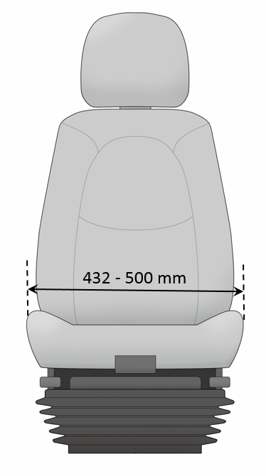
Figure 9: Seat Pan Cushion Width.
Design Guideline: 432 – 533 mm across the front edge of the seat cushion; 508 – 584 mm across the side bolsters

Need for Design Guideline: If the seat pan is too narrow, the sides of the seat pan could come into contact with the bony protrusions (greater trochanters) on the side of the hips, restricting blood flow and causing discomfort in the hips and in the lower extremities (Reed, Schneider, and Ricci, 1994). Furthermore, narrow seat pan widths tend to restrict occupants when they attempt to adjust their seated posture. Adequate clearance between the armrests should be provided to accommodate the wider hip breadths of occupants and their clothing. Additionally, the seat cushion should deflect evenly across a lateral section at the hips. If the cushion is stiffer at the outer edges because of interference from seat structures, a hammock-like effect will constrict the sitter’s buttocks, causing the seat to feel narrower even if the dimensional specifications are met. Finally, side bolsters should not overly restrict leg splay. Please see APPENDIX B: International Transit Bus Operator Workstation Guideline Matrix for contour guidance for side bolsters.

Seat Pan Cushion Height

Definition: Seat Pan Cushion Height is the vertical distance of the un-deflected surface of the front edge of the cushion (waterfall) to the bus operator platform, or Accelerator Heel Point (AHP) (Figure 10). This dimension is related to the Seat Up/Down (Vertical) Adjustment Range dimension.

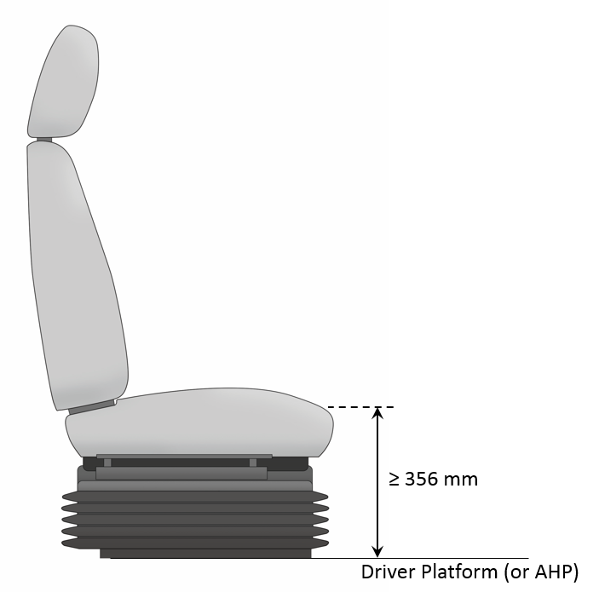
Figure 10: Seat Pan Cushion Height.
Design Guideline: Shall adjust in height from a minimum of 356 mm, with a minimum 165 mm vertical range of adjustment.

Need for Design Guideline: As with the Seat Up/Down (Vertical) Adjustment Range, an excessive seat height can be extremely uncomfortable, due to the pressure on the back of the thighs (i.e., popliteal fossa) at the knee. Therefore, the vertical height of the un-deflected surface of the front edge of the cushion (waterfall) to the floor is an important factor for assessing the seat occupant’s seated comfort.

Seat Back Width

Definition: The Seat Back Width is the lateral distance across the seat back (Figure 11).

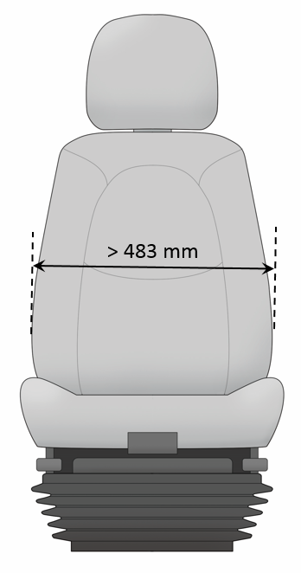
Figure 11: Seat Back Width.
Design Guideline: No less than 483 mm

Need for Design Guideline: If the backrest is not wide enough, it may not accommodate the larger back widths of some commercial bus operators and may not provide adequate lateral stability to the seat’s occupant during cornering maneuvers. In addition, the contour of the backrest should be nearly flat so it does not obstruct arm movement.

Seat Back Lumbar Support

Definition: The longitudinal backrest contour is frequently referred to as the lumbar support since the seat’s reaction forces are in the vicinity of the seat occupant’s lumbar spine. Keegan (1964) specifies that the purpose of the lumbar support is to prevent the flattening of the lumbar lordosis, and he recommends that seat design should promote a neutral lumbar spine curvature about midway between the standing lordosis and a flattened spine.

Design Guideline: Shall provide adjustable-depth lumbar back support with three individual operating lumbar cells within a minimum range of 178 – 279 mm.

Need for Design Guideline: Chaffin et al. (1999) found that spinal disc pressure decreased as lumbar support increased because the lumbar support fills in the lumbar lordosis area, promoting a neutral lumbar spine curvature.

Seat Control Locations

Definition: These are the location(s) for the primary controls to operate seat adjustments such as position, length, and angles.

Design Guideline: While seated, the driver shall be able to make seat adjustments by hand without complexity, excessive effort, or pinching. Controls shall be designed and oriented in accordance to proper human factors direction-of-motion stereotypes (e.g., up for increase, down for decrease). Adjustment mechanisms shall hold the adjustments and shall not be subject to inadvertent changes.

Need for Design Guideline: Seat controls should be located in an easily accessible spot and should operate according to the expectations of the bus operator.

Seat Head Restraint Height Above Seat Reference Point

Definition: This is the vertical distance from the seat reference point (SgRP) to the top of the seat head restraint measured parallel to the seat back angle (Figure 12).

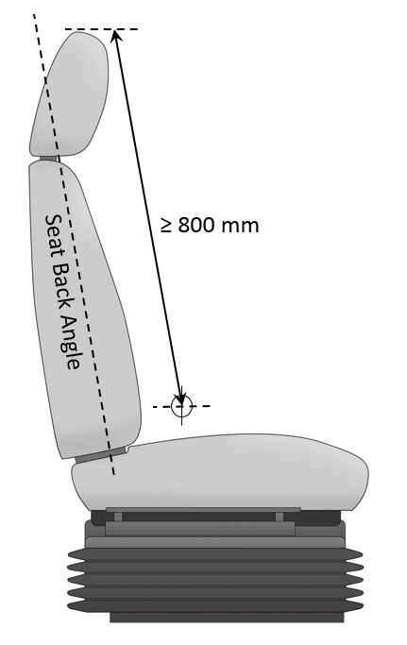
Figure 12: Seat Head Restraint Height above SgRP.

Design Guideline: ≥ 800 mm

Need for Design Guideline: The seat head restraint is designed to prevent whiplash injuries. However, if the seat back cushion is too high, it could restrict rearward vision for small bus operators (Reed, Schneider, and Ricci, 1994).

STEERING WHEEL

The steering wheel controls the transit bus’s lateral movement. The near-constant contact between the steering wheel and the bus operator while the vehicle is in motion requires an efficient design. Its spatial relationship with other bus components influences the bus operator’s chosen posture and overall accommodation of the operator workstation. Table 3 provides a summary of the steering wheel design guidelines.

Table 3. Steering Wheel Design Guideline Summary
Dimension/Attribute | Updated Design Guideline
Steering Column Dampening | The steering column must be designed in a manner that appropriately dampens vibrations.
Steering Wheel Diameter | 457 (recommended) – 508 mm
Steering Wheel Rim Diameter | 22 – 32 mm
Steering Wheel Rim Clearance | ≥ 38 mm
Steering Wheel Telescope Adjustment Range | 50 - 127 mm
Steering Wheel Plane Neutral Horizontal Angle | 27º
Steering Wheel Plane Horizontal Angle Adjustment Range | ± 15º (required); ± 20º (recommended)
Steering Wheel Plane Height from Floor | The mid-range position should be 710 mm.
Steering Wheel Turning Effort | The torque required to turn the steering wheel 10º shall be no less than 5 ft-lbs and no more than 10 ft-lbs. Steering torque may increase to 70 ft-lbs when the wheels are approaching the steering stops, as the relief valve activates.

Steering Column Dampening

Definition: Dampening of the steering column mitigates the transmission of vibration from the roadway to the operator.

Design Guideline: The steering column must be designed in a manner that appropriately dampens vibrations.

Need for Design Guideline: The steering column is coupled to the bus’s suspension and frame and provides a path for transferring vibrations from the roadway to the operator. The vibrations received through the operator gripping the steering wheel must be considered in the management of the overall whole-body vibration experienced by the operator. See Seat Suspension Type (p. 10) for more information on whole-body vibration.

Steering Wheel Diameter

Definition: The Steering Wheel Diameter is a measurement of the straight-line distance that passes through the center from the outer edges of the steering wheel (Figure 13).

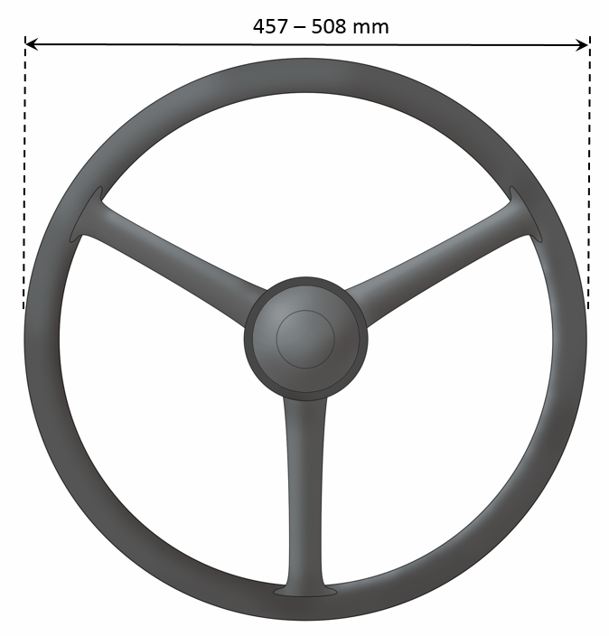
Figure 13. Steering Wheel Diameter.

Design Guideline: 457 (recommended) – 508 mm

Need for Design Guideline: The diameter of the steering wheel is a balance of (1) providing a means of directional control of the bus without too much sensitivity, (2) comfortable posture for the arms and upper torso, and (3) clearance for the torso (i.e., belly room). With reliable power-assist steering from either steer-by-wire or hydraulics, the large diameter wheels are not as important to bus operators for exerting force into the steering of the bus. Therefore, smaller diameter steering wheels can be considered in the design.

Steering Wheel Rim Diameter

Definition: This is the diameter of the steering wheel cross-section (Figure 14).

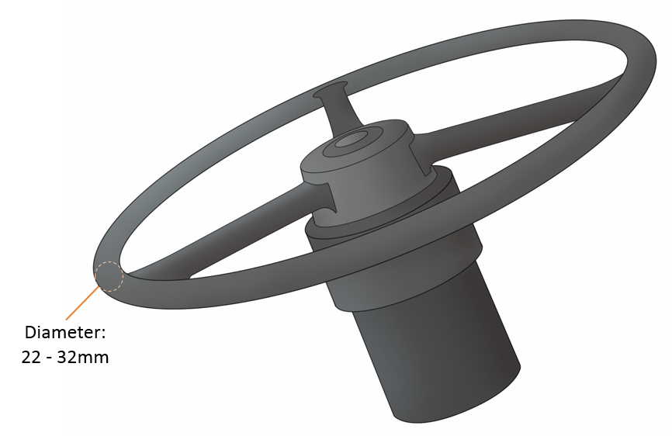
Figure 14. Steering Wheel Rim Diameter.
Design Guideline: 22 – 32 mm

Need for Design Guideline: The steering wheel rim diameter should provide the bus operator with a sufficient surface to grip in a relaxed manner.

Steering Wheel Rim Clearance

Definition: This is the clearance for bus operator hands to surrounding components.
Design Guideline: ≥ 38 mm

Need for Design Guideline: The clearance for bus operators’ hands, while grasping the steering wheel, to surrounding components (e.g., gauge panel, instrument panels and controls) is needed to provide vehicle control through uninterrupted rotation of the steering wheel.

Steering Wheel Telescope Adjustment Range

Definition: This is the linear distance that the steering wheel protrudes from its lowest position on the steering column.

Design Guideline: 50 – 127 mm

Need for Design Guideline: Steering wheel telescoping adjustment allows the bus operator to choose a steering wheel position that produces a comfortable arm posture and reduces stress on the shoulders and back.

Steering Wheel Plane Neutral Horizontal Angle

Definition: This is the design nominal value for the angle between the steering wheel plane and the horizontal plane (Figure 15).

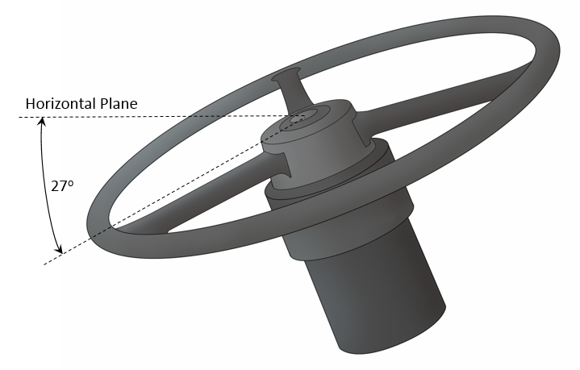
Figure 15. Steering Wheel Plane Neutral Horizontal Angle.

Design Guideline: 27º

Need for Design Guideline: Although this guideline is not necessary for the procurement of the operator workstation, it is an important standard value for completing ergonomic analyses such as bus operator packaging and gauge cluster visibility.

Steering Wheel Plane Horizontal Angle Adjustment Range

Definition: This range refers to the angular movement of the steering wheel relative to the horizontal plane at 0º.
Design Guideline: ± 15º (required); ± 20º (recommended)

Need for Design Guideline: The adjustment of steering wheel plane horizontal angle allows the bus operator to choose a steering wheel position that produces a comfortable arm posture and reduces stress on the shoulders and back.

Steering Wheel Plane Height from Floor

Definition: This measures the vertical height of the center of the steering wheel from the floor (AHP) (Figure 18). This is the same measurement as the H17 as defined by the SAE Recommended Practice J1100, revised February 2001.

Design Guideline: The mid-range position should be 710 mm.

Need for Design Guideline: This is the same measurement as the H17 as defined by the SAE Recommended Practice J1100, revised February 2001. Although this guideline is not necessary for the procurement of the operator workstation, it is an important standard value for completing ergonomic analyses such as bus operator packaging and gauge cluster visibility.

Steering Wheel Turning Effort

Definition: This refers to the force required by the operator to maintain lateral control of the bus through the steering wheel.
Design Guideline: The torque required to turn the steering wheel 10º shall be no less than 5 ft-lbs and no more than 10 ft-lbs. Steering torque may increase to 70 ft-lbs when the wheels are approaching the steering stops, as the relief valve activates.
Note: Steering effort shall be measured with the bus at Gross Vehicle Weight Rate (GVWR), stopped with the brakes released and the engine at normal idling speed on clean, dry, level, commercial asphalt pavement with the tires inflated to recommended pressure.

Need for Design Guideline: The force needed to turn the steering wheel must be balanced between being too high which can tire the operator and being too low which can hinder the operator’s ability to maintain vehicle’s lateral position because of the lack of steering feedback.

FOOT CONTROLS

The foot controls allow the transit operator to adjust longitudinal speed and actuate directional turn signals. The design of these controls is important because the bus operator operates them without sight through natural positioning of the foot. The key characteristic is the spatial relationship between the foot controls as sufficient spacing prevents accidental activation of adjacent foot controls. Table 4 provides a summary of the foot control general design guidelines.

Table 4. Foot Control Design Guideline Summary
Dimension/Attribute | Updated Design Guideline
Foot Control General Design | The pedals should be arranged so the foot movement is rotational (designed for ankle motion) during operation and the heel is supported. The manufacturer can select either hanging or standing (i.e., treadle) pedals.
Foot Control Surface | Wear-resistant, nonskid, replaceable material
Foot Control Spacing | Accelerator pedal: longitudinal spacing with bodywork (min. 50 mm); lateral spacing with bodywork (min. 30 mm)  Brake pedal: clearance between accelerator pedal (min. 50 mm); lateral spacing with bodywork (min. 30 mm)
Foot Control Location | The accelerator pedal shall not be positioned higher than the brake pedal.
Foot Control Clearance | Sufficient clearance within bus operator foot well shall be provided around the accelerator and brake pedals (min. 350 mm).

Foot Control General Design

Definition: This applies to the operation of the pedals by the bus operator’s foot.

Design Guideline: The pedals should be arranged so the foot movement is rotational (designed for ankle motion) during operation and the heel is supported. The manufacturer can select either hanging or standing (i.e., treadle) pedals.

Need for Design Guideline: The actuation of the pedals should match the rotation of the foot to prevent strain on the operator’s ankle. Also, a mismatch between pedal travel and the rotational movement of the foot requires the operator to continually adjust the foot’s position to maintain control of the pedal.

Foot Control Surface

Definition: This guideline refers to the pedals’ surface material and texture.

Design Guideline: Wear-resistant, nonskid, replaceable material

Need for Design Guideline: For proper operation of the foot pedals, the contact surface between the foot control and the operator’s footwear must have sufficient friction to prevent the footwear from sliding off the pedal surface when force is applied.

Foot Control Spacing

Definition: The foot control spacing is the distance between the individual control surfaces and surrounding bus surfaces.

Design Guideline: Accelerator pedal: longitudinal spacing with bodywork (min. 50 mm); lateral spacing with bodywork (min. 30 mm)
Brake pedal: clearance between accelerator pedal (min. 50 mm); lateral spacing with bodywork (min. 30 mm)

Need for Design Guideline: The spacing should be sufficient enough to minimize the likelihood that the foot could actuate the accelerator and brake pedals simultaneously (Van Cott and Kinkade, 1972) or cause the foot to rub adjacent bus structure when using the pedals.

Foot Control Location

Definition: The foot control location refers to the general resting (non-active) positioning of the accelerator and brake pedal plates.

Design Guideline: The accelerator pedal shall not be positioned higher than the brake pedal.

Need for Design Guideline: The spatial relationship between the accelerator and brake pedal plates must lessen the probability of unintended acceleration of the vehicle. Schmidt (1989) stated that a sudden, unexpected acceleration of the vehicle was due to “insufficient height differential between the brake and accelerator pedals.” Casey and Rogers (1987) found that inadvertent activation of the accelerator while braking is more likely with coplanar pedals. Therefore, the accelerator pedal plate should be positioned lower than the brake pedal so the brake system is activated at a higher amount if there is an accelerator misapplication during a braking event.

Foot Control Clearance

Definition: The foot control clearance refers to the clearance in the foot well area of the bus operator compartment surrounding the accelerator and brake pedals.

Design Guideline: The depth of the footwell, forward of the accelerator pedal heel point, shall be greater than or equal to 350 mm.

Need for Design Guideline: Clearance is required for the bus operator to safely and effectively apply the accelerator and brake pedals without interference with their shoe or boot.

ACCELERATOR PEDAL DESIGN

Table 5 provides a summary for the accelerator pedal design guidelines. Additional guideline information is provided later in this section.

Table 5. Accelerator Pedal Design Guideline Summary
Dimension/Attribute | Updated Design Guideline
Accelerator Pedal Plate Length | 254 – 305 mm for standing pedals
Accelerator Pedal Plate Width | 76 – 102 mm for standing pedals
Accelerator Pedal Lateral Angle | 10º – 15º
Accelerator Pedal Horizontal Angle | 37º – 60º at idle position  (40º is recommended)
Accelerator Pedal Actuation Angle | 20º – 30º  (25º is recommended)
Accelerator Pedal Actuation Force | 15 – 40 N (required)

Accelerator Pedal Plate Length

Definition: This is the straight-line distance from the bottom to the top of the accelerator pedal plate (Figure 16).

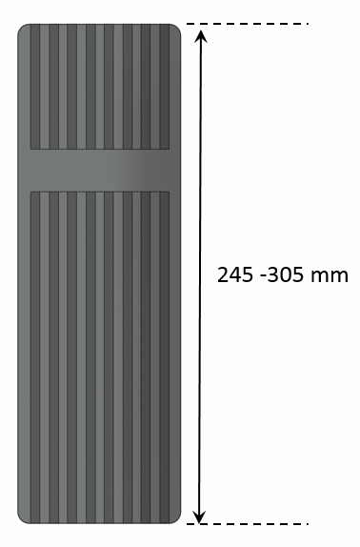
Figure 16. Accelerator Pedal Plate Length.

Design Guideline: 245 – 305 mm for standing pedals

Need for Design Guideline: The accelerator pedal plate should be a size that allows both small- and large-footed operators to depress the pedal with the ball of the foot (Woodson et al., 1992).

Accelerator Pedal Plate Width

Definition: This is the straight-line distance from the left and right edges of the accelerator pedal plate (Figure 17).

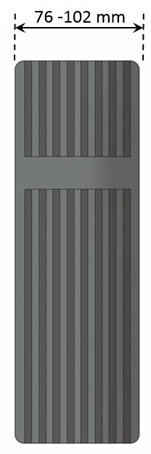
Figure 17. Accelerator Pedal Plate Length.

Design Guideline: 76 - 102 mm for standing pedals

Need for Design Guideline: The accelerator pedal plate should be sufficient size to allow both small- and large-footed operators to depress the pedal with the ball of the foot (Woodson et al., 1992).

Accelerator Pedal Lateral Angle

Definition: The Accelerator Pedal Lateral Angle is the angle between the operator centerline and the AHP.

Design Guideline: 10º – 15º

Need for Design Guideline: The lateral positioning of the accelerator pedal allows the operator to reach for the pedal with natural splay of the right leg. If the accelerator pedal is positioned appreciably outside of this recommended angle, the operator may tire easily; a poorly configured pedal requires the body to twist or the leg and ankle to extend in order to operate the control (Woodson et al., 1992; p. 406).

Accelerator Pedal Plate Horizontal Angle

Definition: The Accelerator Pedal Plate Horizontal Angle refers to the angle between the horizontal angle (0º) and the accelerator pedal plate plane.

Design Guideline: 37º – 60º at idle position (40º is recommended)

Need for Design Guideline: The resting (non-active) angle of the pedal must not be too steep; otherwise, the operator’s ankle tires easily as the pedal is released repeatedly (Woodson et al., 1992).

Accelerator Pedal Plate Actuation Angle

Definition: The accelerator pedal plate actuation angle refers to the angular movement of the accelerator pedal plate during its full range of motion (Figure 18).

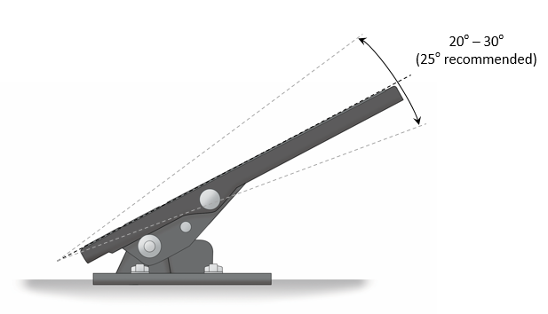
Figure 18. Accelerator Pedal Plate Actuation Angle.
Design Guideline: 20º – 30º (25º is recommended)
45 deg is recommended

Need for Design Guideline: The actuation angle should be balanced between the needed rotation of the ankle and the sensitivity of the pedal’s response.
Accelerator Pedal Actuation Force

Definition: The Accelerator Pedal Actuation Force is the necessary effort exerted by the operator to depress the accelerator pedal.

Design Guideline: 15 – 40 N (required)
45 deg is recommended

Need for Design Guideline: The actuation force must allow the operator to smoothly accelerate the vehicle. A force too high can tire the operator while a force too low can hinder the operator’s ability to maintain pedal position because of the lack of pedal feedback, which impedes smooth acceleration.

BRAKE PEDAL DESIGN

Table 6 provides a summary for the brake pedal design guidelines. Additional guideline information is provided later in this section.

Table 6. Brake Pedal Design Guideline Summary
Dimension/Attribute | Updated Design Guideline
Brake Pedal Plate Length | 245 – 305 mm for standing pedals
Brake Pedal Plate Width | 76 – 102 mm for standing pedals
Brake Pedal Plate Horizontal Angle | 37º – 60º at idle position  (45º is recommended)
Brake Pedal Actuation Angle | 20º – 30º  (25º is recommended)
Brake Pedal Actuation Force | The force to activate the brake pedal control shall be a linear function of the bus deceleration rate and shall not exceed 311 N (75 lbs) at a point 178 mm above the heel point of the pedal to achieve maximum braking. The heel point is the location of the bus operator’s heel when the foot rests flat on the pedal and the heel touches the floor or heel pad of the pedal.

Brake Pedal Plate Length

Definition: This is the straight-line distance from the bottom to the top of the brake pedal plate (Figure 19).

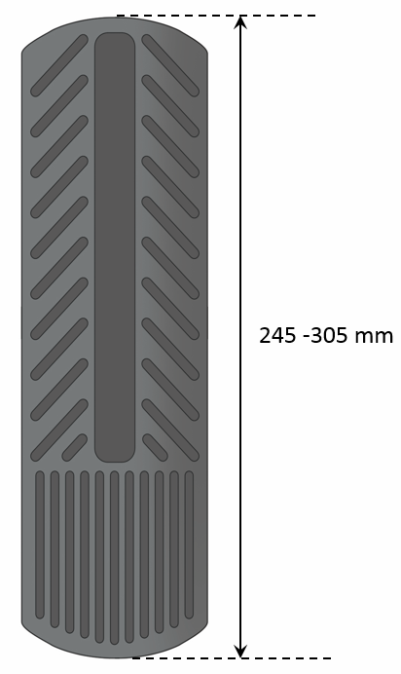
Figure 19. Brake Pedal Plate Length.

Design Guideline: 245 – 305 mm for standing pedals

Need for Design Guideline: The brake pedal plate should be a size that allows both small- and large-footed operators to depress the pedal with the ball of the foot (Woodson et al., 1992).

Brake Pedal Plate Width

Definition: This is the straight-line distance from the left and right edges of the accelerator pedal plate (Figure 20).

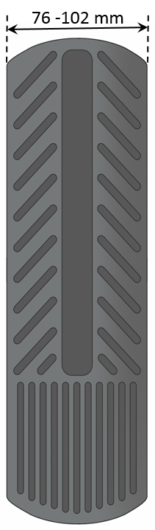
Figure 20. Brake Pedal Plate Width.

Design Guideline: 76 -– 102 mm for standing pedals

Need for Design Guideline: The brake pedal plate should be a size that allows both small- and large-footed operators to depress the pedal with the ball of the foot (Woodson et al., 1992).

Brake Pedal Plate Horizontal Angle

Definition: This refers to the angle between the horizontal angle (0º) and the accelerator pedal plate plane.

Design Guideline: 37º – 60º at idle position (40º is recommended)

Need for Design Guideline: The resting (non-active) angle of the pedal must not be too steep, so the operator’s ankle will not tire easily as the pedal is repeatedly released (Woodson et al., 1992).

Brake Pedal Plate Actuation Angle

Definition: This refers to the angular movement of the accelerator pedal plate during the pedal’s full range of motion (Figure 21).

Figure 21. Brake Pedal Plate Actuation Angle.

Design Guideline: 20º – 30º (25º recommended)
45 deg is recommended

Need for Design Guideline: Like the accelerator, the brake actuation angle needs to be balanced between the needed rotation of the ankle and the sensitivity of the pedal’s response.

Brake Pedal Actuation Force

Definition: This force is the necessary effort exerted by the operator to depress the accelerator pedal.

Design Guideline: The force to activate the brake pedal control shall be a linear function of the bus deceleration rate and shall not exceed 311 N (75 lbs) at a point 178 mm above the heel point of the pedal to achieve maximum braking. The heel point is the location of the driver’s heel when the foot rests flat on the pedal and the heel touches the floor or heel pad of the pedal.
45 deg is recommended

Need for Design Guideline: The actuation force must allow the operator to smoothly accelerate the vehicle. A force too high can tire the operator while a force too low can hinder the operator’s ability to maintain pedal position because of the lack of pedal feedback, which impedes smooth acceleration.

TURN SIGNAL PLATFORM DESIGN

Table 7 provides a summary for the turn signal design guidelines. Additional guideline information is provided later in this section.

Table 7. Turn Signal Platform Design Guideline Summary
Dimension/Attribute | Updated Design Guideline
Turn Signal Platform Content | Turn signals, high beam, stop announcement switch, silent alarm, and hazard switch
Turn Signal Platform Angle | 10º – 37º (23º recommended)
Turn Signal Platform Location | No closer to the seat front than the heel point of the accelerator pedal

Turn Signal Platform Content

Definition: The Turn Signal Platform houses several foot switches incorporated into its top surface.

Design Guideline: Turn signals, high beam, stop announcement switch, silent alarm, and hazard switch
45 deg is recommended

Need for Design Guideline: The content of the turn signal platform is specific to the tasks of transit operators. The number of functions should be limited to maintain spacing between switches so operators can distinguish them without looking.

Turn Signal Platform Angle

Definition: The Turn Signal Platform Angle refers to the angle between the horizontal angle (0º) and the accelerator pedal plate plane.

Design Guideline: 10º – 37º (23º recommended)
45 deg is recommended

Need for Design Guideline: Like the accelerator, it is important that the angle of the turn signal platform is not too steep; otherwise, the operator’s ankle may tire easily (Woodson et al., 1992).

Turn Signal Platform Location

Definition: The Turn Signal Platform Location refers to the longitudinal (fore/aft) positioning of the platform relative to the operator.
Design Guideline: No closer to the seat front than the heel point of the accelerator pedal
45 deg is recommended

Need for Design Guideline: This guideline creates symmetry between the accelerator pedal and the turn signal platform so the operator can maintain comfortable leg postures for both legs.

FARE BOX PLATFORM DESIGN

Table 8 provides a summary for the steering wheel design guidelines. Additional guideline information is provided later in this section.

Table 8. Fare Box Platform Design Guideline Summary
Dimension/Attribute | Updated Design Guideline
Positioning | Position to minimize impact to passenger access and interference with the bus operator’s line of sight. It shall not restrict access to the bus operator area, operation of bus operator controls, or the bus operator’s field of view per SAE Recommended Practice J1050, either by itself or in combination with stanchions, transfer mounting, cutting and punching equipment, or route destination signs.

Fare Box Platform Positioning

Definition: The Fare Box Platform Positioning refers to the device’s mounting location and size within the operator workstation.

Design Guideline: Position to minimize impact to passenger access and interference with the driver’s line of sight. It shall not restrict access to the driver area, operation of driver controls, or the driver’s field of view per SAE Recommended Practice J1050, either by itself or in combination with stanchions, transfer mounting, cutting and punching equipment, or route destination signs.

Need for Design Guideline: While the fare box must be located in a convenient location for both the operator and passengers, the operator must have an unobstructed view of the roadway, especially through the windshield towards the curbside. The fare box should not obstruct the pathway for either the bus operators or the passengers as they travel to their seats.

BUS OPERATOR CONTROLS DESIGN

Table 9 provides a summary for the steering wheel design guidelines. Additional guideline information is provided later in this section.

Table 9. Bus Operator Controls Design Guideline Summary
Dimension/Attribute | Updated Design Guideline
Bus operator Controls General | Frequently used controls must be in easily accessible locations and operate in an expected way.
Door Control Location | It shall be located in the operator’s area within the Transit Bus Manikin Hand Reach Envelope for Driving/Primary Control provided as a supplement in a 3D Computer-Aided Design (CAD) model. It shall provide tactile feedback to indicate commanded door position, resist inadvertent door actuation, and be identifiable by shape, touch, and permanent markings.

Bus Operator Controls General

Definition: Bus operator controls refer to hand-operated controls such as buttons, switches, and knobs.

Design Guideline: Frequently used controls must be in easily accessible locations and operate in an expected way (see Table 10).

Need for Design Guideline: Certain natural directions of motion expectations exist: Table 10 details those recommended control motions.

Table 10. Recommended Control Motions (Van Cott and Kinkade, 1972)
Function | Control Action
On | Up, right, forward, press
Off | Down, left, rearward, pull
Right | Clockwise, right
Left | Counterclockwise, left
Up | Up, rearward
Down | Down, forward
Retract | Rearward, pull, counterclockwise, up
Extend | Forward, push, clockwise, down
Increase | Right, up, forward, clockwise
Decrease | Left, down, rearward, counterclockwise

Door Control Location

Definition: This is the recommended location for the control that actuates the transit buses doors.

Design Guideline: It shall be located in the operator’s area within the Transit Bus Manikin Hand Reach Envelope for Driving/Primary Control (Figures 22 and 23) provided as a supplement in a 3D Computer-Aided Design (CAD) model. It shall provide tactile feedback to indicate commanded door position, resist inadvertent door actuation, and be identifiable by shape, touch, and permanent markings.

Need for Design Guideline: The controls listed in APPENDIX A: Transit Bus Frequently Used and Critical Controls in Operator Workstation are considered frequently used or critical to the operation of the bus and therefore should be within easy reach of the operator as defined by the Transit Bus Manikin Hand Reach Envelope for Driving/Primary Controls. Although secondary controls can be located outside the Transit Bus Manikin Hand Reach Envelope for Driving/Primary Controls curves, these control locations will require some of the bus operators to lean to actuate the controls.

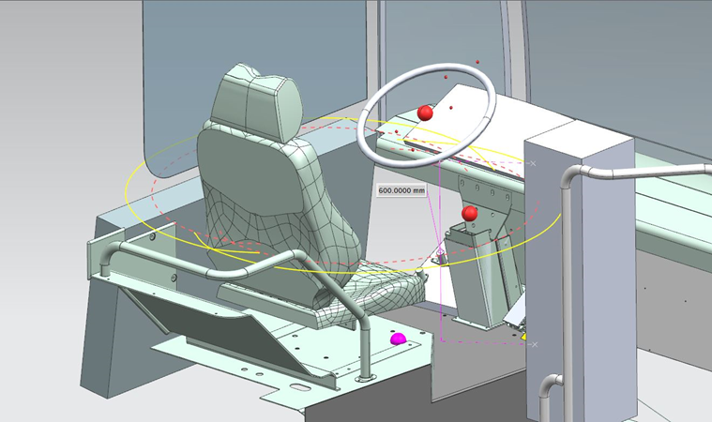
Figure 22. ISO view: The reach curve section on the surface at Zc: 600 for Manikin Female U. The solid (yellow) curve provides the maximum reach for primary controls that are required for safe operation of the vehicle in motion. Hand grasp controls should be kept within the dotted (orange) curve.

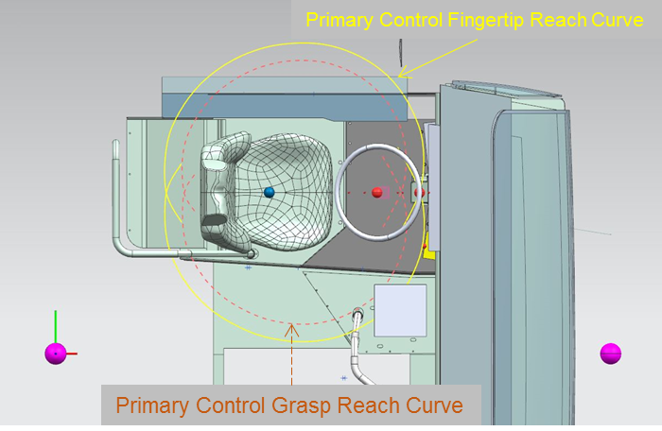
Figure 23. Top view: The reach curves section at Zc: 600 mm for Manikin Female U.

MIRROR DESIGN

Table 11 provides a summary for the steering wheel design guidelines. Additional guideline information is provided later in this section.

Table 11. Mirrors Design Guideline Summary
Dimension/Attribute | Updated Design Guideline
Flat Mirror Reflective Surface | 323 cm² (50 in²)
Curbside Mirror Height Above Ground | No less than 1930 mm

Flat Mirror Reflective Surface

Definition: This refers to the area of reflective surface in a flat mirror.

Design Guideline: 323 cm²

Need for Design Guideline: This requirement is in accordance with 49 CFR 571.111 (S8.1): Review Mirrors.

Curbside Mirror Height Above Ground

Definition: This is the vertical distance between the ground and the lowest portion of the curbside mirror housing (Figure 24).
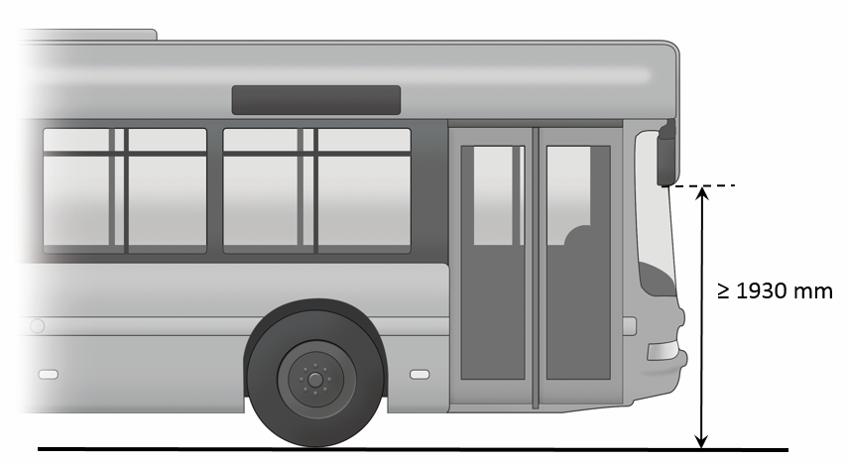
Figure 24. Curbside Mirror Height above the Ground.
Design Guideline: No less than 1930 mm

Need for Design Guideline: This guideline should reduce the likelihood that a pedestrian standing beside the bus might be struck by the mirror assembly. The recommended height will provide approximately 20 mm of clearance to a person walking next to the bus who has a 99th percentile male stature of 1910 mm (Open Design Lab, 2014).

DAYLIGHT OPENINGS DESIGN

Table 12 provides a summary for the steering wheel design guidelines. Additional guideline information is provided later in this section.

Table 12. Daylight Openings Design Guideline Summary
Dimension/Attribute | Updated Design Guideline
Street-side Window View | The bus operator’s view, perpendicular through operator’s side window glazing, should extend a minimum of 1008 mm to the rear of the heel point on the accelerator and must accommodate a 95th percentile male operator. The view through the glazing at the front of the assembly should begin not more than 26 in (560 mm) above the operator’s floor to ensure visibility of an under-mounted convex mirror.

Street-Side Window View

Definition: This is the relative position between the operator and the rear-most portion of the side window.

Design Guideline: The driver’s view, perpendicular through operator’s side window glazing, should extend a minimum of 1008 mm to the rear of the heel point on the accelerator and must accommodate a 95th percentile male operator. The view through the glazing at the front of the assembly should begin not more than 26 in (560 mm) above the operator’s floor to ensure visibility of an under-mounted convex mirror.

Need for Design Guideline: This dimension helps ensure that the bus operator has sufficient view of the adjacent lane and traffic.

REFERENCES

- Bhise, V. D. (2011). Ergonomics in the automotive design process. CRC Press.
- Blood, R. P., & Johnson, P. W. (2011). Quantifying whole body vibration exposures in metropolitan bus drivers: an evaluation of three seats. Noise & Vibration Worldwide, 42(2), 22-29.
- British Standards Institution (1987). Measurement and evaluation of human response to whole-body mechanical vibration and repeated shock, BS 6841. London: British Standards Institution
- Casey, S. M., & Rogers, S. P. (1987). The case against coplanar pedals in automobiles. Human Factors: The Journal of the Human Factors and Ergonomics Society, 29(1), 83-86.
- Chaffin, D. B., Andersson, G., & Martin, B. J. (1991). Occupational biomechanics (pp. 14-52). New York: Wiley.
- Díaz, C., & Pedrero, A. (2006). Sound exposure during daily activities. Applied acoustics, 67(3), 271-283.

- Diffrient, N., Tilley, A. R., and Harman, D. (1981). Human Scale 7/8/9. The MIT Press: Cambridge, MA.

- European Agency for Safety and Health Work (2007). Factsheet 67 - Noise in Figures. Retrieved from https://osha.europa.eu/en/publications/factsheets/67.

- Guan, J., Hsiao, H., Bradtmiller, B., Kau, T. Y., Reed, M. R., Jahns, S. K., ... & Piamonte, D. P. T. (2012). US truck driver anthropometric study and multivariate anthropometric models for cab designs. Human Factors: The Journal of the Human Factors and Ergonomics Society, 54(5), 849-871.

- International Organization for Standardization (1997). Mechanical vibration and shock – Evaluation of human exposure to whole-body vibration – Part 1: General Requirements. ISO 2631-1. Geneva: International Organization for Standardization.

- ISO. (2012). Road Vehicles- Ergonomic Requirements for the Driver’s Workplace in Line-Service Buses – Part 1: General Description, Basic Requirements. ISO 16121-1:2012. Retrieved from https://www.iso.org/obp/ui/#iso:std:iso:16121:-1:ed-2:v1:en.

- Keegan, J.J. (1964). The medical problem of lumbar spine flattening in automobile seats. SAE Technical Paper 838A. New York, NY: Society of Automotive Engineers, Inc.

- Kroemer, K. H., Kroemer, H. B., & Kroemer-Elbert, K. E. (1994). Ergonomics: how to design for ease and efficiency (Vol. 2). Englewood Cliffs, NJ: Prentice Hall.

- Magnusson, M. L., Pope, M. H., Wilder, D. G., & Areskoug, B. (1996). Are occupational drivers at an increased risk for developing musculoskeletal disorders? Spine, 21(6), 710-717.

- Mansfield, N.J., 2005. Human response to vibration. Boca Raton, FL: CRC Press

- National Institute of Occupational Safety and Health (NIOSH) (1997). Musculoskeletal Disorders (MSDs) and Workplace Factors: A Clinical Review of Epidemiological Evidence for Work-Related Musculoskeletal Disorders of the Neck, Upper Extremities, and Low Back. NIOSH: PB 97 141; 97-141.

- Nelson, C. M., & Brereton, P. F. (2005). The European vibration directive. Industrial Health, 43(3), 472-479.

- Open Design Lab. (2014). NHANES Data Explorer. Retrieved from http://openlab.psu.edu/tools/nhanes.htm. Penn State: University Park, PA.

- Okunribido, O. O., Shimbles, S. J., Magnusson, M., & Pope, M. (2007). City bus driving and low back pain: a study of the exposures to posture demands, manual materials handling and whole-body vibration. Applied Ergonomics, 38(1), 29-38.

- Parkinson, M. B., Reed, M. P., Kokkolaras, M., & Papalambros, P. Y. (2005, January). Robust truck cabin layout optimization using advanced driver variance models. In ASME 2005 International Design Engineering Technical Conferences and Computers and Information in Engineering Conference (pp. 1103-1109). American Society of Mechanical Engineers.

- Passchier-Vermeer, W., & Passchier, W. F. (2000). Noise exposure and public health. Environmental health perspectives, 108(Suppl 1), 123.

- Porter, J. M., & Gyi, D. E. (2002). The prevalence of musculoskeletal troubles among car drivers. Occupational Medicine, 52(1), 4-12.

- Reed, M. P., Schneider, L. W., & Ricci, L. L. (1994). Survey of auto seat design recommendations for improved comfort (No. UMTRI-94-6). University of Michigan, Transportation Research Institute.

- SAE, J185: Access systems for off-road machines. SAE International. 2003.

- Schmidt, R. (1989). Unintended Acceleration: A Review of Human Factors Contributions. Human Factors, 31(3), 345-364.

- Spath, D., Braun, M., & Hagenmeyer, L. (2006). Human factors and ergonomics in manufacturing and process control. Handbook of Human Factors and Ergonomics, Third Edition, 1597-1625.

- American Public Transit Association (2013). Standard Bus Procurement Guidelines: A standardized request for proposal contract form for the transit industry. Washington, D.C., 2013. Retrieved from http://www.apta.com/resources/reportsandpublications/Documents/APTA%20Bus%20Procurement%20Guidelines%20%28June%202013%29.docx

- Stramler Jr, J. H. (1992). The dictionary for human factors/ergonomics. CRC Press.

- Troup, J. D. G. (1988). Clinical effects of shock and vibration on the spine. Clinical Biomechanics, 3(4), 232-235.

- Van Cott, H. P., & Kinkade, R. G. (1972). Human engineering guide to equipment design. (Revised ed.).

- Woodson, W. E., Tillman, B., & Tillman, P. (1992). Human factors design handbook: information and guidelines for the design of systems, facilities, equipment, and products for human use.

APPENDIX A: Transit Bus Frequently Used and Critical Controls in Operator Workstation
(American Public Transit Association, 2013)

Device | Description | Location | Function | Visual/ Audible
Master run switch | Rotary, four-position detent | Side console | Master control for bus, off, day run, night run and clearance ID lights
Engine start, front | Approved momentary switch | Side console | Activates engine starter motor
Drive selector | Touch panel switch | Side console | Provides selection of propulsion: forward, reverse and neutral | Gear selection
HVAC | Switch or switches to control HVAC | Side console | Permits selection of passenger ventilation: off, cool, heat, low fan, high fan or full auto with on/off only
Driver’s ventilation | Rotary, three-position detent | Side console or dash left wing | Permits supplemental ventilation: fan off, low or high
Defroster fan | Rotary, three-position detent | Side console or dash left wing | Permits defroster: fan off, low, medium or high
Defroster temperature | Variable position | Side console or dash left wing | Adjusts defroster water flow and temperature
Windshield wiper | One-variable rotary position operating both wipers | Dash left wing | Variable speed control of left and right windshield wipers
Windshield washer | Push button | Dash left wing | Activates windshield washers
Dash panel lights | Rotary rheostat or stepping switch | Side console or dash left wing | Provides adjustment for light intensity in night run position
Interior lights | Three-position switch | Side console | Selects mode of passenger compartment lighting: off, on, normal
Fast idle | Two-position switch | Side console | Selects high idle speed of engine
WC ramp/  kneel enable | Two-position switch¹ | Side console or dash right wing | Permits operation of ramp and kneel operations at each door remote panel | Amber light
Front door ramp/kneel enable | Two-position keyed switch¹ | Front door remote or dash right wing | Permits ramp and kneel activation from front door area, key required¹ | Amber light
Front door ramp | Three-position momentary switch | Right side of steering wheel | Permits deploy and stow of front ramp | Red light
Front kneel | Three-position momentary switch | Front door remote | Permits kneeling activation and raise and normal at front door remote location | Amber or red dash indicator; exterior alarm and amber light
Rear door ramp/kneel enable | Two-position keyed switch¹ | Rear door remote | Permits ramp and kneel activation from rear door area; key required¹ | Red light
Rear door ramp | Three-position momentary switch | Rear door remote | Permits deploy and stow of rear ramp
Rear kneel | Three-position momentary switch | Rear door remote | Permits kneeling activation and raise and normal at rear door remote location
Silent alarm | Recessed push button, NO and NC contacts momentary | Side console | Activates emergency radio alarm at dispatch and permits covert microphone and/or enables destination sign emergency message
Video system event switch | Momentary on/off momentary switch with plastic guard | Side console | Triggers event equipment, triggers event light on dash | Amber light
Left remote mirror | Four-position toggle type | Side console | Permits two-axis adjustment of left exterior mirror
Right remote mirror | Four-position toggle type | Side console | Permits two-axis adjustment of right exterior mirror
Mirror heater | Switch or temperature activated | Side console | Permits heating of outside mirrors when required
Passenger door control | Five-position handle type detent or two momentary push buttons | Side console, forward | Permits open/close control of front and rear passenger doors | Red light
Rear door override | Two-position switch in approved location | Side console, forward | Allows driver to override activation of rear door passenger tape switches
Engine shutdown override | Momentary switch with operation protection | Side console | Permits driver to override auto engine shutdown
Hazard flashers | Two-position switch | Side console or dash right wing | Activates emergency flashers | Two green lights
Fire suppression | Red push button with protective cover | Dash left wing or dash center | Permits driver to override and manually discharge fire suppression system | Red light
Mobile data terminal | Mobile data terminal coach operator interface panel | Above right dash wing | Facilitates driver interaction with communication system and master log-on | LCD display with visual status and text messages
Farebox interface | Farebox coach operator interface panel | Near farebox | Facilitates driver interaction with farebox system | LCD display
Destination sign interface | Destination sign interface panel | In approved location | Facilitates driver interaction with destination sign system, manual entry | LCD display
Turn signals | Momentary push button (two required) raised from other switches | Left foot panel | Activates left and right turn signals | Two green lights and optional audible indicator
PA manual | Momentary push button | In approved location | Permits driver to manually activate public address microphone
Low-profile microphone | Low-profile discrete mounting | Steering column | Permits driver to make announcements with both hands on the wheel and focusing on road conditions
High beam | Push button with detents | In approved location | Permits driver to toggle between low and high beam | Blue light
Parking brake | Pneumatic PPV | Side console or dash left wing | Permits driver to apply and release parking brake | Red light
Park brake release | Pneumatic PPV | Vertical side of the side console or dash center | Permits driver to push and hold to release brakes
Hill holder | Two-position momentary switch | Side console | Applies brakes to prevent bus from rolling
Remote engine speed | Rotary rheostat | Engine compartment | Permits technician to raise and lower engine RPM from engine compartment
Master door/  interlock | Multi-pole toggle, with detents | Out of operator’s reach | Permits driver override to disable door and brake/throttle interlock | Red light
Warning interlocks deactivated | Red indicator light | Dash panel center | Illuminates to warn driver that interlocks have been deactivated | Red light
Retarder disable | Multi-pole switch with detents | Within reach of operator or approved location | Permits driver override to disable brake retardation/regeneration | Red light
Alarm acknowledge | Push button momentary | Approved location | Permits driver to acknowledge alarm condition
Rear door passenger sensor disable | Multi-pole toggle, with detents | In sign compartment or driver’s barrier compartment | Permits driver to override rear door passenger sensing system
Indicator/  alarm test button | Momentary switch or programming¹ | Dash center panel | Permits driver to activate test of sentry, indicators and audible alarms | All visuals and audibles
Auxiliary power | 110 V power receptacle | Approved location | Property to specify what function to supply
Speedometer | Speedometer, odometer, and diagnostic capability, 5-mile increments | Dash center panel | Visual indication of speed and distance traveled, accumulated vehicle mileage, fault condition display | Visual
Air pressure gauge | Primary and secondary,  5 psi increments | Dash center panel | Visual indication of primary and secondary air systems | Red light and buzzer
Fire detection | Coach operator display | Property specific or dash center | Indication of fire detection activation by zone/location | Buzzer and red light
Door obstruction | Sensing of door obstruction | Dash center | Indication of rear door sensitive edge activation | Buzzer and red light
Door ajar | Door not properly closed | Property specific or dash center | Indication of rear door not properly closed | Buzzer or alarm and red light
Low system air pressure | Sensing low primary and secondary air tank pressure | Dash center | Indication of low air system pressure | Buzzer and red light
Methane detection function | Detection of system integrity | Property specific or dash center | Detects system failure | No start condition, amber light
Methane detection | Indication of 20% LED emergency light (LEL) | Property specific or dash center | Detects levels of methane | Flashing red at 20% LEL
Methane detection | Indication of 50% LEL | Property specific or dash center | Detects levels of methane | Solid red at 50% LEL
Engine coolant indicator | Low coolant indicator may be supplied as audible alert and visual and/or text message | Within driver’s sight | Detects low coolant condition | Amber light
Hot engine indicator | Coolant temperature indicator may be supplied as audible alert and visual and/or text message | Within driver’s sight | Detects hot engine condition and initiates time delay shutdown | Red light
Low engine oil pressure indicator | Engine oil pressure indicator may be supplied as audible alert and visual and/or text message | Within driver’s sight | Detects low engine oil pressure condition and initiates time-delayed shutdown | Red light
ABS indicator | Detects system status | Dash center | Displays system failure | Amber light
HVAC indicator | Detects system status | Dash center | Displays system failure | Amber or red light
Charging system indicator (12/24 V) | Detect charging system status | Dash center | Detects no charge condition and optionally detects battery high, low, imbalance, no charge condition, and initiates time-delayed shutdown | Red light flashing or solid based on condition
Bike rack deployed indicator | Detects bike rack position | Dash center | Indication of bike rack not being in fully stowed position | Amber or red light
Fuel tank level | Analog gauge, graduated based on fuel type | Dash center | Indication of fuel tank level/pressure
DEF gauge | Level Indicator | Center dash | Displays level of DEF tank and indicates with warning light when low | Red light
Active regeneration | Detects status | Dash center | Indication of electric regeneration | Amber or red light
Turntable | Detects status | Dash center | Warning indication for hinge locking | Audible and amber warning and red light if locked
Turntable | Interlock momentary switch | Side console | Momentarily release interlock brakes due to over-angled condition

APPENDIX B: International Transit Bus Operator Workstation Guideline Matrix
Design Variables |  | Report 25 Guidelines | APTA Specification Guidelines | European Bus System of the Future | ISO 16121-1 through 4 | Updated for Report 25
Seat | General | N/A | Shall be comfortable and adjustable so that people ranging in size from a 95th-percentile male to a 5th-percentile female may operate the bus. | N/A | N/A | No
 | Workplace width | N/A | N/A | N/A | ≥ 800 mm centered around operator centerline | Yes
 | Horizontal distance of NDEP from NSRP | 59 mm | N/A | N/A | N/A | Omitted
 | Vertical distance of NDEP from NSRP | 759 mm | N/A | N/A | N/A | Omitted
 | Seat back neutral vertical angle | 10º | N/A | N/A | N/A | No
 | Seat back angle adjustment range | ±10º | Shall adjust in angle from a minimum of no more than 90º (upright) to at least 105º (reclined), with infinite adjustment in between. | 10º – 25º (required)  0º – 30º (recommended) | +10º – +25º adjustable (required)  0º – 30º adjustable (recommended) | Yes
 | Seat pan neutral horizontal angle | 5º | N/A | N/A | N/A | Omitted
 | Seat pan angle adjustment range (See Note 1) | 0º | The seat pan shall adjust in its slope from no less than plus 12º (rearward “bucket seat” incline) to no less than minus 5º (forward slope). | 5º – 10º (required) | 5º ±5º (required)  5º ±10º adjustable (recommended) | Yes
 | Seat fore/aft adjustment range (See Note 2) | 185 mm | Shall travel horizontally a minimum of 229 mm. It shall adjust no closer to the heel point than 152 mm. | ≥230 mm (required)  ≥250 mm (recommended) | ≥ 200 mm (required)  ≥ 230 mm (recommended) | Represented by 3D CAD Models
 | Seat upward/ downward adjustment range | 143 mm | N/A | 120 mm | ≥ 100 mm (required)  ≥ 130 mm (recommended) | Represented by 3D CAD Models
 | Vertical distance from NSRP to WO | 367 mm | N/A | N/A | N/A | Omitted
 | Seat suspension type | Pin-jointed with back side support | Appropriately dampened to support a minimum weight of 172 kg. The suspension shall be capable of dampening adjustment in both directions. Rubber bumpers shall be provided to prevent metal-to-metal contact. | Shall be equipped with adaptive suspension and adjustable damping. It is recommended that it is equipped with a manually adjustable damping. The weight adjustment for damping of the seat should be between 45 and 130 kg. | The seat shall be equipped with a suspension. The natural frequency of that suspension shall take into account the natural frequency of the complete vehicle. The system shall be tuned in such a way that a transfer ratio of <1 is maintained under typical operations. Weight adjustment for dampening of the seat should be 45 kg – 130 kg | Yes
 | Seat Pan Cushion Length (see Note 3) | N/A | Shall be no less than 419 mm at its minimum length and no more than 521 mm at its maximum length. | 390 – 500 mm (required) | 400 – 450 mm (required)  390 – 500 mm adjustable (recommended) | Yes
 | Seat Pan Cushion Width | N/A | 432 – 533 mm across the front edge of the seat cushion; 508 – 584 mm across the side bolsters. | ≥480 mm (required) | ≥450 mm (required)  ≥480 mm (recommended) | Yes
 | Seat Pan Cushion Height (see Note 4) | N/A | Shall adjust in height from a minimum of 356 mm, with a minimum 152 mm vertical range of adjustment. | N/A | N/A | Yes
 | Seat Back Width | N/A | No less than 483 mm | ≥475 mm (required) | ≥475 mm (required) | Yes
 | Seat Back Lumbar Support | Air actuated lumbar | Shall provide adjustable-depth lumbar back support with three individual operating lumbar cells within a minimum range of 178 to 279 mm. | N/A | N/A | Yes
 | Seat Control Locations | N/A | While seated, the bus operator shall be able to make seat adjustments by hand without complexity, excessive effort, or being pinched. Adjustment mechanisms shall hold the adjustments and shall not be subject to inadvertent changes. | Shall be capable of manual adjustment – without the use of tools – from the bus operator`s seat position. | Shall be capable of manual adjustment – without the use of tools – from the bus operator`s seat position. | Yes
 | Head Restraint height above seat pan | N/A | N/A | ≥840 mm (required) | ≥840 mm (required) | Yes
Steering Wheel | Wheel diameter | 457 mm | 457 – 508 mm | 450 (±25) mm (required)  450 mm (recommended) | ≤ 500 mm (required)  450 (±25) mm (recommended) | Yes
 | Rim diameter | N/A | 22 – 32 mm | N/A | N/A | Yes
 | Rim clearance | N/A | N/A | N/A | N/A | Yes
 | Wheel plane neutral horizontal angle | 40º | N/A | 27º (±2º) (required)  27º (recommended) | 27º (recommended) | Yes
 | Wheel telescope adjustment range | 110 mm | 51 – 127 mm | N/A | ≥ 80 mm (required)  ≥ 110 mm (recommended) | Yes
 | Wheel plane horizontal angle adjustment range | 20º | 40º | ±5º (required)  ±10º (recommended) | ±5º (required)  ±10º (recommended) | Yes
 | Horizontal distance of NSWRP from NSRP | 443 mm | N/A | N/A | N/A | Omitted
 | Vertical distance of NSWRP from NSRP | 296 mm | N/A | N/A | N/A | Omitted
 | Height from floor | N/A | 737 mm, measured from the top of the steering wheel rim in the horizontal position to the cab floor at the heel point. | 800 (±25) mm (required)  770 mm (recommended)  Measured from the wheel center | 800 (±40) mm (required)  770 mm (recommended)  Measured from the wheel center | Yes
 | Turning effort (see Note 5) | N/A | The torque required to turn the steering wheel 10º shall be no less than 5 ft-lbs and no more than 10 ft-lbs. Steering torque may increase to 70 ft-lbs when the wheels are approaching the steering stops, as the relief valve activates. | N/A | N/A | Yes
Pedals | General | Hanging Type | Designed for ankle motion | The pedals should be arranged in such a way that the foot movement is rotational during operation and the heel is supported. The manufacturer can select between hanging and standing pedals. | The pedals should be arranged in such a way that the foot movement is rotational during operation and the heel is supported. The manufacturer can select between hanging and standing pedals. | Yes
 | Surface | N/A | Wear-resistant, nonskid, replaceable material | N/A | N/A | Yes
 | Spacing | N/A | 25 – 51 mm measured at the heel of the pedals | Accelerator pedal:  longitudinal spacing with bodywork (min. 50 mm)  lateral spacing with bodywork (min. 30 mm)  Brake pedal:  clearance between accelerator pedal (min. 50 mm) lateral spacing with bodywork (min. 30 mm) | Accelerator pedal:  longitudinal spacing with bodywork (≥ 50 mm) lateral spacing with bodywork (≥ 30 mm) clearance between accelerator and brake (50-75 mm; recommended)  Brake pedal:  clearance between brake pedal and any component (≥ 30 mm) | Yes
 | Footwell Depth | N/A | N/A | N/A | ≥350 from AHP | Yes
 | Location | N/A | Located on approximately the same plane coincident to the surface of the pedals. | Accelerator pedal shall not be positioned higher than brake pedal. | N/A | Yes
Brake Pedal | Brake pedal plate length | 80 mm | N/A | N/A | N/A | Yes
 | Brake pedal plate width | 100 mm | N/A | Min. 60 mm (required) | ≥ 60 mm (required) | Yes
 | Brake pedal plate shape | Curved | N/A | N/A | N/A | Omitted
 | Brake pedal plate lateral angle | 0º | N/A | 0º – 8º (required)  5º (recommended) | 0º – 8º (required)  5º (recommended) | Omitted
 | Brake pedal plate horizontal angle | 40º | 37º – 50º at the point of initiation of contact | 43º – 60º at idle position (required)  45º (recommended) | 43º – 60º at idle position (required)  43º – 49º at idle position (recommended) | Yes
 | Brake pedal plate pivot angle range | 0º | N/A | N/A | N/A | Omitted
 | Lateral distance of BPRP from NSRP | 89 mm | Determined by the manufacturer, based on space needs, visibility, lower edge of windshield and vertical h-point | N/A | N/A | Omitted
 | Horizontal distance of BPRP from NSRP | 866 mm |  | N/A | N/A | Omitted
 | Vertical distance of BPRP from WO | 116 mm |  | N/A | N/A | Omitted
 | Brake pedal actuation angle | 30º | 37º – 50º at the point of initiation of contact and extend downward to an angle of 10º – 18º at full throttle | 20º – 30º (required)  25º (recommended) | 20º – 30º (required)  25º (recommended) | Yes
 | Brake pedal actuation force | 66.8 – 155.8 N | Force to activate the brake pedal control shall be an essentially linear function of the bus deceleration rate and shall not exceed 311 N (75 lbs) at a point 178 mm above the heel point of the pedal to achieve maximum braking. The heel point is the location of the bus operator’s heel when his or her foot is rested flat on the pedal and the heel is touching the floor or heel pad of the pedal. | Force at maximum braking:  < 550 N (required)  ≤ 450 N (recommended) | Force at maximum braking:  ≤ 250 N (recommended) | Yes
 | Brake pedal recovery force | 22.2 N | N/A | N/A | N/A | Omitted
Accelerator Pedal | Accelerator pedal plate length | 140 mm | 254 – 305 mm (floor-mounted) | N/A | N/A | Yes
 | Accelerator pedal plate width | 56 mm | 76 – 102 mm (floor-mounted) | Min. 50 mm (required) | ≥ 40 mm (required) | Yes
 | Accelerator pedal plate shape | Flat | N/A | N/A | N/A | Omitted
 | Accelerator pedal plate lateral angle | 12º | N/A | 8º – 15º (required)  12º (recommended) | 8º – 15º (required)  12º (recommended) | Yes
 | Accelerator pedal plate horizontal angle | 30º | 37º – 50º at the point of initiation of contact | 35º – 55º at idle position (required)  45º (recommended) | 32º – 60º at idle position (required)  43º – 49º (recommended) | Yes
 | Accelerator pedal plate pivot angle range | 10º | N/A | N/A | N/A | Omitted
 | Lateral distance of APRP from NSRP | 218 mm | Determined by the manufacturer, based on space needs, visibility, lower edge of windshield and vertical h-point. | N/A | N/A | Omitted
 | Horizontal distance of APRP from NSRP | 864 mm |  | N/A | N/A | Omitted
 | Vertical distance of APRP from WO | 90 mm |  | N/A | N/A | Omitted
 | Accelerator pedal actuation angle | 20º | 37º – 50º at the point of initiation of contact and extend downward to an angle of 10º – 18º at full throttle. | 20º – 30º (required)  25º (recommended) | 20º – 30º (required)  20º (recommended) | Yes
 | Accelerator pedal actuation force | 31.2 – 40 N | N/A | 15 – 40 N (required)  15 – 40 N (recommended)  Without kick-down | 25 – 40 N (required)  30 – 35 N (recommended) | Yes
 | Accelerator pedal actuation recovery force | 22.2 N | N/A | N/A | N/A | Omitted
Left Instrument Panel | Left instrument panel horizontal angle | 5º | Within the hand reach envelope described in SAE Recommended Practice J287, “Driver Hand Control Reach.” | Preferably, the complete dashboard should be adjustable. It is recommended that the steering wheel and dashboard be designed as a combined adjustable unit. The range bounded by two forward-facing hemispheres of 750 mm radius constructed from both the left and right shoulder points (i.e., 530 mm vertically above the H-point of the seat and 170 mm on either side of the centerline of the seat). | If dashboard is adjustable, the adjustment of dashboard and steering wheel should be carried out simultaneously. Control areas should be accessible from the normal driving position without bending the upper part of the body forward. There should be sufficient distance to the plane of the steering wheel, according to ISO 4040. No operation of devices through the steering wheel. There should be sufficient leg room clearance between instrument panel and seat for all seating positions. There should be no interference arising with adjacent components during adjustment. There should be no jamming or crushing of parts of the body. The reach range bounded by two forward-facing hemispheres of 750 mm radius constructed from both the left and right shoulder points (i.e., 530 mm vertically above the H-point of the seat and 170mm on either side of the centerline of the seat). | Represented by 3-D CAD Models
 | Left instrument panel horizontal adjustment range | 99 mm
 | Left instrument panel Vertical adjustment range | 40 mm
 | Lateral distance of NLIRP from NSRP | 330 mm |  |  |  | Omitted
 | Horizontal distance of NLIRP from NSRP | 381 mm |  |  |  | Omitted
 | Vertical distance of NLIRP from NSRP | 129 mm |  |  |  | Omitted
 | Control Types | Secondary/Pre-driving controls | SAE Recommended Practice J680, Revised 1988, “Location and Operation of Instruments and Controls in Motor Truck Cabs. Controls must be easily accessible. Shall be identifiable by shape, touch and permanent markings.” | Hazard flasher, any equipment for automatic vehicle monitoring system and ticketing or similar devices, headlights, front fog lamps, rear fog lamps, interior lighting, alternative position for video monitors, parking brake, and heating/ventilation. | Per ISO 4040 for Zone B (Hazard Flasher, any equipment for automatic vehicle monitoring and ticketing, headlights, front fog lamps, rear fog lamps, interior lighting, alt. position for video monitor), Zone B₁ (if available, alt. position for headlights, alt. position for front and rear fog lamps, alt. positioning for interior lighting, Zone D (alt. position location for equipment for automatic vehicle monitoring and ticketing, parking brake, heating/ventilation. | Yes
 | Announcement System | Push Button Activation or “hands-free” | N/A | N/A | N/A | No
Right Instrument Panel | Right instrument panel horizontal angle | 30º | Within the hand reach envelope described in SAE Recommended Practice J287, “Driver Hand Control Reach.” | Preferably, the complete dashboard should be adjustable. It is recommended that the steering wheel and dashboard be designed as a combined adjustable unit. | If dashboard is adjustable, the adjustment of dashboard and steering wheel should be carried out simultaneously. Control areas should be accessible from the normal driving position without bending the upper part of the body forward. There should be sufficient distance to the plane of the steering wheel, according to ISO 4040. No operation of devices through the steering wheel. There should be sufficient leg room clearance between instrument panel and seat for all seating positions. There should be no interference arising with adjacent components during adjustment. There should be no jamming or crushing of parts of the body. | Represented by 3-D CAD Models
 | Right instrument panel horizontal adjustment range | 133 mm
 | Right instrument panel vertical adjustment range | 45 mm
 | Lateral distance of NRIRP from NSRP | 370 mm |  |  |  | Omitted
 | Horizontal distance of NRIRP from NSRP | 452 mm |  |  |  | Omitted
 | Vertical distance of NRIRP from NSRP | 305 mm |  |  |  | Omitted
 | Control Types | Primary/  Driving controls | SAE Recommended Practice J680, Revised 1988, “Location and Operation of Instruments and Controls in Motor Truck Cabs. Controls must be easily accessible. Shall be identifiable by shape, touch and permanent markings.” | Door control push-buttons, bus stop brake, kneeling control, hazard flasher, lowering lift/ramp, any equipment for automatic vehicle monitoring system and ticketing or similar devices, alternative position for video monitors, parking brake, heating/ventilation controls. | Per ISO 4040 for Zone C (Door control switch, bus stop brake, kneeling control, hazard flasher, lowering lift/ramp), Zone C₁ (if available, alt. position for Door control switch, bus stop brake, kneeling control, hazard flasher, lowering lift/ramp), Zone E (alt. position location for equipment for automatic vehicle monitoring and ticketing, parking brake, heating/ventilation, alt. position for door control switch, kneeling control, and lowering lift/ramp). | Yes
Center Instrument Panel | Display Types | Tell-tale display,  clock,  speedometer, air pressure | See Table 6 (page 138) in APTA Design Guidelines. | Indicator lamps, central information display, warning indicators, alert indicators, display of video observation (optional). | Per ISO 4040 for Zone A (indicator lamps, central information display, warnings and alerts indicators). | Yes
 | Driver Controls | N/A | Easily accessible. Shall be identifiable by shape, touch and permanent markings. | N/A | Control areas should be accessible from the normal driving position without bending the upper part of the body forward. | Yes
Turn Signal Platform (Foot rest) | Content | Turn signals, high beam, stop announcement switch | Turn signals, high beam, stop announcement switch, silent alarm, hazard | N/A | N/A | Yes
 | Angle to horizontal plane | 30º | 10º – 37º | N/A | 25º – 30º (required) | Yes
 | Location | N/A | No closer to the seat front than the heel point of the accelerator pedal. | N/A | N/A | Yes
 | Length | N/A | N/A | N/A | ≥ 300 mm (required)  ≥ 350 mm (recommended) | Yes
Fare box | Positioning | Minimize obstruction of Driver’s view | Minimize impact to passenger access and interference with the bus operator’s line of sight. shall not restrict access to the bus operator area, shall not restrict operation of bus operator controls and shall not—either by itself or in combination with stanchions, transfer mounting, cutting and punching equipment, or route destination signs—restrict the bus operator’s field of view per SAE Recommended Practice J1050. | N/A | N/A | Yes
 | Height | Less than 914 mm above the floor | N/A | N/A | N/A | Omitted
Door Control | Location | N/A | Shall be located in the operator’s area within the hand reach envelope described in SAE Recommended Practice J287, “Driver Hand Control Reach.” Shall provide tactile feedback to indicate commanded door position and resist inadvertent door actuation. | N/A | N/A | Represented by 3-D CAD Models
Bus Floor | Height above ground | N/A | No more than 406 mm | N/A | N/A | No
Driver Platform | Height | N/A | Allows a seated bus operator to see a target positioned 610 mm in front of the bumper and 1067 mm above the ground. The height of the platform shall also allow the bus operator’s vertical upward view is less than 15º. | 300 (±50) mm above the bus floor and be reachable by a single step. If the platform height is greater than 350 mm, steps with equal height shall be provided with a maximum height of 250 mm and a minimum height of 125 mm. | Clear and unrestricted access to the bus operator’s workplace shall be ensured, with a passage width of at least 500 mm. | Yes
Driver’s Area | Glare | N/A | Minimize to the extent possible. | N/A | Reflections in windscreen originating from interior light sources shall be minimize to the extent possible. | Yes
Flat Mirrors | Reflective surface area | N/A | 32258 mm² | N/A | N/A | Yes
Curbside Mirror | Height above ground | N/A | No less than 1930 mm | N/A | N/A | Yes
Street-side Window | Driver’s view | N/A | The bus operator’s view, perpendicular through operator’s side window glazing, should extend a minimum of 840 mm to the rear of the heel point on the accelerator, and in any case must accommodate a 95th percentile male operator. The view through the glazing at the front of the assembly should begin not more than 26 in. (560 mm) above the operator’s floor to ensure visibility of an under-mounted convex mirror. | N/A | N/A | Yes
Driver’s area lighting | General Illumination | N/A | Shall illuminate the half of the steering wheel nearest the bus operator to a level of 5 to 10 foot-candles. | N/A | N/A | Yes
Driver’s area lighting | General Illumination | N/A | N/A | N/A | N/A | Yes
Driver’s area Noise | General | N/A | N/A | Driving noise at 50 km/h must not exceed 70 dB(A) at the bus operator’s ear height (measuring method in accordance with DIN ISO 5128). Noise level at low idle must not exceed 55 dB(A). | The driving noise, expressed as an L_{eq} (taken over two minutes) at 50 km/h, shall not exceed 70 dB(A) at the bus operator’s ear height (measured in accordance with ISO 5128). Noise level, when the bus is stationary and engine is idle, shall be > 60 dB(A). | Yes
Ventilation, Climate | General | N/A | N/A | Basic system must consist of conventional air heating and ventilation, optionally  plus radiant panel heating. | Acceptable to majority of the bus operators working in the normal conditions prevailing in the region throughout the year. | Yes
 | Heating | N/A | N/A | The set temperatures must be attainable in a normal operating condition and at an outside temperature of −15°C. | Subject to agreement between the client and manufacturer. | Yes
 | Air quality | N/A | N/A | The bus operator's cab must be ventilated with 75% outside air. For the filtration of the outside air, outside air filters must have a retention rate of at least 50% for particles ≥ 3 μm | Driver’s workplace shall be capable of being ventilated from either external ambient air or re-circulated cabin air per ISO/TS 11155-1 and ISO/TS 11155-2. | Yes
Notes:
¹Measurement is the slope of the plane created by connecting the two high points of the seat, one at the rear of the seat at its intersection with the seat back and the other at the front of the seat just before it waterfalls downward at the edge. The slope can be measured using an inclinometer and shall be stated in degrees of incline relative to the horizontal plane (0º).
²Measurement is the horizontal distance from the heel point to the front edge of the seat. The minimum and maximum distances shall be measured from the front edge of the seat when it is adjusted to its minimum seat pan depth.
³Seat Pan Cushion Length measurement shall be from the front edge of the seat pan to the rear at its intersection with the seat back.
⁴Seat Pan Cushion Height measurement shall be from the cab floor to the top of the level seat at its center midpoint.
⁵Steering effort shall be measured with the bus at GVWR, stopped with the brakes released and the engine at normal idling speed on clean, dry, level, commercial asphalt pavement and the tires inflated to recommended pressure.

http://www.apta.com/resources/standards/Documents/APTA%20Bus%20Procurement%20Guidelines.docx.
CFR 399.207(4) defines foot accommodation for a climbing person as the area characterized by a minimum 5-inch (127 mm) disc.
http://www.ncbi.nlm.nih.gov/pmc/articles/PMC2707461/#bib28

