NCHRP 20-24(128) State of the Art Review of Cooperative Automated Transportation Systems
2022 United Kingdom Scan Tour
Post-Trip Debriefing Packet

Executive Summary of Observations 2
Background 6
Day 1 - Monday 7
Day 2 - Tuesday 13
Day 3 - Wednesday 16
Day 4 - Thursday 20
Supplemental Information 23
Debrief Meeting with the Panel 24

NCHRP 20-24(128) State of the Art Review of Cooperative Automated Transportation Systems
2022 United Kingdom Scan Tour
Summary Observations

Executive Summary of Observations

Vision
UK government’s approach was to establish key milestones and have 2025 as their target for “initial deployment” readiness of CAM.
They created the CCAV - its mission was to “make it happen in UK before buying somewhere else.” The CCAV is a joint effort of the Department for Transport and the Department for Business, Energy & Industrial Strategy (similar to our Dept of Commerce).
The CCAV and their programs in general represent a balance between 3 key areas: technology, regulation, and commercialization. In the US our government role is strong on the technology (and testing), but not so much on the regulation and commercialization elements.
“Safety shouldn’t be used to differentiate” – similar quote we’ve heard throughout our scan tour
Zenzic developed a CAV Roadmap for 2040 that was built through input from more than 200 organizations and 300 individuals.
Victoria - The UK has done a good job identifying and documenting their ultimate goals for CAM – what problems are you solving, what is the technology for?
Carlos - Roadmap a great idea – should it be initiated by government. There hasn’t been an overall assessment of what’s going on across the US – having some sense of development, testing, operating nationwide would be a big help.
Scott - We need a roadmap/national strategy – identify the gaps – they’ve illustrated the power of that
Shante - They have a very clear vision that is communicated and understood by all the potential stakeholders. They also have a great focus on leading at the government level, not just hoping industry will figure it out.

Technology & Planning
In recognition of the short-range technology debate (ITSG5 vs C-V2X) they have focused more recently on regular cellular services for now.
Found that UK citizens liked connected services (based on feedback during pilots) but not sure they want to pay extra for them; would prefer to get them integrated into existing platforms like smart phones and navigation services.
International and national standards are very important – they help codify knowledge, reduce the variety of options, define minimum levels of quality, and support interoperability. But they can also regularly take 5 years to develop/publish. The UK has developed a PAS process – publicly available specification – that can be done in about 1 year.
“Fast-track standardization allows the UK to stay agile to CAM technology development whilst ensuring CAM safety and security are prioritized throughout, with right-size oversight from government.”
“If you have a robot with wheels, you have a self-driving car; if you add a SIM card, you now have a mobility solution” – Gary Staunton
Steve - They have a lot of testbeds – we have a lot of testbeds. They have strong government-led coordination across the testbeds, we have no coordination. Gap needs filling.

Institutional
An important part of the UK’s program is to develop a clear regulatory framework. Earlier this year (2022) the Law Commission Review released 75 recommendations, and DfT must respond to them. The new regulatory framework must include 3 phases: vehicle approval, authorization, and in-use monitoring.
In response to the law commission review the CCAV has launched its CAVPASS program – connected & automated vehicles: process for assuring safety and cybersecurity – to provide confidence that CAVs on UK roads are safe and to institute cross-department agency collaboration.
The CAVPASS program is driven by the 2025 deadline like the rest of the programs, recognizing that safety and security assurance process are necessary to enable CAVs and improve their road safety record in the UK.
Scott - Greatest opportunity to advance = regulations and legislation – its powerful and we probably have an undertone of gravitas that is diminishing our energy
Steve - In the US we have a national focus on research and development but fall short on regulations and commercialization. A few states (e.g., Michigan and Florida) have been successful with both legislation and commercialization – and maybe not surprisingly they are leaders. We need more emphasis on commercialization at the national level.

Partnerships
In 2016 CCAV put out an RFP to focus on developing a UK Testing Ecosystem for CAVs – winning team evolved into Zenzic. What started as just a testing collaboration expanded to include insights, innovation, collaboration – and is jointly funded by government and industry. It is focused on high-value high-impact issues.
Zenic now has 3 pillars:
- CAM Testbed UK – building on collective test and development capability of the UK
- CAM Scale-Up – design to accelerate start-ups and disruptors entering the CAM sector
- CAM supply chain – joint invest to enable the commercialization of CAM at scale
One testing location is the Smart Mobility Living Lab (SMLL) in London. It includes two different test locations (older roads vs newer roads) and was launched with seed money from the UK government.
Another test facility is Horiba Mira, and automotive-based private company doing testing for most of the OEMs in the UK and doing more than just CAM. Their capabilities include simulation/modeling, controlled test environments, and on-road testing. A lot of ADAS functions are currently being tested there.
The Warwick Manufacturing Group is a department within the University of Warwick solely focused driving innovation in partnership with the private sector. They do a variety of testing for CAM components (like radios and simulations). They work with Warwickshire County Council for public road testing.
UTAC Millbrook-Culham is also a test site within the Zenzic consortium, also incorporating both closed test courses and open roads. They work closely with the Oxfordshire County Council for public roads.
King - Collaboration between the public and private sectors here in the UK, along with between DfT and counties – is very strong. Lots of different consortia – perhaps similar to the IAM we saw in Phoenix or Drive Ohio – we’re 50 states, how can we scale this, so it works in the US?
King - Collaboration with BAES – our DOT is working a little bit with DOE, but not much with Commerce – we can learn from the UK example
Patrick - Cooperation and collaboration here shows how it can be done – can we do it like this in the US? Might take some experimentation, but if we have a will to achieve, we have a better chance.
Scott - Dramatically impressed with level of cooperation across so many sectors – yes, we have complexity in the US, but we still can do better and learn from this

Organizational Readiness
They are engaging the insurance industry in these early conversations as well. There is an Automated Driving Insurance Group and DfT has some seats on that group. Many of the answers still not there yet – how often can courts intervene and redefine definitions? Nobody has remotely drive a car down a motorway, crashed it, and bee taken to court – don’t know how it will play out.
UK innovation philosophy: don’t wait for money to turn up, start doing things and money will come.
Oxfordshire worked closely with the CCAV, DfT, Law Commission, locals, and the private sector – similar to some of the active counties in the US (like Maricopa and Oakland). They also have a CAV contact form on their website.
Oxfordshire does have some exclusion zones for testing such as around hsopitals – don’t want to interfere with ambulances.
Patrick - Notion of favoring action before funding is interesting – you learn nothing when standing still

Data
They have tried to “nudge” broader data sharing with the OEMs but don’t know if it will eventually require legislation. If you buy a vehicle today it is already sharing data with its manufacturer – so what is the government’s role and how can we broaden that sharing?
Insurance in the UK is regulated in terms of what data is allowed to be collected and how (opt-in only), and how they process it is also regulated. Don’t have actual data for AVs yet, but they know a lot about cars, what changes in this case is the driver. So they are now in the process of learning from some data to build out models that will eventually affect pricing for ADS – right now its still experimental.
Safety Pool Scenario Database – Zenzic is building a database to help deepen their AI capabilities. Will be the world’s largest public scenario database
Having a high-end laptop is nice – but you connect a bunch together and you get real value. The more we share, the more intelligence we have. If you have to do it yourself, you’ll spend a lot of money – if you collaborate you can advance significantly

People
Have conducted deliberative social research to get more in-depth insight; in some instances, have gone back to the same group over an extended period of time (using both on-line and face2face) – surveys, focus groups, cognitive testing
Looking into attitudes toward CAVs – 10 days/each, grouping people based on where they live – safety was apparently a concern. Also doing research into MaaS, attitutes toward shared mobility more generally, and attitudes toward data sharing.
The Great Self-Driving Exploration took this approach further and included geographical areas where people haven’t been talked to yet. Included combination of demos and traditional surveys/focus groups. Once given the opportunity to try the tech (and talk to experts both virtually and in-person), measured feedback from deep exposure to one-time exposure. This helps them also develop additional driver training and education materials as well as influencing the ALKS training, education, and regulation.
Julie - Connecting the social side with the physical side is critical – we do a disservice when we turn this into a choice, it can (and should) be both.
Tracy - The end user, social engineering, technology solving problems – their approach of how to best integrate and adopt new technology is fresh

NCHRP 20-24(128) State of the Art Review of Cooperative Automated Transportation Systems
2022 United Kingdom Scan Tour
Internal Notes, Quotes, and Observations

Background
Why – the purpose of the trip was:
- To gain knowledge of the most recent Cooperative Automated Transportation projects, activities, development, and plans, with emphasis on viewing from the perspective of infrastructure owners/operators.
- To broaden our awareness of regional differences between the US and UK when it comes to cooperative automated mobility. We have spent much of the past three years understanding the market drivers and influencing factors in the US, and this trip will help us better compare and contrast to lessons learned in the UK.
Success was measured by:
- Individual dialogue with participants gathering lessons learned that might go beyond what’s written in a report, press release, or document.
- Having an opportunity to speak with other infrastructure owners/operators and gathering their unique experience in preparing for and engaging in cooperative automated mobility.
- Having an opportunity to speak with private companies or organizations and gathering their experiences in dealing with infrastructure owners/operators in cooperative automated mobility.
The participants were:
- Chief Executives from several US State Departments of Transportation, and some key industry leaders: Scott Marler (Director, Iowa DOT), Julie Lorenz (Secretary, Kansas DOT), Carlos Braceras (Executive Director, Utah DOT), Roger Millar (Secretary, Washington State DOT), Victoria Sheehan (Commissioner, New Hampshire DOT), Patrick McKenna (Director, Missouri DOT), Shante Hastings (Deputy Secretary, Delaware DOT), Randy Iwasaki (Amazon Web Services), Tracy Larkin Thomason (ITS America), John Corbin (US DOT, Federal Highway Administration), King Gee (AASHTO), Waseem Dekelbab (TRB), and Steve Kuciemba (WSP USA).
Resources:
- Presentations: Additional Resources on CAT Scan Web Page
- Pictures: Shutterfly CAT Scan Photo Page
The dates of the trip were:
- The week of July 18, 2022

Day 1 - Monday
Our first day of the tour was heavily focused on meetings with the UK Department for Transport (DfT) and key organizations in the CAM sphere. We covered a broad variety of topics with dedicated time blocks to emphasize vision, data, connectivity, legislation/regulation, decarbonization, and standards.

VISION
Both political parties want the UK to be an “Innovation Nation” which has helped keep momentum largely isolated from political changes.
In 2015 they decided to bring the demand side (operations/technology) together with the supply side (economic benefits) and created the CCAV. It’s mission was to “make it happen in UK before buying somewhere else.” The CCAV is a joint effort of the Department for Transport and the Department for Business, Energy & Industrial Strategy (similar to our Dept of Commerce).
CCAV uses its unique position to bring together world-class expertise from across the public, private and academic sectors to create a strong, collaborative UK ecosystem delivering safe, innovative, and appropriately regulated technologies and services.
UK government’s approach was to establish key milestones and have set 2025 as the target for “initial deployment” readiness. Their strategy is focused on five key elements:
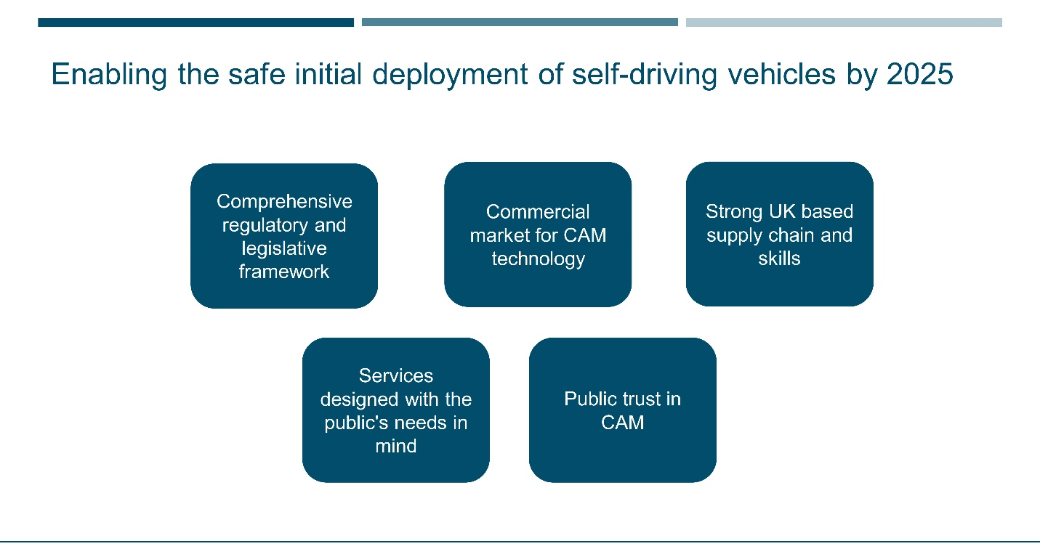
The original roadmap targeted 2018/2019, but an updated review established 2024-2026 as the goal – when they would start to see movement – and this resulted in the 2025 target date.
Evolution vs Revolution – lorry/delivery vehicles will be first. Robotaxis could have big benefits but how early? TBD.

TECHNOLOGY and INSTITUTIONAL
Presentations from the DfT’s connected vehicle program explained that they have done several CV-related pilots similar to what we’ve done in the US, but more recently have decided that a hybrid approach (Wi-Fi and Cellular) is very effective. People liked the services we provided but don’t want to pay extra for them. They also preferred to get integrated into existing platforms like smart phones and navigation services. Bottom line: lots of potential benefits but scale and duration often limited the impacts during the pilots.
Have established their terminology:
- ITS – broadcast
- C-ITS – cooperative, data flows both ways
They have tried to “nudge” broader data sharing with the OEMs but don’t know if it will eventually require legislation. If you buy a vehicle today it is already sharing data with its manufacturer – so what is the government’s role and how can we broaden that sharing?
Noted that data quality is an issue, but don’t have it solved yet. The data for road safety project was a good example of collaboration but will be a long time before they can retire their roadside sensors.
UK government’s high-level commitment to end of hydro-carbon fueled vehicles and net zero includes recognition that connected vehicles will be central to achieving this.
In the UK there are many different organizations responsible for the road network making it a very complex picture:
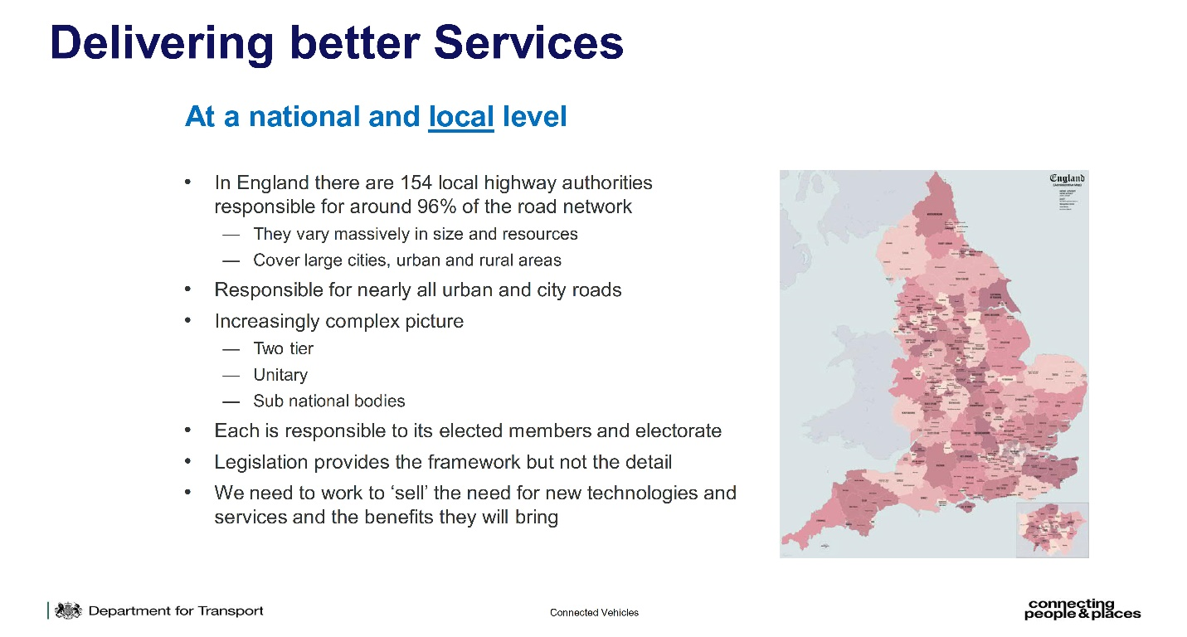
DfT role focused on delivering better services –
- Providing guidance – business case development, procurement support, cybersecurity, knowledge and experience exchange
- Setting standards – national access point, national parking platform, alliance for parking data standard, digital traffic regulation orders, digital traffic signal controller standards, growing existing equipment and software standards
National Highways Agency manages over 4,300 miles of motorways and major roads in England known as the strategic road network. They too have been engaged in a number of CV pilot programs, and have developed a connected services roadmap focused on looking at all levels/types of data and trying to put “as much info out as possible.”
In recognition of the short-range technology debate (ITSG5 vs C-V2X) they have focused more recently on regular cellular services for now.
National Highways Agency had their own app for travel information and data but decommissioned it recently in favor of simply putting out good data and allowing private companies to do what they do best – service customers. They have a digital roads strategy and customer service strategy with a roadmap that has progressed through the planning stages; expecting to “put a digital spade in the ground” in Jan 2023 and build the ecosystem within two years for enhanced data sharing and distribution.
Another big agency is TfL, who has a very aggressive data sharing program in place. Have built their own ecosystem for sharing construction data, bus AVL data, static info, CCTV/ANPR data – for the signals they control, can make adjustments in real-time based on all the data. TFL looks to create a “data community” that everyone can contribute to the ecosystem, but it’s broader than just CAVs and includes data that can have impacts on all elements of their operation:
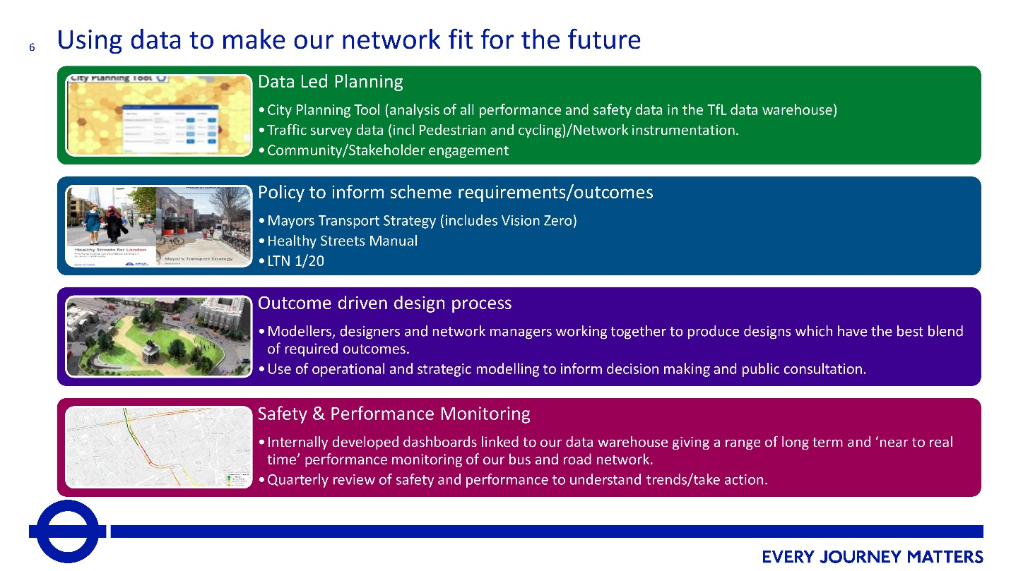

LEGISLATION and INSTITUTIONAL
An important part of the UK’s program is to develop a clear regulatory framework. Originally tried to do testing with minimal regulation but updated in 2019 to refine data collection and communication with government – but still tried to stay advisory. They’ve now reached the time for really advanced trials (including starting to remove the safety operator), which lead to a review of “what’s next? and a 2021 Code of Practice for AV trailing report released by the CCAV.
Earlier this year (2022) the Law Commission Review released 75 recommendations, and DfT must respond to them. Some of the key outputs included:
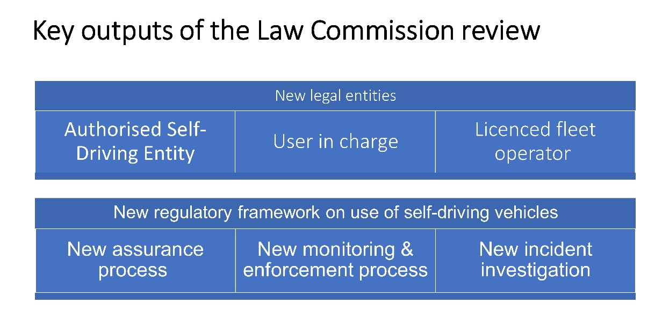
The new regulatory framework must include 3 phases: vehicle approval, authorization, and in-use monitoring. In response to this the CCAV has launched its CAVPASS program – connected & automated vehicles: process for assuring safety and cybersecurity – to provide confidence that CAVs on UK roads are safe and to institute cross-department agency collaboration.

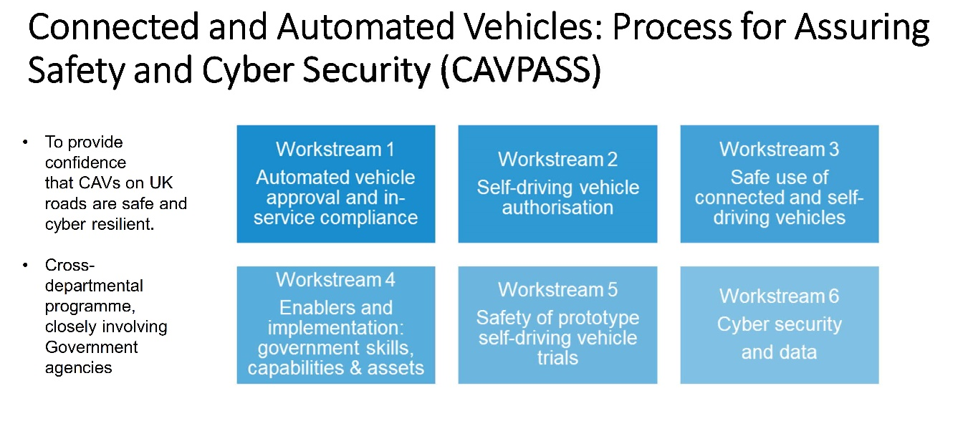

The CAVPASS program is driven by the 2025 deadline like the rest of the programs, recognizing that safety and security assurance process are necessary to enable CAVs and improve their road safety record in the UK.
A legislative framework provides opportunity for vehicles to be used on roads, subject to some standard safety and security reassurance for initial piloting phase with a safety driver in the vehicle – important to build on this to make sure that it was appropriate for now and going forward as based on older work.
- While policy and regulations are being developed elsewhere, we’re in a position to make the most of the being independent from the European Union to provide a framework that is right for the UK
- This approach also provides opportunities for the UK CAV industry to develop, with the opportunity to engage with the sector to inform policy and regulation development to make sure the final outcome in 2025 is the right one
- Links to next stage in working with organsiations in terms of what’s needed for them to operate trails and understand when may be needed for future regulation
Once again their approach is more than just technology, but incorporates commercialization and consumer sentiments.
Expecting a bill this Fall for the first round of legislation (expect it will require several rounds).
They are engaging the insurance industry in these early conversations as well. There is an Automated Driving Insurance Group and DfT has some seats on that group. Many of the answers still not there yet – how often can courts intervene and redefine definitions? Nobody has remotely drive a car down a motorway, crashed it, and bee taken to court – don’t know how it will play out.
Focus for now is to look at causation of crashes – was it the vehicle or software? Working closely with the law commission to anticipate requiring vehicles stay within legal limits (i.e., can’t be programmed to speed).

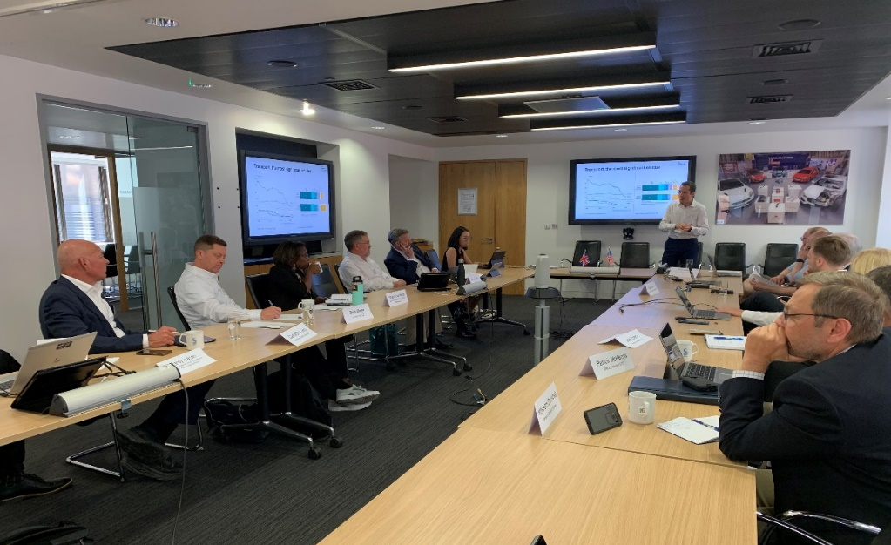

TECHNOLOGY & STANDARDS
International and national standards are very important – they help codify knowledge, reduce the variety of options, define minimum levels of quality, and support interoperability. But they can also regularly take 5 years to develop/publish. The UK has developed a PAS process – publicly available specification – that can be done in about 1 year.
“Fast-track standardization allows the UK to stay agile to CAM technology development whilst ensuring CAM safety and security are prioritized throughout, with right-size oversight from government.”
They have also further developed a Flex option, which is a method for developing consensus-based good practice that can be created in just a few weeks or months and can be iterated rapidly.
Current catalog includes:
- PAS 1880 - Developing and Assessing Control Systems for Automated Vehicles
- PAS 1881 - Assuring the operational safety of automated vehicles
- PAS 1882 - Data collection and management for automated vehicle trials for the purpose of incident investigation
- PAS 1883 - Operational Design Domain taxonomy for an automated driving system
- PAS 1884 - Safety operators in automated vehicle testing and trialling
- PAS 1885 - The fundamental principles of automotive cyber security.
- Flex 1890 - CAV Vocabulary
- Flex 1889 – Natural Language description for Abstract Scenarios for ADS
British Standards Institute (BSI) is heavily engaged. There has been plenty of input to the PAS and FLEX standards and they believe this has accelerated efforts in the UK.
Most standards are not called into laws given the timeframe for legislation and standards to both evolve.
PAS/FLEX – what can we do now?
Regular Standards – what can we do for the future?

Day 2 - Tuesday
Day 2 began with one more session that couldn’t be squeezed into the first day (due to availability of speakers), and then was heavily focused on testing and innovation.

POLICY, PEOPLE, and INSTITUTIONAL
Equity [still waiting for slide deck]
Equality Act of 2010 set the stage for much of the current policy: “public bodies have to consider all individuals when carrying out their day-to-day work – in shaping policy, in delivering services and in relation to their own employees.”

POLICY, PEOPLE, and INSTITUTIONAL
Social Behavioral Research
Different methods and reasons for engaging with the public: research, education, and behavioral change.
Have conducted deliberative research to get more in-depth insight; in some instances, have gone back to the same group over an extended period of time (using both on-line and face2face) – surveys, focus groups, cognitive testing
Looking into attitudes toward CAVs – 10 days/each, grouping people based on where they live – safety was apparently a concern. Trying to discern what information has the most impact on the views of CAV safety and society. Also doing research into MaaS and responses to “nudges” or incentives; exploring attitudes toward shared mobility more generally; and attitudes toward data sharing including assurances needed for public trust and how they can be communicated.
Currently developing a resource pack for ALKS education (automated lane keeping system). Expecting that this will be on the roads later this year as automakers add more and more ADAS into vehicles.
The Great Self-Driving Exploration was a large-scale project to more thoroughly explore attitudes and included geographical areas where people haven’t been talked to yet. Included combination of demos and traditional surveys/focus groups.
Once given the opportunity to try the tech (and talk to experts both virtually and in-person), measured feedback from deep exposure to one-time exposure. This helps them also develop additional driver training and education materials as well as influencing the ALKS training, education, and regulation.
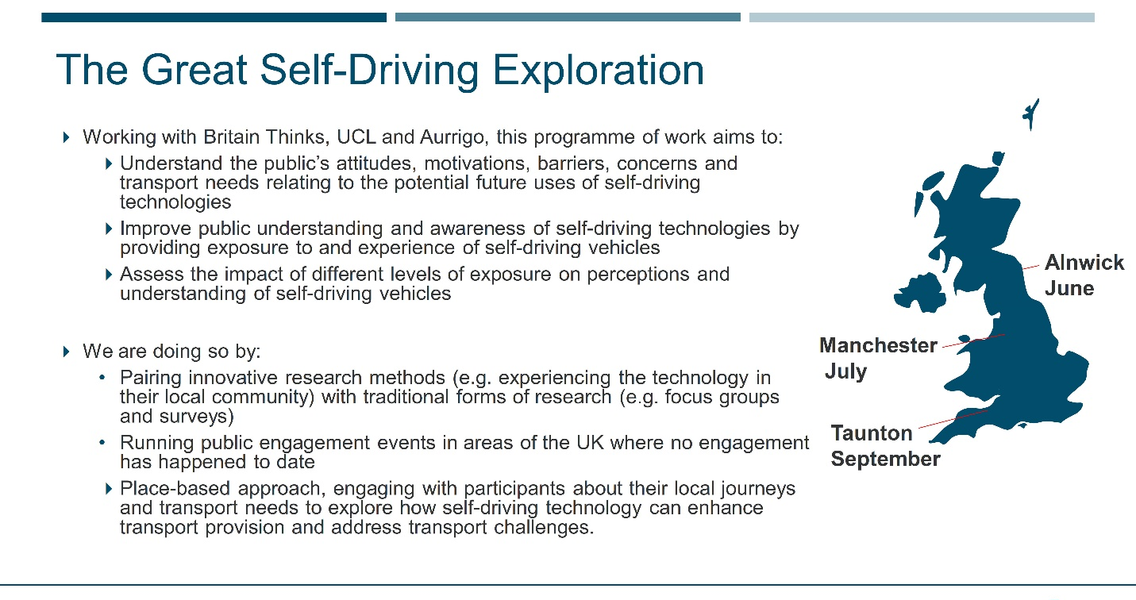
Can now have evidence-based recommendations about knowledge and capabilities, enable policy, develop behavioral interventions if needed, and ensure needs of ALL are embedded into future decisions.
For many of our panelists there was recognition that too often we focus on the tech whereas this is an important focus on the people.
DfT acknowledges that it’s hard to be regulated nationally but implemented locally if you haven’t done this kind of research. Context is key, wouldn’t have the same impact 5 years ago – and will evolve 5 years from now.

TECHNOLOGY, PARTNERSHIPS, and INSTITUTIONAL
Tour of SMLL
The Smart Mobility Living Lab [link] includes two different test locations – one with older roads and congestion, one with newer roads around Olympic Park.
SMLL used a £20M grant to install infrastructure along the two different routes that include fiber network, mesh network, cameras and detectors, and even an ITS-G5 network (DSRC). They even have a particulate matter sensor and are doing some resource-sharing with the conduits for fiber. Some of the funds were also used to outfit vans that can be used for ground-truth validation of sensors, cameras, LiDAR, etc.
SMLL run by TRL which used to be public but is now privately owned and operated (with some government contracts still). Because of the government investment in infrastructure, SMLL can now use the facilities to not only support CCAV-sponsored testing but can work with private companies to test various roadside devices, vehicle-based sensors, and coordination between the two. These are now testbeds integrated into live-traffic situations.
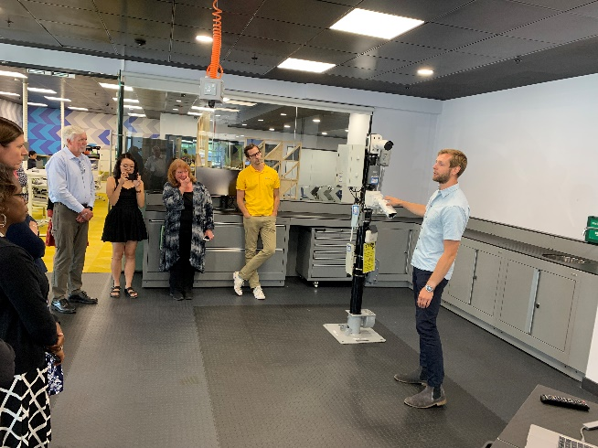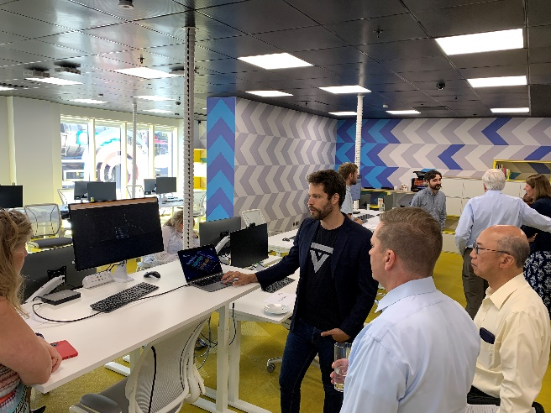
We also had individual round-robin meetings with individual companies:
Admiral Insurance – international insurance firm (some in TX – Elephant Insurance). 17% market share in the UK. They are taking Ford vehicle data and learning from it – using a telematics plug-in device, have learned a lot over the past 10 years. Insurance in the UK is regulated in terms of what data is allowed to be collected and how (opt-in only), and how they process it is also regulated. Don’t have actual data for AVs yet, but they know a lot about cars, what changes in this case is the driver. So they are now in the process of learning from some data to build out models that will eventually affect pricing for ADS – right now its still experimental. Questions remain about liability – if a driver not in charge, can’t be liable – if the vehicle is in AV mode, then what was the cause? Still reasonable straight forward except who is the other party and what was their role in the crash? Personal liability vs tort liability – diversification helps. How can insurance companies survive with fewer crashes: if cars safer they’re not engaging with customers as much and their expenses go down.
Valerann – looking to create trust in the data by offering traffic management software as well as traffic data service offerings. Hoping to enable incident response based on the data, there is often a trust-gap with the TMC operators. Their service allows you to select levels of automation with the software – decision support vs decision support + taking actions. Can set thresholds based on various inputs – flexible solution. Data cleaning – don’t throw it away, just classify thresholds of confidence with the data. Also exploring pattern recognition and expert systems.
Humanising Autonomy - Connects to any CCTV and allows prediction of human behavior – will they dart out into the road? What is their eye movements, posture, position. Protects PII, includes video storage/sharing. Can help with urban planning. Currently doing a project in NYC with trucks and is activated when they activate their turn signals.
Appyway - Most apps give good navigation, but not enough destination info – curbside, parking, etc. With this the local authority can manage their inputs and get data back – its like air traffic control for a city. Pilot with a delivery service, reduced failed delivery attempts by 30%. Can take data from vehicles, knows where parking is from infrastructure. Is built on a platform from an existing app with over 100K users, this new one is still growing. Can also match EV charging stations to parking history and can partner to add charging locations.

Day 3 - Wednesday
On Day 3 our theme was testing and verification. We had several opportunities to learn more about CAM testing facilities and visit a university with an extensive industry-oriented department supporting a broad range of research, testing, and development.

TECHNOLOGY, PARTNERSHIPS, and INSTITUTIONAL
Visit to Horiba Mira – large scale testing for automotive, part of the Horiba group with more than 40 major capital facilities worldwide. Instead of OEMs using their own, can utilized the Horiba test services business (note: most OEMs do have their own, but can’t always test in all conditions in all locations at all times, so this business is a supplement).
HM also does engineering and consulting, supporting new product development, problem solving, and strategy.
The Horiba Mira facility is also a technology park, enabling customers to have offices in their campuses. They have over 50 customers co-located in the industrial park – almost like a technology incubator.
Milking Stool Approach: (1) simulation & modeling to understand the pain points of a design, (2) controlled environment to test reproducible situations, and (3) on-road testing to finalize the acceptance.
While their facility comes with a digital twin, many OEMs are still mapping it out for themselves – similar issue we’ve encountered in the US.
The OEMs in the UK don’t have as extensive of proving grounds like many of the US OEMs do, so they rely heavily on HM for everything from emissions testing, CAV, attribute engineering, durability, chassis, and cybersecurity evaluation.
Their facilities cannot be viewed by those outside the site, work in a very confidential way with customers.
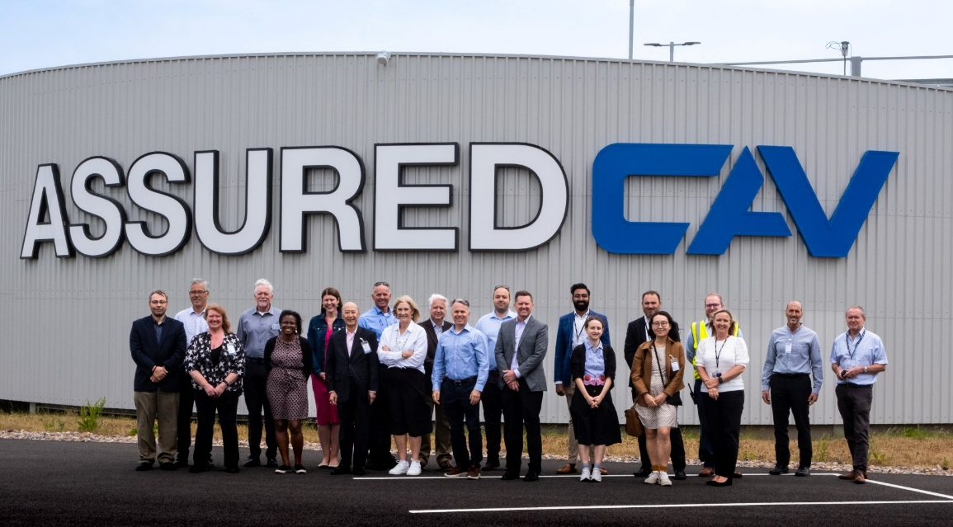

TECHNOLOGY, PARTNERSHIPS, and INSTITUTIONAL
The Warwick Manufacturing Group (WMG) is a department within the University of Warwick solely focused driving innovation in partnership with the private sector. Not only is there a big research group housed within WMG, but also a heavy emphasis on skills/education (massive post-grad program). WMG is huge - close to 800 employees. Part of WMG is the National Automotive Innovation Centre, focused on mobility innovation. Here is a good YouTube video demonstrating their focus.
[still waiting for slide deck]
“Safety shouldn’t be used to differentiate” – similar quote we’ve heard throughout our scan tour
WMG is different from other UK universities in that they don’t do many business spin-offs, and instead cater their services to business as a support/consult mechanism.

ORGANIZATIONAL READINESS, PARTNERSHIPS, and INSTITUTIONAL
Transport for West Midlands
[still waiting for slide deck]
Looked at a 3-point effort to
- Avoid – reduce driving
- Shift – focus on safety
- Improve – electrification
63% of citizens in the West Midlands make their journey with a car, despite having a robust bus network
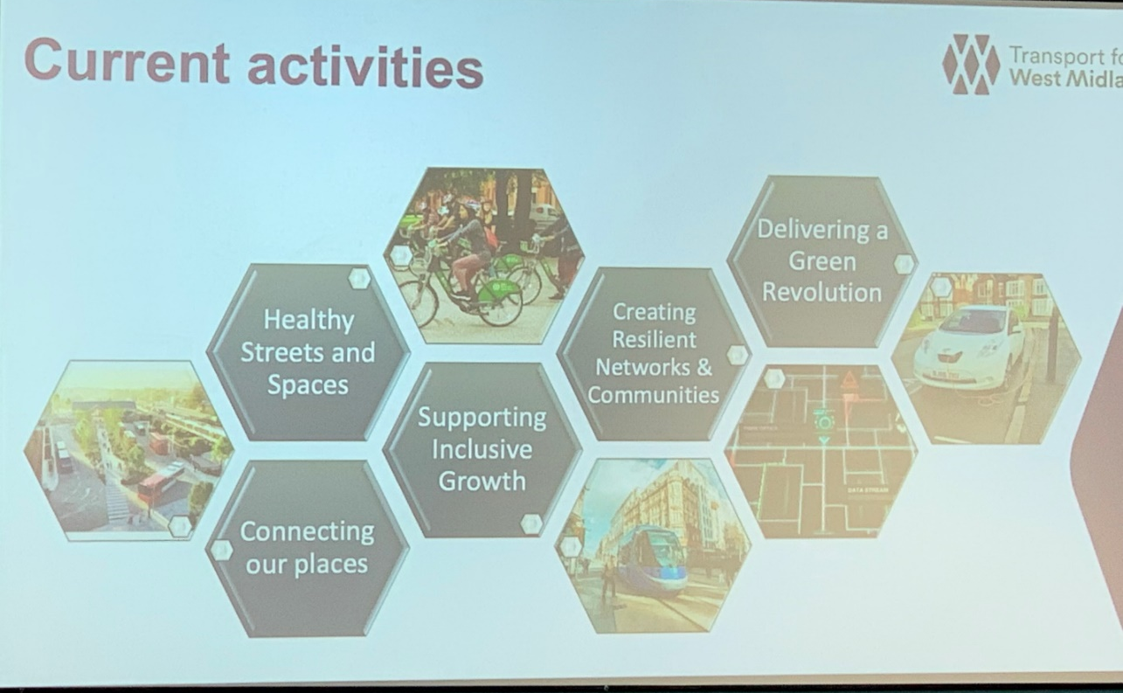

They support a CAM testbed, a 5G testbed, and Mobility Hubs within WM.
Aurrigo shuttles, pods, airside vehicles – partnered with WMG for immersive 3D simulation expertise using their own AVs. Currently working on baggage handling use case.

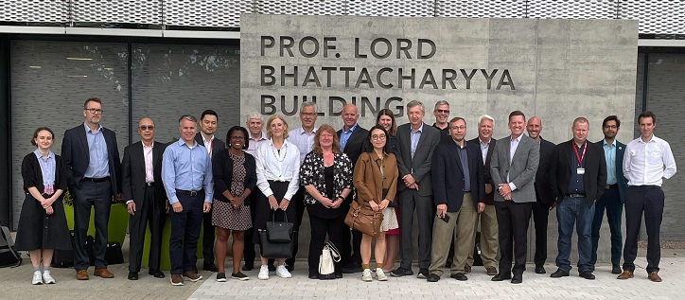

PARTNERSHIPS and VISION
In 2016 CCAV put out an RFP to focus on developing a UK Testing Ecosystem for CAVs – winning team evolved into Zenzic. What started as just a testing collaboration expanded to include insights, innovation, collaboration – and is jointly funded by government and industry. It is focused on high-value high-impact issues.
Zenzic developed a CAV Roadmap for 2040 that was built through input from more than 200 organizations and 300 individuals. “the roadmap highlights significant challenges that require cross industry support such as cyber resilience, use of simulation environments, sign-off and type approval, and in-use compliance … Connected and Automated Mobility is the future and the roadmap provides a direction and a well ordered set of critical enablers.” Ford Motor Company
It’s important to note that the UK Government was part of the Roadmap development but it’s not an official government document – it is a consensus doc from government and industry.
Zenzic now has 3 pillars:
- CAM Testbed UK – building on collective test and development capability of the UK
- CAM Scale-Up – design to accelerate start-ups and disruptors entering the CAM sector
- CAM supply chain – joint invest to enable the commercialization of CAM at scale
CAM Testbed is six different sites doing complementary testing.
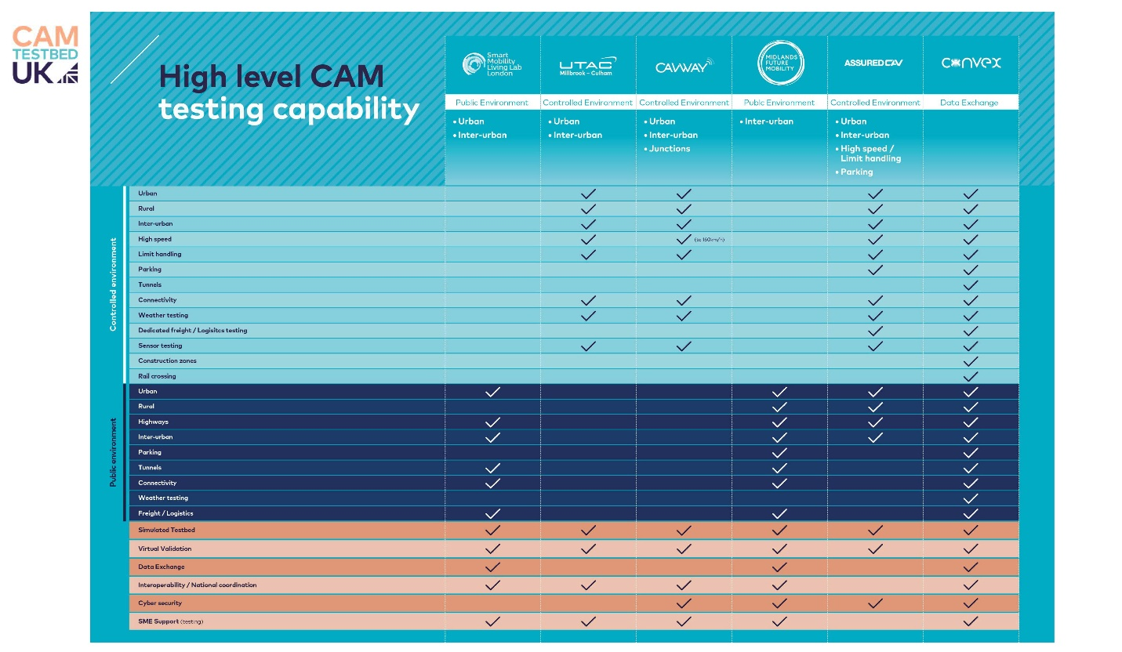
CAM Scale-Up is like an incubator, helps start-up and SME participants develop innovative CAM solutions. The CAM Scale-Up offers more than just some seed funding –
- Access to CAM Testbeds
- A stage for investments/investors
- SME help/guidance
- Corporate partner program to help with launching products
A community perspective for low-risk R&D pipeline of emerging start-ups and SMEs, opening opportunities to explore innovative solutions and growth to commercialization
CAM Supply Chain is focused on moving from a CAM ecosystem to a CAM supply chain.
Safety Pool Scenario Database – Zenzic is building a database to help deepen their AI capabilities. Will be the world’s largest public scenario database [need slides]
Question: without government funding would Zenzic had formed? Answer: no (from all)

Day 4 - Thursday
Our final day of the trip was centered in Oxford. We continued our CAM Testing theme for part of the morning, visiting another Zenzic coordinated test site – then transition into more of a research focus for the afternoon at the University of Oxford.

TECHNOLOGY, PARTNERSHIPS & VISION
The UTAC Millbrook-Culham testing site is part of the Zenzic consortium of test facilities – mix of public and private funds. Lots of experimenting going from closed test course to open roads – and in doing so have worked a lot with oxford county council to use public roads.
RACE – Remote Applications in Challenging Environments
Robots pass through an environment – either carry things or sensing the environment – that is mobility
UK innovation philosophy: don’t wait for money to turn up, start doing things and money will come.
Culham Harwell Mobility living lab (CHARM) – a regional area allowing different mobility use cases and testing, learning about benefits to society rather than just technology for technology’s sake
When they do engage with the public, they make sure and do it scientifically – social engagement is critical. Aurrigo did a project with wounded vets, learned that guide dogs didn’t always like the AV tech and had to explore solutions.
Culham provides a challenging environment for testing, doing safety driver training, simulating many different radio scenarios, interface with trains, etc.
Having a high-end laptop is nice – but you connect a bunch together and you get real value. The more we share, the more intelligence we have. If you have to do it yourself you’ll spend a lot of money – if you collaborate you can advance significantly
“If you have a robot with wheels, you have a self-driving car; if you add a SIM card, you now have a mobility solution” – Gary Staunton
Currently planning an AV bus shuttle to the train station and it will circulate around the RACE campus – good use case.

ORANIZATIONAL READINESS and PARTNERSHIPS
Oxfordshire – Llewelyn Morgan, head of innovation with Oxfordshire County Council
[still waiting for slide deck]
Have had an innovation interest for 5-6 years, and happily provide a living lab for transport innovation.
Built a mobility roadmap but have to be flexible with disruptive strategies.
Philosophy for transportation planning includes predict & provide, Decide & provide, and Iterate & adapt. Have also considered economic development as part of their efforts.
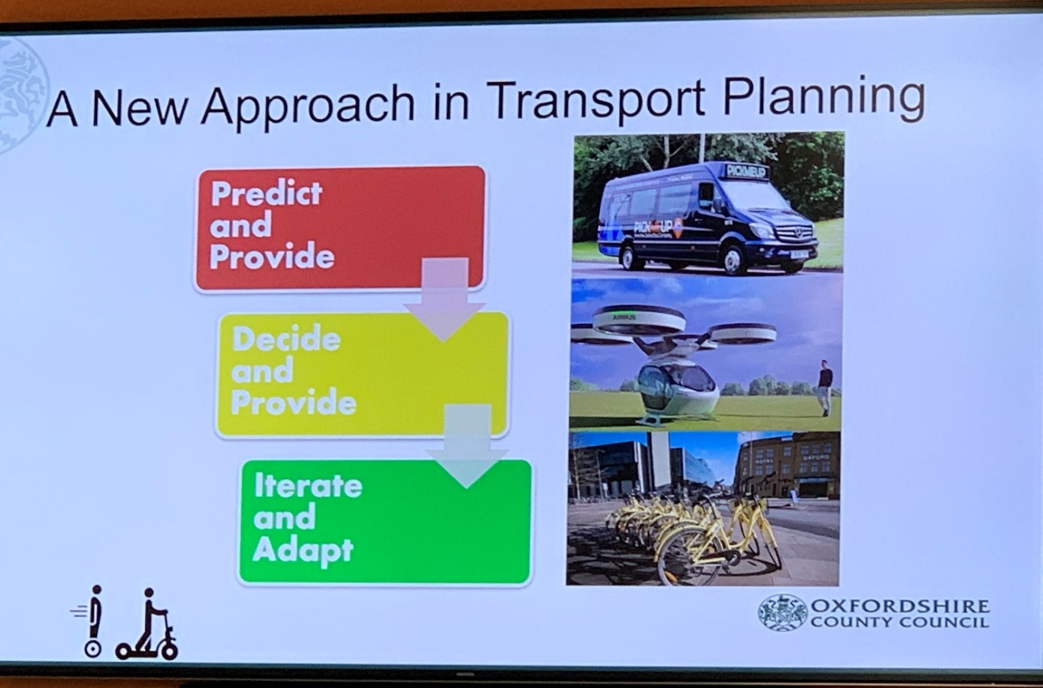

Oxfordshire worked closely with the CCAV, DfT, Law Commission, locals, and the private sector – similar to some of the active counties in the US (like Maricopa and Oakland).
They have an expression of interest link on their website to welcome interest. [link]
They do have some exclusion zones for testing such as around hsopitals – don’t want to interfere with ambulances.
15 companies involved or testing in Oxfordshire – also keeping aware of automation in agriculture as well.
A couple of years ago ran a competition – got a government grant to fund private innovation for data fusion on highways - https://apply-for-innovation-funding.service.gov.uk/competition/328/overview. From that grant worked with Aimsun/Siemens to develop a predictive data engine including network management, adjusting signals ,ect - https://www.aimsun.com/articles/oxfordshire-using-real-time-traffic-simulation-to-reduce-congestion-and-emissions/

TECHNOLOGY
Oxbotica - Main product is the software and emphasize a B2B delivery
Simulation a big part of their work
Have a common sled bottom, can add anything on top of it – shuttles, grocery delivery (with Ocado), industrial
Working with Ocado (UK based online grocery fulfillment company that is also aligned with Kroger in the US) for AV grocery delivery. Still in development but 2025 commercialization expected.
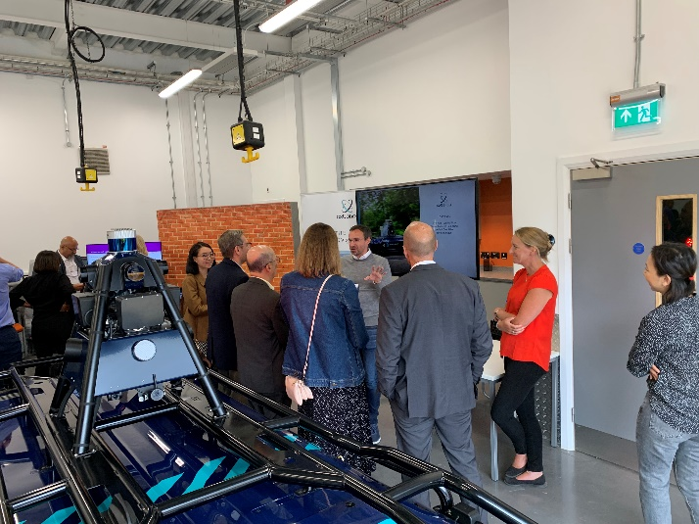
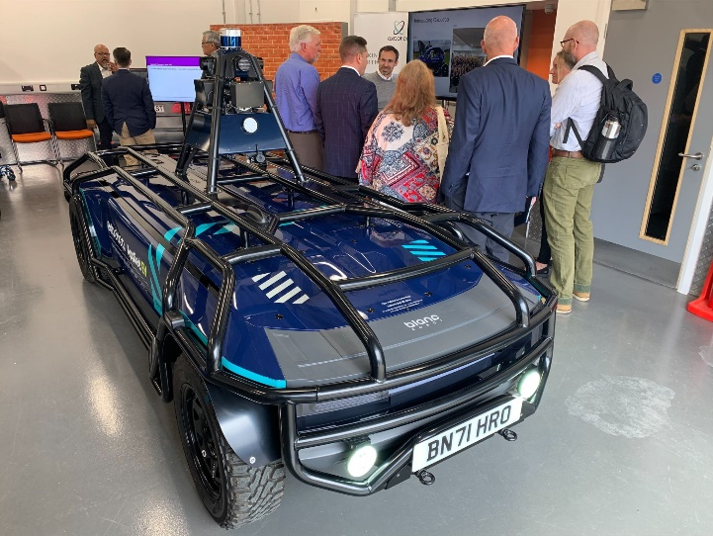

Oxford University
Sebastian – CCS – combined charging system – if comms to charger gets interrupted, the charging stops
Cable is an unintentional antenna – shielding helps, but doesn’t prevent re-authentication.

Supplemental Information
Follow-up conversations about CCAV
- Previous focus of UK government = test beds; next phase of UK government = commercialization
- Starting a pilot soon, ahead of the 2025 regulation expected. Pilot includes customer interactions.
Phase two of CCAV’s roadmap is now on the clock. Phase 1 was focused on coordinating the testbeds and getting the regulatory process in motion. Phase 2 will be focused on larger-scale early-deployment programs that demonstrate commercialization of CAM.
** In strand 1 of the competition, a proposal must target early commercial self-driving vehicle opportunities and support the UK supply chain to grow and fill technology gaps necessary for their deployment. They have allocated up to £41.5 million to fund industrial research and experimental development projects in this strand. The advertisement closed in mid-August. https://apply-for-innovation-funding.service.gov.uk/competition/1179/overview
** In strand 2 of the competition, a proposal must identify applications and quantify the real-life potential of Connected and Automated Mobility (CAM) as a mass transit solution. They have allocated up to £1.5 million to fund feasibility study projects in this strand. The advertisement for this closed in July, but information can be found here: https://apply-for-innovation-funding.service.gov.uk/competition/1178/overview

Debrief Meeting with the Panel
Asked each panel member to discuss what they saw as value added, few nuggets, top 2 or 3 observations from the trip

Victoria Sheehan
- Self-certification – in the US states license and inspect vehicles but NHTSA establishes the certification, we need stronger relationships with NHTSA for AVs – in the UK there is a stronger tie between government agencies responsible for vehicle design and vehicle inspection.
- There has been impressive collaboration across government here in the UK – everyone needs/wants to use 5G and they are coordinating quite effectively toward it
- The UK has done a good job identifying and documenting their ultimate goals for CAM – what problems are you solving, what is the technology for?

King Gee
- Collaboration between the public and private sectors here in the UK, along with between DfT and counties – is very strong. Lots of different consortia – perhaps similar to the IAM we saw in Phoenix or Drive Ohio – we’re 50 states, how can we scale this so it works in the US?
- Collaboration with BAES – our DOT is working a little bit with DOE, but not much with Commerce – we can learn from the UK example
- Evolution of the CAT Coalition – should be informed based on things we’ve learned here in the UK

Shante Hastings
- They have a great focus on People and Customers
- They have a great focus on leading at the government level, not just hoping industry will figure it out
- They have a strong focus on economic benefits
- They have a very clear vision that is communicated and understood by all the potential stakeholders

Julie Lorenz
- Its more cost effective if we can SEE the benefits
- Connecting the social side with the physical side is critical – we do a disservice when we turn this into a choice, it can (and should) be both.
- Vision – think about the moonshot/AASHTO project and how it could be informed by this trip, how the strategy might evolve. The 50 states working together is very powerful.

Patrick McKenna
- Automation can help with safety IF we move away from bias in development – lessons learned from the makers of the test dummies here who hadn’t considered skin tone or clothing types – standards and best practices should consider that up fron during the development process. Maybe we should contact standard setting groups so we don’t go through development get unintended consequences
- Cooperation and collaboration here shows how it can be done – can we do it like this in the US? Might take some experimentation, but if we have a will to achieve, we have a better chance.
- Notion of favoring action before funding is interesting – you learn nothing when standing still

Roger Millar
- Nice to peak above the modal silo once in a while, and remember ITS is bigger than just highways – need to make sure CAT Coalition and Moonshot are doing the same
- Biggest value CAV can have in rural and small towns – we can’t afford to run transit to rural, government may have to intervene
- There will be disruptors – they had a congesting pricing strategy and a disruptor (Uber) killed it pretty quickly – can these technologies grow transportation of stuff and manufacturing of stuff?

Carlos Braceras
- Crack-on/move-on – they are intentional about what they are doing – a feeling of “we’re the small guys and we need to get together to be successful.” Some economic concerns behind their efforts, but it has some pretty strong potential outcomes from this focus.
- Here they approve before testing – government will never have the ability to keep up with evolution – maybe its an allocation of risk issue? The risk model needs review in the US to allow operating in public spaces.
- Roadmap a great idea – should it be initiated by government. There hasn’t been an overall assessment of what’s going on across the US – having some sense of development, testing, operating nationwide would be a big help.
- Philosophy of all these differences thriving people is attracting – slide from the local guy was great – innovative friendly environment

Randy Iwasaki
- Use technology to address user-problems – CCTA/GoMentum was a great place to fail in private – don’t design tech for a shiny object
- Liked the Oxfordshire modeling effort – picked air quality as an important benefit, worried about their kids
- There is more than one agency that needs to think about bias in targets/ISO standards

Tracy Larkin-Thomason
- Vision, national perspective is strong here – need regional brought in to determine their roles
- Data transfer, sensor fusion, all important – especially as we consider multiple sectors and modes
- The end user, social engineering, technology soliving problems – their approach of how to best integrate and adopt new technology is fresh

John Corbin
- Accountability - some evolving way that FHWA and JPO can work better, as well as with NHTSA – is necessary
- Urgency – other international scans made something happen quickly – this terrain mapping exercise is important
- Gratitude – have a much better appreciation and understanding of the urgency that FHWA is involved in this

Scott Marler
- Dramatically impressed with level of cooperation across so many sectors – yes we have complexity in the US, but we still can do better and learn from this
- We need a roadmap/national strategy – identify the gaps – they’ve illustrated the power of that
- We need an equivalent of Zenzic – don’t need more test beds, but need more coordination
- Greatest opportunity to advance = regulations and legislation – its powerful and we probably have an undertone of gravitas that is diminishing our energy

Waseem Dekalbab
- This is a great way to take advantage of TRB and NCHRP to help advance this
- BIL will have more money in NCHRP which could mean more opportunities
- We have 7 CEOs here, how can we better inform the rest of the CEO’s – maybe through Insights or Events?

Steve Kuciemba
- In the US we have a national focus on research and development but fall short on regulations and commercialization. A few states (e.g., Michigan and Florida) have been successful with both legislation and commercialization – and maybe not surprisingly they are leaders. We need more emphasis on commercialization at the national level.
- They have a lot of testbeds – we have a lot of testbeds. They have strong government-led coordination across the testbeds, we have no coordination. Gap needs filling.
- They have paused their direct CV communications efforts but have accelerated looking at other communications outside of using dedicated spectrum. Similar to the US. We all need to coordinate better on this, but also learn from Europe and Japan who have strong direct communication efforts underway. We have no federal/national leadership on CV/V2X and we need it.

Group Discussion
- How did SHRP start? Might be lessons to learn from this.
- How can transportation help all users?
- Collaborative, impactful research pays dividends
- We need that scale for everything we talked about this week.
- Zenzic – let’s not reinvent things, let’s fill gaps, share knowledge
- International collaboration on safety case makes sense
- Start with vision and then be more intentional
- Can’t just wait for tech companies, need to engage now
- Awareness, alignment, collaboration, facilitation, leadership – all important
- This report won’t have actions but will have observations. And we as people are involved in a lot of parallel activities like the CAT Coalition, ITSA, etc – we have forums for this conversation.
- We have places where we can take what we’ve done and instigate action.
- Zenzic was seeded by all these groups financially and let go on their own for some of it – independence, not just a DOT driven enterprise now
- Terrain map, moonshot, very different focus
- Grants and funding focused on iteration and adaption – need multimodal vision and map

