NCHRP 20-24(128)
State of the Art Review of Cooperative Automated Transportation Systems

Summary of Observations

Prepared for
National Cooperative Highway Research Program
Transportation Research Board
of
The National Academies of Sciences, Engineering and Medicine

The information contained in this report was prepared as part of NCHRP Project 20-24(128), National Cooperative Highway Research Program.
SPECIAL NOTE: This report IS NOT an official publication of the National Cooperative Highway Research Program, Transportation Research Board, National Research Council, or The National Academies.

Prepared By:

Steve Kuciemba
WSP USA
Baltimore, MD

30 September 2022

Table of Contents

Executive Summary 3
Background and Key Activities 4
Panel 4
Timeline 4
Key Deliverables 5
Additional Deliverables 5
Key Observations 7
Vision 7
Organizational Readiness 8
Partnerships 10
Technology 11
Institutional Issues 12
Data 13
People 14
Sample of Photos from Scan Tours 16

Executive Summary
The objective of NCHRP 20-24(128) was to document and disseminate lessons learned from Cooperative Automated Transportation (CAT) system deployments (both domestic and international) that can have immediate benefit to State DOT executive leaders. The project began in mid-2019 with an expectation of doing 3 domestic and 1 international scan tours, but the unexpected global pandemic with COVID-19 changed the approach for this project to be virtual during that period. As we drew to a conclusion, more in-person meetings resumed, and in total we held more than 150 conversations with infrastructure owners & operators, technology vendors, automotive companies, consultants, educators, and researchers.
A key outcome from the first two years was recognition that lack of national vision for CAT was a significant gap. Discussions within our panel ensued after several virtual scan meetings, and ultimately contributed to an AASHTO/NCHRP initiative that is exploring the need for a national vision for future transportation innovation. These conversations also contributed to workshop discussions focused on developing the next generation of the CAT Coalition, a group of public, private, and academic stakeholders focused on advancing the deployment of CAT technology and services nationally.
A list of key observations was made throughout the duration of the project and was captured as “rolling trends” on a website available only to panel members. However, these rolling trends also provided instant talking points as the panel continued to meet with stakeholders, gave presentations during organized conferences, and in general advanced the state-of-practice within their own agencies.
While the lessons learned and observations cut across many technical and policy areas, the panel centered on 7 key areas for focus:

- Vision
- Organizational Readiness
- Partnerships
- Technology & Planning
- Institutional Issues
- Data
- People

It was the last category – people – that emerged the strongest during the latter part of the project as a key focus of conversation and will inspire additional research in the coming months and years.
The observations from these scan tours were intended to help support and promote cooperation between infrastructure owners & operators (IOOs) and the private sector to ensure mutually beneficial outcomes with public safety being the primary goal. As a measure of success in that area, several panel members have sought follow-up conversations with contacts made during these visits and virtual conversations. This has proven not only important for individual agencies looking to advance their own programs, but valuable in expanding their awareness of opportunities that might not have existed were it not for the knowledge gained during these meetings.
An important element of this project was also to share their observations more broadly with other State & Local DOT CEOs – as well as the rest of the industry and key stakeholders. And as another measure of success, there were meetings and presentations across a broad array of other organizations, conferences & meetings, and written materials made available to help spread the messages and lessons learned from this effort.

Background and Key Activities
NCHRP 20-24(128) began in mid-2019 with a simple scope: an 18-month effort expected to execute 3 domestic and 1 international scan tours. The objective was to document and disseminate lessons learned from Cooperative Automated Transportation (CAT) system deployments (both domestic and international) that can have immediate benefit to State DOT executive leaders.
The observations from these scan tours were intended to help support and promote cooperation between infrastructure owners & operators (IOOs) and the private sector to ensure mutually beneficial outcomes with public safety being the primary goal.
The unexpected global pandemic with COVID-19 changed the approach for this project dramatically during 2020 and 2021. We made adjustments during the lock-downs and learned how to be virtual, and more importantly we evolved with the industry – turning this into a three-year hybrid experience that encompassed more than 150 conversations with infrastructure owners & operators, technology vendors, automotive companies, consultants, educators, and researchers.

Panel
Our panel is made up primarily of State & Local DOT CEOs. They purposefully represented agencies at different stages of engagement in the connected & automated vehicle space. Some are just starting, while others have been “in the game” for a few years. Each of the CEOs also look at this issue from different angles – some ascending through the ranks of their organizations as planners or engineers – while others came in from outside organizations and brought their own backgrounds and knowledge to bear. Complementing the CEOs were several additional industry experts, representing key associations and organizations that are vital to the future of CAV.
Scott Marler, Panel Chair | Director, Iowa DOT
Carlos Braceras | Executive Director, Utah DOT
Shante Hastings | Deputy Secretary & Chief Engineer, Delaware DOT
Russell McMurry | Commissioner, Georgia DOT
Jennifer Toth | Director, Maricopa Co (AZ)
Patrick McKenna | Director, Missouri DOT
Roger Millar | Secretary, Washington DOT
Julie Lorenz | Secretary, Kansas DOT
Victoria Sheehan | Commissioner, New Hampshire DOT
Randy Iwasaki | Amazon (former CCTA and Caltrans Director)
John Corbin | FHWA
Tracy Larkin-Thomason | ITS America (Former Nevada DOT Deputy Director)
King Gee | AASHTO
Gummada Murthy | AASHTO
Waseem Dekalbab | NCHRP Staff
Steve Kuciemba | WSP USA (contractor)

Timeline
- June 2019 - Dec 2019: In-Person Scans
- Jan 2020 - Aug 2021: Virtual Scans
- Oct 2021 – Sept 2022 - In-Person Scans

Key Deliverables
The core focus of this project was to gain knowledge through scan tours, so naturally the key deliverables for this effort included the planning, organization, and execution of both in-person and virtual scan tours.

Scan Tours (in-person)

Las Vegas | Aptiv, City of Las Vegas, Keolis, Nevada DOT, Regional Transportation Commission for Southern Nevada (RTC), WayCare
Phoenix | Arizona Commerce Authority, Arizona DOT, Caltrans, City of Chandler, City of Scottsdale, City of Tempe, Exponent, Intel, Local Motors, Maricopa Association of Governments, Maricopa County DOT, State Farm, TuSimple, University of Arizona, Utah DOT, Waymo
Hamburg, Germany | ITS World Congress 2021 - sessions, exhibition, tours  L3 Pilot (Europe) - Volkswagen, Aptiv, Argo AI, BMW, Ford, Toyota, University of Leeds, Würzburg Institute for Traffic Science  Connekt (Netherlands) - Rijkswaterstaat, Connekt staff, National Road Data Warehouse
England (UK) | UK Department for Transport, National Highways Agency, Transport for London, Transport for West Midlands, Oxfordshire County Council, Admiral Insurance, Appyway, Horiba Mira, Oxbotica, Valerann, UTAC, Zenzic, British Standards Institute, Smart Mobility Living Lab, Society of Motor Manufactuers & Traders, University of Oxford, University of Warwick

Scan Tours (virtual)

Private Companies | Argo AI (Oct ‘20), Aurora (Aug ‘21), Beep (Nov ‘20), Cavnue (June ‘21), Cruise (Aug ‘20), FedEx (Mar ‘21), Gatik (Mar ‘21), Robotic Research (Aug ‘20)
Infrastructure Owners/Operators | City of Marysville, OH (Sept ‘20), Florida DOT (Nov ‘20), MetroPlan Orlando, FL (Sept ‘20), Oakland County, MI (Sept ‘20)
Academia & Subject Matter Experts | Richard Bishop (March ‘21), University of Florida (Nov ‘20)

Additional Deliverables
An important element of this project was to not only educate the 14 panel members, but to gather observations and share them more broadly with other State & Local DOT CEOs – as well as the rest of the industry and key stakeholders. Several additional deliverables were part of this project in response to that need to spread the knowledge more broadly.

Panel Meetings
The panel has met both virtually and in-person throughout the duration of this project, and in many instances, there has been important open dialogue concerning a broad range of issues. This panel has provided not only an outlet for these critical conversations, but a framework for understanding and categorizing key elements such as partnerships, readiness, technology, vision, policy, sustainability, and the international footprint in the CAT space.

Blog Articles
In an effort to share some of the messages gained during the COVID lock-downs, the panel expressed an interest in having strawman blog articles that individual members could re-brand and publish. Three different articles were crafted by contractor staff, with plans to continue this into 2022. ITS America published all three, while some individual panel members incorporated key messages in their own publications periodically.
- Article 1: Overview. This article provided a brief summary of the scan tour project (to date) and some high-level observations; essentially setting the stage for future articles.
- Article 2: Partnerships. This article not only afforded the opportunity to reinforce the importance of partnerships (which was a clear observation from early scan meetings), but also provided an avenue to introduce one of our now frequently repeated tag lines: “cooperation is the new competitive advantage.”
- Article 3: Data. This article allowed us to expand not only on the importance of data sharing, but to introduce the importance of being “outcome oriented” in the development of data sharing arrangements.

Conference Sessions
Panel members gathered occasionally at national conferences to share their observations. In all three instances, there was a moderated discussion surrounding key messages, and a dialogue with the audience during open Q&A portions. Contractor staff developed comprehensive talking points to support, and the contractor PI was the moderator for both.
- TRB 2020 - prior to the onset of COVID, panel members gathered at the 2020 TRB Annual Meeting and executed a session covering what we had learned primarily through Las Vegas and Phoenix.
- ITS America 2021 - as we began to emerge from COVID, panel members once again gathered at the ITS America meeting in Charlotte, to execute a session packed with content that had now spanned nearly two years and had expanded to include national vision and more.
- ITS World Congress 2022 – as the final stage of this three-year journey panel members gathered to present a session for the world stage. The rolling trends were explored, along with more recent observations from the comprehensive UK scan tour held in July of 2022.

Committee Briefings
Similar to the conference sessions, panel members have briefed various AASHTO and ITS America committees during the past three years, as well as providing a comprehensive overview to the CAT Coalition during an open meeting in early 2020.

National Organization Briefings/Meetings
The panel has met with both the National Governor’s Association (NGA) and the National council of State Legislators.
- TRB: January 10, 2022 – met with NGA for a hybrid conversation (some in-person, some virtual), and had a lengthy conversation about observations. Noted that policy development with DOTs often focus on safety - and most companies agree that safety needs to be number one. BUT there is an economic imperative associated with CAT deployment policy too, and that can sometimes get overlooked.
- AASHTO Washington Briefing: March 2, 2022- met with NCSL transportation team for another hybrid conversation. Recognition that this topic is still “not quite top-of-mind for their constituents” was expected, requiring additional education and conversation if we’re going to truly advance the state of the practice in the US.

Key Observations
Lessons learned and observations certainly cut across many technical and policy areas. The panel has discovered that Vision, Organizational Readiness, and Partnerships found their way into nearly every aspect of the dialogue, as did Technology & Planning, Institutional Issues, Data, and People. In fact it was the last category – people – that emerged the strongest during the latter part of the project duration causing one panel member to reflect “the project started out with a large technology focus, and evolved into more of a human-centered focus.”

Vision
A key outcome from the first two years was recognition that lack of national vision was a significant gap. Discussions within our panel ensued after several virtual scan meetings, and ultimately contributed to a new NCHRP project focused on “Collective and Individual Actions for State Departments of Transportation Envisioning and Realizing the Next Era of America’s Transportation Infrastructure.”
Additional observations under the Vision category included:
- We as a country have never really had a national vision for AV. Perhaps if we had a national- scale deployment plan and associated business case investment it would usher in more coordinated policies? Several people have suggested a comparison to the "moon-shot" mission to land a man on the moon.
- Federal leadership in setting a national vision, and in providing clear and consistent regulation that is appropriate to the federal level would be beneficial. States will continue to set their own goals, potentially including economic growth and attracting private sector testing/business operations. But having a “North Star” or “moon-shot” from the USDOT would help guide states toward “doing the same thing” In a manner that would enable more private sector engagement with the broad understanding that their actions benefit many, and not individual states.
- We are very encouraged not only by our own Moonshot effort, but by USDOT’s recent pledge to create a national vision for V2X connectivity. The combination of a national vision for AV and national vision for CV is a critical need as we look to the future.
- When creating a national vision, emphasize cooperation. We heard from several organizations that “it’s not healthy to compete on safety.” Even when visiting the UK this summer we heard “safety shouldn’t be used to differentiate.” This theme has been consistent throughout the 3 years of this project.
- There are two big challenges in developing a national vision specifically for AV:
  - Challenge #1: Complexity. One challenge in resolving this deficiency is complexity. There are many different stakeholders involved in automating transportation, more than there were for the moon-shot. Hundreds (thousands?) of state, regional, and municipal departments of transportation, transit operating agencies, metropolitan planning agencies (MPO’s), toll agencies, and more make up the public sector. There are likewise hundreds (or more?) of private companies engaged currently in some aspect of developing AV. Many if not not most have different approaches, business models, and goals. It’s incredibly complex.
  - Challenge #2: Scope. There are so many different aspects of transportation that are evolving at the same time, and not always on the same path. Connectivity, automation, electrification, shared mobility - it’s an extremely broad scope of changes all going on, and impacted in different ways depending on the specific use-case you’re looking to explore. When mapped across the complexity of stakeholders - and mixed with ever-changing politics and socio-economic factors - the scope is very difficult to narrow in focus.
- The future is important in setting a vision, but we need to also keep focus on benefits that can be felt today. One company noted that "we need to meet people where they live now, not in 20 years." For Example: the technology installed during pilot projects should also be designed to provide enhanced benefits for human drivers - maybe through extra data collection, information dissemination, or system design.
- Another company we met with mentioned that they are frequently asked by IOOs what do you need from us? Their answer is consistent: "what is good for drivers today will be good for us tomorrow."
- We learned on our UK trip that the UK government’s approach was to establish key milestones and have 2025 as their target for “initial deployment” readiness of CAM.
  - They created the Center for Connected & Autonomous Vehicles (CCAV) - its mission was to “make it happen in UK before buying somewhere else.” The CCAV is a joint effort of the Department for Transport and the Department for Business, Energy & Industrial Strategy (similar to our Dept of Commerce).
  - The CCAV and their programs in general represent a balance between 3 key areas: technology, regulation, and commercialization. In the US our government role is strong on the technology (and testing), but not so much on the regulation and commercialization elements.

Organizational Readiness
Since there is no industry-accepted definition for what it means to be ready, the panel sought to explore some of the key actions an IOO can do to help increase what might be perceived as helping you “get ready for CAV.” Some of the observations included:
- Maintain a state of good repair. States should invest in good repair while technology is being developed (e.g., if signals are inoperable, V2X doesn’t matter; “good striping, good signage, good hardware/back to basics”). The ongoing challenge of directing funds away from physical infrastructure repair (e.g., potholes) or construction (new lanes) toward technology remains, and investment decisions will continue to be based on sound cost/benefit analysis - but done so through a longer-term lens in some instances.
- A diverse range of stakeholders and diffused or uneven leadership exists. Organizational readiness is a significant challenge within CAT because, unlike some past technological revolutions or endeavors, a diverse range of stakeholders and diffused or uneven leadership exists. The same complexity that has challenged the development of a national vision also challenges the notion of readiness.
- What Is Your Focus? One solution to improving mobility might be a low-speed AV shuttle. We met with a company who wants to specialize in building the automated vehicles, but they have other private partners that focus on the artificial intelligence and other needs. We have since met with other companies that don’t want to focus on the vehicles at all. In fact, when we met with one they made it clear - they want to build the world’s most experienced driver through software, they don’t want to build a driverless vehicle. And yet with another, they are focused on both the vehicle and the AI/Driver. Entirely different points of focus, even though we tend to “lump them all together” in the AV category of companies.
- Not only are companies taking a different focus, but the vehicle "type" could influence the complexity. Low-speed shuttle vs ride-hailing passenger vehicle - there are dramatically different needs, issues, operational domains, and risks. The needs for an organization to be “ready” are dramatically different.
- Complexity Shifts. Just as politics can shift an agency's focus, the marketplace can shift a company’s focus over time, either by necessity or deliberate strategy. One AV truck company that’s testing and operating right now sees itself evolving into a software company eventually offering subscription-based automated driving software and mapping packages in the future. But today they are operating trucks and maintaining vehicles.
- Engage in dialogue now, even if not ready to deploy! One company noted that “Tech can happen to you or happen with you.” The message was clear: engage in dialogue now, don’t wait until it’s already starting to deploy.
- During a conversation with another company, it was clear that early dialogue will help uncover inconsistent expectations - such as a private company assuming it will get a dedicated lane for CAV while the public agency doesn't see that to be financially, politically, or operationally feasible anytime soon.
- Over in the UK they are engaging the insurance industry in these early conversations as well through an Automated Driving Insurance Group. Many of the answers still not there yet – how often can courts intervene and redefine definitions? Nobody has remotely drive a car down a motorway, crashed it, and bee taken to court – don’t know how it will play out.
- We also learned that agencies and organizations in the UK have an aggressive innovation philosophy: don’t wait for money to turn up, start doing things and money will come.

Partnerships
Going into this project a foundational assumption was that partnerships would be important – and that was reinforced repeatedly across in-person and virtual conversations. Whether it’s a public-public partnership, a public-private partnership, or even a private-private partnership – it was clear we can get farther and faster together than alone. Some of the observations included:
- You can go farther by partnering. Many companies and organizations we heard from recognize that you can go farther by partnering compared to going fast by going alone - but not all follow this philosophy. How will that impact long-term evolution of CAV?
- All partnership types are critical - not all partnerships are simply public-private ventures.
  - Partnerships between State and Local DOTs are critical. RCOC has had a successful partnership with Michigan DOT that has been mutually beneficial (e.g., each benefits from the other’s different areas of expertise) and has learned that state DOT’s can be quite helpful in the purchasing of equipment (e.g. thermal cameras) and in the standardization of CV applications (e.g. security credential management system) and interoperability.
  - Partnerships with academia are significant to help develop the talent and workforce required of CAT technology—both developers and application users.
  - And partnerships with Public Safety are critical to ensuring successful pilot demonstrations, such as Waymo’s outreach efforts with the City of Chandler police/fire ahead of beginning operations. Argo AI and Beep both recently confirmed this by noting their strong relationships with police, fire, and EMS in all cities in which it is testing - providing briefings on how to interact with its vehicles, perform extractions, and the general capabilities of the vehicles they are running.
- Cooperation is the new competitive advantage. A consortium of public-private-academia in a Southwestern State here in the US features a public-private-academic partnership model that facilitates the sharing of research resources and results, data sharing methods that protect proprietary interests, testing facilities and tools, and traffic incident management training for autonomous mobility technology.
- The CEO of a company a Southeastern State underscored the importance of cooperation across all partnerships. He noted that "we need everyone to succeed....one failure sets everyone back."
- Even in the middle of the country, an executive from yet another company noted that several years ago the landscape was highly competitive and not at all collaborative. While the competition level still exists, there is a lot more collaboration, particularly in testing and development.
- During our trip to the UK one of our panelists noted that they were “dramatically impressed with level of cooperation across so many sectors.” In in particular when you talk about partnerships for testing and development the UK has created an interesting model with what has become Zenzic.
- In 2016 the UK’s Center for Connected & Autonomous Vehicles put out an RFP to focus on developing a UK Testing Ecosystem for CAVs – and the winning consortiuim evolved into Zenzic.
  - What started as just a testing collaboration expanded to include insights, innovation, collaboration – and is jointly funded by government and industry. It is focused on high-value high-impact issues.
  - Zenic now has 3 pillars:
- CAM Testbed UK – building on collective test and development capability of the UK
- CAM Scale-Up – design to accelerate start-ups and disruptors entering the CAM sector
- CAM supply chain – joint invest to enable the commercialization of CAM at scale

Technology
This was another foundational topic going into the project that was assumed to be important, and indeed there were dozens of conversations that at times became highly technical. However we also discovered that the technology itself isn’t always the challenge, but in some instances it was the utilization of technology and policy levers that drive it that became just as large of an issue. Some of our observations included:
- We don’t have to solve every problem for every scenario. When pilot testing or developing new solutions, it’s important to remember that perfect can be the enemy of good. We spoke to one private company who noted that we don’t have to solve every problem for every scenario - perhaps the use case is narrow, but testing & deployment is thorough within that narrow environment.
- Example: a truck automation company suggested they had trouble solving AI issues in ice/snow conditions, so their initial testing and deployment will be focused along portions of I-10 that don’t encounter ice/snow conditions. There are no written rules than an application must be applicable to every possible domain.
- CAV technology is still in its infancy – be prepared to learn and adjust. Much of the technology is still immature, such as one state’s experience with low speed AV shuttles experiencing problems with weather tolerance, sensor “false positives,” and mechanical issues; or another agency’s experience with DSRC implementations where basic device design didn’t incorporate enough weather-hardened considerations and had to be adjusted after the initial deployments. They key is to recognize that we’re all learning and sharing lessons-learned is extremely valuable during these formative stages of CAT.
- AV use-cases are complex. One company pointed out that some freight companies are jumping right to Level 4 automation, while many passenger cars are starting with ADAS and incrementally building up toward ADS. The differences are varied and stakeholders diverse.
  - In the early stages of AV testing, we saw a lot of operations focused predominantly on transit substitutes or transit augmentation (e.g. AV rideshare, low-speed AV shuttle applications) and long-distance freight movement (e.g., automated truck operations) use-cases. The majority of these activities have been led by the private sector. The public sector is both encouraging this private- sector development by enabling permissive regulatory environments and piloting several AV use-cases themselves, especially the feasibility and public reaction to applications of low-speed AV shuttles.
- CV use-cases, however, have been more commonly led by the public sector. This is not to say the private sector doesn't care about connectivity, but a significant number of companies we met with suggested that the ongoing regulatory uncertainty and challenges toward ubiquitous deployment of CV technology has led them to "accept it if available, but not rely on it solely."
  - One state is aggressively pursuing traffic signal priority CV applications for bus transit and snowplows, along with other safety-related CV applications such as curve speed warnings and road weather warnings. They have also partnered with a large private company to deploy the necessary physical and digital infrastructure for these future deployments and develop a “back-office” data warehousing component.
- We heard a great quote while in the UK a few months ago, that really underscores the benefit of connectivity. “If you have a robot with wheels, you have a self-driving car; if you add a SIM card, you now have a mobility solution.”
- During our travels this past summer we learned that UK citizens liked connected services (based on feedback during pilots) but not sure they want to pay extra for them; would prefer to get them integrated into existing platforms like smart phones and navigation services.
- Another common conversation both domestically and internationally is that standards are very important – they help codify knowledge, reduce the variety of options, define minimum levels of quality, and support interoperability. But they can also regularly take 5 years to develop/publish. The UK has developed a PAS process – publicly available specification – that can be done in about 1 year.
  - “Fast-track standardization allows the UK to stay agile to CAM technology development whilst ensuring CAM safety and security are prioritized throughout, with right-size oversight from government.”

Institutional Issues
As mentioned in the technology section, how the technology is implemented and the key policy levers behind the decision-making are often as important (or more important) than the technology itself. We learned several key lessons and observations during this project including:
- Multi-disciplinary work groups are an easy and successful activity to pursue. Having a statewide AV workgroup has proven beneficial in several locations both here in the US as well as internationally.
- Safety is key – but not the only issue. Policy development with DOTs often focus on safety - and most companies agree that safety needs to be number one. BUT, there is an economic imperative associated with CAT deployment policy too, and that can sometimes get overlooked.
- We’ve mentioned that over in the UK their programs in general represent a balance between 3 key areas: technology, regulation, and commercialization. In the US our government role is strong on the technology (and testing), but not so much on the regulation and commercialization elements.
- We heard from many companies and organizations here in the US that readiness for CAT will benefit from a well-understood and effective regulatory environment. State legislation or other regulatory or policy guidance on the testing and deployment of AVs may take on growing significance as federal and state roles begin to blur. But for now, such policy must still work within a federal regulatory framework that is based on human drivers.
- We also heard the suggestion that state and local agencies should participate in the legislative process for AV testing and eventual deployment. One such company identified several principles to guide the AV regulatory framework:
- have a clear path to deployment (laws and regulations should be explicit in authorizing AV deployments and remove existing roadblocks that assume a human driver).
- real-world environment testing (ensure testing is permitted in areas that replicate the locations in which deployments will occur).
- statewide applicability (have a single unified, statewide framework instead of a patchwork of regulations).
- service neutrality (ensure the framework permits both transport of people and goods in AV’s).
- technology neutrality (encourage governments to permit new technology to mature and avoid overly prescriptive approaches that may constrain progress, innovation, and effect).
- insurance (insurance requirements should reflect a state’s requirements for other vehicles in the same category).
- Turning back to the UK again, we said that an important part of the UK’s program is to develop a clear regulatory framework. Earlier this year (2022) the Law Commission Review released 75 recommendations, and DfT must respond to them. The new regulatory framework must include 3 phases: vehicle approval, authorization, and in-use monitoring.
- In response to the law commission review the CCAV has launched its CAVPASS program – connected & automated vehicles: process for assuring safety and cybersecurity – to provide confidence that CAVs on UK roads are safe and to institute cross-department agency collaboration.
  - The CAVPASS program is driven by the 2025 deadline like the rest of the programs, recognizing that safety and security assurance process are necessary to enable CAVs and improve their road safety record in the UK.

Data
Another topic we assumed would be important from the very beginning, and indeed it was a frequent conversation point with both public and private sector stakeholders. Some of the key lessons we learned include:
- Government needs to be more specific in identifying their data needs – don’t just ask for everything. Several panelists agreed that public agencies don’t always do a good job identifying what information we need to know - complicated by different ways to talk to the tech industry (through a standard vs through an opportunity) - too often we just say "give us everything and we’ll figure it out later," which can have negative implications for private industry.
- Public agencies should focus more on the desired outcomes as opposed to the inputs, how to achieve those outcomes, and what can be achieved together in terms of safety and efficiency by identifying the necessary information to achieve those outcomes. To do so would require being able to partner with the engineers and data analysts of private companies to collaboratively solve problems rather than by just asking for the data.
- A bigger conversation regarding the standardization of what DOT’s need (in terms of data) should take place (perhaps a cause that AASHTO can take up) and establish a national platform requiring that every state and local DOT get "XYZ data" so that there can be a single dataset.
- Local, county, and regional governments and MPO’s see a partnership with state DOT’s regarding the secure access to data, data storage and governance in which state DOT’s help to develop policies and regulations to create equity between jurisdictions. There also needs to be standards regarding data sharing so that state and local DOT’s “can speak to each other” (i.e. achieve interoperability).
- A large internet company suggested to the panel that efforts toward a national vision should also include an emphasis on national data standards. They suggested three ways to view data standardization: (1) how to ingest data into the cloud, (2) how to share data internally to your organization, and (3) how to share data externally with other partners, developers, and consumers.
- Public agencies also have information to offer private partners. For example, data on the use of physical infrastructure (e.g. travel data or intersection data), however in other areas, private companies may collect their own (e.g. LiDAR) because they don’t trust or want to wait for what is available from the public agency.
- A symbiotic relationship looks likely in the future in that DOT’s will receive the data for use in their operations centers and feed it back into the system, which ultimately results in a better service with the private companies helping with the data management.
- We learned about a unique project in the UK called the Safety Pool Scenario Database – Zenzic is building a database to help deepen their AI capabilities. Will be the world’s largest public scenario database. We also learned during our meetings with folks from the Netherlands last year about their National Data Warehouse, and it’s efforts to coordinate all roadway data into a single back-office operation.
- Private-sector stakeholders are often reluctant to share “all” their data, particularly in a competitive business environment. They need to see the clear value for sharing their (often proprietary) data.
- We found the same challenge during our UK travels. In fact they noted an attempt to “nudge” broader data sharing with the OEMs but don’t know if it will eventually require legislation. If you buy a vehicle today it is already sharing data with its manufacturer – so what is the government’s role and how can we broaden that sharing?
- Another great quote from our UK friends: Having a high-end laptop is nice – but you connect a bunch together and you get real value. The more we share, the more intelligence we have. If you have to do it yourself, you’ll spend a lot of money – if you collaborate you can advance significantly

People
And finally the people category, one that wasn’t on the radar at the beginning of the project but quickly elevated in importance throughout the duration. The people element turned out to be one of the more prominent focal points during the UK trip, our last scan tour on the schedule. Observations included:
- This was a big conversation during our UK trip this summer. They have conducted deliberative social research to get more in-depth insight; in some instances, have gone back to the same group over an extended period of time (using both on-line and face2face) – surveys, focus groups, cognitive testing
- Looking into attitudes toward CAVs – 10 days/each, grouping people based on where they live – safety was apparently a concern. Also doing research into MaaS, attitutes toward shared mobility more generally, and attitudes toward data sharing.
  - The Great Self-Driving Exploration took this approach further and included geographical areas where people haven’t been talked to yet. Included combination of demos and traditional surveys/focus groups. Once given the opportunity to try the tech (and talk to experts both virtually and in-person), measured feedback from deep exposure to one-time exposure. This helps them also develop additional driver training and education materials as well as influencing the ALKS training, education, and regulation.
- One of our panelists noted that connecting the social side with the physical side is critical – we do a disservice when we turn this into a choice, it can (and should) be both. And that’s been a theme we’ve heard during our domestic scans over the past few years, that it is important to articulate the value provided to the public. The public has to be comfortable with the technology and see the benefits. At the same time, there also needs to be trust in public institutions that policies are in place to, among other things, preserve safety and promote an equitable distribution of benefits.
- Testing can provide a valuable opportunity to measure and/or enhance public acceptance. Agencies and/or private companies looking to pilot CAT technology should make the case through economic studies that show cost reduction, increased transit usage, the better use of public funds, etc. We often focus only on the high- level safety case, when additional justification might be of benefit to all parties.
- Rely on Partnerships. Pilot programs can also open the door to new investment opportunities. One agency saw small cell/5G coming and recognized the need for a CV business model, resulting in a public-private partnership. Its goal was to raise money to support the deployment of CV including on-going operations and maintenance. This required the hiring of a third-party to broker agreements with cellular companies, and revenue was shared with the broker. As of now, there are 267 sites. In the future, the agency plans to have cellular companies install V2X as part of small cell and use cellular companies’ communication backbone. Another private company also suggested that consumer engagement could be more robust, and they welcome help from DOTs in that regard.
- Training the future workforce is a shared responsibility. One state DOT has instituted 4 hours of training for all TSMO program engineers in each District. There are 13 modules in the comprehensive course meant to not only build awareness but identify gaps and opportunities for future growth.

Sample of Photos from Scan Tours

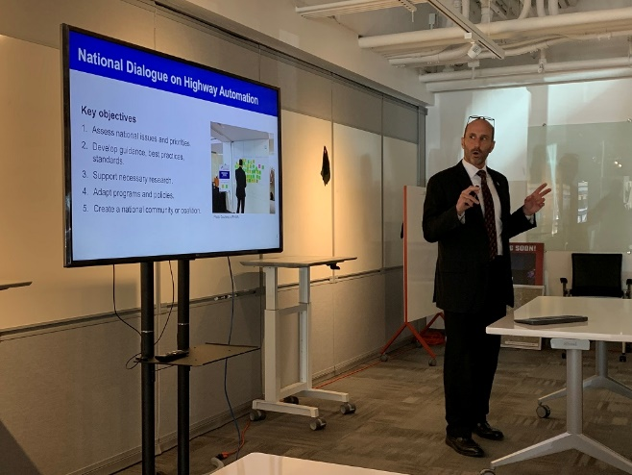  John Corbin (FHWA) giving a presentation on CAT during the Kick-Off Meeting, June 2019, Las Vegas (NV) | 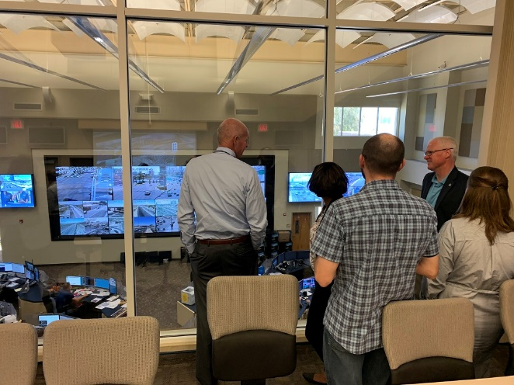  Carlos Braceras, Russel McMurry, and panel members view a TMC during the Kick-Off Meeting, June 2019, Las Vegas (NV)
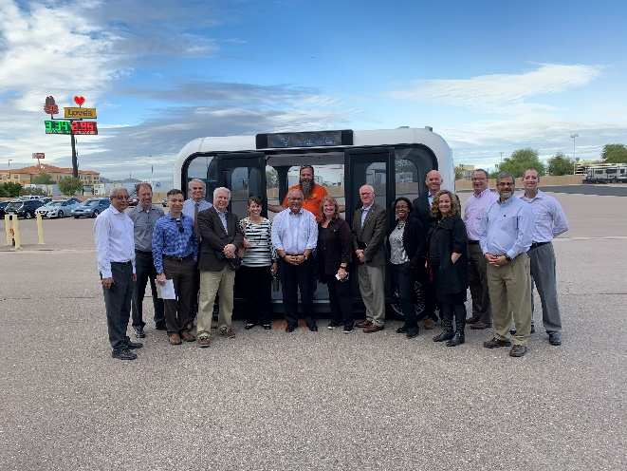  Panel Members visiting Local Motors, Dec 2019, Chandler (AZ) | 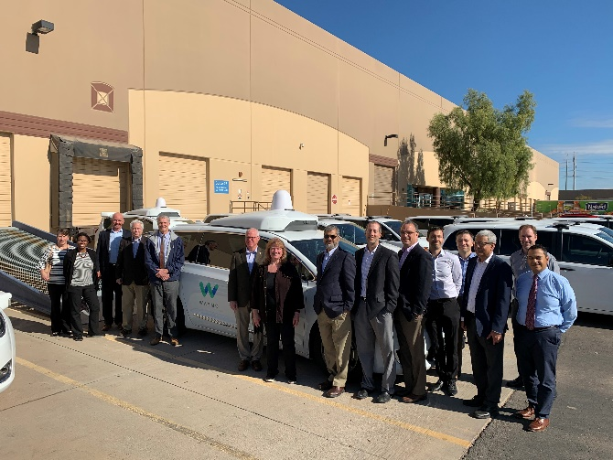  Panel Members after a ride-n-drive with Waymo, Dec 2019, Chandler (AZ)
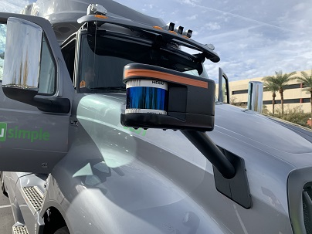  LiDAR device on a TuSimple automated truck, Dec 2019, Chandler (AZ) | 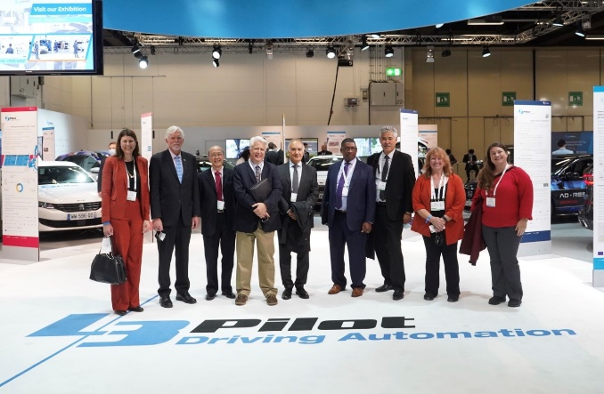  Panel Members at the ITS World Congress learning about the European L3 Pilot, Oct 2021, Hamburg, Germany

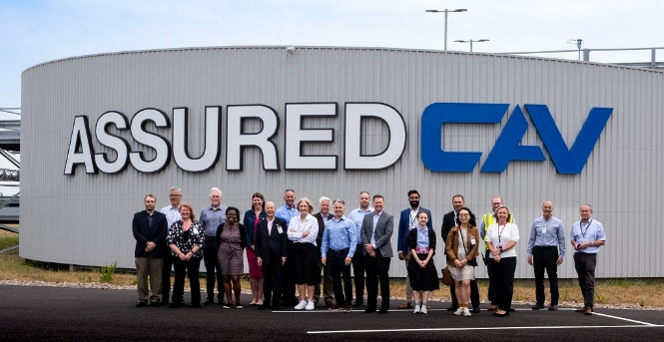  Panel Members visiting the Horiba Mira test facility, July 2022, Nuneaton, England | 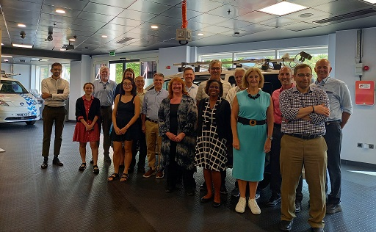  Panel Members visiting the Smart Mobility Living Lab, July 2022, London, England
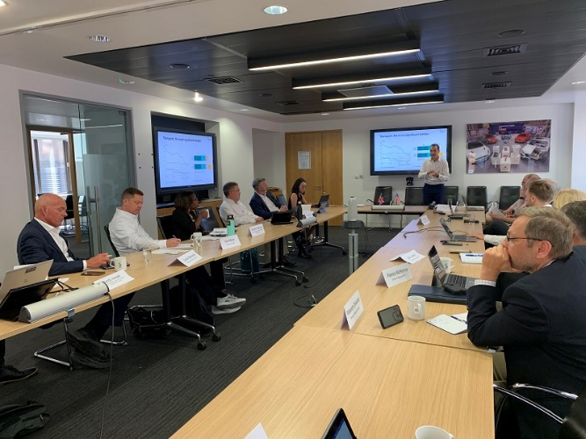  Panel discussions with the Society for Motor Manufacturers and Traders, July 2022, London, England | 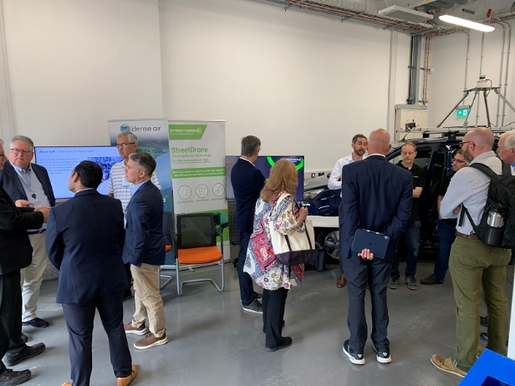  Panel members meet with private companies at the UTAC-Culham test facility, July 2022, Culham, England

