ACRP Research Report 241: Toward A Touchless Airport Journey
Attachment A: Solution Worksheet

Taking Action
Solution Worksheet
As you read Chapter 2: “Touchless Solutions Across the Airport Journey Areas,” you can use this worksheet to help decide which solutions to consider and implement for your airport. Using the same progression as Chapter 2, this worksheet identifies the solutions applicable to each area as well as the overall cost range and technology requirements of implementation. It then provides a place for taking notes specific to your airport, as shown in the template below:

 |  | Cost | Low-Tech Application | Passenger Centric Device | System/ Infrastructure
 | Example Touchless Solution | $$ | • | • | •
Status | [Select from the following]  Not Considering  Considering  In-Progress  Implemented | Notes: [Insert any notes of next steps or unique aspects of your implementation]

The cost information is generalized into categories of $, $$, $$$. These estimates are not meant to be exhaustive and are aimed at providing a quick and easy reference regarding the relative costs of different touchless solutions, including considerations for implementation, operation, and maintenance. Criteria used to assign a $ reference are based on the type of product, its ease of implementation, the extent of enabling works and customization, the unit cost, and the overall complexity of the operation and maintenance of the solution. While some solutions may be simple and cost-effective ($), their broad implementation may still be cumulatively expensive because of the scale of the airport facilities. The criteria, therefore, primarily compare costs in relation to similar-sized solutions. The following describes the general factors making up each cost category:

$ | - Low-tech and off-the-shelf products.  - Stand-alone with little to no maintenance or operation costs required.  - Low unit-cost but the cumulative cost will vary based on the scope of implementation.
$$ | - Some enabling works.  - Off-the-shelf technology with customized implementation.  - Ongoing operation and maintenance requirements.  - Significant unit and cumulative costs (Over $100,000 total).
$$$ | - Costly enabling works required.  - High-tech and customized applications.  - Complex operation and maintenance requirements.  - High-unit and cumulative costs (Over $500,000).

The technology requirements are broken into three general categories: Low-Tech Application, Passenger Centric Device, and System/Infrastructure. For this document, the IT requirements are broken up into broad descriptions that give further detail on the level of costs that may be required for each solution.

Low-Tech Application: This group of technology requirements typically includes stand-alone devices that do not require additional airport IT Infrastructure. Other items that may fall into this category include the following:
- Staffing resources.
- Cleaning products.
- Stand-alone service offering (e.g., baggage pickup or delivery).

Passenger Centric Device: This group of technology requirements is accessed by the passenger and needs the assistance of one of the following:
- Mobile App.
- Website.
- Tablet.

System/Infrastructure: This group of technology requirements typically has more complex installations and may include any of the following:
- Hardware.
- Software.
- Cabling, conduit.
- Wi-Fi.
- Building infrastructure/layout changes.

Pre-Airport
Solutions that specifically apply to when a passenger is at home or work, in a car, at the train station, or other areas leading to arrival to the airport property

Review the corresponding section of the quick reference guide and assess where you are in achieving the touchless journey in each step of the journey. Enter your status and any corresponding notes for that technology.

 |  | Cost | Low-Tech Application | Passenger Centric Device | System/ Infrastructure
 | Parking Reservation System (Pre-Airport Registration) | $$ |  | • | •
Status | Insert your status… | Notes: Insert your notes…
 | Virtual/Digital Queue Solutions  (Pre-Airport Registration) | $$ |  | • | •
Status | Insert your status… | Notes: Insert your notes…
 | Baggage Divesting Solutions
Status | Insert your status… | Notes: Insert your notes…
Remote Bag Drop |  | $$ |  |  | •
Status | Insert your status… | Notes: Insert your notes…
Baggage Pickup or Delivery |  | $ | •
Status | Insert your status… | Notes: Insert your notes…
 | Biometric Technology (Pre-Enrollment) | $$ |  | • | •
Status | Insert your status… | Notes: Insert your notes…
 | Online Service Booking
Status | Insert your status… | Notes: Insert your notes…
Club/Lounge |  | $ |  | • | •
Status | Insert your status… | Notes: Insert your notes…
Meeting Space |  | $ |  | • | •
Status | Insert your status… | Notes: Insert your notes…
Traveler with Disabilities Registration |  | $ |  | • | •
Status | Insert your status… | Notes: Insert your notes…
Wheelchair |  | $ |  | • | •
Status | Insert your status… | Notes: Insert your notes…
Business Center |  | $ |  | • | •
Status | Insert your status… | Notes: Insert your notes…
Car Detailing |  | $ |  | • | •
Status | Insert your status… | Notes: Insert your notes…
 | Passenger-Assistance-Related Solutions
Status | Insert your status… | Notes: Insert your notes…
Website Chatbots |  | $ |  | • | •
Status | Insert your status… | Notes: Insert your notes…
Mobile Apps |  | $ |  | • | •
Status | Insert your status… | Notes: Insert your notes…
Social Media |  | $ |  | • | •
Status | Insert your status… | Notes: Insert your notes…
 | Travel Health-Related Solutions | $$ |  | • | •
Status | Insert your status… | Notes: Insert your notes…
 | Baggage Prepping Solutions
Status | Insert your status… | Notes: Insert your notes…
Home-Printed Bag Tags and Electronic Bag Tags (EBTs) |  | $$ |  |  | •
Status | Insert your status… | Notes: Insert your notes…
Baggage Wrapping Services |  | $ | •
Status | Insert your status… | Notes: Insert your notes…
Transportation Reservations (Transportation Network Company, Taxi, Ground Transportation, Rail) |  | $ |  | • | •
Status | Insert your status… | Notes: Insert your notes…

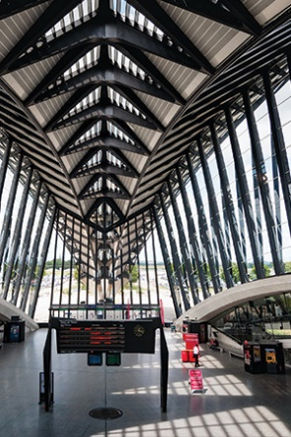
On-Airport
Solutions that generally apply to all common areas located on the airport campus

Since the solutions noted in this section apply generally to all on-airport areas, be sure to consider each area as you review solutions such as elevator and restroom enhancements.

 |  | Cost | Low-Tech Application | Passenger Centric Device | System / Infrastructure
 | Elevator-Related Solutions
Status | Insert your status… | Notes: Insert your notes…
Homing |  | $ | •
Status | Insert your status… | Notes: Insert your notes…
Automatic Scheduling |  | $ | •
Status | Insert your status… | Notes: Insert your notes…
Remote Calling |  | $$ |  | • | •
Status | Insert your status… | Notes: Insert your notes…
Touchless Buttons |  | $$ | •
Status | Insert your status… | Notes: Insert your notes…
Foot Pedal Buttons |  | $$ | •
Status | Insert your status… | Notes: Insert your notes…
 | Restroom-Related Solutions
Status | Insert your status… | Notes: Insert your notes…
Touchless Fixtures |  | $ | •
Status | Insert your status… | Notes: Insert your notes…
Increased Circulation Areas |  | $$-$$$ |  |  | •
Status | Insert your status… | Notes: Insert your notes…
One-Way Airflow |  | $$-$$$ |  |  | •
Status | Insert your status… | Notes: Insert your notes…
Restroom Use Monitoring |  | $-$$ |  |  | •
Status | Insert your status… | Notes: Insert your notes…
 | Enhanced Surface-Cleaning-Related Solutions
Status | Insert your status… | Notes: Insert your notes…
Antimicrobial Coatings |  | $ | •
Status | Insert your status… | Notes: Insert your notes…
Cleaning Accreditation |  | $ | •
Status | Insert your status… | Notes: Insert your notes…
Disinfectant Sprays |  | $ | •
Status | Insert your status… | Notes: Insert your notes…
Escalator and People Mover Automatic Cleaning |  | $ | •
Status | Insert your status… | Notes: Insert your notes…
Visible Cleaning Procedures |  | $ | •
Status | Insert your status… | Notes: Insert your notes…
UV-C Autonomous Cleaning Robots |  | $$ |  |  | •
Status | Insert your status… | Notes: Insert your notes…
UV-C Footwear Sanitization |  | $$ |  |  | •
Status | Insert your status… | Notes: Insert your notes…
UV-C Pod for Wheelchairs and Trolleys |  | $$ |  |  | •
Status | Insert your status… | Notes: Insert your notes…
Other UV-C-Related Solutions |  | $$ |  |  | •
Status | Insert your status… | Notes: Insert your notes…
 | Passenger-Assistance Related Solutions
Status | Insert your status… | Notes: Insert your notes…
Ambassadors |  | $ | •
Status | Insert your status… | Notes: Insert your notes…
Social Media |  | $ |  | • | •
Status | Insert your status… | Notes: Insert your notes…
Virtual Ambassadors |  | $$ | • | • | •
Status | Insert your status… | Notes: Insert your notes…
Augmented Reality Wayfinding |  | $$ |  | • | •
Status | Insert your status… | Notes: Insert your notes…
Wayfinding Beacons |  | $$ |  | • | •
Status | Insert your status… | Notes: Insert your notes…
 | Smart Building Systems
Status | Insert your status… | Notes: Insert your notes…
Lighting |  | $$ |  |  | •
Status | Insert your status… | Notes: Insert your notes…
Ventilation |  | $$-$$$ |  |  | •
Status | Insert your status… | Notes: Insert your notes…
Heating and Cooling |  | $$-$$$ |  |  | •
Status | Insert your status… | Notes: Insert your notes…
 | Signage
Status | Insert your status… | Notes: Insert your notes…
Static |  | $ | •
Status | Insert your status… | Notes: Insert your notes…
Dynamic |  | $$-$$$ |  |  | •
Status | Insert your status… | Notes: Insert your notes…
 | Queue Management Systems | $-$$ |  |  | •
Status | Insert your status… | Notes: Insert your notes…
Personal Hygiene and Health-Related Solutions |  | $ | •
Status | Insert your status… | Notes: Insert your notes…
Touchless Water Bottle Filling Stations |  | $ | •
Status | Insert your status… | Notes: Insert your notes…
Feedback Devices |  | $ | •
Status | Insert your status… | Notes: Insert your notes…

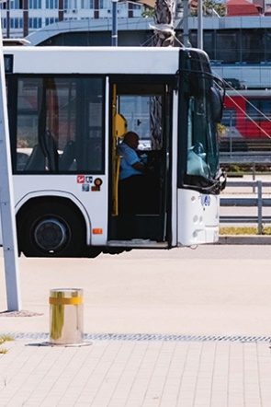
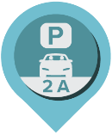
Parking and Arrival/Exit
Solutions that specifically apply to parking garages and lots, entry roadways, intermodal facilities, curbside, or other related areas
 |  | Cost | Low-Tech Application | Passenger Centric Device | System / Infrastructure
 | Parking Reservation Systems | $$ |  | • | •
Status | Insert your status… | Notes: Insert your notes…
 | Parking Entry and Exit Kiosks | $$ |  | • | •
Status | Insert your status… | Notes: Insert your notes…
 | Parking Pay-on-Foot Kiosks | $$ |  |  | •
Status | Insert your status… | Notes: Insert your notes…
 | License Plate Recognition | $$ |  |  | •
Status | Insert your status… | Notes: Insert your notes…
 | Virtual/Digital Queue Solutions | $$$ |  | • | •
Status | Insert your status… | Notes: Insert your notes…
 | Remote Baggage Drop | $$ |  |  | •
Status | Insert your status… | Notes: Insert your notes…
 | Self-Service Kiosk | $$ |  | • | •
Status | Insert your status… | Notes: Insert your notes…
 | Automated Car Park Systems | $$-$$$ |  | • | •
Status | Insert your status… | Notes: Insert your notes…

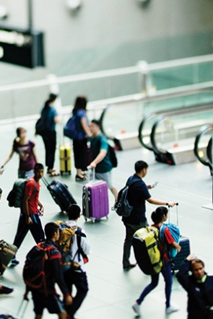
Landside
Solutions that specifically apply to the check-in lobby, landside concessions and shopping areas, and baggage claim

 |  | Cost | Low-Tech Application | Passenger Centric Device | System / Infrastructure
 | Autonomous Wheelchairs | $$ |  |  | •
Status | Insert your status… | Notes: Insert your notes…
 | Self-Service Kiosks
Status | Insert your status… | Notes: Insert your notes…
Mobile Screen Control |  | $$ |  | • | •
Status | Insert your status… | Notes: Insert your notes…
Key Fobs |  | $$ |  |  | •
Status | Insert your status… | Notes: Insert your notes…
Hover Screen Control |  | $ | •
Status | Insert your status… | Notes: Insert your notes…
 | Self-Service Bag Drop | $$ |  |  | •
Status | Insert your status… | Notes: Insert your notes…
 | Virtual/Digital Queue Solutions | $$$ |  | • | •
Status | Insert your status… | Notes: Insert your notes…
 | Biometric Technology | $$$ |  | • | •
Status | Insert your status… | Notes: Insert your notes…
 | Automated Access Systems | $$-$$$ |  | • | •
Status | Insert your status… | Notes: Insert your notes…
Virtual Assistance |  | $$ | • | • | •
Status | Insert your status… | Notes: Insert your notes…
Retail, Food and Beverage Purchase, and Delivery Options |  | $-$$ | • | • | •
Status | Insert your status… | Notes: Insert your notes…
Access Control Systems |  | $-$$$ |  |  | •
Status | Insert your status… | Notes: Insert your notes…

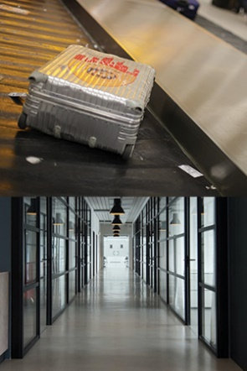
Back of House
Solutions that specifically apply to staff-specific areas such as baggage processing and airport management offices

 |  | Cost | Low-Tech Application | Passenger Centric Device | System / Infrastructure
 | Access Control Systems | $-$$$ |  |  | •
Status | Insert your status… | Notes: Insert your notes…
Baggage Screening Systems |  | $$ |  |  | •
Status | Insert your status… | Notes: Insert your notes…

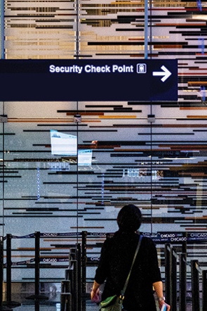
Security
Solutions that specifically apply to the security screening areas managed by the Transportation Security Administration (TSA)

 |  | Cost | Low-Tech Application | Passenger Centric Device | System / Infrastructure
 | Virtual/Digital Queue Solutions | $$$ |  | • | •
Status | Insert your status… | Notes: Insert your notes…
 | TSA Credential Authentication Technology | $$-$$$ |  |  | •
Status | Insert your status… | Notes: Insert your notes…
 | Baggage Screening Systems | $$-$$$ |  |  | •
Status | Insert your status… | Notes: Insert your notes…
 | Automated Access Systems | $$-$$$ |  |  | •
Status | Insert your status… | Notes: Insert your notes…
Enhanced Advanced Imaging Technology (eAIT) |  | $$$ |  |  | •
Status | Insert your status… | Notes: Insert your notes…

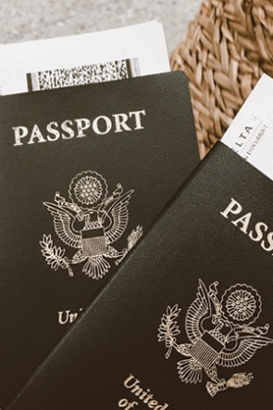
Immigration Control
Solutions that specifically apply to the immigration and passport control area managed by U.S. Customs and Border Protection

 |  | Cost | Low-Tech Application | Passenger Centric Device | System / Infrastructure
 | Automated Access Systems | $$-$$$ |  |  | •
Status | Insert your status… | Notes: Insert your notes…
 | Self-Service Kiosks | $$ |  | • | •
Status | Insert your status… | Notes: Insert your notes…
 | Biometric Technology | $$ |  | • | •
Status | Insert your status… | Notes: Insert your notes…
Automated Passport Control Kiosks |  | $$ |  | • | •
Status | Insert your status… | Notes: Insert your notes…
Retail, Food and Beverage Purchase, and Delivery Options |  | $-$$ | • | • | •
Status | Insert your status… | Notes: Insert your notes…
Virtual Queue |  | $$$ |  |  | •
Status | Insert your status… | Notes: Insert your notes…

Airside
Solutions that specifically apply to areas such as holdrooms, airside concessions and shopping, and other amenities

 |  | Cost | Low-Tech Application | Passenger Centric Device | System / Infrastructure
 | Automated Access Systems | $$-$$$ |  |  | •
Status | Insert your status… | Notes: Insert your notes…
 | Food Ordering and Delivery
Status | Insert your status… | Notes: Insert your notes…
Contactless Payment |  | $ |  | • | •
Status | Insert your status… | Notes: Insert your notes…
Self-Service Kiosks |  | $ |  |  | •
Status | Insert your status… | Notes: Insert your notes…
Self-Service Tablets |  | $ |  |  | •
Status | Insert your status… | Notes: Insert your notes…
Mobile App |  | $ |  | • | •
Status | Insert your status… | Notes: Insert your notes…
Online Purchase (Pickup or Delivery) |  | $ |  | • | •
Status | Insert your status… | Notes: Insert your notes…
Delivery Robots |  | $-$$ |  |  | •
Status | Insert your status… | Notes: Insert your notes…
Access Control Systems |  | $-$$$ |  |  | •
Status | Insert your status… | Notes: Insert your notes…
Self-Service Kiosks |  | $ |  | • | •
Status | Insert your status… | Notes: Insert your notes…

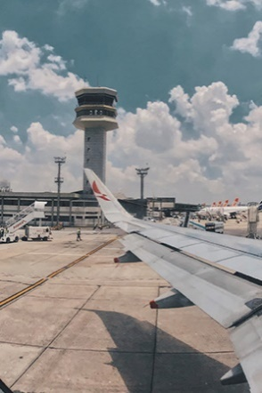
Airfield
Solutions that specifically apply to airfield processes such as baggage handling and ground support

 |  | Cost | Low-Tech Application | Passenger Centric Device | System / Infrastructure
Access Control Systems |  | $-$$$ |  |  | •
Status | Insert your status… | Notes: Insert your notes…
MSP Implementation |  | $$-$$$ |  |  | •
Status | Insert your status… | Notes: Insert your notes…
Self-Sanitizing Gloves |  | $-$$ | •
Status | Insert your status… | Notes: Insert your notes…
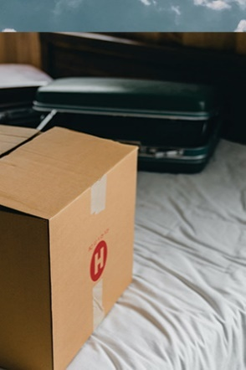
Post-Airport
Solutions that can move processes that typically occur on-airport to a post-airport location

 |  | Cost | Low-Tech Application | Passenger Centric Device | System / Infrastructure
Insert additional solutions here…
Status | Insert your status… | Notes: Insert your notes…

