Impact of Decline in Volunteerism on Rural Transit Systems

Final Guidebook

Prepared for NCHRP Transportation Research Board

Of

The National Academies of Sciences, Engineering, and Medicine

TRANSPORTATION RESEARCH BOARD OF THE NATIONAL ACADEMIES OF SCIENCES, ENGINEERING AND MEDICINE
PRIVILEDGED DOCUMENT

This document, not released for publication, is finished only for review to members of or participants in the work of CRP. This document is to be regarded as fully privileged and dissemination of the information included herein must be approved by CRP.

Frank Douma, University of Minnesota, Minneapolis, MN

Toni Horst, PhD, AECOM, Arlington, VA

December 2022

Permission to use any unoriginal material has been obtained from all copyright holders as needed.

Executive Summary 1
Purpose of the Guidebook 1
Brief Overview of Use of Volunteer Drivers in the U.S. 1
Is Volunteering to Drive Declining and How Big of a Problem is This? 1
Potential Remedies 2
Study Limitations and Suggestions for Further Study 3
Chapter 1: Orientation to the Guidebook and Key Issues 4
Goal of the Guidebook 4
Using the Guidebook 4
Organization of the Guidebook 5
Table of Acronyms 5
Chapter Conclusion 5
Chapter 2: Overview of Volunteering and Driver Programs in the U.S. 6
Volunteering in the U.S. 6
Volunteer Driver Programs in the U.S. 9
Organizational Funding Sources 10
Paid Volunteer Staff 11
Volunteer Roles Within the Organization 11
Importance of Volunteers to Mission 13
Chapter Conclusion 14
Chapter 2 Addendum: Survey Implementation 15
Survey Development 15
Survey Participant Recruitment 15
Overall sample demographics 16
Chapter 3: Describing the Volunteer Driver Challenge 18
Demographic Shifts in Volunteer Driver Recruitment Potential 19
Funding and Reimbursement Concerns 19
Insurance and Other Regulatory Challenges 20
Short Term Effects From the COVID-19 Pandemic 20
Challenges for Volunteer Driver Organizations 21
Meeting demand 21
Cancelled Trips 21
Reimbursement 21
Chapter Conclusion 23
Chapter 4: Options for Recruiting and Retaining Volunteers 24
Recruiting methods 25
Ideas for Recruiting and Retention 26
Chapter 5: Volunteer Program Business Model Components 29
Overview 29
Types of Models 29
Volunteering Without Reimbursement for Time or Mileage 30
Volunteering with Mileage Reimbursed 30
Trip Banking/Time Banking 30
Mobility on Demand 30
Voucher Models 30
Chapter Conclusion 31
Chapter 6: Volunteer Program Funding Transitions 32
Overview 32
Survey Respondents NOT using volunteers 32
Costs to Individual Volunteer 32
Costs to Organization Using Volunteers 33
Candidate Funding Sources for Supporting Volunteer Programs 34
Volunteer Service as Funding Match 34
Chapter Conclusion 34
Appendix 1: TRB Volunteer Driving Survey 39
Appendix 2: Task 78 “Rural Transit Survey” Report 48
Introduction 48
Method 48
Participant Recruitment 49
Results 50
Challenges for Volunteer Driver Organizations 56
Importance of Volunteers to Mission 60
Analysis and Discussion 61
Study Limitations and Suggestions for Further Study 63
Appendix 3: Bibliography 64

Executive Summary
Purpose of the Guidebook
The objective of the Impact of Decline in Volunteerism on Rural Transit Systems project and resulting guidebook is to 1) summarize the literature and experience of existing volunteer transportation programs; 2) understand the factors that contribute to volunteer programs’ success or decline; 3) describe the value delivered by these programs; and 4) based on the understanding of items 1 through 3, develop a set of strategies for use by organizations seeking to mitigate the loss of current volunteers or transition to a different business model to maintain their programs.
Brief Overview of Use of Volunteer Drivers in the U.S.
Volunteers who provide transportation services are part of a larger national volunteer labor force that contributes to their local communities. Approximately 30 percent of the U.S. adult population volunteered in some way, according to the most recent Current Population Data available. Of these volunteers, approximately one in five engages in “general labor or provides transportation services” according to the same source. The available data do not breakout transportation services out as a standalone category.
In order to narrow the focus to just volunteers working to provide transportation services, the work to develop this guidebook included a survey of organizations who utilize volunteers (now or in the past) to deliver transportation service to the local community. Of the 114 survey responses received, 84 respondents indicated they did indeed use volunteers when providing transportation services. Of note, while the bulk of these respondents (81) used volunteers to drive clients, many used volunteers in additional related capacities, including for the completion of administrative duties (28 organizations), for dispatching rides (8 organizations), and for “other” duties, such as running errands and making deliveries to clients. Additionally, some of these organizations used volunteer drivers to provide caregiving services such as household chores, filling out tax forms, and/or providing socialization (35 respondents). This suggests that these volunteer driving services fill a greater community need than just the simple transiting of users from point-to-point.
The mean age of 64 and median of 67 of the volunteer drivers reported by the respondents provides insight into one of the main challenges faced by the organizations in recruiting drivers. While one organization reported a low average age of 24 (which was a service based at a public university), most of the drivers recruited are retirees, who may only have a limited number of years ahead of them before they may need these services themselves. With the smaller “Generation X” moving into this age bracket, and the larger “Baby Boom” generation moving out of it, there will be a structural imbalance between the number of potential volunteers and those needing the services of volunteers for years to come.
Is Volunteering to Drive Declining and How Big of a Problem is This?
The decline in, or at least the increased challenge in finding enough, volunteers is real. In reviewing the results of the survey developed for this guidebook, organizations that rely on volunteers to provide their work, particularly to provide transportation services to those that can no longer bike, walk or drive themselves, are facing significant challenges. In this survey, more than three out of four (76.5%) respondents reported problems recruiting enough volunteers to meet their needs, and, that just among the 114 organizations responding, we estimate 5,800 trips are cancelled annually due to a lack of drivers. The survey showed that nearly half of these cancelled trips may have been for medical purposes, which could lead to not only inconvenience to the client, but possibly detrimental health impacts.
COVID-19 is not seen as a major long-term contributor to the problem. Interestingly, however, despite these issues outlined above, the COVID-19 pandemic, which was still a major factor when this survey was administered (February – April 2021, when vaccines were available, but had yet to have much of an impact), did not appear to have a significant long-term impact on these organizations. Only four organizations indicated they stopped using volunteers during the pandemic, and while many respondents noted the pandemic was an additional challenge, fewer than one in four believed the increased challenges would last past the pandemic.
The problem is due to economic and demographic factors. Respondents noted that the greatest challenges were those posed by larger, structural issues: generational change and finding sufficient funds, both of which were expected to find based upon previous studies. Generationally, many of these organizations are finding fewer people with the time and funds available to volunteer. Many of the volunteers from the baby boom generation are becoming too old to safely drive, and there are fewer members of the younger generations to follow them. Respondents found this to be an economic rather than a values issue, i.e. people in the younger generation lacked the time to volunteer due to obligations to their paying job and family, rather than younger people not volunteering because they did not believe it was their role to do so, or that the government or other entity should pay employees to provide this service. Supporting this point of view, respondents stated many younger potential volunteers do not do so because lack the time as they still need to work paying jobs to make ends meet. While the survey found that providing mileage reimbursement helped recruiting overall, even those organizations providing higher levels of reimbursement were not having a significantly easier time finding enough people.
It is also worth noting that while previous studies had noted lower reimbursement rates, insurance, and other government regulations as potential problems, very few respondents indicated these as actual impediments. Further, there did not appear to be significant trends based upon the size of the organization, nor its geographic location.
Potential Remedies
Solutions may lie in qualitative, rather than quantitative data: the most successful organizations focus on serving their volunteers as well as their clients. As a result, the quantitative data obtained through the survey provide a clearer picture of the challenges faced by these organizations, but little insight as to potential solutions. This information, instead, appears to lie in the qualitative information. First, when asked for final comments, many respondents were effusive in their praise of, and need for, volunteers to fulfill their mission and work. Combined with the quantitative data showing that despite all of the challenges, fewer than 10 respondents no longer used volunteers, these comments further support the central, possibly existential, importance of volunteers to these organizations.
Follow up interviews revealed possible solutions. While many respondents noted the challenges of finding enough money and time to recruit volunteers, the most successful organizations achieved their success by focusing on them. The organizations found non-transportation grants and other funding to support activities that built community and other connections between the volunteers, and between the volunteers and the organization. As a result, the volunteers want to continue to be part of the organization, and also serve as recruiters of other volunteers, creating a virtuous cycle that ultimately benefits the organization’s clients, as they receive high quality rides when they need them.
The Exception that proves the rule? One large organization caught the research team’s attention. It provided just over 1000 rides per month before the pandemic, and found that they had more volunteers during the pandemic. They have 275 volunteers, 150 of which are drivers, and they kept them as busy as possible during the pandemic doing deliveries, as well as providing limited rides to “Critical destinations” (health care, wellness, etc.).
They are thriving due to the effort they make to build community among their volunteers. As the Executive Director stated in a follow-up interview, “I wish you could see our space!” They have a room dedicated to the volunteers, where they can have snacks and relax between trips, provide training and refresher training 4 times per year, and host numerous social events, from monthly coffee hours, evening gatherings in the summer and an annual appreciation dinner.
They pay for these additional services by raising non-transportation funds, whether through fund-raisers, or of particular note, they receive funds through the Americorps Seniors program, which allows them to dedicate a part time position to recruit through social media and otherwise spread the word about their opportunities.
Essentially, this organization has found that by recognizing their volunteers as “the eyes and ears in the community,” and prioritizing service to them, they are then able to provide great service to their clients.
Study Limitations and Suggestions for Further Study
A key limitation to survey research is that it provides quantitative data to support or disprove previously identified questions, but provides limited data to evaluate the value of new insights gleaned in the course of analysis. Such is the case in this work, where we found support for organizations that use volunteer drivers facing key challenges in changing demographics and funding, but little support for the notion that these challenges were compounded by insurance and regulatory issues, especially as related to reimbursing the drivers’ expenses. However, we also picked up that a key solution could be in the ability of these organizations to create an attractive and supportive space for the volunteers, and their ability to be creative in finding the financial support for these volunteer support efforts. Consequently, follow up work in examining how these organizations support and retain their volunteers would be helpful in fleshing out this finding. In particular, recognizing that the overall population pool for volunteers is more generationally and culturally diverse than even two decades ago, understanding whether there are generational and cultural differences that affect the effectiveness of recruiting and retention strategies should be examined.

Chapter 1: Orientation to the Guidebook and Key Issues
In the United States (U.S.), volunteers are vital to the sustained operation of transit agencies—especially small, rural transit agencies. For many residents of these communities, these services are lifelines to medical services, shopping and social engagement. Identifying a national downward trend in volunteer participation between 2009 and 2013, Task 78 was undertaken to understand the factors influencing the volunteer trend, how a continued loss of volunteers would affect a rural transit service delivery model and whether there are ways to mitigate or offset this risk. Data on volunteer activity is published with a lag, and as more recent data show, the downward trend in volunteer participation was nearing an inflection point and beginning to rise when this guidebook was requested by the panel. Even so, some organizations—those who provide transit service as well as other types of service—continue to report challenges in recruiting or retaining volunteers despite the stabilization in volunteer participation rates. The guidebook thus serves as a means to understand the factors that challenge organizations’ ability to attract sufficient volunteer labor for their transit programs. Volunteers are important partners for many transit providers, and a sustained challenges in leveraging this labor supply could threaten the capacity or continued existence of some organizations.
This orientation chapter explains this guidebook’s goal, organization and ideas for usage.

There is a large and rich literature on volunteerism, charitable giving and philanthropy that informs the questions addressed in this study. This literature is complemented by a survey of transit operators conducted as part of this project. The survey results provide actual on-the-ground experience to complement the literature’s findings. The NCHRP panel guiding this work specifically directed that the work be in the form of a guidebook understanding that transit staff, particularly those in small urban or rural communities typically “wear many hats” and do not have the bandwidth to review a report or study. Rather, by presenting the material in a guidebook, the information is presented in focused topical sections that allow time-limited readers to quickly access the material most relevant to their questions.
Goal of the Guidebook
The objective of the Impact of Decline in Volunteerism on Rural Transit Systems project and resulting guidebook is to 1) summarize the literature and experience of existing volunteer transportation programs; 2) understand the factors that contribute to volunteer programs’ success or decline; 3) describe the value delivered by these programs; and 4) based on the understanding of items 1 through 3, develop a set of strategies for use by organizations seeking to mitigate the loss of current volunteers or transition to a different business model to maintain their programs.
Using the Guidebook
Depending on the reader’s familiarity with volunteer driver program, this guidebook can be used in one of two ways. For those who have little to no experience with these programs, it might be most useful to read the Guidebook chapter-by-chapter in order to gain an overview of these programs and how they fit in the larger realm of transit and transportation planning. On the other hand, those who are already familiar with different aspects of volunteer programs may prefer to use the guidebook as a reference manual, focusing on specific areas of interest. This guidebook is organized to accommodate both types of readers. A summary of the guidebook’s organization by chapter is described in the section that follows.
Organization of the Guidebook
Chapter 1: Orientation to the Guidebook and Key Issues
Chapter 2: Overview of Volunteering and Driver Programs in the U.S.
Chapter 3: Describing the Volunteer Driver Challenge
Chapter 4: Options for Recruiting and Retaining Volunteers
Chapter 5: Volunteer Program Business Model Components
Chapter 6: Volunteer Funding Program Transitions

Table of Acronyms
ADA | Americans with Disabilities Act
CMS | Centers for Medicare & Medicaid Services
FTA | Federal Transit Administration
HHS | U.S. Department of Health and Human Services
HRTG | Highly Rural Transportation Grants
MPO | Metropolitan Planning Organization
NEMT | Medicaid “Non-Emergency Medical Transportation”
TNC | Transportation Network Company
TRB | Transportation Research Board
VSO | Veteran Service Organization
VTS | Veterans Transportation Service

Chapter Conclusion
This chapter introduced the guidebook’s intention to support transportation planners and community service professionals in the development and management of volunteers needed to provide transportation services to communities in need. This guidebook is about the organization, use, retention, recruitment and value of such volunteers in the transportation sector. A summary of each chapter is provided to help the reader navigate the material efficiently.

Chapter 2: Overview of Volunteering and Driver Programs in the U.S.
Volunteering in the U.S.
Charity, volunteering and philanthropic activities all grow out of the same decision to “give back” to the larger community. Charity is an umbrella term, understood to encompass both one-time and sustained monetary, time or in-kind donations. This can mean dropping off household items at the thrift shop, texting a donation to a relief organization following a natural disaster, or showing up at the food bank for a weekly shift. Volunteering typically means donating time. Philanthropy means making strategic investments over time to solve a problem. Volunteers who provide transportation services are part of a larger national volunteer labor force that contributes to their local communities.
This chapter describes national trends in volunteering and charitable activities. It also provides a summary of organizations using volunteer drivers surveyed for this guidebook. The information provides a background and benchmarks for organizations seeking to compare their organization to the broader community of groups using volunteers to provide transportation services.
The voluntary gift of time and money can be both complements (one activity supports or leads to the other) and substitutes (one activity replaces the other). For example, a number of researchers who analyze charitable behavior conclude that sustained volunteering is a substitute for monetary contributions, and that the propensity to give money instead of time rises with the income of the charitable individual. Other researchers maintain that volunteering and repeated financial donations are complements. In their model, people are motivated by a cause and begin to volunteer. Over time, they see that the organization has financial needs and may begin to give donations to the places that they volunteer—knowing the funds will be put to good use and that the charitable organization has a need for the funding. Similarly, someone may give funding as a sustained philanthropic strategy and begin to give time by serving on committees related to the issue or by volunteering for specific events. The key point from all the literature is that volunteers and repeated donors are motivated by the charitable organization’s mission. The personal satisfaction that a volunteer gets from giving those hours of time exceeds the value that the volunteer would get from using those hours of time to earn money at work or to enjoy leisure. Similarly, the financial donor gains more satisfaction from giving money to advance the organization’s mission than through spending the equivalent amount on goods or services. Volunteers are motivated by the sense of mission, by their ability to make a difference to the cause for which they volunteer. This is critical to recruiting and retaining volunteer’s support. People from different generations and cultures have different life experiences and may become aware of the need for volunteers and the difference their service could make in different ways.
As unpaid work, volunteering is not tracked in the monthly or annual federal employment statistics. However, there are three national surveys that track trends in volunteering; these are the U.S. Bureau of Labor Statistics’ Current Population Survey (CPS), the Census Bureau’s American Time Use Survey, and the Gallop Poll. The CPS sample is larger making its estimates more reliable but the data lags; the last published estimate was for 2019, reported in 2021. The Gallop Poll surveys a smaller base of respondents but provides more recent estimates. The Census Bureau’s American Time Use Survey reports volunteering but the question asks about a typical day. Moreover, the three surveys are structured differently such that the Gallop Poll’s estimate of volunteering activity has historically been about twice the estimate provided by the U.S. Census Bureau. Taken together, the Gallop Poll and CPS data sources of information are most frequently cited in the literature to provide insight into the nation’s volunteering trends.
The Gallop Poll data shown in Figure 1 highlight several trends about volunteering.

- The participation rate varies over time, ranging between 55 percent and 60 percent of the adult population over the past two decades.

- The propensity to volunteer dipped to its lowest point during the Great Recession (December 2007 to June 2009) but rose in 2011, a period of national unity following the 9/11 attacks. This suggests that people make the decision to volunteer at least partially in response to external events in their community.

- The propensity to volunteer dropped in 2020 and 2021 in response to the COVID-19 pandemic, as the associated stay-at-home orders and health concerns kept people out of public spaces except for essential trips. Charitable activity appears to be rebounding, however, as the likelihood of making a donation (that does not require personal contact) rose in 2020 (the value reported in 2021 is about activity in 2020 as the survey question asks about last year).
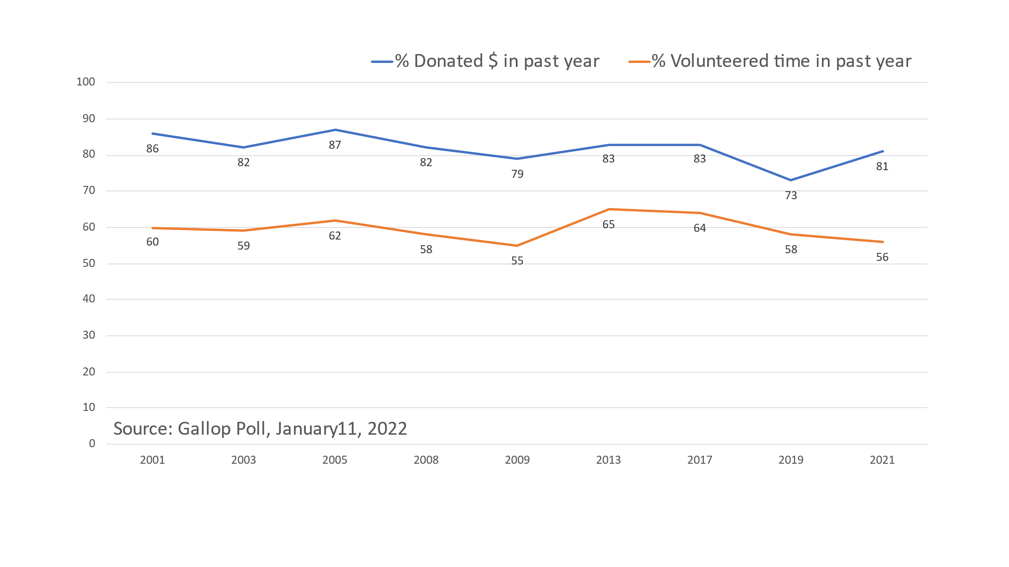
Data from the Current Population survey differ from the Gallop Poll data, but support some of the same findings.

As shown in Figure 2, although the values are lower than estimated in the Gallop Poll, the CPS data display the same variation within a range—here between 20 percent to 30 percent of the adult population.
Figure 1 Long-term Trends in Volunteering According to the Gallop Poll

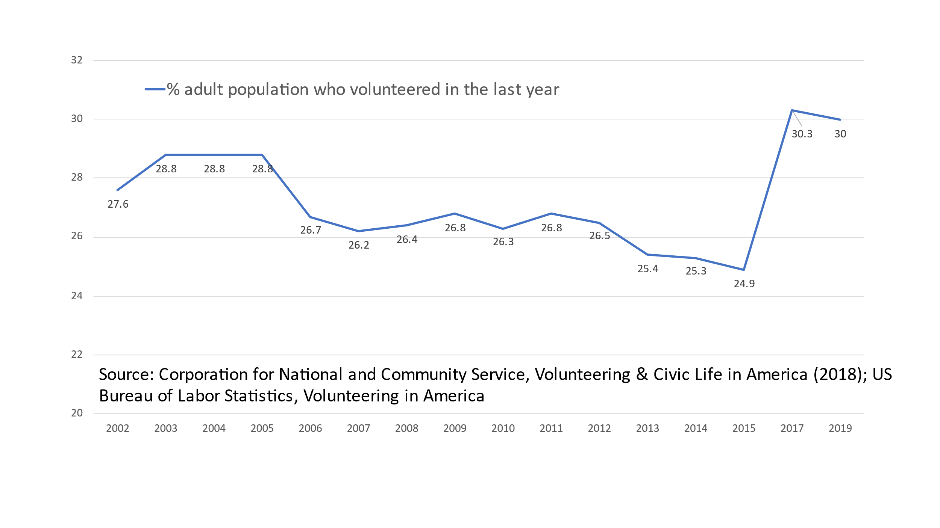
The data similarly display a small dip and rise in sync with the Great Recession and the uptick in civic collegiality following 9/11 (or temporary reduction of national divisions), though not as pronounced. It also displays the general downward trend in volunteering through 2015, that supported the observations that led to the NCHRP Panel requesting this research. The distinctive element is the sharp uptick in volunteering in the latter part of the decade leading into the pandemic. This trend was unexpected and while it is likely to have fallen off during the COVID pandemic as suggested by the Gallop Poll data, it suggests that there has been an underlying change—particularly as the upward trend is supported by two survey years, reducing the chance that survey anomalies created the uptick.
Figure 2 Long-term Trend in Volunteering According to the U.S. Current Population Survey
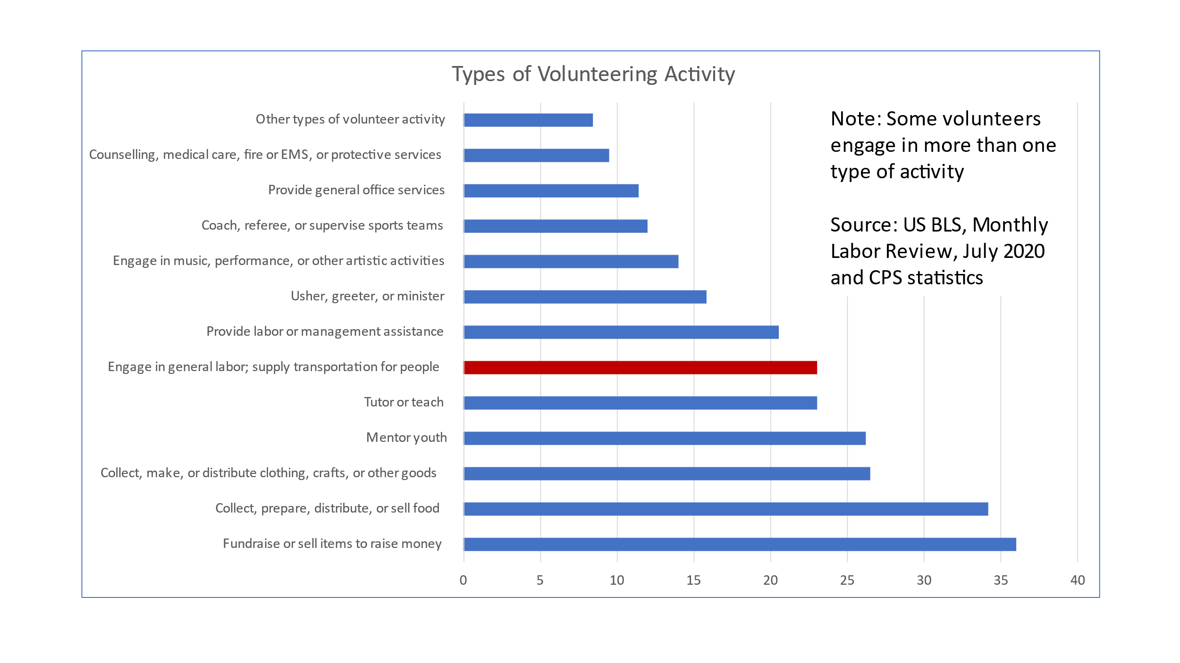
Figure 3 Approximately One in Four Volunteers Engages in General Labor or Supplying Transportation Services
Approximately one in five volunteers engages in general labor or provides transportation services, as shown in Figure 3. Among volunteers, fundraising is the most frequent type of activity, followed by activities related to collecting or providing food (ex. Meals on Wheels, foodbanks, meal centers). Activities related to teaching or mentoring youth are followed by those related to general labor or supplying transportation services. While a more discrete estimate of transportation-related services would be helpful for this guidebook, this is the available data at a national level. It does suggest that transportation services are a typical way people choose to volunteer. In 2015, the National Volunteer Transportation Center database identified 706 volunteer driver programs located across 30 states. These programs relied on just under 55,000 volunteer drivers to provide about 5 million one-way rides on an annual basis.
Volunteer Driver Programs in the U.S.
The Task 78 research team undertook a survey of organizations that use volunteers to provide a closer look at volunteering to provide transportation services. The “Rural Transit Survey” was conducted the spring of 2021 (attached as Appendix 2). This survey was based upon a similar instrument developed for a 2016 - 17 study by Frank Douma in Minnesota (see Appendix 1), which focused on “documenting the organizations that use volunteer drivers to help meet the transportation needs of their clients, how they organize and fund their volunteer driver programs, and the challenges these organizations face in continuing to provide these services with volunteer drivers, including issues with insurance coverage.”
The research team sent surveys to nearly 500 different entities across the U.S. In total, 114 responses were received, representing charitable organizations from 45 states, a majority of which (65 respondents, or 56.5%) were non-faith-based, non-profits, which were not operated by state or local transit organizations. Most respondent programs were also relatively small, with 67 indicating that they provided fewer than 500 trips per month. Six respondents were local (non-county) human service providers.
Nine respondents indicated that they provided more than 5,000 trips per month. Of note, this group was not dominated by public transit providers, as only 4 of 9 public transit providers indicated that they provided that many trips. Furthermore, only a few of these were national organizations, which represented amalgamations of multiple smaller providers.
Of the 114 survey responses received, 84 respondents indicated they did use volunteers when providing transportation services. While the bulk of these respondents (81) obviously used volunteers to drive clients, many used volunteers in additional related capacities, including for the completion of administrative duties (28 organizations), for dispatching rides (8 organizations), and for “other” duties, such as running errands and making deliveries to clients. Additionally, some of these organizations used volunteer drivers to provide caregiving services such as household chores, filling out tax forms, and/or providing socialization (35 respondents). This suggests that these volunteer driving services fill a greater community need than simply helping customers get from point-to-point.
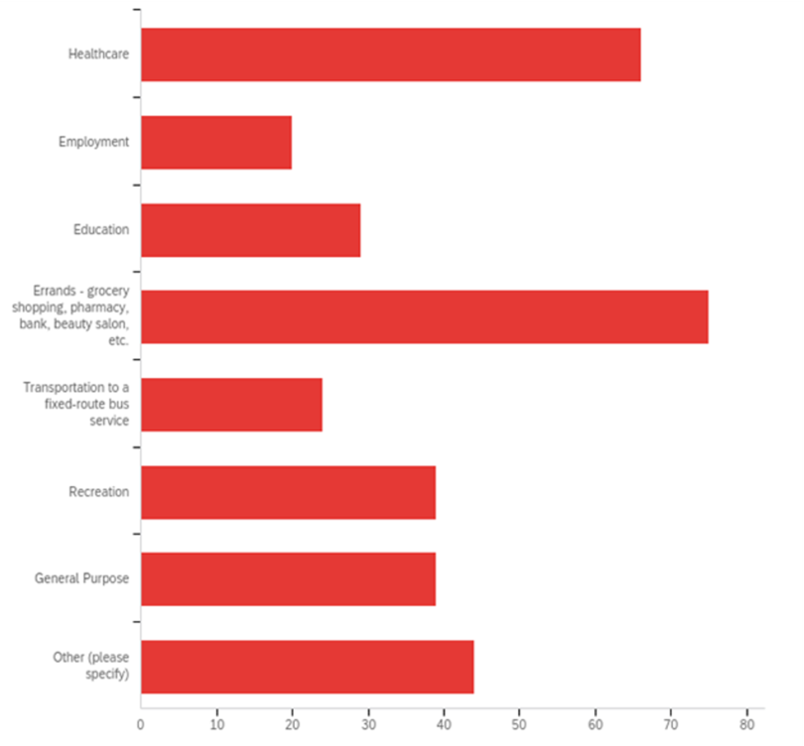
This analysis fits with the responses received for which types of care a volunteer transit organization was most frequently being used to provide. As shown in Figure 4, respondents answered that their services provided all types of trips, with errands (75 respondents) and healthcare (66 respondents) being the most common trip purposes. Of the 44 “other” trip types listed, “socialization” and deliveries were also common types that would not otherwise fit into existing categories, reinforcing the assessment that the provision of these trips is a vital support system for residents.
Figure 4 Types of Trips Provided
Organizational Funding Sources
None of the responding organizations represented a “for profit” entity, and only 9 (7.8%) represented public transit agencies as shown in Figure 5. Instead, a majority (65 respondents, or 65.5%) were non-faith-based non-profits.

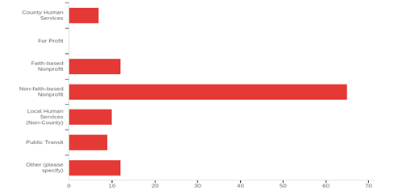
These organizations receive funding from all possible sources, as shown in Figure 6, with private donations being most common (82 respondents) followed closely by government funding sources (70 respondents noted receiving funding from local government, 65 from the federal government, and 61 from state government), and foundations (57 respondents). Only 35 collect fares from the riders. (Respondents could select more than one option on this question.)
Figure 5 Type of Organization

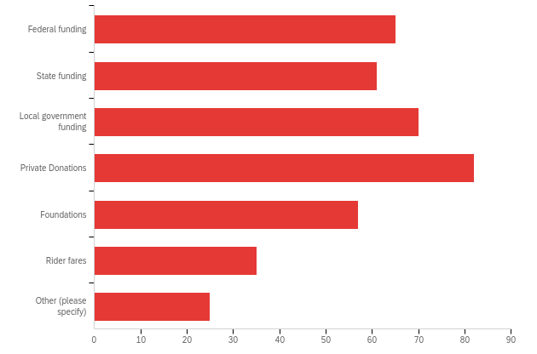
Figure 6 Funding Sources
Of the 25 “other” sources of funding listed, most common were specific grants, fundraisers and healthcare providers.

In terms of financial support, the organizations surveyed for this guidebook received funding from a wide variety of possible sources, with private donations being the most common (82 respondents). This was followed closely by governmental funding (71 from local government, 65 from the federal government, and 61 from state government), and foundational funding (57 respondents). Only 35 collected fares from riders.
Paid Volunteer Staff
An estimated 87% of respondents with volunteer drivers indicated that they had volunteer coordinators to help manage their volunteers. Most of these (64) included coordinators as part of their paid staff, ranging from 1/3 of a full-time position to full-time employees. Nine (9) organizations included a volunteer coordinator as an unpaid volunteer position. This group was particularly notable in that they appeared to have less difficulty recruiting volunteers (only 55% of respondents vs. 70% in the other two categories).
Volunteer Roles Within the Organization
Of the 84 survey respondents who indicated they did use volunteers in providing transportation services. 81 of these use volunteers to drive clients, but 28 also use volunteers for administrative duties, 8 for dispatching rides, and 35 indicated “other” duties, which include running errands and making deliveries to clients (7 respondents), and caregiving services (e.g. household chores, filling out tax forms and socialization) (7 respondents).

Respondents with Volunteer Drivers
As mentioned above, 81 respondents use volunteers to provide rides to their clients. Table 1 summarizes characteristics about the drivers. One aspect to note is that our sample included a relatively large number of large organizations, which pulled the mean higher than the median. Consequently, the latter measure may better represent the “typical” respondent.

Table 1 Summary Statistics for Respondents Using Volunteer Drivers
 | # Drivers | Age of Drivers | Years Served | # Hours / Month | # Trips / Month
Mean | 51 | 64 | 7.14 | 24 | 19
Median | 40 | 67 | 7 | 15 | 10
Minimum | 1 (1 resp) | 24 (1 resp) | 1 (1 resp) | 2 (1 resp) | 3 (4 resps)
Maximum | 100 (21 resps) | 72 (9 resps) | 20 (2 resps) | 160 (1 resp) | 100 (5 resps)
Number of Drivers
These organizations have an average of more than 50 drivers each, with one respondent stating they had one driver, and 21 respondents indicating they had more than 100 (at least 2 of these respondents appear to be regional or national organizations, reporting results of several individual providers, however). Due to this relatively large number of respondents with large numbers of volunteers, and our overall sample having a larger number of smaller organizations, it is not surprising that the median is notably smaller, at only 40 drivers per respondent.
Age of Drivers
The mean age of 64 and median of 67 of the volunteer drivers reported by the respondents provides insight into one of the main challenges faced by the organizations in recruiting drivers. While one organization reported a low average age of 24 (which was a service based at a public university), most of the drivers recruited are retirees, who may only have a limited number of years ahead of them before they may need these services themselves. With the smaller “Generation X” moving into this age bracket, and the larger “Baby Boom” generation moving out of it, there will be a structural imbalance between the number of potential volunteers and those needing the services of volunteers for years to come.
Years Drivers have Served
It is perhaps not surprising, given the close relationship between the mean and median age of the drivers, and the relatively high age of the drivers, that the mean and median duration of service is also very close: just over seven years. While two respondents indicated that the average duration was over 20 years per volunteer, the standard deviation was only 3.82 years, meaning that 76 of the 80 respondents reported an average duration of service between 3 and 10 years. This again supports the generational issue mentioned above, as a driver that starts at age 65 probably begins to see their physical abilities to drive begin to decline around age 75. (Insurance Institute for Highway Safety, 2021)
Number of Hours per Month per Driver
The median number of hours per month per volunteer was reported at 15 hours per month, which supports the notion that most drivers appear to treat this activity as a part-time engagement, an expected behavior for those who are recently retired and looking to remain productive. This description may not be the case for all drivers, however, as the average number of hours is quite a bit higher, at 24 hours per month. This difference appears to be driven by several drivers willing to volunteer much more time than others. One respondent reported the highest number of hours at 160 (basically full time), but with a standard deviation of 25 hours, one-third of the 81 respondents to this question reported drivers volunteering 50 hours per month or more.
Number of Trips per Month per Driver
The trips appear to usually take 1 – 2 hours each, as the average response was 19 trips per driver per month (with an average of 24 hour volunteered each month, as discussed above). The mean is again skewed to the high end, as the median response was only 10 trips per month (although the time per trip remains roughly the same, with those 10 trips taking 15 hours). Overall, responses varied widely, with 4 respondents reporting only three trips per driver in an average month, and five respondents reporting their drivers make over 100 trips per month. As a result, the standard deviation is also quite broad: 24.5 trips per month.
Importance of Volunteers to Mission
The survey closed with an open-ended question asking for any final “questions, concerns or comments you would like to share about the role of volunteers in your organization,” which yielded 35 responses (about 30% of all respondents). The responses largely fell into two categories: further articulation of the challenges faced, and how important volunteers are to their organization. These comments are listed in Figure 7 and Figure 8.
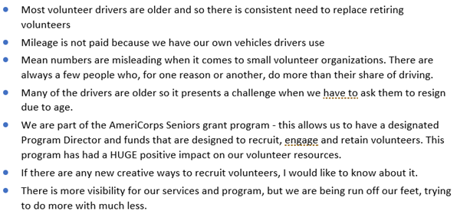
Figure 7 Selected Comments Discussing Challenges
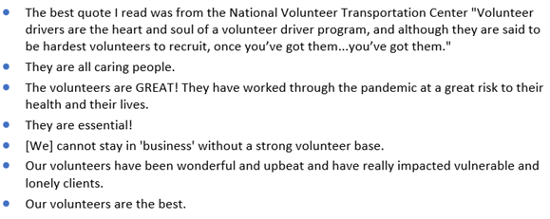
Figure 8 Selected Comments Discussing Importance of Volunteers
Chapter Conclusion
Over 80 percent of the organizations surveyed for this guidebook successfully use volunteers to provide essential transportation services to their communities. The mean age of 64 and median of 67 of the volunteer drivers reported by the respondents provides insight into one of the main challenges faced by the organizations in recruiting drivers. The greatest factors challenging this model of service delivery are demographics and economics.

Chapter 2 Addendum: Survey Implementation
Survey Development
The survey was based upon a similar instrument developed for a 2016-17 study in Minnesota, which focused on “documenting the organizations that use volunteer drivers to help meet the transportation needs of their clients, how they organize and fund their volunteer driver programs, and the challenges these organizations face in continuing to provide these services with volunteer drivers, including issues with insurance coverage.” (Douma, 2017). That study found that continued use of volunteer drivers in Minnesota faced two significant obstacles: a demographic issue of aging volunteers that were not being sufficiently replaced by volunteers from the next, smaller generation, and regulatory issues related to insurance and regulation of reimbursements. (Douma, 2017)
Both the original Minnesota survey and this survey were administered using the on-line survey instrument from Qualtrics. The original survey consisted of 40 questions and covered the following areas:

- Organizational information (location, type, funding, services offered, etc.)
- Information about volunteer drivers (number of drivers, age of drivers, length of service, number of trips, etc.)
- Operational questions (types of trips provided, reservation processes, whether trips are denied, etc.)
- Issues related to using volunteer drivers (insurance needs, reimbursement, etc.)
- Request for contact information if respondent was interested in a follow-up conversation

For this project, the Minnesota survey was adapted to reflect the national scope of this study, and input from the project panel. The following changes were made, bringing the total to 50 questions:

- Location information changed from Minnesota counties to U.S. States
- Questions removed related to specific Minnesota issues
- Question added about other volunteer work done in the organization
- Questions added about organizations that used to use volunteers, but do not do so at the time of the survey
- Questions added related to fare collection and volunteer recruitment
- Questions added specifically asking about the impact of the COVID-19 pandemic and plans for “post-pandemic” operations.

The survey was pilot tested with 10 colleagues of the researchers and students at the University of Minnesota’s Humphrey School of Public Affairs, all of whom are engaged in transportation planning and/or transportation research. Several of these people have specific experience in research related to this kind of “community-based.” transportation.
Survey Participant Recruitment
Despite the study title referring to “Rural Transit Systems,” the project panel encouraged the research team to seek responses from a wide variety of transportation providers, not just transit agencies. As a result, the primary source for recruitment was a list of 646 contacts from the Community Transportation Association of America (CTAA), which included transit agencies, but many other social service providers as well. After cleaning the list for duplicate e-mails and bad addresses (e.g. no longer in business or contact no longer with organization after checking the listed website, etc.), we uploaded 526 e-mail addresses for survey distribution. This initial set of surveys were sent out on February 25, 2021, at which time, Qualtrics reported 18 additional duplicate addresses, 10 additional addresses that “failed” (no such address), and 2 that “bounced” (returned), leaving an initial survey population of 498 possible respondents. Recipients were asked to respond by March 8, and reminders were sent on March 1, 4 and 8 to those that had not responded by that date. Of this initial population, 116 respondents started the survey, and 90 completed it.
Several steps ensued to further increase the responses. First, survey respondents provided e-mail addresses of 11 organizations that were not included in the initial CTAA list, three of whom ended up completing the survey. CTAA also included the survey link in their newsletter on March 22, which resulted in 16 additional responses. Finally, after a review of the initial results indicated that 9 states did not have any organizations responding, 44 contacts from those 9 states were specifically targeted in a final solicitation on April 8, which resulted in five more responses from four of those states. Ultimately, we received 114 completed responses. These results are shown in Table 2 below.
Table 2: Survey Recruitment and Response
 | Email addresses | Duplicate addresses | No such address | “Bounced” | Net addresses | Surveys started | Surveys completed
Initial list | 526 | 18 | 10 | 2 | 498 | 116 | 90
Added from respondents | 11 | 0 | 1 | 0 | 10 | 3 | 3
Follow up to states with no-response | 44 | 0 | 0 | 0 | 44 | 5 | 5
Link in CTAA newsletter | n/a | n/a | n/a | n/a | n/a | n/a | 16
Total | 537 | 18 | 11 | 2 | 598 | 124 | 114
Overall sample demographics
The 114 responses were collected from 45 states, with only Nebraska, Oklahoma, Rhode Island, Tennessee and Utah not responding. As Figure 9 shows, these states each had 3 or fewer organizations in the contact list, which may have as much to do with the lack of response as any policy, organizational or structural reason. Also, the list of organizations in our sample did not include any organizations listing addresses in Washington, D.C. or Puerto Rico. As the purpose of this survey was to obtain qualitative information about the experiences of a wide range of providers that may use volunteer drivers, this sample is neither random nor presented as being representative of all providers.
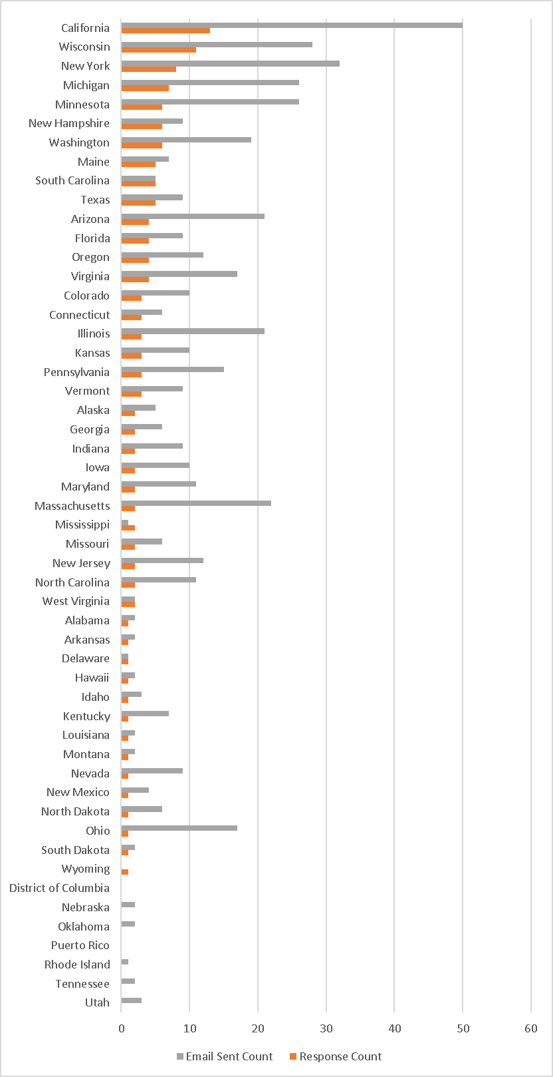
Figure 9 Response by State

Chapter 3: Describing the Volunteer Driver Challenge
A confluence of demographic, technological and regulatory trends have come together to reduce the number of potential volunteers available to volunteer transit providers, as well as their propensity to volunteer. Such challenges have had real consequences for these organizations, such as cancellations for client trips due to lack of drivers or in a few cases, transition to a model that does not use volunteers.
This chapter describes the challenges faced by organizations as they recruit new volunteers and retain valuable trained volunteers.
Without the population density to support public transit, most residents of rural areas and small towns drive, walk or bike. When driving is not an option but the trip cannot be made without a vehicle, hired transportation and community transportation services can be used to fill this gap. When low population density limits the market for hired transport such as taxis or Travel Network Companies (TNCs), community organizations may turn to volunteer drivers to supply this much needed service.
Such a service gap is at the heart of most volunteer driver programs. Understanding that transportation is a lifeline to accessing the requirements of everyday life (including health care, shopping, opportunities to observe one’s faith, the maintenance of social ties, etc.), many communities, particularly those in rural areas, have developed volunteer programs to provide transportation for people who are unable to drive in areas where public transit cannot be effectively provided.
The Douma/Minnesota study upon which this Rural Transit Study was based found that the continued use of volunteer drivers in Minnesota faced multiple significant obstacles: a demographic issue, wherein aging volunteers were not being sufficiently replaced by volunteers from the next, smaller generations; regulatory issues related to obtaining insurance and regulating reimbursements; competition from TNCs providing the same service; and static IRS reimbursement rates whose value had been eroded by inflation over time.
Based on Rural Transit Survey conducted for this guidebook, the project team concluded that similar factors were at play nationwide, which have dampened the volunteer recruitment potential of organizations. These factors included:
- Demographic shifts that have reduced the pool of potential volunteer drivers;
- Financial and funding limitations that have impacted the recruitment and/or retention of volunteers;
- State regulations that have imposed burdens on volunteers; and
- The Covid-19 pandemic, in the short-term.
Demographic Shifts in Volunteer Driver Recruitment Potential
Within the survey conducted for this guidebook, finding and retaining volunteer drivers was the greatest challenge for most respondents. 62 of 81 respondents (76.5%) indicated that “it was a challenge to find volunteer drivers,” and 64% of those (52 respondents) stated that they did not have enough drivers to meet demand. Furthermore, a vast majority of survey respondents concurred that they were having difficulties recruiting volunteers of all types (56 of 79 respondents), whether drivers or not.
When asked about the nature of their recruitment/retainment difficulties for the AECOM study, the majority of respondents (14) mentioned demographic issues: either that there were too few people available locally of volunteering age with enough time, or simply that the population in the area was shrinking / had already been very small.
The demographic issues related to the age of the volunteer pool were the most significant. Because current volunteers tended to be Baby Boomers, many of them were getting too old to safely drive (as reflected in the mean age of 64 for current volunteer drivers within surveyed organizations). Younger Gen X or Millennial volunteers would naturally be the choice to fill those positions, but organizations reported that they had trouble recruiting members of these age groups, as they generally needed to work/spend time with family, and did not have the time or financial resources to volunteer.
Interestingly, no respondents indicated that they could not meet demand due to lack of interest from younger drivers; only lack of available time. Respondents deemed their problem to be economic rather than driven by values – i.e. younger people were opting not to volunteer because they lacked the time due to work and family obligations, rather than because they did not believe it was their role to do so, or that the government or another entity should pay employees to provide this service. While the survey found that providing mileage reimbursement helped the recruitment of such younger people overall, even those organizations that could provide higher levels of reimbursement were not having a significantly easier time finding enough people.
Funding and Reimbursement Concerns
The second-highest set of responses (12) discussed the lack of time available to dedicate to recruitment, as well as recalcitrant issues such as lack of appropriate funding for recruitment and reimbursement of drivers. Such responses indicated that many organizations are facing larger structural and/or resource-related impediments to sourcing volunteers. When respondents were asked about challenges related to volunteer drivers in general, 21 cited financial concerns; furthermore, while funding for reimbursement of drivers was mentioned, overall operating expenses was mentioned more often.
64% of respondent organizations (52 of the 81) reported that they did reimburse drivers for mileage, which appeared to make a difference in recruiting drivers. As shown in Figure 2, however, 71% of respondents that did provide reimbursement still found recruiting volunteers to be a challenge, a number which greatly increased to 86% (25 out of 29) if they did not reimburse.

Figure 2: How Reimbursement Affects the Perception of Volunteer Recruitment Being a Challenge
Insurance and Other Regulatory Challenges
While not a key issue affecting recruitment potential of volunteer drivers in our survey, 7 survey respondents mentioned insurance issues related to retaining volunteer drivers, as being an impediment. It can be noted, however, that none mentioned the need to pay extremely high premiums as prohibitive, as was found in the Minnesota study. Five organizations also stated “regulatory concerns” (although one of these included “liability” and “insurance” as such regulatory concerns).
Short Term Effects From the COVID-19 Pandemic
Interestingly, and perhaps surprisingly, COVID-19 was not seen as a major long-term contributor to volunteer driver recruitment. While 4 organizations indicated they had stopped using volunteers during the pandemic, and though many respondents noted that the pandemic was an additional challenge, fewer than one in four believed the increased challenges would last past the pandemic. This was notable given that the COVID-19 pandemic was still a major factor when the survey was administered (between February and April of 2021), with vaccines not yet widely available.
While this indicated that that most organizations did not see the pandemic as a significant obstacle to their ongoing success, many did report that it had created short-term problems. 61 of 79 respondents (77%) stated that the pandemic had created additional difficulties in recruiting volunteers, though most (44 respondents, or 72%) believed that their recruitment levels would return to “normal” after the pandemic.
Those that believed they would not return to “normal” again cited some of the structural issues noted above (e.g., that their volunteer pool would have aged further), but also that volunteers’ perspectives towards the risk of being in close proximity with multiple unknown clients per day may have been permanently changed. In other words, they considered it likely that potential drivers may always now harbor an increased cautiousness about sharing their vehicle with people they did not know, and/or be more averse to risking infections.

Challenges for Volunteer Driver Organizations
Meeting demand
Finding and retaining volunteer drivers is a challenge for most of the respondents. 62 of 81 respondents (76.5%) indicated that “it is a challenge to find volunteer drivers,” and 52 (64%) of them stated that they do not have enough drivers to meet demand. When asked in an open-ended question about the nature of the challenge, answers varied: 15 cited COVID issues; 8 noted the challenges related to age of most volunteer drivers, as discussed above; 5 noted regulatory issues and 4 noted they were unable to provide enough compensation/reimbursement to attract and retain enough drivers. Interestingly, despite the age challenge, no respondents indicated that they could not meet demand due to lack of interest from younger drivers.
Cancelled Trips
The challenges respondents have encountered in recruiting and retaining volunteer drivers has had real consequences, in the form of trips being cancelled due to lack of drivers. 45 of 75 respondents (60%) indicated that they have had to cancel trips for this reason, with an average of 11 trips cancelled each month for each of the 44 organizations that provided an estimate, which works out to 484 trips per month, and just over 5800 trips per year, just among this sample. One organization reported cancelling over 100 trips (although this organization stated they provide over 10,000 trips per month), and 6 reported only cancelling one trip. The trip cancellations are skewed, however, with 2 organizations reporting 172 of the 484 trips cancelled and leaving the median number of cancelled trips at only 5 per respondent. Of the trips that were reported cancelled, 35 reported cancelling non-medical trips, and 32 reported cancelling medical trips (respondents could choose both answers).
Reimbursement
Respondents were asked about challenges related to volunteer drivers in general, and provided with specific answers: money, Insurance, regulatory concerns and “other.” In this case, the most respondents (24), chose “other,” but only three cited COVID here. More common “other” answers related to the nature of operating with volunteer drivers, including availability of drivers, and timing and need to train them. Of the 3 choices offered, 21 cited financial concerns, but while reimbursement of drivers was mentioned, overall operating expenses were mentioned more often. Seven respondents mentioned insurance, although none mentioned the need to pay the highest possible premiums, as was found in the Minnesota study (Douma, 2017), and only one mentioned “specific requirements. Five stated regulatory concerns, although one of these mentioned “liability” and “insurance” as regulatory concerns.
Regarding reimbursement issues, 52 of the 81 responding organizations (64%) reported that they do reimburse driver mileage, which appears to make a difference in recruiting drivers. As shown in Figure 5, 71% of respondents that do provide reimbursement find recruiting volunteers to be a challenge, but if they do not reimburse, the figure rises to 86% (25 out of 29).

Figure 10: How Reimbursement Affects the Perception of Volunteer Recruitment Being a Challenge
While this may be expected, examining the reimbursement rates reveals that the amount of reimbursement does not appear to correlate with the ability to recruit volunteers. As shown in Figure 6, more than 70% of those using the higher federal business rate (13 of 18) or using a non-federally defined rate (14 of 17), indicate that finding volunteers is a challenge. However, of those using the lower federal charitable rate, only 50% (7 of 14) indicated difficulty recruiting volunteers.

Figure 11: How Reimbursement Rates Affect the Perception of Volunteer Recruitment Being a Challenge
Another way organizations can reimburse volunteers is for “no-load” mileage, i.e. reimburse drivers for the miles they drive on their way to pick up the client, and returning home after completing the client’s trip. Of the 52 organizations that provide reimbursement, 44 do so for no-load miles as well as miles with the client. However, offering no-load reimbursement does not appear to attract more volunteers, as 73% of the organizations offering no-load miles (32 of 44) reported challenges finding volunteers, and only 63.5% (5 of 8) reported similar issues.

Chapter Conclusion
From the Rural Transit Survey results, it was concluded that the two greatest issues facing organizations wishing to recruit volunteer drivers were demographic and economic. While previous studies had noted lower reimbursement rates, insurance, and other government regulations as potential problems, very few respondents in the survey indicated these as actual impediments. Furthermore, there did not appear to be significant trends based upon the size of the organization, nor its geographic location.
Thus, it appears that larger, structural issues related to generational shifts and sufficiency of funding are having the most burdensome impacts upon these organizations. Though these are difficult issues to solve without long-term planning and strategy, in Chapter 4, this Guidebook will offer potential options for improving the recruitment and retainment of these greatly-needed volunteers.

Chapter 4: Options for Recruiting and Retaining Volunteers
When asked about ease of recruiting volunteers, 56 of 79 respondents stated they were having difficulties recruiting volunteers of all types. When asked about the nature of their difficulties, most (14) mentioned demographic issues: too few people in their local area with enough time, because previous volunteers are getting too old, younger volunteers need to work, or simply the population in the area is shrinking or was very small to begin with. The second-highest set of responses (12) discussed the lack of time dedicated to recruiting or similar issues that indicated the organization faced some similar structural and/or resource impediment to finding enough volunteers. Only 7 respondents mentioned the COVID-19 pandemic.
This chapter describes ways that volunteer programs might increase their recruitment and retention of volunteers. The value of multiple methods of recruiting, use of online sources, and use of volunteer coordinators is highlighted.
While the lack of mentions of the pandemic indicates that that most organizations did not see it as a significant obstacle to their long-term success, it did create short-term problems. 61 of 79 respondents (77%) stated that the pandemic had created additional difficulties in recruiting volunteers. 44 of these respondents (72%) believed the issues would be short term, expecting that their recruiting will return to “normal” after the pandemic. Those that believed they will not return to “normal” again cited some of the structural issues noted above (e.g. their volunteer pool will have aged further), but also that volunteers’ perspectives will be permanently changed (i.e. they will be more cautious about sharing their vehicle with people they do not know, or simply more averse to risking infections).
Interestingly, eight respondents stated that the pandemic had made recruiting easier, and follow up conversations indicated that this was due to some volunteers having more time, duties changed to even more attractive options (e.g. delivering to clients rather than driving them on errands), or simply that the number of volunteer opportunities dropped more than the number of volunteers did, leaving them with more volunteers relative to opportunities.
Finally, we asked if these organizations had volunteer coordinators to help manage their volunteers. 64 of 87 respondents (87%) indicated that they did. Most of these (64 respondents) included coordinators as part of their paid staff, ranging from 1/3 of a full-time position to 6 full time employees. 9 other organizations include a volunteer coordinator as an unpaid volunteer position. This group is particularly notable as they appear to have less difficulty recruiting volunteers (only 55% of respondents vs. 70% in the other two categories), as shown in Table 3.

Table 3 Difficulty Finding Volunteers by Use of Volunteer Coordinators
 |  | Use Volunteer Coordinator
 |  | Paid Volunteer Coordinator | Unpaid Volunteer Coordinator | No Volunteer Coordinator
Difficulty Finding Volunteers | Yes | 70% (45) | 55% (5) | 71% (10)
 | No | 30% (19) | 45% (4) | 29% (4)

Solutions to the difficult problem of recruiting and retaining volunteer drivers may lie in qualitative, rather than quantitative data: from the survey conducted for this guidebook, it became clear that the most successful organizations focused on serving their volunteers as well as their clients.
Most respondents were effusive in their praise of, and need for, volunteers to fulfill their mission and work. While many respondents noted the challenges of finding enough money and time to recruit volunteers, the most successful organizations achieved success by focusing on their volunteers first and foremost. These organizations found non-transportation grants and other funding to support activities that built community and other connections between the volunteers, and between the volunteers and the organization. As a result, the volunteers wanted to continue to be part of the organization, and also to serve as recruiters of other volunteers, creating a virtuous cycle that ultimately benefited the organization’s clients, as they received high quality rides when they needed them.
Recruiting methods
Difficulty finding recruits is not for lack of effort. When offered the options shown in Figure 7, the 82 organizations that responded provided 347 answers (respondents could choose more than one option), an average of more than 4 efforts per respondent. The most traditional, personal contacts (72 respondents) and most recent, social media (69 respondents) being the most popular. No option was chosen fewer than 20 times. Among the “other” options, respondents noted recruiting at church and other faith-based organizations 6 times, word of mouth referrals 5 times and presentations to other community groups 4 times.
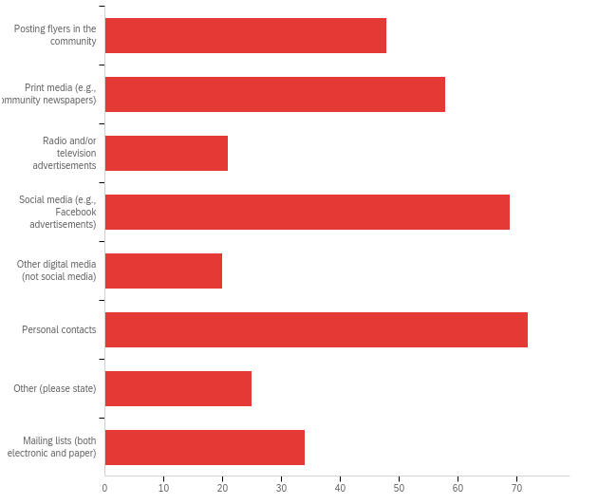
Figure 7: Recruiting Methods Used by Respondents
Figure 8, however, shows that there is little pattern regarding which methods are more effective. When compared against respondents indicating that they do not find recruiting volunteers to be a challenge, those used least often appear to have the highest percentage of use by those that are finding enough volunteers. For example, radio and television advertisements, along with “other digital medial (not social media)” are used by nearly 35% of respondents that have enough volunteers, but those were the least selected options overall (21 and 20 responses, respectively), so the number of “successful” organizations choosing them is comparatively small as well: only seven respondents in each case. While social media comes as close as any option to the “sweet spot” of being used by the largest number of “successful” organizations and those organizations make up a significant percentage of all respondents using that strategy (19 “successful” respondents making up nearly 30% of all respondents), perhaps the best lesson here is that there is no one or two “magic” strategies, and all organizations need to dedicate significant efforts into a wide range of recruiting strategies to successfully recruit enough volunteers.

Figure 12: Effectiveness of Recruiting Strategies, as measured by number of respondents that are finding enough volunteers, and percent of total respondents
Ideas for Recruiting and Retention
How can it be that the propensity to volunteer is on the rise, as discussed in Chapter 2, but organizations such as those in this study’s survey report difficulty finding and retaining volunteers? While the deceleration of the overall population’s growth plays a role, an additional factor suggested in the literature is that the nature of volunteers has changed. Recent research on volunteering summarized exhaustively by Susan Chambre (see footnote), has found that while “altruistic and communally oriented reasons for volunteering remain strong…..there has been an increase in relational motives—namely, volunteering motivated by giving back to an organization that has beneﬁtted an individual and or his or her family…..The shift in motives for volunteering can also be explained by sharp declines in generalized and political trust …It is possible that more people are turning to organizations and causes to which they have a personal connection, a connection arising from their knowledge that the organization or cause is trustworthy”. The population pool that supplies volunteers has become more generationally and culturally diverse in recent decades; future research on how these factors affect recruiting and retention would help inform these efforts.

With the survey results and literature as background, some recruiting and retention strategies include:

Recruiting
- Reach out to people who know the work of your organization. Family members or neighbors who see the value of the transportation program in their own inner circle. They already know the value of the organization.

- Use multiple ways methods as different generations search differently.

- Include online notices in your call for volunteers. Both the survey for this guidebook and the survey results shown in Figure 13 highlight the value of this outreach method.
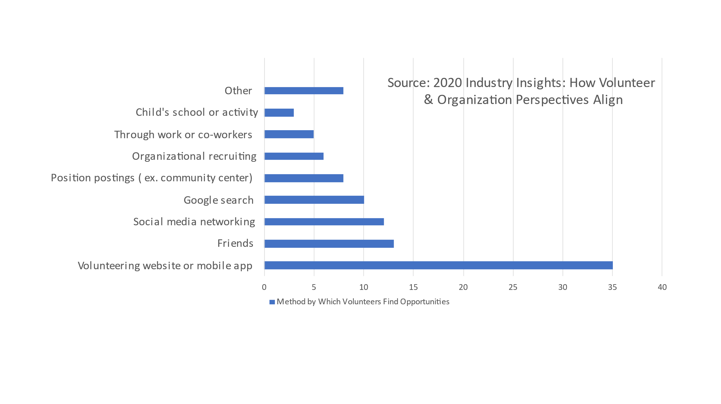
Figure 13 Methods Used by Volunteers to Find Opportunities

Retention
- Probably the best suggestion comes from the comments made to the survey instrument about the use of volunteer coordinators. They are able to communicate the value of the work performed by the volunteers and keep the mission front and center in the organization. It also strengthens the personal connection between the volunteer and the organization. These themes were identified in the survey conducted for this guidebook but also identified in the literature on volunteering as highlighted in Figure 14.

Figure 14 What Part of the Volunteer Experience Keeps People Coming Back

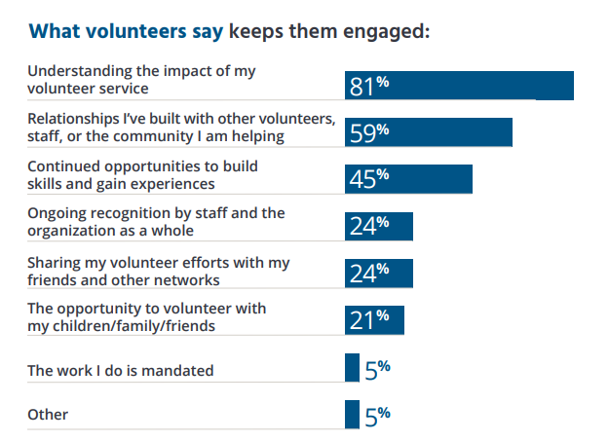

Chapter 5: Volunteer Program Business Model Components
Overview
Transportation service providers that use volunteers create their programs to address an unmet community demand for transit service. As a home-grown solution to a local need, the framework for volunteer use varies widely. Variations in the type of demand served—the who, where, why, and when—in turn, influence the choices for volunteer service delivery. Programs vary by a variety of factors such as service area, trip purpose(s), rider eligibility, hours of coverage during the week (e.g., weekdays and/or weekends), type of agency operating the program, size of volunteer program, whether volunteers are reimbursed, amount of program funding, additional services provided, etc. (see Figure 15). This variety is demonstrated in the mix of respondent types to the survey conducted for this study and in the comprehensive resources provided by the Rural Health Information Hub, “Rural Transportation Toolkit.”
This chapter describes the various ways that volunteer programs organize themselves, and the factors that influence the business model selected for a volunteer service program.

Figure 15 Demand Factors Influence Selection of Volunteer Business Model Components
Demand Factors
Volunteer Business Model Components

Types of Models
This section describes different ways that volunteer transportation services have organized to provide services. While some programs mostly align with one model, there are many services that could be considered “hybrid” models, which combine attributes of the categories outlined below.
Volunteering Without Reimbursement for Time or Mileage
This model is closest to a traditional volunteer arrangement. Individuals act as volunteers in contributing their time, and as donors by contributing resources, driving their own vehicles and providing their own gasoline without receiving any type of reimbursement. For such a program an organizer recruits a group of volunteers and assigns trips from its driver pool. Volunteers may play other roles in the organization as well, such as supporting recruitment and dispatch.
Volunteering with Mileage Reimbursed
This model is similar to the traditional model; volunteers provide their time without remuneration, but they are compensated (fully or partially) for the direct costs of providing the transportation service on a per mile basis. Drivers track their mileage or trip history in order to receive reimbursement. The amount of reimbursement varies by program – some programs may reimburse in accordance with the government's mileage reimbursement rate, others pay a lesser rate, and others pay volunteers per trip with a cap.
Trip Banking/Time Banking
This approach differs from a traditional model in that volunteers can bank the time spent providing services. The intuition is that the organization runs as a co-operative for transportation services. For example, a volunteer who spent an hour providing transportation for someone can claim an hour of transportation for their own use at another time, or may donate their earned hour to someone else. Some programs allow volunteers to exchange hours driven for other goods or services, like housekeeping or financial services. Partners in Care (in Maryland) is an example of a program using this model.
Mobility on Demand
In this model, the volunteer program is typically partnered with other organizations or a wider range of services under a single organizational umbrella. Mobility on Demand models integrate and connect multiple modes and services within a community, with an organization working as a hub for scheduling and coordinating across programs. Typically, these services are implemented using smartphone technology or payment apps. This approach can be more challenging in rural areas with limited cell coverage or when serving older clientele that are less comfortable with smartphones. Success in this model requires partnerships between the volunteer program and service providers such as veterans service groups, community health groups, or senior centers for example.
Voucher Models
Under the voucher model, the volunteer organization is compensated for each trip; some of this payment may be shared with the volunteer or used to cover other expenses. The voucher is a ticket or QR code that eligible riders (defined by the program’s sponsors and funding sources) use to pay for rides. The voucher may be provided to the rider for free or at a reduced cost relative to the monetary value of the voucher. For example, riders might purchase a $10 trip voucher for $5. Given the difficulty of making change with vouchers, some programs utilize a smart card in the place of a voucher. After the trip is completed and the voucher expended, the transportation provider is reimbursed by the funding sponsor. Some voucher systems allow the passenger to select from multiple providers; other programs require the use of a single program. Success in this model requires partnerships.
Chapter Conclusion
Transportation service models that use volunteers develop and adapt to local conditions and needs; as a result, the way they are organized to provide service varies widely. Variations in the type of demand served—the who, where, why, and when—in turn, influence the choices for volunteer service delivery. Volunteer programs are not static in their form; as they mature, they gain partners and greater experience in acquiring and managing funding sources.

Chapter 6: Volunteer Program Funding Transitions
Overview
Although volunteers are not paid for their labor (though some are compensated for expenses), their use in providing transit trips is not free—neither to the individual volunteer nor to the organization utilizing the volunteer’s services. If volunteering were free to the organization, presumably more organizations would utilize this resource, particularly when a community had unmet demand for public transit service. The study team, however, found both organizations that did not use volunteers and those that had used volunteers in the past but had discontinued that practice.
This chapter describes candidate funding sources that can provide temporary or sustained support for volunteer programs delivering public. transportation services.
Survey Respondents NOT using volunteers
Of the 114 surveys collected, 104 respondents answered the question about whether they used volunteers. Twenty (20) of these indicated that they do NOT use volunteers. Of these, 13 indicated that they had never used volunteers, at which point they were thanked for their time and taken to the end of the survey. Seven respondents indicated they used volunteers in the past, but no longer do so. Of these, 3 stated they stopped using volunteers because they were no longer able to find and retain volunteers, and 4 respondents specifically cited the COVID-19 pandemic as the reason for no longer using volunteers. This small number of respondents—just 2.6 percent of respondents--indicating they are no longer able to find and retain enough volunteers indicates a strong dedication to using volunteers despite the challenges discussed below.
Costs to Individual Volunteer
On the volunteer’s side, their costs are the value of time spent performing unpaid labor and any direct costs incurred if the volunteer’s own vehicle is used but not (or only partially) reimbursed by the organization. The value of time from the volunteer’s perspective can be assessed by the opportunity cost of volunteering—the value of what the volunteer could be doing if not providing public transportation services to the community. Because volunteers vary in their employment status and wage rates, a generalized value of time is useful in these applications. Two values are considered in this study; $10 (as directed by the research panel) and $21.65, the average wage for bus driving occupations in rural and intercity bus industry. In reality, each volunteer has their own reservation wage, understood to be the least amount of money a person would consider working for in a particular position or type of employment.

Using values drawn from the survey about volume of trips delivered and length of trip, the value of service delivered by the drivers at the volunteer organizations responding to just this survey is between $14,128,000 ($10/hour) and $30,587,000 annually. The value of all volunteer services is higher as this estimate omits volunteers in other positions needed to deliver the transportation service such as dispatchers. The estimate is provided to illustrate the amount of funding needed to replace the volunteers with paid employee drivers.
Costs to Organization Using Volunteers
From the organization’s perspective, multiple costs exist when utilizing volunteers to provide public transportation service. While costs vary for each program, they may typically include:

Recruitment costs—costs to advertise or post program descriptions to recruit volunteers. Also, costs associated with onboarding volunteers, such as background checks if conducted.
Training—cost of time and materials required to train program volunteers. These costs can be significant, as the volume of training is higher than with permanent paid employees. Volunteer turnover tends to be higher, and given that most volunteers work a partial week, more people are required to cover a week of service than if full-time employees provided the service.
Management costs—costs of coordinating the day-to-day activities of the volunteers—scheduling, making assignments and following up. There can be hidden costs for the organization here. These costs may be captured by the salary for a volunteer coordinator but may miss the management time of staff in other parts of the organization spent training or coordinating volunteers. As with training costs, management costs tend to be higher with volunteers than with permanent employees.
Physical space—cost of providing office space, telephones and other overhead for the volunteer program. This may include lockers for volunteers’ personal items or a “break room” for drivers between scheduled trips. Coffee, beverages, or other amenities may also add to the cost.
Recognition—Volunteers frequently offer their time to drive or perform other functions in a transit organization because they feel a sense of mission and believe in the organization. Some programs may thus have quarterly or annual meetings to recognize volunteer contributions, which may also include printed or electronic newsletters or announcements. That connection is essential to retaining volunteers and building a program. Investments to address this category of costs can reduce training and management costs over time.
Equipment and software—costs to provide software to manage volunteers and equipment that may be used to communicate with drivers in the field.
Reimbursement—Some programs may choose to reimburse volunteer drivers who use their own vehicles for the cost of vehicle operations. This reimbursement may be for the full or partial cost of trips provided.
Insurance—Many programs purchase insurance coverage for their volunteers. Depending on the organization, this may include accident and illness insurance or workers’ compensation insurance, as well as auto insurance if volunteers drive their own cars, and additional liability insurance, depending on the work that the volunteers do.
The mix of the cost categories listed above will vary by program and delivery model.

The following section outlines different types of funding sources used to fund volunteer transportation programs and provides a wealth of information regarding funding resources for volunteer and rural transit driving programs (see Table 4). This mix of sources may change over time and can be used to fund a transition toward greater reliance on volunteers, or to transition away from a volunteer model and toward one delivered by fully paid professional staff reliant on traditional transportation funding sources.
Candidate Funding Sources for Supporting Volunteer Programs
Volunteer transportation programs are best supported by a variety of funding sources; indeed, research has shown that the most resilient programs are supported by three or more sources. Eligible funding sources are influenced by the type of organization providing the service, by the types of trips provided, and by location. The type of organization also influences eligibility for fund receipt. The funding mix can change over time.
Volunteer Service as Funding Match
In the context of program funding, some programs permit the value of volunteer service to be counted as match against overall program funding. This approach can expand available resources for the overall program.
Chapter Conclusion
Although volunteer programs allow transit service providers to offer services at a lower cost, and serve markets that would otherwise go unserved, these programs do have cost, and they can be significant. Thankfully, a variety of governmental and non-governmental programs are available to support such costs.
Furthermore, the most sustainable programs are supported by three or more funding sources. Some programs, such as Portland’s “Ride Connection Service” have a large portfolio of funders that includes corporate donors. These relationships are built over time and rely on a variety of partnerships across the community.

Table 4 Volunteer Driver Transit Program Funding Programs

Source | Program | Eligibility | Restrictions | Notes
Government
Centers for Medicare & Medicaid Services (CMS) | Medicaid Non-Emergency  Medical Transportation | Medicaid non-emergency medical transportation (NEMT) is an important benefit for beneficiaries who need to get to and from medical services but have no means of  transportation. The Code of Federal Regulations requires States to ensure that eligible, qualified Medicaid beneficiaries have NEMT to take them to and from providers. | States can also contract with independent transportation providers. Providers must be qualified to provide the transportation under applicable State law.  These transportation providers may include State-approved volunteers.  Trips must be for medical services. States vary in other restrictions such as needing prior approval or determination of need. | Accessed: https://www.cms.gov/Medicare-Medicaid-Coordination/Fraud-Prevention/Medicaid-Integrity-Education/Downloads/nemt-booklet.pdf
Federal Transit Administration (FTA) | Enhanced Mobility of Seniors & Individuals with Disabilities - Section 5310 | Provides formula funding to states for the purpose of assisting private non-profit groups in meeting the transportation needs of older adults and people with disabilities when the transportation service provided is unavailable, insufficient, or inappropriate for meeting these needs. Funds are apportioned based on each state’s share of the population for these two groups. Formula funds are apportioned to direct recipients. For rural and small urban areas, this is done by the state Department of Transportation, while in large urban areas, a designated recipient is chosen by the governor. Direct recipients have flexibility in how they select sub-recipient projects. Volunteer programs are considered non-traditional recipients. | Section 5310 funds are available to the states during the fiscal year of apportionment plus two additional years (total of three years).  A match is required. The federal share of eligible capital costs may not exceed 80 percent, and 50 percent for operating assistance. The 10 percent that is eligible to fund program administrative costs including administration, planning, and technical assistance may be funded at 100 percent federal share. | https://www.transit.dot.gov/funding/grants/enhanced-mobility-seniors-individuals-disabilities-section-5310  Proactive organizations using this funding have worked with their local Metropolitan Planning  Organization (MPO) or RPO (the direct recipient) to have the Volunteer Transportation program  included in the local Coordinated Transit-Human Services Transportation Plan, to further establish the program’s eligibility for future Section 5310/5311 funding that is managed by the MPO/RPO.
Federal Transit Administration (FTA) | Formula Grants for Rural Areas Program (Section 5311) | Eligible recipients include states and federally recognized Indian Tribes. Sub-recipients may include state or local government authorities, non-profit organizations, and operators of public transportation or intercity bus service. Organizations that use volunteers are eligible subrecipients. | The federal share is 80 percent for capital projects, 50 percent for operating assistance, and 80 percent for Americans with Disabilities Act (ADA) non-fixed route paratransit service. Section 5311 funds are available to the States during the fiscal year of apportionment plus two additional years (total of three years). Funds are apportioned to States based on a formula that includes land area, population, revenue vehicle miles, and low-income individuals in rural areas. | Proactive organizations using this funding have worked with their local Metropolitan Planning  Organization (MPO) or RPO (the direct recipient) to have the Volunteer Transportation program  included in the local Coordinated Transit-Human Services Transportation Plan, to further establish the program’s eligibility for future Section 5310/5311 funding that is managed by the MPO/RPO.
U.S. Department of Veterans Affairs | Veterans Transportation Service (VTS) | Veteran Service Organizations (VSOs)  Local and national non-profit groups  Federal, state and local transportation services |  | Details on the VTS program and volunteers are available at: file:///C:/Users/horstt/Downloads/1695_D_2019-09-18.pdf
U.S. Department of Veterans Affairs | Highly Rural Transportation Grants (HRTG) | Veteran Service Organizations (VSOs) or State Veteran Service Agencies and operating in an area with population density of 7 or fewer persons per sq. mi. | Grants are typically $50,000 and recipients must sign a grant agreement stipulating reporting requirements and other program requirements. | https://www.va.gov/healthbenefits/vtp/index.asp
Transit Districts | Varies | Varies |  | Some transit districts partner with volunteer transportation organizations to meet gaps in service. This is a more prevalent model in urban areas, although the RTAP Community Rides program supports rural partnerships.
Americorps | AmeriCorps Seniors RSVP | Provides grants to organizations with a dual purpose: to engage Americans 55 years and older in volunteer service to meet critical community needs, and to provide a high-quality experience for the volunteers. |  | https://www.americorps.gov/partner/how-it-works/americorps-seniors-rsvp  https://www.americorps.gov/funding-opportunity/fy-2023-volunteer-generation-fund
Americorps | Volunteer Generation Fund | Provides grants for volunteer coordinators. | Minimum award of $100,000  One-time award to enhance recruitment | FY 2023 Volunteer Generation Fund | AmeriCorps
Non-Government
Rider Contributions | ---- | ----- | ----- | Some funding programs prevent riders from paying a fare but often permit a voluntary donation.
Corporate Donors | Multiple | Varies | Varies | For example, Ride Connection in Oregon receives funding from PGE Oregon, Fred Meyer, and the Westinghouse Foundation. Accessed: Portland Community Partners | Ride Connection
Local Community Service Groups | Varies with location | Varies with location | Varies with location | United Way and Rotary and Kiwanis Clubs, and service organizations such as the American Red Cross and the American Cancer Society

Non-Profit Grants | Varies over time | Varies over time | Varies over time | Non-profit organizations update their giving objectives annually. These non-profits have funded transportation in the past: The Harry and Jeanette Weinberg Foundation, the Helen Andrus Benedict Foundation, the Retirement Research Foundation, the Winter Park Health Foundation and the Archstone Foundation. The State Farm Foundation is another source.

Appendix 1: TRB Volunteer Driving Survey
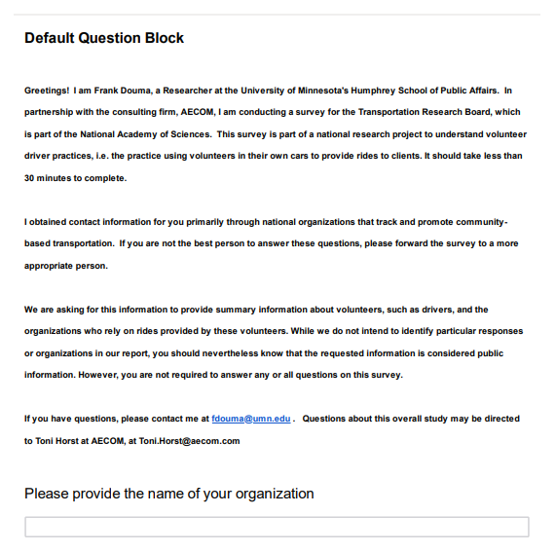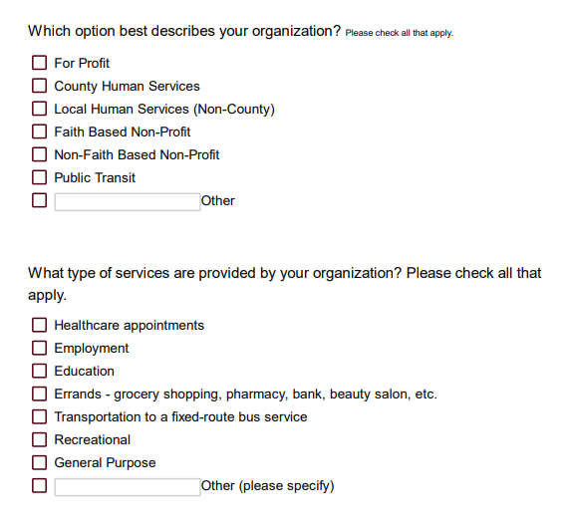
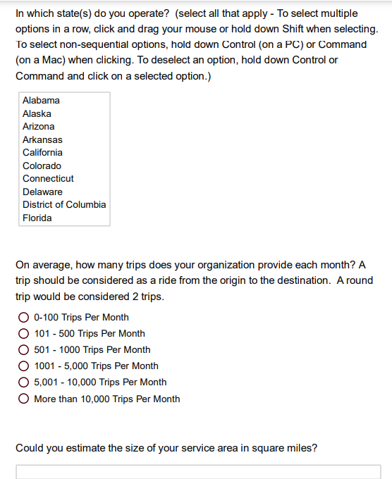
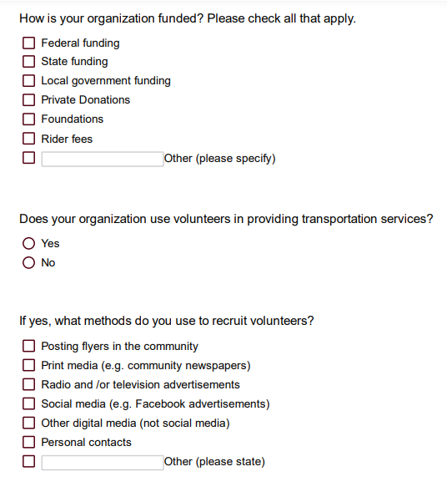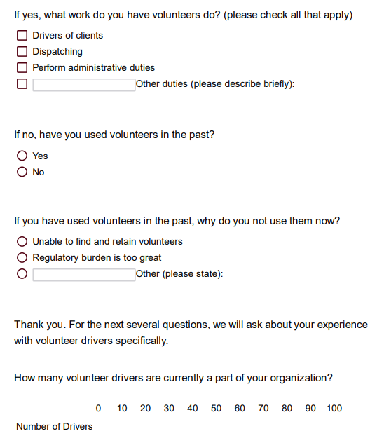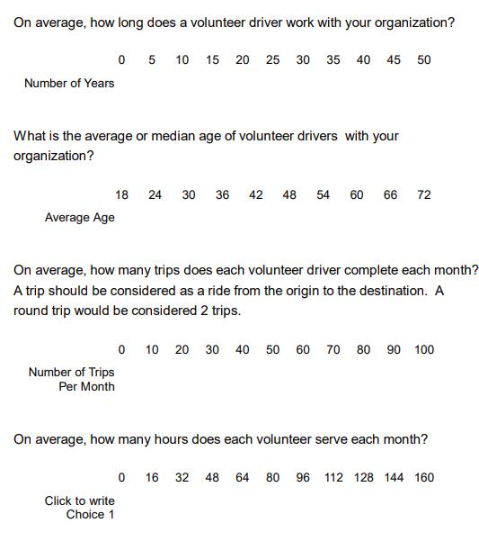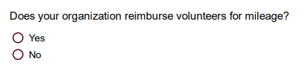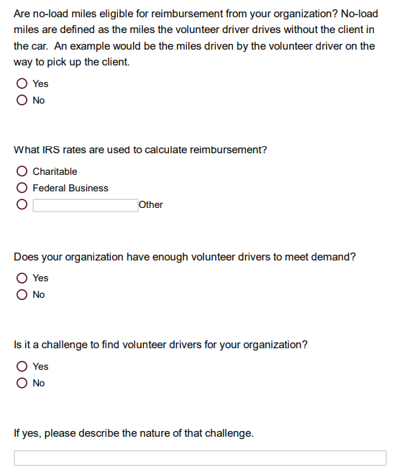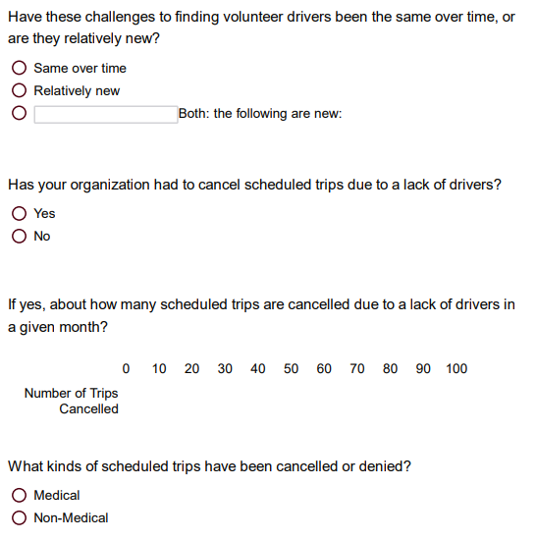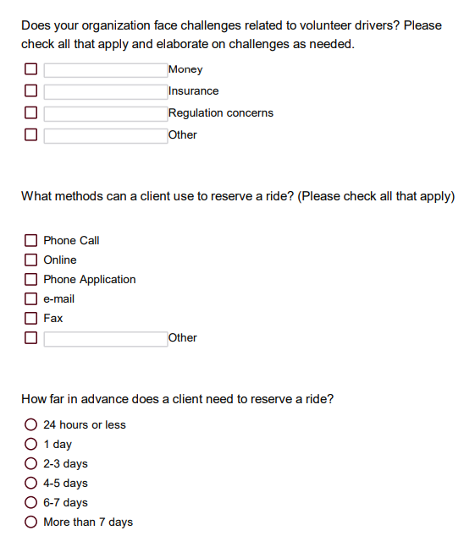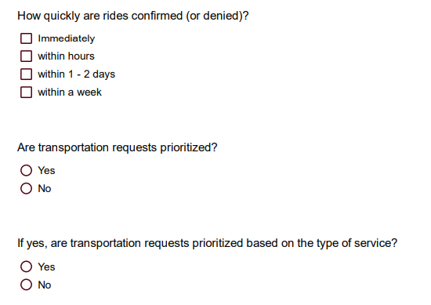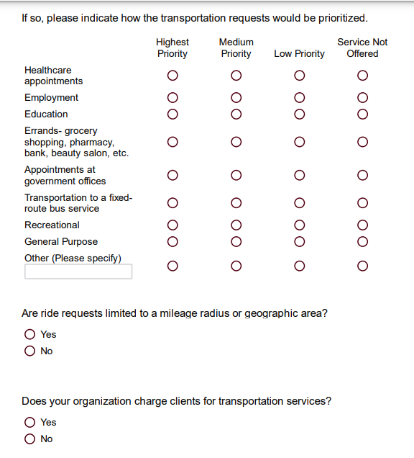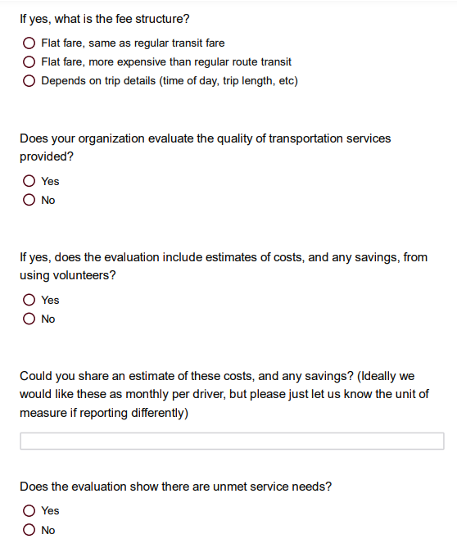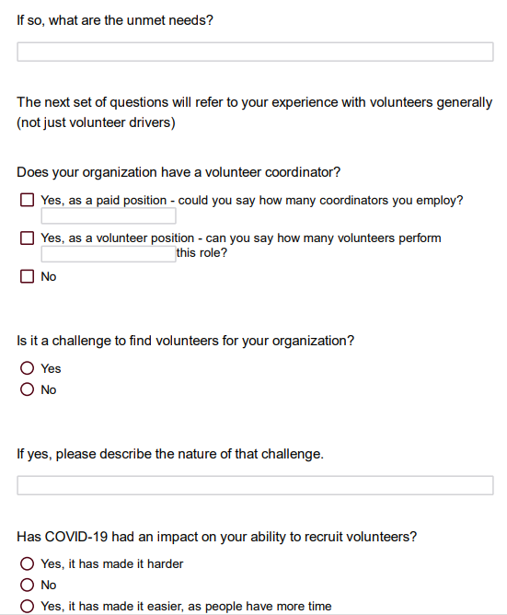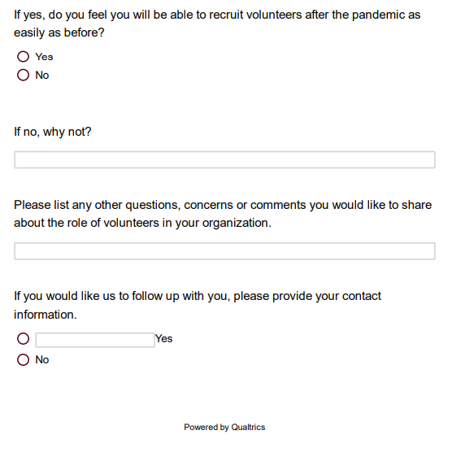
Appendix 2: Task 78 “Rural Transit Survey” Report
Introduction
This survey was developed as part of National Cooperative Highway Research Program (NCHRP) project 20-65, Task 78, “Impact of Decline in Volunteerism on Rural Transit Systems.” Without the population density to support public transit, most residents of rural areas and small towns drive, walk or bike. When driving is no longer an option or when the trip cannot be made by walking/biking, hired transportation and community transportation services fill the gap for those without family members able to help make the trip. Low population density limits the market for hired transport (taxi or TNCs) options in many places. Volunteer drivers supply this much needed service when the market does not support its provision.
A confluence of demographic, technological, and regulatory trends have come together to reduce the number of potential volunteers and propensity to volunteer. Some of these factors include: A demographic shift in that there are fewer people in Generation X than in the older Baby-Boom population, reducing the pool of potential volunteer drivers; Competition from Transportation Network Companies (TNCs) for providing the same service; Static IRS reimbursement rates whose value has been eroded by inflation over time; and State regulations that impose burdens on volunteers (such as insurance requirements in Minnesota for example). To obtain some quantitative measure of the impacts of these changes, as well as additional qualitative data to further flesh out the issues faced by these organizations, a survey was developed and administered to organizations using volunteer drivers.
Method
Survey Development. This survey was based upon a similar instrument developed for a 2016-17 study in Minnesota, which focused on “documenting the organizations that use volunteer drivers to help meet the transportation needs of their clients, how they organize and fund their volunteer driver programs, and the challenges these organizations face in continuing to provide these services with volunteer drivers, including issues with insurance coverage” (Douma, 2017). That study found that continued use of volunteer drivers in Minnesota faced two significant obstacles: a demographic issue of aging volunteers that were not being sufficiently replaced by volunteers from the next, smaller generation, and regulatory issues related to insurance and regulation of reimbursements (Douma, 2017).
Both the original Minnesota survey and this survey were administered using the on-line survey instrument from Qualtrics. The original survey consisted of 40 questions and covered the following areas:

- Organizational information (location, type, funding, services offered, etc.)
- Information about volunteer drivers (number of drivers, age of drivers, length of service, number of trips, etc.)
- Operational questions (types of trips provided, reservation processes, whether trips are denied, etc.)
- Issues related to using volunteer drivers (insurance needs, reimbursement, etc.)
- Request for contact information if respondent was interested in a follow-up conversation

For this project, the Minnesota survey was adapted to reflect the national scope of this study, and input from the project panel. The following changes were made, bringing the total to 50 questions :

- Location information changed from Minnesota counties to U.S. States
- Questions removed related to specific Minnesota issues
- Question added about other volunteer work done in the organization
- Questions added about organizations that used to use volunteers, but do not do so at the time of the survey
- Questions added related to fare collection and volunteer recruitment
- Questions added specifically asking about the impact of the COVID-19 pandemic and plans for “post-pandemic” operations.

The survey was pilot tested with 10 colleagues of the researchers and students at the University of Minnesota’s Humphrey School of Public Affairs, all of whom are engaged in transportation planning and/or transportation research. Several of these people have specific experience in research related to this kind of “community-based.” transportation.
Participant Recruitment
Despite the study title referring to “Rural Transit Systems,” the project panel encouraged us to seek responses from a wide variety of transportation providers, not just transit agencies. As a result, the primary source for recruitment was a list of 646 contacts from the Community Transportation Association of America (CTAA), which included transit agencies, but many other social service providers as well. After cleaning the list for duplicate e-mails and bad addresses (e.g. no longer in business after checking the listed website, etc.), we uploaded 526 e-mail addresses for survey distribution. This initial set of surveys were sent out on February 25, 2021, at which time, Qualtrics reported 18 additional duplicate addresses, 10 additional addresses that “failed” (no such address), and 2 that “bounced” (returned), leaving an initial survey population of 498 possible respondents. Recipients were asked to respond by March 8, and reminders were sent on March 1, 4 and 8 to those that had not responded by that date. Of this initial population, 116 respondents started the survey, and 90 completed it.
Several steps ensued to further increase the responses. First, survey respondents provided e-mail addresses of 11 organizations that were not included in the initial CTAA list, three of whom ended up completing the survey. CTAA also included the survey link in their newsletter on March 22, which resulted in 16 additional responses. Finally, after a review of the initial results indicated that 9 states did not have any organizations responding, 44 contacts from those 9 states were specifically targeted in a final solicitation on April 8, which resulted in five more responses from four of those states. Ultimately, we received 114 completed responses. These results are shown in Table 5: Survey Recruitment and Response below.

Table 5: Survey Recruitment and Response
 | Email addresses | Duplicate addresses | No such address | “Bounced” | Net addresses | Surveys started | Surveys completed
Initial list | 526 | 18 | 10 | 2 | 498 | 116 | 90
Added from respondents | 11 | 0 | 1 | 0 | 10 | 3 | 3
Follow up to states with no-response | 44 | 0 | 0 | 0 | 44 | 5 | 5
Link in CTAA newsletter | n/a | n/a | n/a | n/a | n/a | n/a | 16
Total | 537 | 18 | 11 | 2 | 598 | 124 | 114
Results
Overall sample demographics
114 responses were collected from 45 states, with only Nebraska, Oklahoma, Rhode Island, Tennessee and Utah not responding. As Figure 1 shows, these states each had 3 or fewer organizations in the contact list, which may have as much to do with the lack of response as any policy, organizational or structural reason. Also, the list of organizations in our sample did not include any organizations listing addresses in Washington, D.C. or Puerto Rico. As the purpose of this survey was to obtain qualitative information about the experiences of a wide range of providers that may use volunteer drivers, this sample is neither random nor presented as being representative of all providers.
Figure 1: Response by State
Figure 2 next shows that none of the respondents represented a “for profit” entity, and only 9 (7.8%) represented public transit agencies. Instead, a majority (65 respondents, or 56.5%) were non-faith-based non-profits.

Figure 2: Organization Type
These organizations receive funding from all possible sources, as shown in Figure 3, with private donations being most common (82 respondents) followed closely by government funding sources (70 respondents noted receiving funding from local government, 65 from the federal government, and 61 from state government), and foundations (57 respondents). Only 35 collect fares from the riders. (Respondents could select more than one option on this question.)

Figure 3: Funding Sources
Of the 25 “other” sources of funding listed, most common were specific grants, fundraisers and healthcare providers.
The respondents also provide all types of trips, as shown in Figure 4, with errands (75 respondents) and healthcare (66 respondents) as the most common trip purposes. Of the 44 “other” trip types listed, “socialization” and deliveries were the most common types that would not otherwise fit into the existing categories (i.e. several respondents listed “healthcare” as “other.”)
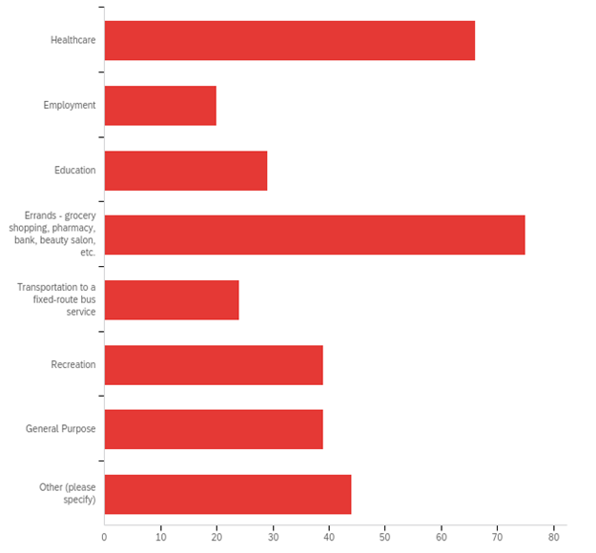
Figure 4: Types of trips provided
Most respondents are relatively small, with 67 indicating that the provide fewer than 500 trips per month. These organizations were predominantly non-profits, with 42 non-faith-based (representing 65.6% of all non-faith-based nonprofit respondents) and 9 faith-based (representing 75% of all faith-based respondents) falling into this category. 6 other respondents in this group were local (non-county) human service providers (of 10 non-county human service respondents). On the other hand, 9 respondents indicated that they provide more than 5000 trips per month. Interestingly, this was not dominated by public transit providers, as only 4 of 9 public transit providers indicated they provide that many trips. Instead, the largest category was non-faith-based nonprofits, with 5 respondents. A few of these were national organizations, however, reporting an amalgamation of many providers.
Respondents NOT using volunteers
104 respondents answered the question about whether they used volunteers. 20 of these indicated that they do NOT use volunteers. Of these, 13 indicated that they had never used volunteers, at which point they were thanked for their time and taken to the end of the survey. 7 indicated they used volunteers in the past, but no longer do so. 3 stated they stopped using volunteers because they were no longer able to find and retain volunteers, and 4 respondents specifically cited the COVID-19 pandemic as the reason for no longer using volunteers. This small number of respondents indicating they are no longer able to find and retain enough volunteers indicates a strong dedication to using volunteers despite the challenges discussed below.
Respondents using volunteers in transportation services
The remaining 84 respondents indicated they did use volunteers in providing transportation services. 81 of these use volunteers to drive clients, but 28 also use volunteers for administrative duties, 8 for dispatching rides, and 35 indicated “other” duties, which include running errands and making deliveries to clients (7 respondents), and caregiving services (e.g. household chores, filling out tax forms and socialization) (7 respondents).
When asked about ease of recruiting volunteers, 56 of 79 respondents stated they were having difficulties recruiting volunteers of all types. When asked about the nature of their difficulties, most (14) mentioned demographic issues: too few people in their local area with enough time, because previous volunteers are getting too old, younger volunteers need to work, or simply the population in the area is shrinking or was very small to begin with. The second-highest set of responses (12) discussed the lack of time dedicated to recruiting or similar issues that indicated the organization faced some similar structural and/or resource impediment to finding enough volunteers. Only 7 respondents mentioned the COVID-19 pandemic.
While the lack of mentions of the pandemic indicates that that most organizations did not see it as a significant obstacle to their long-term success, it did create short-term problems. 61 of 79 respondents (77%) stated that the pandemic had created additional difficulties in recruiting volunteers. 44 of these respondents (72%) believed the issues would be short term, expecting that their recruiting will return to “normal” after the pandemic. Those that believed they will not return to “normal” again cited some of the structural issues noted above (e.g. their volunteer pool will have aged further), but also that volunteers’ perspectives will be permanently changed (i.e. they will be more cautious about sharing their vehicle with people they do not know, or simply more averse to risking infections).
Interestingly, eight respondents stated that the pandemic had made recruiting easier, and follow up conversations indicated that this was due to some volunteers having more time, duties changed to even more attractive options (e.g. delivering to clients rather than driving them on errands), or simply that the number of volunteer opportunities dropped more than the number of volunteers did, leaving them with more volunteers relative to opportunities.
Finally, we asked if these organizations had volunteer coordinators to help manage their volunteers. 64 of 87 respondents (87%) indicated that they did. Most of these (64 respondents) included coordinators as part of their paid staff, ranging from 1/3 of a full-time position to 6 full time employees. 9 other organizations include a volunteer coordinator as an unpaid volunteer position. This group is particularly notable as they appear to have less difficulty recruiting volunteers (only 55% of respondents vs. 70% in the other two categories), as shown in Table 1.

Table 1: Difficulty Finding Volunteers by Use of Volunteer Coordinators
 |  | Use Volunteer Coordinator
 |  | Paid Volunteer Coordinator | Unpaid Volunteer Coordinator | No Volunteer Coordinator
Difficulty Finding Volunteers | Yes | 70% (45) | 55% (5) | 71% (10)
 | No | 30% (19) | 45% (4) | 29% (4)
Respondents with Volunteer Drivers
As mentioned above, 81 respondents use volunteers to provide rides to their clients. Table 2 summarizes the following information. One aspect to note is that our sample included a relatively large number of large organizations, which pulled the mean higher than the median. Consequently, the latter measure may better represent the “typical” respondent.
Table 2: Summary Statistics for Respondents Using Volunteer Drivers
 | # Drivers | Age of Drivers | Years Served | # Hours / Month | # Trips / Month
Mean | 51 | 64 | 7.14 | 24 | 19
Median | 40 | 67 | 7 | 15 | 10
Minimum | 1 (1 resp) | 24 (1 resp) | 1 (1 resp) | 2 (1 resp) | 3 (4 resps)
Maximum | 100 (21 resps) | 72 (9 resps) | 20 (2 resps) | 160 (1 resp) | 100 (5 resps)
Number of Drivers
These organizations have an average of more than 50 drivers each, with one respondent stating they had one driver, and 21 respondents indicating they had more than 100 (at least 2 of these respondents appear to be regional or national organizations, reporting results of several individual providers, however). Due to this relatively large number of respondents with large numbers of volunteers, and our overall sample having a larger number of smaller organizations, it is not surprising that the median is notably smaller, at only 40 drivers per respondent.
Age of Drivers
The mean age of 64 and median of 67 of the volunteer drivers reported by the respondents provides insight into one of the main challenges faced by the organizations in recruiting drivers. While one organization reported a low average age of 24 (which was a service based at a public university), most of the drivers recruited are retirees, who may only have a limited number of years ahead of them before they may need these services themselves. With the smaller “Generation X” moving into this age bracket, and the larger “Baby Boom” generation moving out of it, there will be a structural imbalance between the number of potential volunteers and those needing the services of volunteers for years to come.
Years Drivers have Served
It is perhaps not surprising, given the close relationship between the mean and median age of the drivers, and the relatively high age of the drivers, that the mean and median duration of service is also very close: just over seven years. While two respondents indicated that the average duration was over 20 years per volunteer, the standard deviation was only 3.82 years, meaning that 76 of the 80 respondents reported an average duration of service between 3 and 10 years. This again supports the generational issue mentioned above, as a driver that starts at age 65 probably begins to see their physical abilities to drive begin to decline around age 75 (Insurance Institute for Highway Safety, 2021).
Number of Hours per Month per Driver
The median number of hours per month per volunteer was reported at 15 hours per month, which supports the notion that most drivers appear to treat this activity as a part-time engagement, an expected behavior for those who are recently retired and looking to remain productive. This description may not be the case for all drivers, however, as the average number of hours is quite a bit higher, at 24 hours per month. This difference appears to be driven by several drivers willing to volunteer much more time than others. One respondent reported the highest number of hours at 160 (basically full time), but with a standard deviation of 25 hours, one-third of the 81 respondents to this question reported drivers volunteering 50 hours per month or more.
Number of Trips per Month per Driver
The trips appear to usually take 1 – 2 hours each, as the average response was 19 trips per driver per month (with an average of 24 hour volunteered each month, as discussed above). The mean is again skewed to the high end, as the median response was only 10 trips per month (although the time per trip remains roughly the same, with those 10 trips taking 15 hours). Overall, responses varied widely, with 4 respondents reporting only three trips per driver in an average month, and five respondents reporting their drivers make over 100 trips per month. As a result, the standard deviation is also quite broad: 24.5 trips per month.
Challenges for Volunteer Driver Organizations
Meeting demand
Finding and retaining volunteer drivers is a challenge for most of the respondents. 62 of 81 respondents (76.5%) indicated that “it is a challenge to find volunteer drivers,” and 52 (64%) of them stated that they do not have enough drivers to meet demand. When asked in an open-ended question about the nature of the challenge, answers varied: 15 cited COVID issues; 8 noted the challenges related to age of most volunteer drivers, as discussed above; 5 noted regulatory issues and 4 noted they were unable to provide enough compensation/reimbursement to attract and retain enough drivers. Interestingly, despite the age challenge, no respondents indicated that they could not meet demand due to lack of interest from younger drivers.
Cancelled Trips
The challenges respondents have encountered in recruiting and retaining volunteer drivers has had real consequences, in the form of trips being cancelled due to lack of drivers. 45 of 75 respondents (60%) indicated that they have had to cancel trips for this reason, with an average of 11 trips cancelled each month for each of the 44 organizations that provided an estimate, which works out to 484 trips per month, and just over 5800 trips per year, just among this sample. One organization reported cancelling over 100 trips (although this organization stated they provide over 10,000 trips per month), and 6 reported only cancelling one trip. The trip cancellations are skewed, however, with 2 organizations reporting 172 of the 484 trips cancelled and leaving the median number of cancelled trips at only 5 per respondent. Of the trips that were reported cancelled, 35 reported cancelling non-medical trips, and 32 reported cancelling medical trips (respondents could choose both answers).
Reimbursement
Respondents were asked about challenges related to volunteer drivers in general, and provided with specific answers: money, Insurance, regulatory concerns and “other.” In this case, the most respondents (24), chose “other,” but only three cited COVID here. More common “other” answers related to the nature of operating with volunteer drivers, including availability of drivers, and timing and need to train them. Of the 3 choices offered, 21 cited financial concerns, but while reimbursement of drivers was mentioned, overall operating expenses were mentioned more often. Seven (7) respondents mentioned insurance, although none mentioned the need to pay the highest possible premiums, as was found in the Minnesota study (Douma, 2017), and only one mentioned “specific requirements. Five (5) stated regulatory concerns, although one of these mentioned “liability” and “insurance” as regulatory concerns.
Regarding reimbursement issues, 52 of the 81 responding organizations (64%) reported that they do reimburse driver mileage, which appears to make a difference in recruiting drivers. As shown in Figure 5, 71% of respondents that do provide reimbursement find recruiting volunteers to be a challenge, but if they do not reimburse, the figure rises to 86% (25 out of 29).

Figure 16: How Reimbursement Affects the Perception of Volunteer Recruitment Being a Challenge
While this may be expected, examining the reimbursement rates reveals that the amount of reimbursement does not appear to correlate with the ability to recruit volunteers. As shown in Figure 6, more than 70% of those using the higher federal business rate (13 of 18) or using a non-federally defined rate (14 of 17), indicate that finding volunteers is a challenge. However, of those using the lower federal charitable rate, only 50% (7 of 14) indicated difficulty recruiting volunteers.

Figure 17: How Reimbursement Rates Affect the Perception of Volunteer Recruitment Being a Challenge
Another way organizations can reimburse volunteers is for “no-load” mileage, i.e., reimburse drivers for the miles they drive on their way to pick up the client, and returning home after completing the client’s trip. Of the 52 organizations that provide reimbursement, 44 do so for no-load miles as well as miles with the client. However, offering no-load reimbursement does not appear to attract more volunteers, as 73% of the organizations offering no-load miles (32 of 44) reported challenges finding volunteers, and only 63.5% (5 of 8) reported similar issues.
Recruiting methods
Difficulty finding recruits is not for lack of effort. When offered the options shown in Figure 7, the 82 organizations that responded provided 347 answers (respondents could choose more than one option), an average of more than 4 efforts per respondent. The most traditional, personal contacts (72 respondents) and most recent, social media (69 respondents) being the most popular. No option was chosen fewer than 20 times. Among the “other” options, respondents noted recruiting at church and other faith-based organizations 6 times, word of mouth referrals 5 times and presentations to other community groups 4 times.
Figure 7: Recruiting Methods Used by Respondents
Figure 8, however, shows that there is little pattern regarding which methods are more effective. When compared against respondents indicating that they do not find recruiting volunteers to be a challenge, those used least often appear to have the highest percentage of use by those that are finding enough volunteers. For example, radio and television advertisements, along with “other digital medial (not social media)” are used by nearly 35% of respondents that have enough volunteers, but those were the least selected options overall (21 and 20 responses, respectively), so the number of “successful” organizations choosing them is comparatively small as well: only seven respondents in each case. While social media comes as close as any option to the “sweet spot” of being used by the largest number of “successful” organizations and those organizations make up a significant percentage of all respondents using that strategy (19 “successful” respondents making up nearly 30% of all respondents), perhaps the best lesson here is that there is no one or two “magic” strategies, and all organizations need to dedicate significant efforts into a wide range of recruiting strategies to successfully recruit enough volunteers.

Figure 18: Effectiveness of Recruiting Strategies, as measured by number of respondents that are finding enough volunteers, and percent of total respondents
Importance of Volunteers to Mission
The survey closed with an open-ended question asking for any final “questions, concerns or comments you would like to share about the role of volunteers in your organization,” which yielded 35 responses (about 30% of all respondents). The responses largely fell into two categories: further articulation of the challenges faced, and how important volunteers are to their organization. These comments are listed in Figures 9 and 10.
Figure 9: Selected Comments Discussing Challenges
Figure 10: Selected Comments Discussing Importance of Volunteers
Analysis and Discussion
The decline in, or at least the increased challenge in finding enough, volunteers is real. In reviewing the results of this survey, organizations that rely on volunteers to provide their work, particularly to provide transportation services to those that can no longer bike, walk or drive themselves, are facing significant challenges. In this survey, more than three out of four (76.5%) respondents reported problems recruiting enough volunteers to meet their needs, and, that just among the 114 organizations responding, we estimate 5800 trips are cancelled annually due to a lack of drivers. The survey showed that nearly half of these cancelled trips may have been for medical purposes, which could lead to not only inconvenience to the client, but possibly detrimental health impacts.
COVID-19 is not seen as a major long-term contributor to the problem. Interestingly, however, despite these issues, the COVID-19 pandemic, which was still a major factor when this survey was administered (February – April 2021, so while vaccines were available, they had yet to have much of an impact), did not appear to have a significant long-term impact on these organizations. Only 4 organizations indicated they stopped using volunteers during the pandemic, and while many respondents noted the pandemic was an additional challenge, fewer than one in four believed the increased challenges would last past the pandemic.
The problem is due to economic and demographic factors. Respondents noted that the greatest challenges were those posed by larger, structural issues: generational change and finding sufficient funds, both of which we expected to find based upon previous studies. Generationally, many of these organizations are finding fewer people with the time and funds available to volunteer. Many of the volunteers from the baby boom generation are becoming too old to safely drive, and there are fewer members of the younger generations to follow them. Respondents found this to be an economic rather than a values issue, i.e. people in the younger generation lacked the time to volunteer due to obligations to their paying job and family, rather than younger people not volunteering because they did not believe it was their role to do so, or that the government or other entity should pay employees to provide this service. Supporting this point of view, respondents stated many younger potential volunteers do not do so because lack the time as they still need to work paying jobs to make ends meet. While the survey found that providing mileage reimbursement helped recruiting overall, even those organizations providing higher levels of reimbursement were not having a significantly easier time finding enough people.
It is also worth noting that while previous studies had noted lower reimbursement rates, insurance, and other government regulations as potential problems, very few respondents indicated these as actual impediments. Further, there did not appear to be significant trends based upon the size of the organization, nor its geographic location.
Solutions may lie in qualitative, rather than quantitative data: the most successful organizations focus on serving their volunteers as well as their clients. As a result, the quantitative data obtained through the survey provide a clearer picture of the challenges faced by these organizations, but little insight as to potential solutions. This information, instead, appears to lie in the qualitative information. First, when asked for final comments, many respondents were effusive in their praise of, and need for, volunteers to fulfill their mission and work. Combined with the quantitative data showing that despite all of the challenges, fewer than 10 respondents no longer used volunteers, these comments further support the central, possibly existential, importance of volunteers to these organizations. Next, follow-up interviews (see inset box) revealed possible solutions. While many respondents noted the challenges of finding enough money and time to recruit volunteers, the most successful organizations achieved their success by focusing on them. The organizations found non-transportation grants and other funding to support activities that built community and other connections between the volunteers, and between the volunteers and the organization. As a result, the volunteers want to continue to be part of the organization, and also serve as recruiters of other volunteers, creating a virtuous cycle that ultimately benefits the organization’s clients, as they receive high quality rides when they need them.
The Exception that proves the rule?
One large organization caught our attention. It provided just over 1000 rides per month before the pandemic, and found that they had more volunteers during the pandemic. They have 275 volunteers, 150 of which are drivers, and they kept them as busy as possible during the pandemic doing deliveries, as well as providing limited rides to “Critical destinations” (health care, wellness, etc.).
They are thriving due to the effort they make to build community among their volunteers. As the Executive Director stated in a follow-up interview, “I wish you could see our space!” They have a room dedicated to the volunteers, where they can have snacks and relax between trips, provide training and refresher training 4 times per year, and host numerous social events, from monthly coffee hours, evening gatherings in the summer and an annual appreciation dinner.
They pay for these additional services by raising non-transportation funds, whether through fund-raisers, or of particular note, they receive funds through the Americorps Seniors program, which allows them to dedicate a part time position to recruit through social media and otherwise spread the word about their opportunities.
Essentially, this organization has found that by recognizing their volunteers as “the eyes and ears in the community,” and prioritizing service to them, they are then able to provide great service to their clients.
Study Limitations and Suggestions for Further Study
A key limitation to survey research is that it provides quantitative data to support or disprove previously identified questions but provides limited data to evaluate the value of new insights gleaned in the course of analysis. Such is the case in this work, where we found support for organizations that use volunteer drivers facing key challenges in changing demographics and funding, but little support for the notion that these challenges were compounded by insurance and regulatory issues, especially as related to reimbursing the drivers’ expenses. However, we also picked up that a key solution could be in the ability of these organizations to create an attractive and supportive space for the volunteers, and their ability to be creative in finding the financial support for these volunteer support efforts. Consequently, follow up work in examining how these organizations support and retain their volunteers would be helpful in fleshing out this finding.

Appendix 3: Bibliography

- AECOM. “Rural Transit Study.” April, 2021.

- Americorps. “Seniors RSVP Grant Funding.” https://www.americorps.gov/funding-opportunity/fy-2023-volunteer-generation-fund.

- Americorps. “Volunteer Generation Funding Program.” https://www.americorps.gov/funding-opportunity/fy-2023-volunteer-generation-fund.

- Centers for Medicare & Medicaid Services (CMS). “Medicaid Non-Emergency Medical Transportation.” https://www.cms.gov/Medicare-Medicaid-Coordination/Fraud-Prevention/Medicaid-Integrity-Education/Downloads/nemt-booklet.pdf

- Douma, Frank. “Volunteer Driver Programs in Minnesota: Benefits and Barriers.” Minnesota Council on Transportation Access. February 2017.

- Federal Transit Administration (FTA). “Enhanced Mobility of Seniors & Individuals with Disabilities (Section 5310).” https://www.transit.dot.gov/funding/grants/enhanced-mobility-seniors-individuals-disabilities-section-5310

- Federal Transit Administration (FTA). “Formula Grants for Rural Areas Program (Section 5311).” https://www.transit.dot.gov/rural-formula-grants-5311.

- Kerschner, Helen. “Volunteer Driver Programs.” Published by Grantmakers in Aging. Accessed April 3, 2018. https://www.giaging.org/issues/volunteer-driver-programs

- National Aging and Disability Transportation Center. “2021 FTA Section 5310 Compendium: Volunteer Driver Programs and the Use of Section 5310 Funding.”

- Rural Health Information Hub. Health Resources and Services Administration (HRSA) of the U.S. Department of Health and Human Services (HHS). “Rural Transit Toolkit.” https://www.ruralhealthinfo.org/toolkits/transportation.

- Transit Cooperative Research Program. “Guidebook for Rural Demand-Response Transportation: Measuring, assessing, and improving performance.” 2009. https://nap.nationalacademies.org/catalog/14330/guidebook-for-rural-demand-response-transportation-measuring-assessing-and-improving-performance.

- U.S. Department of Transportation. “Benefit-Cost Analysis Guidance for Discretionary Grant Programs.” March 2022. https://www.transportation.gov/sites/dot.gov/files/2022-03/Benefit%20Cost%20Analysis%20Guidance%202022%20%28Revised%29.pdf.

- U.S. Department of Veterans Affairs. “Highly Rural Transportation Grants.” https://www.va.gov/HEALTHBENEFITS/vtp/highly_rural_transportation_grants.asp.

The total number of volunteer driver programs in the U.S. is unknown. There is one benchmark value. In 2015, the National Volunteer Transportation Center identified 706 programs in its database. If that value is still representative, then the 114 responding organizations in the survey conducted for this guidebook represent approximately 16 percent of the national total. To the degree that the guidebook survey results are representative, the 5,800 missed trips in our survey would scale up to a total of 36,250 nationally.
The CPS values are historically about “half” the values reported in the Gallop Poll. The differences are due to the wording of the question and the sample size.
As volunteers may engage in more than one type of activity, the totals in Figure 3 will not total to 100 percent.
Helen Kerschner, Ph.D., Director, National Volunteer Transportation Center, January 2015. Accessed: Volunteer Drivers | Grantmakers in Aging (giaging.org)
Frank Douma, “Volunteer Driver Programs in Minnesota: Benefits and Barriers.” Minnesota Council on Transportation Access, February 2017.
Maximum value provided in survey
Id
Id
For example, the Insurance Institute for Highway Safety reports that in 2016-2017, fatal crash rates increase from 1.3 and 1.7 per 100 million miles traveled for drivers aged 65-69 and 70-74, respectively, to 2.1 for drivers aged 75-79, 4.3 for those aged 80-84, and 7.6 for those greater than 85.
Since this was included in the newsletter as an anonymous link, and some readers of this newsletter may have already received a direct solicitation, and possibly responded, the total number of “recipients” is unknown.
Since the 44 recipients from the “no-response” states were included in the initial sample, they are not included in the total.
45 of 75 respondents (60%) indicated that they had had to cancel trips for this reason, with an average of 11 trips having been cancelled each month for each of the 44 organizations that provided an estimate. Overall, this works out to 484 trips per month, and just over 5,800 trips per year, just among this sample. Of the trips that were reported cancelled, 35 reported cancelling non-medical trips, and 32 reported cancelling medical trips (respondents could choose both answers). “Rural Transit Study,” 2021. See Appendix 2.
Only 7 respondents mentioned that the COVID-19 pandemic was foreseen to be a long-term impediment.
Chambre, Susan M., 2020. “Has Volunteering Changed in the United States? Trends, Styles, and Motivations in Historical Perspective,” Social Service Review, 94 (2), 373-421.
Chambre, Susan. P. 407.
“2021 FTA Section 5310 Compendium: Volunteer Driver Programs and the Use of Section 5310 Funding.” National Aging and Disability Transportation Center.
The Rural Health Information Hub, set up by the U.S Department of Health and Human Services, provides an excellent overview of volunteer and non-volunteer delivery models commonly used. Available via the web. https://www.ruralhealthinfo.org/toolkits/transportation.
Estimate made as follows. 81 responding organizations used volunteer drivers and the average size was 51. The average number of trips per month was 19 and each trip was an average 1.5 hours.
Between 1983 and 2008, the Robert Wood Johnson Foundation established and supported its “Faith in Action” initiative to serve chronically ill and frail older adults. Their objective was to establish interfaith partnerships in communities across the U.S. to mobilize volunteers in providing assistance related to the activities of daily living, one of which was transportation. In an evaluation of the program, a key finding was that the community program projects with at least three different funding sources were more likely to survive than projects that did not meet that threshold. This study is described in “Volunteer Driver Programs,” by Helen Kerschner, published by Grantmakers in Aging. https://www.giaging.org/issues/volunteer-driver-programs.
Since this was included in the newsletter as an anonymous link, and some readers of this newsletter may have already received a direct solicitation, and possibly responded, the total number of “recipients” is unknown.
Since the 44 recipients from the “no-response” states were included in the initial sample, they are not included in the total.
Maximum value provided in survey
Id
Id
For example, the Insurance Institute for Highway Safety reports that in 2016-2017, fatal crash rates increase from 1.3 and 1.7 per 100 million miles traveled for drivers aged 65-69 and 70-74, respectively, to 2.1 for drivers aged 75-79, 4.3 for those aged 80-84, and 7.6 for those greater than 85.

