Note: Due to the huge size of the climatic data which is used for the selection of project location, it is necessary to download the data and paste it under the folder you copy the SPT program in. Please follow the instruction below:
Installation of the program
1. Copy the whole "AMPT_QA_Program" folder and paste it in your hard disk.
2. Find the "hcd" files within the hcd folder in the following website:
http://onlinepubs.trb.org/onlinepubs/archive/mepdg/climatic_state.htm
3. After downloading the folder and paste it under the "AMPT_QA_Program" as shown below:
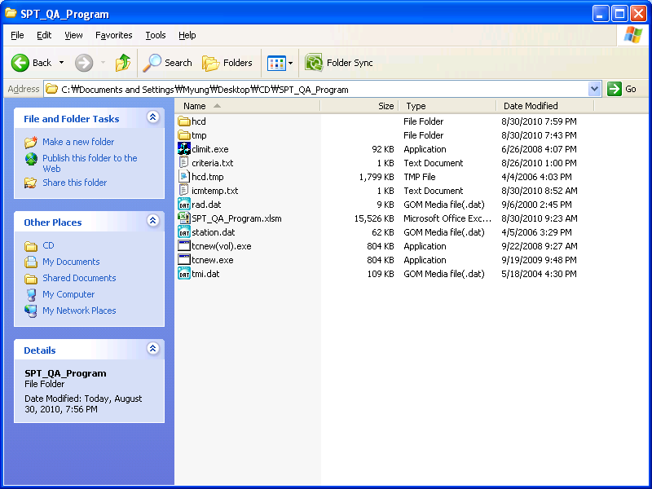
4. Run the “AMPT_QA_Program” file.
*If you run into any problems while operating the program, please report them to Myung Jeong (myunggoo.jeong@amec.com)

