Appendix F
Worksheets

Appendix F of NCHRP Research Report 1000: Accessibility Measures in Practice: A Guide for Transportation Agencies provides worksheets that can be used by individuals or groups to facilitate a discussion of the steps in Chapter 3 of the report. The report was produced under NCHRP Project 08-121.

The National Cooperative Highway Research Program (NCHRP) is sponsored by the individual state departments of transportation of the American Association of State Highway and Transportation Officials. NCHRP is administered by the Transportation Research Board (TRB), part of the National Academies of Sciences, Engineering, and Medicine, under a cooperative agreement with the Federal Highway Administration (FHWA). Any opinions and conclusions expressed or implied in resulting research products are those of the individuals and organizations who performed the research and are not necessarily those of TRB; the National Academies of Sciences, Engineering, and Medicine; the FHWA; or NCHRP sponsors.
Agency: ____________________________________________ Date: ____________

Project Name: ____________________________________________________________________________

Participants: ______________________________________________________________________________

Step 1: Identify goals, objectives, and context (Section 3.1)
Think about how your performance management and decision-making process connects to agency goals and objectives. Summarize your goals and objectives below. Then, determine whether an accessibility perspective can help you achieve one or more of those goals.

Goal | Is accessibility the right concept?
 | Yes No
 | Yes No
 | Yes No
 | Yes No
 | Yes No
Next, think about the planning context in which accessibility measures will be applied.

Decision-making process
Examples include corridor analysis, project prioritization and selection, equity analysis, transit planning, long-range planning, scenario performance analysis, and nonmotorized planning

Geographic character
Agency size, region size, population density, land use, and urban form

Audiences
Internal, external, and familiarity with accessibility

Resources
Available staff, technical capacity, software, data, time resources, and budgets

Step 2: Screen candidate measures or concepts (Section 3.2)
Using the goals, objectives, and context described in Step 1, you can determine which accessibility measures are appropriate and applicable. This step will help users consider which measures fit based on application areas and help eliminate measures that are not a good fit.

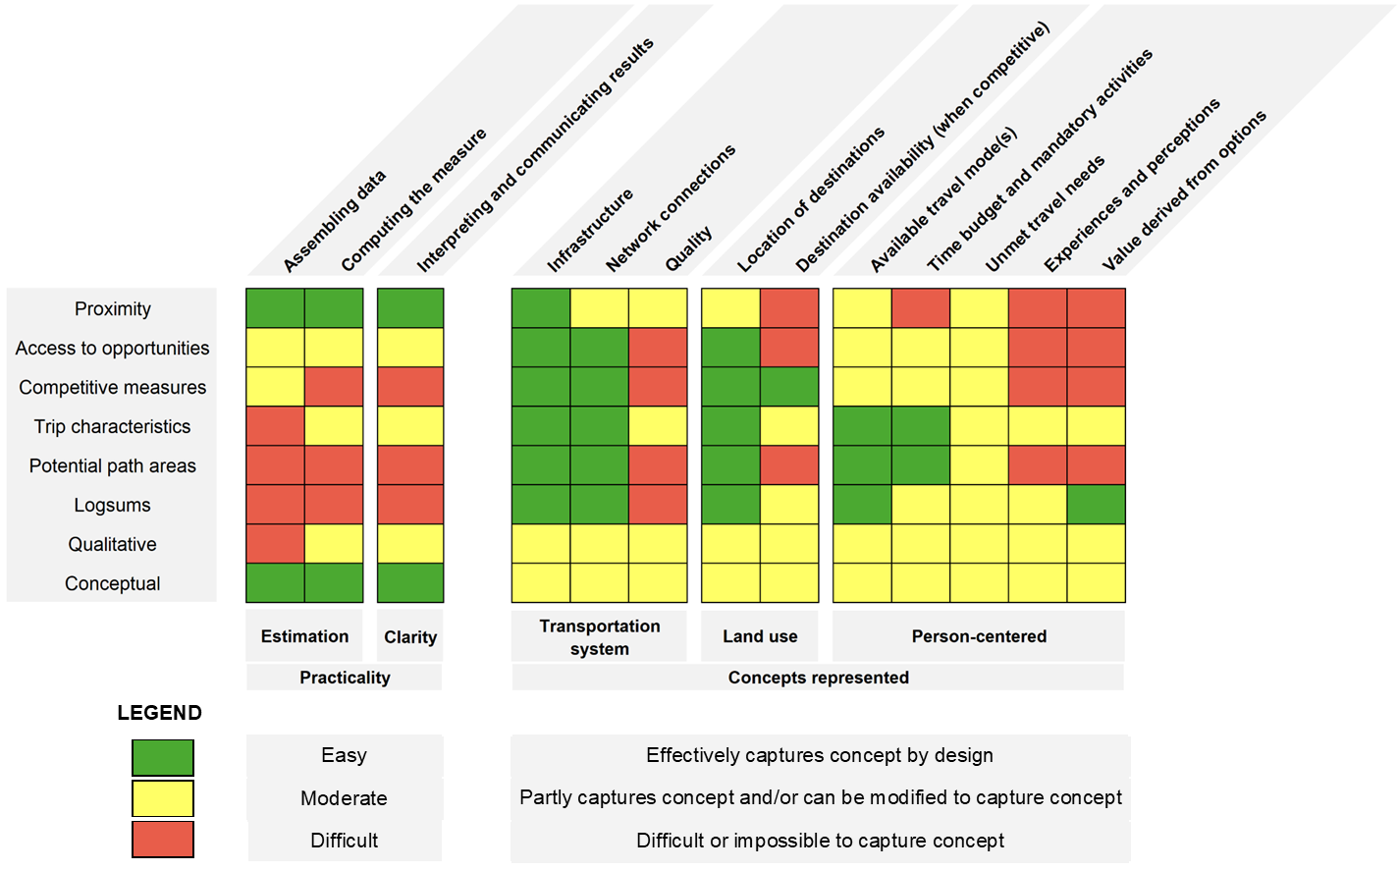

Candidate measures

Step 3: Select accessibility measures and dimensions (Section 3.3)
Here are descriptions and examples of each type of accessibility measure and dimension. Decide which measures and dimensions are applicable and appropriate for your goals. Appendix A has additional examples from practice.

Measure type | Description | Example
Proximity | How close is transportation infrastructure? | Share of the population within ¼ mile of transit stops
Access to Opportunities | How many destinations can be reached? | Number of jobs reachable within 30-minute drive
Competitive | How does competition from others affect people’s access to opportunities? | Access to jobs by auto when accounting for the number of job seekers
Trip Characteristics | How easily can people travel to destinations? | Estimated public transit trip characteristics for different demographic groups
Potential Path Areas | Where can I go given my destination, time, mode, and socioeconomic constraints? | Reachable locations on transit given 90-minute travel time budget
Logsums | What value do people derive from available choices? | Monetized change in the logsum due to a change in overall travel costs
Conceptual | Conceptual representation of accessibility | Including accessibility concept in discussions; may include a score or rank
Qualitative | Qualitatively determined accessibility score or rank | Accessibility score or rank based on a survey or participatory mapping
Other | Other types of measures | Combining above measures into an index

Primary dimensions | Examples
Impedance | Mode-specific travel time  Travel distance  Travel cost  Network quality  Perceived safety or security
Opportunity type | Job counts  Grocery stores  Schools  Healthcare facilities
Person/Place perspective | Population of interest  Location of interest
Secondary dimensions | Examples
Travel mode | Auto  Walk  Bike  Public transit  Multimodal
Time of day | Public transit departure times
Spatial disaggregation | Census spatial units (e.g. tract, block)  Transportation analysis zones
Implied origin | Home-based trips  Trip chaining
Selected measure | Primary dimensions | Secondary dimensions
Step 4: Identify data sources and estimate measures (Section 3.4)
Determine your data sources and analysis methods. The table that follows shows some data sources for each type of dimension.

Primary accessibility dimension | Secondary accessibility dimensions | Possible data sources
Impedance | - Travel mode  - Time of day  - Spatial disaggregation | - Regional travel demand model skims  - Google Maps API  - Bing Maps API  - GIS-based network analysis data sources for applications in ArcMap, OpenTripPlanner, R, and/or Python environments:  - OpenStreetMap  - HERE data  - Detailed sidewalk data (only available locally)  - Detailed bike infrastructure (only available locally)  - General Transit Feed Specification (GTFS) data  - Real-time vehicle location data (automatic vehicle location or GTFS-real-time sources)
Opportunity Type/Land Use | - Time of day  - Spatial disaggregation | - Regional TAZ-level base year and forecast land use data  - Longitudinal Employer-Household Dynamics (US Census)  - Census Transportation Planning Package  - ArcGIS Business Analyst  - Caliper Maptitude  - Orbis (Bureau van Dijk)  - Other publicly available datasets documenting facility locations and their characteristics  - Regional travel/activity surveys  - Infrastructure location layers
Person/Place perspective | - Spatial disaggregation  - Implied origin | - Regional travel/activity surveys  - Public transit rider surveys  - National Household Travel Survey  - Anonymous location data  - Decennial census  - American Community Survey  - Longitudinal Employer-Household Dynamics Origin-Destination Employment Statistics (LODES)  - Census Transportation Planning Package

Example analysis methods for each measure type are described in Section 3.4 of this guide. Additional methodology resources are summarized in Appendix D. Appendix E includes additional detail about software and data resources.

Selected measure | Data sources | Analysis methods
Step 5: Evaluate, interpret, and communicate measures (Section 3.5)
Explore how measures will be shared with internal and external stakeholders. Depending on the context, bar charts, maps, or presentations may be appropriate. Describe each measure’s limitations.

Selected measure | Communication | Limitations

Step 6: Revise accessibility applications (Section 3.6)
Reflect on your measure’s ability to reflect your goals and its communicability. It may take several iterations until your measure is satisfactory and achieves your goals.

