APPENDIX C

ANALYSIS OF GENERIC SPANS FOR FORMULA B TRUCKS

This Appendix consists of the following sections:

- INTRODUCTION
- ANALYSIS OF GENERIC SPANS FOR CANDIDATE LOAD MODELS
- COMPARE CANDIDATE LOAD MODELS TO STATE POSTING LOADS THAT SATISFY ALL FORMULA B REQUIREMENTS
- Governing Formula B Trucks

PROPOSED NOTIONAL RATING LOAD MODEL
- COMPARE FORCES INDUCED BY THE PROPOSED RATING TRUCK WITH HS20 & AASHTO LEGAL LOADS

PROPOSED LEGAL LOADS FOR POSTING
- COMPARISON OF RATING FACTORS

SUMMARY OF FINDINGS

Introduction

A test suite of simple and continuous span bridges were assembled and used in the analysis of load effects. The span increments were 5 feet for spans under 100 feet and 10 feet were spans between 100 ft and 200 ft. The longer spans are less sensitive and less vulnerable to the effects of these short heavy trucks and a 10 ft increment was considered satisfactory for the purposes of this study without with out compromising accuracy. The continuous spans were made up of two-span, three-span and four-span continuous structures with span ratios selected to represent actual bridge configurations. For the two-span, two equal spans were used. For the three-span, each end spans was set at 0.8 times the interior span. For the four-span, the two equal end spans were 0.8 times the two equal interior spans. For the analysis of three and four span configurations a more selective use of trucks in the suite of candidate loads was done, omitting trucks considered unlikely to govern based on the findings of the two-span analysis.

Bridges having transverse members were also included in the test suite assembled for this purpose. Floorbeam spacings from 10 feet to 30 feet (in one foot increments) were used in this study. The analytical studies were done to determine the stringer live load reactions (stringers simply supported between floorbeams) on floorbeams and caps, which were compared with reactions from the AASHTO legal trucks. From the results it was also easy to identify the governing trucks for floorbeam and cap ratings. As live load reaction is the key parameter that impacts load rating of transverse members, the results of this study will expose the potential impact of the candidate load models on transverse member ratings.

ANALYSIS OF GENERIC SPANS FOR CANDIDATE LOAD MODELS

The following series of tables and charts present the findings of the analytical studies. In the tables, the governing load effects are shaded for easy identification. Table C-1 summarizes the results for simple and continuous spans. Results for transverse members are given in Table C-13. In each table, the governing FBF truck moments and shears for all spans are compiled into a single column. Ratios obtained by dividing FBF trucks load effects by AASHTO trucks load effects provide a quick metric for the level of bridge overstress. Charts of this overstress ratio by span length, along with charts of moments and shears, are also given below.
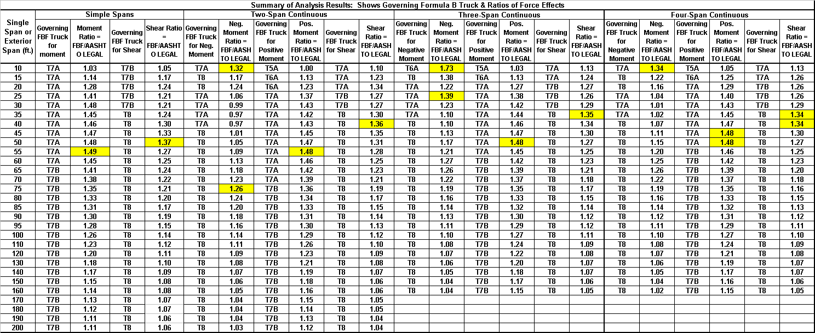
Table C-1 Summary of Analysis Results
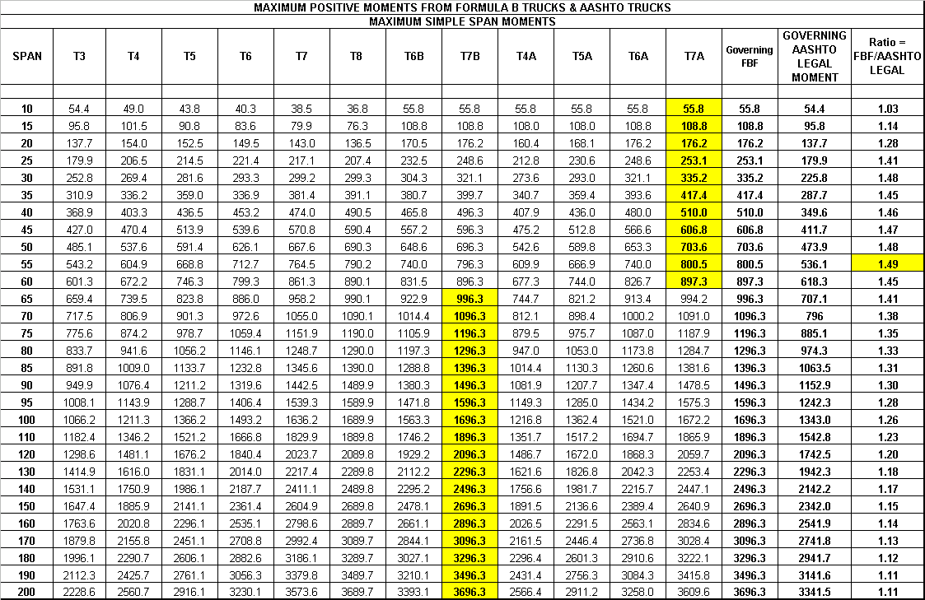
TABLE C-2 Simple Span Moments (Units: Ft., K-Ft)
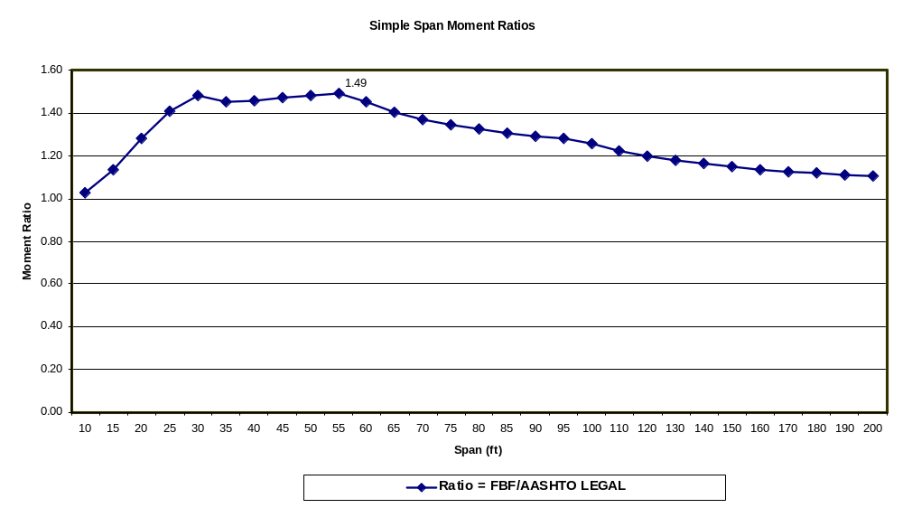

Figure C-1 Simple Span Moment Ratios
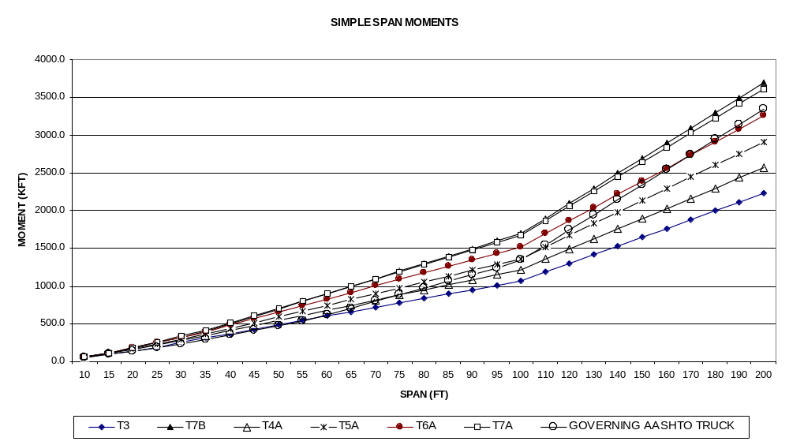
Figure C-2 Simple Span Moments

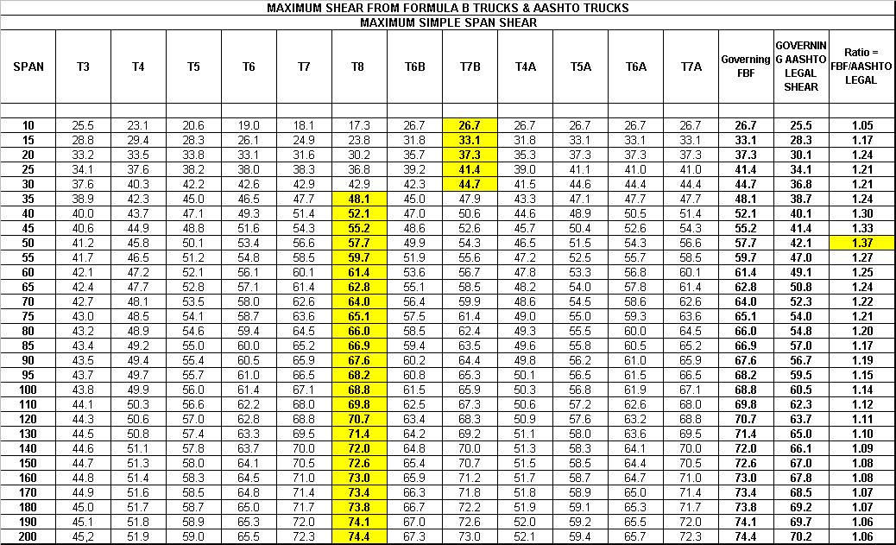
TABLE C-3 Simple Span Shears (Units: Ft., K)

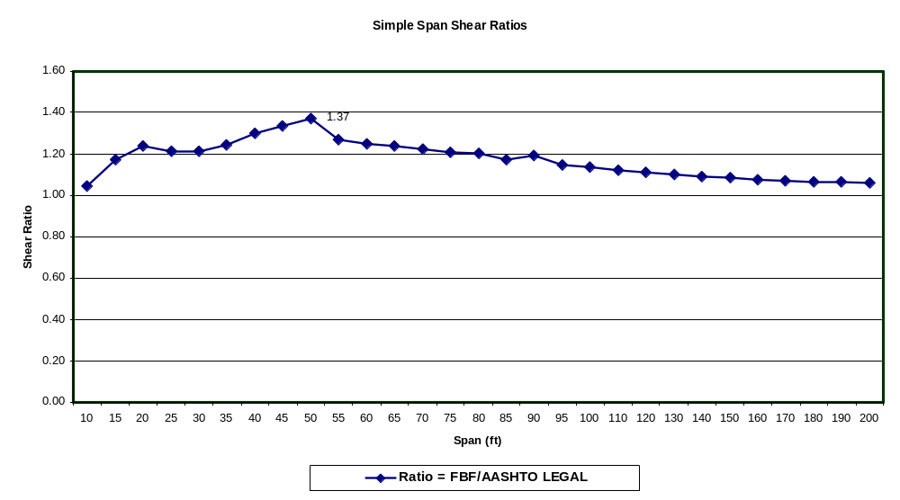

Figure C-3 Simple Span Shear Ratios
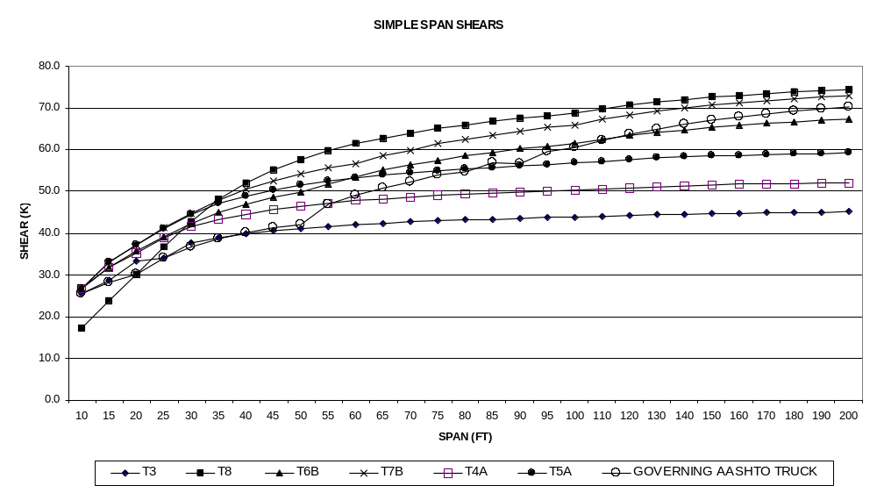
Figure C-4 Simple Span Shears

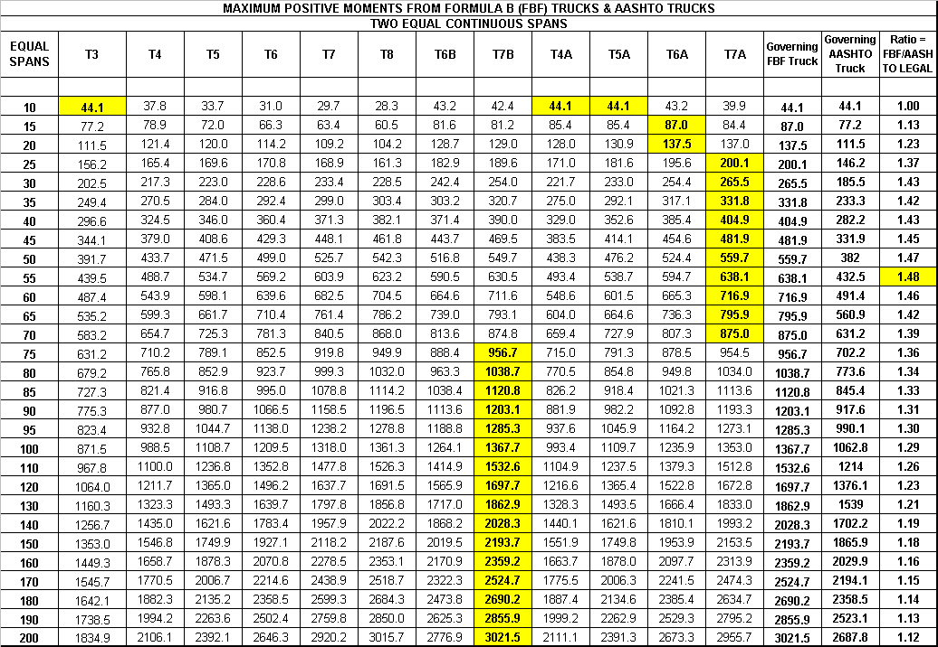
TABLE C-4 Maximum Positive Moment ⎯ Two-Span Continuous (Units: Ft., K-Ft)

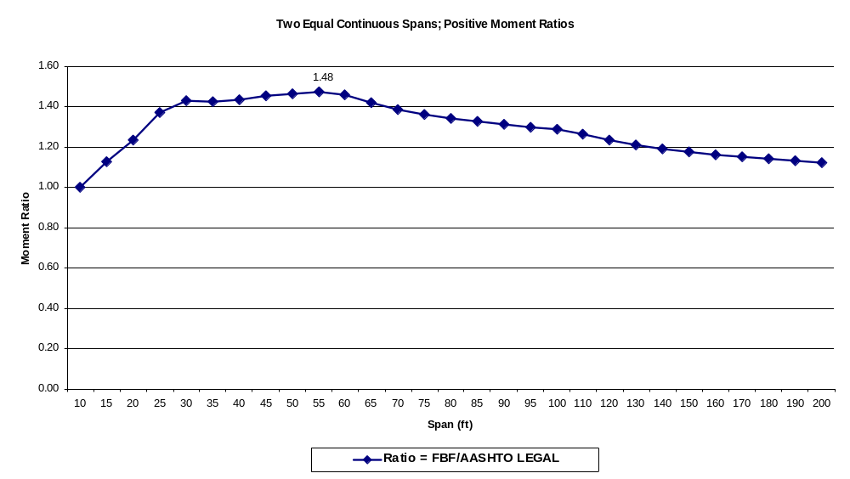
Figure C-5 Positive Moment Ratios ⎯ Two-Span Continuous
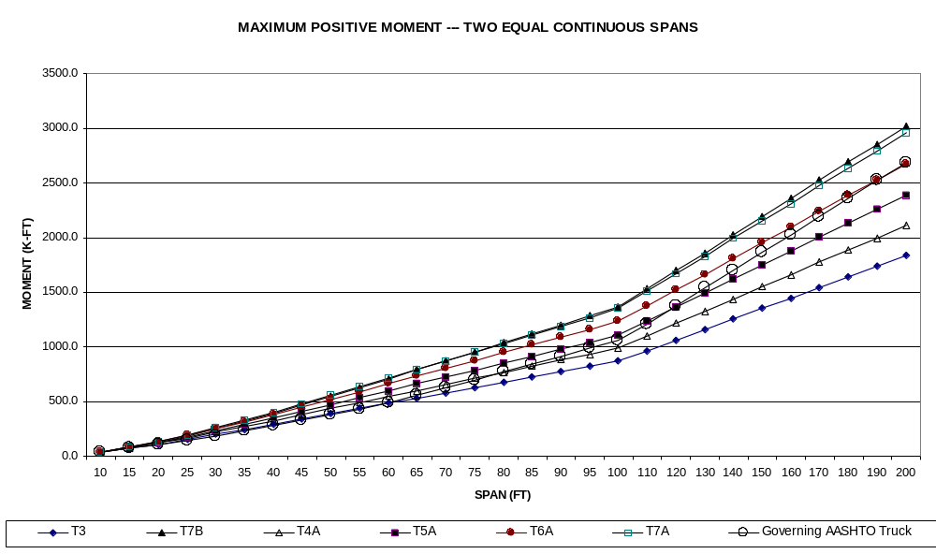
Figure C-6 Maximum Positive Moments ⎯ Two-Span Continuous

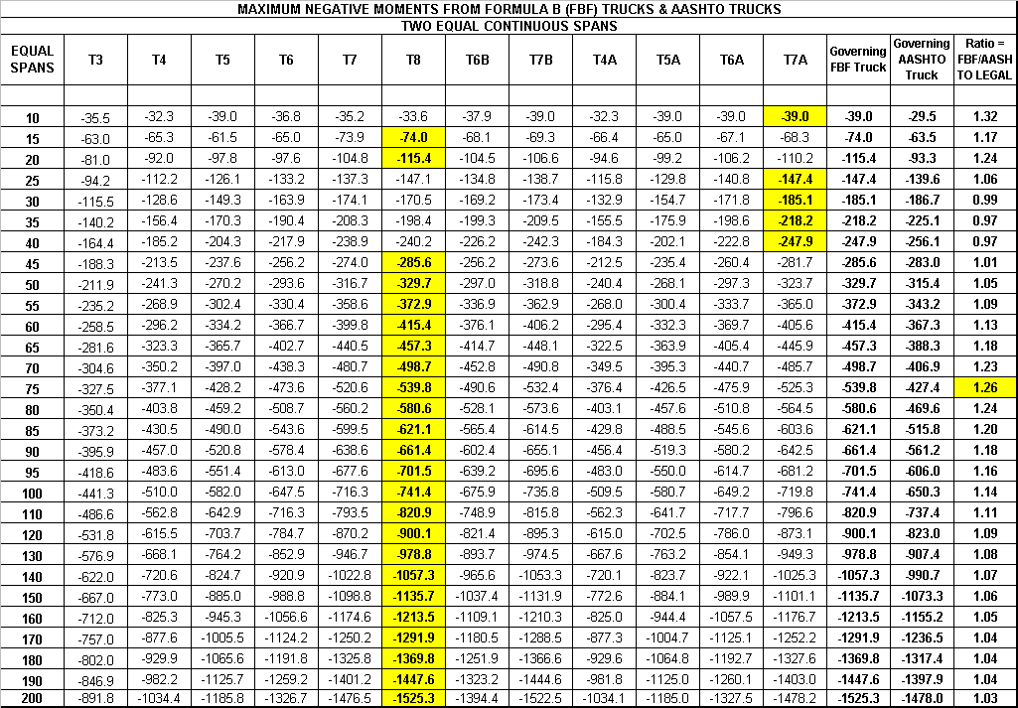
TABLE C-5 Maximum Negative Moment ⎯ Two-Span Continuous (Units: Ft., K-Ft)
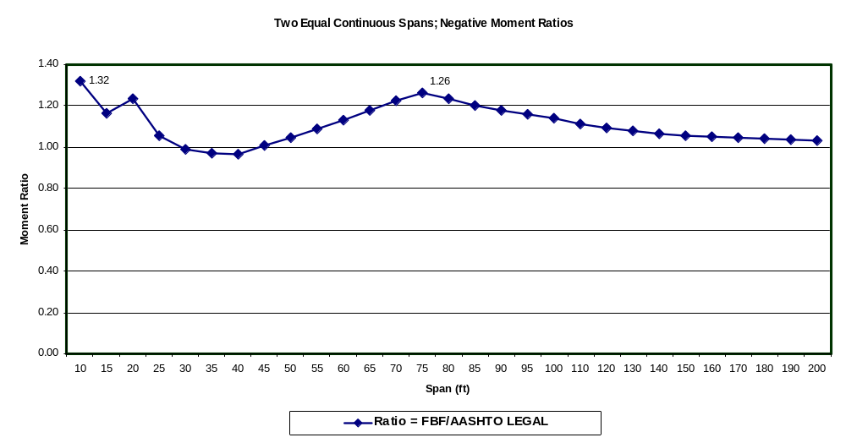
Figure C-7 Negative Moment Ratios ⎯ Two-Span Continuous
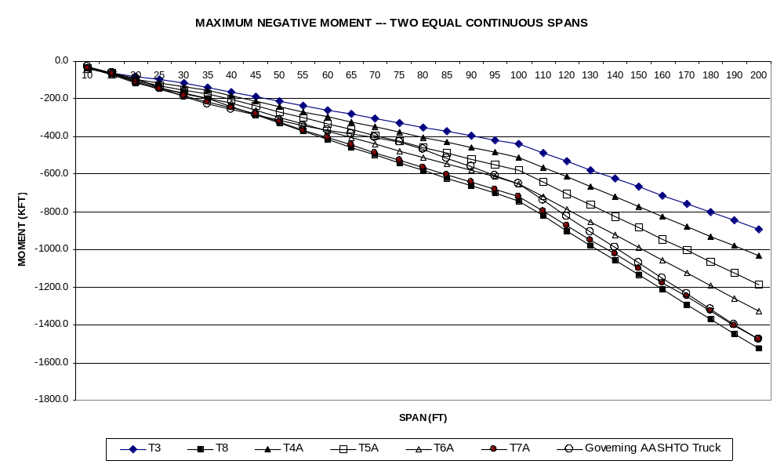
Figure C-8 Maximum Negative Moments ⎯ Two-Span Continuous
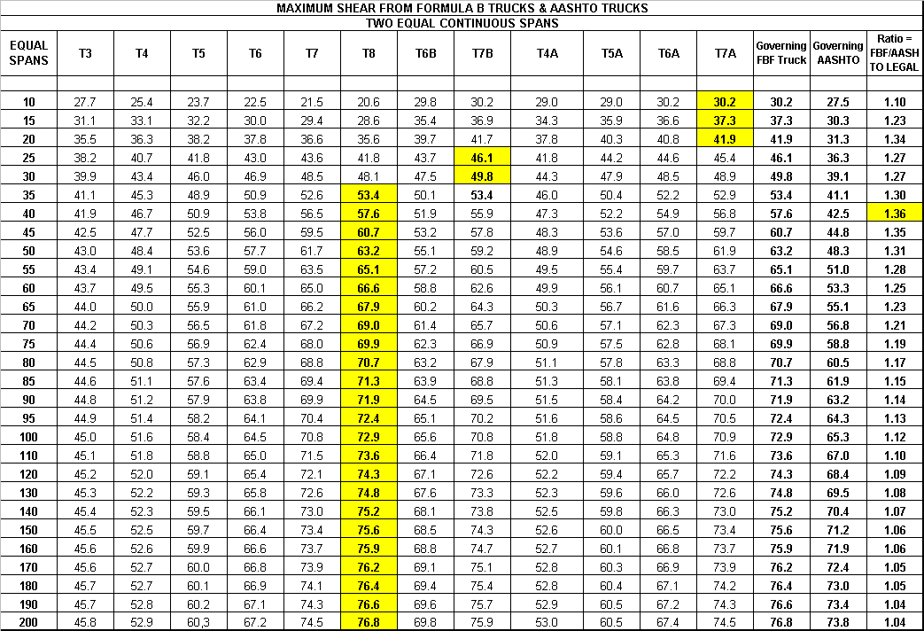
TABLE C-6 Maximum Shear ⎯ Two-Span Continuous (Units: Ft., K)

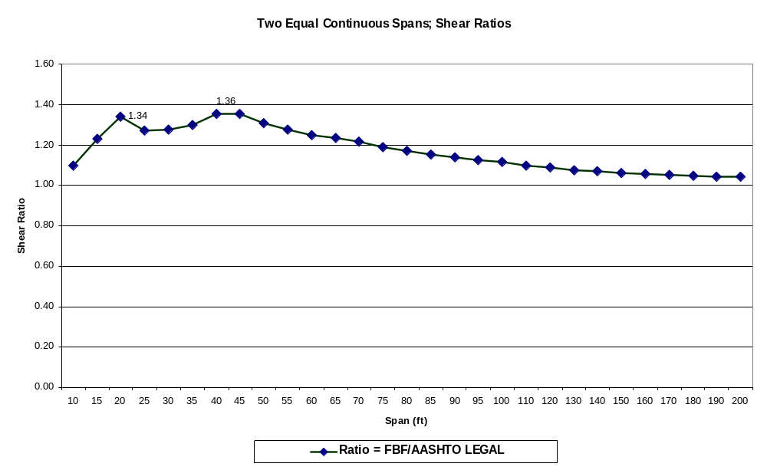

Figure C-9 Shear Ratios ⎯ Two-Span Continuous
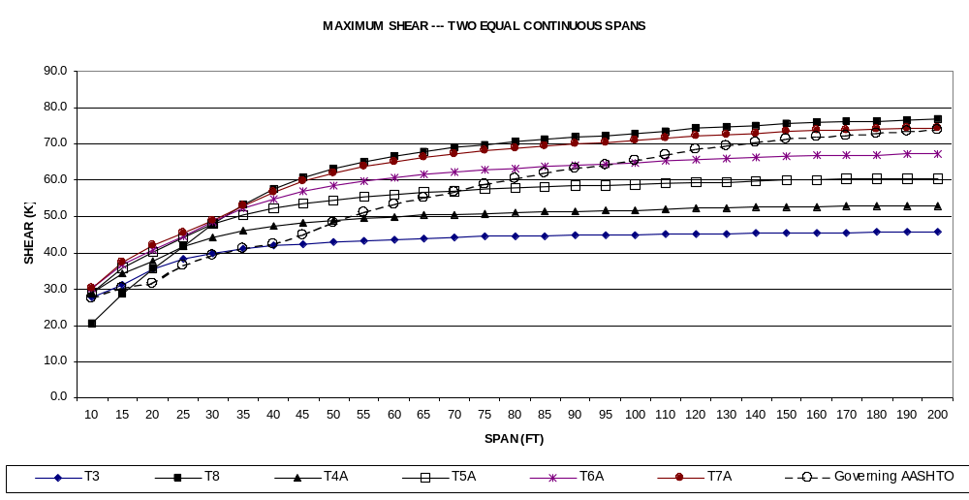

Figure C-10 Maximum Shear ⎯ Two-Span Continuous

TABLE C-7 Maximum Positive Moment ⎯ Three-Span Continuous (Units: Ft., K-Ft)
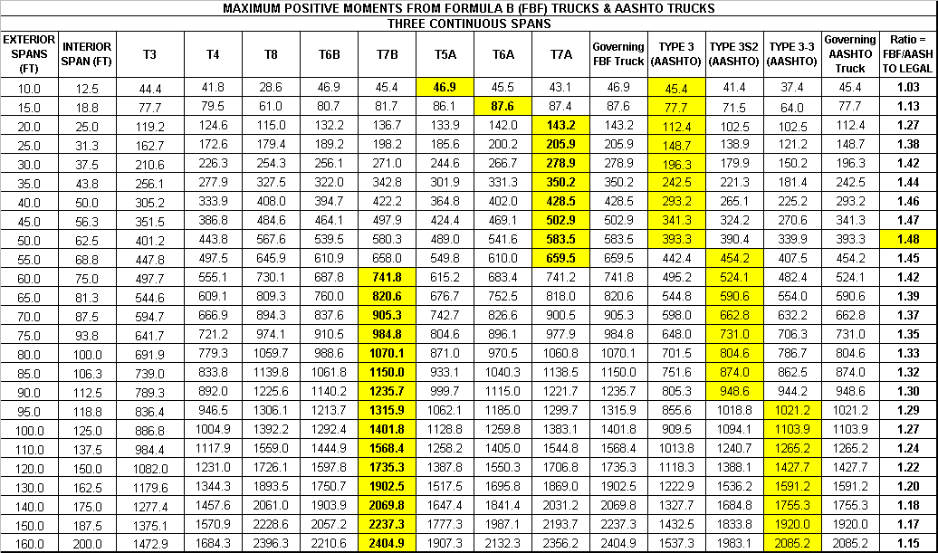
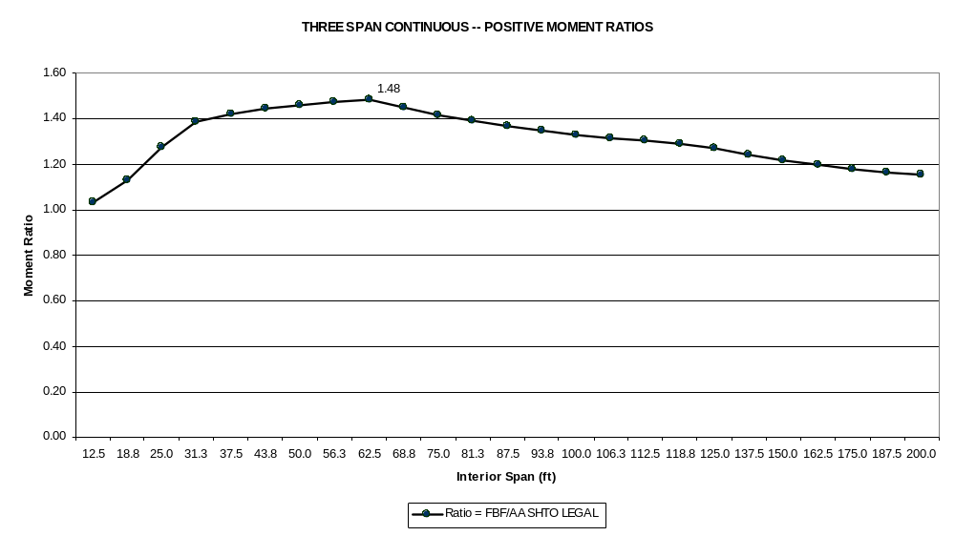
Figure C-11 Positive Moment Ratios ⎯ Three-Span Continuous

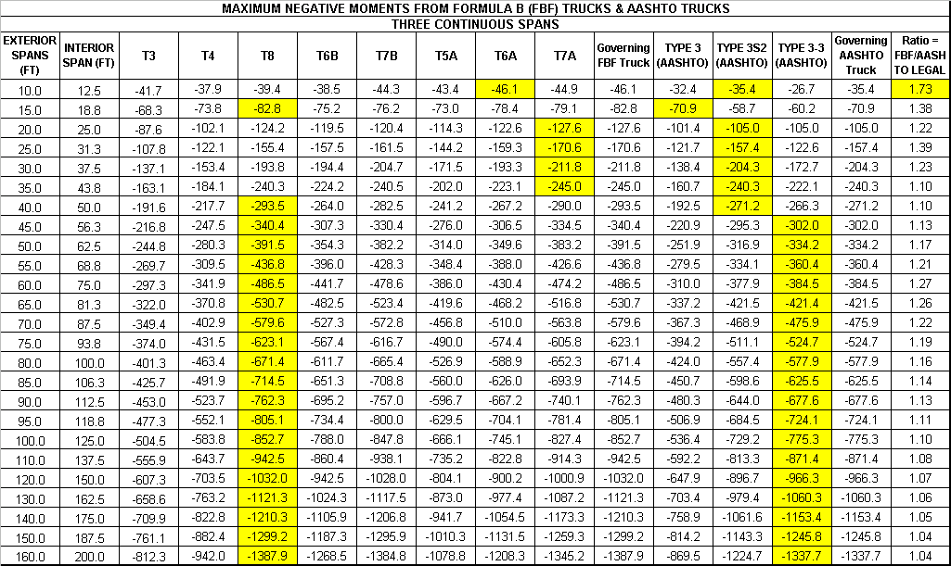
TABLE C-8 Maximum Negative Moment ⎯ Three-Span Continuous (Units: Ft., K-Ft)

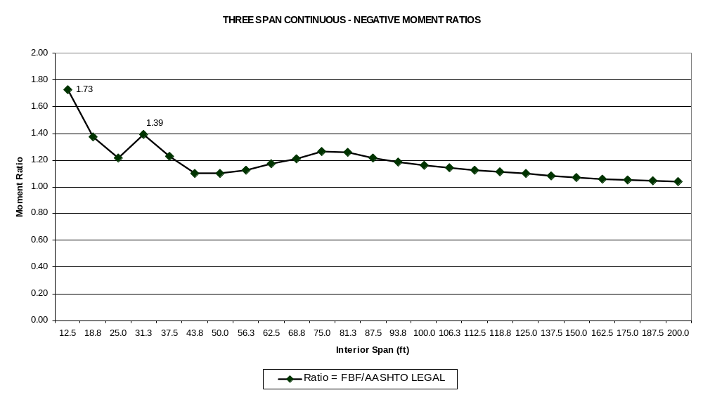
Figure C-12 Negative Moment Ratios ⎯ Three-Span Continuous

TABLE C-9 Maximum Shear ⎯ Three-Span Continuous (Units: Ft., K)
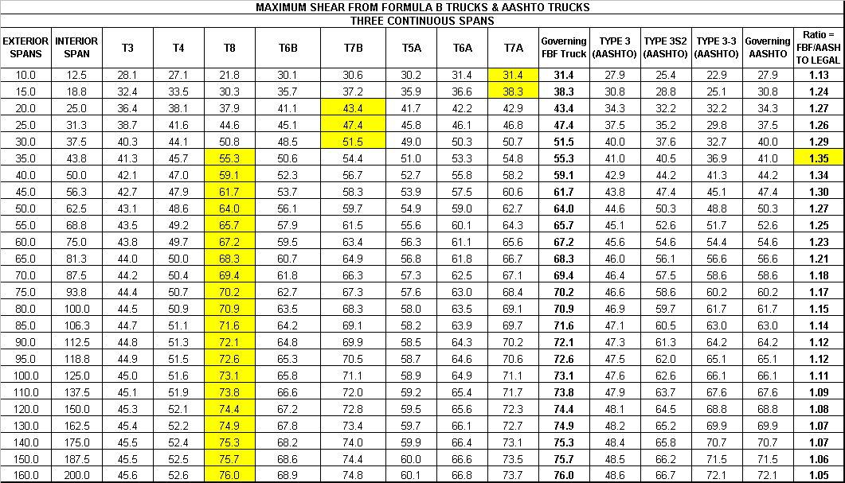

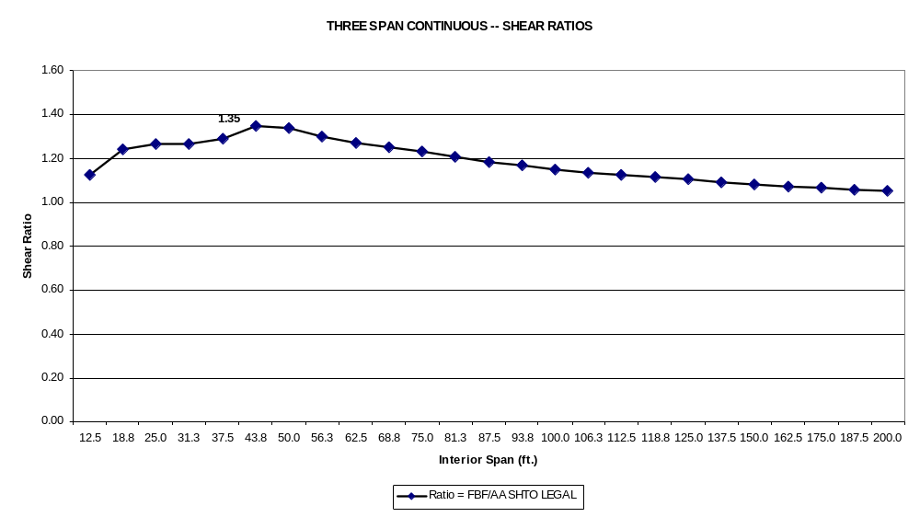
Figure C-13 Shear Ratios ⎯ Three-Span Continuous

TABLE C-10 Maximum Positive Moments ⎯ Four-Span Continuous (Units: Ft., K-Ft)
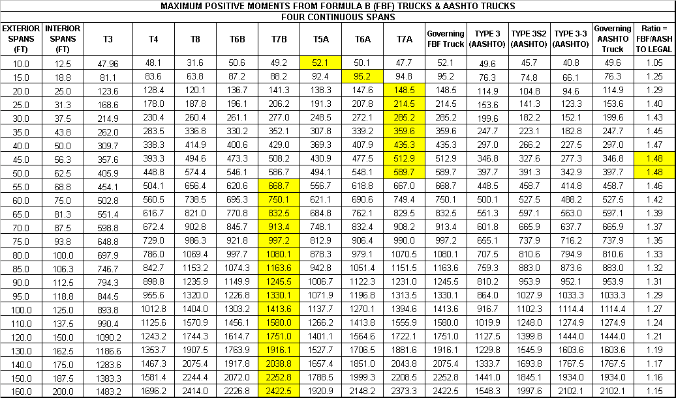
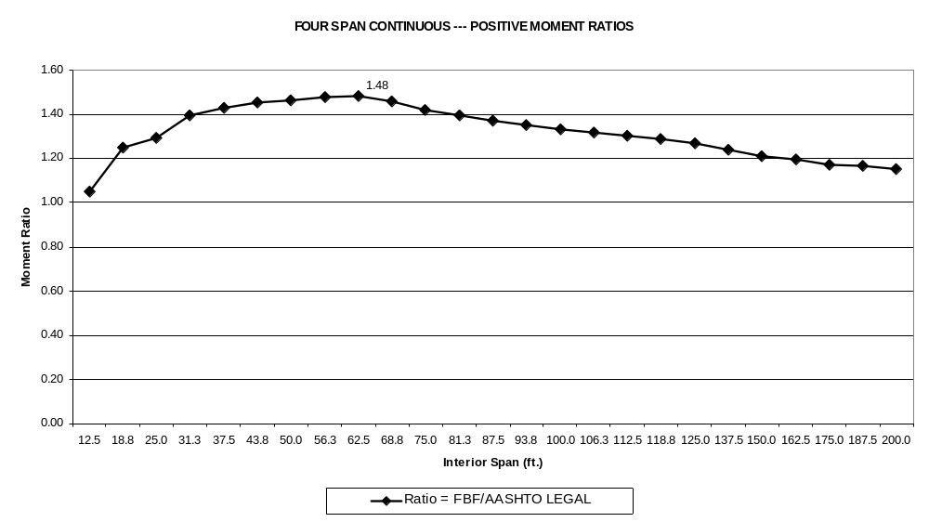
Figure C-14 Positive Moment Ratios ⎯ Four-Span Continuous

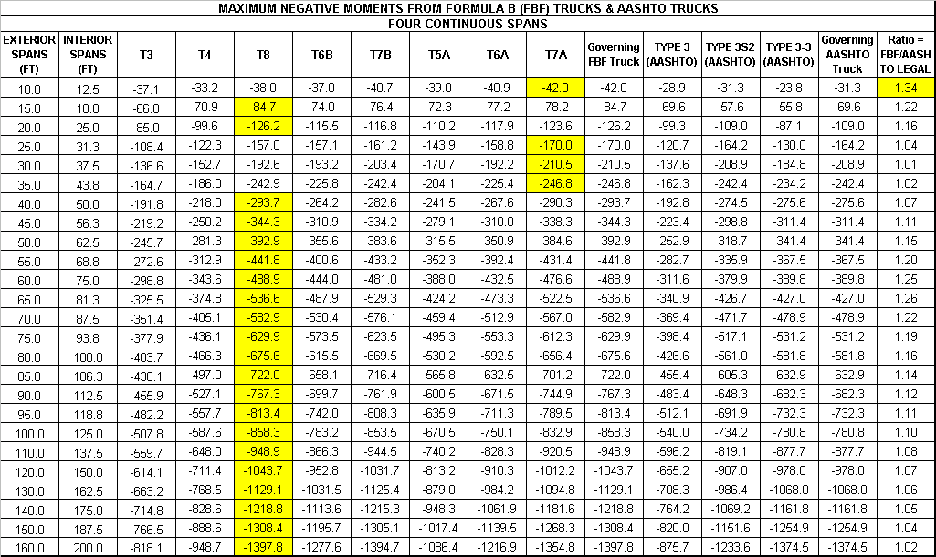
TABLE C-11 Maximum Negative Moments ⎯ Four-Span Continuous (Units: Ft., K-Ft)
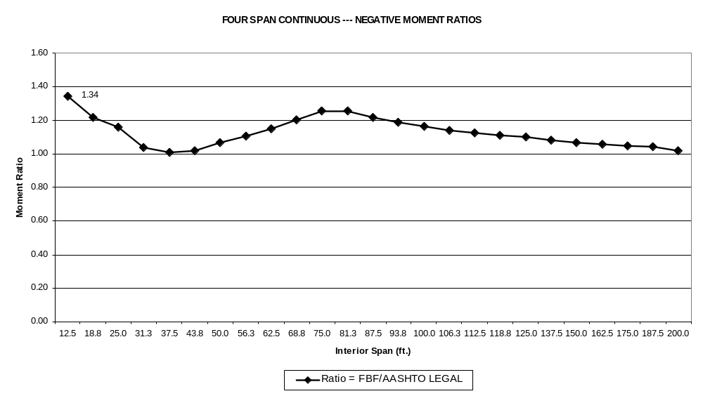
Figure C-15 Negative Moment Ratios ⎯ Four-Span Continuous

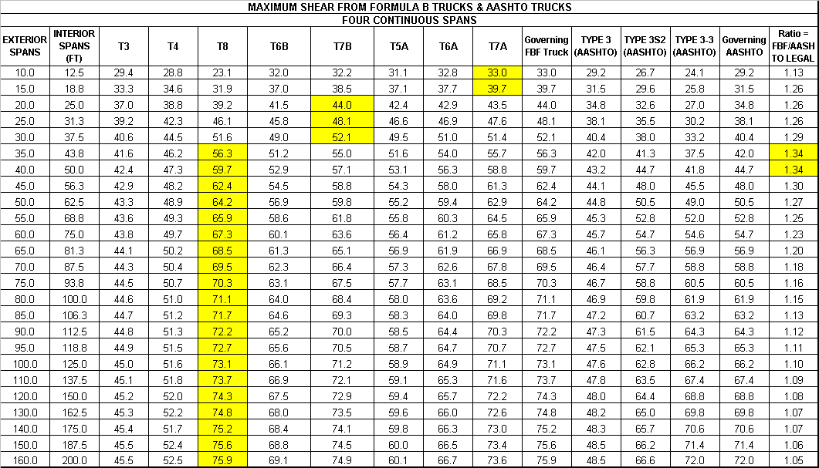
TABLE C-12 Maximum Shear ⎯ Four-Span Continuous (Units: Ft., K)
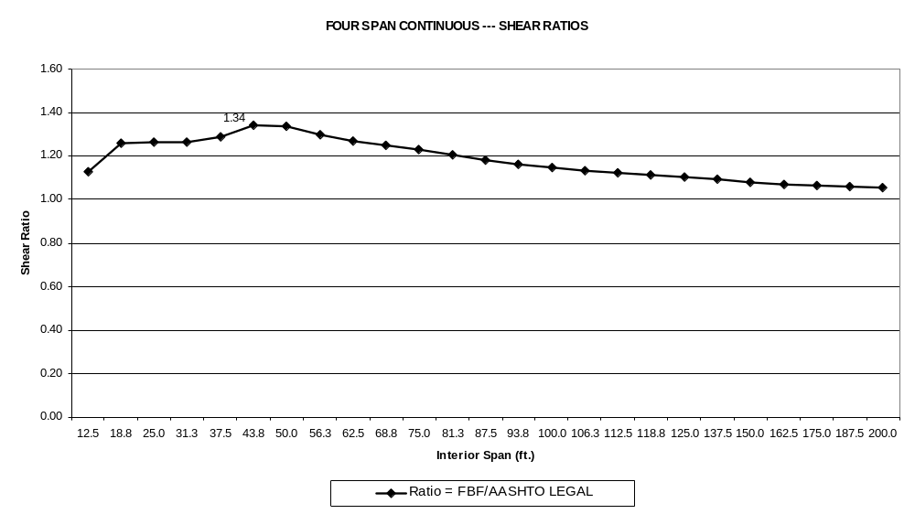
Figure C-16 Shear Ratios ⎯ Four-Span Continuous
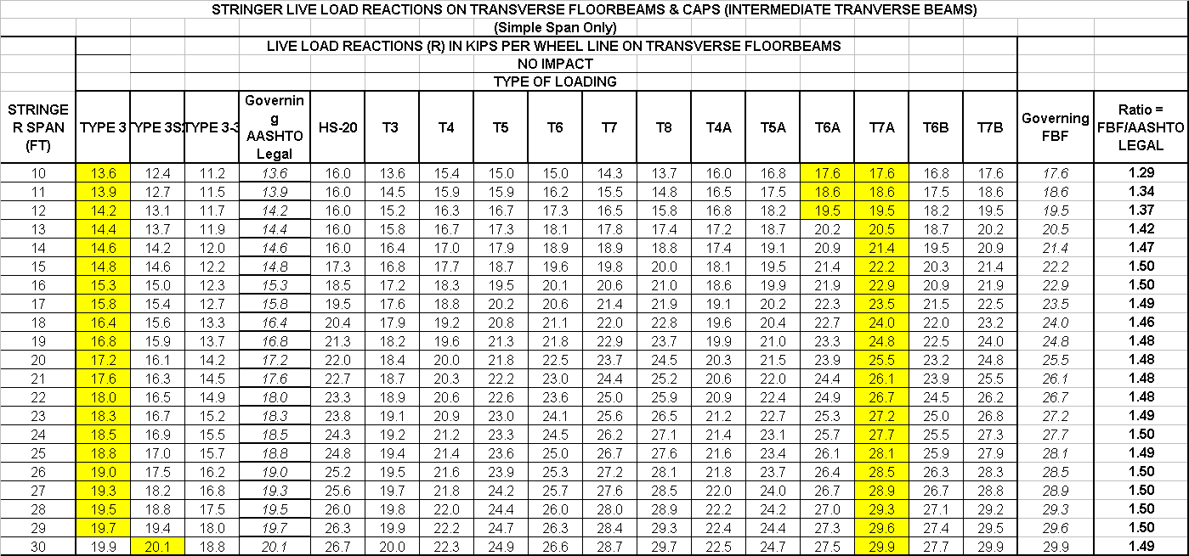
TABLE C-13 Stringer Live Load Reactions on Transverse Members

COMPARE CANDIDATE LOAD MODELS TO STATE POSTING LOADS THAT SATISFY ALL FORMULA B REQUIREMENTS

The previous tables and charts described the analysis results for the suite of twelve candidate FBF truck models with 3 to 8 axles. Overstress ratios were computed that compare the governing FBF truck load effects with that of the three AASHTO trucks (also Formula B trucks). This section reports the results of an analytical study that compared the load effects produced by the FBF truck models with the load effects from the State rating and posting loads that satisfy all Formula B requirements (gross weight and consecutive axle weights). This is only a small subset of State posting loads as the most severe State posting loads are not Formula B trucks. If trucks that only violate the inner-bridge Formula B limits were considered, this number will increase significantly and will include the heavy multi-axle single–unit trucks used by North Carolina and Pennsylvania (these trucks with a small reduction in axle loads will become conforming FBF trucks).

The intent of this study is to verify that the suite of candidate FBF trucks developed will also be the envelope vehicles for other Formula B axle configurations that are currently in current use as State legal loads and posting loads. A total of ten such trucks that meet this criterion are shown in Fig. C-17. These trucks have 2, 3 or 4 axles and are not particularly heavy as some of the candidate FBF loads. As discussed, the heavier trucks with five or more axles do not meet the weight limits for consecutive axles. Only the most severe loadings in the 2 to 4 axle configuration were considered in this analysis. The results given in Tables C-14 thru C-17 show that the controlling candidate FBF truck models appear to envelop the reported Formula B state posting vehicles, with the exception of a slight overstress for the 10 ft span.

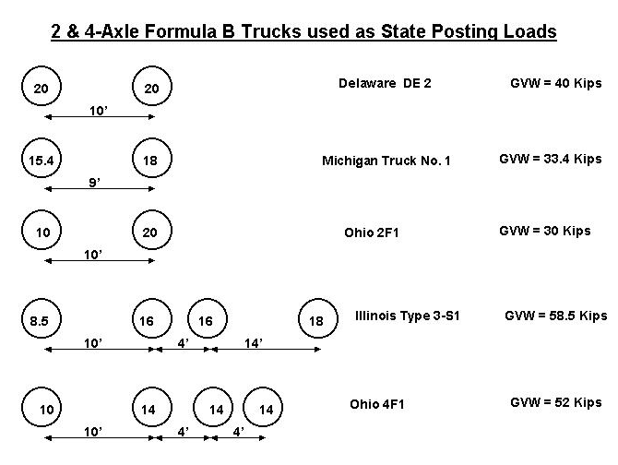

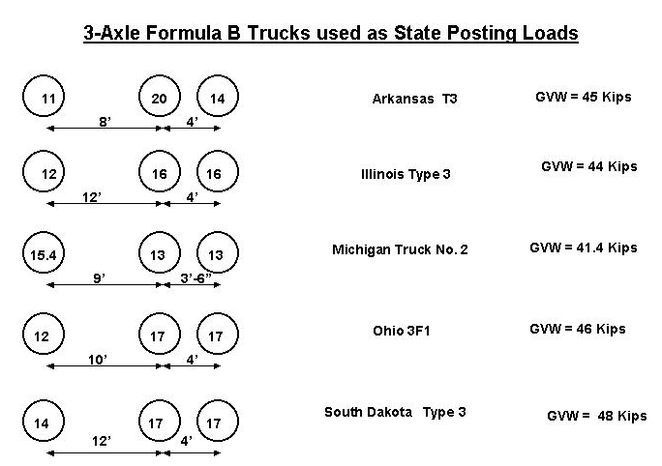

Figure C-17 Formula B State Posting Loads
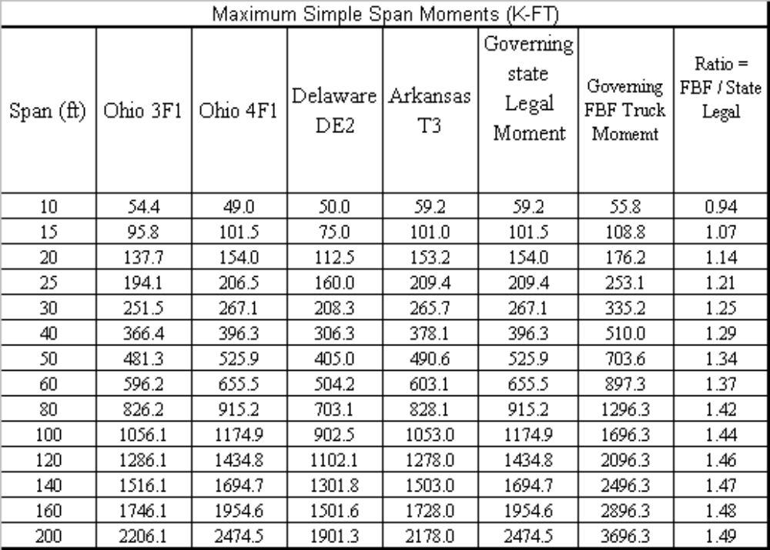TABLE C-14 Simple Span Moments from Formula B Posting Loads

TABLE C-15 Simple Span Shear from Formula B Posting Loads
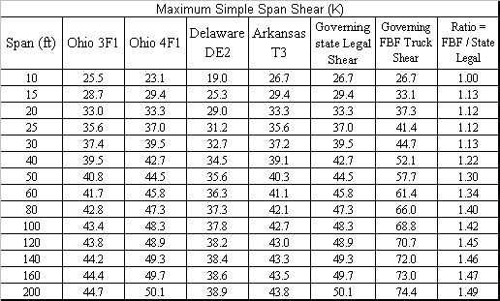

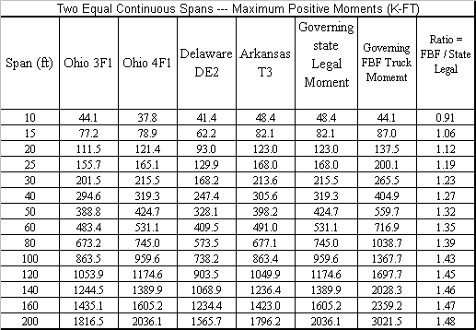
TABLE C-16 Two-Span Continuous ---Positive Moments from Formula B Posting
Loads

TABLE C-17 Two-Span Continuous ----- Negative Moments from Formula B Posting
Loads
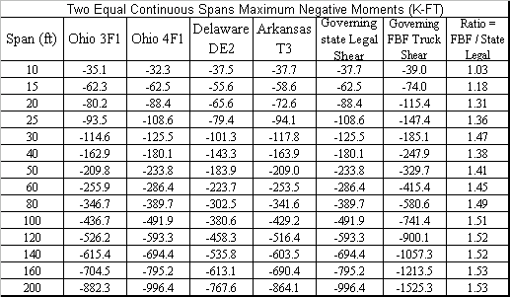
Governing Formula B Trucks

Maximum moments and shears for the data set of short wheelbase multi-axle trucks meeting Formula B were calculated for the suite of simple and continuous span bridges with span ranges from 10 feet to 200 feet. The results of the analyses performed are summarized in the tables and charts given below. It is evident that truck models T7A, T7B and T8 impose the highest load effects in most spans. In a few instances, for very short spans under 20 feet, one of the other shorter trucks could govern, but the governing values are not significantly higher than the maximum load effects imposed by these three trucks. Hence, it is considered appropriate to utilize the three trucks shown below (Figure C-18) ⎯ T7A, T7B, and T8 ⎯ as envelope vehicles for all likely and reasonable Formula B trucks. These are the heaviest Formula B trucks in the suite. They also have the most number of axles. Two of the three trucks, T7B and T8, are vehicles governed by the 80,000 pound gross weight limit and not by Formula B limits, which are higher. It seems logical that the three heaviest trucks in the suite with the most number of axles are in fact the envelope vehicles. As seen in Table C-23 the difference in load effects among the three trucks is highest in the 40 ft and under span range. This reiterates the fact that short spans are most sensitive to axle configurations. Truck T7A also induces the highest wheel load reaction on transverse floorbeams (see Table C-18).

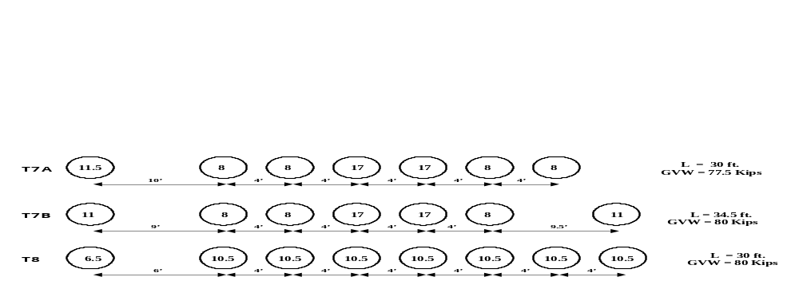
Figure C-18 Envelope Vehicles for All Formula B Trucks

TABLE C-18 Live Load Reactions on Transverse Floorbeams
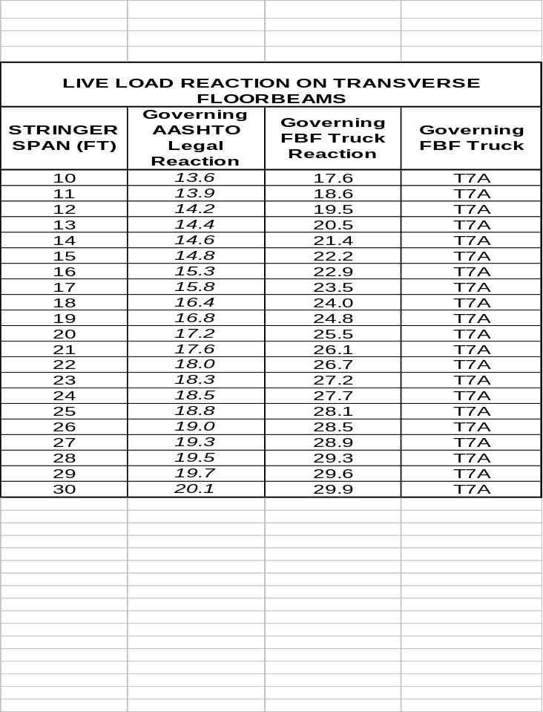

TABLE C-19 Maximum Simple Span Moments and Shears
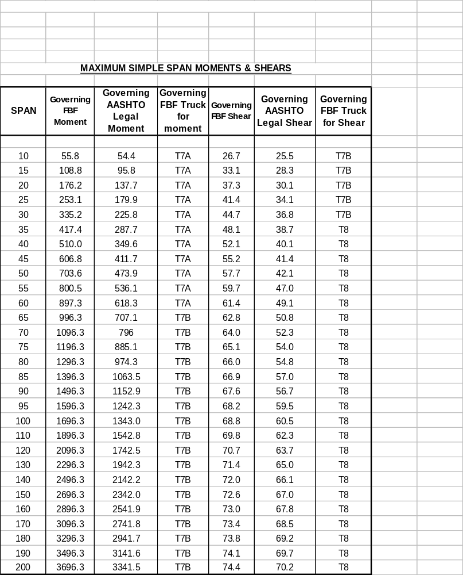

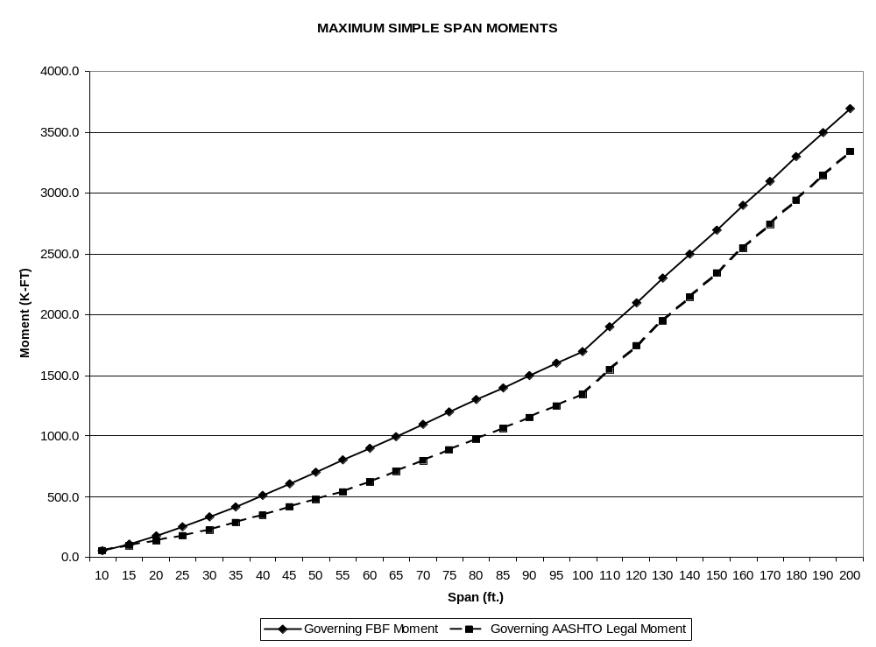

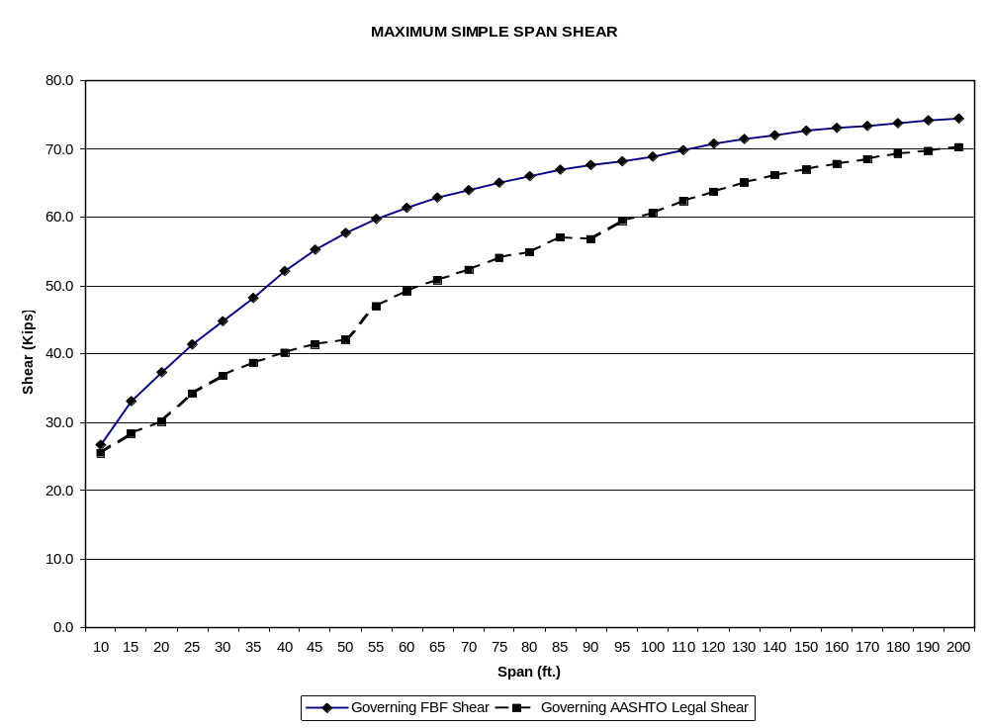

Figure C-19 Simple Span Maximum Moment and Shear Charts

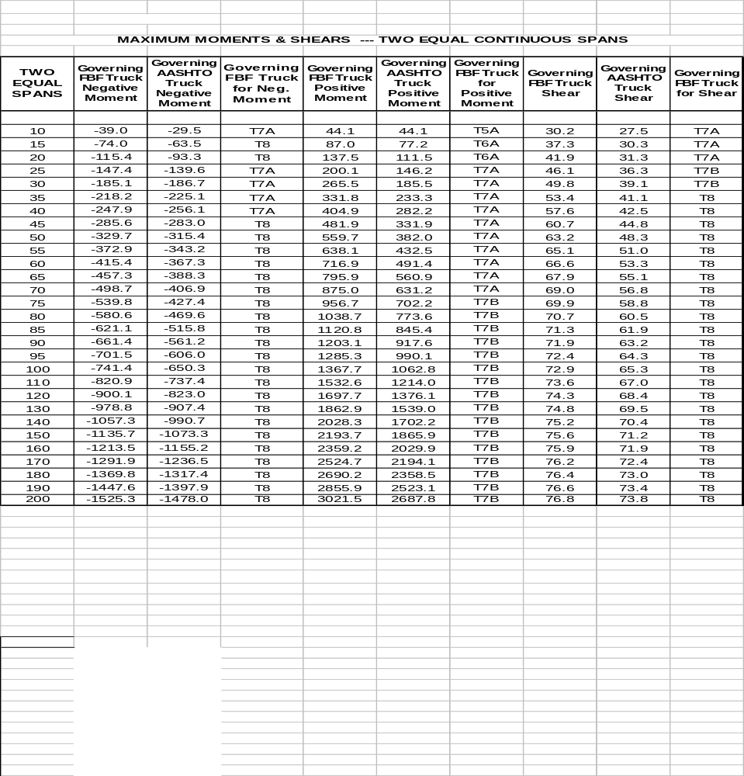
TABLE C-20 Maximum Moments and Shears -- Two Equal Continuous Spans

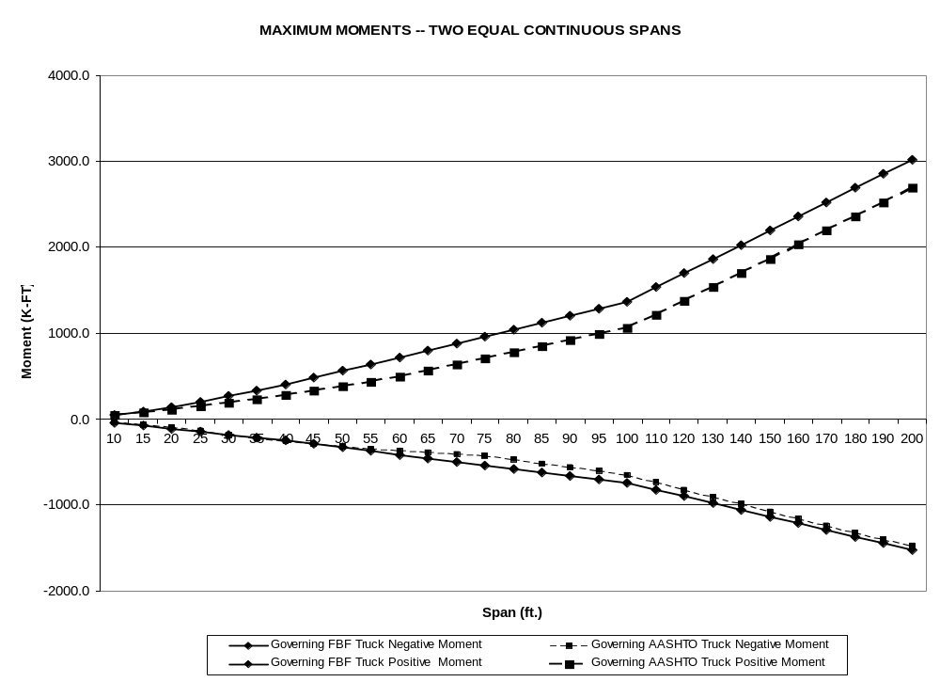

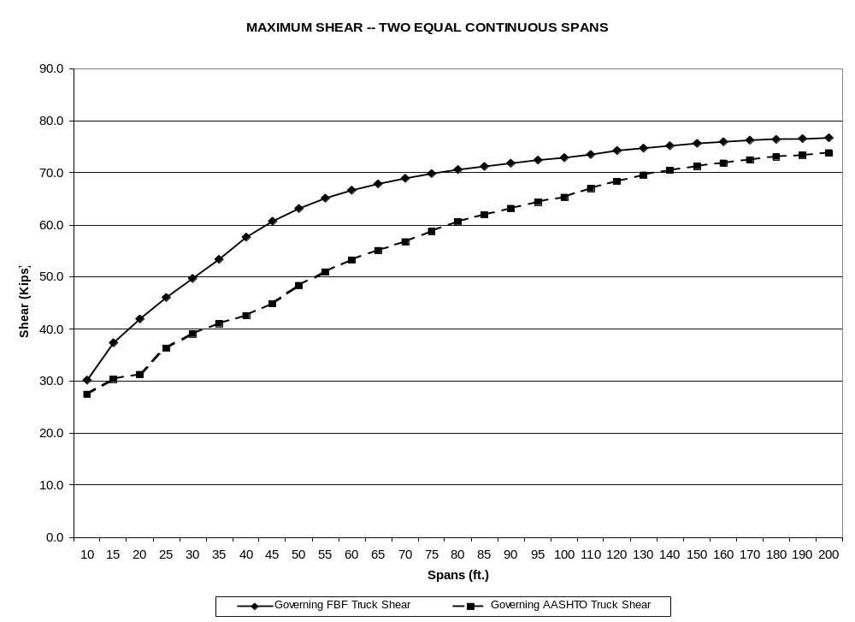

Figure C-20 Maximum Moment and Shear Charts -- Two Equal Continuous Spans

TABLE C-21 Maximum Moments and Shears -- Three Continuous Spans
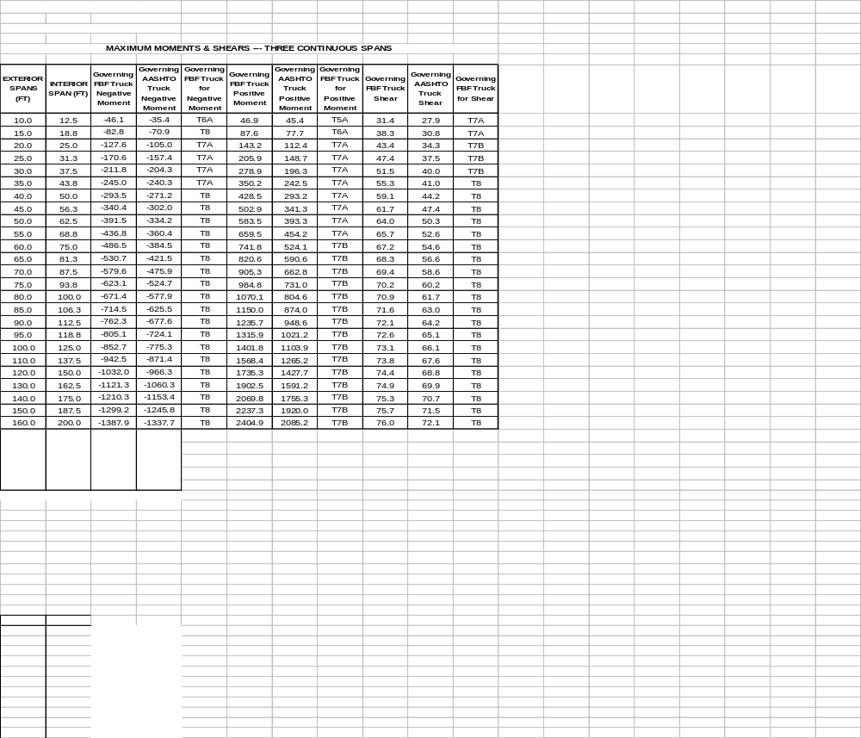

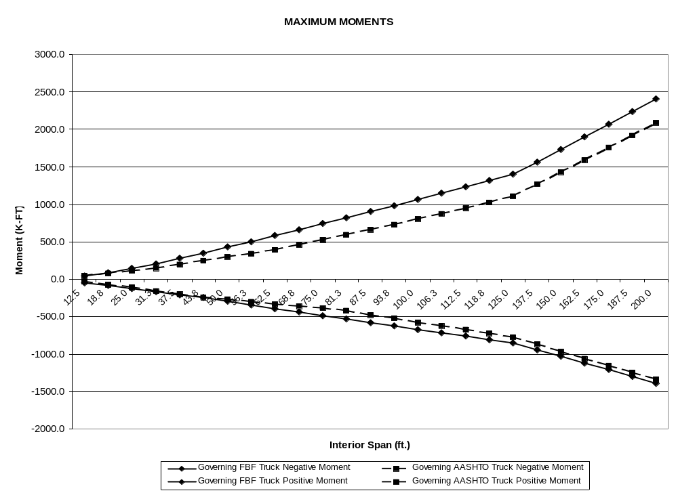

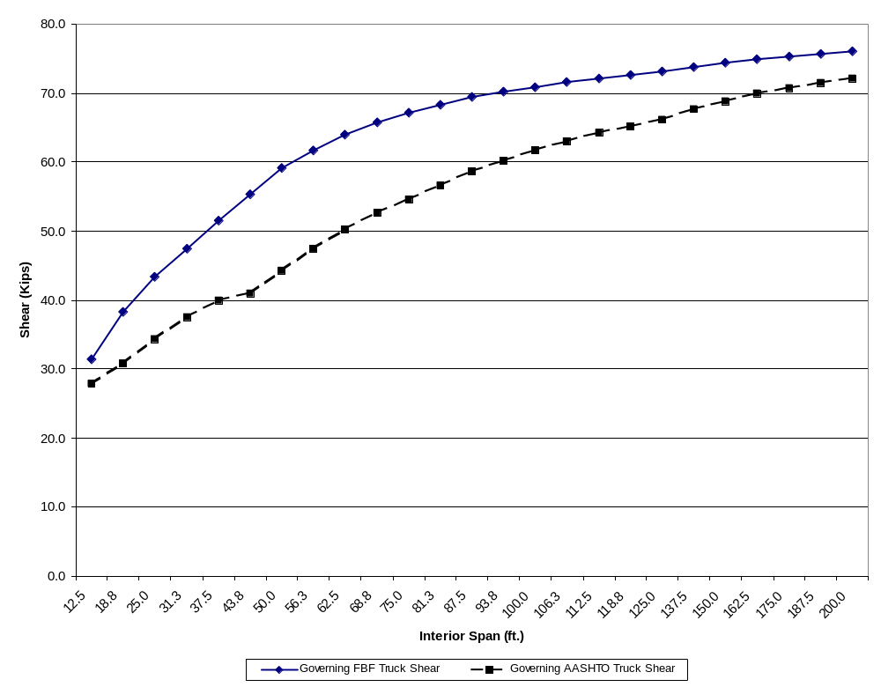

Figure C-21 Maximum Moment and Shear Charts -- Three Continuous Spans

TABLE C-22 Maximum Moments and Shears -- Four Continuous Spans
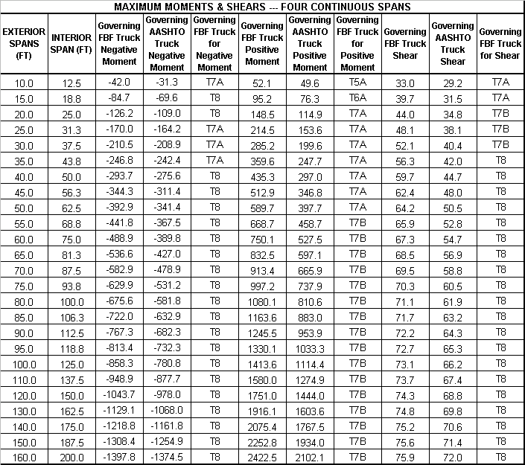

TABLE C-23 Maximum Simple Span Moments

Span (ft) | T8 | Governing FBF Moment | Ratio = Governing FBF/ T8 | Span (ft) | T8 | Governing FBF Moment | Ratio = Governing FBF/ T8
10 | 36.8 | 55.8 | 1.52 | 80 | 1290.0 | 1296.3 | 1.00
15 | 76.3 | 108.8 | 1.43 | 85 | 1390.0 | 1396.3 | 1.00
20 | 136.5 | 176.2 | 1.29 | 90 | 1489.9 | 1496.3 | 1.00
25 | 207.4 | 253.1 | 1.22 | 95 | 1589.9 | 1596.3 | 1.00
30 | 299.3 | 335.2 | 1.12 | 100 | 1689.9 | 1696.3 | 1.00
35 | 391.1 | 417.4 | 1.07 | 110 | 1889.8 | 1896.3 | 1.00
40 | 490.5 | 510.0 | 1.04 | 120 | 2089.8 | 2096.3 | 1.00
45 | 590.4 | 606.8 | 1.03 | 130 | 2289.8 | 2296.3 | 1.00
50 | 690.3 | 703.6 | 1.02 | 140 | 2489.8 | 2496.3 | 1.00
55 | 790.2 | 800.5 | 1.01 | 150 | 2689.8 | 2696.3 | 1.00
60 | 890.1 | 897.3 | 1.01 | 160 | 2889.7 | 2896.3 | 1.00
65 | 990.1 | 996.3 | 1.01 | 170 | 3089.7 | 3096.3 | 1.00
70 | 1090.1 | 1096.3 | 1.01 | 180 | 3289.7 | 3296.3 | 1.00
75 | 1190.0 | 1196.3 | 1.01 | 190 | 3489.7 | 3496.3 | 1.00
 |  |  |  | 200 | 3689.7 | 3696.3 | 1.00

PROPOSED NOTIONAL RATING LOAD MODEL

The analytical studies have identified a single rating vehicle (80 Kips) that will envelope the load effects of all reasonable Formula B truck configurations on simple and continuous spans ranging from 10 feet to 200 feet in length (Fig C-22). This truck meets all Formula B requirements (inner and outer) and all Federal weight laws. This truck will be referred to herein as Truck BFT (Bridge Formula Truck). Bridges that rate for the truck BFT are safe for all Formula B configurations, represented by the twelve FBF truck models shown previously. A Rating Factor < 1.0 indicates that further analysis is required to determine the need for posting. In some cases posting may not be required as the load effects of the posting loads may be less than for the BFT.

When using truck BFT (Fig C-22), computation of load effects are to be done in accordance with the following guidelines:

- Axles that do not contribute to the maximum load effect shall be neglected.
2) The drive axle spacing can be varied from 6’ to 14’ in order to maximize force effects.

The force effects induced by the candidate rating truck BFT and the suite of twelve representative Formula B trucks with 3 to 8 axles (Formula B trucks are denoted as FBF trucks) are compared in the following tables and figures:

Table C-24: Maximum and Minimum Ratios of Force Effects
Table C-25: Maximum Moments – Simple Spans (Governing FBF Truck vs. BFT)
Table C-26: Maximum Shear – Simple Spans (Governing FBF Truck vs. BFT)
Figure C-23: Maximum Moments – Simple Spans (Governing FBF Truck vs. BFT)
Figure C-24: Maximum Shear – Simple Spans (Governing FBF Truck vs. BFT)

Table C-27: Maximum Positive Moments – Two-Span Cont. (Governing FBF Truck vs. BFT)
Table C-28: Maximum Negative Moments – Two-Span Cont. (Governing FBF Truck vs. BFT)
Table C-29: Maximum Shear – Two-Span Cont. (Governing FBF Truck vs. BFT)
Figure C-25: Maximum Negative Moments – Two-Span Cont. (Governing FBF Truck vs. BFT)
Figure C-26: Maximum Positive Moments – Two-Span Cont. (Governing FBF Truck vs. BFT)
Figure C-27: Maximum Shear – Two-Span Cont. (Governing FBF Truck vs. BFT)

Table C-30: Maximum Shear – Three-Span Cont. (Governing FBF Truck vs. BFT)
Table C-31: Maximum Positive Moments – Three-Span Cont. (Governing FBF Truck vs. BFT)
Table C-32: Maximum Negative Moments – Three-Span Cont. (Governing FBF Truck vs. BFT)
Figure C-28: Maximum Positive Moments – Three-Span Cont. (Governing FBF Truck vs. BFT)
Figure C-29: Maximum Negative Moments – Three-Span Cont. (Governing FBF Truck vs. BFT)
Figure C-30: Maximum Shear – Three-Span Cont. (Governing FBF Truck vs. BFT)

Table C-33: Maximum Positive Moments – Four-Span Cont. (Governing FBF Truck vs. BFT)
Table C-34: Maximum Shear – Four-Span Cont. (Governing FBF Truck vs. BFT)
Table C-35: Maximum Negative Moments – Four-Span Cont. (Governing FBF Truck vs. BFT)
Figure C-31: Maximum Positive Moments – Four-Span Cont. (Governing FBF Truck vs. BFT)
Figure C-32: Maximum Shear – Four-Span Cont. (Governing FBF Truck vs. BFT)
Figure C-33: Maximum Negative Moments – Four-Span Cont. (Governing FBF Truck vs. BFT)

A number of trials were performed prior to selecting truck BFT as the best envelope vehicle for the suite of FBF trucks. Moment and shear ratios (BFT/FBF) are also reported in the tables to facilitate easy comparison. A ratio greater than 1.0 indicates that the proposed rating truck BFT produces a higher force effect than the representative Formula B configurations. A desirable characteristic of the BFT truck selected is that the moment and shear ratios for the various span lengths and span configurations are consistently slightly above 1.0, except for a few very short continuous spans (less than 20 ft) where the ratios were slightly below 1.0. In summary, truck BFT appears to be a very good envelope vehicle for the suite of FBF trucks.

TABLE C-24 Maximum and Minimum Ratios of Force Effects
FORCE EFFECT | Ratio BFT/FBF: Min, Max
Maximum Moments – Simple Spans | 1.00, 1.05
Maximum Shear – Simple Spans | 0.99, 1.04
Maximum Positive Moments – Two-Span Cont | 1.00, 1.05
Maximum Negative Moments – Two-Span Cont. | 0.94, 1.04 Min @ span = 20 ft
Maximum Shear – Two-Span Cont. | 1.00, 1.04
Maximum Shear – Three-Span Cont. | 0.98, 1.02 Min @ span = 10 ft.
Maximum Positive Moments – Three-Span Cont. | 0.99, 1.04
Maximum Negative Moments – Three-Span Cont. | 0.97, 1.03 Min @ span = 10 ft
Maximum Positive Moments – Four-Span Cont. | 0.90, 1.04 Min @ span = 10 ft
Maximum Shear – Four-Span Cont. | 0.95, 1.03 Min @ span = 10 ft
Maximum Negative Moments – Four-Span Cont. | 0.99, 1.15 Max @ span = 10 ft.

The standard truck BFT configuration (8-axle truck with 6’ drive axle spacing) will generally govern the rating analyses of bridges. A few exceptions to this statement are evident and should be noted. In order to maximize the BFT positive moment in very short continuous spans, certain end axles had to be omitted during the analysis (see Tables C-27, C-31 & C-33). Typically, continuous span bridges with span lengths less than 25 feet required the omission of one or more end axles to maximize the positive moment. For the Formula B trucks (FBF trucks), the same force effect was governed by the 5 or 6 axle truck (T5A or T6A). So, it is to be expected that certain axles in the BFT load model that do not contribute to the maximum positive moments need to be neglected or they will contribute to bending in the opposite (negative) direction. Identifying the governing axle configuration may require a few trials; not considered particularly difficult as most continuous beam analyses are automated. This requirement should not affect many load ratings as the population of continuous bridges with spans under 25 feet is not likely to be significant. To guide the rating engineer the Manual commentary could explain that all simple spans and continuous spans with spans > 25 feet would not be affected by the requirement to omit axles that do not contribute to the maximum load effect. Axles that fall outside the bridge are not affected by this requirement as they are automatically neglected in the analysis.

In a few cases, the drive axle spacing was also varied to increase the positive moments in short continuous spans (see Tables C-27, C-31 & C-33). Increasing the drive axle spacing from 6 feet to 14 feet resulted in a slight increase in positive moments for continuous span bridges with spans less than 35 feet. Language in the commentary could guide the rating engineer as to where the variable drive axle spacing may be important and should be evaluated.

TABLE C-25 Maximum Moments – Simple Spans
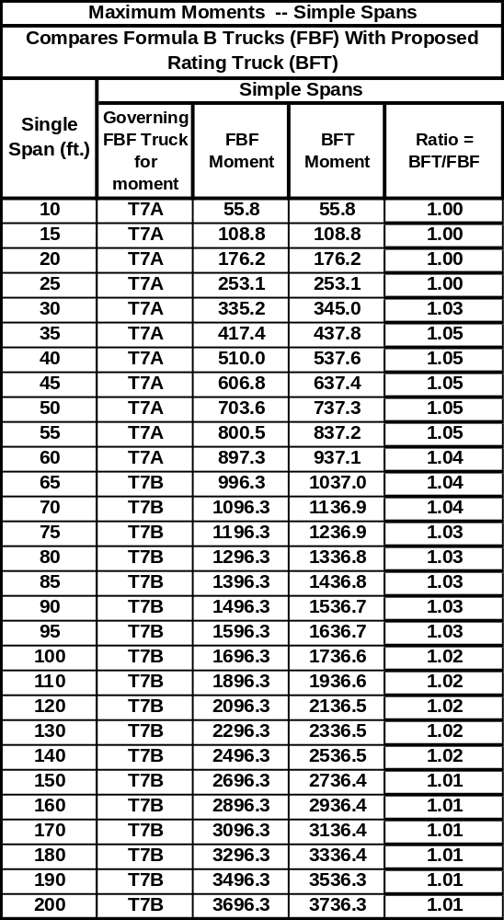

TABLE C-26 Maximum Shear–Simple Spans
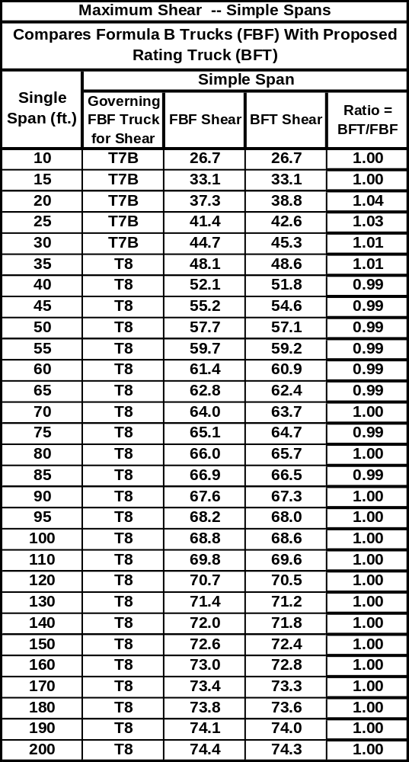

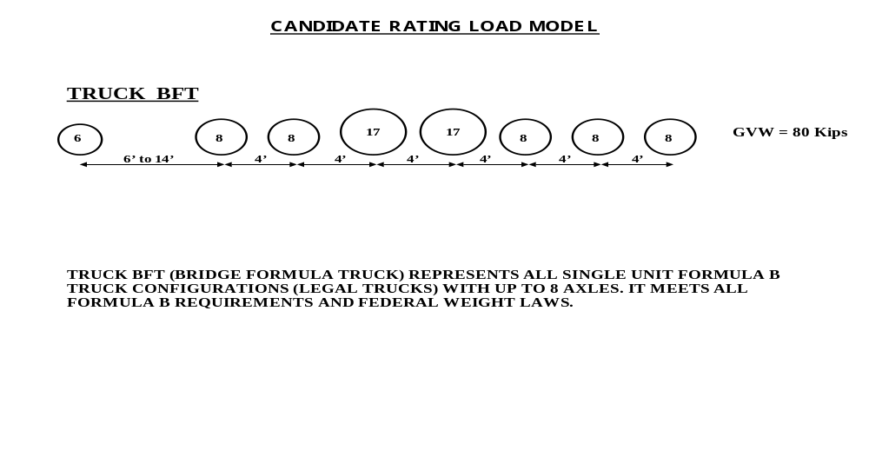
Figure C-22 Bridge Formula Truck (BFT)

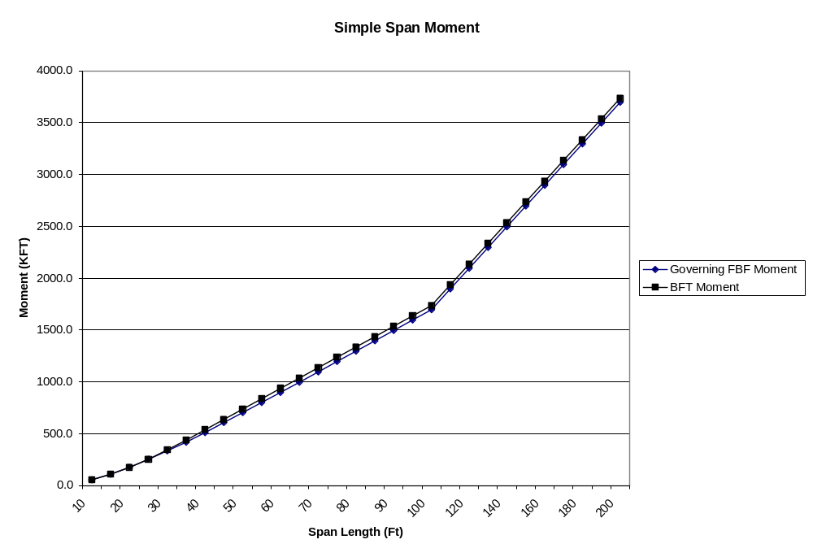
Figure C-23 Maximum Moments – Simple Spans
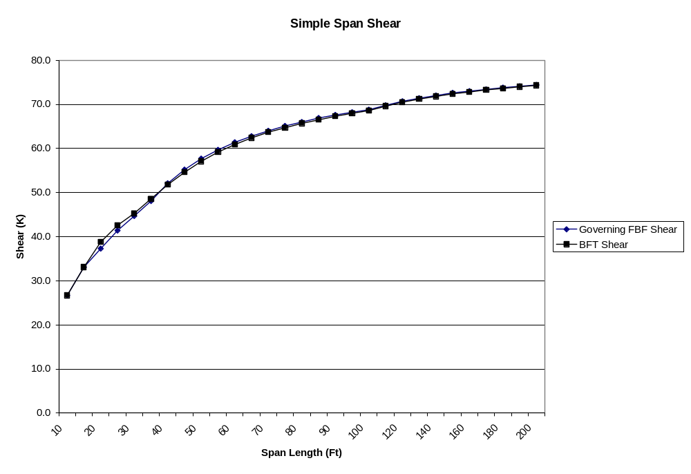
Figure C-24 Maximum Shear – Simple Spans
TABLE C-27 Maximum Positive Moments – Two-Span Cont.
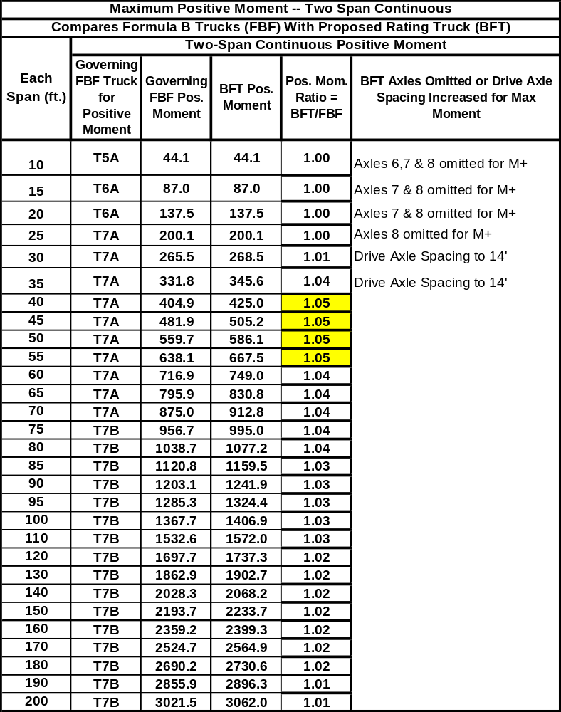

TABLE C-28 Maximum Negative Moments – Two-Span Cont.
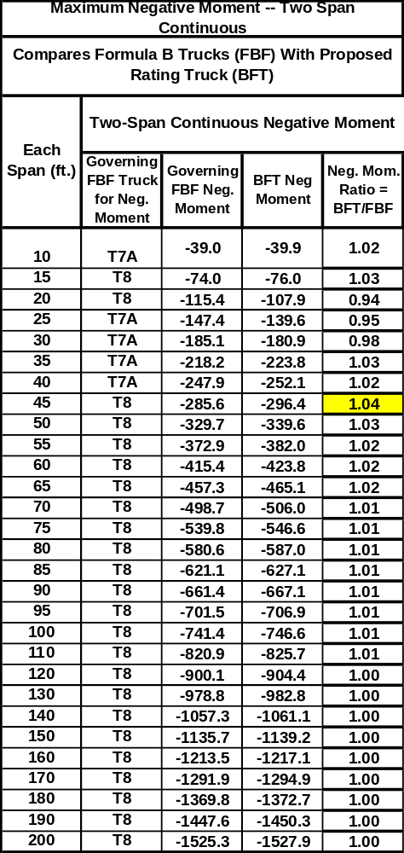

TABLE C-29 Maximum Shear – Two-Span 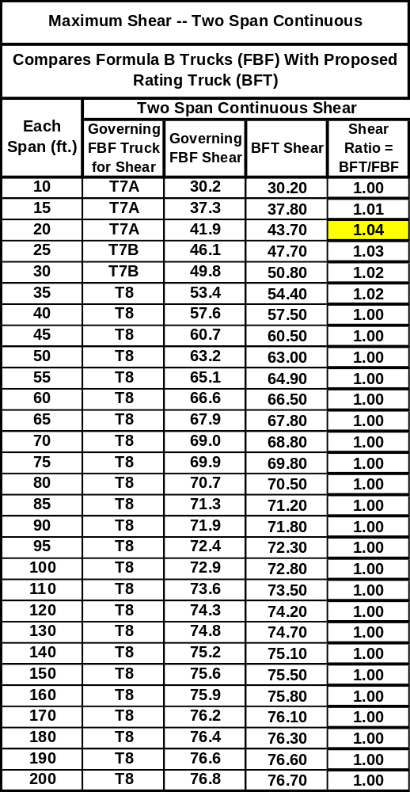

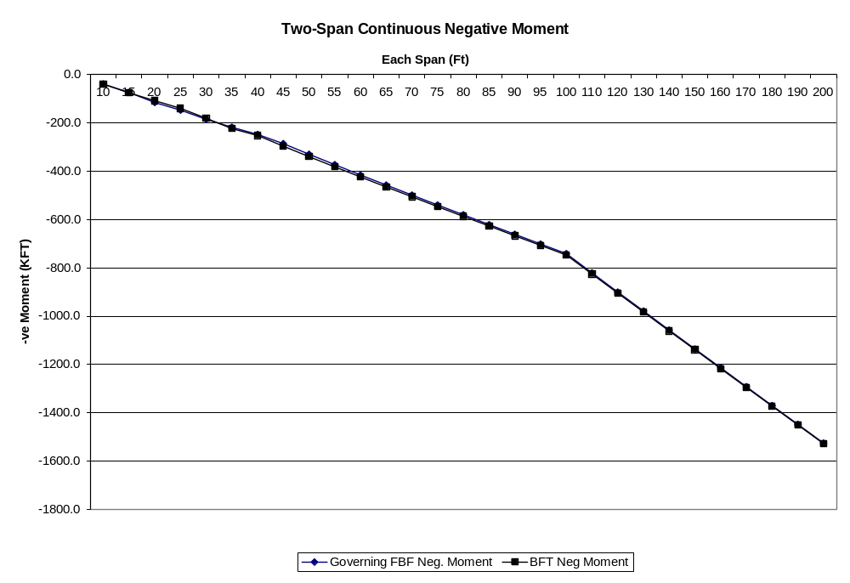
Figure C-25 Maximum Negative Moments – Two-Span Cont.

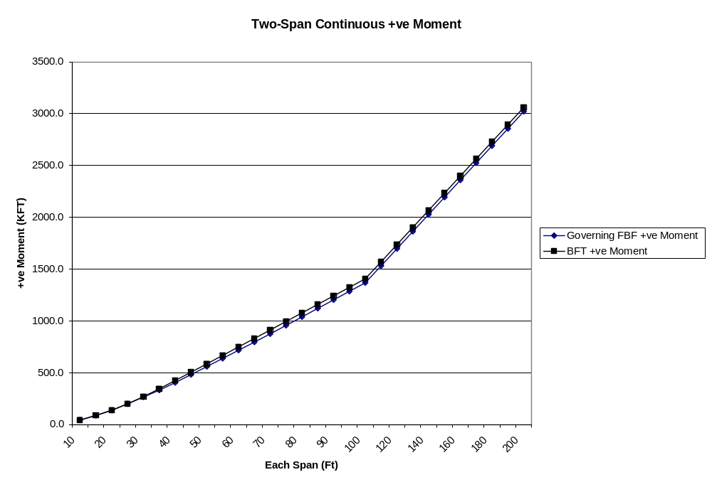

Figure C-26 Maximum Positive Moments – Two-Span Cont.

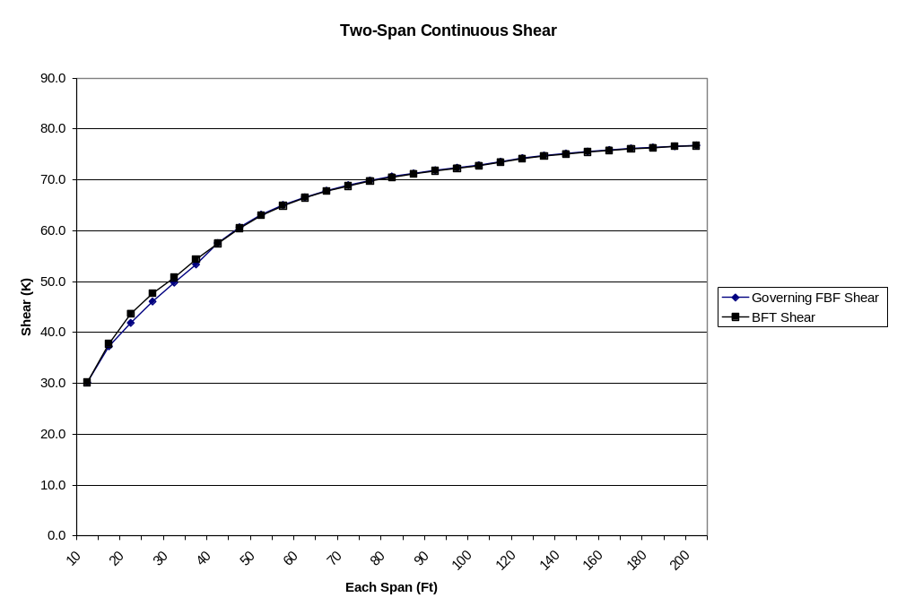
Figure C-27 Maximum Shear – Two-Span Cont.
TABLE C-30 Maximum Shear – Three-Span 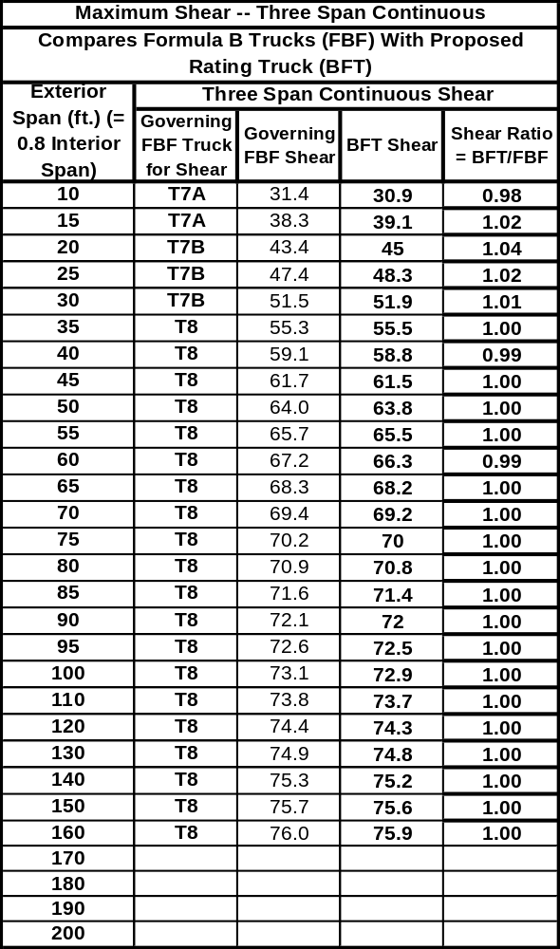

TABLE C-31 Maximum Positive Moments – Three-Span Cont.
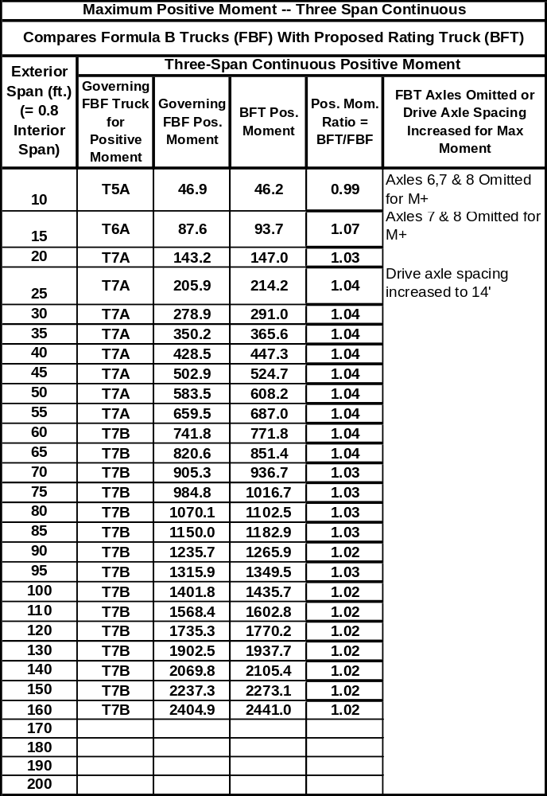

TABLE C-32 Maximum Negative Moments –Three-Span Cont.
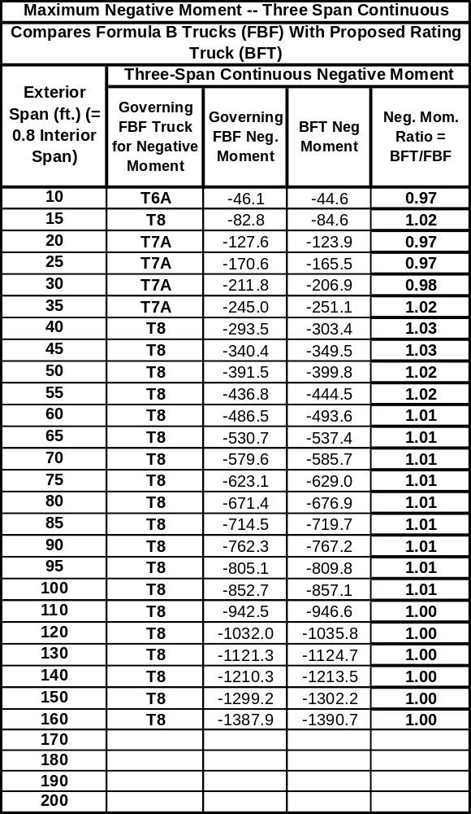

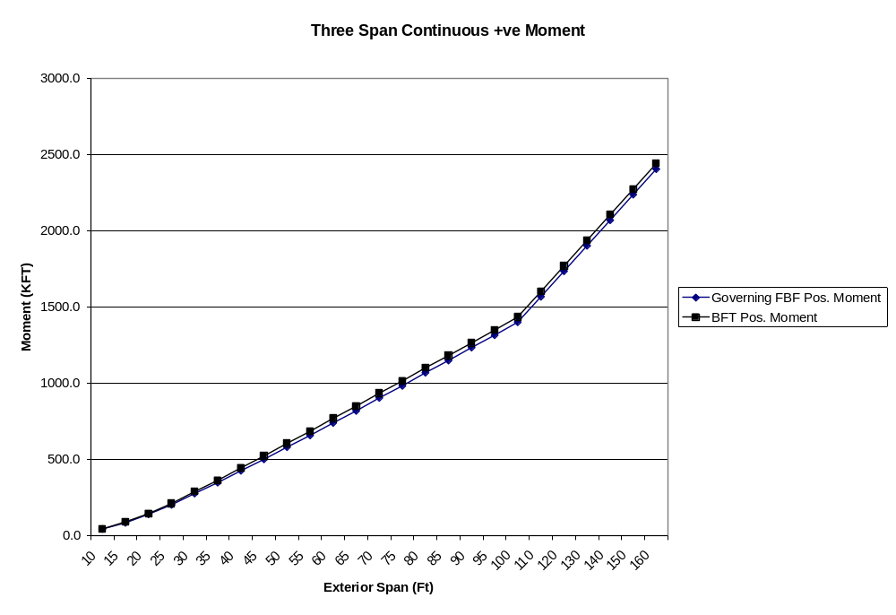
Figure C-28 Maximum Positive Moments – Three-Span Cont.

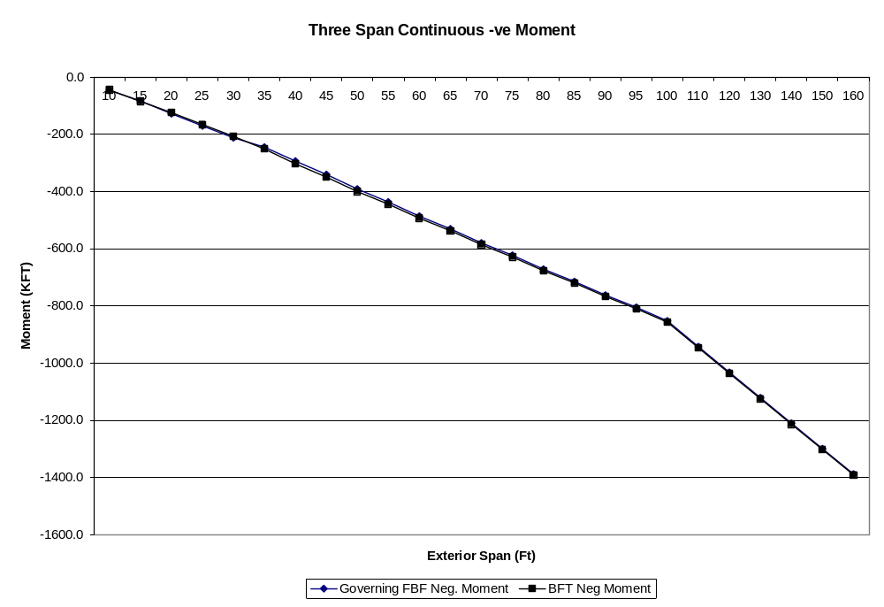

Figure C-29 Maximum Negative Moments – Three-Span Cont.

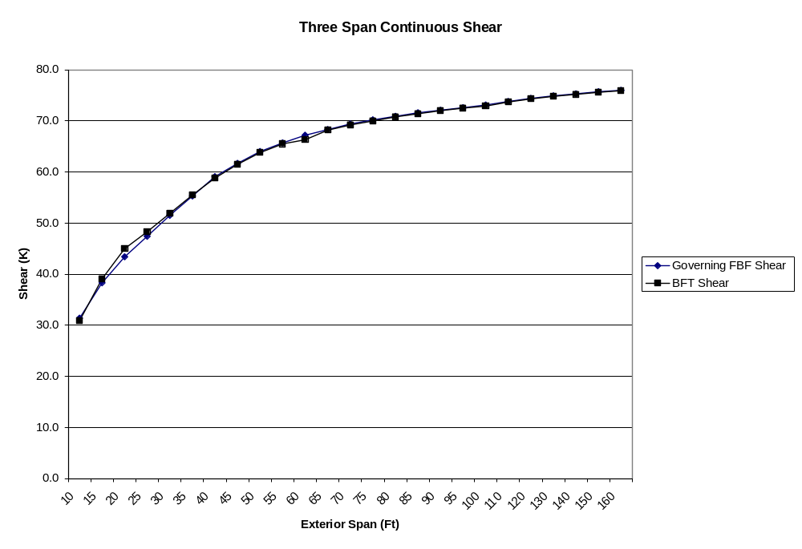
Figure C-30 Maximum Shear – Three-Span Cont.
TABLE C-33 Maximum Positive Moments – Four-Span Cont.
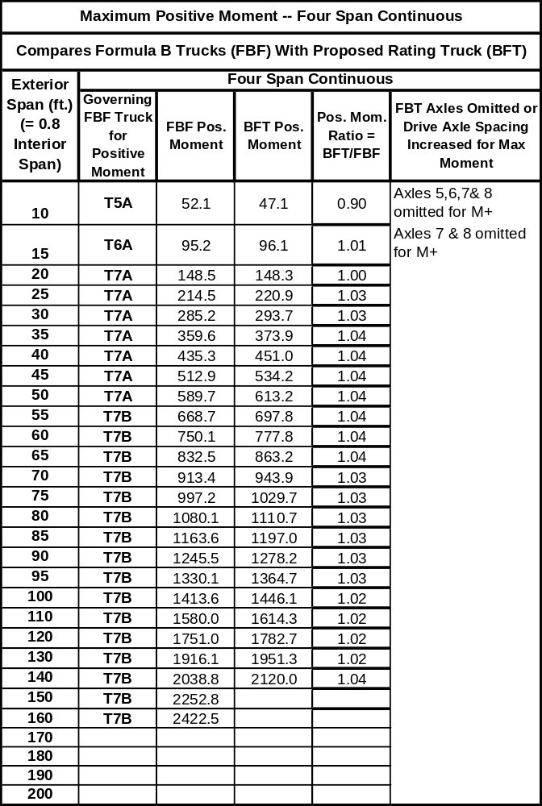

TABLE C-34 Maximum Shear – Four-Span Cont.
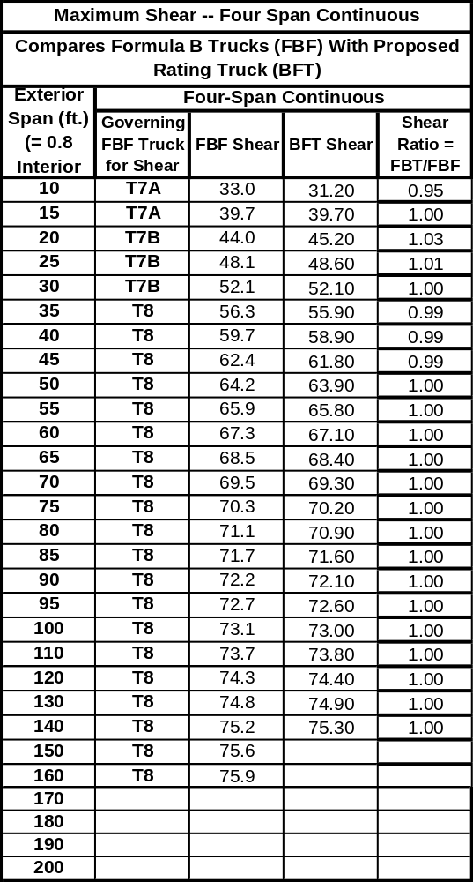

TABLE C-35 Maximum Negative Moments – Four-Span Cont.
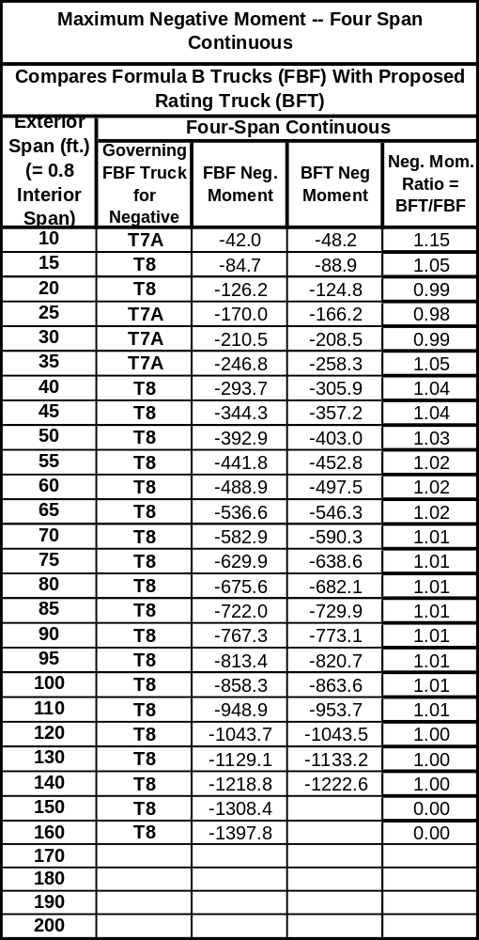

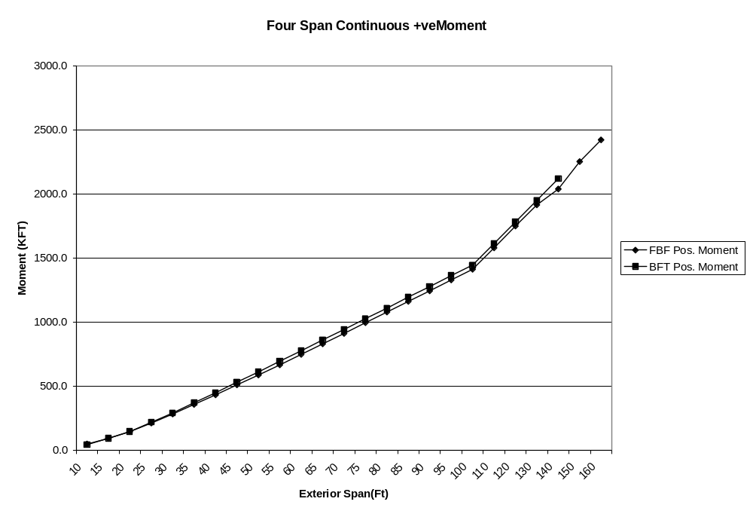
Figure C-31 Maximum Positive Moments – Four-Span Cont.

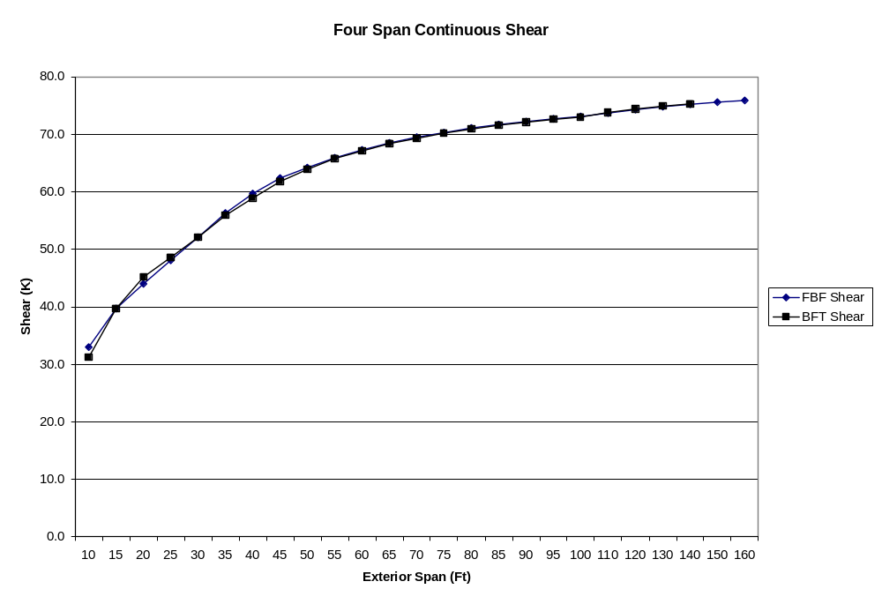
Figure C-32 Maximum Shear – Four-Span Cont.

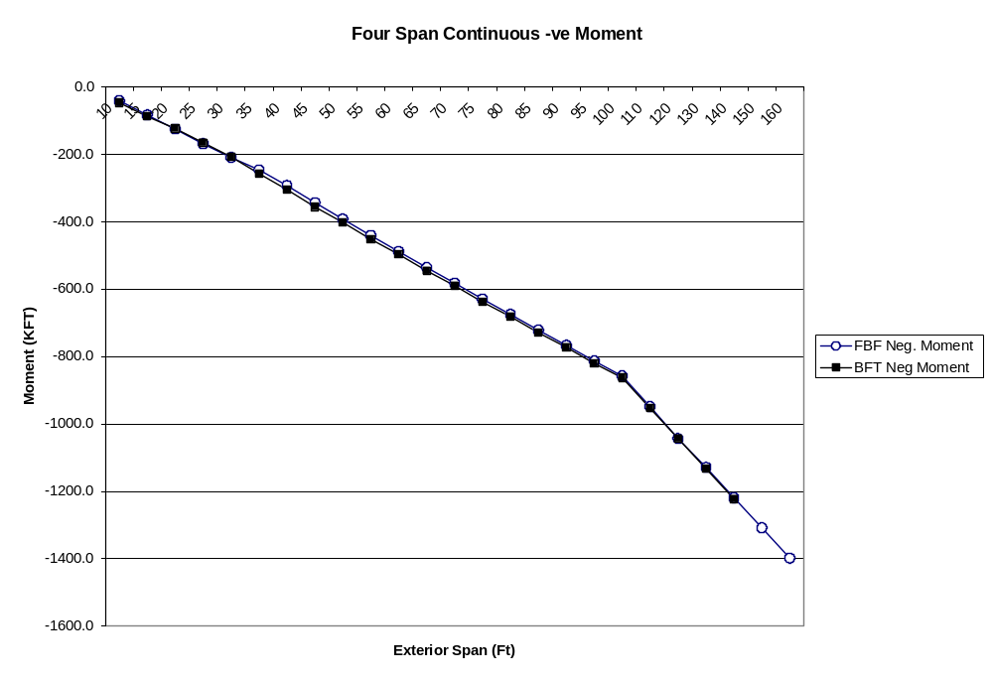
Figure C-33 Maximum Negative Moments – Four-Span Cont.
COMPARE FORCES INDUCED BY THE PROPOSED RATING TRUCK (BFT) WITH HS20 & AASHTO LEGAL LOADS

The test suite of simple and continuous span bridges (spans ranging from 10 feet to 200 feet) were utilized to compare the force effects induced by the proposed rating truck BFT and current AASHTO legal loads for posting to the forces produced by HS20 loading. The results are summarized in the following tables and figures:

Table C-36: Force Effect Ratios
Table C-37: Maximum Moments – Simple Spans (HS20, AASHTO Legal vs. BFT)
Table C-38: Maximum Shear – Simple Spans (HS20, AASHTO Legal vs. BFT)
Figure C-34: Maximum Shear – Simple Spans (HS20, AASHTO Legal vs. BFT)
Figure C-35: Maximum Moments – Simple Spans (HS20, AASHTO Legal vs. BFT)

Table C-39: Maximum Negative Moments – Two-Span Cont. (HS20, AASHTO Legal, BFT)
Table C-40: Maximum Positive Moments – Two-Span Cont. (HS20, AASHTO Legal, BFT)
Table C-41: Maximum Shear – Two-Span Cont. (HS20, AASHTO Legal vs. BFT)
Figure C-36: Maximum Positive Moments – Two-Span Cont. (HS20, AASHTO Legal, BFT)
Figure C-37: Maximum Negative Moments – Two-Span Cont. (HS20, AASHTO Legal, BFT)
Figure C-38: Maximum Shear – Two-Span Cont. (HS20, AASHTO Legal, BFT)

Table C-42: Maximum Shear – Three-Span Cont. (HS20, AASHTO Legal, BFT)
Table C-43: Maximum Positive Moments – Three-Span Cont. (HS20, AASHTO Legal, BFT)
Table C-44: Maximum Negative Moments – Three-Span Cont.(HS20, AASHTO Legal, BFT)
Figure C-39: Maximum Positive Moments – Three-Span Cont. (HS20, AASHTO Legal, BFT)
Figure C-40: Maximum Negative Moments – Three-Span Cont.(HS20, AASHTO Legal, BFT)
Figure C-41: Maximum Shear – Three-Span Cont. (HS20, AASHTO Legal , BFT)

Table C-45: Maximum Positive Moments – Four-Span Cont. (HS20, AASHTO Legal, BFT)
Table C-46: Maximum Negative Moment – Four-Span Cont. (HS20, AASHTO Legal, BFT)
Table C-47: Maximum Shear – Four-Span Cont. (HS20, AASHTO Legal vs. BFT)
Figure C-42: Maximum Positive Moments – Four-Span Cont. (HS20, AASHTO Legal, BFT)
Figure C-43: Maximum Shear – Four-Span Cont. (HS20, AASHTO Legal vs. BFT)
Figure C-44: Maximum Negative Moments – Four-Span Cont. (HS20, AASHTO Legal, BFT)

TABLE C-36 Force Effect Ratios
FORCE EFFECT | BFT/HS20  Range of Values | BFT/AASHTO Legal  Range of Values
Maximum Moments – Simple Spans | 0.70 to 1.22 | 1.03 to 1.56
Maximum Shear – Simple Spans | 0.88 to 1.08 | 1.05 to 1.36
Maximum Negative Moments – Two-Span Cont | 0.39 to 0.98 | 0.97 to 1.35
Maximum Positive Moments – Two-Span Cont. | 0.67 to 1.20 | 1.00 to 1.54
Maximum Shear – Two-Span Cont. | 0.72 to 1.08 | 1.04 to 1.40
Maximum Shear – Three-Span Cont. | 0.79 to 1.07 | 1.05 to 1.35
Maximum Positive Moments – Three-Span Cont. | 0.66 to 1.19 | 1.02 to 1.55
Maximum Negative Moments – Three-Span Cont. | 0.47 to 1.04 | 1.01 to 1.28
Maximum Positive Moments – Four-Span Cont. | 0.67 to 1.20 | 0.95 to 1.54
Maximum Shear – Four-Span Cont. | 0.84 to 1.07 | 1.07 to 1.33
Maximum Negative Moments – Four-Span Cont. | 0.48 to 0.99 | 1.00 to 1.54

Some findings of these analyses are:

- The proposed rating truck BFT consistently produces higher force effects than the current AASHTO legal loads for the test suite of simple and continuous span bridges.
- Simple span BFT moments are about 10% to 20% higher than HS20 for spans governed by the HS20 truck loading. For longer spans governed by HS20 lane loading (over 170 ft), HS20 moments exceed BFT moments. BFT moments are significantly higher than AASHTO legal loads for most simple spans (Table C-37).
- Simple span shears for BFT and HS20 truck are within 8% for most spans (Table C-37).
- HS20 negative moments are significantly higher than the BFT negative moments for most continuous span configurations. The difference increases with increasing span. It should be noted that the HS20 negative moments are governed by the lane load model, whereas, the BFT negative moments are computed for a single truck. BFT negative moments, however, exceed the AASHTO legal load negative moments (also computed for a single truck).
- BFT positive moments for most continuous spans are higher than the HS20 moments by up to 20% (truck governs). For the same force effect, BFT exceeds the AASHTO legal loads by over 50% in certain cases.
- Continuous span shears for BFT and HS20 generally do not vary by more than 8%, except when the lane load governs HS20 shear.

It should be noted that a Rating Factor < 1.0 only indicates that further analysis is required to determine the need for posting. In some cases posting may not be required as the load effects of the posting loads may be less than for the BFT.

TABLE C-37 Maximum Moments – Simple Spans
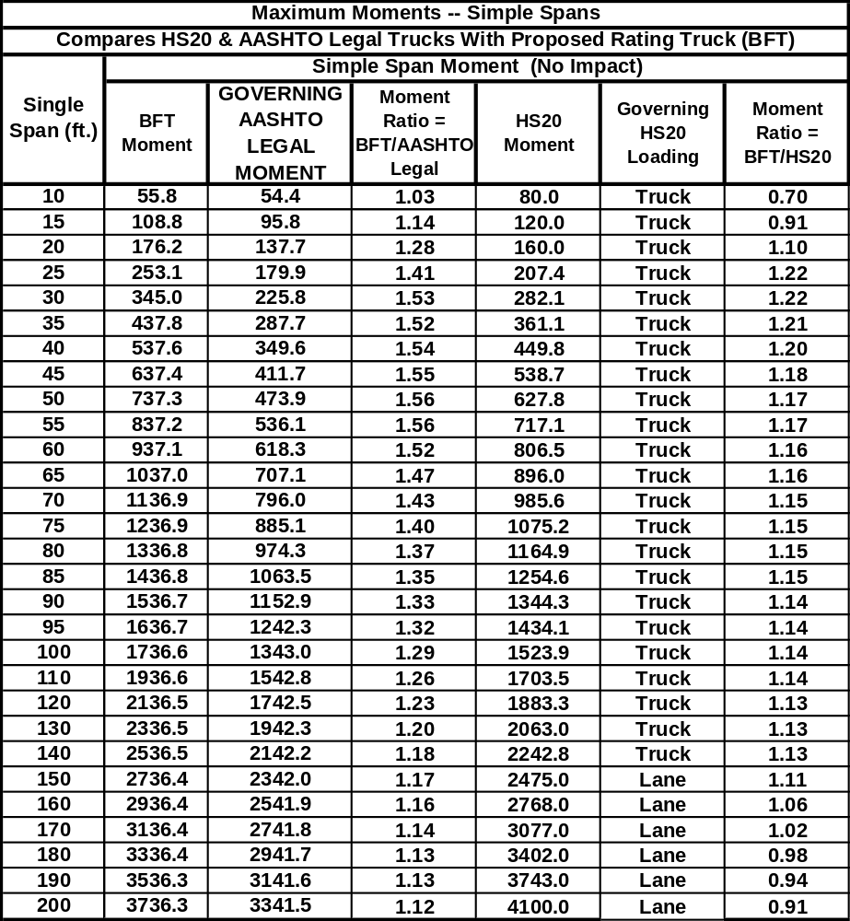

TABLE C-38 Maximum Shear – Simple Spans
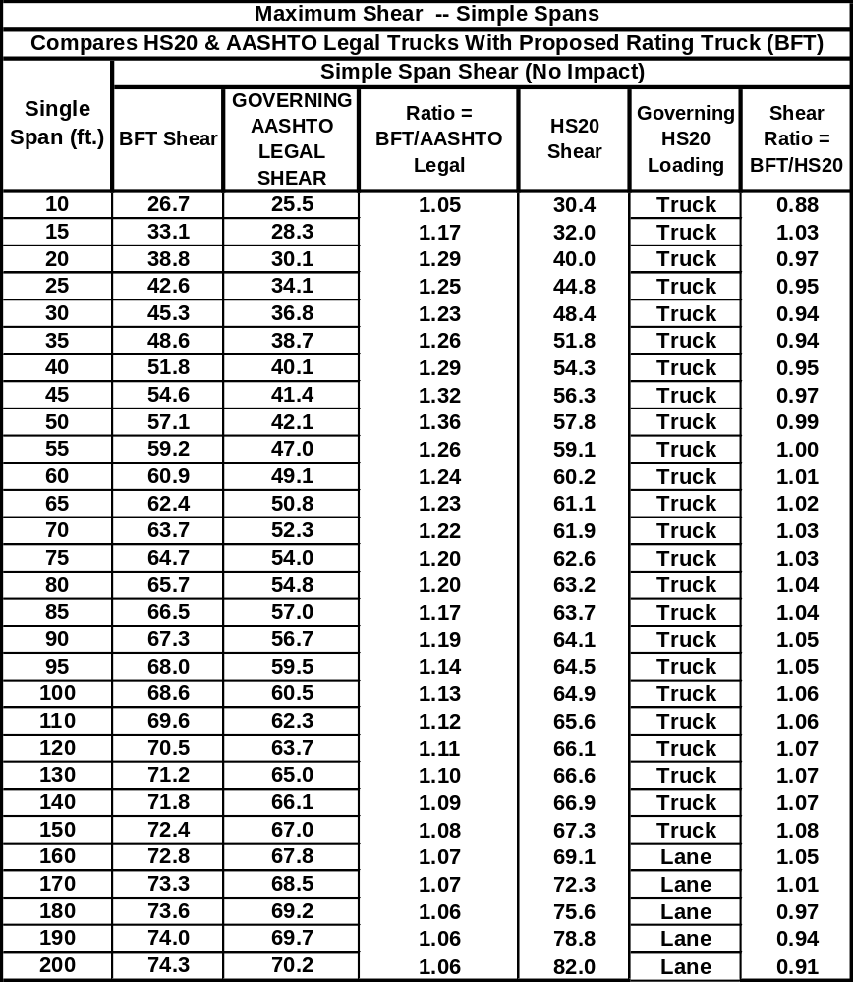

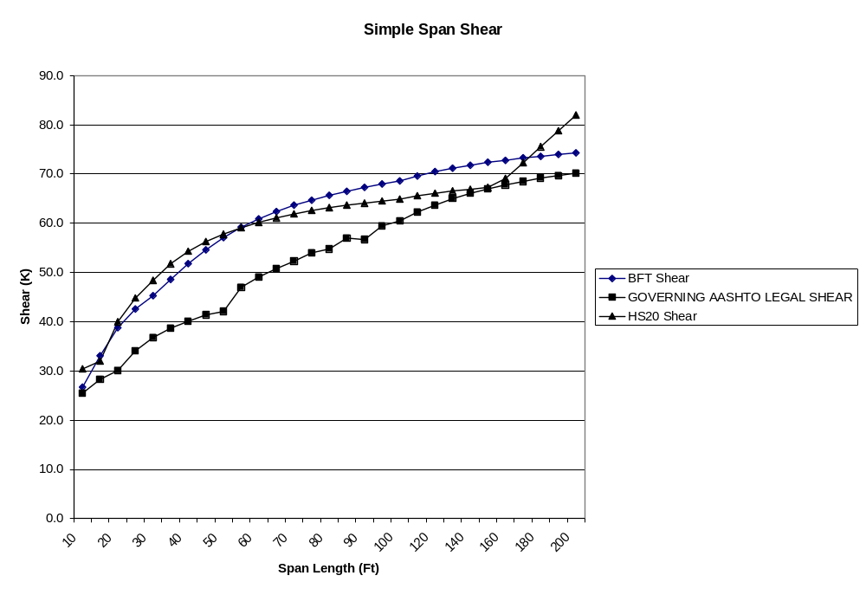
Figure C-34 Maximum Shear – Simple Spans
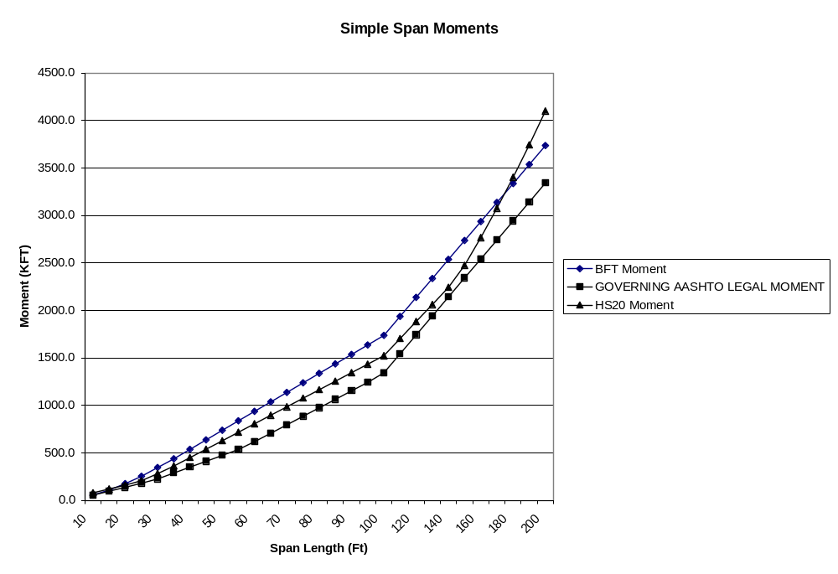
Figure C-35 Maximum Moments – Simple Spans
TABLE C-39 Maximum Negative Moments – Two-Span Cont.
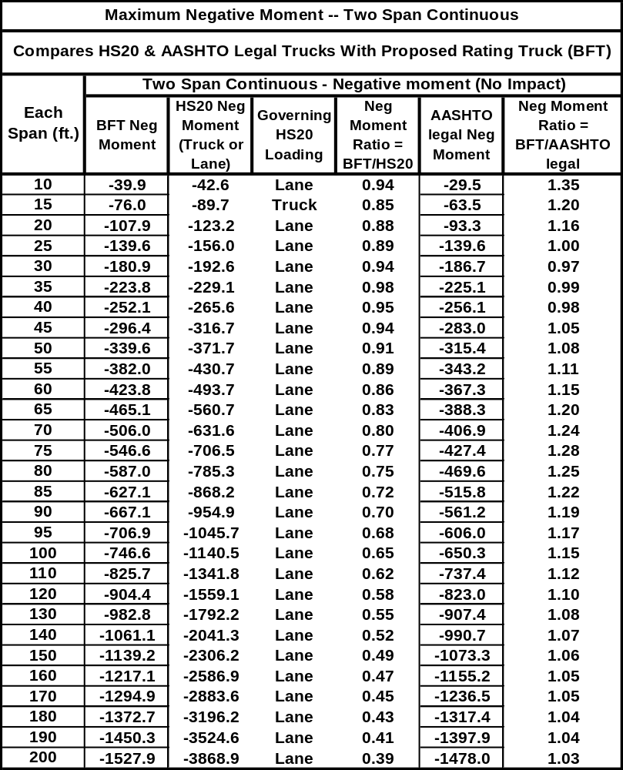

TABLE C-40 Maximum Positive Moments – Two-Span Cont.
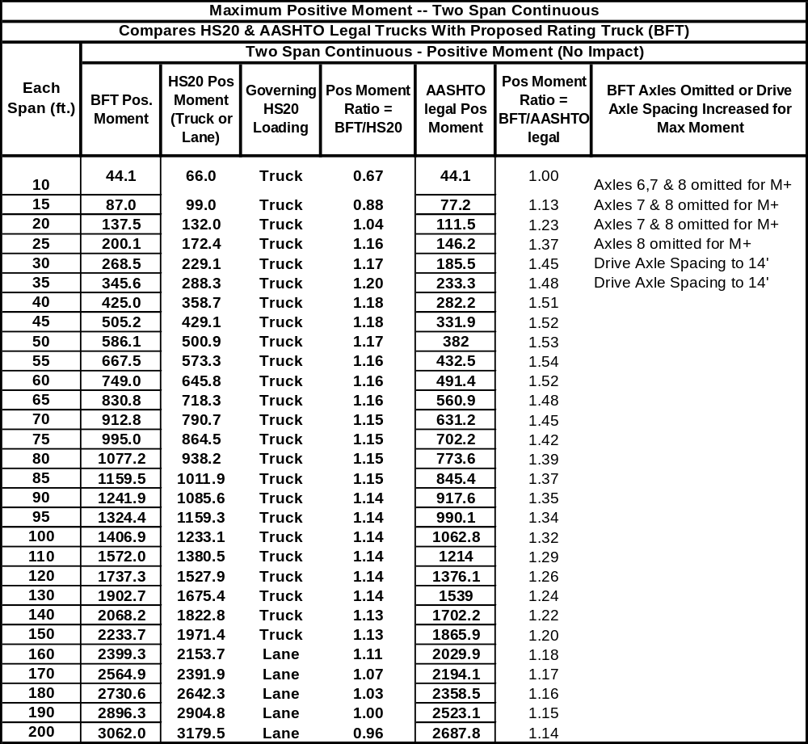

TABLE C-41 Maximum Shear – Two-Span Cont.
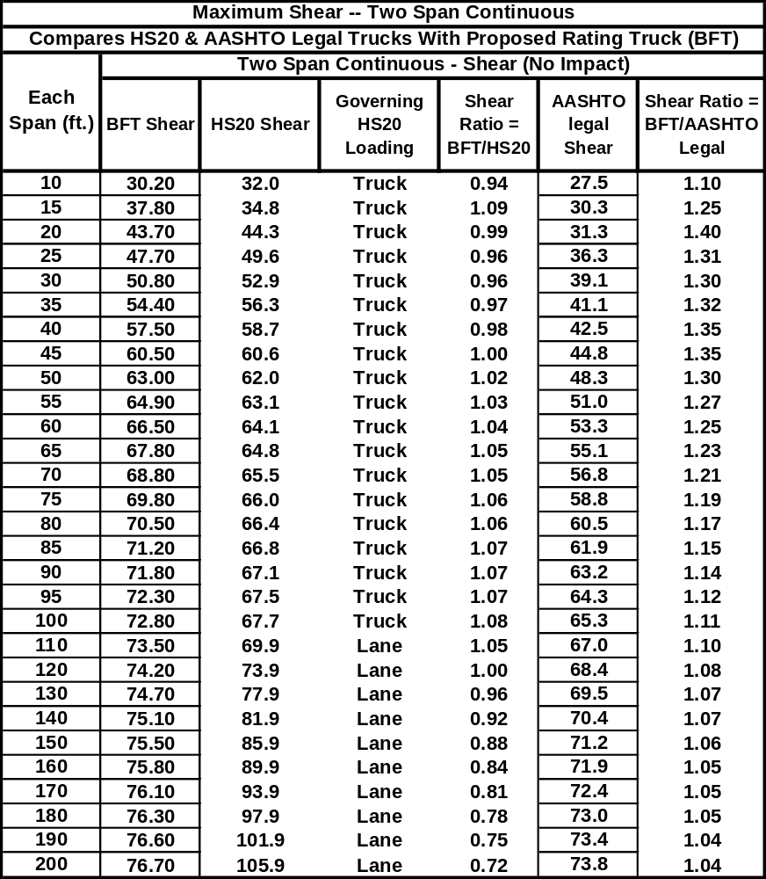

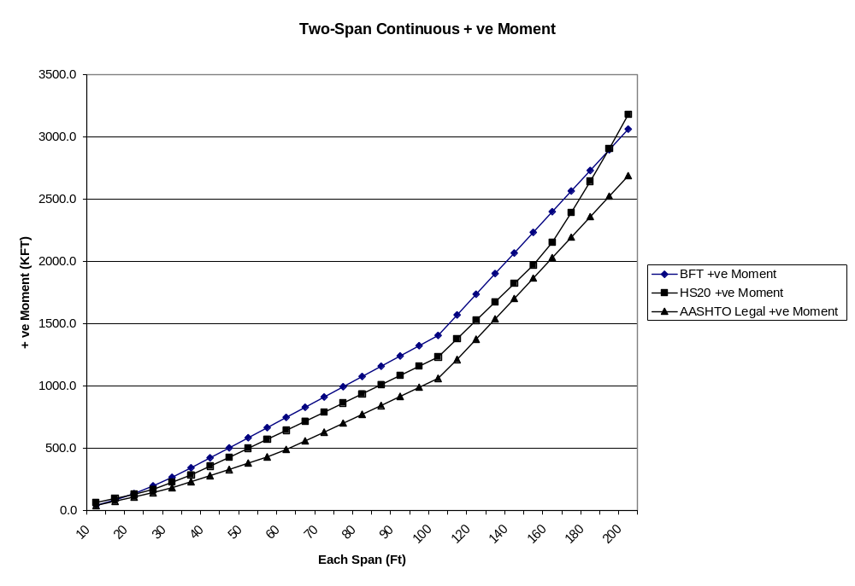
Figure C-36 Maximum Positive Moments – Two-Span Cont.

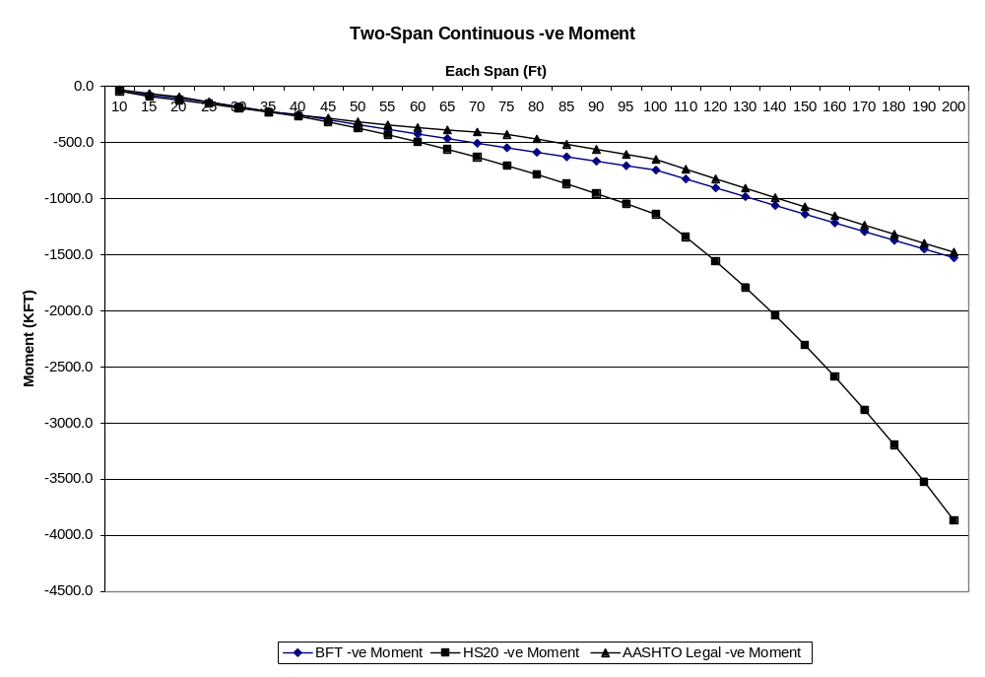
Figure C-37 Maximum Negative Moments – Two-Span Cont.
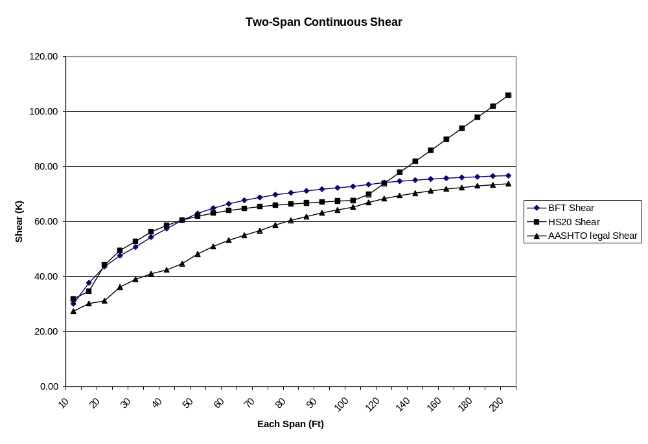
Figure C-38 Maximum Shear – Two-Span Cont.
TABLE C-42 Maximum Shear – Three-Span Cont.
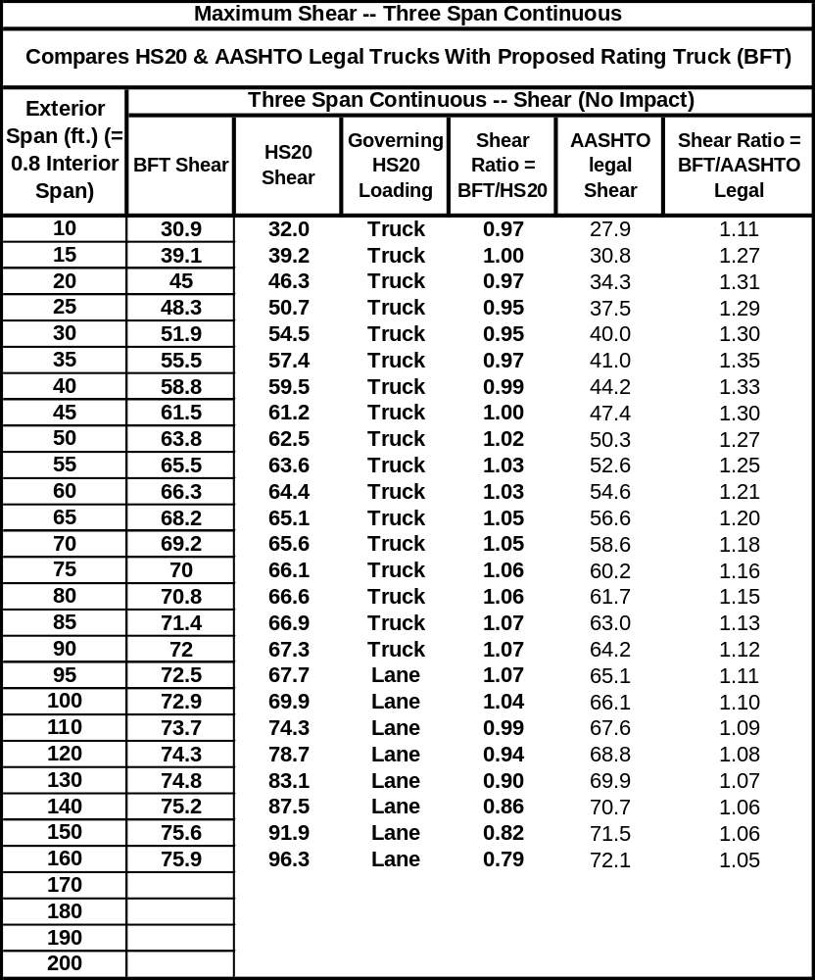

TABLE C-43 Maximum Positive Moments – Three-Span Cont.
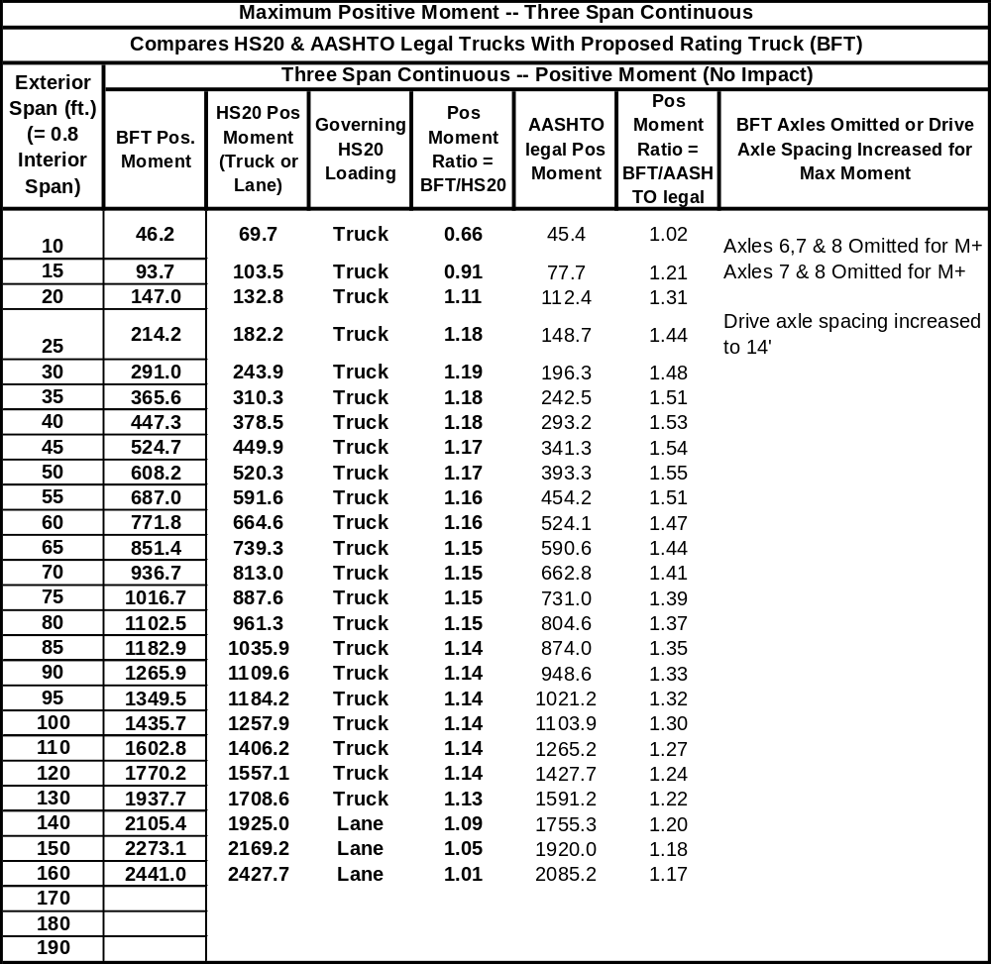

TABLE C-44 Maximum Negative Moments – Three-Span Cont.
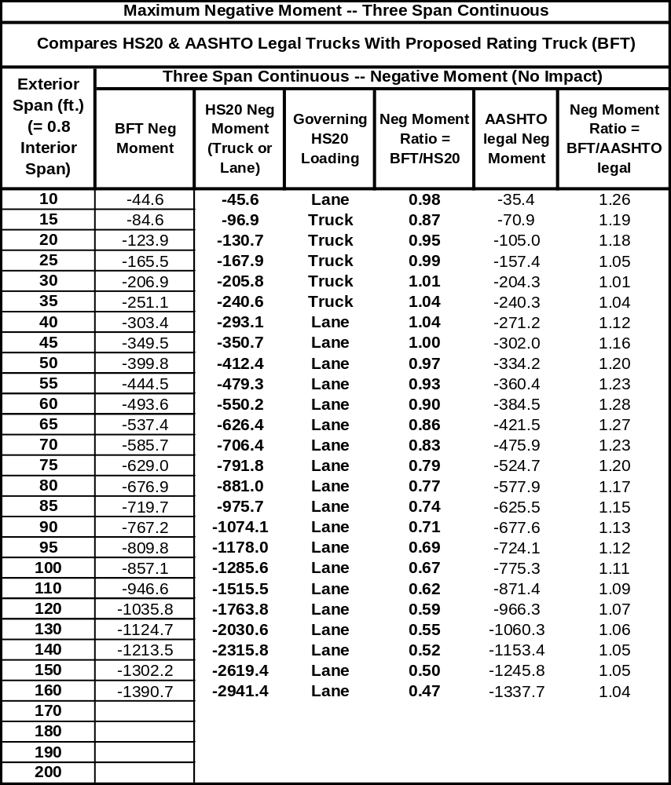

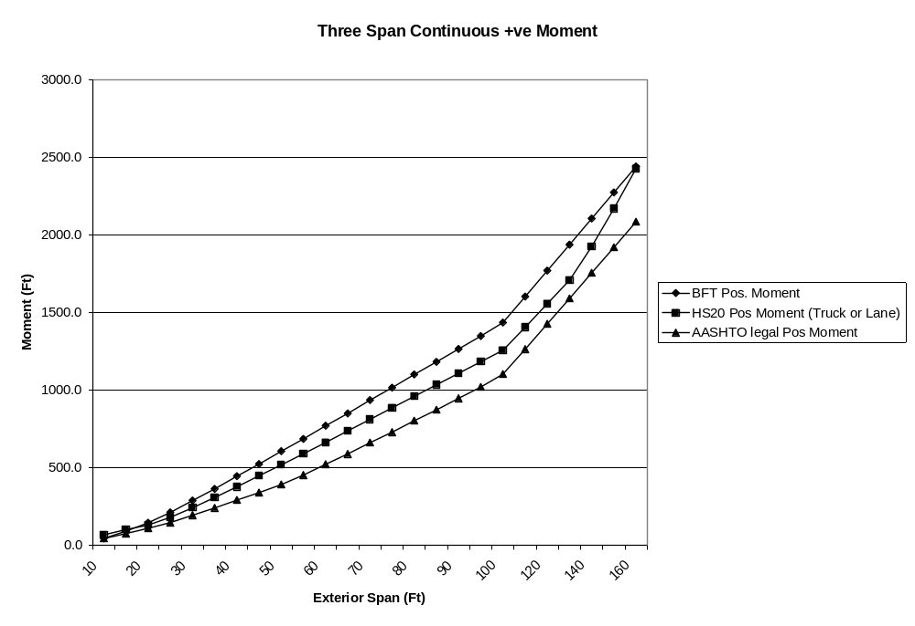
Figure C-39 Maximum Positive Moments – Three-Span Cont.
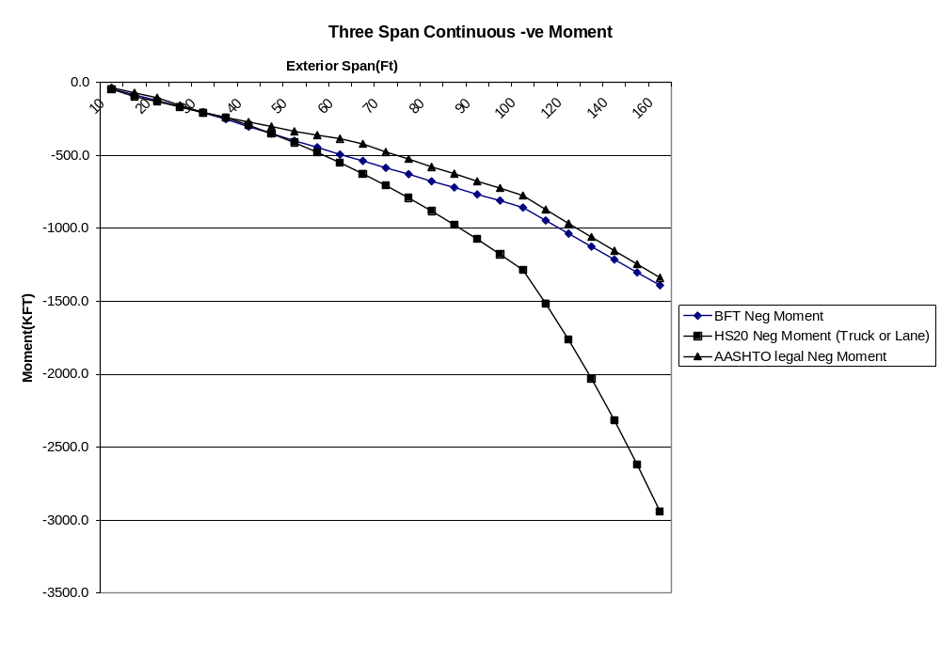
Figure C-40 Maximum Negative Moments – Three-Span Cont.
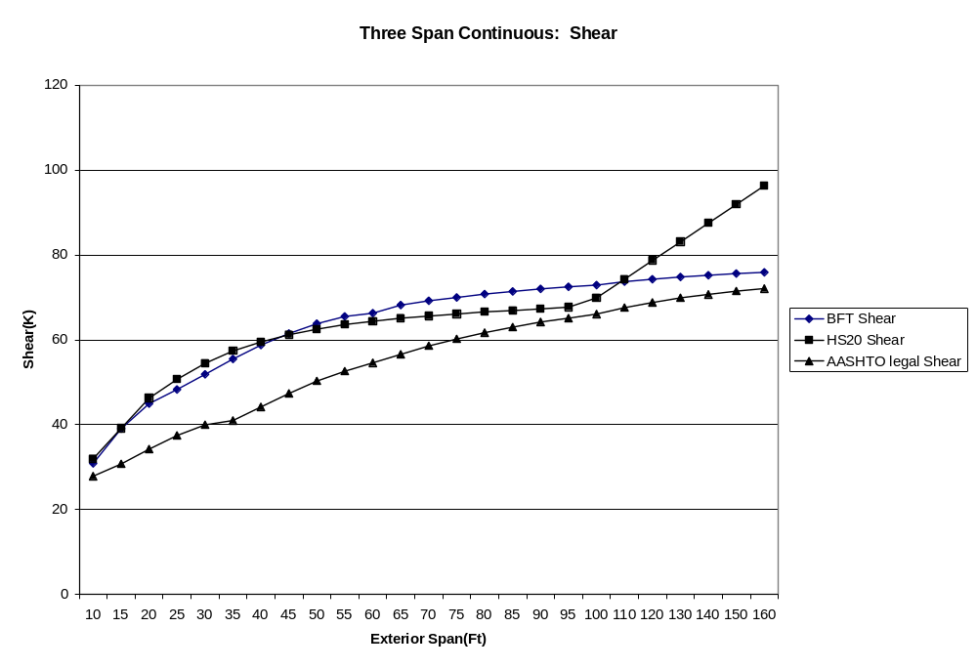
Figure C-41 Maximum Shear – Three-Span Cont.
TABLE C-45 Maximum Positive Moments – Four-Span 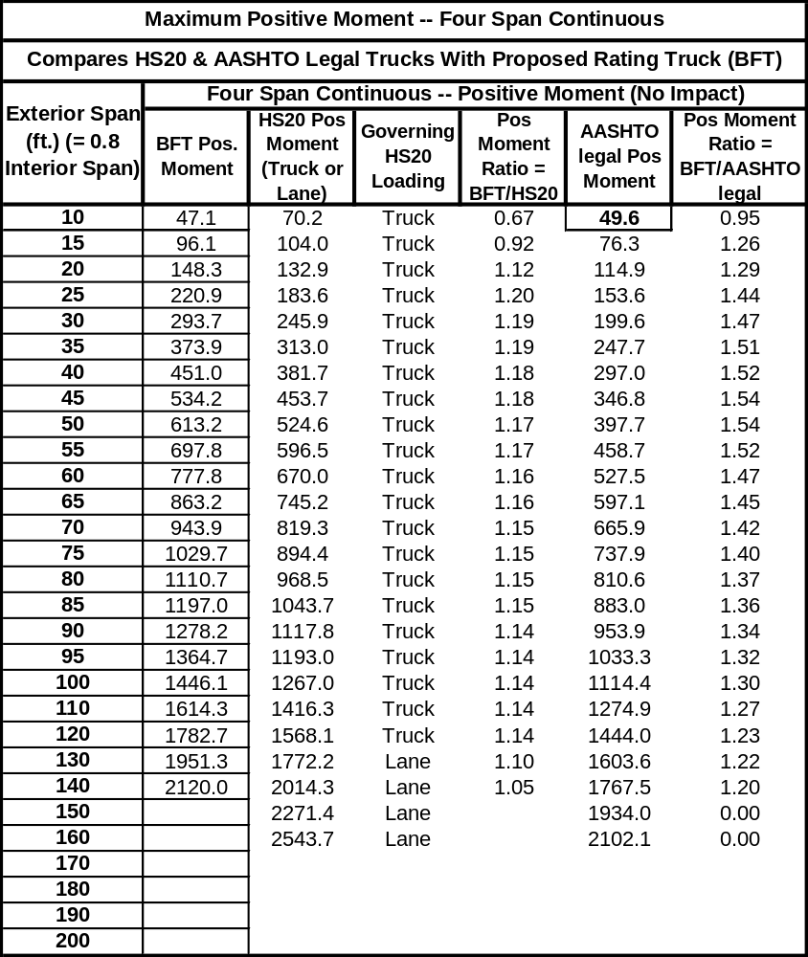

TABLE C-46 Maximum Negative Moment – Four-Span Cont.
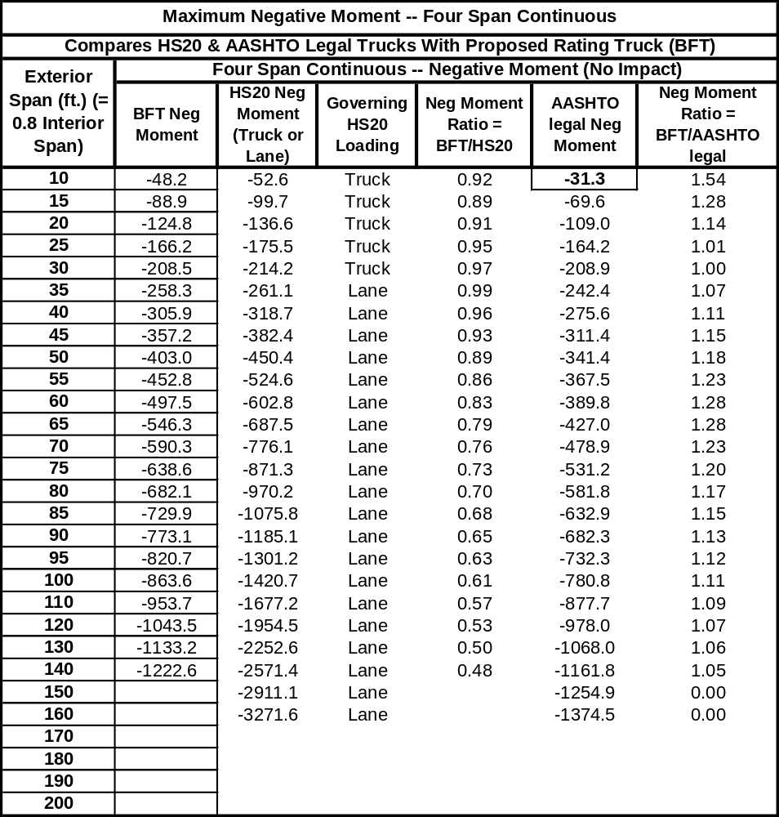

TABLE C-47 Maximum Shear – Four-Span Cont.
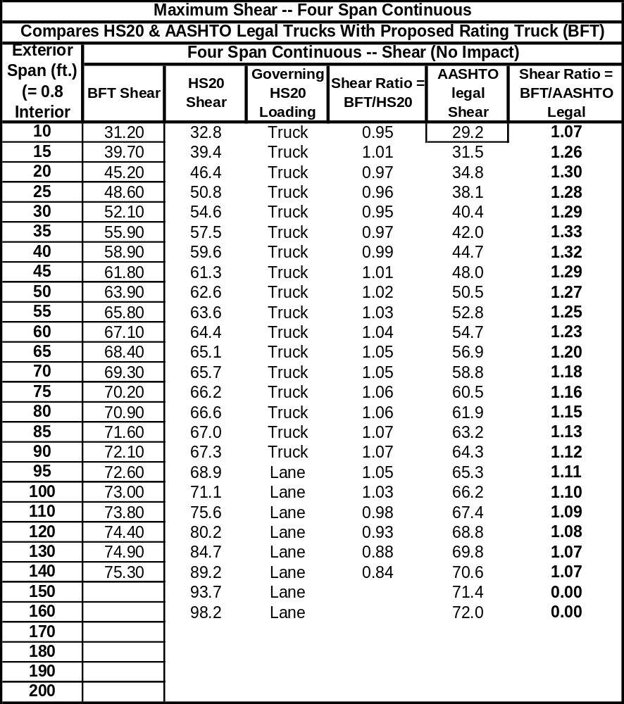

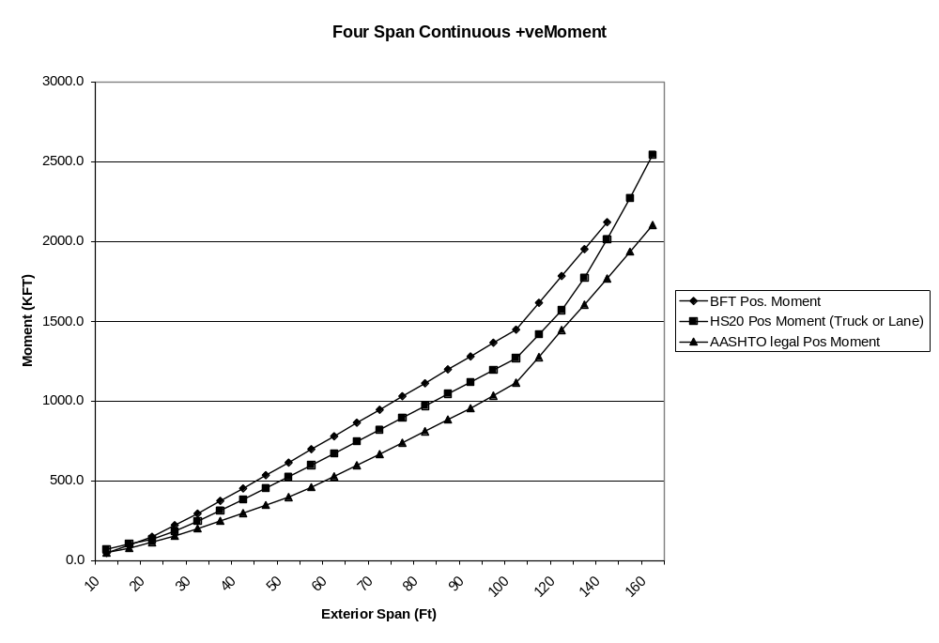
Figure C-42 Maximum Positive Moments – Four-Span Cont.
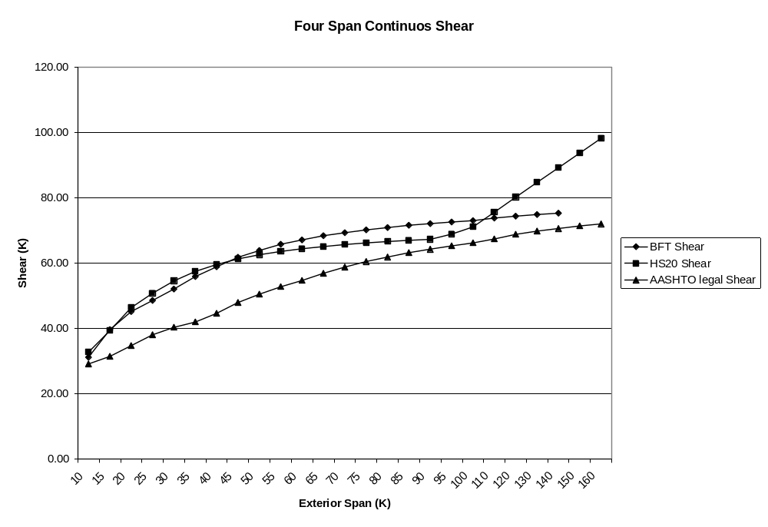
Figure C-43 Maximum Shear – Four-Span Cont.
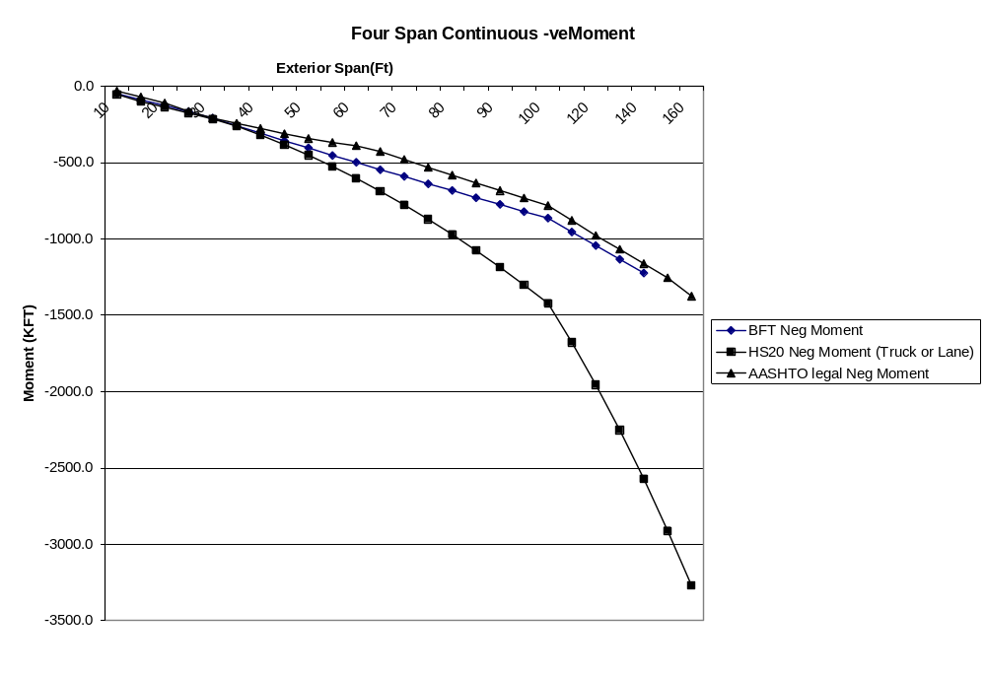
Figure C-44 Maximum Negative Moments – Four-Span Cont.

PROPOSED LEGAL LOADS FOR POSTING

While a single envelope rating vehicle can provide considerable simplification of load rating computations and establish posting eligibility, it may not be the ideal solution for all posting situations. A linear ratio of posting weights and ratings may not suffice (not conservative), as the moment effects per unit weight may be different for different axle configurations.

Another issue to be considered is that certain multi-axle configurations that cause the highest load effects appear to be common only in some States, and they should not lead to reduced postings in all States. Setting weight limits for posting often requires the evaluator to determine safe load capacities for commercial truck types that operate within a given State, in accordance with State posting practices. Additional AASHTO legal loads for posting may be needed to give more accurate posting values.

Two options were investigated for selecting the proposed legal loads for posting:

Option 1: Includes the worst 4-axle (T4A), worst 5-axle (T5A), worst 6-axle (T6A) and worst 7-axle (T7A) trucks as shown in Fig. C-45. (7-axle is also representative of 8-axle trucks)

Option 2: Includes the worst 4-axle truck (T4A), and uses truck T5A as a single representative truck for Formula B truck configurations with 5 to 8 axles (Fig. C-46).

Under Option 1, for bridges that do not rate for truck BFT (RF < 1.0), the rating engineer will perform a posting analysis to establish the need for posting and the posting load limit using posting loads (selected from the suite of four trucks) representative of commercial trucks operating within the State. For instance, if a State does not have six or seven axle SHVs in the normal traffic stream then only T4A and T5A will be used in the posting analysis. Posting signs can show a load limit for each truck type (4-axle, 5-axle, etc.) or a single tonnage (governing) for all multi-axle single-unit trucks.

Further simplification of the posting analysis is possible if certain posting loads could be eliminated thereby reducing the number of new posting loads. If it can be shown that a smaller subset of these four posting load models will consistently produce the governing posting load then a procedure is available to eliminate certain load models from the posting analysis.

The analytical approach given below shows that the posting load remains unchanged, irrespective of truck weight and configuration, if a set of posting loads produce the same moment (or shear) per unit weight of truck. In other words, the truck that produces the highest moment or shear per unit weight will govern the posting value (result in the lowest weight limit).

Determining the Governing Truck Model for load Posting of bridges

Posting Load = RF X W (W= Truck Weight)
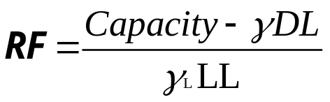

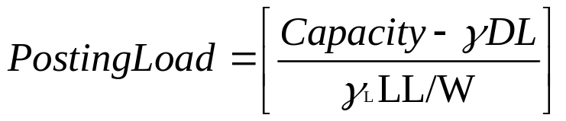

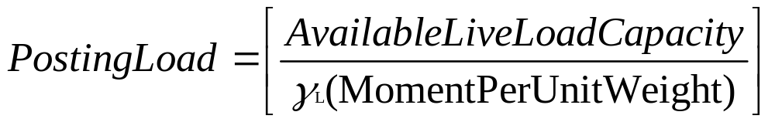

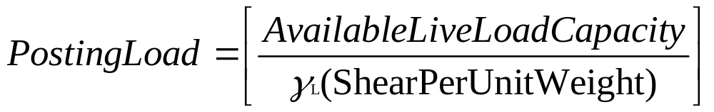

The available live load capacity for a bridge is a constant. The truck that produces the highest moment (or shear) per unit weight of truck will have the lowest weight limit for posting. This could be used to identify the critical truck for the posting analysis.

This posting load characteristic is valid provided the span moments and shears result from truck loads and not axle loads, as in the case of very short spans. For very short spans (spans < 30 ft) the shorter trucks will always govern posting. To illustrate this, posting loads were determined for two bridges: 1) A 65 ft simple span bridge, 2) A 25 ft simple span bridge. The posting loads for these bridges are as follows:

TABLE C-48 Posting Loads for Truck Types
Span | Load Model | Posting Load (Kips)
65 ft Simple Span | HS20 | 95.8
65 ft Simple Span | Type 3 | 90.0
65 ft Simple Span | Type 3S2 | 121.0
65 ft Simple Span | Type 3-3 | 146.4
65 ft Simple Span | T4A | 85.9
65 ft Simple Span | T5A | 89.9
65 ft Simple Span | T6A | 90.4
65 ft Simple Span | T7A | 92.2
65 ft Simple Span | Truck BFT | 92.0
25 ft Simple Span | HS20 | 69.8
25 ft Simple Span | Type 3 | 55.5
25 ft Simple Span | Type 3S2 | 84.2
25 ft Simple Span | Type 3-3 | 108.0
25 ft Simple Span | T4A | 50.8
25 ft Simple Span | T5A | 53.9
25 ft Simple Span | T6A | 56.3
25 ft Simple Span | T7A | 61.2
25 ft Simple Span | Truck BFT | 63.2

The short truck T4A has the lowest posting value in both examples. For the 65 ft span the posting loads for T5A, T6A, and T7A are nearly equal. For the 25 ft span, which is mostly governed by axle loads, there is greater separation in the SHV posting loads with the shorter trucks T4A and T5A having weight limits significantly lower than that for T7A and BFT.

The moments induced per unit weight of each truck for the various span lengths are given in the following tables:

Table C-49: Moment per Unit Weight -- Simple Spans
Table C-50: Negative Moment per Unit Weight -- Two Span Continuous
Table C-51: Positive Moment per Unit Weight – Two Span Continuous

Some findings from these tables and charts are:

- All Formula B trucks included in these analyses have similar moment per unit weight profiles resulting in nearly parallel curves (Figs. C-47).
- T4A consistently generates the highest moment per unit weight for all span lengths.
- Of the other trucks with 5 to 8 axles T5A would be the most critical for posting, though the differences in the moment per unit weight values for trucks T5A, T6A, T7A and BFT for spans greater than 40 feet are very small (under 5%). For spans under 40 feet, the differences are larger and are quite sensitive to span lengths.

If it is desirable to reduce the number of posting loads to simplify the posting analysis then it would be appropriate to select T4A and T5A as the candidate posting loads. This is designated as the second option for the selection of posting loads:

Option 2: Includes the worst 4-axle truck (T4A), and uses truck T5A as a single representative truck for Formula B truck configurations with 5 to 8 axles (Fig. C-46).

T4A is a very common short hauling vehicle in most States (tri-axle dump truck) and would be a suitable posting load for use nationally. Many States already use such a vehicle as a State legal load (not all satisfy Formula B). As discussed previously, T4A would govern the posting and some States such as CT & AL use a truck symbol to post specifically for these trucks. In the posting analysis T5A will serve as a single representative truck for Formula B configurations with 5 to 8 axles. The posting weight limit determined for T5A will apply to all single unit trucks with 5 or more axles. The posting sign could note this using text.

A State may also choose the T4A posting load to apply to all single unit trucks to further simplify the signing. Each simplification will introduce added conservatism in posting.

Note that the comparison of moments per unit weight assumes that the live load factor is the same for all posting load models. Calibration may lead to different load factors for each truck model due to differences in volumes and moment ratios. More precise posting evaluation is possible in LRFR using targeted load factors for a suite of posting loads.

Another issue to be considered is the posting analysis is the likely “unbalancing” of the axle loads for a posted truck. The loads on a posted truck may not be placed in the same proportion as a fully loaded truck assumed in the analysis, which may affect the load effects induced per unit weight.

Further simplification of the posting analysis is considered possible if certain posting loads could be eliminated thereby reducing the number of new posting loads (Option 2). It is shown in this section that for bridges governed by truck loads (not axle loads) the posting weight limit remains unchanged (irrespective of truck weight and configuration) when trucks produce the same moment (or shear) per unit weight. Or, the truck that produces the highest moment or shear per unit weight will govern the posting value. If it is desirable to reduce the number of posting loads to simplify the posting analysis then it would be appropriate to select T4A and T5A as the candidate posting loads (using truck T5A as a single representative truck for Formula B truck configurations with 5 to 8 axles). These trucks exhibit the highest moment & shear per unit weight. This simplification will introduce added conservatism and less flexibility in posting. Option 2 is particularly appealing to States that post bridges for a single tonnage.

Panel review comments showed that there was no clear favorite for the posting load choices. This is understandable as the choice of posting loads is contingent on posting and signing practices and the use of truck symbols on posting signs. There is little uniformity here. The survey of States done for this project revealed that of the 48 States responding 32 use truck symbols on posting signs. These States may favor more posting load choices to allow more selective use of truck symbols and weight limits. As Option 2 is a subset of Option 1, all four candidate posting loads are being carried forward through the remaining tasks.

Analytical studies discussed in this report provides additional data to support the selection of the posting load models. Using T5A as a single posting vehicle for all Formula B trucks having 5 thru 8 axles has advantages in its simplicity, and some disadvantages as outlined below:

- A bridge span may have a Rating Factor of greater than 1.0 for T5A, but may not rate (RF < 1.0) for the worst six, seven and eight axle trucks. This will lead to a situation where the T5A is being used to determine a posting load for a bridge even though the bridge has adequate capacity for the T5A truck. The concern here is whether it will cause confusion in the minds of the rating engineers when implementing the new rating and posting loads and procedures. Theoretically, the simplification of using T5A as a single representative posting load for a series of trucks presents a valid approach if practical difficulties are not considered a problem.
- T5A as a single posting vehicle works quite well for spans over 40 ft governed by the full truck load. For very short spans where only a portion of the truck may be on the bridge, the posting values obtained using T5A may be too conservative (over 20% less) to be considered an acceptable simplification, especially when load restrictions are involved.
- States that do not see all the multi-axle Formula B vehicle configurations represented by T5A, for posting purposes, may prefer to be more selective and post only for SHVs that are common in that State. Having more posting load models to choose from will allow the States to pick the appropriate load models to obtain more precise posting values. For instance, if a State finds that seven axle trucks are in common use, but not the five or six axle trucks, then it would be more advantageous to post for the T7A than the T5A.
- Having more posting loads would be beneficial to States that show truck symbols with associated weight limits on posting signs. Here the posting loads are targeted to specific vehicle configurations.

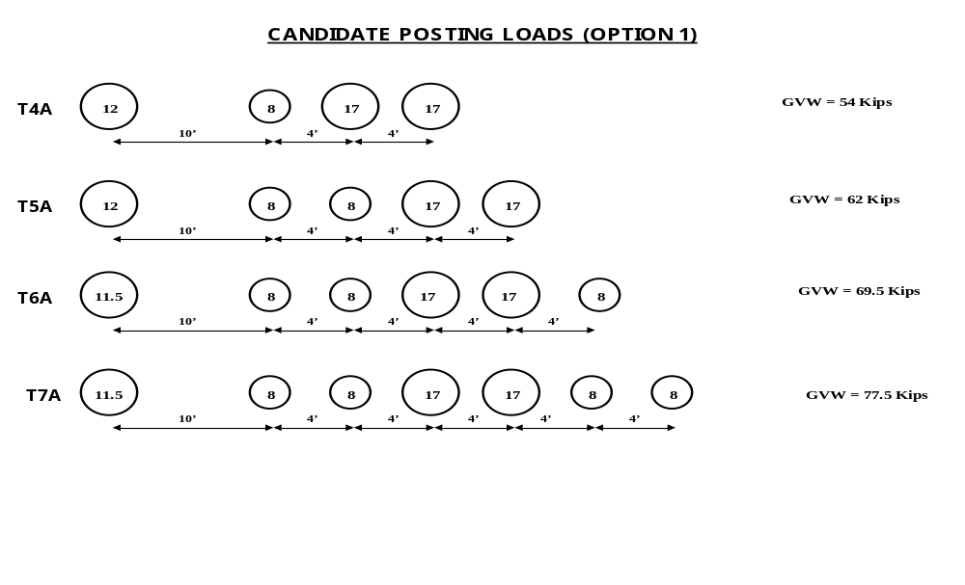
Figure C-45 Candidate Posting Loads (Option 1)

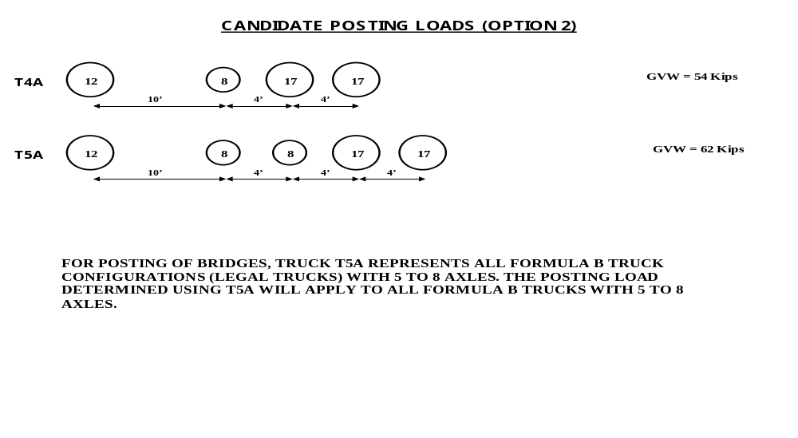
Figure C-46 Candidate Posting Loads (Option 2)
TABLE C-49 Moment per Unit Weight -- Simple Spans
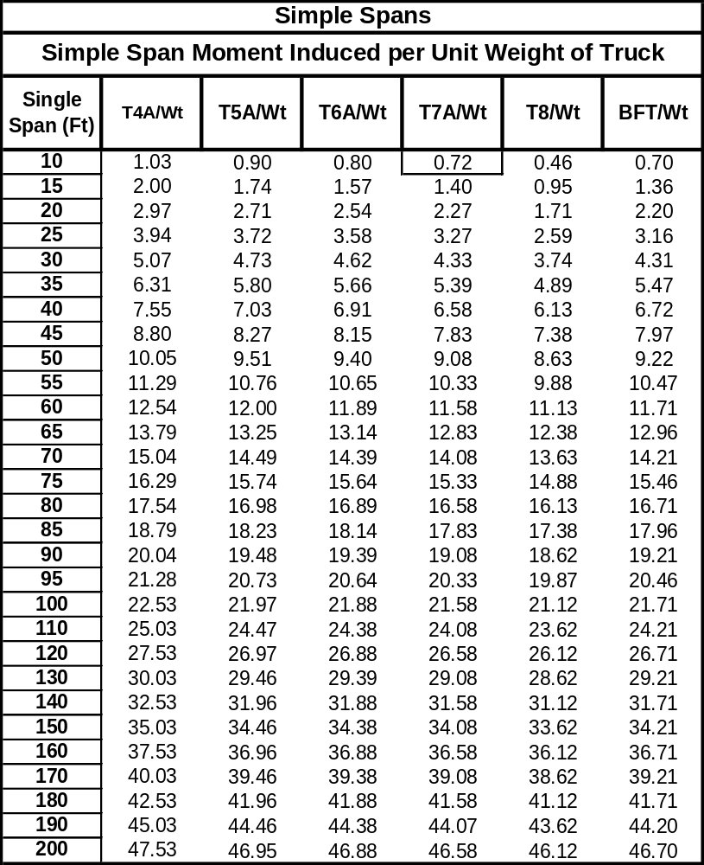

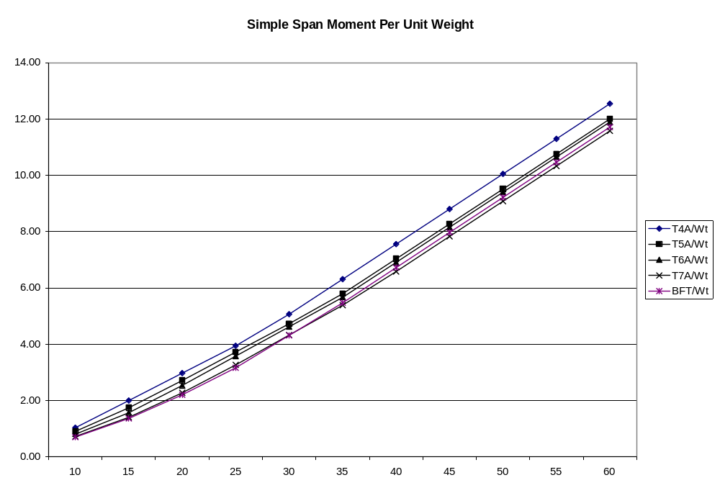
Figure C-47 Moment Per Unit Weight – Simple Spans
TABLE C-50 Negative Moment per Unit Weight -- Two Span Continuous
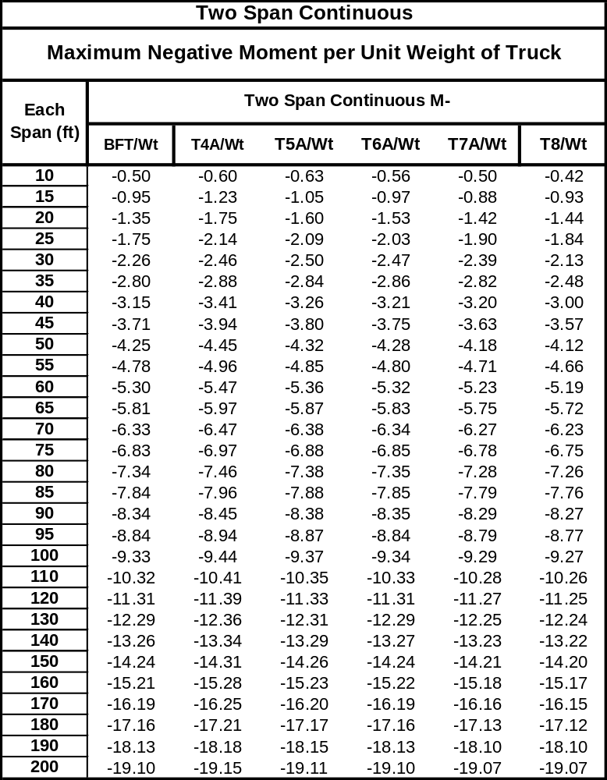

TABLE C-51 Positive Moment per Unit Weight – Two Span Continuous
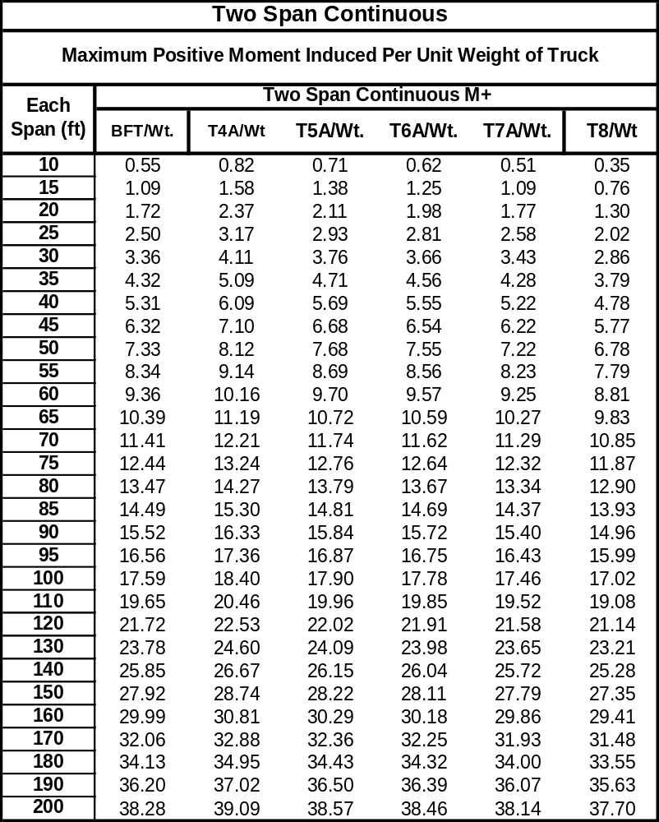

COMPARISON OF RATING FACTORS

To provide a uniform basis that will allow easy comparisons of ratings and postings, the member resistance for each span in the test suite was assumed such that the span will have a Inventory Rating Factor = 1.0 (Load Factor Rating) for the current family of three AASHTO legal loads. What this means is that under LFR ratings these bridges will not have to be load posted for current AASHTO legal loads. The member resistances thus determined were then used to obtain new Inventory Rating Factors and posting loads for the proposed BFT truck and the proposed posting vehicles (T4A, T5A, T6A and T7A). HS20 ratings were also computed for each span. If a bridge rates less than 1.0 for the proposed legal loads then we have a situation where a bridge that is currently not posted will need to be posted in the future for the new generation of Formula B trucks. This process is important to understand the potential impact of the new legal loads on current bridge postings and to also ascertain the practical implications of reducing the number of new posting vehicles from four to two (i.e., Option 1 vs. Option 2.). Analytical studies were done on simple spans and continuous bridges with two to four spans (10 ft to 200 ft). Only the simple span and two-span continuous bridges are discussed here. The findings are similar for the three and four span bridge configurations.

Live load reactions were computed for transverse members for the proposed rating and posting vehicles. Transverse member ratings will also be governed by the seven and eight axle trucks. These trucks produce the highest live load reactions on transverse members.

The following Tables and Figures summarize the results of the analyses:

Rating Factors

Simple Span Rating Factors

Table C-52: Rating Factor – Simple Span Bending
Figure C-48: Simple Span Moment Rating Factors
Table C-53: Rating Factor – Simple Span Shear
Figure C-49: Simple Span Shear Rating Factors

Two-Span Continuous Rating Factors

Table C-54: Rating Factor – Two Span Continuous Positive Moments
Figure C-50: Two Span Continuous +ve Moment Rating Factor
Table C-55: Rating Factor – Two Span Continuous Negative Moments
Figure C-51: Two Span Continuous – ve Moment Rating Factor
Table C-56: Rating Factor – Two Span Continuous Shear
Figure C-52: Two Span Continuous Shear Rating Factors.

Posting Loads

Simple Span Posting Loads

Table C-57: Posting Load – Simple Span Bending
Figure C-53: Simple Span Moment Posting Load
Table C-58: Posting Load – Simple Span Shear
Figure C-54: Simple Span Shear Posting Load

Two-Span Continuous Posting Loads

Table C-59: Posting Load – Two Span Continuous Positive Moments
Figure C-55: Two Span Continuous +ve Moment Posting Load
Table C-60: Posting Load – Two Span Continuous Negative Moment
Figure C-56: Two Span Continuous Negative Moment Posting Load
Table C-61: Posting Load – Two Span Continuous Shear
Figure C-57: Two Span Continuous Shear Posting Load

Transverse Member Live Load Reactions

Table C-62: Live Load Reactions on Transverse Floorbeams.
Figure C-58: Reactions per Unit Weight on Transverse members
TABLE C-52 Rating Factor – Simple Span Bending
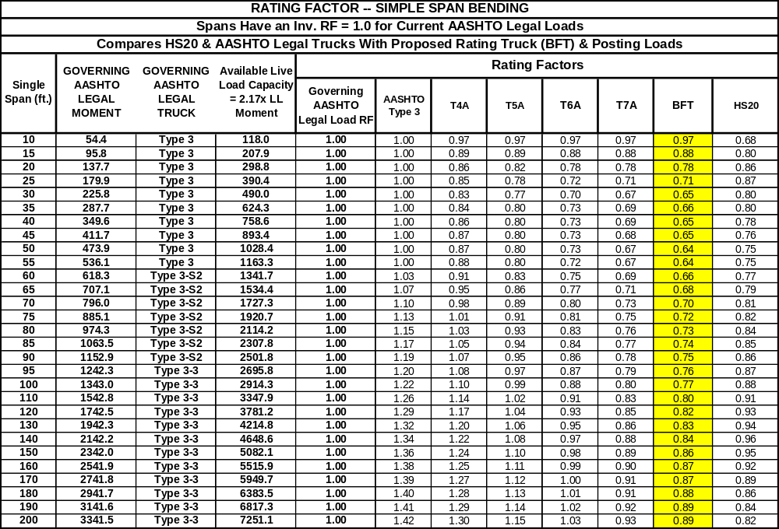

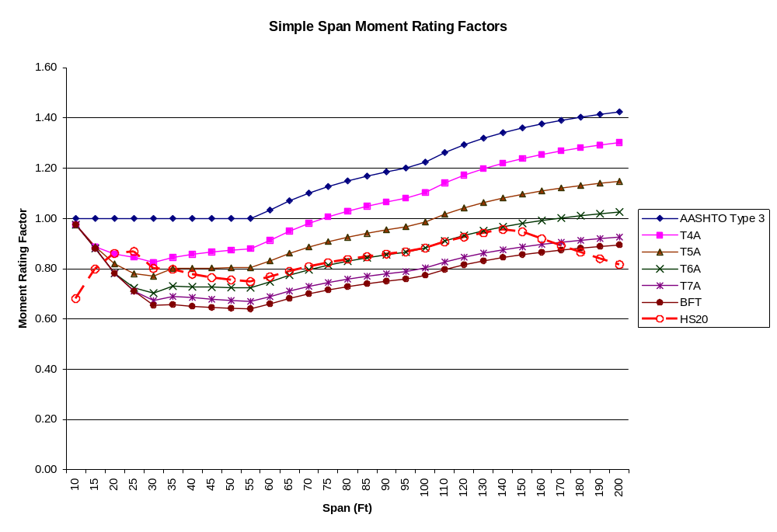
Figure C-48 Simple Span Moment Rating Factors
TABLE C-53 Rating Factor – Simple Span Shear
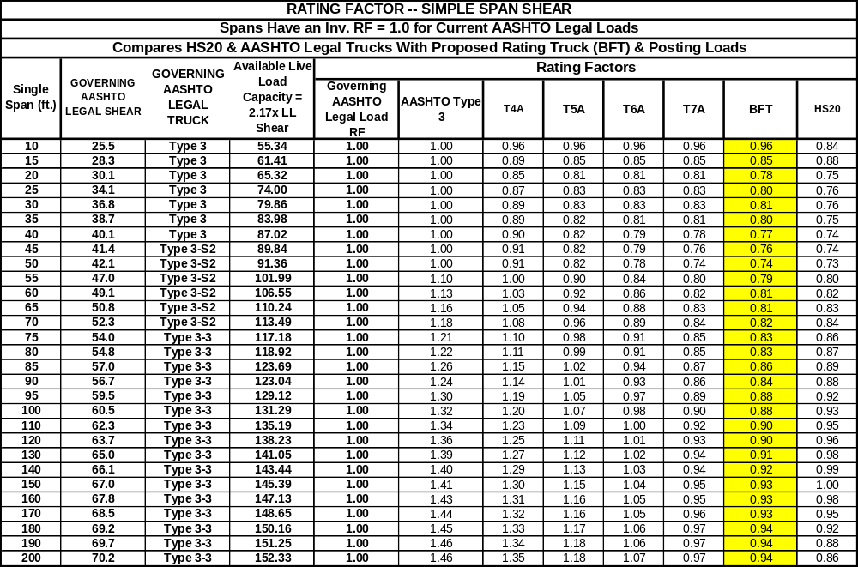

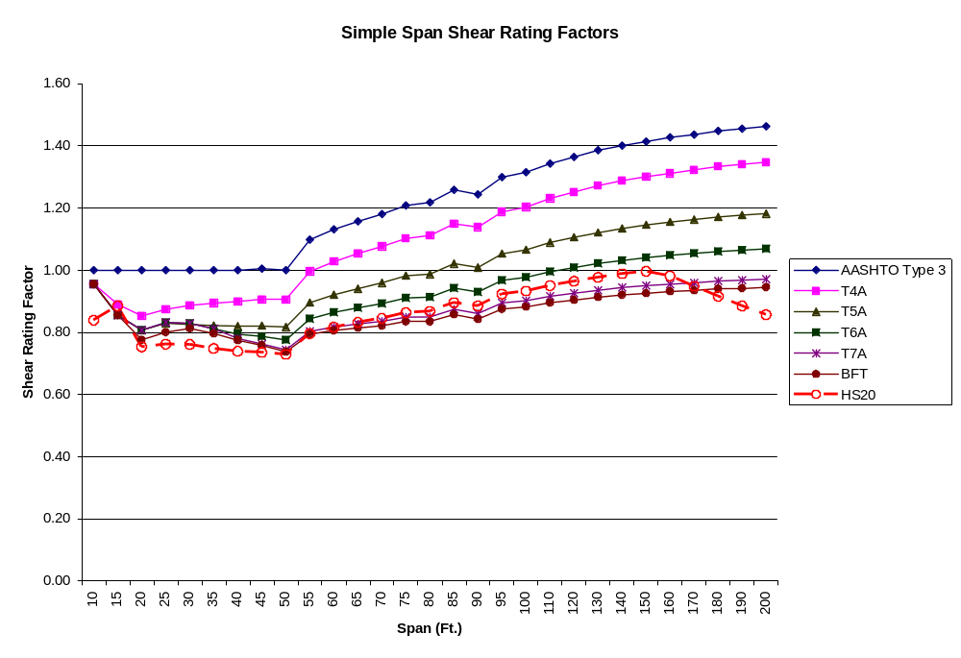
Figure C-49 Simple Span Shear Rating Factors
TABLE C-54 Rating Factor – Two Span Continuous Positive Moments
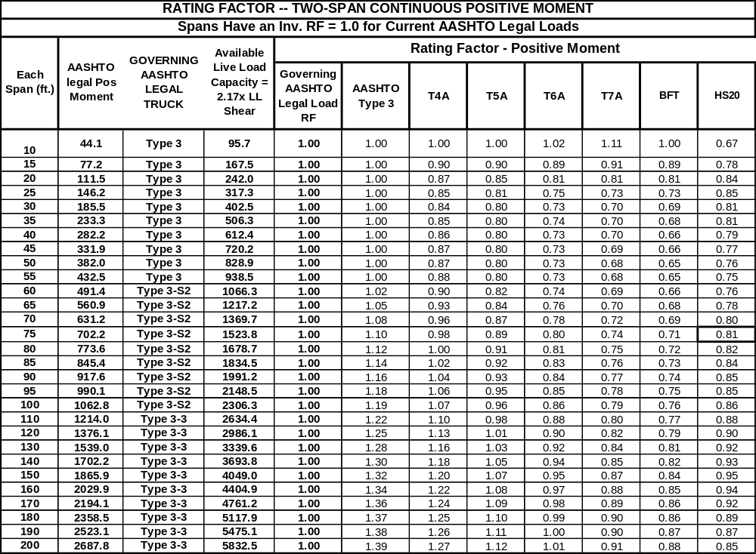

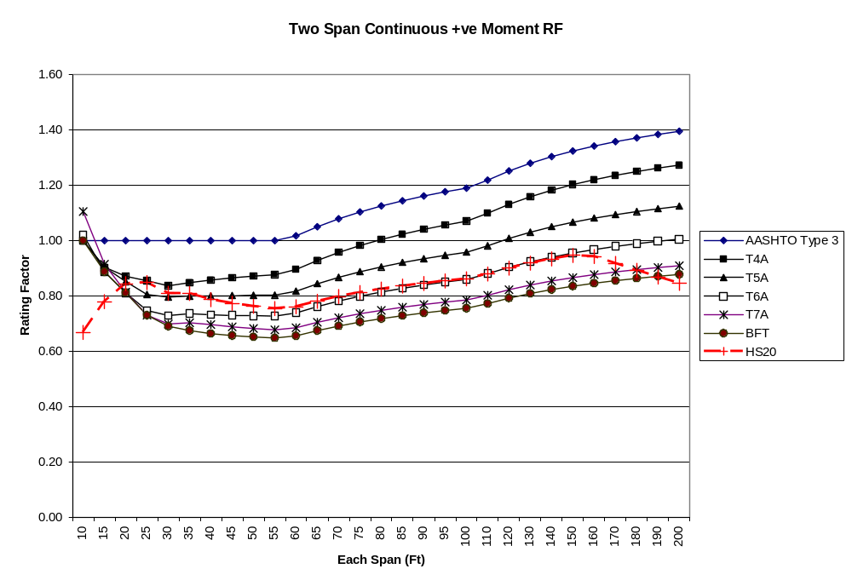
Figure C-50 Two Span Continuous +ve Moment Rating Factor

TABLE C-55 Rating Factor – Two Span Continuous Negative Moments
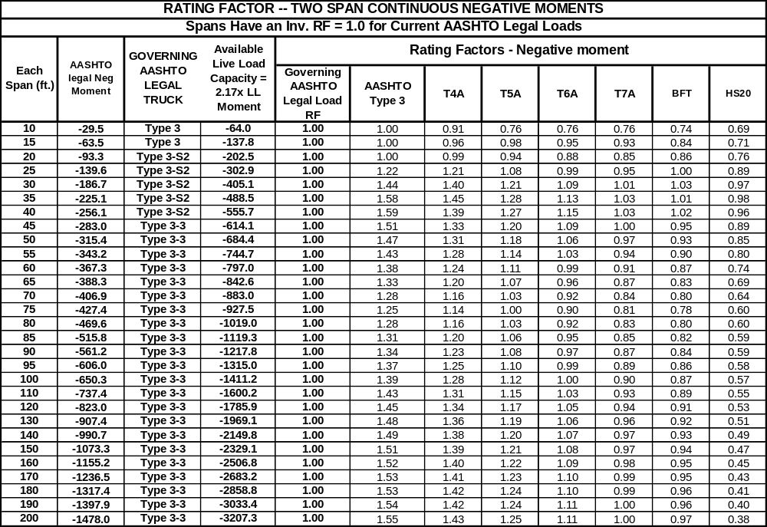
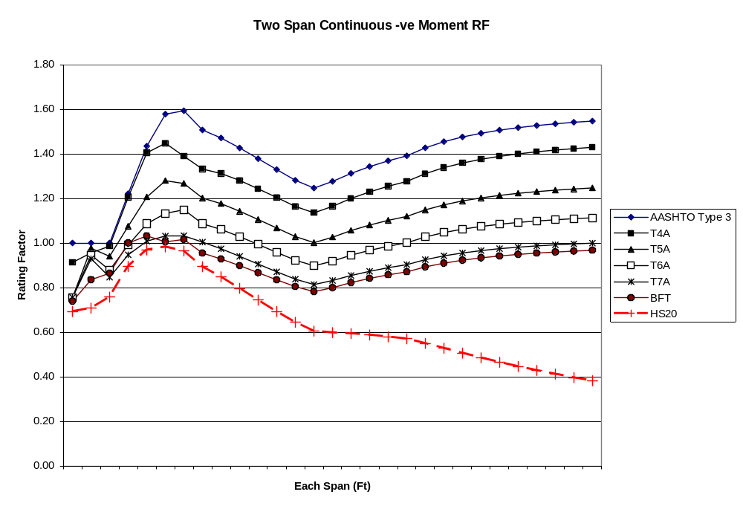
Figure C-51 Two Span Continuous – ve Moment Rating Factor
TABLE C-56 Rating Factor – Two Span Continuous Shear
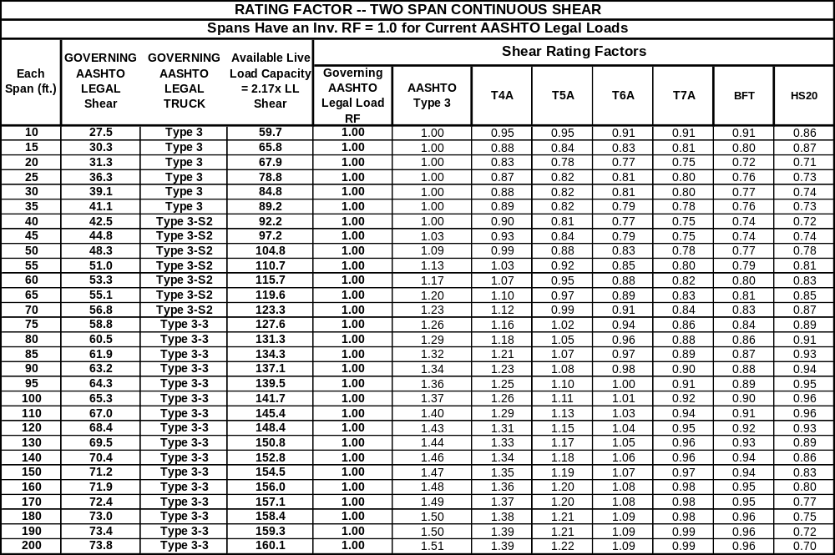
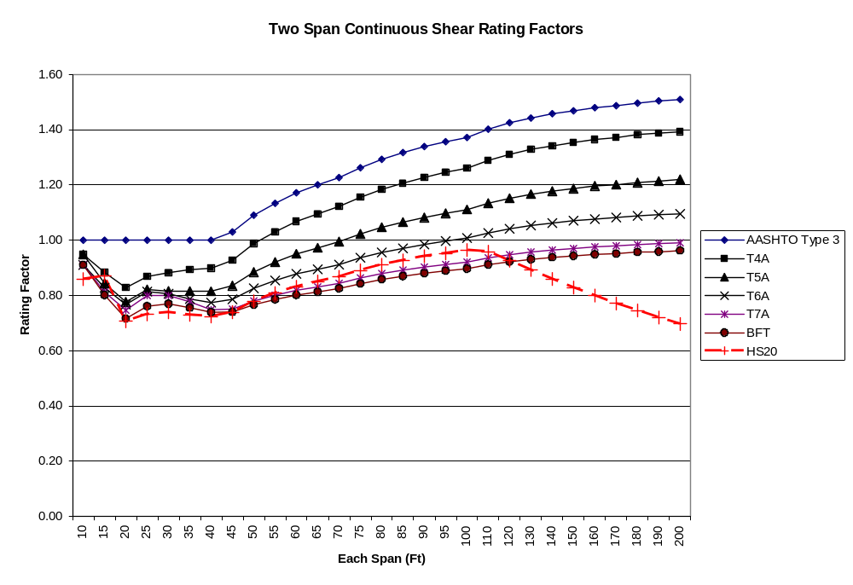
Figure C-52 Two Span Continuous Shear Rating Factors
TABLE C-57 Posting Load – Simple Span Bending
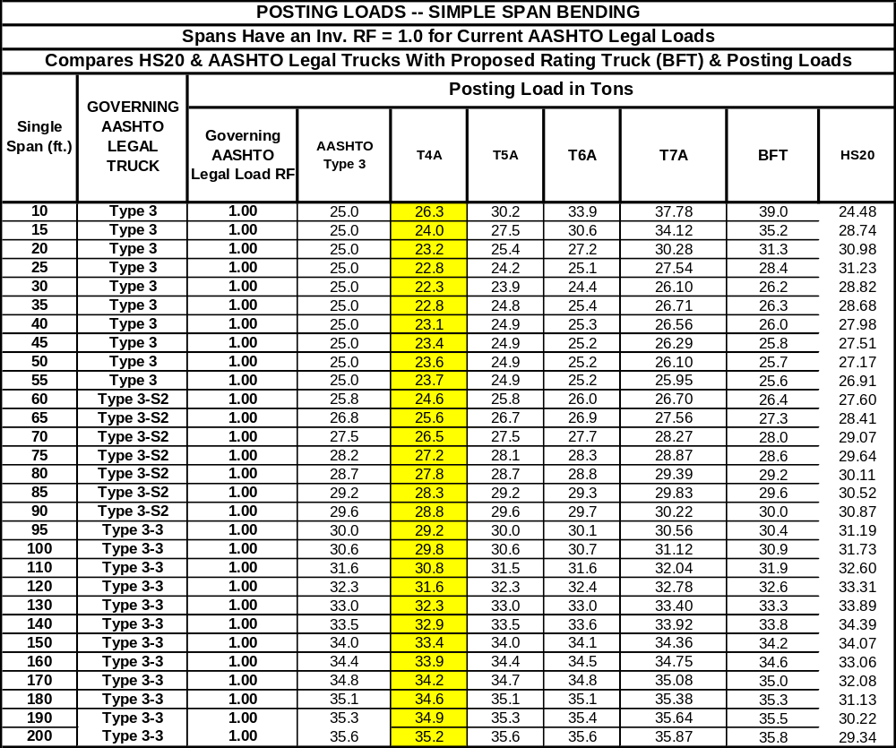
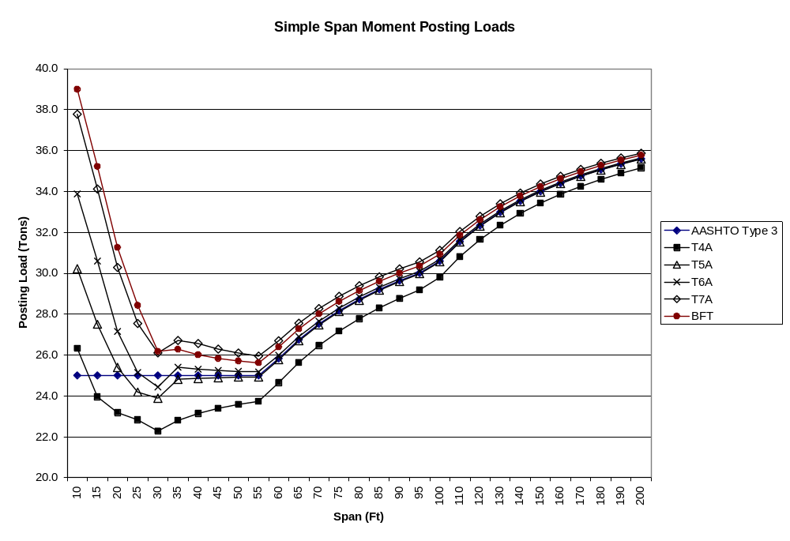
Figure C-53 Simple Span Moment Posting Load
TABLE C-58 Posting Load – Simple Span Shear
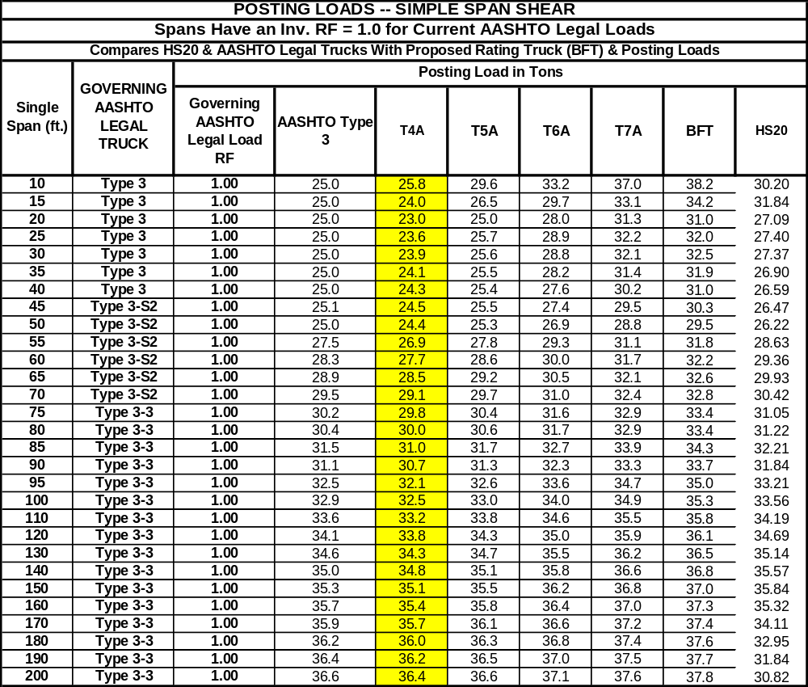
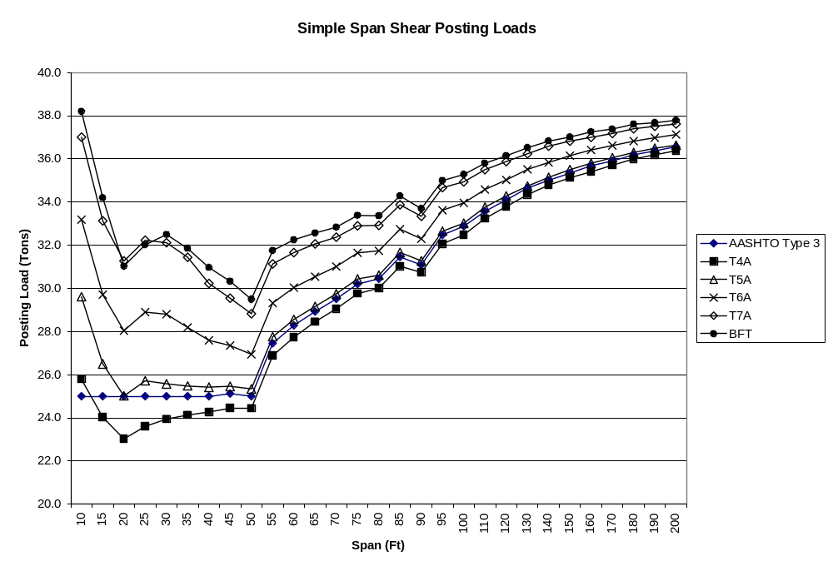
Figure C-54 Simple Span Shear Posting Load
TABLE C-59 Posting Load – Two Span Continuous Positive Moments
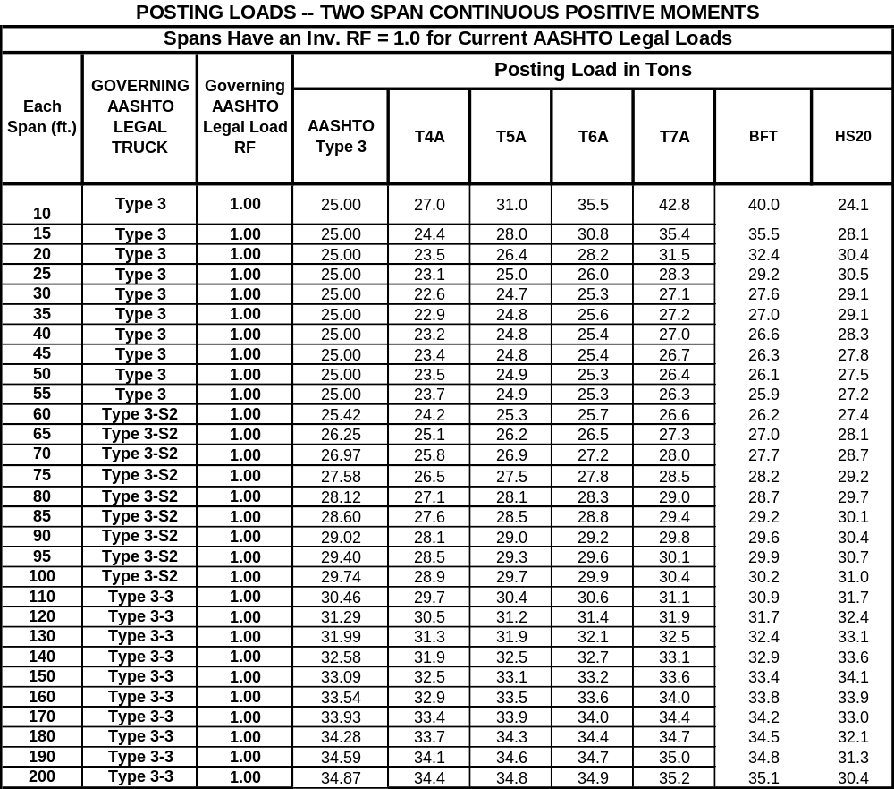
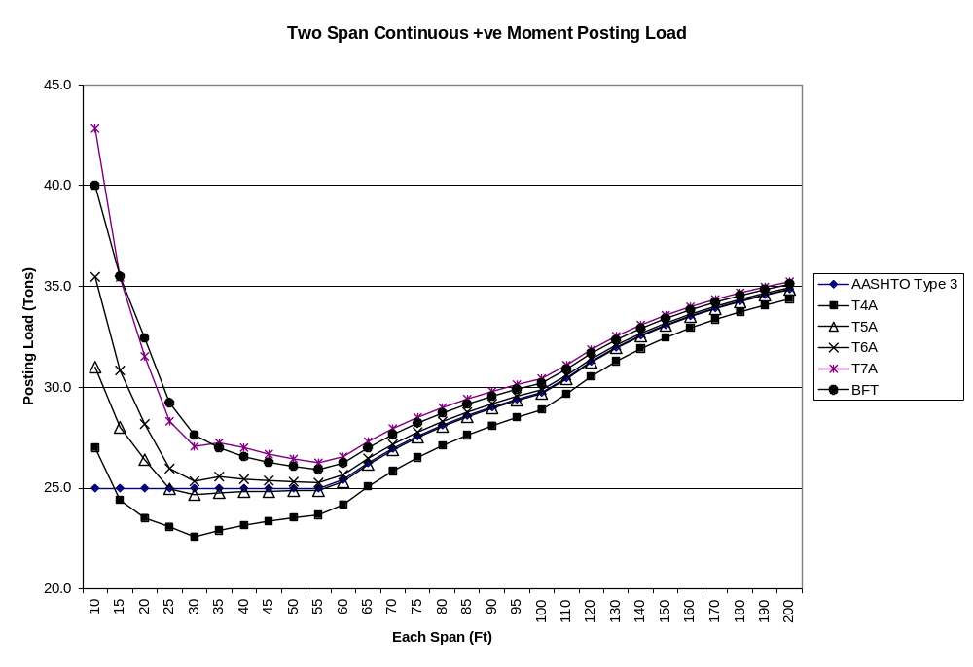
Figure C-55 Two Span Continuous +ve Moment Posting Load

TABLE C-60 Posting Load – Two Span Continuous Negative Moment
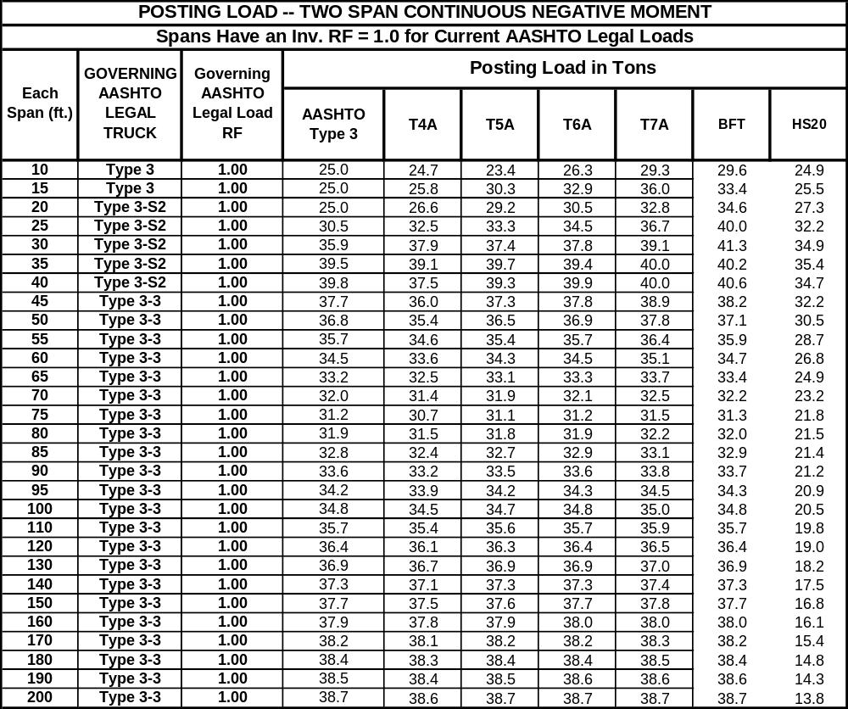
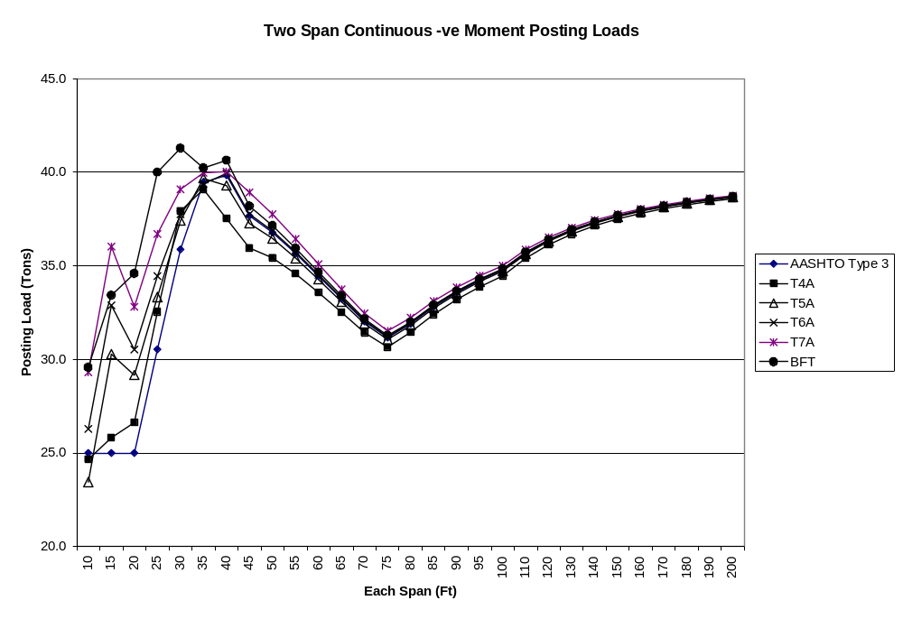
Figure C-56 Two Span Continuous Negative Moment Posting Load
TABLE C-61 Posting Load – Two Span Continuous Shear
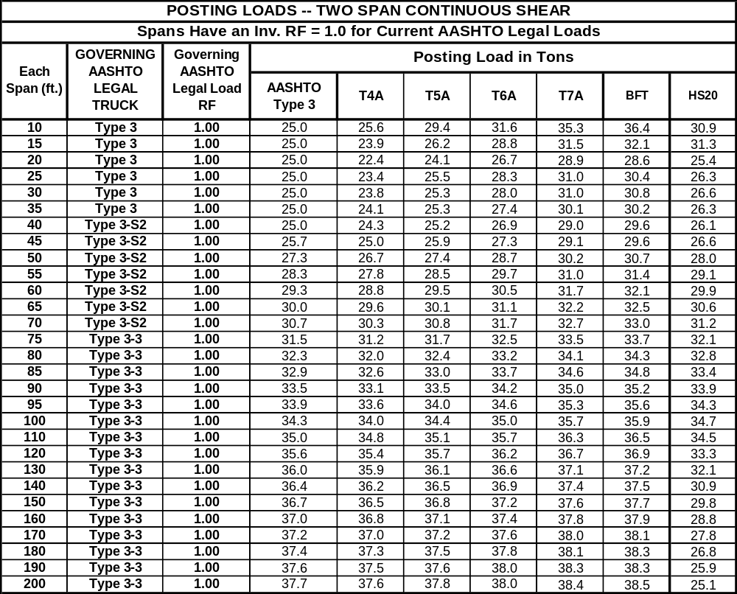
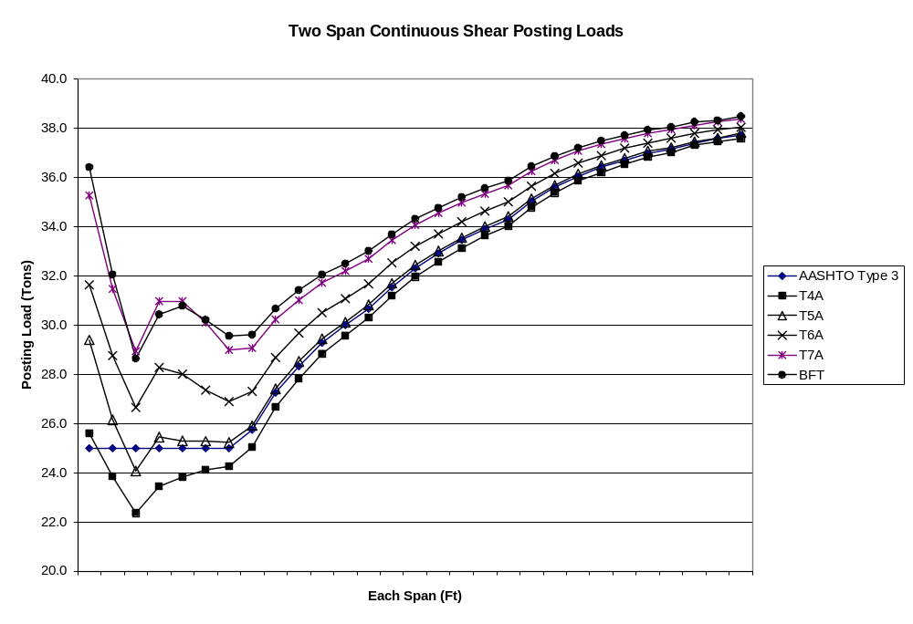
Figure C-57 Two Span Continuous Shear Posting Load

TABLE C-62 Live Load Reactions on Transverse Floorbeams.
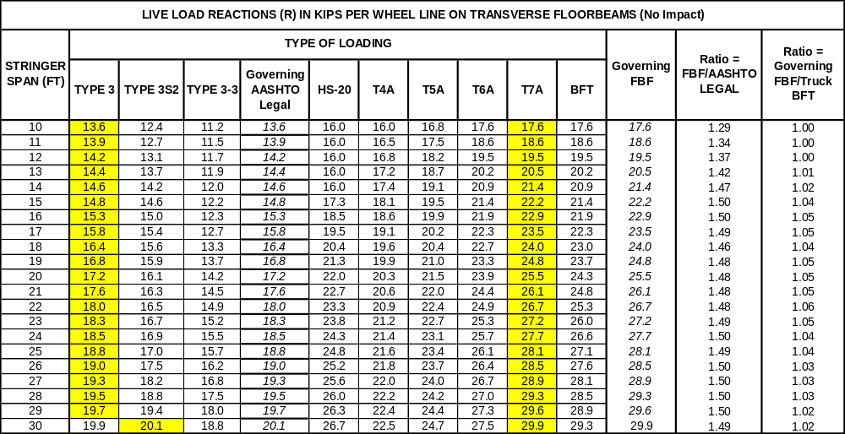

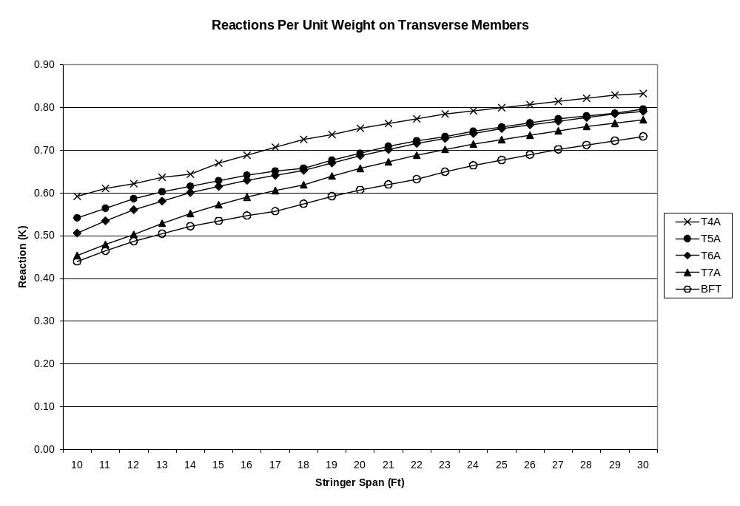
Figure C-58 Reactions per Unit Weight on Transverse members

SUMMARY OF FINDINGS

The member resistance for each span in the test suite was assumed such that the span will have a Rating Factor = 1.0 for the current family of three AASHTO legal loads. The tables and figures also show the single unit AASHTO Type 3 rating factors, which may be greater than 1.0 for spans governed by the AASHTO combination vehicles. In all cases the Type 3 truck has the highest rating factors.

The results of the analyses provide a detailed assessment of the performance of existing bridges under the new loadings and potential impacts on current ratings and postings.

Rating Factors – Longitudinal Members

A) Moment Rating Factors – Simple Spans

- Truck BFT will have the lowest ratings, varies from 0.97 to 0.64 (Table C-52). This indicates that all spans should be subjected to a posting analysis for the new posting vehicles.
- Spans over 110 ft will have a RF > 1.0 for T5A, whereas, T6A, T7A and BFT will have a RF < 1.0 for these spans (Fig C-48). If T5A was to be used as a single posting loads for all vehicles with 5 to 8 axles, we could have a situation (say a 140 ft span) where T5A is used for posting a bridge even though the bridge has adequate rating for T5A. Though it is a valid analytical convenience as shown in the previous QPR, there is some concern that this may cause confusion in the mind of the evaluator.
- The moment ratings for the 7 and 8 axle BFT trucks are lower than the HS20 ratings for most spans (Fig.C-48). This shows that HS20 is not a suitable screening load model for all Formula B trucks.

B) Shear Rating Factors – Simple Spans

- Truck BFT will have the lowest ratings, varies from 0.96 to 0.74 (Table C-53). This indicates that all spans should be subjected to a posting analysis for the new posting vehicles.
- Spans over 85 ft will have a RF > 1.0 for T5A, whereas, T6A (spans up to 120’), T7A and BFT will have a RF < 1.0 for these spans (Fig C-49). Same concerns about using T5A for posting a bridge even though the bridge has adequate rating for T5A applies here as well.
- The shear ratings for the 7 and 8 axle BFT trucks are lower than the HS20 ratings for most spans (Fig. C-49). HS20 is not a suitable screening load model for all Formula B trucks.

C) Moment Rating Factors -- Two Span Continuous Positive Moment

- Truck BFT will have the lowest ratings, varies from 1.0 to 0.68 (Table C-54). This indicates that all spans over 10 ft should be subjected to a posting analysis for the new posting vehicles.
- Spans over 110 ft will have a RF > 1.0 for T5A, whereas, T6A, T7A and BFT will have a RF < 1.0 for these spans (Fig C-50). Same concerns about using T5A for posting a bridge even though the bridge has adequate rating for T5A applies here as well for spans over 110 ft.
- The ratings for the 7 and 8 axle BFT trucks are lower than the HS20 ratings for most spans (Fig. C-50). HS20 is not a suitable screening load model for all Formula B trucks.

D) Moment Rating Factors -- Two span Continuous Negative Moment

- Truck BFT will have the lowest ratings, varies from 1.02 to 0.74 (Table C-55). This indicates that most spans will require a posting analysis for the new posting vehicles.
- Spans over 20 ft will have a RF > 1.0 for T5A, whereas, T7A and BFT will have a RF < 1.0 for most spans (Fig C-51). Same concerns about using T5A for posting a bridge even though the bridge has adequate rating for T5A applies here as well.
- HS20 negative moment ratings are lower than the BFT ratings for all spans (Fig. C-51). HS20 rating factors for the longer spans (governed by the lane load model) are significantly lower than the BFT ratings.

E) Shear Rating Factors -- Two span Continuous

- Truck BFT will have the lowest ratings, varies from 0.96 to 0.72 (Table C-56). This indicates that all spans will require a posting analysis for shear for the new posting vehicles.
- Spans over 70 ft will have a RF > 1.0 for T5A, whereas, T7A and BFT will have a RF < 1.0 for all spans (Fig C-52). Using T5A as a posting load even though a span has adequate rating for T5A has to be considered.
- HS20 shear moment ratings are lower than the BFT shear ratings for the longer spans governed by the lane load model (Fig C-52).

Posting Loads – Longitudinal Members

A) Posting Loads – Simple Span Bending

- T4A will produce the lowest posting load of all Formula B vehicles (Table C-57). This compact truck has the highest moment per unit weight resulting in the lowest posting limit.
- Of the trucks with 5 or more axles, T5A will have the lowest posting load (Fig C-53). However, the degree of conservatism introduced by using T5A as a single posting load is dependant on the span length. An adverse impact is seen in the very short spans that are controlled by wheel loads (see table below).

TABLE C-63 Posting Loads (Tons) – Simple Span Bending
Span length | 20 Ft | 40 Ft | 80 Ft | 120 Ft
T5A Posting Load (Tons) | 25.4 | 24.9 | 28.7 | 32.3
T6A Posting Load (Tons) | 27.2 | 25.3 | 28.8 | 32.4
T7A Posting Load (Tons) | 30.3 | 26.6 | 29.4 | 32.8

B) Posting Loads – Simple Span Shear

- T4A will produce the lowest posting load of all Formula B vehicles (Table C-58).
- Of the trucks with 5 or more axles, T5A will have the lowest posting load (Fig C-54). However, the degree of conservatism introduced by using T5A as a single posting load is dependant on the span length. An adverse impact is seen in the very short spans that are controlled by wheel loads (see table below).

TABLE C-64 Posting Loads (Tons) – Simple Span Shear
Span length | 20 Ft | 40 Ft | 80 Ft | 120 Ft
T5A Posting Load (Tons) | 26.4 | 24.8 | 28.1 | 31.2
T6A Posting Load (Tons) | 28.2 | 25.4 | 28.3 | 31.4
T7A Posting Load (Tons) | 31.5 | 27.0 | 29.0 | 31.9

Posting Loads – Two Span Continuous Positive Moments

- T4A will produce the lowest posting load of all Formula B vehicles (Table C-59). This compact truck has the highest moment per unit weight resulting in the lowest posting limit.
- Of the trucks with 5 or more axles, T5A will have the lowest posting load (Fig C-55). However, the degree of conservatism introduced by using T5A as a single posting load is dependant on the span length. An adverse impact is seen in the very short spans that are controlled by wheel loads (see table below).

TABLE C-65 Posting Loads (Tons) – Two-span continuous + ve moments
Span length | 20 Ft | 40 Ft | 80 Ft | 120 Ft
T5A Posting Load (Tons) | 26.4 | 24.8 | 28.1 | 31.2
T6A Posting Load (Tons) | 28.2 | 25.4 | 28.3 | 31.4
T7A Posting Load (Tons) | 31.5 | 27.0 | 29.0 | 31.9

D) Posting Loads – Two Span Continuous Negative Moments
- T4A will produce the lowest posting load of all Formula B vehicles (Table C-60). This compact truck has the highest moment per unit weight resulting in the lowest posting limit.
- Of the trucks with 5 or more axles, T5A will have the lowest posting load (Fig C-56). However, the degree of conservatism introduced by using T5A as a single posting load is dependant on the span length. An adverse impact is seen in the very short spans that are controlled by wheel loads (see table below).

TABLE C-66 Posting Loads (Tons) – Two-span continuous - ve moments
Span length | 20 Ft | 40 Ft | 80 Ft | 120 Ft
T5A Posting Load (Tons) | 29.2 | 39.3 | 31.8 | 36.3
T6A Posting Load (Tons) | 30.5 | 39.9 | 31.9 | 36.4
T7A Posting Load (Tons) | 32.8 | 40.0 | 32.2 | 36.5

E) Posting Loads – Two Span Continuous Shear
- T4A will produce the lowest posting load of all Formula B vehicles (Table C-61). This compact truck has the highest moment per unit weight resulting in the lowest posting limit.
- Of the trucks with 5 or more axles, T5A will have the lowest posting load (Fig C-57). However, the degree of conservatism introduced by using T5A as a single posting load is dependant on the span length. An adverse impact is seen in the very short spans that are controlled by wheel loads (see table below).

TABLE C-67 Posting Loads (Tons) – Two-span continuous shear
Span length | 20 Ft | 40 Ft | 80 Ft | 120 Ft
T5A Posting Load (Tons) | 24.1 | 25.2 | 32.4 | 35.7
T6A Posting Load (Tons) | 26.7 | 26.9 | 33.2 | 36.2
T7A Posting Load (Tons) | 28.9 | 29.0 | 34.1 | 36.7

Live Load Reactions -- Transverse Members

- Truck T7A has the highest live load reaction on transverse members for stringer spans from 10 ft to 30 ft (Table C-62). Truck BFT reactions are within 5% of the truck T7A values and may be used as a single rating vehicle for screening purposes.
- Truck T4A has the highest wheel reaction on transverse members per unit weight (Fig C-58) and will result in the lowest posting. Truck T5A will have the next lowest posting.
- This shows that like longitudinal members, the posting of transverse members will also be governed by the four and five axle trucks.

