What are the effects on my community?  The effects on a community depend on the distance to highways and the frequency and duration of weather conditions. Weather patterns that change sound levels may be more common in certain areas. Higher sound levels will be more common in areas where the wind typically blows from a highway toward a community (downwind) than the opposite direction (upwind). You may also notice that sound levels are lower during the day than at night even though there may be more traffic during the day. This occurs in areas where nighttime temperature inversions are common. Rain can also affect traffic noise by changing the temperature profile in addition to the more obvious increase of noise generated from vehicle tires.  [Note: A SHA could customize this section to describe the types of weather conditions that are typical for the state.]  What if my neighborhood  has a noise barrier?  Changes in weather conditions also affect how well a noise barrier performs. Temperature inversions and downwind conditions can increase sound levels in neighborhoods protected by a noise barrier. Temperature lapses and upwind conditions can further reduce sound levels in neighborhoods protected by a noise barrier. The changes in sound levels will depend on the specific wind and temperature conditions.  CONTACT US  Phone: [Telephone]  Email: [Email address]  Web: [Web address]  Source: NCHRP Report 882. The National Cooperative Research Program (NCHRP) is sponsored by the individual state departments of transportation of the American Association of State Highway and Transportation Officials (AASHTO), in cooperation with the Federal Highway Administration (FHWA). NCHRP is administered by the Transportation Research Board (TRB), part of the National Academies of Sciences, Engineering, and Medicine. Any opinions and conclusions expressed or implied in resulting research products are those of the individuals and organizations who performed the research and are not necessarily those of TRB; the National Academies of Sciences, Engineering, and Medicine; or NCHRP sponsors. |  |  | 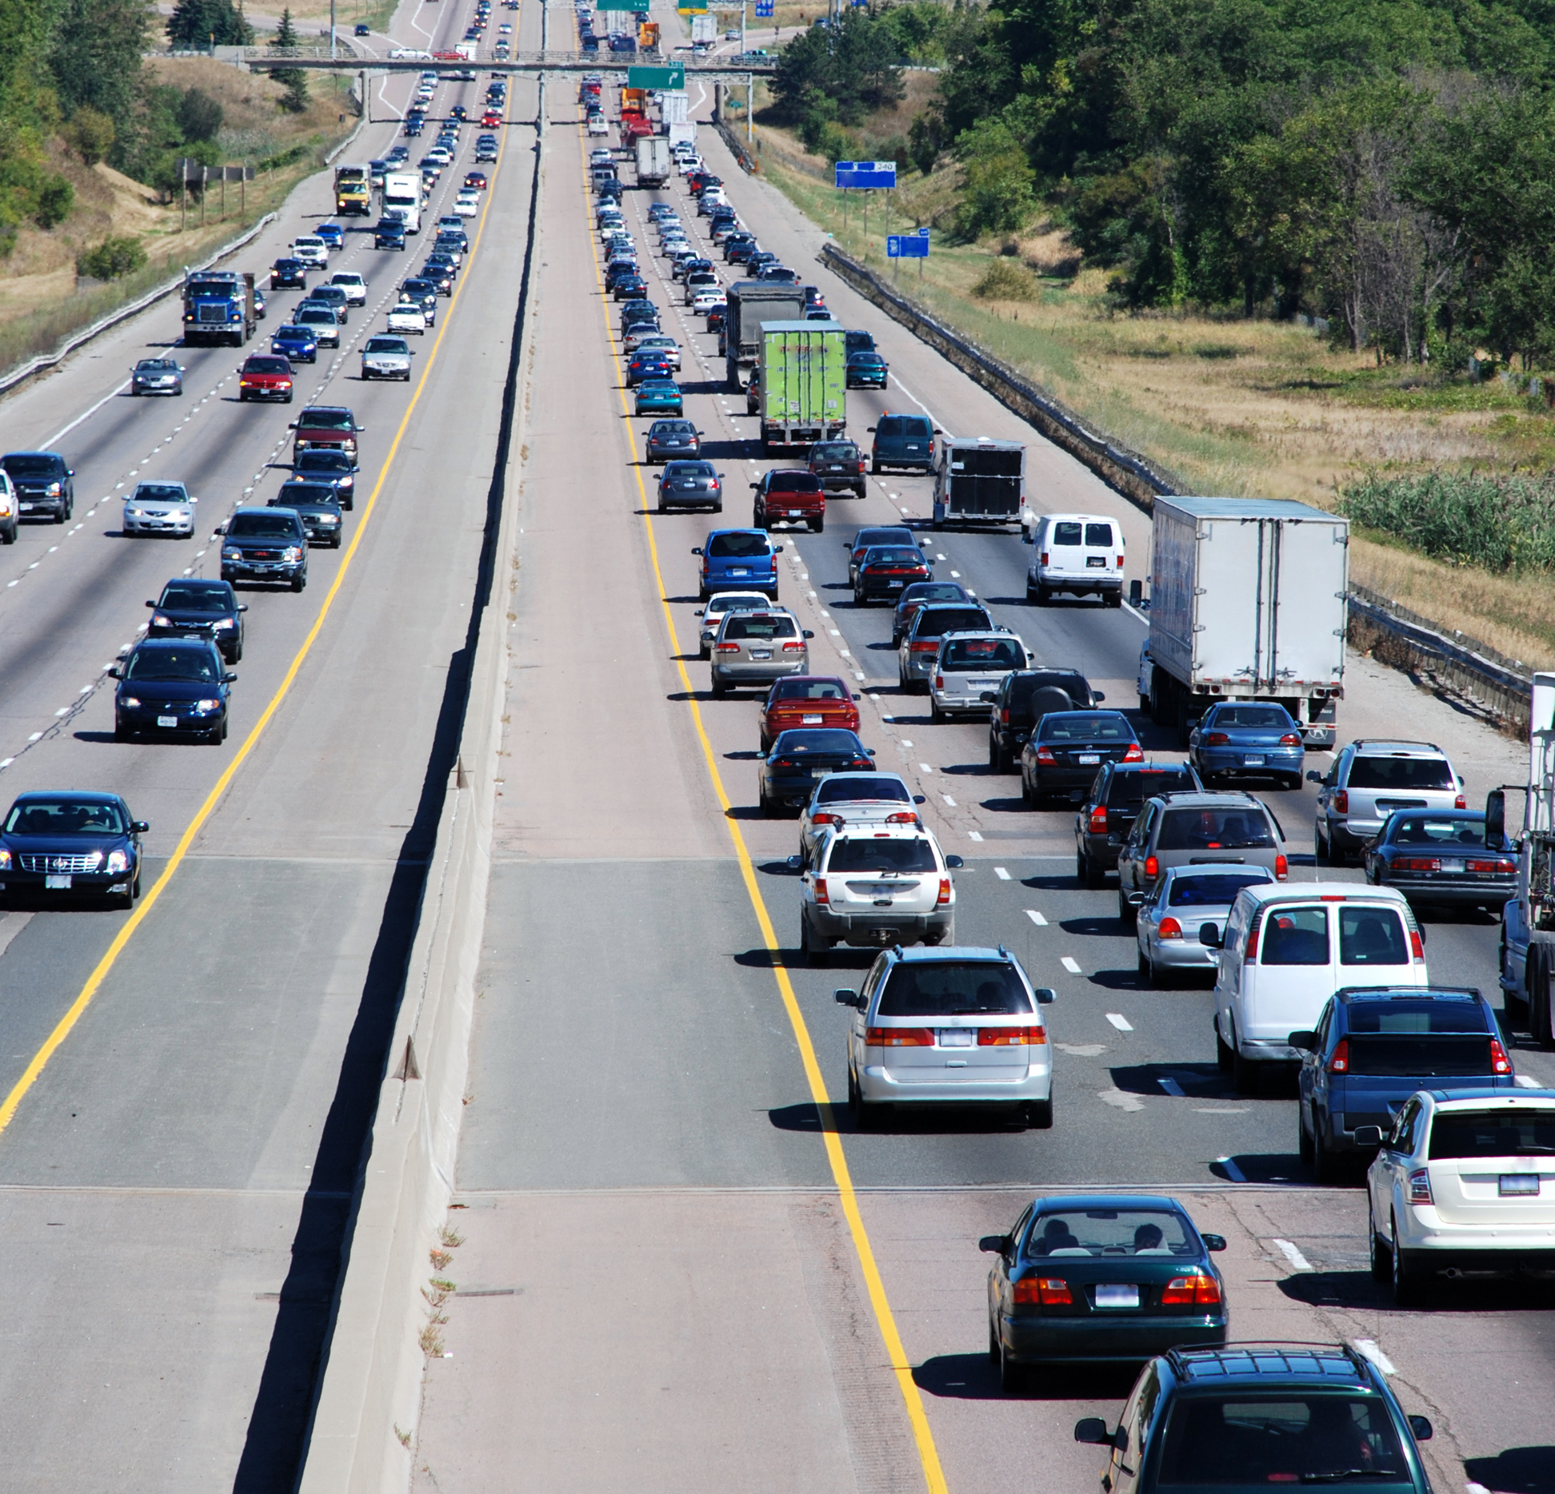  WHY IS IT  SO LOUD  TODAY?  Understanding  how weather  affects traffic  noise levels in  your community  [INSERT SHA LOGO]
Have you heard? You may have  noticed that sound levels from highways  or other sources are much louder or quieter  during particular times of the day or year.  Changes in weather conditions are often the  cause of these higher or lower sound levels.  What happens when the wind changes?  Changing wind speeds above the ground cause sound waves to bend toward or away from the earth—a process called refraction. The change in the sound level depends on the differences in wind speeds above the ground and the wind direction. You might notice that sound levels are higher when the wind is blowing from the highway toward you (downwind) as illustrated below. Conversely, you might notice that sound levels are lower when the wind is blowing away from you and toward the highway (upwind). |  | 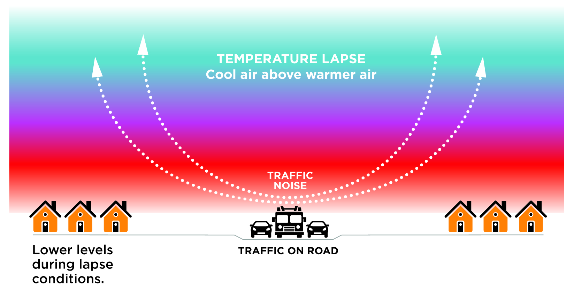 | What happens when  the temperature changes?  The temperature of the air above the ground changes with height. A temperature lapse occurs when the air above the ground is cooler than the air near the ground. Temperature lapses are common during the day. Lapses cause sound waves to bend away from the earth and reduce sound levels in nearby communities as illustrated below. You might notice that sound levels are lower during the day than at night even though there may be more traffic on the road.  Conversely, a temperature inversion occurs when the air above the ground is warmer than the air near the ground. Temperature inversions are common at night when the weather is clear and winds are calm. Inversions cause sound waves to bend back toward the earth and increase sound levels as illustrated below. You might notice that sound levels are higher at night or in the early morning than during the day.
