Guidelines Document

to the

NATIONAL COOPERATIVE HIGHWAY RESEARCH PROGRAM

On

NCHRP Project 03-132

SAFE AND EFFECTIVE TEMPORARY TRAFFIC CONTROL FOR MOBILE OPERATIONS ON TWO-LANE ROADWAYS

LIMITED USE DOCUMENT

This guidelines document is furnished only for review by members of the NCHRP project panel and is regarded as fully privileged. Dissemination of information included herein must be approved by the NCHRP.

Submitted by:

LuAnn Theiss and Gerald L. Ullman, TTI
Jon Jackels, SRF

11-30-2022

Guidelines Document
Web Only Document 354 - Safe and Effective Temporary Traffic Control for Mobile Operations on Two-Lane Roadways

Background
Mobile operations on two-lane two-way roadways present unique challenges to highway agencies. These operations vary in speed and length of the work convoy and are performed on roadways with a variety of traffic and geometric conditions. Unpredictable driver behavior presents additional safety hazards for workers. The objective of this research project was to develop guidelines for temporary traffic control procedures to improve safety and effectiveness of these operations.

State of the Practice
A review of current practices nationally identified many factors that influence temporary traffic control (TTC) decisions for mobile operations, including:
- Land use (rural versus urban).
- Terrain (flat versus rolling versus mountainous).
- Available sight distance for approaching vehicles (from both directions).
- Speed limit (either the normal speed limit or, if the mobile operation occurs within a defined construction zone, the reduced work zone speed limit in that zone).
- Pavement width.
- Shoulder availability (type, width, condition).
- Traffic (multiple metrics mentioned, including average daily traffic, hourly volumes, vehicle mix, driver familiarity).
- Frequency of side roads and driveways.
- Time of day of the work activity.
- Season/weather conditions (affecting expected pavement conditions, amount of daylight available, etc.).
- Location of work within the right-of-way.
- Progression of work (typically dependent upon type of work needed and level of effort required to accomplish work).
- Length of required work space (number of vehicles, distances between those vehicles).
- Expected opportunities for passing (related to traffic volumes, sight distance, and work space length factors listed above).
- Whether workers will be on foot to complete the work activity.
- Agency policy (maximum allowable delays, requirements stated in the specifications).
- Institutional knowledge of work crew supervisor (which roadways require a stationary TTC set-up for a given activity versus which ones can be accomplished using mobile operation TTC).
- Observations of traffic responses to the chosen TTC approach (is the TTC approach causing excessive delays, are drivers screeching tires to stop in time, are motorists complaining, etc.).
Because of the wide range of factors and conditions that influence TTC decision-making, significant differences in TTC strategies exist between continuously moving operations (in which workers remain in work vehicles and the convoy progresses at a constant pace) and intermittently moving operations (in which workers are typically on foot, the work activity is stationary for a short period of time, and then workers move quickly to the next location). Some common practices include the following:
- Some agencies base their definition of a mobile operation on how long the operation can stop in the lane, while others base it on the average speed of the work convoy.
- Some agencies do not allow workers on foot while using mobile operation traffic control.
- Depending on the type of work and speed limit of the roadway, mobile work convoys can vary in length from 100 ft to 1500 ft.
- In addition to speed limit and sight distance considerations, spacings of the convoy vehicles are also sometimes based on paint drying time.
- Minimum roll-ahead distances between the shadow vehicle (with a truck-mounted attenuator) and downstream work vehicle also influence convoy spacing decisions.
- Many agency guidelines include directives to place the shadow vehicle where it is visible to oncoming drivers (either stopping sight distance or decision sight distance are typically used to determine where to place the shadow vehicle).
- Although some agencies use stationary warning signs in advance of the operation, agencies recognize that drivers may not encounter the work operation until they are several miles past the signs. Consequently, many agencies mount warning signs on vehicles that advance along with the work operation.
- For striping operations, some agencies place traffic cones on the centerline to reduce tracking of paint and discourage passing during striping operations.
- Significant variations exist amongst agencies regarding allowances for vehicle operations around different work operations. Some agencies allow passing on the left of the operation, although a few agencies prohibit drivers from passing certain operations by posting DO NOT PASS signs. A few agencies allow passing on the right shoulder when a suitable driving surface is available.
- Several agencies incorporate the use of flaggers using a variety of strategies into their mobile operation traffic control.
  - One strategy is to use one or two flaggers on an occasional basis at locations where sight distance is limited. No advance warning signs or channelizing devices are used. If traffic volumes are low, the flagger server primarily as spotters to ensure that vehicles can negotiate a passing maneuver around the work activity with encountering an oncoming vehicle. Figure 1 shows an example of how Iowa Department of Transportation uses this strategy.
  - Another strategy is to use one or two flaggers that move along with the work activity, but remain within the limits of stationary advance warning signs placed at each end of the planned work area. Figure 2 shows an example of how Illinois Department of Transportation uses this strategy.
  - A third strategy is to use two flaggers that move along with the work activity and use additional FLAGGER AHEAD advance warning signs to ensure that the distance between the last FLAGGER AHEAD warning sign and the work operation is not excessive. Figure 3 shows an example of how Minnesota Department of Transportation uses this strategy.
  - A fourth strategy is to reposition the entire set of advance warning signs at predetermined intervals as the work activity progresses. Figure 4 shows an example of how Missouri Department of Transportation uses this strategy.

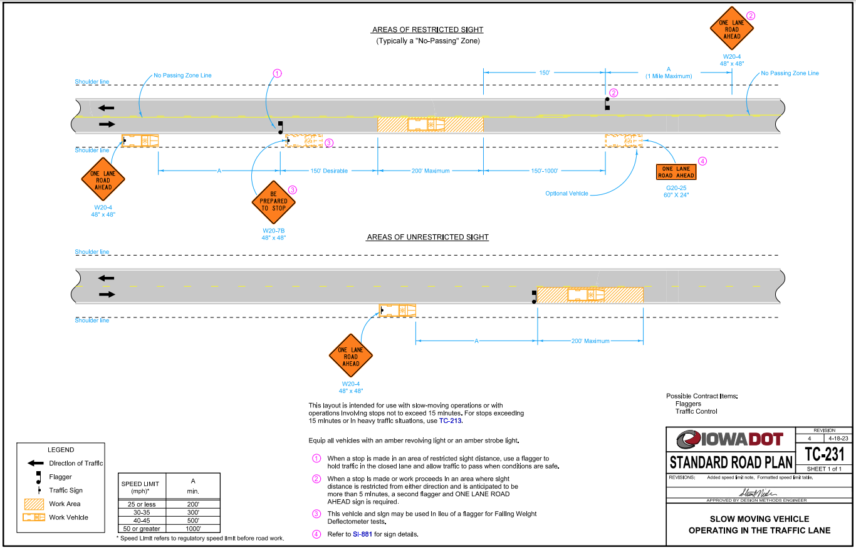
Figure 1. Iowa Department of Transportation TC-231 for Slow Moving Vehicle Using Flaggers (1).

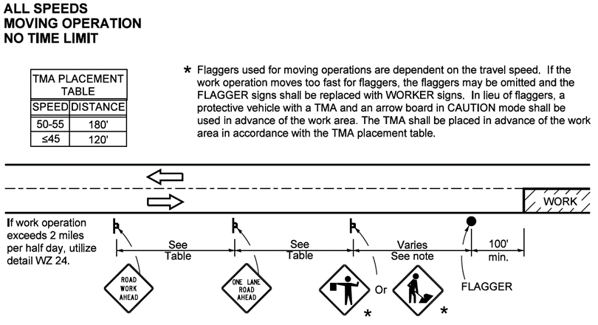
Figure 2. Illinois Department of Transportation WZ-22 for Moving Operations (2).

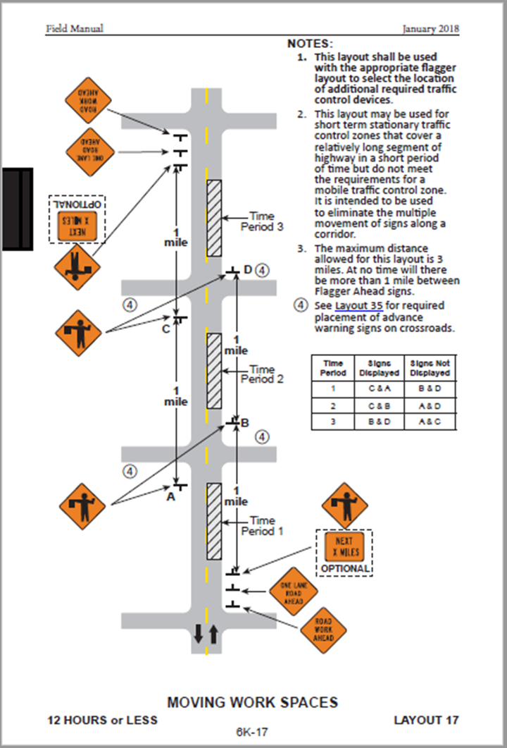

Figure 3. Minnesota Department of Transportation Layout 17 for Moving Work Spaces (3).

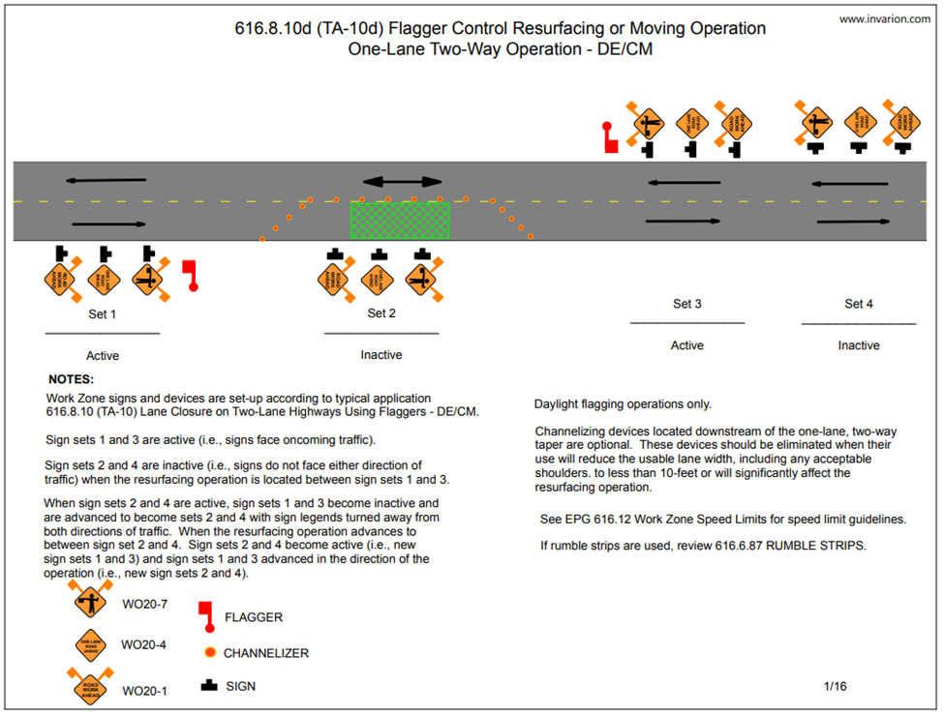
Figure 4. Missouri Department of Transportation TA-10d for Flagger Control Resurfacing or Moving Operation (4).
Despite the TTC guidelines that agencies have developed for their mobile operations on two-lane highways, many agencies still struggle with the trade-offs between using stationary lane closures that are perceived to provide a higher level of safety and control (but are not practical for the conditions) and using mobile TTC operations. Other challenges to mobile operations cited by agencies include the following:
- Unpredictable driver behavior (disobeying DO NOT PASS signs, passing errors, distracted/inattentive, impaired, speeding, tailgating, striking TMA or end of queue).
- Communicating passing instructions (or prohibitions) to motorists.
- Managing side road traffic, pedestrians, and school zones.
- Determining acceptable distance between the work operation and stationary advance warning signs.
- Insufficient staffing and equipment resources.
- Managing the length of the work convoy (number and spacing of vehicles).

Driver Passing Behavior around Mobile Work Operations

Observations of driver behaviors around mobile work operations in Texas and Minnesota yielded a number of important insights into potential strategies to improve safety around these types of operations. Specifically, improper passing by motorists farther back in a queue following a mobile work operation frequently created vehicle-to-vehicle conflicts (see Figure 5) that have the potential to adversely affect both motorist and worker safety.

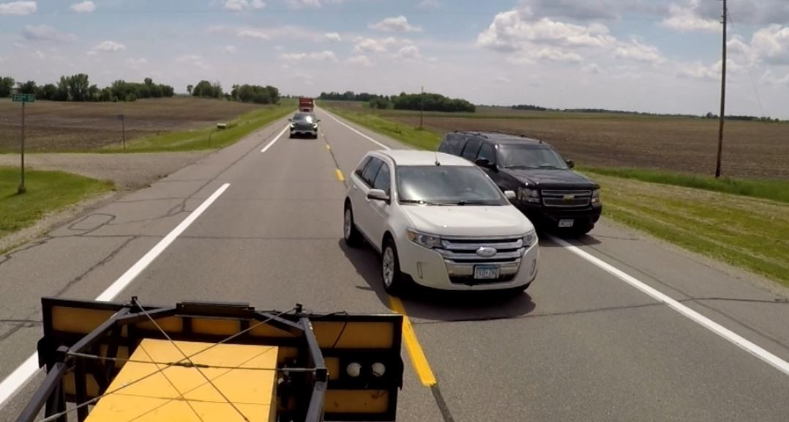
Figure 5. Example of a Passing Conflict.
Based on the observed data, it appears that the likelihood of such improper passing maneuvers is dependent upon how long vehicles must follow one another in queue while following the mobile operation. As shown in Figure 6, there is a 20 percent likelihood that impatient drivers will pass a mobile operation from an undesirable position in the vehicle queue following the work operation even when the amount of time spent waiting to reach the first position in the queue is fairly low (2 minutes or less). However, as the amount of time spent waiting to reach the first position in the queue approaches 4 to 5 minutes, the probability of undesirable passing maneuvers occurring increases significantly (exceeding 50 percent). Finally, when the amount of time spent waiting to reach the first position in the queue is 6 minutes or more, there is a high probability of impatient drivers passing a mobile operation from an undesirable position in the queue following the mobile operation.

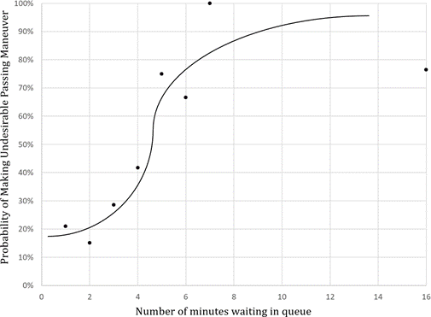
Figure 6. Probability of Occurrence of Undesirable Passing Maneuvers.
Based on the findings, it is recommended that:
- Transportation agencies strive to avoid creating conditions where multiple vehicles will queue (or platoon) behind the work operation and have to remain in that queue for more than four minutes. Selecting work periods where traffic volumes are lower is recommended.
- If roadway and traffic conditions are such that longer elapsed times following the queue are likely to occur, the work crew should be directed to plan to pull over and vacate the travel lane to allow vehicles to pass. Agency pre-planning of potential pull-off locations along a section of roadway would help work crews implement these directions.
- If prior experiences or analysis of a planned mobile operation on a roadway suggests that queues are likely to be created with long elapsed following times and there are not suitable locations for the work convoy to pull over to allow vehicles to pass, a stationary work zone with positive traffic control methods (e.g. flaggers, portable signals, etc.) should be considered.

References

- “Slow Moving Vehicle Operating in the Traffic Lane,” TC-231, Standard Road Plans, Iowa Department of Transportation, October 2017, Available at: https://iowadot.gov/design/SRP/IndividualStandards/tc231.pdf. Accessed November 30, 2022.
- Traffic Control Field Manual for IDOT Employees, Illinois Department of Transportation, Springfield, Illinois, April 2016. Available at: https://idot.illinois.gov/Assets/uploads/files/Doing-Business/Manuals-Guides-&-Handbooks/Highways/Safety-Engineering/Traffic%20Control%20Field%20Manual%20for%20IDOT%20Employees%20(April%202016).pdf. Accessed November 30, 2022.
- Minnesota Temporary Traffic Control Field Manual, Minnesota Department of Transportation, St. Paul, Minnesota, January 2018. Available at: https://www.dot.state.mn.us/trafficeng/publ/fieldmanual/fieldmanual.pdf. Accessed November 30, 2022.
- “Flagger Control Resurfacing or Moving Operation One-Lane Two-Way Operation-DE/CM,” Design/Construction and Materials Figure Number 616.8.10d, Engineering Policy Guide, Missouri Department of Transportation, Jefferson City, Missouri, August 2019. Available at: https://epg.modot.org/files/0/0a/616.8.10d_DECM_2016.pdf. Accessed November 30, 2022.

This research was performed in cooperation with the National Cooperative Highway Research Program (NCHRP). The contents of this report reflect the views of the authors, who are responsible for the facts and accuracy of the data presented here. The contents do not necessarily reflect the official view or policies of the NCHRP. This report does not constitute a standard, specification, or regulation, nor is it intended for construction, bidding, or permit purposes. This guidelines document is furnished only for review by members of the NCHRP project panel and is regarded as fully privileged. Dissemination of information included herein must be approved by the NCHRP.

