ADAPTATION GUIDE FOR THE FRAMEWORK TOOLKIT

The training materials fall under two categories:

- Definitions, explanations, and instructions for using the framework model.
- Instructions on how to customize the model to fit an agency’s terminology and practices.

The definitions, explanations, and instructions would take the shape of pop-ups or additional user guidance within the electronic model. These would address any terms within the input questions that may not be universally understood within the context of the model; the pop-ups would also define or discuss terms within the response options that may not be universally understood within the model context. When a user clicks on a question or possible answer, a pop-up message is likely to appear. Clicking on the pop-up message will bring up a message meant to explain the process or options available. In some cases, a single original term may be connected to multiple explanatory pop-ups or links. The user can pursue the thread as far as it goes, or until satisfied. For many terms and options, pop-ups are not needed.

AIDS FROM INSIDE THE MODEL

Model Inputs
To help the user answer the questions with Likert scale ratings, the tool provides additional user guidance and commentary (instructions) for selected questions/directions as illustrated below.
User Assistance
Users can often understand a question on the surface, but may be unaware of the breadth and depth of the thinking that the model requires for best results. A click on the question’s information icon can present them with factors to consider when formulating their answer. An example of this is the following:

Question: Rate the environmental sensitivity of the project.
Pop-up message: When rating the environmental sensitivity of a project, the project team should consider the following:
- Potential for work within wetlands or waterways
- Potential for noise pollution, particularly if the construction area is near residential areas or occupied buildings
- Need to protect private property from runoff
- Need to maintain existing storm drains
- Potential for flooding
- Potential of discovering hazardous materials, such as gasoline, or a landfill beneath the ground surface during construction
- Proximity of the project to sinkholes and/or caverns.
Definitions
To alleviate any misconceptions about what is meant by certain terms in this context, definitions are provided. Following is an example of a term definition in the framework:
Question: What is the project type?
Answer: One of the options is “RRR.”
Pop-up message: Resurfacing, Restoration, and Rehabilitation.
Explanations
Sometimes, the questions themselves need to be explained, and they too have pop-up messages. An example of this follows:
Question: Rate the need to include people in the CRP, not for their potential input, but solely to increase their knowledge/experience in constructability.
Pop-up message: Experience has shown that inclusion in CR sessions can be a valuable training and knowledge transfer exercise.
Outputs
The tool processes the input information and provides recommendations in the following four output areas:
- Necessity and formality of the constructability review (CR)
- Tools to aid the CR
- Composition of the CR team
- Timing and frequency of reviews
The tool provides additional user assistance and links that explain outputs; for example, levels of CR formality. End users should quickly become acclimated to the different outputs (recommendations) offered by the framework model, but new users will need some help—initially at least. The model offers assistance in the form of pop-up messages that the user must activate. In the case of the CR Formality output, although CRs are effective over a broad range of project types and sizes, the number and types of resources and effort needed for them can be substantial. Therefore, when devising a CRP for a particular project, the project team must strike the right balance between its potential benefits (e.g., refined project designs, enhanced construction efficiency, and reductions of disputes, cost overruns, and delays) and the time and effort it requires. The guidance presents three levels of CR formality:
- Informal CRs: An informal CR mainly relies on project team experience and in-house inputs. The process itself may be largely ad hoc, with minimal use of analytical tools or relaxed adherence to prescribed policies and guidelines.
- Semi-formal CRs: A semi-formal CR will generally incorporate more analytical tools and resources and will document a project’s constructability.
- Formal CRs: A formal CR will strictly adhere to detailed policies/guidelines/procedures to comprehensively evaluate and document a project’s constructability.
As conceptually depicted in Figure 1 below, the tools, resources, and frequency of reviews increases with increasing CR formality.
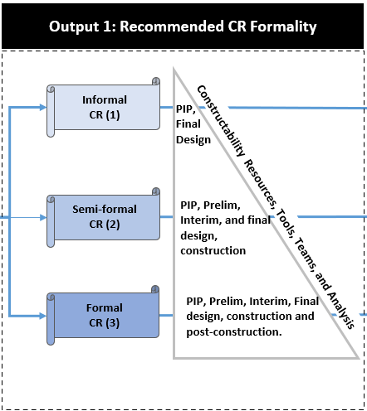
Figure 1 – Levels of CR Formality

Table 1 Attributes of CR Levels
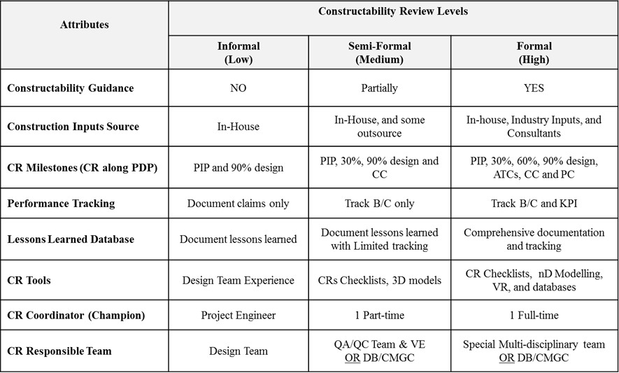
Again, hyperlinks to additional information are provided to help the user make the following decisions: 1) At which project stage should CR tools be used?; 2) Who on the project team or among project stakeholders should implement the CR?; and 3) Which references are most useful for guiding the user. Figure 1 presents the CR tools and show when they should be used during different project phases.

STEPS FOR USING THE FRAMEWORK TOOL

An agency may want to customize the framework model to make it better fit their terminology and practices. If so, users can make changes to the tool. Guidance on customizing the model takes the more conventional form of a chronological process. To customize the model, an end-user at a PTA should take the following steps:

- (Optional) If an existing local custom CRP file is available, Press “Load Custom CRP file”; choose the relevant custom CRP file; press “Open.” Your customized CRP framework will be loaded for editing.

- Press “Start” to begin editing.

- Press “Edit Questions” to make changes related to the questions in the CRP.
- Press “Edit Question” to make changes to a particular question.
- Changes can be made to the question title, the answer-choices, the tools needed, and the people that each choice will lead to.
- To edit the question title or answer-choices, select the corresponding editable textbox and make the required changes.
- To edit the tools or people within a particular group of answer-choices, select the corresponding dropdown list and check/uncheck the boxes as required.
- Press “Finish Editing” to move on to editing another question.

- Press “Edit Tools” to make changes related to the recommended tools.
- A list of tools will be displayed in editable textboxes.
- To edit an existing tool, make the required changes in the corresponding textbox.
- To add a new tool, press “Add Tool.” A newly generated item titled “New Tool” will be displayed at the bottom of the list. Make the required changes in the textbox.
- To revert to the original state of the loaded/default CRP file, press “Revert Changes.”

- Press “Edit Persons” to make changes related to the recommended people.
- A list of people will be displayed in editable textboxes.
- To edit an existing person, make the required changes in the corresponding textbox.
- To add a new person, press “Add Person.” A newly generated item titled “New Person” will be displayed at the bottom of the list. Make the required changes in the textbox.
- To revert to the original state of the loaded/default CRP file, press “Revert Changes.”

- Press “Save Changes” to save the edits made to a local file. A file explorer window will appear. Select a folder or directory to store the custom CRP file.

Below are three examples of the additional user information for CR tools used during the Constructability Planning stage. Most of this information is too lengthy to fit into the pop-up format, but can be accessed by clicking on a link inside a pop-up message.
Constructability Planning
- Checklists
A consistent system of checklists is useful for minimizing the number of errors, inconsistencies, and omissions on construction projects. Checklists are a valuable means of minimizing oversights and errors, particularly for less experienced staff; and they help prevent the problems associated with last-minute fixes.
Checklists serve as a means for the reviewers to focus on the areas and issues of concern (i.e., buildability of design, site investigation, ROW, staging, MOT, schedule). Several agencies have developed detailed checklists of ten or more pages that have historically caused constructability problems, project delays, and cost overruns.
When to Use: PIP through Construction
Probable Users: Core Constructability Team; Designers, Construction Team
References:
https://mdotjboss.state.mi.us/webforms/GetDocument.htm?fileName=1960.pdf
https://wsdot.wa.gov/sites/default/files/2016/05/16/ProjectDelivery-ConstructabilityReview.pdf
- 2. GPS (Global Positioning Systems).
- A satellite-based radio navigation system owned by the United States government. While it is principally a navigational system, GPS is also an important piece of mapping technology. Surveyors and others can use GPS to pinpoint the locations of objects to be shown on maps. GPS receivers installed on moving vehicles, for example, trucks carrying nuclear materials, allow them to be continuously tracked, and maps of their locations can be updated in real time.
When to Use: PIP through Construction
Probable Users: Core Constructability Team, Designers, Construction Team
References: https://www.gps.gov/applications/roads/

- 3. LIDAR (Light Detection and Ranging).
- Also known as 3-D laser scanning, LIDAR is a geospatial remote sensing technology used to make high-resolution maps. It is a method for determining ranges (variable distance) by targeting an object with a laser and measuring the time for the reflected light to return to the receiver. Lidar can also be used to make digital 3-D representations of areas based on differences in laser return times, and on varying laser wavelengths. Topographic lidar typically uses a near-infrared laser to map the land, while bathymetric lidar uses water-penetrating green light to measure seafloor and riverbed elevations.
LiDAR has three primary applications:
- Static LiDAR – system mounted at a single location to collect highly accurate data, but slower than other applications; exposes workers to traffic and other hazards.
- Mobile LiDAR – system attached to a mobile object such as a vehicle or heavy equipment; uses LiDAR, inertial navigation systems, and global positioning system (GPS) to measure roadway markings and cross sections.
- Airborne LiDAR – system installed on an aircraft that can travel at speeds of up to 115 miles per hour at a maximum elevation of 1,600 feet.
A key benefit of LiDAR technology is that its acquired data is useful for several applications. The data collected using LiDAR is analyzed in a digital point cloud format to map highway construction facilities and assets. Mining the collected data can produce suitable inputs for various construction-related design and modeling applications performed by DOTs, e.g., 3D and 4D digitized models and information for automated machine guidance (AMG). National Cooperative Highway Research Program (NCHRP) Report 748 described various mobile LiDAR applications for delivering highway construction projects as follows:
- As-built and maintenance documentation—Integration of LiDAR data into a centralized database that is continuously updated for future planning and construction,
- Pavement smoothness and quality determination— LiDAR data collected at high resolutions can be used to evaluate pavement smoothness and quality,
- Construction automation and quality control—Change detection and deviation analysis software uses digital models to identify deviations from LiDAR point clouds for construction quality control,
- Performing quantity take-off—LiDAR data is used to calculate lengths, areas, or volumes of construction quantities,
- Virtual and 3D Design— LiDAR data can be used for clash detection by checking for intersections of proposed objects with existing objects modeled in the point cloud, and
- Inspections—LiDAR can provide overall geometric information and an overall condition assessment of various highway infrastructure assets (7, 11).

When to Use: 30-percent CR through Construction
Probable Users: Core Constructability Team, Construction Team
References:
Harper, C., Tran, D., Jaselskis, E., Implementation of Visualization and Modeling Technologies for Highway Construction: Current Practices and Future Trends, TRB, 2020.
https://www.usgs.gov/special-topic/earthmri/science/topographic-lidar-surveys
Olsen, M., G. Roe, C. Glennie, F. Persi, M. Reedy, D. Hurwitz, K. Williams, H. Tuss, A. Squellati, and M. Knodler, Guidelines for the Use of Mobile LIDAR in Transportation Applications, NCHRP Report 748, Transportation Research Board of the National Academies, Washington, D.C., 2013.
Yen, K., T. A. Lasky, and B. Ravani, “Cost-Benefit Analysis of Mobile Terrestrial Laser Scanning Applications for Highway Infrastructure,” ASCE Journal of Infrastructure Systems, Vol. 20, No. 4, December 2014.
Figures 2, 3, and 4 present screen captures of the different kinds of pop-up messages in the framework model.

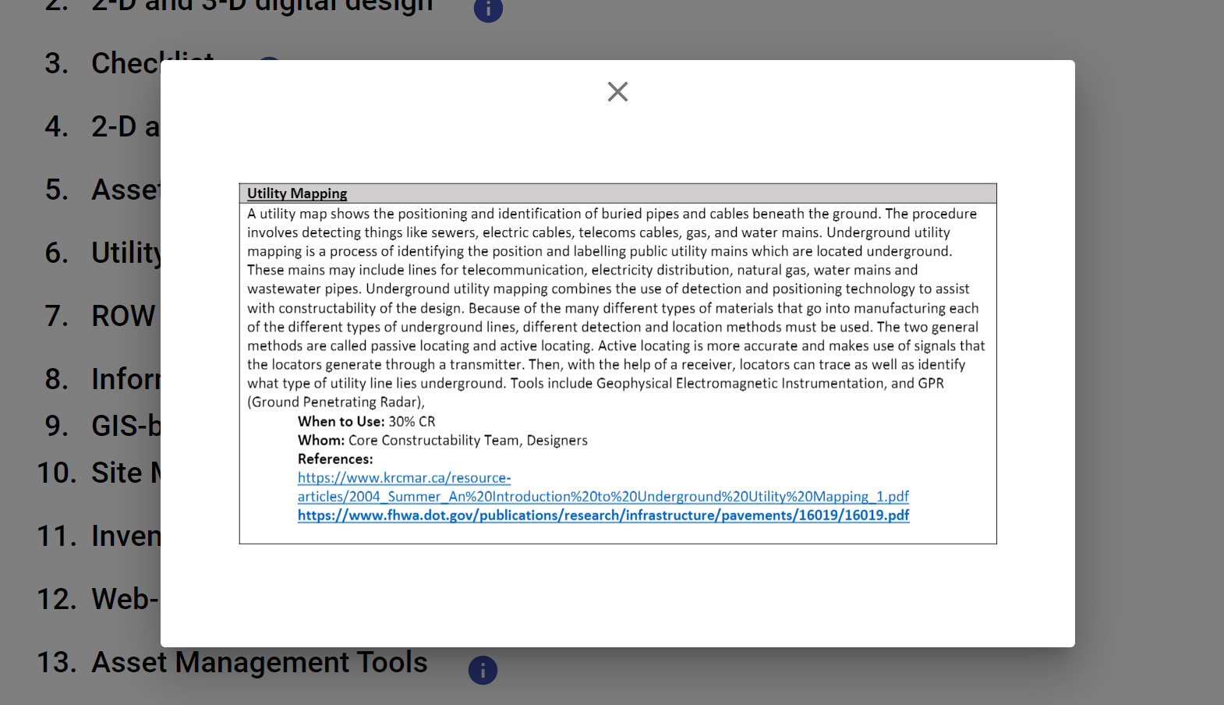
Figure 2. A Definition Pop-Up Message on “Utility Mapping,” superimposed on the Model Input Questions.

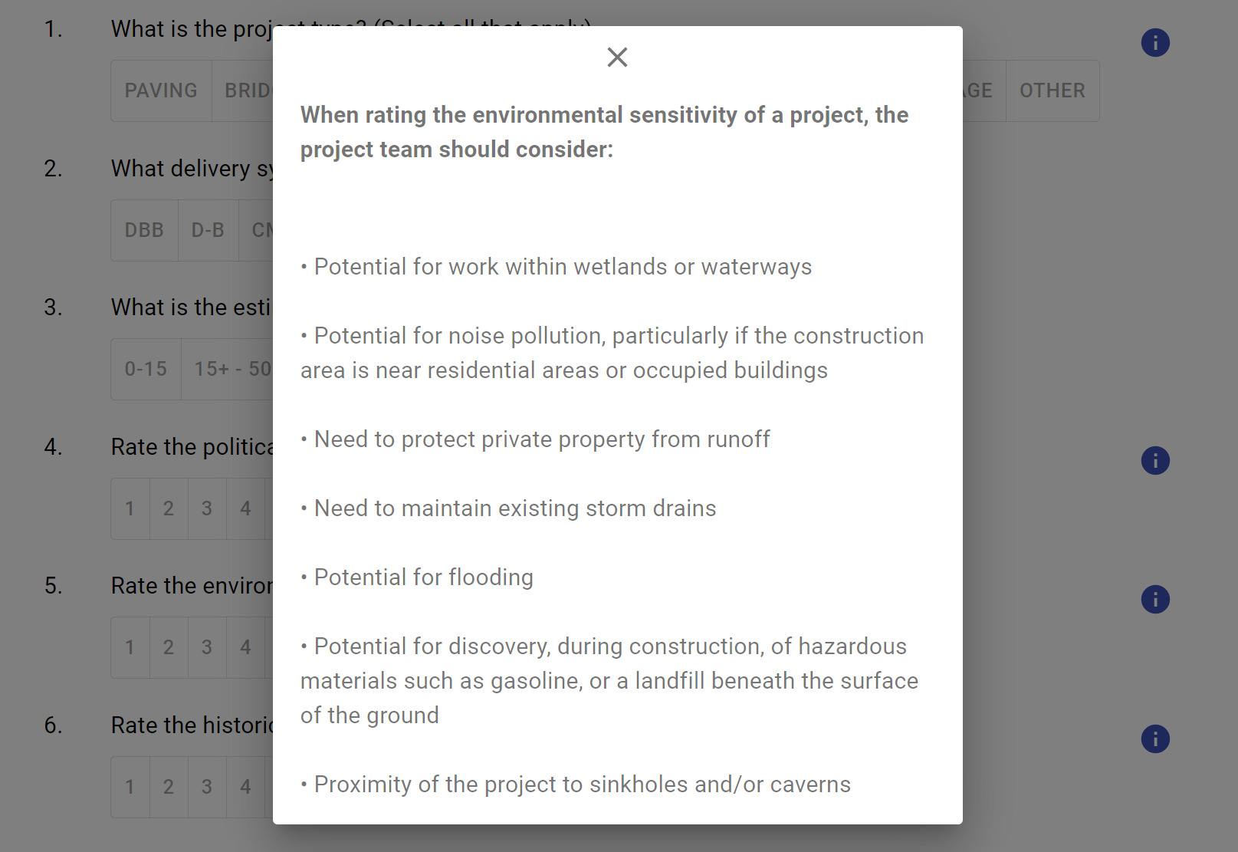
Figure 3. An Instructional Pop-Up Message on an Input Question Superimposed over the Model Input Questions.

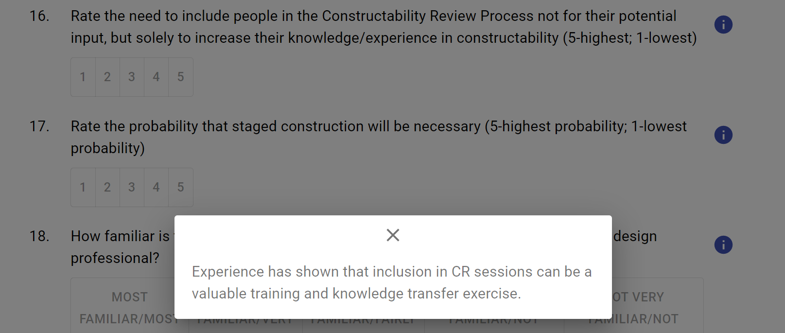
Figure 4. A Pop-Up Message to Explain the Idea Behind a Question Superimposed over the Model Input Questions.
TASK 2-4: ELECTRONIC PRESENTATIONS
The research team created two PowerPoint files to complement the training materials and can be considered part of those materials. The presentations’ main goal is to help the agency personnel successfully execute the CRP Decision-Making Framework on a proposed project. The team developed two versions of this presentation, one long and one abridged. The long version is the one described above. The abridged version of the same presentation, containing no additional information. The two are meant for different audiences. The longer version is for people who will be operating the system, while the abridged version is for agency executives, whose support is crucial to the success of the framework.

The first six slides give an overview of the research project, and the history of constructability. The next 11 slides describe Phase I of the project, the literature review, the definition of the current state of the practice, and the development of the Conceptual Decision-Making Framework. The remainder of the presentation addresses the execution of Phase II tasks, and the subsequent analysis and use of the data gathered from the tasks. These tasks were 1) developing the CRP Decision-Making Framework, 2) conducting the workshop, and 3) developing the training materials. The Training Materials section includes an overview of the guide for PTAs to customize the CRP Decision-Making Framework model to better suit their particular needs, situation, and agency culture.

