Project No. NCHRP 20-07 Task 389 Copy 1

Implications of State Departments of Transportation (DOTs) Participation in the One Call Process as an Underground Facility Operator

FINAL REPORT

Prepared for
NCHRP
Transportation Research Board
of
The National Academies of Sciences, Engineering, and Medicine

Roy E. Sturgill, Jr., P.E., Ph.D.
Timothy R.B. Taylor, P.E., Ph.D.
Ying Li, Ph.D.
University of Kentucky, Kentucky Transportation Center
Lexington, KY
November 2018

Permission to use any unoriginal material has been obtained from all copyright holders as needed.

Acknowledgement of Sponsorship
This work was sponsored by the American Association of State Highway and Transportation Officials, in cooperation with the Federal Highway Administration, and was conducted in the National Cooperative Highway Research Program, which is administered by the Transportation Research Board of the National Academies of Sciences, Engineering, and Medicine.

DiSClaimer
This is an uncorrected draft as submitted by the contractor. The opinions and conclusions expressed or implied herein are those of the contractor. They are not necessarily those of the Transportation Research Board, the Academies, or the program sponsors.

Project No. NCHRP 20-07 Task 389

Implications of State Departments of Transportation (DOTs) Participation in the One Call Process as an Underground Facility Operator

FINAL REPORT

Prepared for
NCHRP
Transportation Research Board
of
The National Academies of Sciences, Engineering, and Medicine

Roy E. Sturgill, Jr., P.E., Ph.D.
Timothy R.B. Taylor, P.E., Ph.D.
Ying Li, Ph.D.
University of Kentucky, Kentucky Transportation Center
Lexington, KY
November 2018

Permission to use any unoriginal material has been obtained from all copyright holders as needed.

Contents

List of Figures and Tables iv
Abstract 1
Summary 2
Chapter 1 Background 4
Chapter 2 Research Approach 6
Chapter 3 Findings and Applications 10
Literature and Legislation Review 10
Literature Review Summary 15
State Department of Transportation Survey Results 15
Case Study Summaries 21
Case Study Interview Summary 26
Chapter 4 Conclusions and Suggested Research 27
One Call Costs & Benefits Overview 27
Implementation 29
Suggested Research 29
References 31
Appendices 33
A: Survey Questionnaire 34
B: Survey Results 44
C: Case Study Interview Questionnaire 65

List of Figures and Tables

Figure 2-1: States that allow exemptions from One Call participation 7
Table 3-1. State One Call System Membership Summary 12
Table 3-2: State DOT Related Right-of-Way and DIRT Reported Incidents 15
Table 3-3: Possible Case Study States from National Survey: Reason for Marking Utilities 17
Table 3-4: Possible Case Study States from National Survey: One Call Participation 18
Table 3-5: Possible Case Study States from National Survey: Additional Comments 19
Table 4-1: Estimated Direct Costs of Utility Strikes 28
Figure 4-1: Facilities Operated by DOT Survey Respondents (16 Responding DOTs) 28

Abstract
State one call centers are part of a nationwide system that has been established to minimize the chance of excavators damaging underground utilities during construction projects. Laws dictating which utility operators must participate in one call systems vary among states. Some utility operators are exempted from taking part in one call systems. Recently, these exemptions have introduced problems by limiting access to grant opportunities available for state one call centers. As such, exemptions have come under greater scrutiny, with some questioning whether exemptions are warranted for any institution or agency. Despite operating underground utilities as part of their transportation networks (e.g. traffic signal cables, roadway lighting, drainage systems), State Departments of Transportation (DOTs) are one group of institutions who have frequently been granted exemptions (both as a facility operator and excavator) from one call requirements. This has especially been the case when facilities are located within agency-managed right-of-way. To discern the impacts of exemptions and membership, the research team began with a review of literature and resources pertaining to one call legislation, administered a survey to state DOT subject-matter experts, and prepared 12 in-depth case studies through one-on-one interviews with state DOT personnel. The conclusion of these efforts was that a definitive solution is not apparent. When a state DOT evaluates whether to become an operator member in a state one call system agency personnel must consider a number of variables and their potentially complex interactions. It is immensely difficult to quantify the costs and benefits of operator membership. Certainly, costs and benefits of operator membership in one call systems vary, although it appears that benefits outweigh costs in urbanized settings and locations where fiber optic facilities merit heightened protection. The institution best positioned to decide whether operator membership in a one call system is warranted is — a state DOT itself. There are several approaches DOTs can use to prevent damage to their facilities, including membership in one call systems, hybrid memberships in one call systems, permitting processes, 3D utility repositories, and the creation of a state call center. State DOTs are responsible for both the safety of the traveling public and the wise stewardship of taxpayer dollars. Accordingly, their voices should be the decisive ones in deliberations over operator membership in one-call systems.

Summary
Executive Summary
Implications of State Departments of Transportation (DOTs) Participation in the One Call Process as an Underground Facility Operator
State one call centers are part of a nationwide system that has been established to minimize the chance of excavators damaging underground utilities during construction projects. These systems are funded through fees assessed to the operators of underground utilities and are free to users (How 811 Works). Laws dictating which utility operators must participate in one call systems vary among states. Some utility operators are exempted from taking part in one call systems. Recently, these exemptions have introduced problems by limiting access to grant opportunities available for state one call centers. As such, exemptions have come under greater scrutiny, with some questioning whether exemptions are warranted for any institution or agency. Despite operating underground utilities as part of their transportation networks (e.g. traffic signal cables, roadway lighting, drainage systems), State Departments of Transportation (DOTs) are one group of institutions who have frequently been granted exemptions (both as a facility operator and excavator) from one call requirements. This has especially been the case when facilities are located within agency-managed right-of-way. This research focuses on costs, benefits, and risks DOTs experience due to the exemptions they may have as facility operators.
To discern the impacts of exemptions and membership, the research team began with a review of literature and resources pertaining to one call legislation, including federal and state regulations, Pipeline and Hazardous Materials Safety Administration (PHMSA) research, and approaches state DOTs use to protect and monitor their utility-type facilities. The team also reviewed available data related to state DOT membership in one call systems, or their exemptions, as well as any recorded dig-in incidents of DOT facilities. Following the literature and legislation review, the research team administered a survey to state DOT subject-matter experts to develop a high-level understanding of the costs and benefits of one call operator membership and prepared 12 in-depth case studies through one-on-one interviews with state DOT personnel. The conclusion of these efforts was that a definitive solution is not apparent. Just as federal regulations allow for state DOTs to manage their utility coordination processes according to the nuances of their delivery approach, individual needs, and local industries, the same flexibility may be needed in consideration of state DOT exemptions to one call membership as operators.
Although some of the costs and benefits of operator membership in one call can be precisely quantified, many cannot. One source of quantifiable cost to DOTs for being an operator member of a one call system is the expense of associated ticket fees. This can be estimated by tallying the number of tickets issued each year and multiplying it by the per ticket fee. Estimating the cost of marking facilities (whether performed by in-house staff or third-party contractors) is a more challenging task, but some estimates indicate the cost of marking facilities can be over 15 times what an agency pays in ticket fees. The benefits of operator membership are more difficult to assess than costs because they can only be estimated by comparing damage caused by underground facility strikes of those with membership versus those without membership. Irrespective of whether a utility owner is an operator member of a one call system, its facilities are exposed and therefore at risk to dig-in events —either from excavators that have not called 811, or improperly marked/unmarked facilities, or inaccuracies in as-built information. A study in the United Kingdom found that even if utility facilities are known to exist, the risk of a strike remains considerable. This review, which examined strikes occurring after utility investigations had been performed or as-builts reviewed, indicated facilities were still struck 50% of the time when the location or as-builts were accurate (Zeiss, 2016). Membership in the one call system does, however, help in assignment of liability in the event of a strike. It is also critical to assess risks posed by facilities typically operated by DOTs. Potential health risks created by dig-in events are relatively low (typically facilities are not high voltage, toxic, hazardous, or flammable). Monetary risks, on the other hand, are moderate to high. Indirect costs (e.g., service loss, travel delays, damage assessments) associated with a strike can be up to 30 times the direct costs associated with facility repair or replacement (Zeiss 2016). Thus, while most DOT facilities are low hazard, fiber optic facilities should be viewed as high-cost, high-risk facilities given that strikes are estimated to be three times as costly as other facility types. The survey revealed that 87% of DOTs operate telecommunication facilities; these would typically be fiber optic facilities. Less than 20% of respondents operate facilities considered flammable. This underscores the potential direct costs of facility strikes but does not entirely capture safety risks, which are inherently difficult to quantify.
When a state DOT evaluates whether to become an operator member in a state one call system, agency personnel must consider a number of variables and their potentially complex interactions. Throughout this report the immense difficulty of quantifying all of the costs and benefits of operator membership is emphasized. Some benefits agencies reported, such as membership improving the design process, are tangible, but challenging to extrapolate across longer timeframes. Certainly, costs and benefits of operator membership in one call systems vary, although it appears that benefits outweigh costs in urbanized settings and locations where fiber optic facilities merit heightened protection. The institution best positioned to decide whether operator membership in a one call system is warranted is — a state DOT itself. There are several approaches DOTs can use to prevent damage to their facilities, including membership in one call systems, hybrid memberships in one call systems, permitting processes, 3D utility repositories, and the creation of a state DOT call center. Making decisions at the national level about memberships or exemptions is not judicious. Indeed, there are instances where a single approach to one call operator membership may not be optimal at the state level. State DOTs are responsible for both the safety of the traveling public and the wise stewardship of taxpayer dollars. Accordingly, their voices should be the decisive ones in deliberations over operator membership in one call systems.

Chapter 1
Background
The location of underground utilities became a critical focus of data collection efforts during the construction and excavation operations that followed the building boom of the 1950s, 1960s, and 1970s (Thorne et. al., 1993). At least two factors contributed to the mounting interest in underground facilities. First, the number of underground utility installations grew dramatically, driven by technological advances in wire coatings that allowed for more resilient underground installations of cable. Second, the period witnessed a growing emphasis on beautifying landscapes and reducing visual pollution following passage of the Highway Beautification Act (Doss, 2012, Marsh, 3M Case Studies & Technical Articles). One goal of data collection was and continues to be the reduction in dig-in events, which occur when excavators strike underground facilities. Dig-in strikes impacting underground facilities result in loss of services, injuries, delays and even deaths, which has promoted the initial establishment and growth of utility location call centers.
The earliest call centers for underground utility notification were located in the northeastern United States. Dig Safely New York, Inc. was established in 1969 and began operations in 1970 (Dig Safely New York). It was formed from a clearinghouse operation that started in 1964 (Thorne et. al., 1993). The Pittsburgh Public Service Coordinating Committee established a local one call service in 1968 that grew and eventually merged with other services, ultimately becoming a statewide service in 1977 (Pennsylvania One Call). During this period, many states began providing similar services. The passage of the 1988 Pipeline Safety Reauthorization Act tied substantial funding availability to states establishing, via legislation, one call notification systems. This legislation called on the USDOT to develop guidelines for establishing qualifications and procedures for operating these centers (Thorne et. al., 1993, United States H.R. 2266, 1988). It also created the network of state-level one call systems that today plays a critical role in minimizing the damage to underground utilities during construction projects. State systems are funded through fees assessed to operators of underground utilities, but it is free to excavators (How 811 Works). While the original legislation mandated that gas pipeline operators participate in one call systems as member institutions, other facility operators are now subject to these requirements unless they have received an exemption (Thorne et. al., 1993, United States H.R. 2266, 1988). Exemptions, if any, vary by state along facility types, institution, and by operator versus excavator status.
One call systems let excavators notify utility operators of their planned activities so that potential conflicts may be circumvented. Typically, utility operators submit the locations and boundaries of their facilities, along with a surrounding buffer, to a one call geospatial database in the form of polygons. Once an excavator notifies one call of where they plan to dig, all utility operators which have polygons touching the dig location are issued a ticket by the one call system. To avoid excavation activities damaging their facilities, utilities have the option of marking the location of their facilities on the ground (either with in-house personnel or contracted staff) or clearing the ticket if they determine excavation will not threaten their facilities. Utility operators are expected to respond within 48 hours of receiving a ticket. In most cases, excavators are notified of ticket clearance. Tickets are cleared once facilities have been marked or deemed clear of the excavation. During locates, a tolerance zone of typically 18 inches is used from each side of the utility as marked, although in some cases the zone may be wider. If an excavator plans to dig within this zone, they are expected to take precautions and use specific practices. One call systems are funded by utility operator fees, which are generally levied as per ticket fees. According to the Common Ground Alliance, there are 25 million ticket requests per year in the United States. Beyond the costs of tickets and membership, a state department of transportation (DOT) must consider the expenses associated with locating and marking facilities when deciding if the benefits of membership exceed requisite outlays.
State DOTs operate underground utilities as part of their transportation networks (e.g. traffic signal cables, roadway lighting, drainage systems). One call laws vary among states, and some DOTs are exempted from being operator members of their state one call systems. Exemptions authorize agencies to exclude their underground facilities from a one call system. In doing so, they do not have to pay fees associated with one call membership or facility locates; though there permitting process will likely include location related costs. To date, the costs, benefits, and risks of these exemptions have not been analyzed. Nor has there been an assessment of whether typical state DOT processes (e.g. encroachment permitting, design review of as-built or existing infrastructure) that capture, map and communicate the location of underground facilities are effective at preventing dig-in events. The goal of this research is to document the experience of agencies which have been exempted from one call requirements as well as to describe the costs and benefits associated with membership in one call systems.
The remaining chapters of this report are organized as follows. Chapter 2 describes the research approach used and how work was distributed across tasks that were approved by the NCHRP research advisory panel. Chapter 3 presents the principal findings and applications of the research. This chapter begins with a review of relevant literature and legislation, including state one call laws, Pipeline and Hazardous Materials Safety Administration (PHMSA) research, federal and state regulations, exemptions, and strategies DOTs employ to protect and monitor their utility-type facilities. Next, the chapter recounts the findings of a survey that was distributed to all 50 state DOTs on the topic of one call operator membership. Although just 16 agencies responded to the survey, we nonetheless acquired useful information about current state practices as well as the costs and benefits of one call membership. Data available regarding DOT membership and exemptions as well as any documented dig-in incidents of DOT facilities was reviewed to understand the impacts and implications regarding the research problem. The final substantive section of Chapter 3 summarizes 12 case studies which were assembled based on interviews with state DOT officials. States chosen for inclusion were selected in consultation with the NCHRP research advisory panel. Chapter 4 discusses the major conclusions drawn from the research as well as recommendations for future work on one call systems and addressing questions of state DOT membership.

Chapter 2
Research Approach
State-managed transportation infrastructure co-exists with increasingly complex utility infrastructure, which can engender conflicts among roadway designers, utility designers, and contractors. Advances in transportation infrastructure technology such as intelligent transportation systems (ITS), smart infrastructure, and autonomous vehicles, means that state departments of transportation (DOTs) will be called on to manage sprawling subsurface and aerial utility infrastructure systems. In the past, many DOTs have been exempt from participating in their state one call systems as facility operators. However, recent legislation has abolished exemptions in some states; other agencies have voluntarily embraced operator membership regardless of exemption status. Some state DOTs, justifiably so, believe they do not require the protection of one call operator membership because their internal policies and practices (e.g., permitting, state DOT call center, utility repository) are sufficient for handling facility related conflicts and locates. This chapter describes the research methods used in this study to investigate the costs, benefits, and risks DOTs accept as a result of either being exempt from or participating in one call systems as operator members.
While highways and utility facilities (e.g., electric, gas, fiber-optic cables) may seem very different, one attribute they share is that they provide services expected by the public. Highway and utility facilities often occupy common physical locations, and in most cases the taxpayers who fund road construction are also ratepayers who use utilities. As such society benefits from efficient management of the interactions among these infrastructure systems. The one call process (e.g., 811) is an example of where these systems interact. The one call approach is a nationwide system established to minimize the likelihood of damaging underground utilities during excavation (e.g., during highway construction projects). Operators of underground facilities are required to participate in a state one call system as member institutions unless laws or exemptions stipulate otherwise. Excavators can make free use of one call systems as they are funded by fees assessed to the operators of underground facilities. Fees come in the form of tickets and sometimes annual dues. Utility owners must document and record the location of their facilities in a geospatial database. These zones are often referred to as prisms or polygons; they vary in size according to the one call system. A ticket is issued when there is overlap between the area an excavator plans to operate in and a facility operator’s prisms. To satisfy the requirements of a ticket, utility owners must locate and mark their facilities on the ground, either performing this work in-house or contracting with a third party. Utility operators foot the bill for tickets; ticket fees are generally modest— in most states they are $2 or less per ticket.
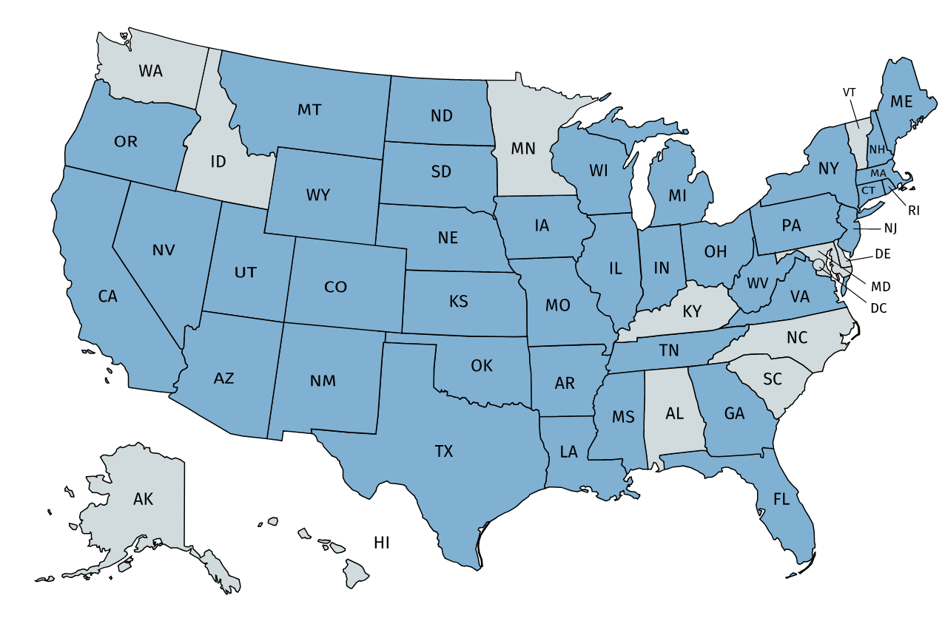
Despite the low cost of ticket fees, the additional expense of locating and marking facilities can be significant. DOTs are often the largest property owner in states, and their operation of underground utilities as part of managing transportation networks (e.g., traffic signal cables, roadway lighting, drainage systems) could result in a high volume of location tickets. Although one call laws vary among states, most DOTs are exempt from including their underground facilities in the one call system and do not have to pay fees associated with one call membership. In Figure 2-1, as reported by the Pipeline and Hazardous Materials Safety Administration (PHMSA), states highlighted in blue currently have one call exemptions (these often include exemptions for DOTs). Many states are considering the repeal of these exemptions for DOTs, but the cost-benefit impact of changing DOT participation rules for the one call process is not well understood.

Source: PHMSA, 2017
Figure 2-1: States that allow exemptions from One Call participation (exempt states shown in blue)
This research sought to document impacts DOTs face due to the loss of one call exemption as well as the consequences of being an operator member of a one call system—while also considering similar approaches to one call such as permitting. The investigation involved a number of impacts, including but not limited to contributing to the funding of one call systems, locating and marking facilities, and notifying and receiving notification from one call centers. This project considered the operational and organizational costs and benefits of memberships and exemptions as well as the legal implications for DOTs. The research also attempted to include documented risks to jobsite safety that have resulted from DOTs not participating in one call centers as an operator member.
The study began by reviewing a 2010 summary of state DOT one call participation and a study from 2014 published by PHMSA. We reviewed salient legislation and literature and administered a national survey to state DOT officials to collect data regarding current practices, opinions, and approaches to one call. The research team prioritized the development and distribution of the survey as well as organized findings into functional, adaptable, and applicable guidance.
The principle deliverable of this research effort is this report. It describes different models of DOT participation in the one call process and presents guidance related to the benefits and costs of DOT membership in one call services as an operator. Report development was iterative and proceeded as information was collected during the following research tasks:
Task 1
The research team met with the NCHRP project panel to discuss the work plan, design of the survey to be conducted in Task 3 and other details of the project’s technical scope, as well as the opportunities for panel-members to make research contributions.
Task 2
The research team reviewed critical PHMSA research as well as laws, regulations, and approaches DOTs use to deal with requirements imposed by the one call laws. Categorizations were developed for the pertinent criteria of DOTs one call requirements and exemptions, including DOT responsibilities, notification of excavation, location requirements, enforcement, and legal impacts.
Task 3
The research team conducted a survey of state DOTs to: (a) identify DOT concerns with particular requirements under their one call laws; (b) identify DOTs with documentation pertaining to costs, benefits, and risks stemming from their operator membership in state one call systems; (c) identify documentable-costs of one call requirements; and (d) identify DOTs with experience and documentation of the costs, risks, and benefits they have attributed to their exemption from or in membership of one call.
Task 4
The research team developed a strategy to prepare case studies for individual states. The goal of the case studies was to identify and evaluate the effectiveness of one call and similar practices used by states which responded to the survey administered in Task 3 and gather detailed information about their respective one call systems (or non-membership if that was the case).
Task 5
With assistance from the research advisory panel, the research team identified state DOTs for detailed case studies. DOTs were selected to provide a representative sample along several axes—size, geography, and a range of experience relative to one call systems.
Task 6
Though quantifiable data was sparse, the research team collected estimates of the costs and benefits of DOTs being operator members of one call systems. Examples of costs include the funding of one call centers, locating facilities, and reviewing and receiving notifications from one call centers. Example Benefits include risk reduction in terms of damage reductions and improved jobsite safety.
Task 7
Case studies and their attendant findings were summarized. Case study summaries focus on the key themes which emerged during the course of interviews with DOTs as well as critical insights which cut across the different studies. A mix of qualitative and quantitative information is presented in the case studies to highlight the differences among agencies.
Task 8
This report represents the final task of the research. It presents different models of one call system participation among the DOTs with regard to funding to one call centers, locating facilities, receiving notification from one call centers and the legal issues that affect their state DOT exemptions or required membership in one call.
Anticipated Products & Actual Outcomes
Throughout this project, the goal has been to equip DOTs with useful guidance on agency relationships with one call systems. Although it was originally thought the project would culminate in the development of a method to analyze the costs and benefits of operator membership, this was not possible given the divergent experiences of DOTs, their use of alternative processes (e.g., permitting) that handle location services, the dissimilar nature of agency highway inventories, and the immense challenges of quantifying costs and benefits. Nevertheless, this report offers readers a starting point to think through the consequence of operator membership for their agencies by delivering the findings of a literature review, survey, case studies, and a high-level analysis of the costs and benefits attached to one call membership. The case studies should prove especially interesting to readers, as they capture information about exemption status, staffing measures, and policy development. This report also provides supporting information for legislative decision making and deliberations over exemption status.
Few resources are available to assist in the cost-benefit analysis for DOT membership in the one call process. This report presents useful guidance to help fill that gap. The guidance developed is general in nature, out of necessity, in order to have applicability across the spectrum of DOTs, but will serve as a starting point for considerations of various costs and benefits associated with one call membership and potentially documentation along these variables.

Chapter 3
Findings and Applications
Research findings were produced through the use of three research methodologies — a literature review, a survey of subject-matter experts, and one-on-one interviews. Researchers performed a review of literature and salient legislation to gather information on one call laws and practices. Information from this review informed the development and finalization of the survey instrument that was distributed to state departments of transportation (DOTs) utility subject-matter experts. Researchers refined the survey and distribution list through feedback from the research advisory panel. Because organizational structures vary among DOTs, the recipients of the survey ranged from state utility, right-of-way, or permitting experts. While the survey response rate was lower than hoped for, the information collected proved useful in selecting experts to interview and in development of the case studies. The interviewee list and questions were amended based on feedback from the research advisory panel. Results and findings from each activity are individually presented in the following sections.
Literature and Legislation Review
The research team’s literature review turned up little material on the impacts and implications of state DOTs being exempted from one call laws as utility facility operators. There are few documents or numerical/statistical evidence that support arguments for or against state DOT exemptions from being utility facility operators in state one call systems. The research team uncovered anecdotal evidence expressing support for both perspectives.
One Call Systems Overview
Before addressing one call exemptions and membership, we briefly discuss how these systems operate and are funded. The primary goal of one call systems is to protect underground facilities from damage. Federal legislation requires states to have damage prevention laws including the operation of one call systems. Legislation varies among states, but typical legislative provisions specify response times, definitions of operators and activities, exemptions, marking standards, and penalties (Thorne et. al., 1993). Some state one call systems support the use of design or planning calls to gather information on underground utility locations for proposed projects. Others only authorize calls for imminent excavation activities.
Typically, excavators must place a call two to three business days before excavation begins. Some one call systems can handle online excavation requests. Once a one call center receives a call, it uses screening methods to identify utility companies whose facilities will potentially be impacted. Once this information has been gathered, the one call center notifies utilities in the excavation area. Utilities then have minimal time to review the notification and mark, or contract to have marked, the approximate locations of their facilities. Often a single contractor marks facilities for all utilities impacted within an excavation area. Several methods are used to locate facilities onsite — utility plans, audio-frequency locators, and surface monuments are common. The approximate locations of utilities are marked using colored flags and/or paint according to the marking standards required by state damage prevention laws. Marking colors are standardized according to the American Public Works Association color assignment by facility type (e.g., gas, electric, and telecommunications). Excavators can review the ticket online or place a follow-up call to determine if utilities have either marked their locations or indicated they are clear of the excavation. Excavation may commence once marking or clearance has been completed (811 Best Practices Guide, Thorne et. al., 1993).
One call systems are funded by grants from multiple sources, such as the Pipeline and Hazardous Material Safety Administration (PHMSA) and operator members of particular one call systems. Being a member of a one call system can entail fees such as annual membership fees, charges per ticket, or a combination thereof. (811 Best Practices Guide, Virginia 811 Laws & Policies, PHMSA Dept. of Transportation Grant Management Process). Annual fees are typically less than $500 while per ticket charges are generally under five dollars. In some cases per ticket charges are assessed based on a fee schedule. Generally, fee schedules entail price reductions for per ticket fees with increased ticket frequency and/or a larger number of facilities in an operator’s network. Additionally, some state damage prevention laws require the deposit of excavator penalties and fines in funds that can be used by the one call system (Review of multiple one call system fee schedules and state legislation). Most operating standards and procedures for one call systems are established legislatively.
Legislation Review
The requirements of the Pipeline Safety, Regulatory Certainty, and Job Creation Act of 2011 have significant implications for this research (Public Law 112-90). This law required PHMSA to study the impacts of excavation damage on pipeline safety (PHMSA 2014). As part of this study, PHMSA analyzed each state’s exemptions to the one call notification system requirements and compared these exemptions to the frequency and types of excavation damage incidents which occurred in each state. PHMSA also looked at the potential benefits and adverse costs of eliminating all exemptions for mechanized excavation from state one call notification systems. The study found that between 1993 and 2012 a total of 1,630 pipeline incidents were the product of third-party excavation damage. These incidents resulted in 141 deaths, 440 injuries, and nearly $370 million in property damages. The PHMSA study — much like our literature review — found little documentation that quantifies the costs, benefits, and risks associated with state DOT exemptions, but did present concerns associated with these exemptions.
Further summarized by the PHMSA study, there are no requirements for one call to notify state DOTs of unpermitted encroachments on the state DOT right-of-way; in some cases those encroaching may not have knowledge of the right-of-way boundaries. Assuming an excavator uses the one call service, if a state DOT has an operator exemption it would not be notified of the upcoming excavation. In general, the study found that states with fewer exemptions have fewer dig-in events. However, the focus was on excavator-type exemptions, which led to the conclusion that further study of exemptions was needed to make a justified determination. The study’s appendix contained feedback from respondents at one DOT who contended that their operator exemption was justified because most of their facilities were located in their right-of-way and they assumed responsibility for damage to them (PHMSA 2014). The PHMSA study focused on legislation related to one call system membership and exemptions. Further details are provided in the ensuing sections.
Membership & Exemptions Review
Table 3-1 summarizes member and operator exemptions in each state. Information presented in this table was collected from the One Call Systems International website and resources, PHMSA’s Summary of Damage Prevention Laws, individual state legislation, and a survey on the topic conducted in 2014 (Scott 2014). Data presented in Table 3-1 was analyzed in combination with survey feedback to inform the selection of states for case studies.

Table 3-1. State One Call System Membership Summary
State | Is there Mandatory Operator Membership? | Are there exemptions? | Is the DOT exempt from being a member as an Operator? | Is your DOT a member of the State One Call System?
Alabama | No | No | Not applicable | No
Alaska | No | No | Not applicable | No
Arizona | Yes | Yes | No | Yes
Arkansas | Yes | Yes | Yes | Yes
California | Yes | Yes | Yes | No
Colorado | Yes | Yes | Yes | Yes
Connecticut | Yes | Yes | No | Yes
Delaware | Yes | No | No | Yes
Florida | Yes | Yes | No | Yes, but not required to locate. They have voluntarily registered some areas to locate in.
Georgia | Yes | Yes | Yes | No
Hawaii | Yes | No | No | Yes
Idaho | Yes | No | Yes. | -
Illinois | Yes | Yes | Yes, according to JULIE FAQ’s but not specifically mentioned in legislation | No
Indiana | Yes | Yes | No | No
Iowa | Yes | Yes | No | Yes
Kansas | Yes | Yes | No | Yes
Kentucky | No | No | Not applicable | No
Louisiana | Yes | Yes | No | No, have a good permitting process in place.
Maine | Yes | Yes | No | Yes
Maryland | Yes | No | No | Yes
Massachusetts | Yes | Yes | No | No
Michigan | Yes | Yes | Yes | No
Minnesota | Yes | No | No | Yes
Mississippi | Yes | Yes | Yes | -
Missouri | Yes | Yes | No | Yes
Montana | Yes | Yes | No | Yes
Nebraska | Yes | Yes | No | -
Nevada | Yes | Yes | Yes | No
New Hampshire | Yes | Yes | No | No
New Jersey | Yes | Yes | No | Yes
New Mexico | Yes | Yes | No | -
New York | Yes | Yes | No | Yes
North Carolina | Yes | No | No | Yes
North Dakota | Yes | Yes | No | Yes
Ohio | Yes | Yes | No | Yes
Oklahoma | Yes | Yes | Yes | -
Oregon | Yes | Yes | No | Yes
Pennsylvania | Yes | Yes | Yes | No
Rhode Island | Yes | Yes | RIPUC has indicated the DOT is not required to mark their facilities | No
South Carolina | Yes | No | No | Yes
South Dakota | Yes | Yes | No | Yes
Tennessee | Yes | Yes | No | One region is and some ITS operations
Texas | Yes | Yes | Yes | No, has a good system in place
Utah | Yes | Yes | No | Yes, and self-locates
Vermont | Yes | No | No | No
Virginia | Yes | Yes | Yes | No
Washington | Yes | No | No | Yes
West Virginia | Yes | Yes | No | No
Wisconsin | Yes | Yes | No | Yes
Wyoming | Yes | Yes | No | Yes
Source: Paul Scott Survey of State DOT’s, 2017.

Paul Scott, a Utility Liaison with Cardno, conducted a state DOT survey in April of 2014 that asked state DOTs if they were members of their state one call system. Some states offered more than a simple yes or no answer, providing more detailed explanations. The fifth column of Table 3-1 contains responses to this survey. Some exempted states noted that they nonetheless participate as members in their state one call system. Scott also published an article entitled “DOTs and One Calls” in the 2015 Excavation Safety Guide & Directory that observed both AASHTO and PHMSA were encouraging state DOTs to participate fully in one call systems. Scott described the pros and cons of state DOT membership in one call. Potential drawbacks of membership include duplicated effort of DOTs and one call, the cost of participating in one call, and the need for DOT permitting processes to continue regardless of one call membership. The primary benefit of membership is that excavators can make one call when near state DOT right-of-way. This precludes the possibility of accidental dig-in incidents occurring as the result of state DOT permitting sections not being notified or catching potential impacts. While state DOT membership opinions varied, agencies were very much in support of the work of the one call systems (Scott, 2015).
Departments of Transportation Processes & Potential Impacts
Along with information on membership in state one call systems, Scott’s survey gave DOTs the opportunity to provide input on processes they have established to protect their facilities as well as the potential impacts to their facilities. State DOTs that do not participate in one call systems often justify their non-participation by pointing out they have a permitting or some other process in place that is sound enough to protect their facilities. They contend the one call process merely replicates permitting procedures. Many DOTs also noted that their facilities are in the agency-owned right-of-way; if an unpermitted dig-in event occurs, the violator is responsible for damages. However, regardless of exemption status, several DOTs participate with some of their fiber optic facilities due to the potential repair costs. Some agencies noted that legislation mandates their participation in a one call system, and that while participating has some advantages the costs of participation are overwhelmingly high compared to the perceived benefits. Membership is a financial strain as are per ticket fees, but the most burdensome costs are tied to paying for laborers (either in-house or contracted) to locate and/or review the ticket notifications. A review of several DOT permitting guidance manuals found a lack of specific guidance to review locations of ITS, storm water, or other state DOT facilities. Although this may be standard practice, the case study portion of this report further addresses this as well as discusses the labor costs associated with state DOT one call membership.
Incidents Review
The final area of investigation is incidents that have occurred on state DOT right-of-way which involved state DOT-operated facilities. Unfortunately, there is little information on these incidents, their damages, and associated costs. As such, these issues are explored more deeply in the survey and case study analysis. In the future, this information will be more easily attainable with changes to the Common Ground Alliance’s Damage Information Reporting Tool (DIRT). The 2014 PHMSA study recommended changes in data collection procedures for the DIRT template. Beginning with the 2018 version, the DIRT template will accommodate more thorough data input on location and facility ownership as part of incident reports. These data will be reportable regardless of exemptions (The New DIRT Field Form Toolkit). Nonetheless, some analysis of incident data obtained from the 2014 DIRT report is possible.
The most recent DIRT report with specific analysis on the location of reported incidents is from 2014. During 2014, there were 273,599 reported events. Of these, location data specific to right-of-way type were collected for approximately 53,500 events (19.6%). Table 3-2 summarizes information on the estimated number of incidents on each right-of-way type, the percentage over the overall sample for each right-of-way type, and the percentage of these events preceded by a one call notification. Notably, excluding City Street incidents, it can be assumed that 92% of the dig-in incidents occurred outside of the typical state DOT right-of-way. Given this is such a high percentage relative to the amount of right-of-way state DOTs manage, it is understandable why many agencies believe they should not be required to participate in one call systems.

Table 3-2: State DOT Related Right-of-Way and DIRT Reported Incidents
Right of Way Type | Estimated Number of Incidents | Percentage of the Sample | Percentage of these Events Preceded by a One Call Notification
Public-Highway | 900 | 1.7% | 17%
Public-County Road | 3,200 | 6.0% | 20%
Public-City Street | 18,500 | 34.6% | 23%
Total | 22,600 | 42.2% | 22.3%
Note: n = 53,500 (19.6% of all events recorded in 2014).
Source: Common Ground Alliance 2014 DIRT Report

Along with this information, it should be noted that dig-in incidents entail varying costs associated with both damages and injuries. Anspach presented that the safety costs associated with these incidents are a metaphorical iceberg (CGA, 2006). Yet even if one call systems are used correctly risks still present themselves. These risks may entail unknown utilities, one call mismarks, or other errors. Anspach, at the 2010 CGA conference, again presented these issues and potential gaps between one call services versus the programmatic use of Subsurface Utility Engineering (SUE). This presents that using one call is not an all-inclusive solution in the realm of utility damage prevention.
Literature Review Summary
Although state DOTs greatly value the work one call centers perform, most agencies believe their internal permitting processes duplicate the purposes and function of the one call system. Even if DOTs participated as operators in one call systems they would still have to issue permits. DOTs are also concerned about the cost of membership fees. While agencies do not consider membership fees to be onerous, the cost of labor (whether in-house or contracted) required to review tickets and locate and mark utilities is considerable. Another concern is the vast amount of right-of-way DOTs manage. Agencies worry that given the large area they are responsible for, the number of notifications they would be issued would be imposingly high. Compound this issue with the prevailing attitude that dig-in incidents at state DOT operated facilities are infrequent and do not involve highly hazardous facility types and a very complex problem emerges. That being said, many state DOTs are operator members in their one call systems. In some cases, agencies are full members; in others they have adopted a hybrid approach, only inventorying more expensive facilities, such as fiber optic cables. The main argument for state DOT membership in one call systems is that excavating contractors want to make a single call when they are working in or near state DOT right-of-way. On the other hand, digging on state DOT right-of-way necessitates a permit but perhaps membership could ensure that the location of facilities is not missed when the permitting process has not been executed fully. The advantages of membership complement the obvious benefits of enhancing the protection of DOT facilities, security of the services they provide, and improved safety.
The information presented in the literature review accurately captures the breadth and content of the best research currently available. Although we located relatively little work that had been done previously, the review informed subsequent research activities. Based on the literature and data we reviewed, we could not arrive at definitive conclusions about the costs and benefits of state DOTs being members of one call systems as operators. Although arguments for and against membership have been advanced, we recognized the need for further analysis of the pros and cons as well as deeper study of alternative processes (such as permitting) available to state DOTs to formulate conclusions.
The next sections of this report describe the results of a survey administered to state DOTs and detail in-person interviews with selected state DOT personnel which formed the basis of our case studies. These case studies capture the depth, detail, and some quantitative data that are unavailable in a high-level literature review.
State Department of Transportation Survey Results
An electronic survey was distributed to all 50 state DOTs to determine which agencies possess quantitative data to support their decision concerning membership or non-membership in a one call system. Finding abundant quantitative data (through both the survey and case studies) proved challenging. Survey results nonetheless gave us a list of potential DOTs to be the focus of case studies. Case studies were eventually selected in consultation with the research advisory panel.
We received completed survey responses from 16 agencies. Although the low response rate was concerning, we attributed it to the current legislative environment surrounding one call laws and exemptions. Some state DOTs have recently lost their exemptions due to grant funding mandates which stipulate one call centers are ineligible for funding if there are any exemptions within a state (not only those associated with DOTs). While not expressing agreement or disagreement with exemptions, several state DOTs have lobbied to retain their exemptions, or at the very least receive authorization for their current practices (e.g., permitting) to be classified as an accepted practice. Some state DOTs may have declined to participate because of the unique circumstances surrounding their one call participation. Additionally, we believe some state DOTs that are members of their state one call systems abstained from the survey to avoid biasing results as they perceived the objective of this study was to support non-membership. Of the responding state DOTs, 65% (11 agencies) participate in one call as a facility operator. Nine (82%) of the 11 agencies said their participation in one call as a facility operator has proven beneficial in terms of reducing facility damages. However, none of the agencies had documentation or statistics that quantified those benefits. Many agencies provided a written response to the survey’s open answer question asking their opinion of DOT membership as operators. These answers suggested that the number of dig-in events which have damaged their facilities is relatively small, however, repairing certain facilities, such as fiber optic lines, can be very expensive. Responses also noted safety concerns which are the consequence of service outages. Many agencies observed that the added cost of operator membership is largely a workforce concern. With the estimated number of locate tickets agencies process ranging from several hundred to over 10,000, the cost of delivering this service runs from $75,000 to $250,000 annually in ticket fees alone. Despite the significant financial commitment, the consensus among responding agencies was that one call membership as an operator reduced damages to DOT facilities and was thus beneficial. Many agencies also noted that membership just seemed like the right thing to do.
The list of potential case studies was produced and narrowed down based on the research advisory panel’s suggestion of the following state DOTs: Alabama, Delaware, Florida, Georgia, Idaho, Kansas, Kentucky, Maryland, Montana, Utah, Virginia, and Wyoming. This sample is representative along several axes — geography, participation in one call as an operator, damage suffered from excavation, and perception of one call participation as a benefit. Table 3-3 lists possible case studies based on reason for marking utilities while Table 3-4 lists potential case studies on the basis of their participation in one call. Table 3-5 summarizes additional comments received from respondents which informed the final selection of the case studies. We used all of the information collected from the literature review and survey to develop interview questions and establish an interview protocol designed to elicit data on the costs and benefits state DOTs have identified as arising from their participation in one call as an operator. Additional survey results can be found in the Appendix.

Table 3-3: Possible Case Study States from National Survey: Reason for Marking Utilities
State | Reason for Marking Utilities
 | Internal policies and procedures | DOT Permit Requirements | State or Local Statute
Wyoming,WY | ✓ | ✓ | ✓
Virginia,VA | ✓
Hawaii,HI | ✓
Delaware,DE |  |  | ✓
Georgia, GA | ✓ | ✓ | ✓
Alabama,AL
Kansas,KS | ✓
Idaho,ID | ✓
South Carolina,SC |  |  | ✓
Montana,MT | ✓ |  | ✓

Source: NCHRP 20-07 Task 389 DOT Survey

Table 3-4: Possible Case Study States from National Survey: One Call Participation
State | Had Excavation Damage | Are a One Call Operator | Participation has been a net benefit | Have data documenting this result | Documentation regarding the One-Call process
 |  |  |  |  | Ticket counts | Miles located | Contracts held | Damage Repair Costs | Staff Utilization | Litigation | Damage counts
Wyoming, WY | Yes | Yes | No | No | ✓ |  |  |  |  |  | ✓
Virginia, VA | Yes | No
Hawaii, HI | No | Yes | No | No | ✓
Delaware, DE | Yes | Yes | Yes | No | ✓ |  | ✓ | ✓ | ✓ |  | ✓
Alabama, AL | No | No
Kansas, KS | Yes | Yes | Yes | Yes | ✓
Idaho, ID | Yes | No
South Carolina, SC | No | Yes | Yes | No | ✓ | ✓
Montana, MT | No | Yes | Yes | No
Source: NCHRP 20-07 Task 389 DOT Survey

Table 3-5: Possible Case Study States from National Survey: Additional Comments
State | Please provide your opinions regarding your DOT’s membership or possible membership in a One-Call center in terms of costs, risks, and benefits. | Please provide any additional perceptions or thoughts.
WY | WYDOT pays an "Annual Membership" fee. WYDOT is listed as a "Municipality" in the One-Call System. WYDOT pays a "per ticket fee" of $0.75 ea. For Example, WYDOT was billed for July 2017 $1,137.00 for 1516 tickets issued. WYDOT did not necessarily have to physically locate all of those. Most tickets issued are cleared via the telephone to the excavator. WYDOT was instrumental in starting Wyoming's "True" One-Call System. WYDOT believes in the One-Call System and have internal policies to make sure our employees "Call before you Dig". It is also in the Wyoming State Law (Title 37 Public Utilities, Chapter 12, Article 3. WYDOT Strives for safety to all the traveling public as well as our employees. So, using the One-Call System is a must.
VA |  | State Code provides exemption for VDOT from being a member of one-call. We voluntarily follow the procedures and publish and mark our facilities with notification numbers for marling facilities
HI | While there are benefits to the system, we do not have the proper manpower to devote to the system as we would like. As such, the lack of damage to the system is due more to the visual nature of the storm sewer (its easy to track the inlets and manholes). Water system is mostly sprinkler systems located in areas not frequently excavated.
DE | DelDOT is not exempt from Delaware's One-Call law so DelDOT is required to participate. Our experience is that participation in the One-Call system is a benefit. Over time, we have transitioned to performing One-Call locates part time with internal personnel to contracting the work out. Additionally, we have tweaked our polygons to make the system more accurate. With the use of a contractor, the cost of tickets has reduced greatly with them refining the polygons associated with DelDOT owned conduit, ITMS and lighting facilities throughout the state rights-of-way. | You will notice that several answers indicate we do not have documentation to support answers to some questions. I want to clarify that by saying we did not readily track information prior to hiring the contractor that currently provides one-call response services on our behalf. However, we should have the ability to pull some information together to support statements if need be. In addition, we do track information through our contractor now so there is data for the past 2 or 3 years. It is also important to note that there have not been any at fault damages for our contractor associated with the agreement services they are responsible to DelDOT for since they went under contract with us.
AL |  | Have a goal of establishing a GIS for utilities on DOT ROW. We have SUE data from some projects as well as topo surveys that may be more accurate than utility company records. Hope to use the information to prevent us from permitting new utility placement on top of existing utilities. It could reduce the need to collect new utility topo if any new permitted utilities are part of the GIS that also has the existing utilities as part of the data. New construction should not happen on our ROW without our knowledge. The utility owns the electric lines that power our lighting or traffic signals. They would be part of the One Call system. Any water or sewer line from a rest area or welcome center would tie to a utility whom we would have an agreement with to provide service and be required to maintain.
GA |  | I have no knowledge of damages due to excavation.
UT | Current state law requires membership with Utah's One-Call Center (Blue Stakes of Utah). Ticketing calls are low ($0.93 each), but ticket volumes for UDOT are high (80K per year). We would love to hear about any emerging alternatives, but state law would ultimately need to change in order for us to pursue such an alternative. | Locating costs are perpetually growing as highway systems enlarge and expand over time. So far, we have not seen an effective model that can help reduce these ever-escalating costs. If such a model exists it would be great to learn about it. Please share the results of this survey.
KS | We have a few miles of fiber on local city streets. We experience 15 to 20 tickets per month. We also have engaged a contractor to receive the tickets and conduct the locates. So there is a monthly fee associated with our located responsibility. We have been fortunate to have avoided any major damage to-date. We are in the process of listing our fiber on One Call. The excavating industry is in tuned to calling One Call for locate services. They do not consider that the DOT has utilities to be located separate from One Call. | We will be taking on an additional expense to locates by listing our fiber on the One Call system. We estimate it will cost $150,000 to $250,000 annually for locate services. But without the services, our fiber is not being located or protected. So we see it as a benefit to get in the One Call system.
ID |  | Past (and possibly current) executive management saw no benefit in being a member of One-Call centers.
ME | We may be able to come up with some information on ticket counts, miles located, or damage counts. It would require some digging and consulting with our marking contractor. Overall, before we participated, we used to damage our own stuff much more frequently. That is much less common now. There is a time and expense, but it's worth it and it's the right thing to do. Also, in Maine, drainage systems are exempt from marking, which also makes sense.
MT | The two primary benefits are for highway project contractors avoiding our facilities and other utility contractors avoiding our facilities. | The one-call locates are a function of each District office under their maintenance staff, so my knowledge of specific advantages and disadvantages is limited. Additional information/answers to specific questions can be provided upon request.
Source: NCHRP 20-07 Task 389 DOT Survey

Case Study Summaries
This section summarizes findings gleaned from our interviews with DOT representatives in the states of Alabama, Delaware, Florida, Georgia, Idaho, Kansas, Kentucky, Maryland, Montana, Utah, Virginia, and Wyoming. Interviewees were asked about agency membership in their state’s one call systems, the perceived costs and benefits of membership or non-membership, whether their agency has measured the costs and benefits of membership or non-membership, the parties responsible for locating their facilities, and whether they believed there was overlap between the one call system and agency permitting or any other internal process. Although opinions about the utility of DOT operator memberships in one call varied, all of the interviewees recognized that one call does important work that helps reduce damage to utility facilities. Similar to findings of the literature review and survey, a number of shared themes emerged through the interviews which suggests a saturation point such that the information gleaned is tenable.

Alabama Department of Transportation
The Alabama Department of Transportation (ALDOT) does not participate in the state one call system as a facility operator. The agency makes use of one call for designating other utilities within its highway projects. It has also entered into the one call system a critical section of fiber optic cable which services its Intelligent Transportation System (ITS) and traffic control system along a major corridor. This is an example of a hybrid approach mentioned in the previous section. High-cost or high-risk facilities are entered into the one call system for added protection. ALDOT is investigating an approach that would require utilities to provide surveyed locations when installing or relocating underground utilities on the agency’s right-of-way (ROW). Similar to a method adopted in Utah, surveys, topographic surveys, and company records would be registered in a utilities repository, which could include ALDOT facilities as well. This would give the DOT an inventory of the utilities on DOT ROW. ALDOT would prefer to invest money that would be spent to be an operator member of one call on the utilities repository approach (due to its improved accuracy) and their Subsurface Utility Engineering (SUE) program. The accuracy of the repository approach would be further supplemented by ALDOTs SUE program. ALDOT believes the repository approach is more important and would generate more accurate results than would be possible with one call operator membership. The ultimate goal of the utility repository is the development of a geographic information system that could assist in avoiding highway design conflicts with existing utilities and provide new or relocating utilities accurate data to avoid conflicts during those installations. ALDOT has no record of notable facility strikes, indicating that not being a one call operator member carries little risk for them. Quantitative data were not available to validate ALDOT’s costs and benefits.
Delaware Department of Transportation
The Delaware Department of Transportation (DelDOT) system includes nearly 1,800 miles of storm drains, over 1,100 signals, nearly 300 miles of fiber optic cable and over 600 Intelligent Transportation System (ITS) devices inclusive of 148 cameras (DelDOT Fact Book, 2015-2016). DelDOT has no one call exemptions. It is an operator member of Miss Utility of Delmarva, which services Delaware, Maryland, and Washington, D.C. The agency has maintained this relationship for an extended period of time. Overall, DelDOT believes that its membership is beneficial, an opinion based on its perception that Miss Utility (and one call in general) does an excellent job in marketing for damage prevention. The agency wants its facilities protected from not only contractors that have a good understanding of underground facilities but also members of the general public who might be installing a mail box, fence post, or who for some other reason (permitted or not) are digging in DelDOT right-of-way. DelDOT believes many people who work in and dig on the agency’s right-of-way are not aware of or do not understand the importance of the permitting process. As such, Miss Utility gives those excavators an opportunity to have DelDOT facilities identified as well as DelDOT the chance to require a permit when necessary. However, the agency has not formalized a relationship with Miss Utility to check for or require permits. Another value in the one call operator membership, according to DelDOT, results from the network-based nature of defining the presence of its facilities. Miss Utility helps to connect the silos within DelDOT. The agency, however, felt that it is not possible to quantify the benefits of missed facility strikes and close calls due to markings. On average, 46,600 ticket requests are made each year, totaling approximately $36,000. Additionally, DelDOT contracts its location services at a cost of roughly $500,000 per year. DelDOT also noted that its SUE program adds more value and improves the accuracy of facility location/marking. While the SUE and one call services overlap and confusion sometimes results when the designations do not align, the agency views this as the best approach for locating facilities in public ROW. Nonetheless, these approaches are not infallible — each year approximately three DelDOT facilities are struck that have been marked through these approaches.
Florida Department of Transportation
While not a member of their state one call system for agency facilities within its ROW, the Florida Department of Transportation (FDOT) does act as an operator member for a small amount of facilities not located on their ROW. Some of the agency’s fiber optic and ITS lines are included in the one call system for added protection in the event an excavator uses one call but not the required permit process. FDOT can accurately locate its lines with in-house personnel and does not contract out this service. For its services outside of agency-owned ROW, FDOT has clearly benefited from its operator membership in one call as it receives notification of excavation operations. For facilities within its ROW, the FDOT permit process replicates the functions of the one call system; state law shields the agency from lability for any damages to facilities on their ROW. The permit process is not bound by the one call 48-hour notice rule, which allows for more time for facility location, and results in more accurate locations. FDOT believes full membership in one call as an operator would be too expensive given the benefits, noting that only 2% of utility strike accidents occur on state ROW.

Georgia Department of Transportation
The Georgia Department of Transportation (GDOT) is not an operator member of the state’s one call system. Nevertheless, the agency collaborates with the one call system and its maintenance forces use the service for excavations over 18 inches. GDOT has been asked to estimate the cost of participating in one call, finding it would be $4 million to $5 million per year. Rather than participating, the agency worked to improve its permits provisions and process. Through its permitting process, GDOT has become more involved in and exercises more control over excavators on its ROW. Facilities have been struck, one of which caused internet service outage at a DOT facility for two months. No hazardous or significant damage to the public has resulted from strikes to its facilities. Often strikes have been to ITS signal systems. While they still function after a strike, it is not as a connected service. These facilities’ locations are marked by in-house staff when determined necessary through permits. GDOT has found that improving its permits process was more cost effective than having an operator membership in the one call system.
Idaho Transportation Department
The Idaho Transportation Department (ITD) is not an operator member of either of Idaho’s two one call systems. ITD considered operator membership, however, management determined that current practices were sufficient for its facilities. ITD uses the one call service when designing projects, despite these services now becoming fee based. One contributing factor which prompted the agency to not become a one call operator member was ITD’s permitting process. Each district office has an electrician familiar with that district’s facilities. Typically, maintenance staff are knowledgeable of facility locations as well. All ITD locates are done in-house, including ITS-type facilities, as part of its permitting process, and usually coincide with one call locates, justifying not being an operator member of one call. ITD does not have the necessary data and information on facility locations available in the format (digitally/electronically) needed for participation in the one call service, such that it could be as effective as its permitting process. The agency has considered a utility repository approach (like Utah), but there have not been enough issues with facilities being damaged by dig-in events to warrant that level of effort. Indeed, Idaho is a predominantly rural state and ITD does not have significant issues with its utility-type facilities being damaged by excavators (with or without permits). However, the agency has recently joined one of the one call systems as an associate member, but pays a reduced fee for this membership.
Kansas Department of Transportation
The Kansas Department of Transportation (KDOT) is in the process of becoming a one call operator member. Two factors motivated the agency’s decision to assume this role. First, while KDOT only had five dig-in events on its facilities over the last 10 years, agency staff believed they had been fortunate for such a small number based on the quantity of new fiber optic facilities being installed. Greater exposure increases risk. Second, KDOT had relied traditionally on its local electricians and technical staff to locate facilities. However, staff attrition has occurred at an alarming rate, leading to a knowledge drain. An additional concern was excavators that are not following KDOT’s permit process. After speaking with the Common Ground Alliance about its concerns, KDOT was advised to join the one call system and to begin loading its facility locations into the system. So far, the agency has been working on inputting its fiber optic facilities. Many of its fiber optic facilities — as with to other DOTs — are installed via joint trench partnership with other utility owners; as part of the agreements for these facilities the other utilities are responsible for locate requests. KDOT is responsible for its branch offs. Increasingly, its lines are installed outside of partnerships. KDOT does not yet have its lighting systems installed in the one call network. The agency typically accomplishes this with the locate technicians when locating the fiber optic facilities. Being an operator member of one call has been especially critical in urbanized areas, such as Wichita and Kansas City (where KDOT partners with the Missouri Department of Transportation on facilities). In response to staff attrition and an increase in its number of underground facilities, KDOT recently entered into a third-party locating contract. The agency has not yet assessed the cost of these third-party services, however, prior to the third-party agreement KDOT estimates the one call ticket costs and in-house location (using electricians and technicians who were not solely locators) ranged between $100,000 and $150,000 per year. KDOT has not yet accumulated sufficient experience with its one call approach to determine how it meshes with its permitting process, although permits require excavators to use one call.
Kentucky Transportation Cabinet
The Kentucky Transportation Cabinet (KYTC) is not an operator member of one call, however, it participates on the state’s one call (811) board in a non-voting role. The agency recently investigated one call operator membership due to pending legislation which ultimately failed to pass. KYTC does not intend to pursue operator membership at this time. If KYTC had been required to participate in one call as an operator member, in all likelihood it would have needed to establish an entirely new program to handle the anticipated high volume of ticket requests. No KYTC facilities have been afflicted by significant strikes, and the agency does not maintain quantitative data on strikes (which could be used to support or argue against membership). Since KYTC facilities reside in KYTC ROW, risks to these facilities are largely abated due to all construction work in these areas requiring an encroachment permit. The Cabinet’s permit process is largely decentralized. Under this arrangement, district-level staff are responsible for reviewing permits and noting potential conflicts with local KYTC facilities. The per ticket cost in Kentucky is $1.65, which is negligible compared to the personnel and resource expenses KYTC would be responsible for if it had to review tickets as well as locate and mark facilities for those tickets (whether using contract or internal labor). KYTC is confident its permit process is adequate for protecting its facilities, and that its facilities do not pose significant safety hazards to excavators.
Maryland State Highway Administration
The Maryland State Highway Administration (MSHA) is an operator member of Miss Utility in Maryland. This one call system is a contractual agreement between One Call Concepts which serves counties west of Chesapeake Bay and Miss Utility which services the remaining areas of Maryland, Delaware, and Washington, D.C. Until the intervention of recent legislation, the agency had been inundated by one call tickets. This legislation, by controlling the limits of excavation and requiring permits or contract identification for work on MSHA’s ROW, has reduced tickets tenfold. The agency observed several benefits of its membership, including a reduction in traffic signal system damages from about $50,000 per year to about $20,000 per year. However, this estimated savings of $30,000 is offset by the $2 million the agency pays each year as an operator member. Most of this funding pays for the personnel and resource costs associated with locates; the per ticket fee is just $1.69. Depending on the facility type and function, locates are handled by either contract labor or in-house personnel. Although facility damage still occurs occasionally, MSHA facilities pose a minimal threat to excavators, and there have been no reported injuries or deaths associated with MSHA facility strikes. Given the benefits it has received, the agency does not believe its required operator membership is worth the costs.
Montana Department of Transportation
The Montana Department of Transportation (MDT) is an operator member of the state’s one call program due to legislative requirements of being a utility owner. The agency cited a number of benefits of its membership. Primary among these is the system facilitates MDT’s management of its ROW and informs staff of who plans excavation on or near those limits. MDT often receives one call tickets related to potential excavations which have not been permitted. Location services are provided by the agency’s maintenance divisions, and personnel costs are estimated at $120,000 per year. Montana one call per ticket fees are $2.00, but given the state’s rural character, ticket volumes are lower than what many DOTs might incur.
Utah Department of Transportation
The Utah Department of Transportation (UDOT) participates in the state one call system as an operator. The agency believes its membership fosters uniformity of process and economies of scale by establishing a single statewide point of contact before excavators dig. Staff have not observed any conflicts arising with their permitting process as a result of its operator membership. The per ticket fee paid by UDOT, which goes toward the one call system and a third-party ticket management service, is $1.13. The third-party service works to limit tickets that do not require locates. This management is critical given that UDOTs annual volume of locate requests is 80,000 and rising due to the state’s rapid growth, expanding highway system, and the climbing number of underground utility facilities. UDOT’s locates are completed by in-house full-time utility locators (one locator in eastern Utah has roles within UDOT beyond location of facilities). However, in response to the increase in locate requests and highway expansion the agency is considering the adoption of a hybrid approach. UDOT initially contemplated using third-party location services, but the approach it is moving toward — and which is of interest to many other DOTs — is the development of a 3D Utility Repository. The agency is working to develop a 3D utility records repository for all facilities on its right-of-way; some facilities off its right-of-way may be included as well. Building a 3D utility records repository, UDOT believes, will improve its knowledge about facility locations and its confidence in data stored in the system beyond the capability currently of one call. More accurate data could reduce the number of necessary locations and when needed markings could be surveyed in for improved accuracy. Of course, this approach would necessitate legislative alterations to be approved in lieu of using one call.
Virginia Department of Transportation
The Virginia Department of Transportation (VDOT) has instituted a unique approach to its membership in the state’s one call system. Although the agency sits on the Damage Prevention Advisory Committee, it is exempted by state statute from being an operator member in the one call system. Despite this, VDOT voluntarily coordinates with one call and its own facility location service. Before establishing its location service, VDOT investigated operator membership in one call, but found it would cost millions of dollars per year. Instead, the agency decided to invest in development of its own call system. Since the introduction of this system, damage to VDOT facilities has fallen to a rate of less than 1% per 1,000 locate requests. VDOT has a unique phone number, and the one call system notifies the agency — at no cost — by phone at one of its regional offices when it may want to locate facilities for an excavator. Facilities covered by this setup include signals, fiber optic lines, and lighting, among others. Thus, regional offices operate as the VDOT call center; typically, in-house staff field these calls and mark facility locations. The agency is not obligated to respond to locate requests within 48 hours, as is the case for one call members. Nonetheless, it attempts to locate facilities within that window. VDOT leverages third-party location services and more formalized location approaches within its northern districts due to the area being largely urbanized, possible trespass events, and potential for dig-in damage. All of its field appurtenances are marked with the VDOT phone number. Because the system has been integrated into the permit process, permitting and location work together seamlessly.
Wyoming Department of Transportation
The Wyoming Department of Transportation (WyDOT) is an operator member of the state’s one call system. Its membership is prescribed by state statute. When the agency joined the one call system it had to retroactively input (as-built information) underground facilities whose construction dated to 1944. Within the last 15 years, the state has merged its East and South one call centers into a single statewide center. This rapid transition was partially funded by WyDOT. The agency owns sanitary sewer, storm sewer, water, natural gas, power, and telecommunications facilities. Ownership is particularly common where utilities do not locate or manage supply lines from their meters to WYDOT facilities. Some of these service lines are quite long. WyDOT believes one call membership has been advantageous due an estimated 75% fall in dig-in events. The agency attributes this decline to the consistency afforded by one call, especially its aggressive efforts to market damage prevention. Membership in one call has also helped the agency avoid design conflicts. Additionally, membership has supported WyDOT’s efforts to standardize its permitting process. The agency has begun requiring the GPS coordinates of utility facilities on its right-of-way (with z-coordinates used for depths) with similar tolerances to that of one call. WyDOT expects permittees to provide as-built locations; if they do not, they will be held liable for dig-in events or relocations. WyDOT also requires its contractors to not only have a permit but have proof of requesting a one call ticket. Each year, the agency pays roughly $15,000 in ticket fees and membership dues, but this figure excludes the cost of locates. In-house traffic and maintenance staff across WyDOT’s five districts locate and mark its facilities. Currently, the agency is attempting to use tracer wire for all new facilities.
Case Study Interview Summary
Developing case studies through interviews with state DOT officials helped deepen the research team’s knowledge of the costs and benefits of one call operator membership beyond what was possible with a literature review or survey alone. Unfortunately, few agencies collect quantitative data on the costs and benefits of DOT one call membership. Based on our conversations with agency officials, it is apparent DOTs have varying perspectives on the value of one call membership. Perception of this value is at least partially influenced by the amount of buried fiber optic facilities on the DOT right-of-way and the proportion of urbanized land in a state. Given the option, DOTs said they would include some of their fiber optic facilities in the one call system even if they are not required to be operator members. The issue of buried fiber optic facilities is especially problematic in urbanized areas where there are often large numbers of excavations. Several DOTs noted that one call systems and their mandatory 48-hour notice period for markings impedes accurate location services; some of these agencies would prefer to invest in SUE programs or utility repositories to protect their facilities and ensure location accuracy. The potential exists to use SUE programs and one call as complementary services for managing right-of-way, but perhaps only in areas identified as suitable by DOTs. The consensus is that one call operator membership may be valuable for DOTs, however, the preferred approach may be a hybrid system that gives DOTs the authority to determine when, where, and which facilities they wish to include into the one call system as an operator. DOT staff are best positioned and equipped to determine whether one call operator membership would be appropriate and beneficial. As such, blanket legislative mandates that require membership are likely not the best approach to deal with the challenges of facility locations.

Chapter 4
Conclusions and Suggested Research
One Call Costs & Benefits Overview
One call systems let excavators notify utility operators of their planned activities so that potential conflicts may be circumvented. Typically, utility operators submit the locations and boundaries of their facilities, along with a surrounding buffer, to a one call geospatial database in the form of polygons. Once an excavator notifies one call of where they plan to dig, all utility operators which have polygons touching the dig location are issued a ticket by the one call system. To avoid excavation activities damaging their facilities, utilities have the option of marking the location of their facilities on the ground (either with in-house personnel or contracted staff) or clearing the ticket if they determine excavation will not threaten their facilities. Utility operators are expected to respond with 48 hours of receiving a ticket. In most cases excavators are notified of ticket clearance. Tickets are cleared once facilities have been marked or deemed clear of the excavation. During locates, a tolerance zone of typically 18 inches is used from each side of the utility as marked, although in some cases the zone may be wider. If an excavator plans to dig within this zone, they are expected to take precautions and use specific practices. One call systems are funded by utility operators fees, which are generally levied as per ticket fees. According to the Common Ground Alliance there are 25 million ticket requests per year in the United States. Beyond the costs of tickets and membership, a DOT must consider the expenses associated with locating and marking facilities when deciding if the benefits of membership exceed requisite outlays.
DOTs can easily estimate the cost of ticket fees by multiplying the anticipated number of annual tickets by the per ticket fee. Estimating the cost of resources needed to mark facilities is more challenging. Some estimates have suggested that marking facilities costs over 15 times what a DOT would pay in ticket fees. Quantifying benefits is an even more daunting task given that it is an exercise which attempts to compare how much damage would be caused with membership versus without membership. Several agencies have limited documentation of direct savings; however, it is unclear if DOTs considering membership would benefit from using this documentation to forecast potential benefits.
The fact is, whether a utility owner is a member of a one call system, their facilities remain at risk from dig-in events — resulting from excavators that did not call 811, improper marking of facilities, unmarked facilities, or inaccuracies in as-built information. A study from the United Kingdom found that even when the location of facilities is known, they remain at risk of being struck. This review of strikes that occurred after utility investigations had been performed or as-builts reviewed indicated that facilities were struck 50% of the time when the location or as-builts were accurate (Zeiss 2016). Nevertheless, membership in a one call system does help with assignment of liability in the event of a strike. Further, it is important to assess the risks posed to DOT-operated facilities. Potential health risks from dig-in events are relatively low because most DOT facilities are not high voltage, toxic, hazardous or flammable. Monetary risks, on the other hand, are moderate to high. Table 4-1 summarizes the findings of Makana et al. (2016), who estimated the cost of strikes to various facility types from dig-in events. In addition to direct costs, they concluded that indirect costs (e.g., service loss, travel delays, damage assessments) can be as much as 30 times the direct costs (2016). Thus, even though DOTs operate low-hazard facilities in terms of safety, facilities with higher replacement costs — such as fiber optic lines — should be factored into analysis and decisions about one call operator membership.

Table 4-1: Estimated Direct Costs of Utility Strikes
Utility Facility Type | Estimated Average Direct Cost of Strike
Electric | $1,300
Gas | $650
Telecommunications | $550
Fiber Optic | $3,800
Water | $400-$1,350
Source: Makana et. al., 2016

The survey (Figure 4-1) indicated that over 87% of respondents operated telecommunications; these would typically be fiber optic facilities. Less than 20% of respondents operated facilities considered flammable. This underscores the potential direct costs of facility damage resulting from strikes. Safety risks, although not thought to be high based on the few number of incidents reported by DOTs, are even more difficult to quantify.

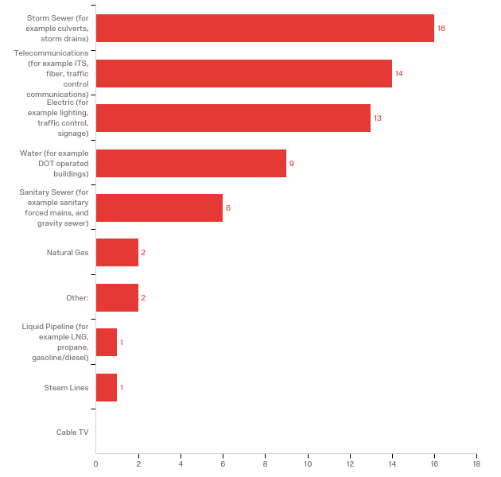
Source: NCHRP 20-07 Task 389 DOT Survey
Figure 4-1: Facilities Operated by DOT Survey Respondents (16 Responding DOTs)

Concluding Summary
When a state DOT evaluates whether to become an operator member in a state one call system agency personnel must consider a number of variables and their potentially complex interactions. Throughout this report the immense difficulty of quantifying all of the costs and benefits of operator membership has been emphasized. Some benefits agencies reported, such as membership improving the design process, are tangible, but challenging to extrapolate across longer time frames. Certainly, costs and benefits of operator membership in one call systems vary, although it appears that benefits outweigh costs in urbanized settings and locations where fiber optic facilities merit heightened protection. The institution best positioned to decide whether operator membership in a one call system is warranted is — a state DOT itself. There are several approaches DOTs can use to prevent damage to their facilities, including membership in one call systems, hybrid memberships in one call systems, permitting processes, 3D utility repositories, and the creation of a state call center. Making decisions at the national level about memberships or exemptions is not judicious. Indeed, there are instances where a single approach to one call operator membership may not be optimal at the state level. State DOTs are responsible for both the safety of the traveling public and the wise stewardship of taxpayer dollars. Accordingly, their voices should be the decisive ones in deliberations over operator membership in one-call systems.
To gain a clearer conclusion to this study, it recommended that state DOTs begin to track dig-in events of their facilities in a more deliberate manner. This information will be further facilitated by recent updates to the DIRT reporting forms but state DOTs could easily capture costs and delays associated with dig-in events through issuing guidance to construction, permitting, and maintenance forces who are likely those involved with those events. The collection of this more detailed data to include the costs, project delays, damages, and the circumstances leading to these damages in the form of a "Utility Hit Report" would provide the data needed to better understand the impacts regarding state DOT facility damages.
Implementation
For implementation the research findings will be offered for presentation to the AASHTO Right-of-Way, Utilities, and Outdoor Advertising Control Committee. We may present this research in other venues to increase its reach. This report in combination with other NCHRP publications will provide guidance state DOTs can use when deliberating on whether to become an operator member of one call systems.
Suggested Research
Many state DOTs are overseeing rapid growth in their highway systems, while development accompanying these expansions is increasing the footprint of utilities in the agency right-of-way. Agencies are increasingly installing fiber optic facilities to control signals and other ITS assets. These trends point to the need for more research and guidance on the future of right-of-way use and accommodation. Currently, there is a need for guidance on the accommodation for newer cellular and broadband systems and future work will be needed to address issues such as connected vehicles. State DOT systems are becoming more connected and more reliant on underground communication facilities. Technological advances are going to place added stress on control of public highway right-of-way, and agencies require guidance to help them address accommodation concerns.
One cost of dig-in events not examined in-depth within this study relates to injuries or deaths due to these damages. This could become especially important in the future as ROW becomes more congested stemming from the future technological needs demanded by society. If this trend involves increased dig-in events and increased injuries, the need for more accurate approaches to locating and marking utilities may be needed. This reiterates the need to have better data regarding these events as has been recommended herein and an endeavor the Common Ground Alliance is working toward.
Furthermore, there is another aspect related to one call systems and their location accuracy that is not addressed by the work herein. Contractors often inflate their bids due the risks associated with not only utility delays but risks of striking utilities that are improperly or inaccurately marked. According to one article this inflation could be 10 to 30% (Zeiss, 2018). These concerns involve liability to facility damages and project delays. While one call locations assist in assigning liability for facility damages, the damage associated delays to projects are not always as easy to settle. The DOT facilities that are not within one call systems therefore entail additional risks to contractors but often the liability assignment occurs in a similar fashion when proper permitting processes have been followed. There is still a question as to the costs that inaccurate or mismarked utility information incurs in inflation of typical construction costs. The importance of underground facility location accuracy should be studied to answer these questions.

References
PHMSA Summary of Damage Prevention Laws. http://primis.phmsa.dot.gov/comm/DamagePreventionSummary.htm. Accessed July 18, 2016.
USDOT “Damage Prevention Assistance Program: Strengthening State Damage Prevention Programs. http://primis.phmsa.dot.gov/comm/publications/DPAP-Guide-FirstEdition-20080911.pdf. Accessed July 12, 2016.
2014 Damage Information Reporting Tool (DIRT), Analysis & Recommendations. Volume 11. Common Ground Alliance. 2014.
“Best Practices 14.0.” Common Ground Alliance [website] http://call811.com/best-practices-guide. Published March 2017. Web Accessed Nov. 2017
“Department of Transportation Grants Management Process (PHMSA) Process Description: Pipeline Safety One-Call Grants – Discretionary”
https://primis.phmsa.dot.gov/comm/publications/Grant%20Criteria%20One%20Call%20Funding.pdf. Web Accessed Nov. 2017
Dig Safely New York. “About Us.” [website] https://www.digsafelynewyork.com/about-us. Web Access, Oct. 2017.
Doss, D. “Underground or Overhead? Exploring Issues of Cost and Reliability.” Electroindustry Magazine. National Electrical Manufacturers Association. p. 12. November, 2012.
“How 811 Works.” [website] http://call811.com/before-you-dig/how-811-works. Web Accessed Nov. 2017.
“H.R. 2266. 100th Congress: Pipeline Safety Reauthorization Act of 1988.” www.GovTrack.us. 1987. https://www.govtrack.us/congress/bills/100/hr2266 Web Access, Oct. 2017.
Marsh, R. “Cable Locating, Past, Present, and Future.” 3M Case Studies & Technical Articles. 3M, Inc. http://solutions.3m.com/3MContentRetrievalAPI/BlobServlet?locale=en_IN&lmd=1258988243000&assetId=1258557598838&assetType=MMM_Image&blobAttribute=ImageFile. Web Access, Oct. 2017.
“The New DIRT Field Form Toolkit.” [website] Common Ground Alliance. http://commongroundalliance.com/damage-prevention/toolkits/new-dirt-field-form-toolkit. Web Accessed Jan. 2018.
One Call Systems International Resource Guide. Common Ground Alliance, One Call Systems International. 2009/2010.
“One Call Systems International.” [website] Common Ground Alliance. http://commongroundalliance.com/programs/one-call-systems-international. Web Accessed Nov. 2017.
“Penalties & Liabilities.” Virginia 811. [website] http://va811.com/lawspolicies/penalties-liabilities/ Web Accessed Nov. 2017
Pennsylvania 811. “About Us-History.” [website]
http://www.pa1call.org/PA811/Public/POCS_Content/About_Us/History.aspx. Web Access, Oct. 2017.
“PHMSA Summary of Damage Prevention Laws.” [website] U.S. Department of Transportation.
https://primis.phmsa.dot.gov/comm/DamagePreventionSummary.htm. Web Accessed Aug. 2017.
“Public Law 112-90. 112th Congress: Pipeline Safety, Regulatory Certainty, and Job Creation Act of 2011.” https://www.gpo.gov/fdsys/pkg/PLAW-112publ90/pdf/PLAW-112publ90.pdf. Web Access, Nov. 2017.
Scott, C. P., “DOTs and One Calls.” 2015 Excavation Safety Guide & Directory. Infrastructure Resources, Inc., pp. 10-11. 2015
Anspach, James. “The Cost of Safety in Construction.” Common Ground Alliance Excavation and Safety Conference. PRESENTATION. Phoenix, AZ. March 13, 2006.
Anspach, James. “The Gap between SUE and Damage Prevention: How Georgia DOT and Georgia Utility Coordinating Council Glued it Together.” Common Ground Alliance Excavation and Safety Conference. PRESENTATION. 2010.
Scott, P. “Subject: Source of Information.” DOTs and One Calls. [Electronic Correspondence]. Dated July 31, 2017
A Study on the Impact of Excavation Damage on Pipeline Safety. Report complying with Section 3 of Pipeline Safety, Regulatory Certainty, and Job Creation Act of 2011, Public Law 112–90, January 3, 2012. U.S. Department of Transportation Pipeline and Hazardous Materials Safety Administration.
https://primis.phmsa.dot.gov/comm/publications/Rpt2Congress-Study-Impact-ExcavationDmgOnPipelineSafety-Oct2014.pdf. 2014.
Thorne, J., Turner, D., and Lindly, J. Highway/Utility Guide. Report FHWA-SA-93-049, Federal Highway Administration, Office of Technology Applications, Washington, D.C., 1993, 10-11, 106-110, 135-146 pp.
Zeiss, Geoff. Geography2050: Accurate location information about underground infrastructure is essential for powering our future planet. November 20, 2018. https://www.linkedin.com/pulse/geography2050-accurate-location-information-essential-geoff-zeiss/

Appendices

Appendix A: Survey Questionnaire
NCHRP 20-07/Task 389 Survey

Introduction

Intro
NCHRP 20-07/Task 389 seeks to determine the impacts to Departments of Transportation (DOTs) relating to exemption or required membership in One-Call centers as underground facility operators. These impacts include the following: Operational costs and benefits Organizational costs and benefits Organizational barriers to members Legal implications to DOTs Facility risks Jobsite safety The intent is to quantify to the extent possible the risks, benefits, costs, and rewards related to DOT membership in One-Call centers as underground utility operators. The implications of both required membership or exemption of membership as operators need to be defined and understood in both scenarios. With legislation and exemptions regarding One-Call centers varying from state-to-state, this survey seeks to gather a snapshot of information for each respondent state DOT for comparison.
The focus of the survey is on the DOT being the utility operator, not the excavator. The survey link can be forwarded for other respondents to complete survey information.
Pilot tests indicated an average time of 15 minutes to complete the survey.
Please complete the online questionnaire by September 29, 2017. If you have questions or would prefer to complete a paper copy questionnaire, please contact:
Tim Taylor Email: tim.taylor@uky.edu Phone (859) 323-3680

Contact Please identify your contact information.
- Agency (5) ________________________________________________
- Address (6) ________________________________________________
- City (7) ________________________________________________
- State (8) ________________________________________________
- Zip Code (9) ________________________________________________
- Questionnaire Contact (4) ________________________________________________
- Position/Title (11) ________________________________________________
- Phone Number (12) ________________________________________________
- Email (13) ________________________________________________

End of Block
Overview

Q1 What kind of facilities does your DOT own and operate (please select all that apply)?
- Telecommunications (for example ITS, fiber, traffic control communications) (4)
- Natural Gas (5)
- Cable TV (6)
- Electric (for example lighting, traffic control, signage) (7)
- Water (for example DOT operated buildings) (8)
- Storm Sewer (for example culverts, storm drains) (9)
- Sanitary Sewer (for example sanitary forced mains, and gravity sewer) (10)
- Liquid Pipeline (for example LNG, propane, gasoline/diesel) (11)
- Steam Lines (12)
- Other: (13) ________________________________________________

Q2 Does your DOT locate and mark your underground facilities when outside entities are performing excavation?
- Yes (28)
- No (29)

Q21 Does your DOT locate and mark your underground facilities when internal or contracted entities are performing excavation?
- Yes (1)
- No (2)

Display This Question:
If Q2 = Yes
Carry Forward Selected Choices - Entered Text from "Q1"

Q2-1 Do you locate all or just some of the facilities? Please select those that you will locate.
- Telecommunications (for example ITS, fiber, traffic control communications) (1)
- Natural Gas (2)
- Cable TV (3)
- Electric (for example lighting, traffic control, signage) (4)
- Water (for example DOT operated buildings) (5)
- Storm Sewer (for example culverts, storm drains) (6)
- Sanitary Sewer (for example sanitary forced mains, and gravity sewer) (7)
- Liquid Pipeline (for example LNG, propane, gasoline/diesel) (8)
- Steam Lines (9)
- Other: (10)

Display This Question:
If Q2 = No

Q2-2 You indicated that you do not mark your facilities for outside entities. Do you provide information regarding your underground facilities though other processes (such as permitting) and do you have data/internal evaluation regarding the decision to not mark your facilities (such as risk assessment of potential damages)?
________________________________________________________________
________________________________________________________________
________________________________________________________________
________________________________________________________________
________________________________________________________________

Display This Question:
If Q21 = No

Q22 You indicated that you do not mark your facilities for internal or contracted entities. Do you provide information regarding your underground facilities though other processes and do you have data/internal evaluation regarding the decision to not mark your facilities (such as risk assessment of potential damages)?
________________________________________________________________
________________________________________________________________
________________________________________________________________
________________________________________________________________
________________________________________________________________

Display This Question:
If Q2 = Yes

Q3 What causes you to mark a particular facility (select all that apply)?
- Internal policies and procedures (4)
- DOT Permit Requirements (5)
- Agreements (6)
- State or Local Statute (7)
- Other: (8) ________________________________________________

End of Block
One Call Participation

Q20 Has your DOT experienced any damages to your underground operated facilities due to excavation?
- Yes (1)
- No (2)

Display This Question:
If Q20 = Yes

Q23 Please briefly describe damages you have experienced, actual or estimated frequency and costs, and what documentation you have available regarding these damage events.
________________________________________________________________
________________________________________________________________
________________________________________________________________
________________________________________________________________
________________________________________________________________

Q4 Does your DOT participate with a One Call Center as a facility operator?
- Yes (23)
- No (24)

Display This Question:
If Q4 = Yes

Q5-1 Has your participation in One Call (as a facility operator) benefited the DOT in terms of reduced damages?
- Yes (23)
- No (24)

Display This Question:
If Q4 = Yes
And Q5-1 = Yes

Q5-2 Do you have any data or documentation that your participation has been of benefit (reduced repair costs, reduction of damages, loss of service)?
- Yes (23)
- No (24)

Display This Question:
If Q4 = Yes

Q6-1 Has your participation in One Call (as a facility operator) caused detriment to the DOT (safety, resource expenditures, etc.)?
- Yes (23)
- No (24)

Display This Question:
If Q4 = Yes
And Q6-1 = Yes

Q6-2 Do you have any data or documentation that your participation been of detriment?
- Yes (23)
- No (24)

Display This Question:
If Q4 = Yes

Q7-1
Has your participation in One Call (as a facility operator) been a net benefit to the DOT?
- Yes (23)
- No (24)

Display This Question:
If Q4 = Yes

Q7-2 Do you have data documenting this result?
- Yes (23)
- No (24)

Display This Question:
If Q4 = Yes

Q8 Regarding your participation in One Call (as a facility operator), what documentation do you have available (please select all that apply)?
- Ticket counts (4)
- Miles located (5)
- Contracts held (6)
- Damage Repair Costs (7)
- Staff Utilization (8)
- Litigation (9)
- Damage counts (10)

Display This Question:
If Q4 = Yes

Q9 Please provide your opinions regarding your DOT’s membership or possible membership in a One-Call center in terms of costs, risks, and benefits.
________________________________________________________________
________________________________________________________________
________________________________________________________________
________________________________________________________________
________________________________________________________________

End of Block
Additional Comments

Q10 Please provide any additional perceptions or thoughts.
________________________________________________________________
________________________________________________________________
________________________________________________________________
________________________________________________________________
________________________________________________________________

End of Block

Appendix B: Survey Responses
States Completing the Survey:
Alabama
Delaware
Georgia
Hawaii
Idaho
Kansas
Maine
Massachusetts
Mississippi
Montana
North Dakota
South Carolina
Utah
Virginia
Washington
Wyoming

Q1 - What kind of facilities does your DOT own and operate (please select all that apply)?
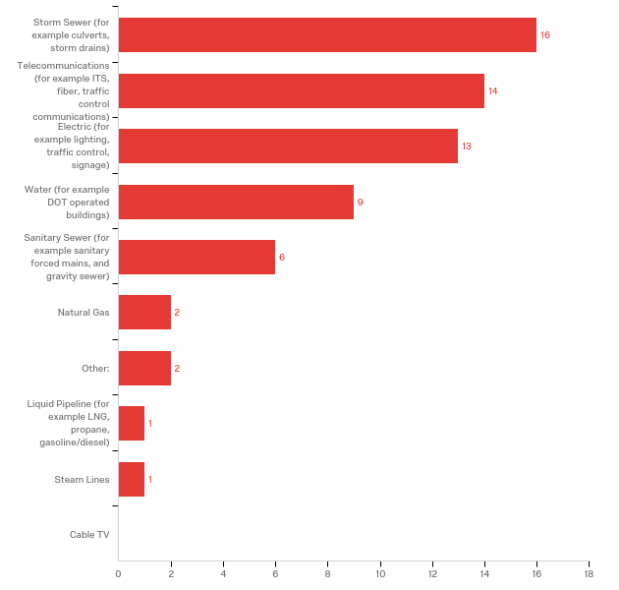

# | Answer | % | Count
4 | Telecommunications (for example ITS, fiber, traffic control communications) | 21.88% | 14
5 | Natural Gas | 3.13% | 2
6 | Cable TV | 0.00% | 0
7 | Electric (for example lighting, traffic control, signage) | 20.31% | 13
8 | Water (for example DOT operated buildings) | 14.06% | 9
9 | Storm Sewer (for example culverts, storm drains) | 25.00% | 16
10 | Sanitary Sewer (for example sanitary forced mains, and gravity sewer) | 9.38% | 6
11 | Liquid Pipeline (for example LNG, propane, gasoline/diesel) | 1.56% | 1
12 | Steam Lines | 1.56% | 1
13 | Other: | 3.13% | 2
 | Total | 100% | 64

Other: - Text | State
ITS - Weigh-in-motion, traffic count stations, etc... | ME
Traffic Signal and Roadway Lighting | MS

Q2 - Does your DOT locate and mark your underground facilities when outside entities are performing excavation?
# | Answer | % | Count
28 | Yes | 88.24% | 15
29 | No | 11.76% | 2
 | Total | 100% | 17

Q21 - Does your DOT locate and mark your underground facilities when internal or contracted entities are performing excavation?
# | Answer | % | Count
1 | Yes | 94.12% | 16
2 | No | 5.88% | 1
 | Total | 100% | 17

Q2-1 - Do you locate all or just some of the facilities? Please select those that you will locate.
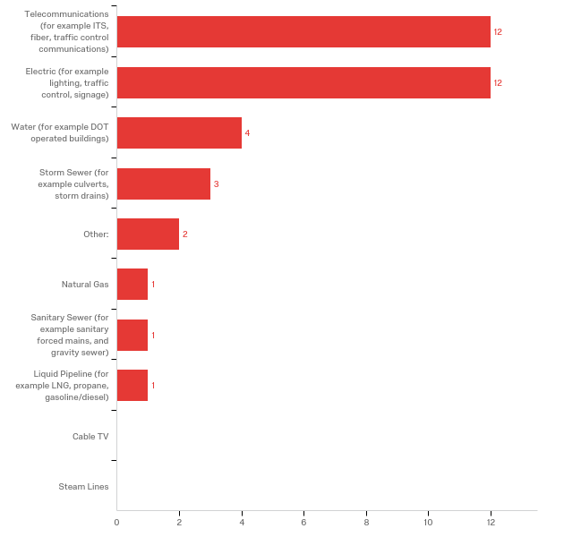

# | Answer | % | Count
4 | Telecommunications (for example ITS, fiber, traffic control communications) | 33.33% | 12
5 | Natural Gas | 2.78% | 1
6 | Cable TV | 0.00% | 0
7 | Electric (for example lighting, traffic control, signage) | 33.33% | 12
8 | Water (for example DOT operated buildings) | 11.11% | 4
9 | Storm Sewer (for example culverts, storm drains) | 8.33% | 3
10 | Sanitary Sewer (for example sanitary forced mains, and gravity sewer) | 2.78% | 1
11 | Liquid Pipeline (for example LNG, propane, gasoline/diesel) | 2.78% | 1
12 | Steam Lines | 0.00% | 0
13 | Other: | 5.56% | 2
 | Total | 100% | 36

Q2-2 - You indicated that you do not mark your facilities for outside entities. Do you provide information regarding your underground facilities though other processes (such as permitting) and do you have data/internal evaluation regarding the decision to not mark your facilities (such as risk assessment of potential damages)?

You indicated that you do not mark your facilities for outside entities. Do you provide information regarding your underground facilities though other processes (such as permitting) and do you have data/internal evaluation regarding the decision to not mark your facilities (such as risk assessment of potential damages)?
We would provide that information if asked.
Yes. Drawings of existing facilities within the proposed project.

Q22 - You indicated that you do not mark your facilities for internal or contracted entities. Do you provide information regarding your underground facilities though other processes and do you have data/internal evaluation regarding the decision to not mark your facilities (such as risk assessment of potential damages)?

You indicated that you do not mark your facilities for internal or contracted entities. Do you provide information regarding your underground facilities though other processes and do you have data/internal evaluation regarding the decision to not mark your facilities (such as risk assessment of potential damages)?
Yes. Drawings of existing facilities within the proposed project.

Q3 - What causes you to mark a particular facility (select all that apply)?
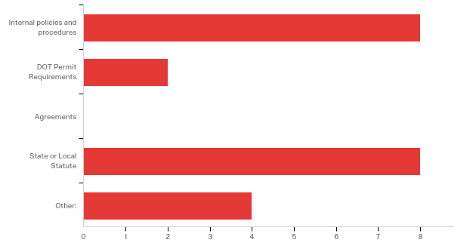

# | Answer | % | Count
4 | Internal policies and procedures | 36.36% | 8
5 | DOT Permit Requirements | 9.09% | 2
6 | Agreements | 0.00% | 0
7 | State or Local Statute | 36.36% | 8
8 | Other: | 18.18% | 4
 | Total | 100% | 22

Other:
Other: - Text
It makes sense
request
WSDOT water, and electric services are provided byothers. Out signals shop does the locates and often doesn thave record other than DOT facilities installed by DOT
State Law

Q20 - Has your DOT experienced any damages to your underground operated facilities due to excavation?
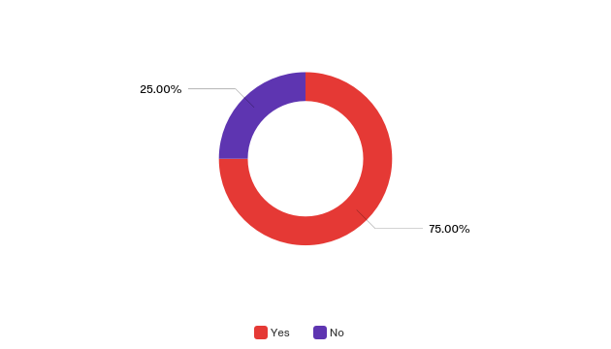

# | Answer | % | Count
1 | Yes | 75.00% | 12
2 | No | 25.00% | 4
 | Total | 100% | 16

Q23 - Please briefly describe damages you have experienced, actual or estimated frequency and costs, and what documentation you have available regarding these damage events.

Please briefly describe damages you have experienced, actual or estimated frequency and costs, and what documentation you have available regarding these damage events. | State
 | MT
Sometimes our records have been incorrect and sometimes our contractor has not responded in a timely manner. | ME
damages to underground conduit to traffic signal equipment and roadway light systems. several times a year, estimated cost $5,000.00 | MS
 | South Carolina
Occasional damage to electrical lines for lighting, traffic signals. Hearsay from Resident Engineers and Permits Coordinators | Idaho
I do not have enough statewide knowledge to answer this in whole. I am only aware of a couple of regions that have experienced damage. In those cases it dealt with an unlocatable facility | WA
 | GA
Twice per year. Power line dug up due to City repair of a waterline break. Fiber dug up due to lack of communication. | KS
We get traffic signal loop impacts. We have had occurrences of fiber impacts. Costs are highly variable depending on the location and type of utility impacted. A very rough estimate is we are seeing a dozen hits per year across the state. Additional information would need to be compiled in order to be more responsive to this question. | UT
Our onecall locators missed some of the lines. | ND
 | AL
We do not have good, easily accessible records for this though we could probably pull some costs related to damages together if needed. We estimate there are 2-3 hits on DelDOT fiber that is marked in the field through Miss Utility alone. This number would be higher if we were to look at locations where marks were inaccurate or where there was no ticket. We have been utilizing a contractor to perform one call locates on our signal/ITMS and lighting facilities since March 2014 and October 2015 respectively. | DE
 | Hawaii
damages from other utilities/contractors during their excavation activities | VA
Street lighting conduit damage | MA
Dig Ins - Due do not being in One-Call System as we still find older utilities that were in the ground prior to One-Call System. I am only aware of one instance of a WYDOT dig in this past year. $1200 repair cost (estimated) | WY

Q4 - Does your DOT participate with a One Call Center as a facility operator?
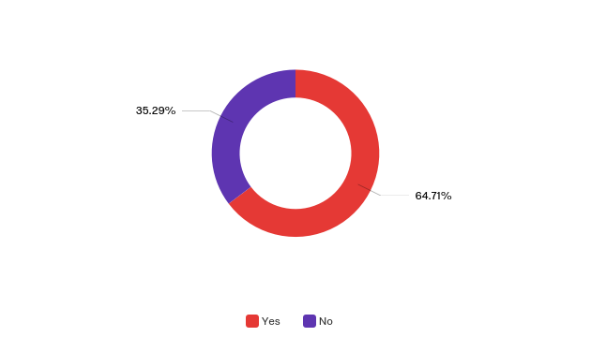

# | Answer | % | Count
23 | Yes | 64.71% | 11
24 | No | 35.29% | 6
 | Total | 100% | 17

Q5-1 - Has your participation in One Call (as a facility operator) benefited the DOT in terms of reduced damages?
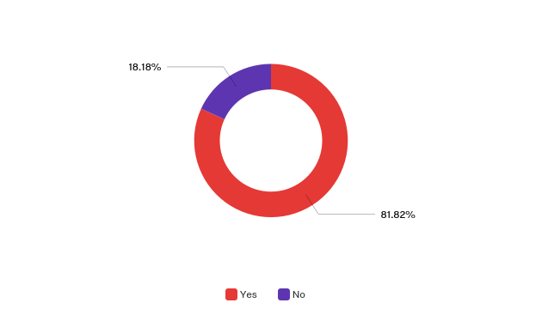

# | Answer | % | Count
23 | Yes | 81.82% | 9
24 | No | 18.18% | 2
 | Total | 100% | 11

Q5-2 - Do you have any data or documentation that your participation has been of benefit (reduced repair costs, reduction of damages, loss of service)?
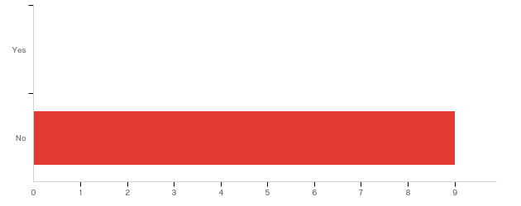

# | Answer | % | Count
23 | Yes | 0.00% | 0
24 | No | 100.00% | 9
 | Total | 100% | 9

Q6-1 - Has your participation in One Call (as a facility operator) caused detriment to the DOT (safety, resource expenditures, etc.)?
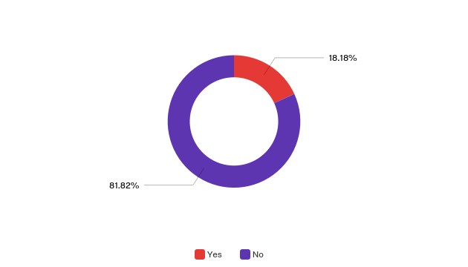

# | Answer | % | Count
23 | Yes | 18.18% | 2
24 | No | 81.82% | 9
 | Total | 100% | 11

Q6-2 - Do you have any data or documentation that your participation been of detriment?
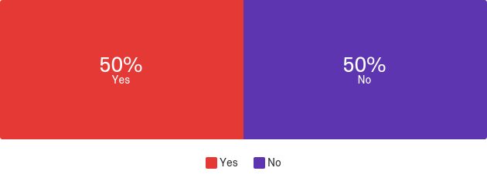

# | Answer | % | Count
23 | Yes | 50.00% | 1
24 | No | 50.00% | 1
 | Total | 100% | 2

Q7-1 - Has your participation in One Call (as a facility operator) been a net benefit to the DOT?
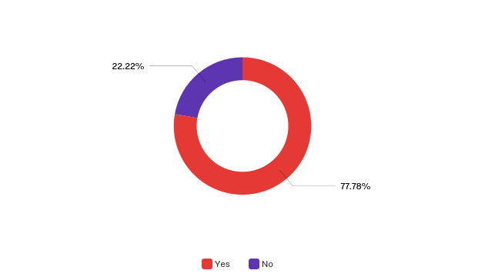

# | Answer | % | Count
23 | Yes | 77.78% | 7
24 | No | 22.22% | 2
 | Total | 100% | 9

Q7-2 - Do you have data documenting this result?

# | Answer | % | Count
23 | Yes | 9.09% | 1
24 | No | 90.91% | 10
 | Total | 100% | 11

Q8 - Regarding your participation in One Call (as a facility operator), what documentation do you have available (please select all that apply)?
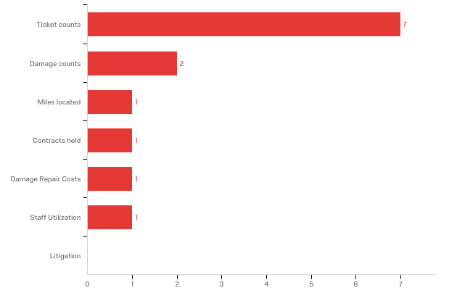

# | Answer | % | Count
4 | Ticket counts | 53.85% | 7
5 | Miles located | 7.69% | 1
6 | Contracts held | 7.69% | 1
7 | Damage Repair Costs | 7.69% | 1
8 | Staff Utilization | 7.69% | 1
9 | Litigation | 0.00% | 0
10 | Damage counts | 15.38% | 2
 | Total | 100% | 13

Q9 - Please provide your opinions regarding your DOT’s membership or possible membership in a One-Call center in terms of costs, risks, and benefits.

Please provide your opinions regarding your DOT’s membership or possible membership in a One-Call center in terms of costs, risks, and benefits. | State
The two primary benefits are for highway project contractors avoiding our facilities and other utility contractors avoiding our facilities. | MT
We may be able to come up with some information on ticket counts, miles located, or damage counts. It would require some digging and consulting with our marking contractor. Overall, before we participated, we used to damage our own stuff much more frequently. That is much less common now. There is a time and expense, but it's worth it and it's the right thing to do. Also, in Maine, drainage systems are exempt from marking, which also makes sense. | ME
 | MS
 | South Carolina
 | Idaho
None | WA
 | GA
We have a few miles of fiber on local city streets. We experience 15 to 20 tickets per month. We also have engaged a contractor to receive the tickets and conduct the locates. So there is a monthly fee associated with our located responsibility. We have been fortunate to have avoided any major damage to-date. We are in the process of listing our fiber on One Call. The excavating industry is in tuned to calling One Call for locate services. They do not consider that the DOT has utilities to be located separate from One Call. | KS
Current state law requires membership with Utah's One-Call Center (Blue Stakes of Utah). Ticketing calls are low ($0.93 each), but ticket volumes for UDOT are high (80K per year). We would love to hear about any emerging alternatives, but state law would ultimately need to change in order for us to pursue such an alternative. | UT
 | ND
 | AL
DelDOT is not exempt from Delaware's One-Call law so DelDOT is required to participate. Our experience is that participation in the One-Call system is a benefit. Over time, we have transitioned to performing One-Call locates part time with internal personnel to contracting the work out. Additionally, we have tweaked our polygons to make the system more accurate. With the use of a contractor, the cost of tickets has reduced greatly with them refining the polygons associated with DelDOT owned conduit, ITMS and lighting facilities throughout the state rights-of-way. | DE
While there are benefits to the system, we do not have the proper manpower to devote to the system as we would like. As such, the lack of damage to the system is due more to the visual nature of the storm sewer (its easy to track the inlets and manholes). Water system is mostly sprinkler systems located in areas not frequently excavated. | Hawaii
 | VA
 | MA
WYDOT pays an "Annual Membership" fee. WYDOT is listed as a "Municipality" in the One-Call System. WYDOT pays a "per ticket fee" of $0.75 ea.. For Example, WYDOT was billed for July 2017 $1,137.00 for 1516 tickets issued. WYDOT did not necessarily have to physically locate all of those. Most tickets issued are cleared via the telephone to the excavator. WYDOT was instrumental in starting Wyoming's "True" One-Call System. WYDOT believes in the One-Call System and have internal policies to make sure our employees "Call before you Dig". It is also in the Wyoming State Law (Title 37 Public Utilities, Chapter 12, Article 3. WYDOT Strives for safety to all the traveling public as well as our employees. So, using the One-Call System is a must. | WY

Q10 - Please provide any additional perceptions or thoughts.

Please provide any additional perceptions or thoughts. | State
The one-call locates are a function of each District office under their maintenance staff, so my knowledge of specific advantages and disadvantages is limited. Additional information/answers to specific questions can be provided upon request. | MT
 | ME
 | MS
 | South Carolina
Past (and possibly current) executive management saw no benefit in being a member of One-Call centers. | Idaho
I apologize for the incompleteness of the survey- I just don't have access to all the information you requested | WA
I have no knowledge of damages due to excavation. | GA
We will be taking on an additional expense to locates by listing our fiber on the One Call system. We estimate it will cost $150,000 to $250,000 annually for locate services. But with out the services, our fiber is not being located or protected. So we see it as a benefit to get in the One Call system. | KS
Locating costs are perpetually growing as highway systems enlarge and expand over time. So far, we have not seen an effective model that can help reduce these ever-escalating costs. If such a model exists it would be great to learn about it. Please share the results of this survey. | UT
 | ND
Have a goal of establishing a GIS for utilities on DOT ROW. We have SUE data from some projects as well as topo surveys that may be more accurate than utility company records. Hope to use the information to prevent us from permitting new utility placement on top of existing utilities. It could reduce the need to collect new utility topo if any new permitted utilities are part of the GIS that also has the existing utilities as part of the data. New construction should not happen on our ROW without our knowledge. The utility owns the electric lines that power our lighting or traffic signals. They would be part of the One Call system. Any water or sewer line from a rest area or welcome center would tie to a utility whom we would have an agreement with to provide service and be required to maintain. | AL
You will notice that several answers indicate we do not have documentation to support answers to some questions. I want to clarify that by saying we did not readily track information prior to hiring the contractor that currently provides one-call response services on our behalf. However, we should have the ability to pull some information together to support statements if need be. In addition, we do track information through our contractor now so there is data for the past 2 or 3 years. It is also important to note that there have not been any at fault damages for our contractor associated with the agreement services they are responsible to DelDOT for since they went under contract with us. | DE
 | Hawaii
State Code provides exemption for VDOT from being a member of one-call. We voluntarily follow the procedures and publish and mark our facilities with notification numbers for marling facilties | VA
 | MA
 | WY

Appendix C: Case Study Interview Questions
One Call Interview Questions
We are requesting an interview as part of NCHRP Project 20-07/Task 389 Implications of State Department of Transportation (DOTs) Participation in the One Call Process as an Underground Facility Operator. The information we hope to gather involves estimates of costs and benefits associated with DOT membership in One Call as a facility operator. This information can be perception but we would also appreciate documentation of costs and benefits if you have that information. Examples of costs would include ticket costs, staff additions, locator contracting, etc. with benefits including reductions of risks to facilities, reduction of dig-in events, improved safety, etc. We also want to understand the perceptions of those who do not participate in One Call as facility operators.
Please use the questions below to gather your thoughts for our discussion. We also welcome any notes you care to submit (electronically or on paper) according to the following questions. Thank you for your assistance!
- Do you participate in One Call as a facility operator?

- Based on your answer to Question 1, what are the benefits of that that arrangement?

- Based on your answer to Question 1, what are the costs of that that arrangement?

- Can you provide documentation of these costs and benefits? (What types of documentation do you have regarding these costs and benefits?)~if you could bring these or provide them electronically that would be great.

If you participate in One Call as a facility operator:
- How/who performs the facility locates/designations?

- Do you feel there is overlap/conflicts with permit processes? Example: An excavator uses One Call to notify the DOT of work but doesn’t follow the permits process, or vice versa.

